Stage 5 unit starter – a sustainable future, making changes together

Introduction
This unit starter has been designed to support the cross-curriculum priorities of Aboriginal and Torres Strait Islander histories and cultures, and sustainability.
You can adapt this unit starter for any language. Modify the unit to suit the needs of your learners, including adding your own resources, modifying content or duration and differentiating for learning needs and learner groups. The learning, teaching and assessment strategies and final assessment task are suggestions only.
We have included some sample resources in English (as this unit starter is generic for all languages) – please spend some time translating the resources into the language you are teaching, and sourcing your own resources. When you see [language] in this document, insert the language of the syllabus you are teaching. When you see text in italics (including in the resources), replace it with appropriate text in the language you are teaching.
Consider the background knowledge your students may or may not have about the local Aboriginal community. If there are Aboriginal or Torres Strait Islander students in your class and they are willing and comfortable, they may wish to add their own knowledge to discussions throughout the unit. Consider inviting Aboriginal Elders for additional local knowledge and support.
For further information and support, the AECG (local and NSW), local Aboriginal Land Councils, Aboriginal Interagency Groups and local government councils often have an Aboriginal Advisory Group and may include information about the local people on their website. You can also liaise with your school’s own Aboriginal Education team.
When consulting with Aboriginal Communities, it’s important to follow the appropriate protocols and follow Indigenous cultural intellectual property. You can learn more about consultation protocols by reading the Working with Aboriginal communities document.

Nura – Country, Place
Nura is a word spoken by the Aboriginal people who live in the Sydney region. It is included in our title here in recognition of the language of the Gadigal of the Eora Nation, the custodians of Country where this unit starter was developed. Please source the translation relevant to the Country or Place you are teaching on.
Land means different things to different people. Aboriginal and Torres Strait Islander peoples have a spiritual, physical, social and cultural connection to Country. Land management and sustainability are central to their way of life. In this unit, students will explore the importance and relevance of beliefs held by Aboriginal and Torres Strait Islander peoples and how we can learn from millennia-old customs. By the end of this unit, students will develop an awareness of the meaning of Country and be able to critically think about the necessary changes needed for a more sustainable future. Students will also continue to build on language structures to express opinions, facts and vocabulary relating to the environment for the purpose of creating an engaging and informative bilingual brochure/infographic on sustainable practices.

Duration
Approximately 4-5 weeks.

Key inquiry questions
- What does Country/Place mean to Aboriginal and Torres Strait Islander peoples?
- How has our local area changed over time?
- What can be learnt from Aboriginal and Torres Strait Islander peoples in relation to sustainable practices?
- How do a range of cultures represent the seasons?
- What can we do to support sustainability?
- How do we share key information with the community in an engaging format?

Learning across the curriculum
- Aboriginal and Torres Strait Islander histories and cultures
- Sustainability
- Intercultural understanding
- Information and communication technology capability
- Critical and creative thinking
- Literacy
Note: Consider consulting your colleagues in science, HSIE and TAS to further examine these ideas from different KLA-perspectives, to add depth and breadth to the content.

Sample assessment of learning
As part of its ‘sustainable practices awareness campaign’, your local council is running a competition for schools. To support the [language]-speaking community to get involved, EITHER:
- create a bilingual brochure or infographic using Microsoft Publisher/Canva (or other multi-media platform) for your local community on 5 things which could be learnt from Aboriginal and Torres Strait Islander peoples relating to sustainability; OR
- create a bilingual brochure or infographic using Microsoft Publisher/Canva (or other multi-media platform) for your local community on 5 sustainable practices that they can adopt.
Non-scripted languages outcomes: LXX5-4C, LXX5-6U
Scripted languages outcomes: LXX5-4C, LXX5-6U, LXX5-7U

Video resources
This unit starter includes links to suggested videos. Please ensure you advise any Aboriginal and Torres Strait Islander peoples that videos may contain the images, voices and names of people who have passed away.

Suggested vocabulary and structures
Vocabulary related to Country | Vocabulary relating to sustainability | Structures | Verbs
- Country/Place (Note: Conceptual accuracy is important. The translation should be as close to the concepts of Country/Place as possible. ‘Nation’ may be appropriate in some languages. Alternatively, use appropriate terms from Aboriginal or Torres Strait Islander languages, or English, even when using the target language.)  - land  - trees  - bark  - plants  - wood  - rocks  - animals  - water  - river  - sea, ocean  - sky  - sun  - rain  - identity  - spirit  - culture  - medicine  - tools  - shelter | - environment  - sustainability  - climate  - season | - conditional  - imperative | - connect  - use  - reuse  - recycle  - upcycle  - care for  - protect  - grow  - compost  - waste  - over- (with verbs), for example overfishing  - learn  - stop  - protect  - have  - place/put  - recycle  - modal verbs – could, must

Outcomes
Outcome code | Scripted language | Non-scripted language
LXX5-2C | identifies and interprets information in a range of texts | identifies and interprets information in a range of texts
LXX5-4C | experiments with linguistic patterns and structures to compose texts in [language], using a range of formats for a variety of contexts, purposes and audiences | experiments with linguistic patterns and structures to compose texts in [language], using a range of formats for a variety of contexts, purposes and audiences
LXX5-5U | demonstrates how [language] pronunciation and intonation are used to convey meaning | demonstrates how [language] pronunciation and intonation are used to convey meaning
LXX5-6U | demonstrates understanding of how [language] writing conventions are used to convey meaning | analyses the function of complex [language] grammatical structures to extend meaning
LXX5-7U | analyses the function of complex [language] grammatical structures to extend meaning | analyses linguistic, structural and cultural features in a range of texts
LXX5-8U | analyses linguistic, structural and cultural features in a range of texts | explains and reflects on the interrelationship between language, culture and identity
LXX5-9U | explains and reflects on the interrelationship between language, culture and identity
All outcomes and learning across the curriculum content and icons referred to in this unit are adapted from the K-10 language syllabuses developed from the Languages K-10 Framework © NSW Education Standards Authority (NESA) for and on behalf of the Crown in right of the State of New South Wales, 2018.
Replace XX with the code for your language, for example LGE5-2C for German or LAR5-5U for Arabic.

Unit starter
Syllabus outcomes (scripted) | Syllabus outcomes (non-scripted) | Suggested teaching and learning strategies | Evidence of learning
LXX5-2C  identifies and interprets information in a range of texts  LXX5-4C  experiments with linguistic patterns and structures to compose texts in [language], using a range of formats for a variety of contexts, purposes and audiences  LXX5-5U  demonstrates how [language] pronunciation and intonation are used to convey meaning  LXX5-6U  demonstrates understanding of how [language] writing conventions are used to convey meaning  LXX5-9U  explains and reflects on the interrelationship between language, culture and identity | LXX5-2C  identifies and interprets information in a range of texts  LXX5-4C  experiments with linguistic patterns and structures to compose texts in [language], using a range of formats for a variety of contexts, purposes and audiences  LXX5-5U  demonstrates how [language] pronunciation and intonation are used to convey meaning  LXX5-8U  explains and reflects on the interrelationship between language, culture and identity | Building the field  Introduce the unit by taking the students for a walk to a chosen location on the school grounds, where they can engage with the natural environment. In [language], ask students to touch the rocks, trees and plants, to feel the sun, to look at the sky and the clouds and to breathe the air. As students move, touch and view the natural world around them, gradually introduce new vocabulary relating to Country (see table on pages 4 and 5).  Allow time to introduce or revise key vocabulary and its pronunciation, related to Country (from table on pages 4 and 5), for example through Quizlet and memory games. Allow 5-10 minutes each week for consolidation.  Understanding the concept of Country  Introduce the topic of Country by watching The land owns us (6 minutes 14 seconds). Students answer the following questions:  - What does Uncle Bob Randall mean when he says ‘Lived on the land as people of the land’?  - Explain the concept of ownership according to Uncle Bob Randall.  - How does the Aboriginal concept of land ownership differ to the Western concept of land ownership?  - What is the ‘granny law’?  - Explain the concept of ‘kanyini’ in your own words.  - Do you have a word or phrase for this concept in the language you speak at home? In your opinion, why or why not?  Using the sample stimulus text (note – this is a Korean version, or you can access the English version and develop your own translation), students complete a range of activities, for example:  - text coding, for example identifying verbs and nouns or identifying known words  - reordering the text (the teacher would need to provide students with chunks of text to reorder)  - cloze activity.  Students then complete a comprehension activity on the same text.  Note: This stimulus text acts as an anchor text for the unit – it contains much of the key vocabulary, and students should be able to read and understand it with confidence by the end of the unit.  Share the following quotation with students (in English and in [language]):  - “The land is the mother and we are of the land; we do not own the land rather the land owns us. The land is our food, our culture, our spirit and our identity.” (Dennis Foley, a Gai-mariagal and Wiradjuri man, and Fulbright scholar)  Using the structures from the stimulus text (translated into [language]), students brainstorm (as a class or in small groups) the concept of Country in [language], copying the information down as a mind map, for example:  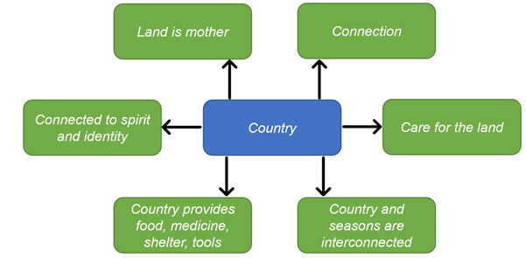  This could also be completed as a think-pair-share activity.  Using discussion points from the concept of Country and/or The land owns us video, students create a simple A4 poster in [language], representing key meanings of Country for display in the classroom throughout the unit. | Active participation in discussions  Completion of vocabulary games  Completion of questions relating to The land owns us  Accurate completion of cloze passage and comprehension questions  Mind map relating to the concept of Country  Creates an engaging A4 poster with appropriate language structures
LXX5-4C  experiments with linguistic patterns and structures to compose texts in [language], using a range of formats for a variety of contexts, purposes and audiences  LXX5-5U  demonstrates how [language] pronunciation and intonation are used to convey meaning  LXX5-6U  demonstrates understanding of how [language] writing conventions are used to convey meaning  LXX5-7U  analyses the function of complex [language] grammatical structures to extend meaning | LXX5-4C  experiments with linguistic patterns and structures to compose texts in [language], using a range of formats for a variety of contexts, purposes and audiences  LXX5-5U  demonstrates how [language] pronunciation and intonation are used to convey meaning  LXX5-6U  analyses the function of complex [language] grammatical structures to extend meaning | The changes to our land  Allow time to introduce or revise verbs related to unit (from table on pages 4 and 5), including pronunciation and revision of present tense conjugations, for example through online worksheets through a platform such as wizer.me or liveworksheets.com, memory games and Quizlet games. Allow 5-10 minutes each week for consolidation.  Introduce the conditional mood (or its equivalent) by presenting students with a historical image of an Australian landscape, for example:  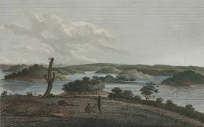  ‘By water to Parramatta, with a distant view of the western mountains, taken from the Windmill-hill at Sydney’, 1798, by J. Heath, licensed under CC BY-SA  This image of the Barramattagal Country was created over 220 years ago. Using a sentence builder in [language], ask students What do you see? For example:  Using a sentence builder in [language], ask students What would you see now (if you looked across the Parramatta landscape)? For example:  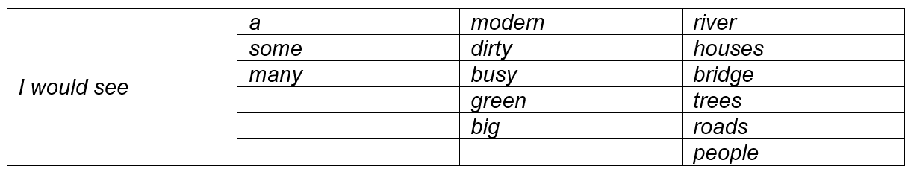  A similar activity could be repeated with the verb hear.  Take students back to the place you took them at the start of the unit. Ask them to close their eyes and imagine they are travelling back in time 250 years. Students then write 5 “I would see…” sentences relating to the landscape prior to invasion and colonisation.  What can be learnt from Aboriginal and Torres Strait Islander peoples about sustainability?  Allow time to introduce or revise key vocabulary related to sustainability (from table on pages 4 and 5), for example through Quizlet and memory games.  As a class, watch Aboriginal Land Management – Wiradjuri Country (4 minutes 4 seconds). Students complete the following:  - What are 3 ways Wiradjuri people use trees to make tools and shelter which are explained in the video?  - Provide 2 environmental benefits of these approaches.  Teachers of Chinese or Japanese languages could encourage students to explore the development of characters, from real life objects to symbols, and draw comparisons with Aboriginal symbolism, such as symbols for people and campfire in Wiradjuri depicted in the video. | Active participation in discussions  Completion of vocabulary games  Accurate completion of present tense verb activities/worksheets  Accurate sentence building and pronunciation  Completion of questions/activities related to Aboriginal Land Management – Wiradjuri Country
LXX5-4C  experiments with linguistic patterns and structures to compose texts in [language], using a range of formats for a variety of contexts, purposes and audiences  LXX5-7U  analyses the function of complex [language] grammatical structures to extend meaning  LXX5-8U  analyses linguistic, structural and cultural features in a range of texts  LXX5-9U  explains and reflects on the interrelationship between language, culture and identity | LXX5-4C  experiments with linguistic patterns and structures to compose texts in [language], using a range of formats for a variety of contexts, purposes and audiences  LXX5-6U  analyses the function of complex [language] grammatical structures to extend meaning  LXX5-7U  analyses linguistic, structural and cultural features in a range of texts  LXX5-8U  explains and reflects on the interrelationship between language, culture and identity | Sustainability and seasons  To introduce the concept of seasons, and how Country and seasons are interconnected, watch the short video 5 Seasons (1 minute 39 seconds) as a class. This video introduces the annual 5-season cycle identified by the Nunggubuyu people who live on the south-west coast of the Gulf of Carpentaria in the Northern Territory. The seasons in the video are:  - Migirarrga (May-July) – cold weather time  - Durrmala (August-October) – turtle egg time, with hot dry winds  - Barra (October-December) – anticipating the coming rains  - Barra Amilmilariri (January-February) – heavy rain with flooding in low-lying areas  - Mariga (March-April) – the drying of the flood plains and anticipating cooler weather.  As a comparison, students read about the Nyoongar calendar.  As a class, discuss (in English):  - How do these 2 calendars differ from the Gregorian calendar? (Or to a lunar calendar, if applicable.)  - How do these 2 calendars link with sustainable practices?  Students view the Gulumoerrgin and Gooniyandi calendars on the CSIRO website, then either create their own seasonal calendar in [language] or a seasonal calendar for the target culture in [language], based on the language they have learned to date and the activities, foods, celebrations and customs they associate with each part of the year. Allow at least 1 lesson for calendar design. Students consider the following in their design:  - How many seasons will my calendar have?  - What will these seasons be called, and why?  - What are the key events, activities and/or celebrations I associate with each season?  - Compare the calendar you have created to the Gregorian calendar and to one of the Aboriginal calendars you have looked at. Which one do you prefer, and why?  How sustainable are our practices?  Introduce or revise frequency words, for example always, often and never. Practise with known structures and vocabulary from previous content (this will vary, based on your context), for example Do you often play piano?, Do you always do homework?, How often do you eat apples?, What do you never do?  In pairs, students review the ‘How sustainable are you?’ quiz (in [language]), ensuring they understand all questions and concepts. Students then complete the quiz individually, scoring 3 points for each always answer, 2 points for each often answer and 1 point for each never answer.  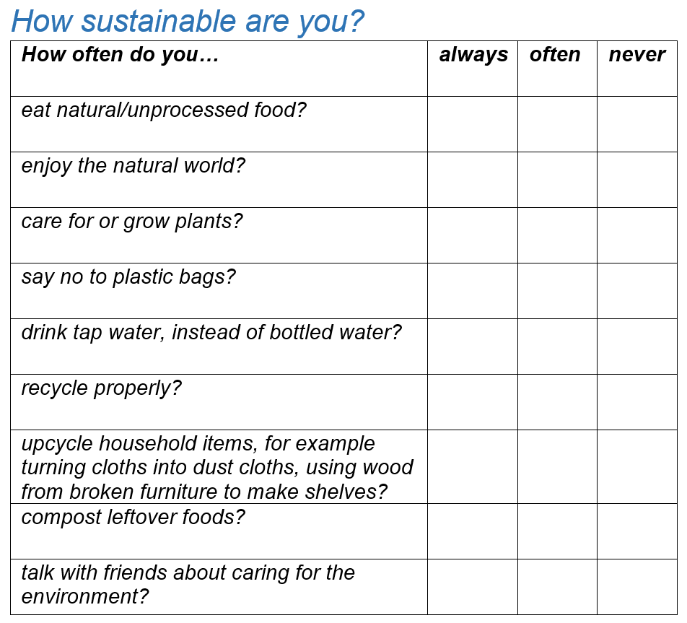  Introduce the concept of could (modal verb) or its equivalent, using the questions from the quiz as a scaffold, for example:  - [Student name] eats natural foods. I could eat natural foods too.  - [Student name] enjoys the natural world. I could enjoy the natural world too.  - [Student name] grows plants. I could grow plants too.  Students then write 2-3 could sentences for how they could improve their score or their commitment to sustainable practices.  As a class, explore the importance of sustainability in a chosen target country. Identify a range of practices or programs in the chosen target country which support sustainability, such as Der Grüne Punkt in Germany. Explore relevant texts or videos. | Active participation in discussions  Creates an engaging seasonal calendar which includes activities, foods, celebrations and customs they associate with each part of the year  Clear understanding of different concepts of calendars and seasons  Accurate completion of quiz and related sentences
LXX5-2C  identifies and interprets information in a range of texts  LXX5-4C  experiments with linguistic patterns and structures to compose texts in [language], using a range of formats for a variety of contexts, purposes and audiences  LXX5-6U  demonstrates understanding of how [language] writing conventions are used to convey meaning  LXX5-7U  analyses the function of complex [language] grammatical structures to extend meaning  LXX5-8U  analyses linguistic, structural and cultural features in a range of texts | LXX5-2C  identifies and interprets information in a range of texts  LXX5-4C  experiments with linguistic patterns and structures to compose texts in [language], using a range of formats for a variety of contexts, purposes and audiences  LXX5-6U  analyses the function of complex [language] grammatical structures to extend meaning  LXX5-7U  analyses linguistic, structural and cultural features in a range of texts | What can we do?  Introduce the imperative mood (or its equivalent) by asking students to complete a table similar to the following, adapted for [language]:  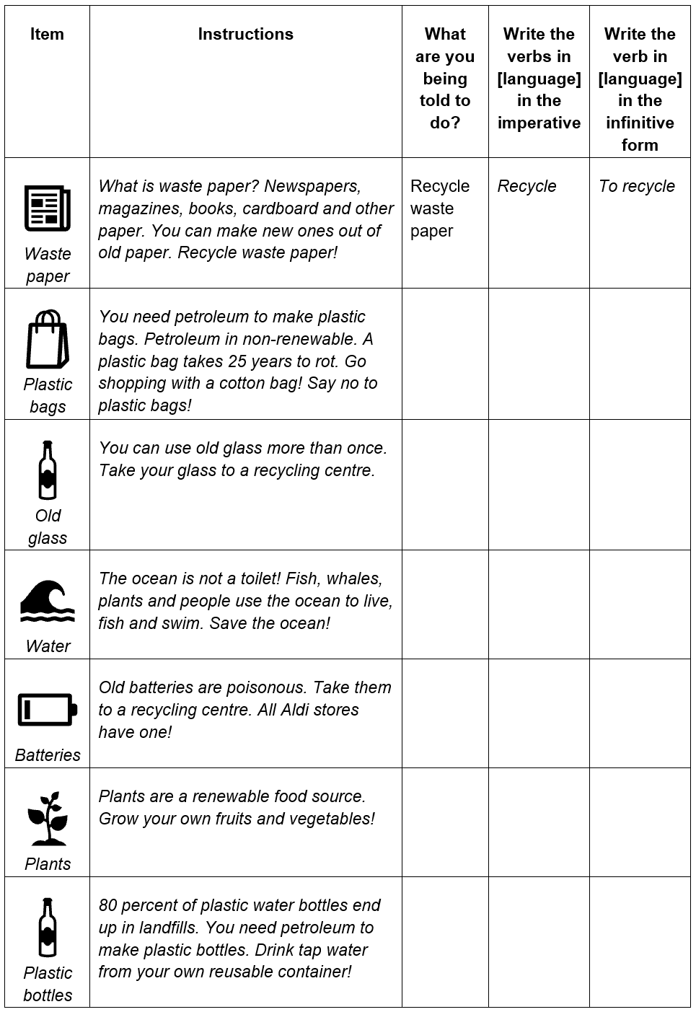  Create and share a short true/false Kahoot quiz with the class, entitled Sustainable – true or false? with the following statements in [language]. The answers and sample text for clarification once you mark/discuss the quiz have also been provided:  - Use plastic bags! False – it’s better to use cloth bags  - Put glass in the red bin! False – it goes in the yellow bin  - Wash bottles and cans before recycling! True – clean them before recycling them  - Recycle paper! True – in goes in the yellow bin (or blue bin, depending where you live)  - Drink bottled water! False – tap water is better for the environment  - Eat processed foods! False – it’s better to eat food as close to its natural state as you can, where possible and safe  - Grow your own fruits and vegetables! True – consider a patch in your garden or some pot plants on your balcony  - Put food in the red bin! False – it’s better to compost food wastes  - Upcycle clothing! True – consider giving to charity or reusing in another way, such as cleaning cloths  - Recycle old phones in the yellow bin! False – take them to a phone recycling centre  Bringing it all together  Students write a reflective journal in [language].  The campaign  Introduce the infographic as a text type. Explain the ‘infographic’ is a portmanteau of the words ‘information’ and ‘graphic’, so it’s a way to display information in a visually engaging way. Students research the elements of a great infographic, for example The 7 Key Components of a Knockout Infographic (blog post) and What Makes and Effective Infographic (video).  Using samples of infographics in [language] relating to the topic of caring for the environment, discuss how the message is conveyed, for example:  - Are students able to identify linguistic similarities?  - Are specific verb tenses used?  - Is the language succinct or descriptive? Why?  - Is there a specific tone?  - How do the images add to the overall information?  As a class, summarise in [language] the key focal points of the unit. Note: Further explanations may be in English.  Allow 1-2 lessons (depending on lesson length) for students to work on their infographics, with the following questions to guide their designs:  - Has the main message been identified?  - Is the hierarchy of the messaging clear?  - Are the language structures appropriate? What is their effect? Are those structures the most effective structures for an awareness campaign?  - Is there a salient image? What is the purpose of the image?  - Have are images been used? If yes, what is their function? | Accurate completion of table, identifying imperative and infinitive verb forms  Active participation in Kahoot  Active participation in discussions  Considered completion of reflective journal  Engaging and accurate bilingual infographic

