Japanese house – activity package
This activity package is designed for Stage 4 students. The package can be incorporated into a variety of existing units of work, for example family or life in Japan. Alternatively, it may be used as a stand-alone activity.
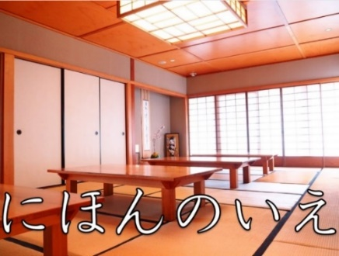
Image source: Nihongo Tanken Centre

Outcomes
LJA4-2C identifies main ideas in, and obtains information from texts
LJA4-6U demonstrates understanding of key aspects of Japanese writing conventions

Package inclusions
- Vocabulary video
- Introduction video
- Vocabulary
- Wizer activities
If you have trouble opening the video or Wizer links, please open them in Google Chrome.

Vocabulary
Japanese | English
たたみ | tatami mat
ざぶとん | Japanese cushion to sit on
しょうじ | sliding door made of wood and paper
にわ | garden
とこのま | alcove
おしいれ | storage space in a Japanese room
ふとん | futon, Japanese sleeping mat
こたつ | heater table
げんかん | entrance
こんにちは | hello
おじゃまします | greeting when entering other people’s houses
すみません | excuse me
スリッパ (surippa) | slippers
とります（とって） | to take, to grab
なか | inside
です | phrase to end the sentence
なかにはいってください | please come in
はいります（はいって） | to come in, to go in
くつ | shoes
ぬぎます（ぬいで） | to take off
きれい | tidy, clean
そろえる（そろえて） | to put in line, to place neatly
だめ | not good
これはなんですか | What is this?
さわる（さわって） | to touch
ディスプレイ (disupurei) | display
する | to do
ところ | place
ハンドル (handoru) | handle
あけます | to open
ねます（ねて） | to sleep
みましょう | try and see
テーブル (teeburu) | table
すわります（すわって） | to sit

