[Language] Stage 1

My dream home!

Student workbook
Name:
Class:

Overview
During these lessons you will learn to recognise, pronounce and write the letters that make the word ‘house’ in [Language], and to recognise the word ‘house’ in text.

Resources

Lesson 1 – 4
- colour pencils
- pencil
- scissors and glue

Lesson 1
During this lesson you will learn to say and recognise the word ‘house’ in [Language].

Activity 1
Ask an adult to help you read the text

My house

Activity 2

Colour in the word ‘house’

house

Activity 3

Find and circle the word ‘house’

This is my house.
My house is big.
My house has six rooms.
I love my house!

Activity 4

Find and colour the word ‘house’

This is my house.
My house is big.
My house has six rooms.
I love my house!

Students with prior learning and/or experience

Record yourself reading the sentences
- Ask an adult to help you read the sentences below.
- Practise reading the sentences using correct pronunciation and intonation.
- Record yourself, if possible, reading the sentences using a computer or mobile phone.
- If possible upload your recording to your class’ digital learning platform.

This is my house.
My house is big.
My house has six rooms.
I love my house!

Lesson 2
During this lesson you will learn to recognise the letters that make the word ‘house’ in [Language].

Activity 1

Find the correct label for the picture
- Cut out the labels.
- Find the correct label and glue it underneath the picture of the house.

Cut out the labels
school | boy
cat | girl
dog | house

Glue the label here

Activity 2

Build the word ‘house’ in [Language]
- Cut out the letters of the alphabet.
- Find the letters you need to build the word ‘house’ in [Language].
- Put them in the correct order and glue them on the paper.

Cut out the letters
o | a | h | s | i | n
u | p | t | r | m | e

Glue your letters here

Activity 3
Find the word ‘house’
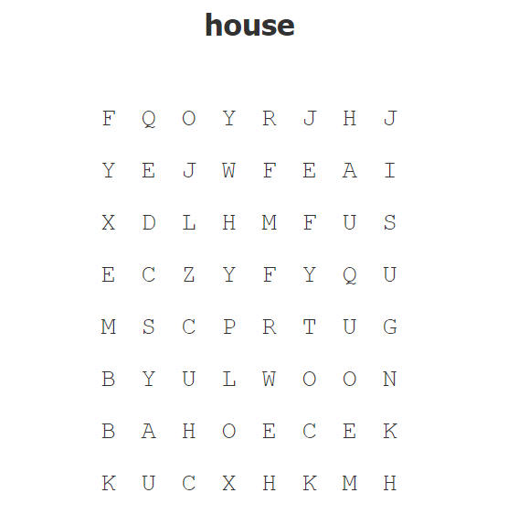

Students with prior learning and/or experience
Create a word search
Create a word search for your class using the word ‘house’ 4 times.

Lesson 3
During this lesson you will learn to write the letters that make the word ‘house’.

Activity 1

Trace the letters

h h h h h h h h h h h h h h h h h h
o o o o o o o o o o o o o o o o o o

u u u u u u u u u u u u u u u u u u
s s s s s s s s s s s s s s s s s s

e e e e e e e e e e e e e e e e e e

Activity 2

Write each letter 6 times

h …………………………………………………………………………………………………………………………….

……………………………………………………………………………………………………………………………
o ……………………………………………………………………………………………………………………………

………………………………………………………………………………………………………………………………
u ……………………………………………………………………………………………………………………………

………….……………………………………………………………………………………………………………………
s …………………………………………………………………………………………………………………

………………………………………………………………………………………………………………………………e ……………………………………………………………………………………………………………………………

…………………………………………………………………………………………………………………………………………….

Activity 3

Write the word ‘house’ in [Language]

house

………………………………………………………………………………………………………………………………

Students with prior learning and/or experience

Copy the sentences

This is my house.

………………………………………………………………………………………………………..

My house is big.

…………………………………………………………………………………………………………

My house has six rooms.

…………………………………………………………………………………………………………

I love my house!

…………………………………………………………………………………………………………

Lesson 4
During this lesson you will compose a text about your house.

Activity 1

Draw your house
Draw your house and write the words ‘My house’ underneath your picture.

Students with prior learning and/or experience

Describe your house
Draw your house and write a brief description. You can use phrases from Lesson 3.

…………………………………………………………………………………………………………………………………………………………………………………………………………………………………………………………………………………………………………………………………………………………………………………………………………………………………………………………………………………………………………………………………………………

Activity 2

Reflection
Think about what you have learnt in these lessons. Use the two stars and a wish structure to guide your reflection.
Star  Something that went well! | Star  Something that went well! | Wish  A goal for next time…
Do not forget to send your wonderful work to your teacher!
You could:
- Post your workbook to your school.
- Scan or take photos of your workbook and email them to your teacher or upload them to your class digital learning platform.
- Email your recording to your teacher or upload it to your class digital learning platform.

