[Language] Stage 3

Caring for the environment! – Part 2

Student workbook
Name:
Class:

Overview
During these lessons you will learn new words and expressions about recycling. You will learn about the benefits of upcycling and how Aboriginal people from Pormpuraaw are upcycling ghost nets to create artworks. You will create your own artwork using clean waste from home and you will present your artwork to your family explaining what materials you have used. If possible, you will ask a family member to record your presentation.

Resources

Lesson 1 – 4
- Student workbook, pen, pencil, colour pencils
- Clean waste material from home, scissors and glue
- A recording device such as mobile phone or video camera

Lesson 1
During this lesson you will learn which materials can be recycled and how to recycle clean waste at home. Using [Language] and drawing or images, you will also design a label to promote recycling in school.

Activity 1
Think before you throw away!!!
These are some of the things that can be recycled. Identify the words in [Language] you know or you think you may know and give a best guess before checking your print/digital dictionary.
Word in English | Word in [Language]
jar
milk carton
can
plastic bag
newspaper
banana
glass bottle
spoon
plastic bottle
tomato
magazine
lettuce
fork
drinking glass

Students with prior learning and/or experience
Create sentences in [Language]
Select any 5 of the above [Language] words and create a sentence for each word.

- [Word]
……………………………………………………………………………………………………………………
- [Word]
……………………………………………………………………………………………………………………
- [Word]
……………………………………………………………………………………………………………………
- [Word]
……………………………………………………………………………………………………………………
- [Word]
……………………………………………………………………………………………………………………

Activity 2
Put the waste in the correct recycling bin!
What are the things on page 2 made of? Put the [Language] words in the appropriate recycling bins:
- things made of glass go into the [glass] bin
- things made of plastic go into the [plastic] bin
- things made of paper go into the [paper] bin
- things made of metal go into the [metal] bin
- vegetables and fruit go into the [compost] bin.

[Paper]  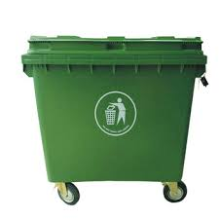  [milk carton]  [Glass] | [Plastic]  [Metal]  [Compost]

Activity 3

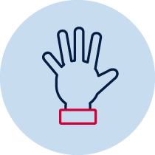Design a label in [Language]
Using language and drawing or images create a label to promote recycling in school.
You can design your label in the space provided below or you can take a photo of your label and paste it on this page.

Lesson 2
During this lesson you will learn about upcycling and how Aboriginal people from Pormpuraaw are upcycling ghost nets to create artworks.
What is upcycling?
Upcycling is taking an old item no longer in use and giving it a new life. For example:
- weave old plastic bags into a new bag
- use a milk carton to make a flower pot
- create a floor or door mat from fabric scraps

Activity 1
Watch the video
Watch the video Ghost Net Art: Pormpuraaw to find out how Aboriginal people from Pormpuraaw are upcycling ghost nets to create artworks.
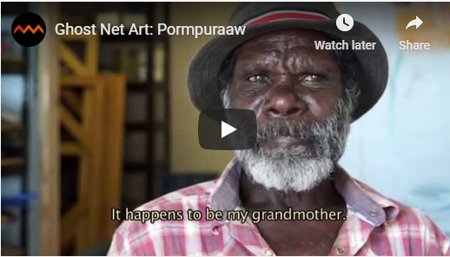
Source: Australian Museum

The Australian Museum has acquired four pieces of Pormpuraaw ghost net sculpture for its new Garrigarang: Sea Country exhibition. Each sculpture tells an Aboriginal traditional story. You can read the article ‘Recycling off the beach: Aboriginal artists and ghost net at Pormpuraaw’ to find more information about the ghost net sculptures featured in the video Ghost Net Art: Pormpuraaw.
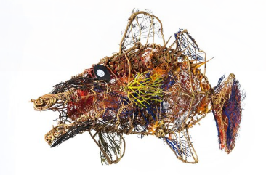
Aboriginal ghost net art at the Australian Museum

Activity 2
My favourite Pormpuraaw ghost net sculpture!
Write in English a short paragraph about your favourite Pormpuraaw ghost net sculpture featured in the video ‘Ghost Net Art: Pormpuraaw’. Include also the name of the Aboriginal artist who made it.
My favourite Pormpuraaw ghost net sculpture is …………………………………
………………………………………………………………………………………………………………………………………………………………………………………………………………………………………………………………………………………………………………………………………………………………………………………………………………………………………………………………………………………………………………………………………………………………………………………………………………………………………………………………………………………………………………………………………………………………………………………………………………………………………………………………………………………………………………………………………………………………………………………………………………………………………………………………Aboriginal artist: …………………………………..…………………………………………………………

Activity 3
Find the [Language] words
From the word list below, identify the words in [Language] you know or you think you may know and give a best guess before checking your print/digital dictionary.
Words in English | Words in [Language]
ocean
beach
crocodile
fish
turtle
jellyfish
frog
mermaid
net
bird
fishing boat

Students with prior learning and/or experience
Create sentences in [Language]
Select any 5 of the above [Language] words and make a sentence for each word.

- [Word]
…………………………………………………………………………………..
- [Word]
…………………………………………………………………………………..
- [Word]
…………………………………………………………………………………..
- [Word]
…………………………………………………………………………………..
- [Word]
…………………………………………………………………………………..

Lesson 3
During this lesson you will learn to name in [Language] different types of waste material. You will collect clean waste material from home and use it to create your own artwork.

Activity 1

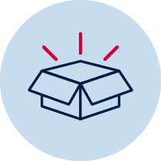Upcycle!
1. Collect the materials you are going to use. For example:
- milk and juice cartons
- plastic bottles and containers
- jars and lids
- cereal boxes
- metal food tins
- old coat hangers, sheets or pillow cases
You could also include other waste items to decorate your artwork. For example:
- lolly wrappers
- colourful pieces of plastic, foil and packaging
- scraps of paper, cardboard and fabric
- old buttons
- old magazines and catalogues
2. Fill in the table below providing information for each material you are going to use in [Language].

What type of material is it?  (paper, plastic, metal, glass) | Where did it come from?  (cereal box, lolly jar newspaper) | What colour is it?  (blue, red, white)

Students with prior learning and/or experience

Upcycle!
1. Collect the materials you are going to use (see examples on page 11)
2. Fill in the table below providing information for each material you are going to use in [Language].

What type of material is it?  (paper, plastic, metal, glass) | Where did it come from?  (cereal box, lolly jar newspaper) | What colour is it?  (blue, red, white) | How does it feel when you touch it?  (soft, spiky, hard, cold)

Activity 2

Create art!
Here is the fun part! Use your imagination and the materials you have collected to create art! Take a photo of your artwork and paste it on the page.

‘There is no must in art because art is free’
Kandinsky 1866 – 1944

Lesson 4
During this lesson you will present your artwork to your family. You will describe your artwork and explain what materials you have used.

Activity 1

Present your artwork in [Language]
Present your artwork to your family using [Language]. In your presentation, name your artwork and explain what materials you have used and where they came from. Ask a family member to record your presentation.

You can use the example below to help you with your presentation.
[Hello]
[This is my artwork ……………………………………………………………….]
….……………………………………………………………………………………
[It has paper from a newspaper, plastic from a plastic milk bottle ……..………………….]

Students with prior learning and/or experience

Present your artwork in [Language]
Present your artwork to your family in [Language]. In your presentation, name and describe your artwork explaining what materials you have used and where they came from. You will also need to talk about one of the benefits of upcycling. Ask a family member to record your presentation.

Activity 2
Time for reflection!
Think about your language use in the presentation. Listen to or watch the recording, think about the questions below and complete the table.
- Did you pronounce all the words correctly?
- Were the words in the correct order?
- Is there a word or words you could learn in [Language] that could help you with this activity?
- Use the two stars and a wish structure to guide your reflection.

Star  Something that went well! | Star  Something that went well! | Wish  A goal for next time…

Activity 3
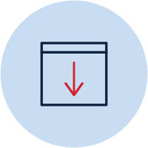Submit your work!
Do not forget to send your wonderful work to your teacher!
You could:
- Post your workbook to your school.
- Scan or take photos of your workbook and email them to your teacher or upload them to your class digital learning platform.
- Email the recording of your presentation to your teacher or upload it to your class digital learning platform.

