[Language] Stage 1

My dream home! – Part 2

Student workbook
Name:
Class:

Overview
During these lessons you will learn to recognise and use [Language] words to describe different types of housing e.g. house, apartment. You will learn to name external features and different rooms/areas of a house and you will make door signs for each room. Finally you will create a print or digital plan of your dream home using pictures and captions to name each room/area. You will present your dream home to your family using simple language. If possible, you will ask a family member to record your presentation.

Resources

Lesson 1 – 5
- Pen, pencil, colour pencils
- cardstock paper
- scissors and glue
- recording device (computer or mobile phone)

Lesson 1
During this lesson you will learn to recognise and use [Language] words to describe different types of housing e.g. house, apartment.

Activity 1
House or apartment?
- Listen to your teacher reading the conversations below.
- Practise reading the conversations using correct pronunciation and intonation.

Do you live in a house or an apartment?
I live in a house 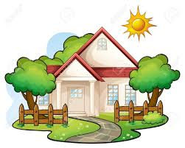

Do you live in a house or an apartment?
I live in an apartment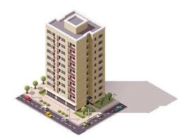

Activity 2a

Match the correct pair

- Do you live …..  - house …..  - apartment ….. | - in a house?

Activity 2b

Label the pictures
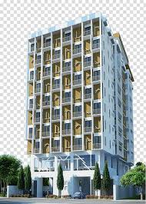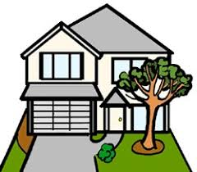

Activity 3

Copy the conversations

Do you live in a house or an apartment?

………………………………………………………………………………………………………..

I live in a house.

…………………………………………………………………………………………………………

Do you live in a house or an apartment?

…………………………………………………………………………………………………………

I live in an apartment.

…………………………………………………………………………………………………………

Students with prior learning and/or experience

Build questions and answers
Unscramble the words to make questions and answers

you | in | Do | house? | a | live

Do ………………………………………………………………………………………………………………………………………….……..
live | an | in | No, | apartment | I

…………………………………………………………………………………………………………………………………………….………………
live | Do | an | you | in | apartment?

…………………………………………………………………………………………………………………………………………………….……..
a | No, | in | house | I | live

…………………………………………………………………………………………………………………………………………………….……..

Activity 4

Fill in the missing words and record a conversation.
- Fill in the missing words to complete the two conversations.
- Choose one of the conversations that reflects the type of house you live in.
- Record the conversation using a different voice for each person.

Do you live in a ……………….…… or an apartment?

I live in an ……………………………… 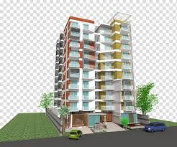

Do you live in a house or an ……………………………………?
I ………………..… in a …………………………

Students with prior learning and/or experience

Create and record a conversation
- Use as an example one of the conversations from Activity 1 that reflects the type of house you live in and create your own conversation.
- Record the conversation using a different voice for each person.

……………………….…………………………………….…………………………………?

……………….……………………………………………………………………………

Lesson 2
During this lesson you will learn to name parts of a house.

Activity 1
Read the labels
- Listen to your teacher reading the labels
- Practise reading the labels using correct pronunciation and intonation
house
sun
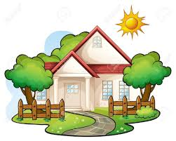
tree
window
garden
door
tree
fence
roof

Activity 2a

Match the correct pair
1. 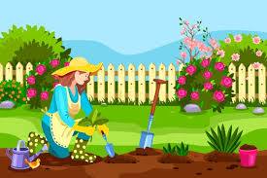 …... a. door

2. 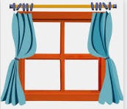 …… b. roof

3. 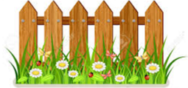 …… c. garden
4. 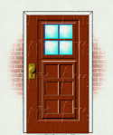 …… d. window

5. …… e. fence

Activity 2b

Colour in the words
- house
door
window
- garden

Students with prior learning and/or experience

Put the words in alphabetical order

garden | door | house | tree
window | sun | fence | roof

- ………………………………………………………………………
- ……………………………………………………………………….
- ……………………………………………………………………….
- ………………………………………………………………………..
- ………………………………………………………………………..
- ………………………………………………………………………..
- ………………………………………………………………………..
- ………………………………………………………………………..

Activity 3

Fill in the missing letters

H………...…….u…………...…….e
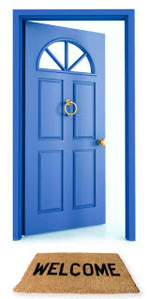 ………………….o………………….r
w………....….….nd….........……….w

g………...…….....rd……..…....…..….n

Students with prior learning and/or experience

Unscramble the letters to make words

i | w | w | n | d | o
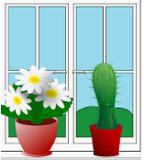 ..…………………………………………………………………..

o | r | d | o
……………………………………………………………………..

r | n | g | d | a | e
….………………………………………………………………….

o | f | r | o
…….………………………………………………………………..

Activity 4
Colour in the picture
- Colour the [door] – blue
- Colour the [window] – red
- Colour the [roof] – brown
- Colour the [garden] – green
- Colour the [fence] – grey
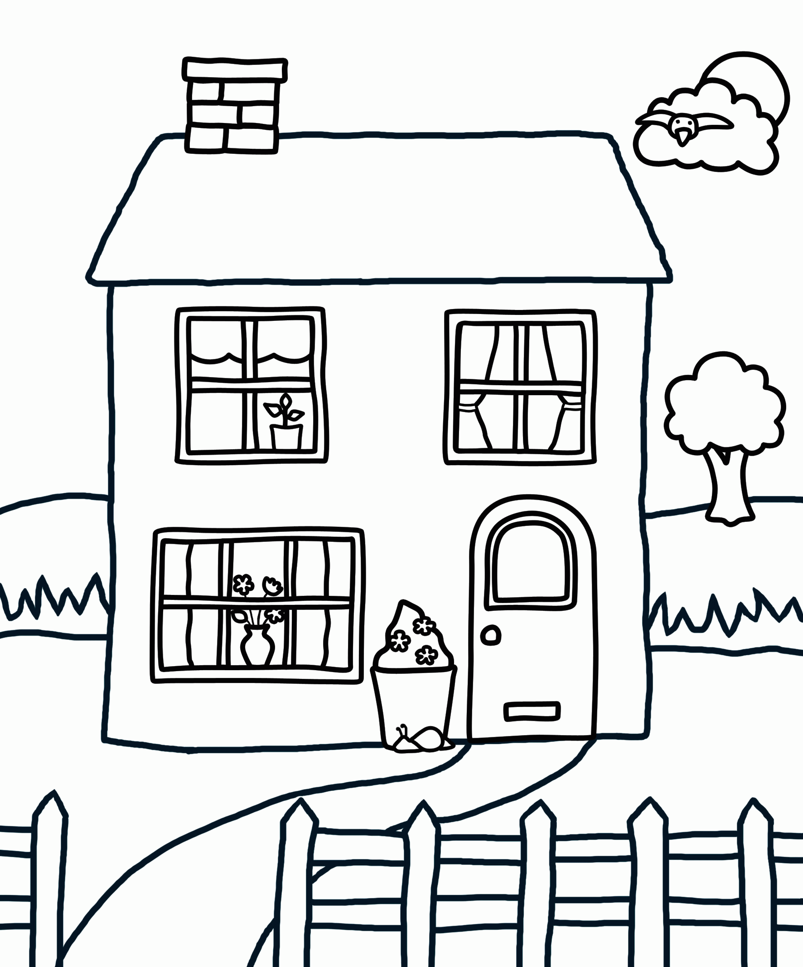

Students with prior learning and/or experience
Colour in the pictures and fill in the missing words

The house has a blue ................................................... and three red 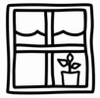......................................................................... .

The house has a brown …..…………..……………………
and a grey .…………………………………………… .

The house has a green 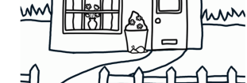 …………………………………. . There is a ………………………..………… near the house.

The sky is blue and the …………….……………… is out.

Activity 5
Draw and label a picture
- Draw a picture of your home.
- Label the different parts of your home in [Language]. If you need any help you can refer to Activity 1.

Students with prior learning and/or experience
Draw and describe a picture
- Draw a picture of your home.
- Write a paragraph to describe your home using language you have learnt in this unit.
………………………………………………………………………………………………………………………………………………………………………………………………………………………………………………………………………………………………………………………………………………………………………………………………………………………………………………………………………………………………………………………………………………………………………………………………………………………………………………………………………………………………………………………………………………………………

Lesson 3
During this lesson you will learn to name different rooms and areas of a house e.g. bedroom, kitchen, bathroom, dining room, living room, garden.

Activity 1
Read the labels
- Listen to your teacher reading the labels
- Practise reading the labels using correct pronunciation and intonation.
kitchen
bathroom

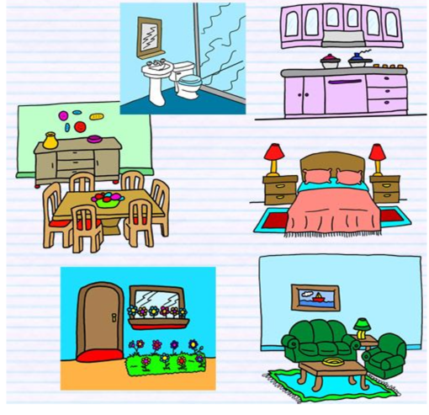
garden
living room
dining room
bedroom

Activity 2

Colour in the correct picture
1. Colour in the bedroom
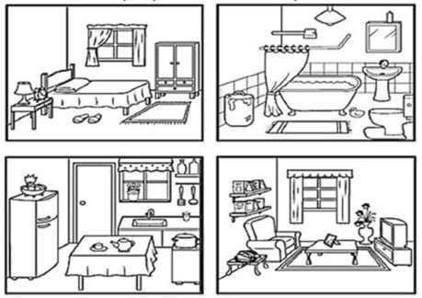
2. Colour in the living room

3. Colour in the [bathroom]
4. Colour in the [kitchen]

Activity 3

Match the pictures with the words
[kitchen]

[living room]

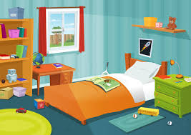

[dining room]

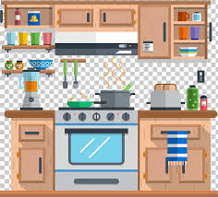

[bedroom]
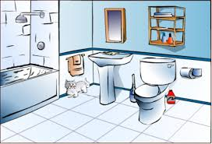

[bathroom]
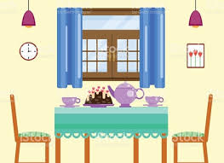

Activity 4

Fill in the missing letters
k……………….tch……..……..…….n

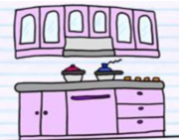

b……………..….dr………………….o…………………

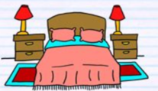

b……………….thr……….…….om
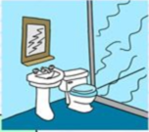

l…..….v……….ng r……….om

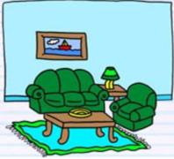

d……….n…........ng ro…….….m
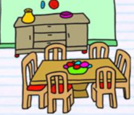

Students with prior learning and/or experience

Label the pictures

b…………………………………

k…………………………………

l……….…..……. r……………………

b…………………………………

Activity 5

Where are they?
living room
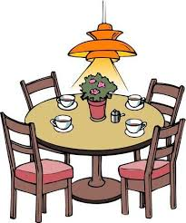

bedroom

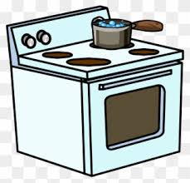
bathroom

dining room
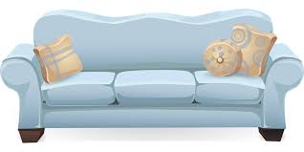

kitchen
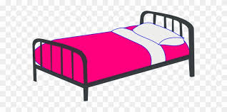

Activity 6

Label the pictures

b…………………………………

l…………..………. r……………………

k……………………………………………

b…………………………………

Students with prior learning and/or experience

Unscramble the letters to make words

i | t | h | k | c | n | e

k.…………………………………………………………………....

d | r | b | o | e | m | o

……………………………………………………………………..

t | o | h | b | m | r | a | o

….………………………………………………………………….

i | n | l | i | g | v

o | r | m | o
l…….………………………………… r……………………………..

i | n | d | g | n | i

o | r | m | o
…….………………………………… r……………………………..

Activity 7

Find the words
Find the words: kitchen, bathroom, bedroom, garden

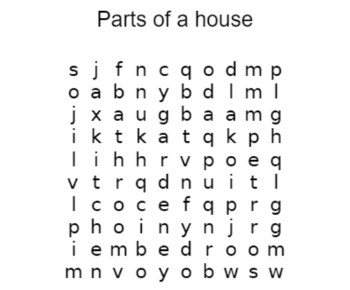

Students with prior learning and/or experience
Create a word search puzzle for your class
Create your own word search using the words: kitchen, bathroom, bedroom, garden

Lesson 4

Activity 1
Make door signs
- With materials that you have at home, make door signs for every room in the house using language and drawings or images.
- Take a photo of each door sign.
- If possible, ask your parent/guardian to help you transfer your photos to your computer, print them and then glue them on this page.

Lesson 5
During this lesson you will draw the plan of your dream home and present it to your family.

Activity 1

Read the text ‘My house’
- Listen to your teacher reading the text ‘My house’
- Practise reading the text using correct pronunciation and intonation.
My house
This is my house 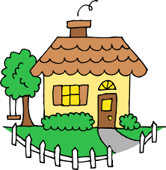. My house has a kitchen 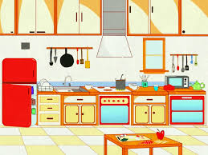 3 bedrooms 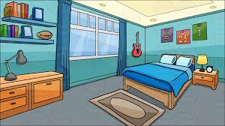 2 bathrooms a living room 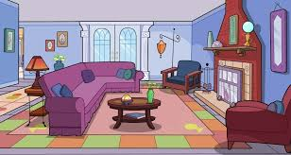 and a garden . I love my house!

Students with prior learning and/or experience
Fill in the missing words.
- Fill in the missing words to complete the text ‘My house’.
- Practise reading the text using correct pronunciation and intonation.

My house

This is my …………………… . My house has a …………..……….…….. 3 ………..…………………………… 2 ………………………………. a ……………………………….. and a …………………………………. . I love my house!

Activity 2
Presentation – Talk about your dream home
Create a print or digital plan of your dream home using pictures and captions to name each room/area. Present your dream home to your family using simple sentences. If possible, ask a family member to record your presentation.

Students with prior learning and/or experience
Presentation – Talk about your dream home
Create a print or digital plan of your dream home using pictures and captions to name and describe each room/area. Present your dream home to your family and respond to questions. If possible, ask a family member to record your presentation.

Activity 3
Reflection
Think about your language use in the presentation. If you recorded it, listen to the recording. Think about the questions below and complete the table. If you didn’t record the presentation, read and think about the questions below and complete the table.
- Did you pronounce all the words correctly?
- Were the words in the correct order?
- Is there a word or words you could learn in [Language] that could help you with this activity?
- Use the two stars and a wish structure to guide your reflection.
Star  Something that went well! | Star  Something that went well! | Wish  A goal for next time…

Do not forget to send your wonderful work to your teacher!
You could:
- Post your workbook to your school.
- Scan or take photos of your workbook and email them to your teacher or upload them to your class digital learning platform.
- Email your recordings to your teacher or upload it to your class digital learning platform.

