Stage 4 Spanish

Activity – ¿Cuánto cuesta?

Unit of work
Shopping

Numeracy skills focus area
Mental computation and numerical reasoning

Aspect/s
Understanding mathematical information in texts and tasks
Understanding money and finance

How will the numeracy skills be supported by this activity?
Students are required to convert currency.

¿Cuánto cuesta?
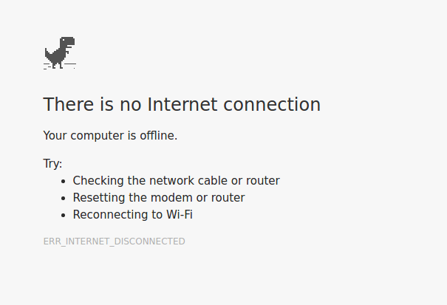
This Photo by Unknown Author is licensed under CC BY-SA
Oh no! There is no internet so you cannot calculate currency conversions online! Read each scenario and answer the questions.

Scenario 1
You are in a cafetería in Barcelona and you want to order churros con chocolate.
In Australia, you can get churros con chocolate at San Churros for $10. In Barcelona, the price for churros con chocolate is 4€.
The last time you checked, the exchange rate was $1 to 0,62€.
Photo by Oscar Nord on Unsplash
Are the churros cheaper in Spain or Australia? Show your working and then write your answer.

Scenario 2
You’ve seen a pair of shoes that you love in a tienda de zapatos.
The shoes cost 70€.
You can buy them on your credit card – your credit card is offering an exchange rate of $1 to 0,62€. However, you will also be charged a 2€ currency conversion fee if you use your card.
Alternatively, you can withdraw money from the nearest ATM at a rate of $1 to 0,63€. You will not be charged a conversion fee at the ATM.
What is the cheapest option – using your credit card or withdrawing the money from the ATM and paying in cash? Show your working and then write your answer.
Photo by Maxwell Nelson on Unsplash

Answer sheet for teacher

Answer – scenario 1
Are the churros cheaper in Spain or Australia?
4€ ÷ $0.62 = $6.45 (the cost of the Spanish churros, in dollars)
or
$10 x $0.62 = 6,20€ (the cost of the Australian churros, in Euro)
Answer: The churros are cheaper in Spain, by $3.55.

Answer – scenario 2
What is the cheapest option – using your credit card or withdrawing the money from the ATM and paying in cash?
If I use my credit card:
- Conversion fee: 2€ ÷ 0,62€= $3.22
- Price of shoes: 70€ ÷ 0,62€= $112.90
The total cost of the shoes if I use my card is $112.9 (shoes) + $3.22 (conversion fee) = $116.12.
If I withdraw money from an ATM:
- Price of shoes: 70€ ÷ 0,63€= A$111.11
Answer: If I withdraw money from the ATM, the shoes are cheaper by $5.01.

