Stage 4 German

Activity – eating out

Numeracy activity name
Essen gehen

Numeracy skills focus area
Mental computation and numerical reasoning

Aspect/s
Understanding mathematical information in texts and tasks
Understanding fractions, decimals, percentages, rates, ratios

Stage
4

Year level
7-8

Language
German

Unit of work
Eating out

How will the numeracy skills be supported by this activity?
Students are required to calculate:
- total costs of items ordered at a restaurant
- the tip as percentage of meal cost
- percentage savings if food is ordered as takeaway instead of table service.

Language structures incorporated

Ich möchte… – I would like…
Wir möchten… – We would like…
einmal/zweimal – one/ two (when ordering)
die Rechnung – the bill
die Bedienung – the water/waitress
Stimmt so! – That’s fine! (keep the change)
die Speisekarte – the menu
zum Mitnehmen – to take away
Spezialitäten – specialty dishes
Beilagen – side dishes
Nachtisch – dessert
Food vocabulary

Essen gehen
Look at the menus for the Potsdamer Schlossküche which are at the end of this activity. There is a dine-in menu and a takeaway menu (zum Mitnehmen).
Use these menus to answer the 3 questions below.

Question 1
You have offered to take a friend for dinner at the Potsdamer Schlossküche. You have decided to dine in at the restaurant and have €40 to spend. You would each like to order a main, a dessert and a drink.
What do you order? (Wir möchten einmal/zweimal…)

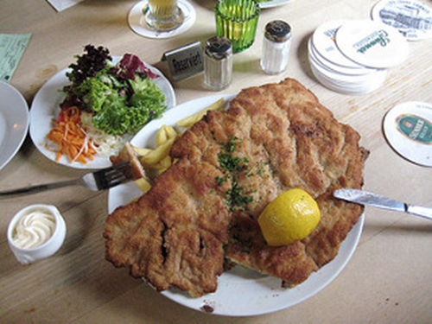
Image: schnitzel, frau-Vogel, CC BY-NC 2.0

Question 2
You are eating at the restaurant alone tonight. You ordered (Ich möchte…) and have now eaten.
You’ve eaten a Jägerschnitzel and Apfelstrudel, and had a small mineral water to drink.

What will the total of your bill (die Rechnung) be?

It’s time to pay your bill – Die Rechnung, bitte!
You’re happy with the service and would like to leave a small tip for die Bedienung.
You give €20,00 and say Stimmt so! (keep the change)
How much was your tip?

What percentage of your meal cost did you tip?

Image: One Euro coins Creative Commons

Question 3
You and your friends are in the mood for some burgers. You want to order one Hänchenburger, two Hamburger, one Vegi-Burger and two portions of Pommes.
How much will that cost if you eat in?

How much will that cost if you get takeaway?

What percentage saving will you receive if you order takeaway?

You realise that’s just too much junk food and change your order.
How much for three fish dishes and two salads? Make sure you get the cheapest takeaway option.

Is it cheaper to eat more healthily in this instance?

