Assessment task – Contestability of the past (Lusitania)
This document references the Modern History Stage 6 Syllabus © 2017 NSW Education Standards Authority (NESA) for and on behalf of the Crown in right of the State of New South Wales.

Purpose of task: Source based Extended Response

Outcomes
Student:
- MH11-3 analyses the role of historical features, individuals, groups and ideas in shaping the past
- MH11-6 analyses and interprets different types of sources for evidence to support an historical account or argument
- MH11-7 discusses and evaluates differing interpretations and representations of the past
- MH11-9 communicates historical understanding, using historical knowledge, concepts and terms, in appropriate and well-structured forms

Objectives

Skills
Students:
- Use historical concepts and skills to examine the modern past.
- Communicate their understanding of history, sources and evidence, and historical interpretations.

Values and attitudes
Students:
- Appreciate the influence of the past on present and the future (VA-1)
- Value the contribution of the study of Modern History to lifelong learning, and active and informed citizenship (VA-2)

Knowledge and understanding
Students:
- KU-1 develop knowledge and understandings of a range of features, people, ideas, movements, events and developments of the modern world in their historical context.
- KU-2 develop an understanding of continuity and change over time.

Learning across the curriculum
General capabilities
Critical and creative thinking
Ethical understanding
Intercultural understanding
Literacy
Other areas of learning
Civics and citizenship
Difference and diversity

Task Description:
This task is to be completed during the yearly exam and will involve a source based extended response with the appropriate structure. You are being asked to analyse a number of sources and present your judgement on who is responsible for the sinking of the Lusitania. Make sure you prepare and use proper extended response paragraph structures, including an introduction, body paragraphs and a conclusion.
Task:
- Extended response of approximately 2 A4 pages written under exam conditions
- Students must make explicit reference to sources in their extended response.
- Make a judgement about who was responsible for the sinking of the Lusitania
- Students present an understanding of the motives and debate surrounding the sinking of the Lusitania in World War
- Extended response structure - introduction, body paragraphs, conclusion
Source A: Warning from the Imperial German Embassy to travellers (New York Tribune, Saturday May 1st 1915)

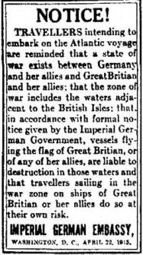
Source: World ship society http://www.worldshipny.com/images/lusitania1.jpg
NOTICE! Travellers intending to embark on the Atlantic voyage are reminded that state of war exists between Germany and her allies and Great Britain and her allies; that the zone of war includes the waters adjacent to the British Isles: that in accordance with formal notice given by the Imperial German Government, vessels flying the flag of Great Britain, or of any of her allies, are liable to destruction in those waters and that travellers sailing in the war zone on ships of Great Britain or her allies do so at their own risk.
Imperial German Embassy, Washington D.C April 22, 1915

Source B: Lusitania Medal, 1915
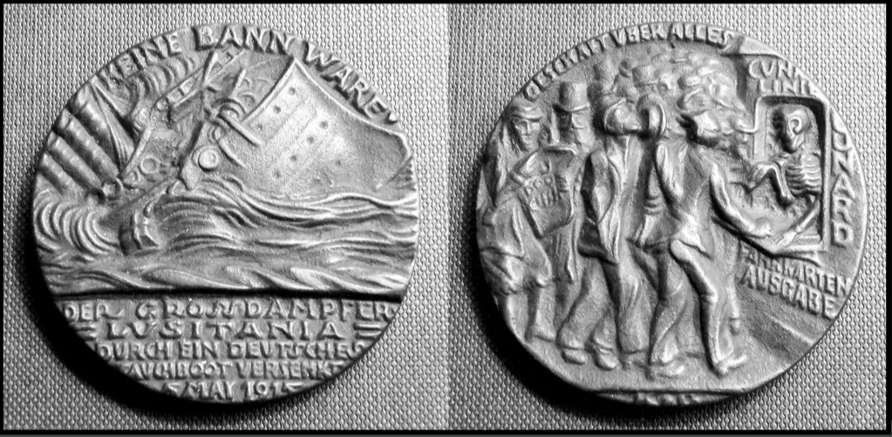
Source: Flickr https://www.flickr.com/photos/rpmarks/6702754423
- With reference to Sources A and B, assess who was ultimately responsible for the sinking of the Lusitania in 1915 (15 marks).

Marking Criteria
Criteria | Marks
- Sophisticated use of BOTH sources and their own knowledge to provide a sustained judgement about who was responsible for the events leading to the sinking of the Lusitania  - Provides a cohesive, logical and well-structured response  - Demonstrates a comprehensive understanding of the issue with accurate, relevant and detailed historical information | 13-15
- Sound use of BOTH sources to provide a judgement about who was responsible for the events leading to the sinking of the Lusitania  - Provides a logical and well-structured response  - Demonstrates a well-developed understanding of the issue with accurate, relevant and detailed historical information | 10- 12
- Makes reference to BOTH sources to provide with some attempt at a judgement about who was responsible for the events leading to the sinking of the Lusitania  - Provides a well-structured response  - Demonstrates an understanding of the issue with accurate, relevant historical information | 7-9
- Makes general statements about the sinking of the Lusitania with reference to AT LEAST one of the sources provided  - Demonstrates some understanding of the issue with mostly relevant historical information | 4-6
- ONE or TWO references to the sources generally OR simple description that may paraphrase one or both sources | 1-3

