Year 11 Modern History - Belgian Congo case study

Mapping task
- Compare the two maps of Africa. How does the location of national boundaries differ? Particularly in northern Africa.
- Which European countries dominate the colonial map?
- Estimate (approximately) the percentage of the continent colonised by England, France and Belgium.
Go to the website Interactive World History Atlas since 3000 BC for help answering this question. http://geacron.com/home-en/?&sid=GeaCron377871Search Africa 1885 to 1919.
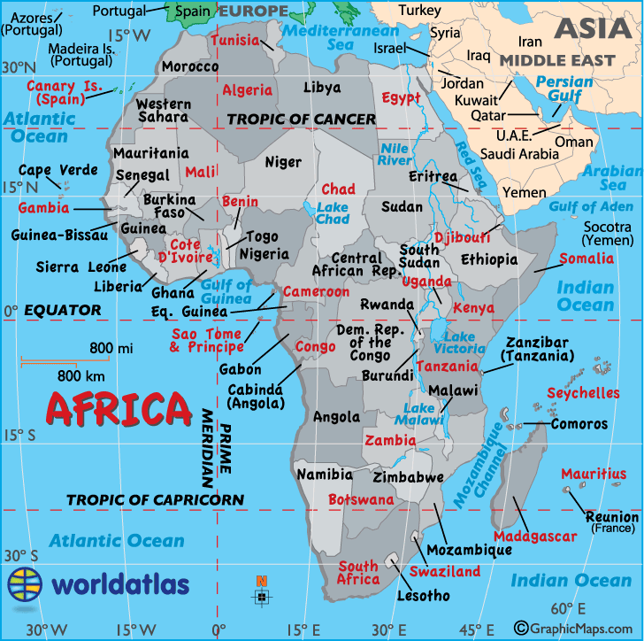
Source - Modern Africa: http://www.worldatlas.com/webimage/countrys/af.htm

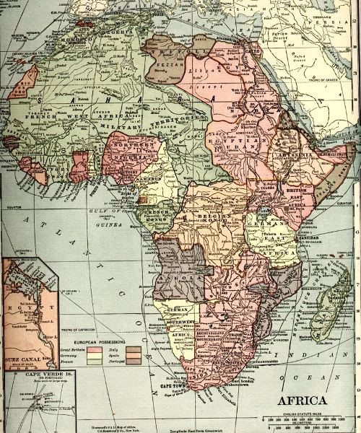
Source - Colonial Africa 1910: http://www.worldatlas.com/webimage/countrys/af.htm
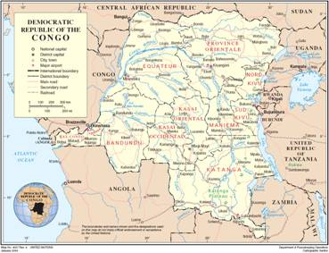
Source -Congo Today: http://www.consciousbeingalliance.com/2010/01/belgian-paratroopers-to-crush-rising-congo-rebellion

Timeline of Important Events

1870 – 1920 European Exploration and Administration
- Region first mapped by British explorer Henry Morton Stanley in preparation for European colonization.

1884 – 1885 Start of European Colonisation
- Berlin Conference: Congo appropriated and given to King Leopold II of Belgium as his own personal property.
- The United States became the first country to recognise the Congo Free State under the rulership of King Leopold II.

1885 – 1908 King Leopold II’s Rule
- Leopold's regime began undertaking various development projects, such as the railway system which took years to complete. The goal of almost all projects was to increase the financial capital of Leopold and his cohorts, e.g. rubber production for use in making tires.
- Exploitation and abuse of people and land in order to obtain maximum profits at minimum financial cost.
- Leopold’s profits used to build several buildings in Brussels and Ostend to honour himself and his country.
- 10 million - 15 million Congolese die within a twenty three year period due to exploitation and diseases as a result of King Leopold's natural resources profiteering ventures.

1908 Belgian Colonial Rule
- Belgium takes over rulership of Congo due to international outcry over the atrocities that King Leopold II committed during his reign.

World War II
- Congolese army wins several battles against the Italians in North Africa.
- Congo supplies uranium used to build atomic bombs that destroyed Hiroshima and Nagasaki.
- Congo offered to Hitler as a bargaining chip for him to lift his occupation of Europe.

1960 Congo Independence
- June 30, 1960, Congo elects its first democratically elected leader Patrice Emery Lumumba who is subsequently assassinated within months, January 17, 1961.

1965 - 1997Mobutu Sese Sekou’s Rule
- Sese Seko begins dictatorship after a Western-backed coup (mainly U.S. & Belgium).
- By 1984, Mobutu said to have amassed 4 billion U.S. dollars, an amount close to the country's national debt, stashed away in personal Swiss bank accounts. Money mostly obtained from Congolese state mining companies.

1997 – 2001 Laurent Desire Kabila’s Rule
- Mobutu's dictatorial rule ends with the takeover of power By Laurent Desire Kabila with the backing of Rwanda and Uganda.

1998 – 2002 The Congo War
- War breaks out after Rwanda tries to remove Kabila from power. Seven other African countries eventually become embroiled in what was dubbed Africa's First World War.
- War officially ends with peace talks in South Africa.

2001 – Present Joseph Kabila’s Rule
- In 2001, Laurent Kabila is assassinated and replaced by his son Joseph Kabila.
- By 2003, a transition government and parliament was established to lead the Congo to elections.
- In 2005, Congolese overwhelmingly vote yes in a referendum on a new Congolese constitution.
- Elections were held in 2006 which resulted in the election of Joseph Kabila as president.
- Kabila appointed long-time Lumumbist Antonie Gizenga of PALU to be prime minister. Gizenga served as deputy prime minister in Patrice Lumumba's government of 1960. Gizenga resigned on September 25, 2008 and was subsequently replaced by former Finance Minister, Adolphe Muzito, on October 10, 2008.
- The last elections took place on November 28, 2011. Joseph Kabila won the 2011 elections due to massive fraud. As a result of the widespread cheating that took place during the elections, he lacks legitimacy among the Congolese masses. Kabila appointed the former Finance Minister, Augustin Matata Ponyo as Prime Minister in April 2012.
Source: http://www.friendsofthecongo.org/history-timeline.html
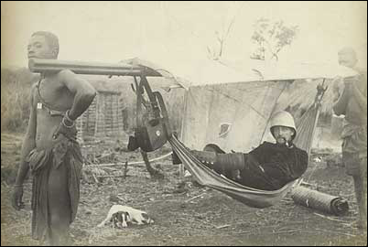
Source - Belgian trader ‘doing it tough’ in Congo: https://latitudetravel.wordpress.com/2013/03/17/the-dark-side-of-globalisation-war-and-exploitation-in-colonial-and-post-colonial-congo/

Timeline exercise
Study the timeline and then match a clue from List A with an answer in List B.

List A | List B
Independence of Congo | Amount stolen by Mobutu
Helped to overthrow Mobutu | 1908
Patrice Lumumba | Henry Stanley Morton
Berlin Conference | 2001
Lost to the Congolese army in WW2 | 1965 - 1997
Explorer who first mapped the region | Rwanda and Uganda
Rule of Mobutu Sese Sekou | Prime minister in 2012
Beginning of Belgian colonial rule | 1960
$4 Billion | Laurent Kabila
Took over from Mobutu | 1884 - 1885
First country to recognise Congo Free State | 1998 - 2002
The Congo War | First democratically elected leader
Kabila Assassinated | Joseph Kabila
Matata Ponyo | USA

Overview
Leopold II was obsessed with achieving international greatness for Belgium and in 1876 he convened an international conference on the exploration of central Africa. This led, the following year, to his sending out the intrepid Henry Morton Stanley to sign treaties with local chieftains and lay the foundations for colonial expansion. Stanley did his work well and in 1885 the Berlin Conference recognized Leopold II as King-Sovereign of the Congo Free State which was to be in personal union with the Crown of Belgium. This effectively made Leopold II private owner of a vast Central African Empire some 80x larger than his entire country. In 1890 King Leopold II organized a military campaign from the Congo Free State to eradicate the Arab slave trade in central Africa which was still booming at the time.
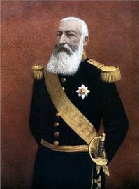
Source - King Leopold II Oppressor, Tyrant and Exploiter of Congo : http://madmonarchist.blogspot.com.au/2010/05/monarch-profile-king-leopold-ii-of.html
This expedition was a success but Leopold also set up a framework for the economic development of the Congo which eventually led to immense profits from the rubber trees there (which greatly took off after the invention of the bicycle and automobile) but also immense cruelties inflicted on the Congolese population. It is for this horror that Leopold II is most remembered these days but a few key facts should be kept in mind. First of all, a lot of the numbers that are tossed about as to the number of people who died are quite often simply absurd, at times ranging from 50% to the entire estimated population of the Congo. Obviously, if these extreme statistics are believed absolutely no one would have been making any profit at all. Perhaps most importantly though is that Leopold II was not inflicting these atrocities intentionally. That is often the image that is portrayed with the King being compared to Hitler. Undoubtedly the King was a hard man and often an unsavoury character but it is an absolute lie that the horrors of the Congo were purposely carried out by him. Where he can be blamed is in setting up the system whereby his local officials were paid based on the amount of rubber they produced which would have seemed to make economic sense but which provided an incentive for unscrupulous officials to brutalize the natives in order to enrich themselves. Also, contrary to what many believe, Leopold was troubled by the reports that began to circulate about the savagery going on in the Congo but, and he can be blamed for this, he was all too willing to believe advisors who assured him these were malicious lies. The Source below indicates that the horrors were not just carried out by ‘unscrupulous’ officials, but were, in fact, the policy of the Belgian authorities.

Source 1.0
“Some were beaten or whipped to death for failing to meet the rigid production quotas for ivory and rubber harvests, imposed by Leopold’s agents. Some were worked to death, forced to labour in slave like conditions as porters, rubber gatherers or miners for little or no pay. Some died of the diseases introduced to (and spread throughout) the Congo by Europeans. And still others died from the increasingly frequent famines that swept the Congo basin as Leopold’s army rampaged through the countryside, appropriating food and crops for its own use while destroying villages and fields.
“Hostage-taking and the grisly severing of hands (from corpses or from living human beings) were part of the government’s deliberate policy — a means of terrorising others into submission. As the “rubber terror” spread through the Congolese rain forest, entire villages were wiped out: Hundreds of dead bodies were dumped in rivers and lakes, while baskets of severed hands were routinely presented to white officers as evidence of how many people had been killed.”
Adam Hochschild, King Leopold’s Ghost. Source: http://en.protothema.gr/meet-king-leopold-ii-of-belgium-the-hitler-of-congo-photos/

Source Questions
Read Source 1.0, and then answer the following questions:
- Who are the ‘some’ referred to in the first paragraph?
- List three occupations undertaken by the Congolese.
- Why did famine occur in areas which produced a great deal of food?
- What were the two purposes of severing hands?
Eventually, however, the reports and international criticism became too great to ignore and in 1904 (though he is seldom given credit for this) it was King Leopold who sent a commission to the Congo to investigate these reports. Many have dismissed these inquisitors as hand-picked “yes men” Leopold knew would never report anything negative. Again, this is untrue as the commission met with native people and leaders as well as colonial officials and returned with a very balanced report. They cited the advances made by the King’s investments; the roads, schools, hospitals and local infrastructure that had been created, the humanitarian work done by the often heroic missionaries but it also reported that a great many abuses were going on as well, many people had died, many mutilated and many more exploited. Once this was done King Leopold issued new regulations to correct this situation and in 1908 the Congo Free State became a colony, the Belgian Congo, under the control of the government rather than being the personal property of the King.
http://madmonarchist.blogspot.com.au/2010/05/monarch-profile-king-leopold-ii-of.html

Source 1.1
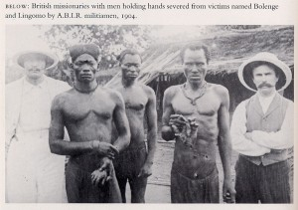
Source - Congolese men ‘holding hands’. The two white men are British missionaries: http://en.protothema.gr/meet-king-leopold-ii-of-belgium-the-hitler-of-congo-photos/

Source questions.
- Why are these men ‘holding hands?’
- What would be the purpose of this picture being published?
- What does this picture tell us about the methods of the ruling Belgians?

Source 1.2
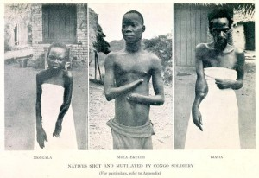
Source - People who have been mutilated for failing to meet a set quota for the production of a particular product e.g.: rubber or ivory. http://en.protothema.gr/meet-king-leopold-ii-of-belgium-the-hitler-of-congo-photos/

Source questions
- What does this picture tell us about how the Belgians treated the Congolese?
- Would these mutilations have served any useful purpose? What?

Source 1.3
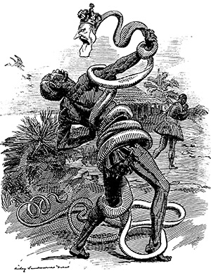
Source - 'In the Rubber Coils', a Punch cartoon of 1906, shows King Leopold's stranglehold on the Congo. http://www.historytoday.com/tim-stanley/belgiums-heart-darkness
- What does this cartoon say about the ‘grip’ King Leopold had on Congo?
- Why specifically ‘rubber’ coils and not coils made from something else?
- What can you say about the impact the Belgians had on the Congolese from the context of this source?
- Analyse each source and examine the audience, purpose and effectiveness of each. You are to write a paragraph on each analysing the usefulness of the source as well as the audience, purpose and effectiveness.

Statistics and Demographic Information
- Congo is a large country in the centre of the African continent.
- Surface (land) area: 2,267,600 sq.km
- Borders (land): Congo-Brazzaville, Central African Republic, South Sudan, Uganda, Rwanda, Burundi, Tanzania, Zambia, Angola
- Climate: tropical humid.
- Ethnic groups: Luba 18%, (Ba)Kongo 16%, Mongo 14%, Rwanda 10%, Azandi 6%, Bandi+Ngali 6%.
- Languages: French (official), Lingala, Swahili, Kikongo, Tshiluba, Azande, Luba, Mongo, Rwanda, Boa, Rundi
- Religious affiliations: Roman Catholic 41%; Protestant 32%; Muslim 10%; indigenous Christian 10%; traditional beliefs 3%.
- Agricultural products: cassava, plantains, bananas, groundnuts, sugar cane, coffee, rubber, cotton, palm oil, cocoa, tea, timber.
- Mining products: copper, diamonds, natural oil & gas, cobalt, zinc, uranium, manganese, tin, gold, cadmium, silver, germanium, radium.
Source: http://www.populstat.info/Africa/congokig.htm
We can see from these figures that Congo is a little smaller in total area than Western Australia (2,600,000 sq.km). This vast region was capable of producing all sorts of valuable agricultural and mineral resources which made very attractive indeed to a potential colonising power.
Using the information above, answer the following questions.
- What is the surface area of Congo? How does this compare to Australia?
- What is the official language and what are the two most commonly observed religions?
- Examine the list of agricultural products. Which of these could not be grown in Belgium due to their tropical nature?
- Few of the mining products are available in great quantities in Belgium. Explain how and why they would have been attractive to the colonists.

Source Work
All of the source information below was provided by the British Museum. https://www.britishmuseum.org/pdf/CongoFreeState_Students_WkSheets_UPDATED.pdf

Source Work One

How well was the Congo Free State governed?
Belgium’s rule over the Congo Free State, which was largely controlled by King Leopold, has come in for much criticism. Leopold has been accused of running the country purely as a business for his own profit, rather than trying to improve the lives of the local people.

Source A
They were no colonists; their administration was merely a squeeze, and nothing more, I suspect. They were conquerors, and for that you want only brute force... They grabbed what they could get for the sake of what was to be got. It was just robbery with violence, aggravated murder on a great scale. Conrad 1902: 21

Source B
The Free State system was little more than one of plunder, and no regard was paid either to the wellbeing of the local population or to the conservation of the herds of elephants or the wild rubber plants. Ewans 2002: 164

Source C
At every important point there is a well-appointed hospital. There are churches, schools and laboratories and well-constructed Government buildings. Vast tracts of equatorial forest have been cleared, and the land has been planted in rubber, cocoa, coffee and other trees and vines, as well as with garden vegetables. Report of a traveller to Congo, quoted in Hunicke 1909: 605

Source D
Whereas with most colonies, imports tended to exceed exports in the early years, due to the need to invest in infrastructure, administration and other areas which did not generate quick returns, in the Congo exports exceeded imports by a wide margin almost from the outset and well into the 1920s. Ewans 2002: 164

Source E
The system of ‘direct rule’ had broken down. Practically all decisions were referred to Leopoldville, with the result that little was decided at all. At the village level there was either a chief who had lost the respect of his people, or a soldier with a gun, usually from some other part of Africa, whose only concern was to enforce payment of taxation in produce or labour. Ascherson 1999: 253
- What benefits did Leopold bring to the Congo?
- To what extent would locals have seen these as benefits?
- What were the negative aspects of Leopold’s rule?
- Why is there disagreement between sources?

Source Work Two

How did the Belgian rulers encourage Africans to work?
The Belgians found the same problem as all colonial powers – how to make African people work on projects in which that they had no interest. They initially tried the same solutions, but when these proved to be unsuccessful they adopted more aggressive methods.

Source A
Under the system, districts were ‘taxed’ for quotas of food, porterage, ivory, rubber and other commodities. The administrators were constantly urged to expand production to the maximum, and it was made clear to them that promotion would be dependent on the amounts of produce they succeeded in obtaining. Ewans 2002: 161

Source B
Incidents of flogging, summary execution, burning of villages, amputation of hands for failure to collect an adequate supply of rubber. Simmons 1963: 12

Source C
In late 1907, [the British] Vice-Consul Armstrong found that Africans were being obliged to work an average of twenty days a month solely to pay the rubber tax. Ascherson 1999: 252

Source D
The imposition of a heavy head tax forced able-bodied men to migrate to work areas: plantations, mines, railway, roads, ports, and white residential areas. Gondola 2002: 84

Source E
The Force Publique arrived in a village and began looting it in retaliation for the villagers’ refusal to carry out orders. The soldiers then attacked the villagers and seized their women, whom they declared as hostages until the chief could bring in the required quantity of rubber... To add insult to injury, the soldiers sold the women back to their families for the price of a couple of goats apiece. Gondola 2002: 68

Source F
If they failed to bring the required amount... native troops, many of them cannibals, were sent into the village to spread terror, if necessary by killing some of the men; but in order to prevent a waste of cartridges, they were ordered to bring one right hand for every cartridge used. If they missed, or used cartridges on big game, they cut off the hands of living people to make up the number. Russell 1934: 453
- Make a list of the negative impacts on the Congolese people described in the above sources.

Source Work Three

What were the effects on the Congo of Leopold’s rule?
The exploitation of rubber in the Congo put great demands on local people who were forced to collect it. The effects could be short or long term. Study these sources to see the way that the lives of Africans were disrupted.

Source A
In the lake district things are pretty bad... Whole villages and districts I knew well and visited as flourishing communities in 1887 are today without a human being; others are reduced to a handful of sick or harassed creatures who say of the government: ‘Are the white men never going home; is this to last forever?’ Casement 1903

Source B
Not only did rubber collection provide no profit [for the Africans], but it also caused a crisis of subsistence because villagers could not tend to their plots when they were most needed. Gondola 2002: 67

Source C
Brutality was widespread in mines and on plantations. The population of the entire state is said to have declined from some 20 million to 8 million. Encyclopaedia Britannica 2010

Source D
On the 25th of July (1903) we reached Lukolela where I spent two days. This district had, when I visited it in 1887, numbered fully 5,000 people; today the population is given, after a careful survey, at less than 600. The reasons given me for their decline in numbers were similar to those furnished elsewhere, namely, sleeping-sickness, general ill-health, insufficiency of food, and the methods employed to obtain labour from them by local officials and the exactions levied on them. Casement 1904

Source E
Soldiers customarily wiped out whole villages and brought the right hands of their victims to the white commissioner. This happened so much that human hands took on a value of their own, becoming a sort of currency. Gondola 2002: 68
- What would be the effects on the lives of those people whose hands were cut off?
- What else did these people suffer?

Source Work Four

How far was King Leopold II responsible for crimes in the Congo Free State?
Most of the Congo was taken on by Leopold as his own personal territory. What he did there was his responsibility. However, he was allowed to behave as he liked by other European powers and the USA, and by the Belgian government. Also, could he be blamed for how his officials in the Congo acted?

Source A
It would be absurd for us to mistreat the blacks because no state prospers unless the population is happy and increasing. I do not deny that there have been cases of misjudgement on the part of Congo officials. Most likely cruelties, even crimes have been committed. There have been a number of convictions before Congo tribunals for these offences. Interview with Leopold II, quoted in Publishers’ Press 1906

Source B
Leopold had won a libel action in 1902 against the publishers of atrocity revelations and extracted from a Baptist delegation to Brussels an address of gratitude for Leopold’s generosity towards their missions on the Congo. Ascherson 1999: 247

Source C
The damning effect [of The Report of the Congo Commission of Enquiry, 1905] would be hard to exaggerate. It spoke of an underlying ‘system’ of merciless commercial exploitation of the natives. In a word, it proved that Leopold had established not a state, in any true sense, but a gigantic trading company, with all other considerations subordinated to profits. Daniels 1908: 893

Source D
Leopold was, by any standards, a monster – a man of immense ability, but one who was wholly devoid of principle and prepared to lie, cheat and deceive on a grand scale in order to achieve his ends. Ewans 2002: 2

Source E
In March 1908, the deal was officially settled. The Belgian Government received full sovereignty over Congo in return for taking on 110 million francs worth of debts that Leopold had incurred. The Belgian government also agreed to pay more than 45 million francs to complete some of the king’s projects in Belgium. They were to pay Leopold another 50 million francs, to be extracted from Congo, as a ‘mark of gratitude for his sacrifices made for Congo.’ Gondola 2002: 75
- Read the evidence and see whether you want to defend or prosecute Leopold for crimes in the Congo Free State. Then make a list of all the points you would use to win your case. Use other pages as well.

Source Work Five

How successful was the Congo Free State?
In its first 10 years, the Congo Free State lost large amounts of money, as few wanted to invest in Leopold’s schemes. However, the rise in the world price of rubber, stimulated by the need for tyres for bicycles and cars, changed all that. But who benefited?

Source A

Rubber

Year | Value 000 Belgians Francs
1888 | 260
1890 | 556
1895 | 2882
1900 | 39,874
1905 | 43,755
Ivory

Year | Value 000 Belgians Francs
1888 | 1096
1889 | 2227
1890 | 4669
1891 | 2835
1892 | 3730

Source B
I am the ruler of the Congo, but the prosperity of the country no more affects me financially than the prosperity of America increases the means of President Roosevelt. I have not one cent invested in Congo industries and I have not received any salary as Congo Executive in the past twenty-two years. Interview with Leopold II, quoted in Publishers’ Press 1906

Source C
The Congo profits were used to fund a grandiose policy of public works and urban improvement – in Belgium. The face of Brussels was to be transformed, and large tracts of urban land were acquired for the purpose. On completion, the buildings immediately became the property of the Belgian state. In all, the Belgian nation received property worth more than $4.800,000 from the Congo. Reader 1998: 537–538

Source D
Although Leopold claimed never to have profited personally from the Congo, a secret trust set up in Germany was subsequently discovered – with £1.8 million of Congo profits on deposit. Reader 1998: 542

Source E
The history of the transformation of Congo Free State from a liability to a highly profitable enterprise can be summed up in two words: red rubber. Gondola 2002: 66
- How did Leopold make money out of the Congo?
- How successful was he?
- Who else, besides Leopold, benefited from the Congo?
- How successful was the Congo Free State?
Extension Activity:
Write an extended response analysing King Leopold’s reign. Look at both the negative and positive aspects of it, including references to the sources above.

Bibliography
Colonialism in the Congo: Conquest, Conflict, and Commerce.
L. Perry Curtis, Nancy Jacobs, Peter Uvin, Henry Leir, Paul Cunningham.
The Watson Institute for International Studies Brown University www.warrenhills.org/.../Imperialism%20Case%20Study-%20The%20Congo%20.pptx
The Belgian colonial education policy http://ultimatehistoryproject.com/belgian-congo.html
Belgium’s imperialist rape of Africa http://www.wsws.org/en/articles/1999/09/king-s06.html
Interactive World History Atlas since 3000 BC http://geacron.com/home-en/?&sid=GeaCron377871
Maps of Africa http://www.worldatlas.com/webimage/countrys/af.htm
New Congo uprising and massacres hidden by media and united nations http://www.consciousbeingalliance.com/2010/01/belgian-paratroopers-to-crush-rising-congo-rebellion
Photographs
“Hitler of Congo” http://en.protothema.gr/meet-king-leopold-ii-of-belgium-the-hitler-of-congo-photos/
Monarch profile – King Leopold II http://madmonarchist.blogspot.com.au/2010/05/monarch-profile-king-leopold-ii-of.html
The dark side of globalisation https://latitudetravel.wordpress.com/2013/03/17/the-dark-side-of-globalisation-war-and-exploitation-in-colonial-and-post-colonial-congo/
Source Work
https://www.britishmuseum.org/pdf/CongoFreeState_Students_WkSheets_UPDATED.pdf
Source 1.0 http://en.protothema.gr/meet-king-leopold-ii-of-belgium-the-hitler-of-congo-photos/
Source 1.1 http://en.protothema.gr/meet-king-leopold-ii-of-belgium-the-hitler-of-congo-photos/
Source 1.2 http://en.protothema.gr/meet-king-leopold-ii-of-belgium-the-hitler-of-congo-photos/
Source 1.3 http://www.historytoday.com/tim-stanley/belgiums-heart-darkness
Statistics and Demographic Information http://www.populstat.info/Africa/congokig.htm
Timeline Information http://www.friendsofthecongo.org/history-timeline.html

