Daily lives past and present
Stage 1 history.
This teaching framework is comprised of the following three inquiries:
- family structures past and present,
- school life past and present, and
- leisure past and present.

Topic – Present and past family life
10 weeks – 90 minutes per week.

Key inquiry questions
- How has family life changed or remained the same over time?
- How can we show that the present is different from or similar to the past?

Overview
Students use a variety of sources, including personal family photographs and oral histories, to investigate the structures of families and roles of family members in the past and the present. They also use a range of sources to investigate the similarities and differences in the daily life of children in the past and the present, with a focus on school days and leisure time.
Inquiry 1 and 3 are guided inquiries, whereas Inquiry 2 is structured as a series of research activity stations enabling independent group work. Inquiry 3 could be amended to become a student-led inquiry.

Outcomes
A student:
- HT1-1 communicates an understanding of change and continuity in family life using appropriate historical terms
- HT1-4 demonstrates skills of historical inquiry and communication

Content
Differences in family structures and roles today, and how these have changed or remained the same over time (ACHHK028).
Differences and similarities between students' daily lives and life during their parents' and grandparents' childhoods, including family traditions, leisure time and communications (ACHHK030).
Students:
- represent graphically the structure of their immediate family
- compare and contrast their immediate family with earlier families through photographs and other sources, discussing similarities and differences
- investigate the roles of present family members and compare with the roles of earlier generations using a range of sources
- discuss similarities and differences from generation to generation, for example family celebrations and traditions, leisure activities and changes in technology/communications over time through a range of sources
- compare and contrast daily life with that of parents and grandparents at the same age through stories or photographs and pose questions to ask parents/grandparents

Historical inquiry skills
Comprehension – chronology, terms and concepts:
- discuss and recount stories of family and local history
- sequence familiar objects and events (ACHHS031, ACHHS047)
- distinguish between the past, present and future (ACHHS032, ACHHS048)
Use of sources:
- explore and use a range of sources about the past (ACHHS034, ACHHS050)
- identify and compare features of objects from the past and present (ACHHS035, ACHHS051)
Perspectives:
- explore a point of view within an historical context (ACHHS036, ACHHS052)
Empathetic understanding:
- recognise that people in the local community may have lived differently in the past
Research:
- pose questions about the past using sources provided (ACHHS033, ACHHS049)
Explanation and communication:
- develop a narrative about the past (ACHHS037, ACHHS053)
- use a range of communication forms (oral, graphic, written, role play) and digital technologies. (ACHHS038, ACHHS054)

Selected historical concepts
Continuity and change – some things change over time and others remain the same, eg changes and similarities in family life over time; aspects in the local community that have changed or remained the same.
Perspectives – people from the past will have different views shaped by their experiences, for example, different points of view about a significant person or site in the local area.
Empathetic understanding – developing an understanding of another's views, life and decisions made, for example, how people lived in the past in the local community and decisions they made.

Assessment
All activities require students to demonstrate their learning. All are assessment for learning activities.

Vocabulary
- Listen, observe, examine, identify, record, describe, sequence, compare, retell, conclude, explain, discuss, illustrate, write, describe, present, role play, reflect.
- Story, oral history, photograph, object, artefact, online collection, museum, reliable source, primary source, evidence.
- Family, family structure, role, childhood, generation, parents, grandparents, immediate family, extended family, daily life, leisure, traditions, celebrations, technology, communication, similarities, differences, change, continue, causes, effects.

Teaching and learning activities
This teaching framework is comprised of three inquiries.

Inquiry 1 – family structures past and present
Students use a variety of sources to investigate family structures and roles today, and how these have changed or remained the same over time.

Stimulus
Discuss the terms ‘immediate family’ and ‘extended family’.
- Examine the photograph of a family in source 1. Make inferences about the potential relationships between the family members.
- Examine the photograph in source 2 and make comparisons to source 1. How family structures from the past changed or remained the same? How can we illustrate the structure of our immediate family?
Note – The definition of ‘immediate family’ varies with the circumstances. Be sensitive to the social and cultural backgrounds of the students and their concept of their immediate family. In particular, be aware of the family structures and kinship system in Aboriginal and Torres Strait Islander families.
Source 1 – Three generations of a family
Happy Extended Family Isolated on White, Public domain pictures, CC0 1.0 Public Domain

Source 2 – Couple with seven children in front of their cottage with bark roof, Hill End (1871-1875)
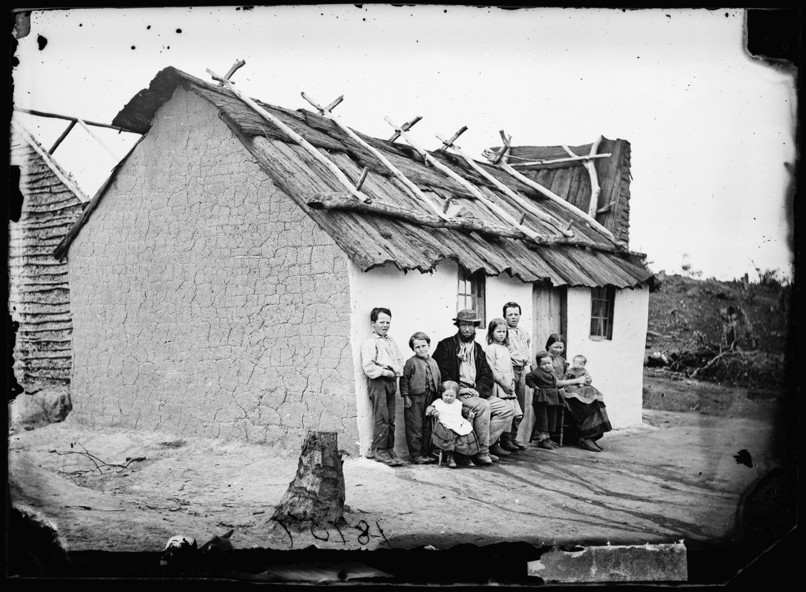
Couple with seven children in front of their cottage with bark roof, Hill End, circa 1873, American and Australasian Photographic Company. NSW State Archives on Flickr. No known copyright restrictions

Historical inquiry step 1 – question
Following examination and comparison of sources 1 and 2, and guided by the syllabus dot points, generate a class set of inquiry questions, for example:
- How can I represent the structure of my immediate family?
- How can I find out about family roles and structures of the past?
- What were the family structures in past generations?
- How is my immediate family structure similar and different to earlier generations of my family?
- What are the roles of my family members and how are they similar and different to earlier generations?
Note – Inquiry questions may need to be redesigned through the historical inquiry process.

Historical inquiry steps 2 and 3 – research and analyse
My family structure
Students bring to school a contemporary photograph of their immediate family.
Model the construction of a concept map or diagram that graphically represents the structure of the family in source 1. Students construct a concept map, diagram or illustration that graphically represents the structure of their own family. Note – As there is great diversity in family structures, enable students freedom in their representations rather than scaffolding this activity.
Change and continuities in family structures
Students bring to school a past family photograph that includes one of their parents or grandparents as a child. Discuss the reliability of photographs as sources. Are they a completely accurate representation of a family? Are there extra people in the photograph or is anyone missing?
Students compare their contemporary family photograph with their one of past generations. They discuss the similarities and differences with a partner. Students then create a Venn diagram to represent the similarities and differences in the structure of their families from the present and past.
Roles of family members past and present
Read a picture book that illustrates roles of family members in the past, for example, Lizzie Nonsense by Jan Ormerod. Compare the past roles of family members to those in the students’ families.
Invite two or three grandparents to share their stories about the roles of each of their family members when they were children, outlining the role of mothers, fathers, caregivers and children. Generate a table of past roles of family members.
With parent/caregiver guidance, students contact and interview an older family member or family friend to ask about the roles within their families. Discuss the reliability of oral histories. Were the experiences of each visiting grandparent and older family member similar or different? Why should we listen to more than one oral history?
Using a T-chart, in the ‘present’ column, students draw an illustration of their family, labelling each family member and their roles. Using information obtained through their interviews or the grandparents’ oral histories, in the ‘past’ column, students draw a family from the past and label the family members and their roles. Students compare the present and past roles verbally or in writing.

Historical inquiry step 4 – evaluate
Discuss the reliability of photographs and oral histories. Whose view is presented? What might be missing? Do the inquiry questions need to be redesigned as a result of evaluating the sources?

Historical inquiry step 5 – communicate
Recreated family portraits
Using costumes and props, students ‘step into’ a family portrait from the past, for example, source 2. They create a freeze frame of the photograph then come to life and enact the activities of each family member immediately before or after the photograph was taken, demonstrating roles of the past. For instance, in source 2, the mother might go inside and start cooking dinner, the girls might be asked to come and help her prepare the food or to bring in the washing, the father might return to work in the mines and the boys might have to chop wood for the fuel stove and tend to the chooks and horse.
Reflection – Students reflect on the historical inquiry process, reflecting on what they learnt, how they learnt it and what else they would like to find out.

Inquiry 2 – school life past and present
Students investigate differences and similarities between past and present children’s daily lives at school: clothing, school activities, playground games and activities. They draw on their own experiences, that of their parents, grandparents’ and great-grandparents’, as well as other sources.

Stimulus
Puzzle pieces of the past
Source 3a – Detail from Balmain Public School, class 2A, circa 1916

Detail from image Balmain Public School, circa 1916, uploaded 30 October 2013, State Archives NSW on Flickr. No known copyright restrictions

Source 3b – Balmain Public School, class 2A, circa 1916
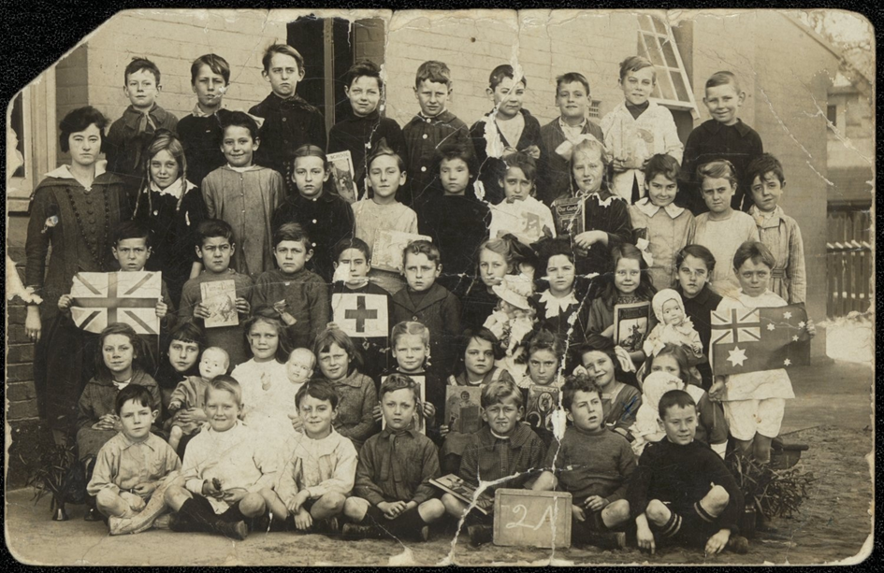
Balmain Public School, circa 1916, uploaded 10 October 2013, State Archives NSW on Flickr. No known copyright restrictions
Print source 3b as an A4 or A3 sized pages and cut into ‘puzzle pieces’, as shown in source 3a. Distribute these for the students to examine, using magnifiers, if available. Students use the See – Think – Wonder prompts to guide their examination.
See – Think – Wonder prompts
See
- Who is in the photograph?
- What are the children holding?
- What are the children wearing?
Think
- What are the ages of the children?
- What are the relationships of the people to each other?
- Why was the photograph taken?
- Where was the photograph taken? How do you know?
- When was the photograph taken?
Wonder
- What do you wonder about when examining the photograph?
Comparing the past and the present – Following examination of their ‘puzzle piece’, the students connect their puzzle pieces to create the complete photo, as shown in source 3b. They compare it to a recent school photo.
- What are the similarities and differences between the past and present school photos?
- What would a child’s day at school be like in the past?
- How would it be similar and different to the present?

Historical inquiry step 1 – question
With reference to the discussions relating to source 2, develop a set of inquiry questions. For example:
- How can we find out what children’s lives were like in the past?
- What did children wear in the past? What was their school day like?
- What are children’s school days like now, in the present?
- How are children’s school days in the past similar and different to those in the present?
- Why are there similarities and differences between the past and the present?
Note – Inquiry questions may need to be redesigned through the historical inquiry process.

Historical inquiry steps 2 and 3 – research and analyse
Discuss ways of finding answers to the inquiry questions, for example, primary sources such as photographs, objects and personal stories of parents, grandparents and great grandparents (oral histories), and secondary sources such as informative texts and picture books.
Research activity stations
Set up a set of ‘daily life past and present’ research activity stations that small groups of students can rotate through over a few lessons, run in a similar manner to literacy groups. At the conclusion of each session, draw out what the students learnt (knowledge and understandings) and how they learnt it (sources examined and source analysis skills).
Suggested research activity stations for small groups of students:
- Grandparents’ stories – oral history
Invite a different grandparent each week to share recollections of their childhood. Brief the grandparent on the focus of the talk and encourage them to bring in photographs or childhood objects to show the students. Students listen and ask questions.
- School children of the past photo gallery
Using computers or tablets, students examine the photographs of schooling in the past in source 4. They select one photograph showing young school children of the past and draw and label a picture of a school child in the clothing of the time. Students add the school and date of their reference photograph. Display the illustrations, with their reference photograph, in chronological order.
- Schools timeline
From sources 4 or 5, select and print a set of eight to ten photographs of young students at school in the past, ensuring each is labelled with a caption stating the school and date. These can be A4-sized and laminated or eight to a page for cutting and pasting. Students examine the printed photographs and sequence them chronologically. They identify and discuss similarities and differences along the timeline. (Note: Flickr is blocked for Stage 1 students.)
- Past school objects
Have available a collection of objects once used at school such as ink pens and ink (used until around 1970) and Cuisenaire rods (used in the 1970s). These may be available in the backs of school storage rooms. If possible, also have available some dress-up items such as pinafores, sailor collars, straw hats, jackets and vests. Using a set of photographs for reference, selected from source 4, students dress-up and use the objects from the past such as constructing a mat of ten using the Cuisenaire rods and handwriting, copying spelling words, or copying times tables, using pen and ink.
- Past and present photo sorting
Using the photographs of school children in their school grounds in sources 6 to 11, and a matching contemporary set taken at school, students sort the images into past and present. They either work manually using printed photographs and a T-chart, or digitally using an interactive program or app. They identify and discuss the similarities and differences.
Note – Photographs of students in school playgrounds from the 1950s to 1980s are available in source 4 and the State Library of NSW digital collections. They are not reproduced here due to copyright restrictions.

Sources for research activity stations
Source 4 – History of New South Wales Government schools, NSW Department of Education
Source 5 – Schools photo album, State Archives NSW on Flickr

Source 6 – Opening of new playground for infants department at Alma Public School, 1927
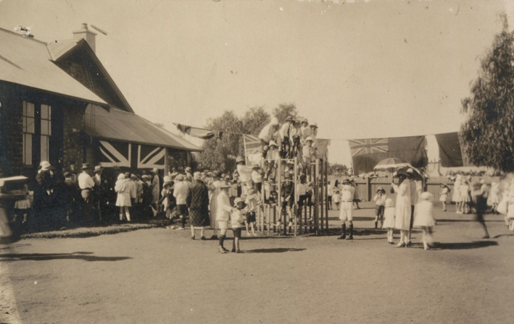
Alma Publci School – opening if new playground for infants department, 1927, Uploaded 9 December 2013, State Archives of NSW on Flickr. No known copyright restrictions
Source 7 – Play time at Brighton-le-Sands Public School, 1920
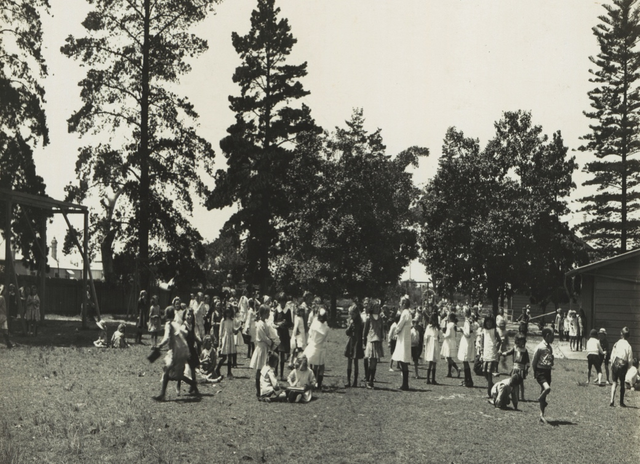
Brighton-le-Sands Public School – play time, 1920, uploaded 10 January 2014, State Archives NSW on Flickr. No known copyright restrictions

Source 8 – Boys playing hockey at Corienbob Public School, circa 1925
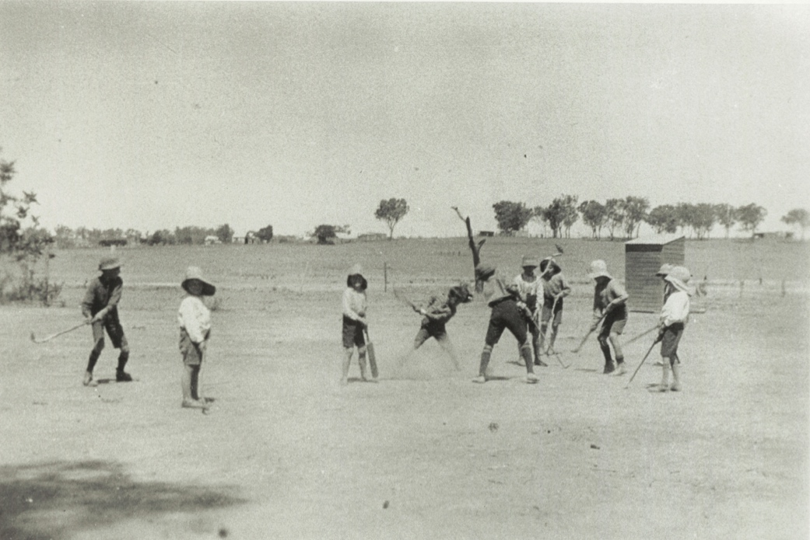
Coreinbob Public School – playing hockey, circa 1925, uploaded 24 July 2014, State Archives NSW on Flickr. No known copyright restrictions
Source 9 – Infants children gardening at Fort Street Public School, circa 1900
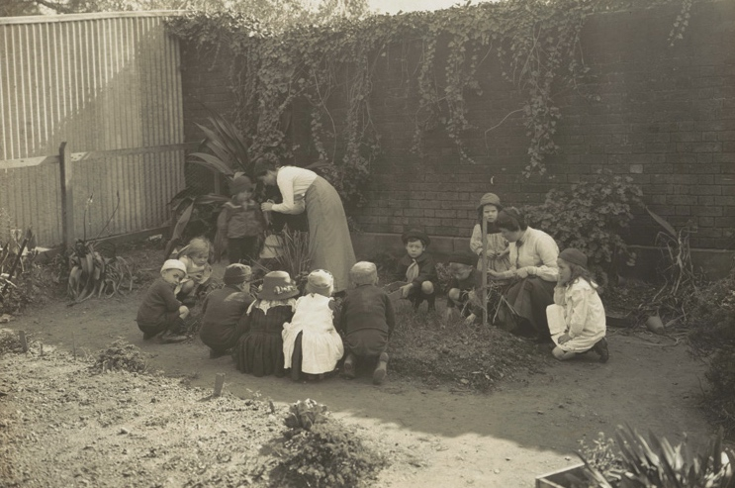
Fort Street Public School – gardening, circa 1900, uploaded 27 March 2015, State Archives NSW on Flickr. No known copyright restrictions

Source 10 – Boys playing cricket at Edith Public School, circa1910
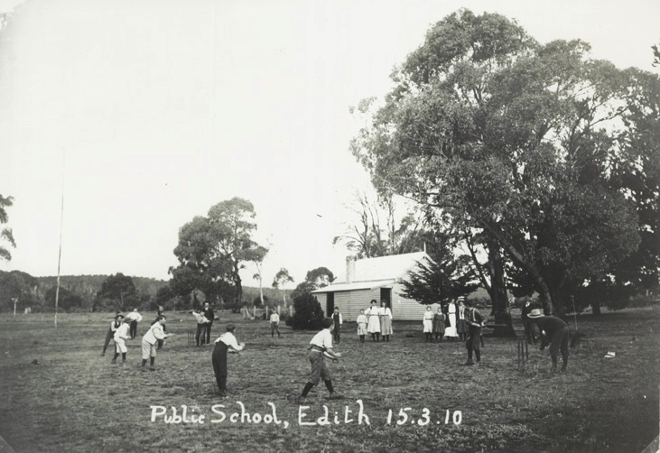
Edith Public School – Cricket, circa 1910, uploaded 11 December 2014, State Archives NSW on Flickr. No known copyright restrictions
Source 11 – Girls skipping at an athletics carnival, circa 1900
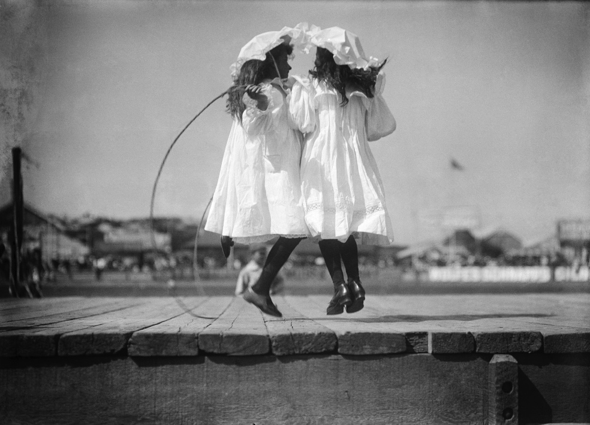
Girls skipping at an athletics carnival, circa1990, Powerhouse Museum on Flickr. No known copyright restrictions
Games of the past (optional) – Hold a ‘games of the past’ afternoon and invite parents or grandparents to teach the students games they used to play. Games could include hopscotch, fly, hand clapping games, What’s the time Mr Wolf, skipping and elastics.

Historical inquiry step 4 – evaluate
Discuss the reliability of photographs and oral histories. Were there inconsistencies between the sources? Do they provide a true representation of all children’s school experiences? Do the inquiry questions need to be redesigned as a result of analysing and evaluating sources?

Historical inquiry step 5 – communicate
Historical narrative – in role as a child from the past.
Students select one of the photographs used in the research activity stations. They imagine they are one of the children in the photograph. Students take on role as the child and provide a verbal or written explanation of a typical school day in that child’s life. If verbal, students could use costumes and props and present their story of their school day to the class. Additionally, in role, they could explain why and where the photograph was taken. Alternatively, students explain the sequence of events in a past child’s school day using third person voice.
Reflection – Students reflect on what they learnt, how they found out and what else they would like to know.

Inquiry 3 – leisure past and present
Students investigate differences and similarities between past and present children’s daily lives on holidays and in their spare time. They draw on their own experiences, that of their parents and grandparents, as well as other sources.
Note – This inquiry could be amended to become a student-led inquiry.

Stimulus
Source 12 – A is for Aunty by Elaine Russell
Read a picture book about daily life in the past, such as ‘A is for Aunty’ by Elaine Russell in source 12.
Identify the author’s representations of what daily life was like in the past. Compare toys and games, the neighbourhood and special places, and meal times in the past and the present. Jointly construct a comparison table comparing those aspects of past and present daily life.
Note – Refer to the Guide to using picture books in history K–10 (Department of Education 2017) for learning activities relating to source 12.

Historical inquiry step 1 – question
With reference to the discussions relating to source 12, develop a set of inquiry questions. For example:
- In the past, what did children do on weekends, and in holiday times?
- What are children’s free-time games, weekend activities and holidays like now?
- How is children’s leisure time in the past similar and different to the present?
- Why are there similarities and differences between the past and the present?
Note – Inquiry questions may need to be redesigned through the historical inquiry process.

Historical inquiry steps 2 and 3 – research and analyse
Leisure past and present
Recall the leisure activities and special places used by author Elaine Russell, as a child, in source 12. In small sharing circles, students share a favourite leisure activity they enjoy with their family. Students could mime their favourite activity.
Using a ‘present and past’ T-chart, generate a class list of present family leisure activities.
Source 13 – Leisure Time photo album, State Archives NSW on Flickr
Collectively view the album of photographs of past leisure activities in source 13, focussing on those with children in the photograph. During the viewing, using the ‘past’ column on the T-chart, generate a list of past leisure activities. (Note – Flickr is blocked for Stage 1 students so they are unable to view the digital album independently) Discuss the reliability of using photographs as a source. Do they accurately represent the leisure experiences of all Australian children?
Guide students to imagine stepping into one or two of the photographs. Ask them what sounds, smells, tastes and textures they would experience and how would they be feeling if they were in that location at that time.
Analyse the present and past lists on the T-chart and identify similarities. Students construct a Venn diagram to represent the similarities and differences in leisure activities in the present and the past.
Picnics
Source 14 – Feeding the family: Picnics, National Museum of Australia
Observe the images of picnics between 1900 and 2011, in source 14.
Undertake the learning activities listed in source 15.These enable students to use the photographs to observe and sequence, research and contextualise, and empathise and speculate.

Historical inquiry step 4 – evaluate
Discuss the reliability of the sources used. Were there inconsistencies between the sources? Do they provide a true representation? Why or why not? Do the inquiry questions need to be redesigned as a result of analysing and evaluating sources?

Historical inquiry step 5 – communicate
Picnicking in the future
As suggested in source 14, students create an artwork of an imagined picnic or leisure activity of the future. Students share their artwork with the class and explain the sounds, smells, tastes and textures they would experience if they were there. Compare and discuss students’ futuristic imaginings.
Reflection – Students reflect on what they learnt, how they found out and what else they would like to know.

Resources
Picture books:
- A is for Aunty by Elaine Russell (PRC K-2)
- Tea and Sugar Christmas by Jane Jolly and Robert Ingpen (PRC K-2)
- Tom Tom by Rosemary Sullivan and Dee Huxley (PRC K-2)
- Lizzie Nonsense by Jan Ormerod (PRC 3-4)
- Remembering Lionsville by Bronwyn Bancroft (PRC 3-4)
- Grandpa's Stories by Rachel Tonkin (PRC 3-4)
- Grandmother by Jeannie Baker
- Papa and the Olden Days by Ian Edwards and Rachel Tonkin
- My First Car was Red by Peter Schossow
Websites and resources:
- Classroom Resources – Feeding the family webpage, National Museum of Australia
- Guide to using picture books in History K–10 (PDF 1947KB), NSW Department of Education, 2017
- How to Play "Fly" (PDF 146KB), NSW Schoolhouse Museum of Public Education, 2012
- How times change, Education Services Australia
- NSW Schoolhouse Museum of Public Education website
- Who are the families of the world? webpage, Global Education
Digital collections:
- Department of Education photographic collection 1850-1991, State Archives and Records NSW
- Historical photo sets hosted on Flickr, Powerhouse Museum
- Historical photo sets hosted on Flickr, State Library of NSW
- History of New South Wales Government schools: , NSW Department of Education
- NSW Schoolhouse Museum photos hosted on Flickr, NSW Schoolhouse Museum of Public Education
- EXN Schools photo set hosted on Flickr, University of Newcastle Cultural Collections
- Schools photo album hosted on Flickr, State Archives NSW
- Trove, National Library of Australia

