History - stage 5 – depth study 4: rights and freedoms (1945-present) resource 1
Note for teachers:
Students are guided in completing an inquiry into changing nature of rights and freedoms in Australia. This sample learning sequence is intended for approximately 3-4 weeks of learning. Most of this learning sequence involves online resources, due to the nature of the source material being used.
Some offline student worksheet options and an extended resource list are included at the end of the learning sequence.
Student:
- sequences and explains the significant patterns of continuity and change in the development of the modern world and Australia
- explains and analyses the motives and actions of past individuals and groups in the historical contexts that shaped the modern world and Australia
- uses relevant evidence from sources to support historical narratives, explanations and analyses of the modern world and Australia
- selects and analyses a range of historical sources to locate information relevant to an historical inquiry
- applies a range of relevant historical terms and concepts when communicating an understanding of the past
This document references the History K-10 Syllabus © 2012 Copyright NSW Education Standards Authority for and on behalf of the Crown in right of the State of New South Wales.

Universal Declaration of Human Rights

Content:
The origins and significance of the Universal Declaration of Human Rights (UDHR), including Australia's involvement in the development of the declaration (ACDSEH023)
Students:
- outline the purpose of the United Nations and describe the origins of the Universal Declaration of Human Rights, including Australia's involvement
- explain the significance of the UDHR
Teacher’s note - this unit builds on the concepts covered in the depth study 1: making a better world and depth study 2: Australia and Asia. The first section focuses on the Universal Declaration of Human Rights (UDHR), its origin and significance. Students will need some prior knowledge of the role and function of the United Nations. If you need to provide non-internet options for this task, please print the PDF version of the UDHR from the United Nations website. If you do not have a shared online classroom space, you may like to set up a padlet or flipgrid for the brainstorming aspect of this activity.

Activities:
- Write a definition for ‘human rights.’ What do you think the most important human rights are in our current world? Discuss your responses through a post in your online classroom or a teacher created padlet or flipgrid.
- Explore the interactive story of our freedom alternatively, watch Magna Carta: the story of our freedom (duration 4:10). Create a short infographic/poster that outlines the timeline of the development of human rights over time.
- Continuing to look at the story of our freedom interactive, focus on the section between 1940 and today. The section about the United Nations depicts Australia as one of the eight nations involved in drafting the UDHR. Explore Australia’s role further by investigating one of the following people – Colonel William Roy Hodgson, Jessie Street or Herbert (Doc) Evatt. Write a brief summary (at least one paragraph) of your chosen individual’s contribution to the creation of the UDHR. Share your summary with your teacher/class.
- Read the Universal Declaration of Human Rights (UDHR) and complete the following questions:
  - When was the UDHR adopted by the United Nations General Assembly?
  - Read the preamble. What does it outline as the purpose of UDHR?
- Using the Australian Human Rights Commission website, briefly summarise the role of Australia in the origin of the UDHR. Make sure you include the role of key individuals.
- According to the Australian Human Rights Commission page on What is the Universal Declaration of Human Rights?, what is the significance of the UDHR?
- Watch ‘what are the universal human rights’ (duration 4:47). After watching, consider the limitations of human rights today. Write a list of things that could and should be done to strengthen the protection of basic human rights across the world.
- Using the understanding you have gained, create a 3-minute presentation/speech in response to the following statement – ‘the Universal Declaration of Human Rights plays a significant role in Australian history and society.’

Rights and freedoms before 1965

Content:
Background to the struggle of Aboriginal and Torres Strait Islander peoples for rights and freedoms before 1965, including the 1938 Day of Mourning and the Stolen Generations (ACDSEH104)
Students:
- explain the purpose and significance of early twentieth-century Aboriginal activism including the 1938 Day of Mourning protest for Aboriginal and Torres Strait Islander peoples
- outline the rights and freedoms denied to Aboriginal and Torres Strait Islander peoples before 1965 and the role and policies of the Aboriginal Protection Board, eg the control of wages and reserves
Teacher’s note – some of the activities refer to terminology that exists within historical source material and is not appropriate for use in our current world. Ensure students are aware of terminology usage guidelines and the contextual nature of the words associated with this area of history.

Activities:
- Use the timeline of Aboriginal rights (and your research) and create a timeline of the following significant events. As a guide, 1cm for each 5 years is a recommended scale. Each event should include a short 1-2 sentence annotation explaining what it refers to:
  - Commonwealth of Australia formed
  - White Australia policy
  - Day of Mourning
  - Indigenous people given the vote in Commonwealth elections.
- Look at the events listed on the timeline you have created. What can you identify as missing from this list? As a class (using online platforms or otherwise), brainstorm as many additional events that you think should be included on a detailed ‘timeline of Aboriginal rights’ list. Select one of these events and write a one-page fact file (include key information, images and primary sources where possible) to share with the class.
- Use the Aborigines Protection Act page from the National Museum of Australia website and the original Protection of the Aborigines source material to complete the following questions:
  - What happened in 1883, 1909 and 1915 in relation to the Aboriginal Protection Board?
  - What was the purpose of the Board for the Protection of Aborigines?
  - What changed in 1909 and what was the effect of this change?
  - What was the Board was able to do after 1915 and what was the effect of these actions?
- Use the internet to research the Cummeragunja Walk Off. Write a newspaper article to present your findings. Your article should include:
  - the historical background of the walk off, including the nature of the Cummeragunja station and the Aborigines Protection Act.
  - a map to highlight the location of the station and where the protestors walked
  - the reason for the walk off
  - the basic facts of the walk off (who/what/where/when)
  - the outcome and legacy of the walk off
  - links to other examples of Aboriginal activism
  - key individuals
- Using the interactive map, select three of the Aboriginal missions, stations or camps that are close to your local area. Using the information provided and further research, create a table to record the following information:
Table 1 Aboriginal missions, stations and camps
Name | Location | Years of operation | Type | Other information
Example – Cummeragunja | Yorta Yorta land.  Opposite village of Barmah, NSW. | 1887-1953 | Station | There was a famous ‘walk off’ from the station of 4 February 1938 – about 200 Yorta Yorta people walked off in protest against poor living conditions and unfair management. The strike lasted nine months. It was described as the first mass strike of Aboriginal people in Australia and brought about changes to the Aborigines Protection Act.
- Watch stolen wages and generations of disadvantage (duration13:52) and read stolen wages: Iris’ story. Using the information in the two sources and your own research, write a report on the issue of Aboriginal stolen wages. Your report should include:
  - first-hand accounts
  - statistics relating to how many people were affected and the money stolen
  - explanation of the ‘Aborigines Protection Act’ and how it allowed the wage theft
  - discussion of the ongoing case to restore lost wages.
- Create a fact file about the 1938 Day of Mourning protests. Your fact file can be done using a design website like Canva or on paper. The fact file should include:
  - What happened?
  - When did it happen?
  - Where did it happen?
  - Who was involved?
  - Why is it a significant event in Australian history?
- Watch Jack Patten’s grandson remembers the legacy of the 1938 National Day of Mourning (duration 3:21) about the legacy of the 1938 National Day of Mourning. Using this video as Source C along with the sources in Worksheet 1 – National Day of Mourning source analysis, answer the following questions for each source:
  - What is the perspective of the source?
  - What can an historian learn about the 1938 Day of Mourning from this source?
  - Are there any issues with the sources?
  - Consider all three sources. Are there gaps or limitations with this group of sources? How would an historian develop a deeper understanding of the Day of Mourning once they have engaged with these sources?

Conclusion
- Using your knowledge and research from the previous activities, answer the following question in a 600-word essay and submit to your teacher for feedback:
To what extent did Australian governments fulfil their obligations under the UDHR in relation to the human rights of Aboriginal Australians in the period to 1965?
Key success criteria:
- refers to specific articles in the UDHR
- refers to specific evidence and actions of governments in relation to Aboriginal Australians.
Ensure you plan and structure your essay to create a high quality piece of writing that demonstrates your learning.
Table 2 Marking Criteria
Criteria | Mark
Uses an extensive range of historical evidence, including both primary and secondary sources.  Explicitly refers to articles of the UDHR.  Provides a detailed evaluation of the actions of governments in relation to Aboriginal Australians.  Accurately applies relevant historical terminology and concepts. | 9-10
Uses a wide range of historical evidence, including primary and/or secondary sources.  Refers to articles of the UDHR.  Provides a thorough evaluation of the actions of governments in relation to Aboriginal Australians.  Appropriately applies relevant historical terminology and concepts. | 7-8
Uses a range of historical evidence, including either primary or secondary sources.  Generalised reference to the UDHR.  Refers to some actions of governments in relation to Aboriginal Australians.  Applies relevant historical terminology and concepts. | 5-6
Uses a limited range of historical evidence.  Limited reference to the UDHR.  Limited reference to actions of governments in relation to Aboriginal Australians.  Uses some historical terminology and concepts. | 3-4
Very little historical evidence used.  Demonstrates limited understanding of the UDHR.  Makes generalised statements.  Limited use of historical terminology and concepts. | 1-2

Worksheet 1 – Day of Mourning source analysis
Source A - left to right: William (Bill) Ferguson, Jack Kinchela, Isaac Ingram, Doris Williams, Esther Ingram, Arthur Williams Jr, Phillip Ingram, unknown, Louisa Agnes Ingram holding daughter Olive, Jack Patten. Mitchell Library, State Library of New South Wales Q 059/9
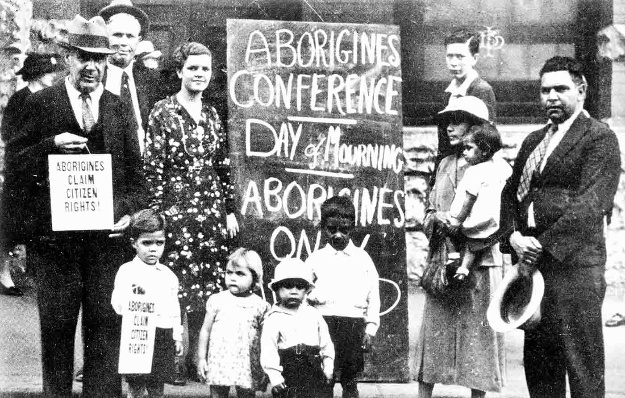

Source B – Jack Patten, Day of Mourning organiser. Quote from National Museum of Australia website.
“We, representing the Aborigines of Australia, assembled in conference at the Australian Hall, Sydney, on the 26th day of January, 1938, this being the 150th Anniversary of the Whiteman’s seizure of our country, hereby make protest against the callous treatment of our people by the whitemen during the past 150 years, and we appeal to the Australian nation of today to make new laws for the education and care of Aborigines, we ask for a new policy which will raise our people to full citizen status and equality within the community.”

Resources
- Universal Declaration of Human Rights commons.wikimedia.org/wiki/File:The_universal_declaration_of_human_rights_10_December_1948.jpg
- United Nations un.org/en/universal-declaration-human-rights/
- Human rights infographic humanrights.gov.au/magnacarta/infographic/
- Human rights video humanrights.gov.au/magnacarta/video/
- What are universal human rights – video ed.ted.com/lessons/what-are-the-universal-human-rights-benedetta-berti
- Terminology use guidelines narragunnawali.org.au/about/terminology-guide
- Primary source – Aborigines Protection Act aiatsis.gov.au/sites/default/files/catalogue_resources/91930.pdf
- Cummeragunja Walk Off archives records.nsw.gov.au/archives/collections-and-research/guides-and-indexes/stories/cummeragunja-walk-off
- Aboriginal missions, stations and camps interactive map aiatsis.gov.au/explore/articles/mapping-nsw-aboriginal-missions-stations-and-camps-1883-1969
- Stolen wages video youtube.com/watch?v=iELQR74RI54
- Stolen wages – Iris’ story australianstogether.org.au/stories/stolen-wages/
- Day of Mourning NITV video youtube.com/watch?v=yj3-pMnyUOI
- Frayer Diagram app.education.nsw.gov.au/digital-learning-selector/LearningActivity
- Australia and the Universal Declaration of Human Rights humanrights.gov.au/our-work/australia-and-universal-declaration-human-rights
- What is the Universal Declaration of Human Rights humanrights.gov.au/our-work/what-universal-declaration-human-rights
- Timeline of Aboriginal Rights sbs.com.au/news/timeline-indigenous-rights-movement
- Aborigines Protection Act nma.gov.au/defining-moments/resources/aborigines-protection-act
- Essay planning advice det.nsw.edu.au/eppcontent/glossary/app/resource/factsheet/4129.pdf

