Australian democracy and citizenship
This learning sequence comprises two inquiries.

Topic – Australia as a nation
6 weeks – 90 minutes per week

Key inquiry questions
- How did Australian society change throughout the twentieth century?

Overview
Inquiry 1 is a semi-guided inquiry into experiences of the status, rights and freedoms of Aboriginal and Torres Strait Islander peoples in Australian democracy. Students investigate the actions of individuals and groups that work to address inequities and instigate change. Inquiry 2 is an independent inquiry into the experiences of Australian democracy and citizenship for groups of migrants, women and children. Students investigate ways in which one of these groups has had their rights and freedoms denied.

Outcomes
A student:
HT3-3 identifies change and continuity and describes the causes and effects of change on Australian society
HT3-4 describes and explains the struggles for rights and freedoms in Australia, including Aboriginal and Torres Strait Islander peoples
HT3-5 applies a variety of skills of historical inquiry and communication

Content
Experiences of Australian democracy and citizenship, including the status and rights of Aboriginal people and/or Torres Strait Islanders, migrants, women and children (ACHHK114)
Students:
- examine Australian human rights, past and present, affecting Aboriginal and/or Torres Strait Islander peoples, migrants, women and children
- explain how Australian society has changed throughout the twentieth century for these groups
- investigate the significance of one of the following in the struggle for the rights and freedoms of Aboriginal and Torres Strait Islander peoples
  - the Stolen Generations
  - the right to vote federally in 1962
  - the 1967 Referendum
  - the Mabo decision

Historical inquiry skills
Comprehension: chronology, terms and concepts
- respond, read and write to show understanding of historical matters
- sequence historical people and events (ACHHS098, ACHHS117)
- use historical terms and concepts (ACHHS099, ACHHS118)
Analysis and use of sources
- locate information relevant to inquiry questions in a range of sources (ACHHS102, ACHHS121)
- compare information from a range of sources (ACHHS103, ACHHS122)
Perspectives and interpretations
- identify different points of view in the past and present (ACHHS104, ACHHS123)
Empathetic understanding
- explain why the behaviour and attitudes of people from the past may differ from today
Research
- identify and pose questions to inform an historical inquiry (ACHHS100, ACHHS119)
- identify and locate a range of relevant sources to support an historical inquiry (ACHHS101, ACHHS120)
Explanation and communication
- develop historical texts, particularly narratives and descriptions, which incorporate source material (ACHHS105, ACHHS124)
- use a range of communication forms (oral, written, graphic) and digital technologies. (ACHHS106, ACHHS125)

Selected historical concepts
Continuity and change – some things change over time and others remain the same, for example, aspects of both continuity and change in Australian society throughout the twentieth century.
Cause and effect – events, decisions or developments in the past that produce later actions, results or effects, for example, events and other reasons that led to migration to Australia; reasons for the struggle for rights and freedoms for various groups in Australia.
Perspectives – people from the past will have different views and experiences, for example, differing attitudes of various groups to Federation or to granting rights and freedoms to women and Aboriginal peoples.
Empathetic understanding – an understanding of another's point of view, way of life and decisions made in a different time, for example, differing attitudes and experiences of living in an Australian colony; understanding the experiences of Aboriginal and Torres Strait Islanders, women and migrants throughout the twentieth century.
Significance – the importance of an event, development or individual/group, for example, determining the importance (significance) of various peoples' contributions to the development of a colony.
Contestability – historical events or issues may be interpreted differently by historians, for example, British ‘invasion’ or ‘settlement’ of Australia.
Syllabus extracts are quoted from History K-10 Syllabus © 2012 NSW Education Standards Authority (NESA) for and on behalf of the Crown in right of the State of New South Wales.

Assessment
All activities require students to demonstrate their learning. All are assessment for learning activities.

Vocabulary
Status, rights, human rights, freedoms, rights and freedoms, past, present, Aboriginal, Torres Strait Islander, Stolen Generations, migrants, women, children, society, democracy, civic, citizenship, referendum, election, vote, significance.

Teaching and learning activities
This learning sequence comprises two inquiries.

Inquiry 1 – status, rights and freedoms of Aboriginal and Torres Strait Islander people
Through a semi-guided inquiry students investigate the status, rights and freedoms of Aboriginal and Torres Strait Islander peoples in Australian democracy. They investigate the actions of individuals and groups that work to address inequities in rights and freedoms in the past and present.

Stimulus
Source 1 – ‘Yes’ campaign, National Museum Australia
View the image in source 1. Read about the ‘Yes’ campaign and 1967 referendum that resulted in inclusion of Aboriginal and Torres Strait Islander peoples in the Australian constitution. Students use the visible thinking strategy think-puzzle-explore to list what they think they know about the topic, what questions they have and ways in which they can investigate the topic.

Historical inquiry step 1 – question
With reference to students’ think-puzzle-explore questions, formulate a set of inquiry questions. Sample questions:
- What are the experiences of democracy for Aboriginal and Torres Strait Islander Peoples?
- In what ways have Aboriginal and Torres Strait Islander people experienced discrimination and inequality in Australia?
- How have people fought for equal rights for Aboriginal and Torres Strait Islander peoples?
Note – Inquiry questions may need to be redesigned through the historical inquiry process.

Historical inquiry steps 2 and 3 – research and analyse
Stolen Generations
Source 2 – The burnt stick by Anthony Hill, Puffin Books, Australia, 1996 and/or Stolen girl by Trina Saffioti and Norma MacDonald, Magabala Books, Australia, 2011 (can be a shared reading)
Source 3 – The Apology, My place for teachers video (3:15min)
Source 4 – Stolen Generations, Behind the News video (3:58min)
Share the books in source 2 with the students. Be sensitive to Aboriginal students who may be impacted by the effects of intergenerational trauma caused by removal of family members. Provide time for quiet personal reflection on the books and the opportunity for discussion.
Students view the videos in sources 3 and 4 and compile key information into table 1. Students use a series of speech bubbles to state experiences and losses for Aboriginal and Torres Strait Islander people due to the Stolen Generations. Statements should demonstrate empathetic understanding and cause and effect.
Table 1 – source analysis table
Source | Title | Creator and audience | Key information | Reliability | Questions raised
2a | The burnt stick
2b | Stolen girl
3 | The Apology
4 | Stolen Generations
Aboriginal activism
Source 5 – Freedom Rides Student Action For Aboriginals (SAFA) outside Moree Artisian Baths,17-26 February, 1965
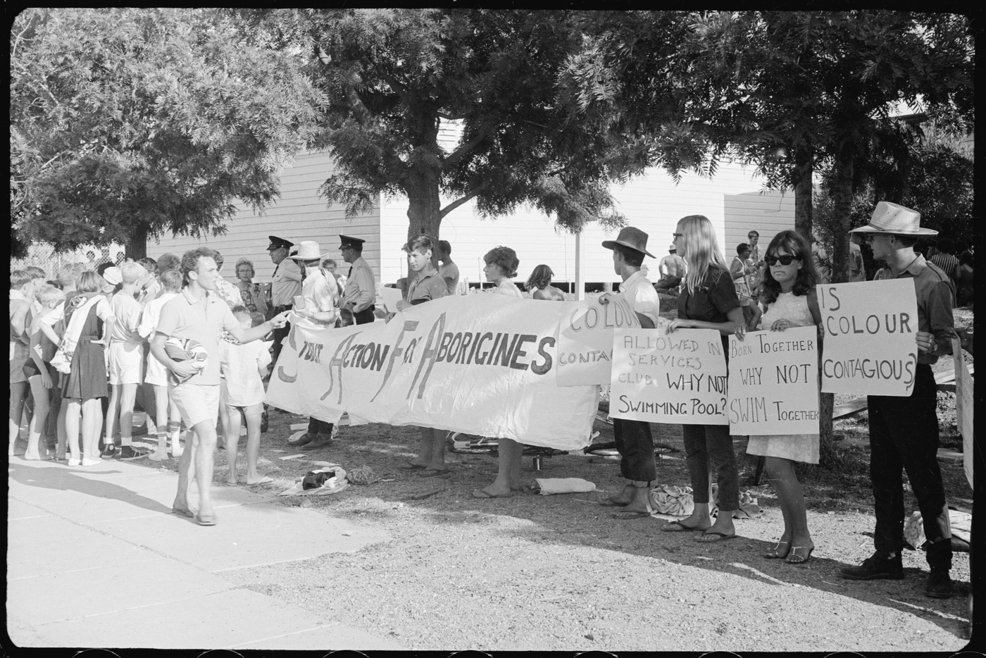
Mitchell Library, State Library of New South Wales and Courtesy SEARCH Foundation. CC BY 4.0
Source 6 – Freedom Ride, Behind the News video (3:54min)
Examine the photograph in source 5. Read the banners people are holding. Students make inferences about the actions of the people in the photograph.
View the video in source 6. Using information from the sources, students write a detailed caption for the photograph in source 5.
1967 Referendum
Source 7 – Say Yes: a story of friendship, fairness and a vote for hope by Jennifer Castles and Paul Seden, Allen and Unwin, Crows Nest, NSW, 2017
Share the picture book in source 7. Students locate a reliable online source that verifies the information about the 1967 referendum provided in source 7. Students list three reasons the 1967 Referendum was significant to Aboriginal and Torres Strait Islander people.
Key events in the struggle for rights and freedoms
Students research one of the following key events. They use table 2 to organise their information. Students create a protest style poster that communicates the key message of the event. They stand with their posters in chronological order to create a physical visual timeline, taking turns to be the timeline and the viewing audience. Examples of key events include:
- 26 January 1938 – Day of Mourning
- March 1962 – Aboriginal and Torres Strait Islander people are given the right to vote federally
- 12 February 1965 – Freedom Ride
- 27 May 1967 – Referendum in which 90.7% of Australians voted yes to count Aboriginal and Torres Strait Islander Peoples in the census
- 11 June 1971 – Neville Bonner AO was the first Aboriginal person to be appointed to the Australian Federal Parliament (Senate)
- 3 June 1992 – the Mabo decision in the High Court of Australia ruled that native title existed
- 21 December 1993 – Native Title Act passed for enactment on 1 January 1994
- 13 February 2008 – The Apology
- 29 May 2019 – Noongar man Ken Wyatt made history by being the first Aboriginal person to be sworn in as Minister for Indigenous Australians.
Table 2 – a key event in the struggle for the rights and freedoms of Aboriginal people
Event
Date
Key people
Key message
Significance
Information sources
Reliability of sources

Historical inquiry step 4 – evaluate
Are there inconsistencies or contradictions between the sources used? Do the inquiry questions need to be redesigned as a result of analysing and evaluating sources?

Historical inquiry step 5 – communicate
Freedom riders
The Freedom riders had a reunion in 2015 and retraced their 1965 journey into country NSW. In role as one of the activists on the reunion bus trip, students reflect on the impact of the Freedom riders’ actions and other significant events that have impacted the status, freedoms and rights of Aboriginal and Torres Strait Islander people since 1965. They communicate this through ‘hot seating’ or role-played interviews.
Reflection
Students reflect on the historical inquiry process, reflecting on what they learnt, how they learnt it and what else they would like to find out.

Inquiry 2 – experiences of migrants, women and children
Students undertake an independent inquiry into the experiences of Australian democracy and citizenship for groups of either migrants, women or children. Students investigate ways in which these groups have had their rights and freedoms denied, impacts and actions that instigated change.

Stimulus
During the first and second world wars people living in Australia who were of nationalities of ‘enemy nations’, such as Germany, were considered as ‘enemy aliens’ and were sent to internment camps, often in remote locations a great distance from home. Most were everyday Australians locked up just because of their nationality.
Students examine the photograph in source 8. Discuss the question, What rights and freedoms were these internees denied? Students turn and talk to a peer to share their reactions to the photograph, description and question.
Source 8 – Meal time at the German internment camp at Holsworthy, NSW, circa 1917
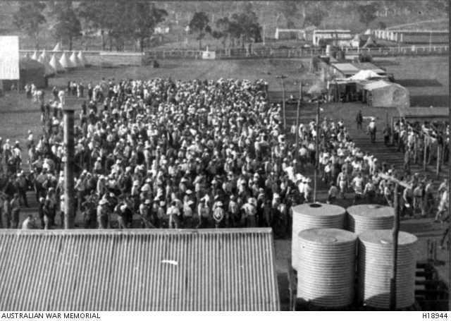
Australian War Memorial. Public domain

Historical inquiry step 1 – question
Formulate a set of inquiry questions. Sample questions:
- How have migrants, women and children been affected by inequalities in status, freedoms and human rights in Australia?
- What is the suffrage movement and what was its significance?
- What groups of people were interned in internment camps during the first and second world wars and why?
- Who are the Dreadnought Boys and what are their experiences in Australia?
- How has Australian society has changed for migrants, women and children?

Historical inquiry steps 2 and 3 – research and analyse
Students select one of the following research tasks. They compile information into table 4 or use their own format, referencing at least one primary source. To communicate their understandings students will compose an historical narrative in first person voice, supported by a primary source, that outlines the experiences of the person or group.
Student research topics:
Equality and empowerment of women
Source 9 – Womens suffrage, National Museum Australia
Source 10 – Australian women’s timeline, AWAVA
Use sources 9 and 10 to select one of the key women involved in the fight for women to be included in Australia’s electoral process through the right to vote and to stand for parliament. Conduct further research on the woman’s background and her role in the suffrage movement. Use the information to prepare a 30 second video, told in first-person voice, on the woman’s experiences, achievements and its impact.
Wartime civilian internment camps
Source 11 – The Japanese and the dark legacy of Australia's camps, SBS News
Source 12 – Japanese survivors recall Australia’s WWII civilian internment camps, SBS News
Read the two SBS News articles in sources 11 and 12 on the internment of Japanese civilians residing in Australia. Record information on the experiences of internment. Identify the reasons for internment and the freedoms and democratic values internees were denied. Use the information to prepare a 30 second video, told in first-person voice, on an internee’s experiences and its impact.
Youth migration and the Dreadnought Boys
Source 13 – Scheyville training farm 1911-1939, Migration Heritage Centre NSW
Source 14 – Photographs of Scheyville training farm, State Archives and Records NSW
Read source 13, noting the experiences of the teenage Dreadnought Boys. View the 1926 photographs of their training activities in source 14. Consider why the series of photographs was taken. Select one photograph from source 14 that represents the promise to the boys made by the Australian government. In first person voice, compose 30 second video that describes the realities of the experience in the training farm and working conditions in country NSW.
Table 4 – experiences of a person or group denied rights in Australia
Group
Name of person
Key dates
Their background
Experiences
Achievements
Significance
Primary source
Other sources
Reliability of sources

Historical inquiry step 4 – evaluate
During research and analysis, students evaluate the reliability of the sources. Are there inconsistencies or contradictions between the sources? Do the inquiry questions need to be redesigned as a result of analysing and evaluating sources?

Historical inquiry step 5 – communicate
My experiences video
Students compose an historical narrative in first person voice that outlines the experiences of the person or group denied rights in Australia. They present this as a 30 second video or speech in role as the person denied rights, including at least one primary source.
Reflection
Students reflect on the historical inquiry process, reflecting on what they learnt, how they learnt it and what else they would like to find out.

Additional resources
Books
The burnt stick by Anthony Hill, Puffin Books, Australia, 1996
Stolen girl by Trina Saffioti and Norma MacDonald, Magabala Books, Australia, 2011
Say Yes – a story of friendship, fairness and a vote for hope by Jennifer Castles and Paul Seden, Allen and Unwin, Crows Nest, NSW, 2017
Teacher resources
Australian Institute of Aboriginal and Torres Strait Islander Studies (AIATSIS)
Civics and citizenship learning sequence, NSW Department of Education
A Guide to using picture books in History K-10, NSW Department of Education
Digital collections
National Archives Australia
Trove
State Archives and Records of NSW

