HSIE: History S3 workbook
Name:
Class:

Overview
Stage 3 – Australia as a Nation
Let’s look into the status, rights and freedoms of Aboriginal and Torres Strait Islander peoples in Australian democracy. You will investigate the actions of individuals and groups that work to address inequities and instigate change.
Key inquiry questions:
• How did Australian society change throughout the twentieth century?

Activity 1
During this activity you are learning to:
- examine Australian human rights, past and present, affecting Aboriginal and/or Torres Strait Islander people
- explain how Australian society has changed throughout the twentieth century for these groups
- investigate the significance of events, such as, the Stolen Generation, the 1967 Referendum or the Mabo Decision in the struggle for the rights and freedoms of Aboriginal and Torres Strait Islander people
Resources – pens, pencils, paper, student workbook
Instruction
During this activity you will examine Australian human rights, past and present, affecting Aboriginal and/or Torres Strait Islander people
Brainstorm/think Read
Source 1 – ‘Yes’ campaign
National Museum Australia - timeline
View the image and information in the timeline in source 1.
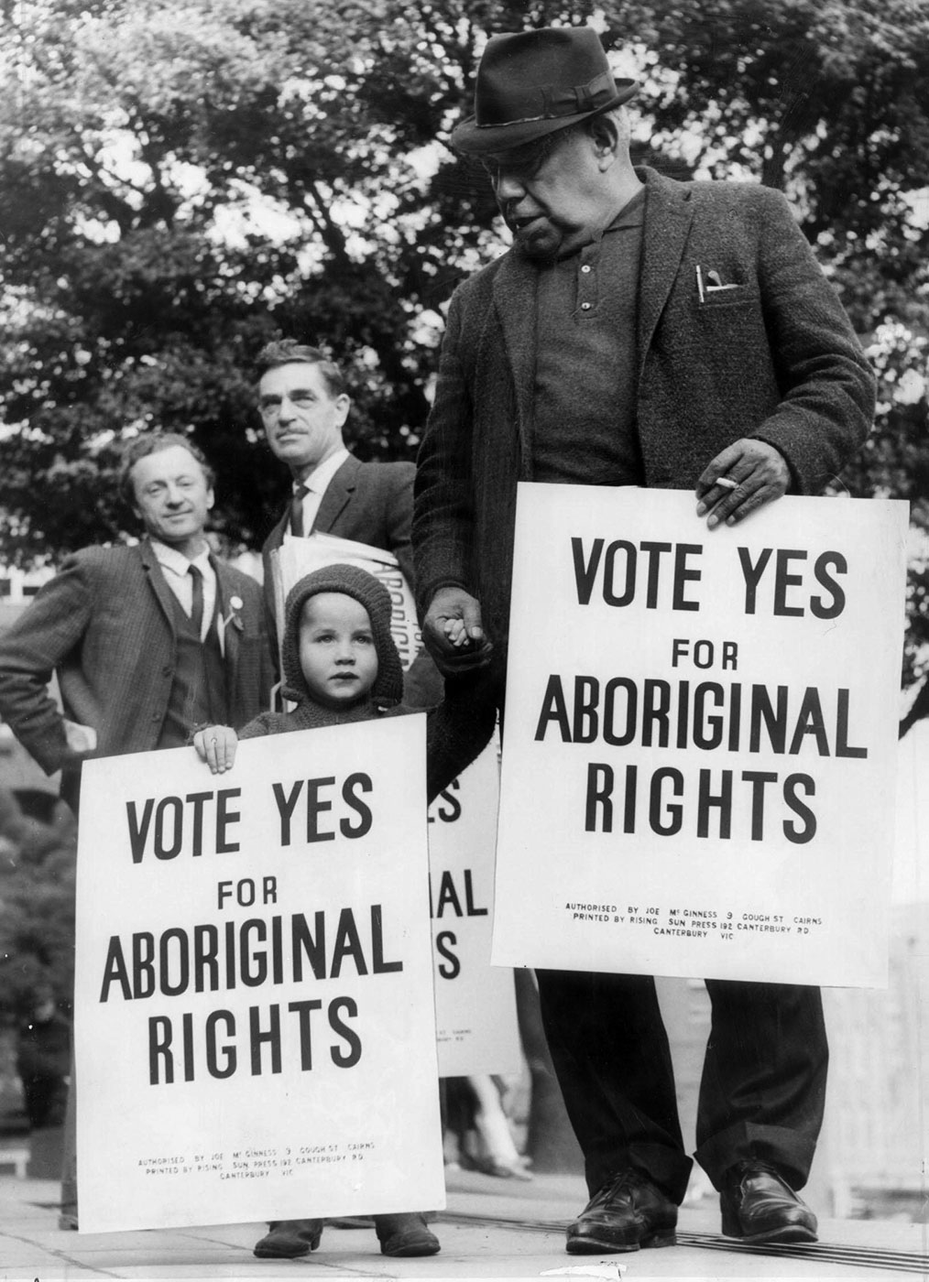
Bill Onus, president of the Aborigines Advancement League (Victoria), campaigning for the ‘Yes’ vote, 1967
Bill Onus 'Yes' campaign 1967, National Museum Australia
Read source 1, about the ‘Yes’ campaign and 1967 referendum that resulted in inclusion of Aboriginal and Torres Strait Islander peoples in the Australian constitution.
Then use the visible thinking strategy ‘Think-puzzle-explore’ to list what you think you know about the topic, what questions you have and ways in which you can investigate the topic.
Then complete the ‘Think, Puzzle, Explore’ table below
Examine source 1- ‘Yes’ campaign

What I think I know about this topic | What questions or puzzles do I have about this topic | How can I explore the puzzles I have about this topic

Brainstorm/discuss Read Write

Read the two picture books in source 2. This could also be a shared reading.
Source 2 – 'The Burnt Stick' by Anthony Hill (safe YouTube)
‘The Burnt Stick’ by Anthony Hill, Puffin Books, Australia, 1996 and/or
'Stolen Girl' by Trina Saffioti (safe YouTube)
‘Stolen Girl’ by Trina Saffioti and Norma MacDonald, Magabala Books, Australia, 2011
When you have read/viewed the two picture books, then view the videos in sources 3 and 4 and compile key information into table 1, below.
Source 3 – The Apology, My place for teachers’ video (3:15min)
Source 4 – Stolen Generations, Behind the News video (3:58min)
Table 1:
Source | Title | Creator and audience | Key information | Reliability | Questions raised
2a | The Burnt Stick
2b | Stolen Girl
3 | The Apology
4 | Stolen Generations
When you have completed the table above use a series of speech bubbles to state experiences and losses for Aboriginal and Torres Strait Islander people due to the Stolen Generations. Your statements should demonstrate empathetic understanding and cause and effect.

Activity 2
During this activity you are learning to:
- investigate the significance of events, such as, the Stolen Generation, the 1967 Referendum or the Mabo Decision in the struggle for the rights and freedoms of Aboriginal and Torres Strait Islander peoples
Resources – pens, pencils, paper, student workbook
Think/brainstorm Read Write
Source 5 – Freedom Rides - Student Action for Aborigines (SAFA) 1965
State Library of NSW
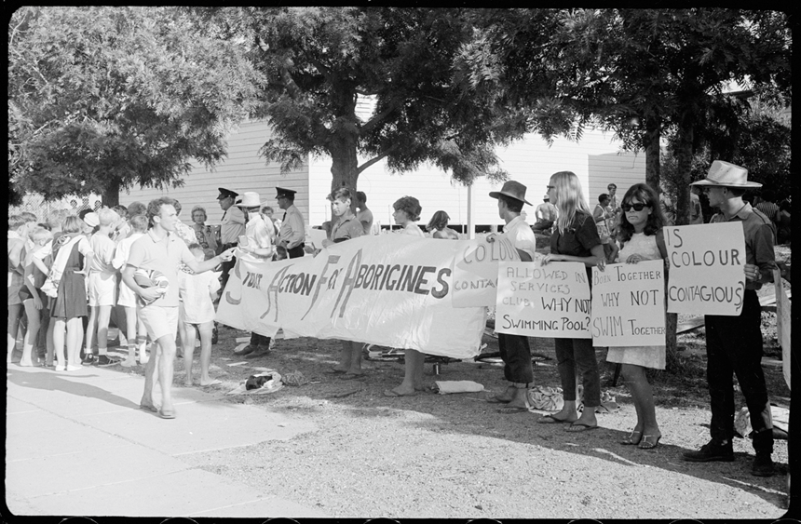
Examine the photograph in source 5, ‘Freedom Rides, Student Action for Aboriginals’ (SAFA) outside Moree Artesian Baths, 17-26 February 1965. Then read the banners people are holding and make inferences about the actions of the people in the photograph.
Then view the video in source 6 – Freedom Ride
Behind the News video (3:54min)
Using information from sources 5 and 6, write a detailed caption for the photograph in source 5.

Detailed caption for the photograph in source 5

Read and write
Source 7 – Say Yes: a story of friendship, fairness and a vote for hope
‘Say Yes: a story of friendship, fairness and a vote for hope’ by Jennifer Castles and Paul Seden.
1967 Referendum
Read or listen to the book in source 7, ‘Say Yes: a story of friendship, fairness and a vote for hope’ by Jennifer Castles and Paul Seden.
Once you have read the picture book in source 7, locate a reliable online source (such as the National Museum of Australia - timeline) that verifies the information about the 1967 referendum provided in source 7. Then list three reasons the 1967 Referendum was significant to Aboriginal and Torres Strait Islander people.

List three reasons the 1967 Referendum was significant to Aboriginal and Torres Strait Islander people
Opportunity for monitoring student learning
Can students create a timeline of a key events in the struggle for the rights and freedoms of Aboriginal people. Can they devise a way to share their key events in a short, sharp and engaging manner.
Suggestions: Pecha-kucha presentation, role play, talking statues, walking ‘tour’, audio visual, poster, PowerPoint, artworks.
What the teacher will look for
- Timeline of significant events to include:
  - Name of events
  - Dates
  - Key people
  - Key messages
  - Significance
  - Sources of information – are they primary or secondary sources
  - Reliability of sources

Reflection
Think about what you have learnt in this activity. Use the two stars and a wish structure to guide your reflection.
Star  Something that went well! | Star  Something that went well! | Wish  A goal for next time…

