HSIE: History workbook S2
Name:
Class:

Overview
Stage 2 – Community and Remembrance
Students investigate important days and weeks that are celebrated or commemorated in Australia. They identify and describe local, state and national symbols and discuss their origins, symbolism and significance. They record and communicate their information through an infographic or poster.

Resources

Activity 1
- Pencils, pens, coloured pencils
- paper
- pictures of events that are celebrated or commemorated in Australia (located in this student workbook – Harmony Day, ANZAC Day, NAIDOC Week)

Activity 2
- help from an adult
- Pencils, pens, coloured pencils
- paper

Activity 1
Instruction
During this activity you will investigate important days and weeks that are celebrated or commemorated in Australia. You will identify and describe local, state and national symbols and discuss their origins, symbolism and significance.
Resources – look at the following three photos and complete the questions.
- Source 1 – Harmony Day, 21 March 2010
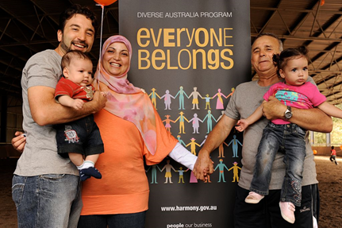
Wikimedia Commons. CC BY 2.0
- Source 2 – Navy officers and sailors from HMAS Watson march past the Martin Place Cenotaph in Sydney on Anzac Day, 25 April 2013
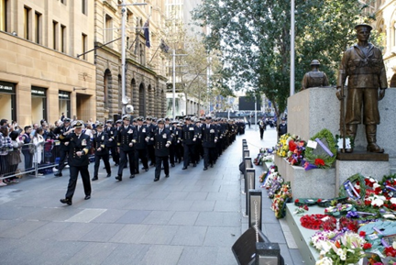
Australian Navy. © Commonwealth of Australia 2018
- Source 3 – NAIDOC Week celebration at Mosman Library, NSW, 2011
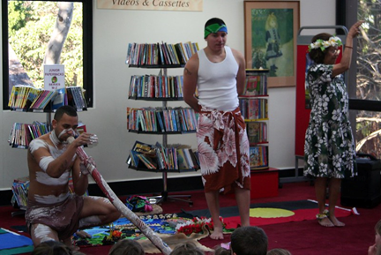
Mosman Library on Flickr. CC BY 2.0
Write
  - Answer questions:
    - What do you see, think and wonder about the photos?
    - What symbols do you recognise in the photographs that gives you a clue to what event is being celebrated or commemorated?
See-think-wonder prompts
Using the photographs students complete a see, think, wonder using the prompts below.
See
- What is in the photograph?
- How are the people in the photograph dressed?
- How do the people in the photograph look?
Think
- Where was the photograph taken? How do you know?
- When was the photograph taken?
- How do you know the photograph is of a celebration or commemoration?
Wonder
- What do you wonder about when examining the photograph?
See, think, wonder
See | Think | Wonder
Photo 1

Photo 2

Photo 3

Reflection
Think about what you have learnt in this activity. Use the two stars and a wish structure to guide your reflection.
Star  Something that went well! | Star  Something that went well! | Wish  A goal for next time…

Activity 2
Instruction
During this activity you will find out more about the significant days and weeks that are celebrated and commemorated in Australia and the symbols and emblems that are associated with them.
Resources – help from an adult
Draw – symbols and emblems
Write – answer questions
  - Draw as many symbols or emblems that you can in five minutes.
  - Symbols and emblems could include: the school logo, Australian and Aboriginal and Torres Strait Islander flags and coats of arms from states and Australia.
  - Answer these questions:
    - What are the significant days that are important to you? Why?
    - What is the difference between a celebration and a commemoration?
    - What are Australia’s important symbols and emblems?
    - Draw and label these symbols and emblems in your workbook

Reflection
Think about what you have learnt in this activity. Use the two stars and a wish structure to guide your reflection.
Star  Something that went well! | Star  Something that went well! | Wish  A goal for next time…

