HSIE: History S2 workbook
Name:
Class:

Overview
Stage 2 – Community and Remembrance
This topic provides a study of the Aboriginal identity and culture in the local area. This learning sequence consists of two short inquiries – connecting to Country and Aboriginal Dreaming stories.
Students investigate the importance of Country and Place to the local Aboriginal people. They identify Aboriginal languages spoken and learn about the special relationship Aboriginal people have with Country. Students explore Dreaming stories. They explore how Dreaming stories explain local connection to Country and respond to Dreaming stories that are presented to them using a variety of sources.
Key inquiry question:
• Who lived here first and how do we know?

Resources
- pens, pencils
- paper
- this workbook
- help from an adult

Activity 1
During this lesson you will:
- investigate the importance of Country and Place to the local Aboriginal people
- identify Aboriginal languages spoken and learn about the special relationship Aboriginal people have with Country.
Resources – pens, pencils, paper, student workbook
Brainstorm/think
When you think of the word Country what do you think of?
Write your responses
________________________________________________________________________________________________________________________________________________________________________________________________________________________________________________________________________________________________________________________________________________________________________
Look at source 2: Aboriginal languages in NSW map from the State Library of NSW, Indigenous Services.

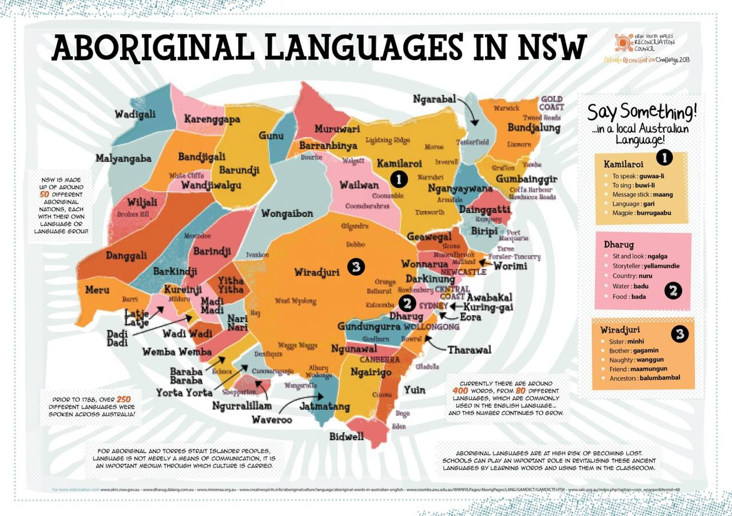https://indigenous-services-slnsw.tumblr.com/post/141124712404/nsw-aboriginal-language-map-language-means
Source 2: Aboriginal languages in NSW map
Aboriginal languages in NSW map from NSW Reconciliation Council which shows the different Aboriginal languages and countries in NSW.
Discussion: the word Country is special to Aboriginal people as it is the place that they are connected to through family. It also represents their connection to nature and land, Dreamtime ancestors and the Dreaming and language, culture, customs and responsibilities. Each Aboriginal Country has its own language, traditions, stories and special places.
Write
Questions:
After exploring the map, answer the questions:
• What do we know about connection to Country?
________________________________________________________________________________________________________________________________________________
• Why is connection to Country special for Aboriginal people?
________________________________________________________________________________________________________________________________________________________________________________________________________________________
• How do we know about connection to Country?
________________________________________________________________________________________________________________________________________________________________________________________________________________________

Activity 2
Read
Using an Aboriginal language map locate your local area and identify the local language group/s. An example of the resources you may be able to use include the campfire in the WilderQuest website or the map on the First languages website.
Observe
View the video Who we are: Country/Place (6:29min) from Reconciliation Australia. After viewing the video write words or sentences that describe what you think Country means to Aboriginal people. Why is it so important to them?
________________________________________________________________________________________________________________________________________________________________________________________________________________________________________________________________________________________________
Reflect/Think
Think of a place that is special to you. Share a personal story about a connection to a special place.
Draw
Create an artwork of your special place and share with other students online.

My special place
Reflect Collaborate
As a class reflect on the special relationship that Aboriginal people have with the land which is similar to the connection they have with their special place. This is part of their connection to Country.
Write Create/Make
Create a text to support connection to Country
Students to think about the following question: Why is connection to Country important to Aboriginal people?
Students create a short information text, video or animation to share their responses.
Make sure you include:
- identification of criteria that supports Connection to Country e.g. family, language, nature, and land, Dreamtime, ancestors and the Dreaming, culture, customs and responsibilities.
- unique belief systems
- spiritual connection to land, sea, sky
- Each Aboriginal Country has its own language, traditions, stories and special places
- Complexity of the relationship and responsibility they have with the land, sea, sky and waterways.

Activity 3
During this activity you will explore Dreaming stories.
Resources – pens, pencils, paper, student workbook
Read
Examine the Aboriginal artwork in source 6 – Aboriginal Art centrepiece Sydney 2000 Paralympic Games opening ceremony
- What do you see in the artwork?
- What does it make you think of?
- What do you wonder about?
- Brainstorm what the word Dreaming means.

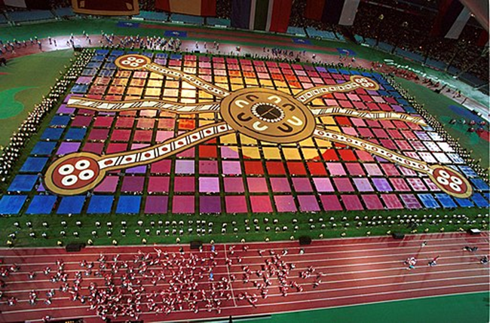Wikimedia Commons. CC BY-SA 3.0
Dreaming stories are told by Aboriginal people to teach a lesson or to explain something about how things were created.

Activity 4
Reflect
After viewing each story ask students what the stories are about, what they explain and why Aboriginal people share Dreaming stories.
Create Draw Compose Write
Students choose one of the Dreaming stories they have read or heard in a book, online or retold by a local Aboriginal person. Ask students to create a story map of the main events that happened in the story. Students use the story map to create a painting, digital animation, dance or role play to express the key messages in the story. Students present their artworks to the class explaining the meaning of the story they chose.
As a class recall the purpose of Dreaming stories, how they explain Aboriginal and Torres Strait Islander Peoples’ connection to Country and Place and why Aboriginal people tell Dreaming stories.

Reflection
Think about what you have learnt in this activity. Use the two stars and a wish structure to guide your reflection.
Star  Something that went well! | Star  Something that went well! | Wish  A goal for next time…

