Significance of time
This learning sequence comprises two short inquiries – language of time, and sequencing events.

Topic – Present and past family life
3 weeks – 90 minutes per week

Key inquiry questions
- How can we show that the present is different from or similar to the past?
- How can we describe the sequence of time?

Overview
In Inquiry 1, students use a photograph of a special family celebration to describe a past event and its significance. In Inquiry 2, students sequence the months of the year and plot significant dates by month on a yearly calendar. They use language that describes the passing of time when recounting past events.
Note – These inquiries have strong connections to the Time content in the Measurement and geometry strand in Mathematics K–10, and to the Weather and seasons content in the Features of places focus area in Geography K–10.

Outcomes
A student:
- HT1-1 communicates an understanding of change and continuity in family life using appropriate historical terms
- HT1-4 demonstrates skills of historical inquiry and communication

Content
How the present, past and future are signified by terms indicating time such as 'a long time ago', 'then and now', 'now and then', 'old and new', 'tomorrow', as well as by dates and changes that may have personal significance, such as birthdays, celebrations and seasons (ACHHK029)
Students:
- sequence days of the week, months and seasons of the year
- identify days, holidays, events celebrated by students and their families and discuss cultural differences in days celebrated
- define and use terms relating to time, sequencing objects or photographs from the past, eg then and now, past and present, a long time ago

Historical inquiry skills
Comprehension: chronology, terms and concepts
- discuss and recount stories of family and local history
- sequence familiar objects and events (ACHHS031, ACHHS047)
- distinguish between the past, present and future (ACHHS032, ACHHS048)
Use of sources
- explore and use a range of sources about the past (ACHHS034, ACHHS050)
- identify and compare features of objects from the past and present (ACHHS035, ACHHS051)
Perspectives
- explore a point of view within an historical context (ACHHS036, ACHHS052)
Empathetic understanding
- recognise that people in the local community may have lived differently in the past
Research
- pose questions about the past using sources provided (ACHHS033, ACHHS049)
Explanation and communication
- develop a narrative about the past (ACHHS037, ACHHS053)
- use a range of communication forms (oral, graphic, written, role play) and digital technologies. (ACHHS038, ACHHS054)

Selected historical concepts
Continuity and change – some things change over time and others remain the same, eg changes and similarities in family life over time; aspects in the local community that have changed or remained the same.
Perspectives – people from the past will have different views shaped by their experiences, eg different points of view about a significant person or site in the local area.
Significance – importance of an event, development or individual/group, eg the importance/significance of a local person or site and a personal or family event that has significance.

Assessment
All activities require students to demonstrate their learning. All are assessment for learning activities.

Vocabulary
Listen, observe, examine, identify, record, describe, sequence, compare, retell, conclude, explain, discuss, illustrate, write, describe, present, role play, reflect
Story, oral history, photograph, object, artefact, online collection, museum, reliable source, primary source, evidence
Now, then, tomorrow, day, date, week, month, season, holiday, event, cultural, differences, time, long time ago, old, new, past, present, time

Teaching and learning activities
This teaching framework comprises two inquiries.

Inquiry 1 – language of time
Students examine a variety of sources and use the terminology of the passing of time in their descriptions and explanations. They tell and listen to stories about objects special to themselves and listen to and retell oral histories of family stories. As a culminating activity, students produce items to add to a class time capsule for future generations.

Stimulus

Treasure box
Prepare a ‘treasure box’ containing a variety of old and new objects and photographs, ensuring some represent past special events. Present it to the students, pretending that its contents are a mystery. Contents could include the students’ kindergarten class photographs, readers from Kindergarten, photographs of school past events, recent photographs, old birthday cards, souvenirs, old and present-day toys and classroom resources. If school archives are available for use, the treasure box could be presented as a just-discovered time capsule that had been buried thirty years ago.
Sitting in a circle, students take turns to take each item out of the box. Students examine and identify each item and decide if it is from the past or the present. Model and encourage student use of terms that denote time and significance: 'a long time ago', 'then and now', 'old and new', 'past and present’, ‘special’, ‘important’, ‘significant’. Generate a word wall of the language and terms used.
Once all the items have been examined, students sequence the items from oldest to newest. During the sequencing, ask students how they are inferring the age of each item and how they could verify their inferences.

Historical inquiry step 1 – question
Generate a class set of inquiry questions, for example:
- What terms do we use to describe the passing of time?
- What words and terms do we use when recounting the past?
Note – Inquiry questions may need to be redesigned through the historical inquiry process.

Historical inquiry steps 2 and 3 – research and analyse

Language of remembering the past
Source 1 – Wilfrid Gordon McDonald Partridge by Mem Fox, illustrated by Julie Vivas, Puffin Books, England, 1984
Share a picture book about objects that trigger memories, such as Wilfrid Gordon McDonald Partridge in source 1. After the reading, add ‘remembered’, ‘long ago’ and ‘had’ to the word wall. Explain that Miss Nancy’s memories are an example of an oral history and that the objects Wilfrid brings help her to remember and recount her past.
Working in pairs, students take on role as Miss Nancy and Wilfrid Gordon. ‘Wilfrid’ enacts handing each ‘item’ to Miss Nancy who enacts holding it and verbalising the memory each triggers. Students change roles and repeat the exercise.

My special things
Students bring to school a toy or object used when they were younger, that is significant to them.
In small sharing circles, students explain the significance of their item, using language that denotes past uses and significance. Students draw or photograph the object and write sentences, or record a verbal explanation, which explains when they used it and its personal significance. These could be compiled into a digital or printed class book.
Reflect on how students know what items are special to other students and why they are special. (Objects and oral histories are primary sources of information.)

Aboriginal knowledge sharing
Source 2 – Shannon Foster Sydney based D'harawal Saltwater Knowledge Keeper and shell midden, Shannon Foster, YouTube. 3:53 min.
View the video in source 2 of Shannon Foster, D’harawal Saltwater Knowledge Keeper, explaining how her Aboriginal ancestors used a rock shelter in the past. Recall the evidence she shows and what each tells her: a midden, soot from cooking fires, and hand stencils.
Discuss how stories of the past are shared orally and through photographs, illustrations, writings, places and objects that have been kept over time.

Capture a family story
Source 3 – How to capture family stories, ABC Splash.
As an at-home activity, encourage students to have a conversation with an elderly family member to obtain a family story from the past, using one of the suggestions in source 3.
In small sharing circles, students re-tell the story to their peers. Alternatively, they write and illustrate, or verbally record, a re-telling of the story.

Historical inquiry step 4 – evaluate
Guide the students in recalling the sources used in finding out about the past: objects, photographs, oral history, picture books, physical remains of the past. Discuss the reliability of the sources. Do memories and stories of the past change over time? Why and how?

Historical inquiry step 5 – communicate

Class time capsule
What special items from school today could be placed into a time capsule and buried for future students to find? What are the best ways to communicate our stories of the present for future generations? What are the most significant items to include that will tell stories of the present?
Students each produce an item to add to a class time capsule. Items could include annotated photographs, labelled illustrations, written descriptions and everyday objects.

Reflection
Students reflect on what they learnt, how they learnt it and what else they would like to find out.

Inquiry 2 – sequencing events
Students compare their birthday and special family celebrations with those of other students. They sequence the months of the year and plot significant dates by month on a yearly calendar. Students sequence the seasons and briefly explore Aboriginal seasonal calendars. They use language that indicates time when recounting past events.

Stimulus

Special days
Source 4 – Children's birthday party at the home of Mrs Lucy Jane Moran, Todman Ave, Kensington, Sydney, 1930s
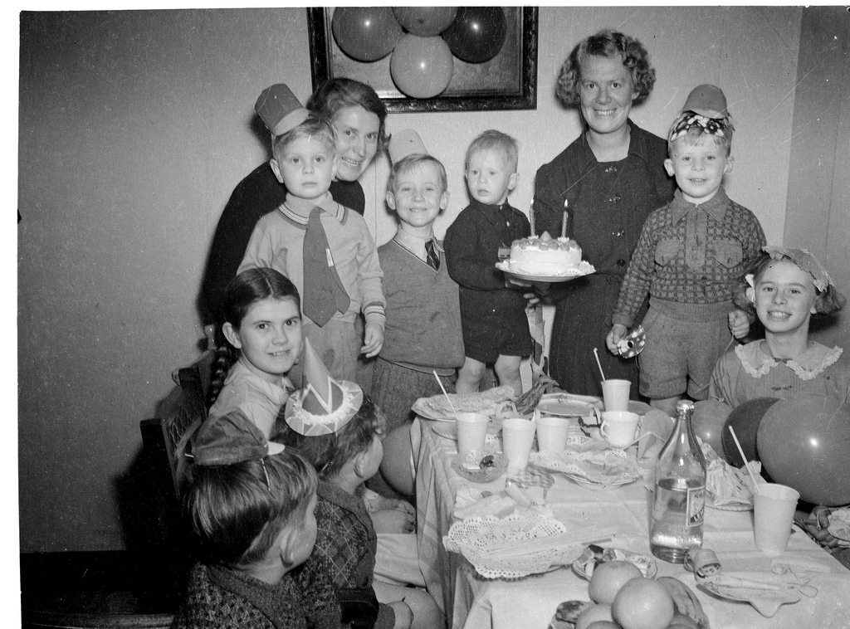
Photographer – Sam Hood. State Library of NSW on Flickr. No known copyright restrictions
Examine the photograph in source 4. Students use the See-Think-Wonder prompts to guide their observations.

See-Think-Wonder prompts
See
- Who is in the photograph?
- What are the children wearing?
- What objects are in the photograph?
- How many candles are on the cake?
Think
- What are the relationships of the people to each other?
- Whose birthday is it?
- Where was the photograph taken?
- Why was the photograph taken?
Wonder
- What do you wonder about when examining the photograph?

Planning special days
Students discuss how birthdays are celebrated in their families. They compare them to the birthday party in source 4. Discuss how people know when to plan for and celebrate birthdays and special events.

Historical inquiry step 1 – question
With reference to the discussions relating to source 4, develop a set of inquiry questions. For example:
- How do we convey time across a year?
- What special days and events do families celebrate?
- How do we know when special days or events occur?
- What are the differences in special days celebrated by families?
Note – Inquiry questions may need to be redesigned through the historical inquiry process.

Historical inquiry steps 2 and 3 – research and analyse

Birthday months
Students bring, or email, to school a photo of their last birthday celebration and/or another special celebration with their family. In small sharing circles, students share their photographs and describe the event. They compare their celebrations with the birthday party shown in source 4. Note: Be sensitive to cultural and religious differences in regard to the celebration of birthdays.
With guidance, students write the day and month of their birthday onto a card to hold. They arrange themselves into a line or circle in birth date order to create a physical timeline of their birthdays throughout a year. Each student takes turn to state his or her birth date and the age they will turn next birthday.
On a large class yearly calendar, such as one from source 5, each student adds his or her birth date. Also plot special events annually undertaken or commemorated at school and the community, for example, Chinese New Year, Harmony Day, Easter Parade, Anzac Day, Ramadan, Book Week, Christmas.
Source 5 – Birthday calendar template

Personal calendar
At home, students ask their parents or carers to write the dates of their main family celebrations and commemorations. At school, students plot the dates onto a personal yearly calendar, such as one from source 5. They add an illustration or symbol that represents each special day or event.
Working with a partner, students analyse both calendars. They explain the events using terms that denote the passing of time. Students then compare the events on their calendar with their partner’s calendar. Together they construct a ‘similar and different’ T-chart, or Venn diagram, to list the similarities and differences in the special days celebrated.
Students share with the class the differences listed on their charts. Ask students to explain the meaning of, and activities undertaken on, special days unfamiliar to other students. Discuss cultural differences in days celebrated by students’ families. Note: The focus is a discussion on cultural differences in days celebrated. Details of celebrations and commemorations are covered in Stage 2 History: Community and remembrance.

Seasonal calendars
List and sequence the seasons of the year and identify the months within each season. Add the seasons to the class calendar.
Explore some of the seasonal calendars developed by Aboriginal and Torres Strait Islander people shown in source 6. What environmental changes signify each season? View the representations of the Yawuru and Kaurna calendars in source 6 and the D’harawal calendar in source 7. Compare them to the class and personal monthly calendars created in the previous activities.
Note – This is intended as a brief overview only. Seasons are covered in greater depth in Stage 1 Geography Features of places.
Source 6 – Indigenous weather knowledge, Bureau of Meteorology
Source 7 – Weather cycles around Sydney from the Bodkin/Andrews clan of the D'harawal People

Historical inquiry step 4 – evaluate
Recall the main sources used in the activities. Are there limitations in the sources used? Do the inquiry questions need to be redesigned?

Historical inquiry step 5 – communicate

Digital album
Students create a digital album of three to five photographs of their birthday and other special family celebrations that occurred in the preceding year. Students sequence the photographs by the month of the event then use a digital storytelling app to create a slideshow with accompanying narration recounting each event. In their recounts, they use terms that indicate the past.

Reflection
Students reflect on what they learnt, how they found out and what else they would like to know.

Resources

Picture books
Wilfrid Gordon McDonald Partridge by Mem Fox and Julie Vivas (K-2)
Isabella's Bed by Alison Lester (PRC K-2)
Grandpa Green by Lane Smith (PRC 3-4)
Remembering Lionsville by Bronwyn Bancroft (PRC 3-4)
The Keeping Quilt by Patricia Polacco

Websites and resources
How times change, Education Services Australia
How to capture family stories, ABC Splash.
Guide to using picture books in History K–10, NSW Department of Education, 2017

Digital collections
Historical photo sets on Flickr, Powerhouse Museum
Historical photo sets on Flickr, State Library of NSW
Trove, National Library of Australia

