Local history
This learning sequence comprises two inquiries.

Topic – The past in the present
5 weeks – 90 minutes per week

Key inquiry questions
- What aspects of the past can you see today?
- What do they tell us?

Overview
This topic provides a study of local history. Students explore, recognise and appreciate the history of their local area by examining aspects of the past and considering what they tell us. This learning sequence comprises two inquiries – our school history and the local school in the past and the present. Students use a variety of sources to identify and describe the aspects of the past that they can see around the local school environment. Students investigate information about the local school in the past and present. They draw on their own investigations, that of the local older generations such as their parents and grandparents’, as well as other sources.

Outcomes
A student:
- HT1-2 identifies and describes significant people, events, places and sites in the local community over time
- HT1-4 demonstrates skills of historical inquiry and communication

Content
The history of a significant person, building, site or part of the natural environment in the local community and what it reveals about the past (ACHHK044)
Students:
- brainstorm what aspects of the past can be seen in the local area
- identify a significant person, building, site or part of the natural environment in the local community and discuss what they reveal about the past and why they are considered important
- investigate an aspect of local history
- develop a narrative on their chosen aspect of local history which focuses on the remains of the past.

Historical inquiry skills
Comprehension: chronology, terms and concepts
- discuss and recount stories of family and local history
- sequence familiar objects and events (ACHHS031, ACHHS047)
- distinguish between the past, present and future (ACHHS032, ACHHS048)
Use of sources
- explore and use a range of sources about the past (ACHHS034, ACHHS050)
- identify and compare features of objects from the past and present (ACHHS035, ACHHS051)
Perspectives
- explore a point of view within an historical context (ACHHS036, ACHHS052)
Empathetic understanding
- recognise that people in the local community may have lived differently in the past
Research
- pose questions about the past using sources provided (ACHHS033, ACHHS049)
Explanation and communication
- develop a narrative about the past (ACHHS037, ACHHS053)
- use a range of communication forms (oral, graphic, written, role play) and digital technologies. (ACHHS038, ACHHS054)

Selected historical concepts
Continuity and change – some things change over time and others remain the same, for example, changes and similarities in family life over time; aspects in the local community that have changed or remained the same.
Empathetic understanding – developing an understanding of another's views, life and decisions made, for example, how people lived in the past in the local community and decisions they made.
Significance – importance of an event, development or individual/group, for example, the importance/significance of a local person or site and a personal or family event that has significance.
Syllabus extracts are quoted from History K-10 Syllabus © 2012 NSW Education Standards Authority (NESA) for and on behalf of the Crown in right of the State of New South Wales.

Assessment
All activities require students to demonstrate their learning. All are assessment for learning activities.

Vocabulary
Ask, investigate, listen, explore, examine, identify, record, describe, sequence, compare, explain, discuss, illustrate, write, present
Oral history, photograph, object, artefact, site, reliable source, primary source, secondary source, point of view, evidence
People, place, building, community

Teaching and learning activities
This learning sequence comprises two inquiries.

Inquiry 1 – our school history
Students use a variety of sources to identify and describe the aspects of the past that they can see around the local school environment. They examine what the sources tell them about the past.

Stimulus
Discuss the terms ‘primary source’ and ‘secondary source’. A primary source is something that has been created or written during the time being investigated, for example, photographs, letters, objects, personal stories. A secondary source is an account that has been created after the time being investigated, for example, informative texts and picture books.
Examine the photograph of the school building in source 1. Discuss what students can see in the photograph. Ask students whether this an example of a primary or secondary source.
Examine the photograph of a plaque in source 2. Discuss what information can be found on the plaque. What different information can this source tell us compared to source 1? Ask students whether this an example of a primary or secondary source.
Explain to students that they are going to be using a range of sources to help them to find out about the past of the local school environment.
Source 1 – Belmont High School opening, 27 January 1953
Sam Hood, State Library of NSW. CC BY 4.0 (cropped)
Source 2 – Tumut Public School plaque to commemorate its opening

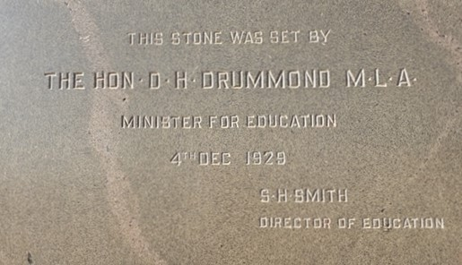
NSW Department of Education. No copyright restrictions

Historical inquiry step 1 – question
Following examination and comparison of sources 1 and 2, and guided by the syllabus dot points, generate a class set of inquiry questions, for example:
- What can we use to help us to learn about the past?
- What aspects of the past can be seen in our school? What do they tell us?
Note – inquiry questions may need to be redesigned through the historical inquiry process.

Historical inquiry steps 2 and 3 – research and analyse
Artefacts as sources of information
Ask students if they have heard of the term artefact. Brainstorm the meaning of the word artefact. Explain to students that an artefact is an example of a primary source. They help us to learn about things from the past. Artefacts are things made by humans in the past. An example of an artefact could be a building, object or place.
Artefact search around the school
Take students for a walk around the school to identify artefacts that provide information about the past. Before you go on the walk brainstorm what sort of artefacts may be found, for example, plaques, signs, old buildings and show some examples. On the search students record the artefacts they find by taking photographs or drawing.
As a class organise the photographs and drawings of the artefacts that were identified. Put them in order from the oldest to newest based on details of the artefact or previous research you may have completed.

Provide students with a school map and a list of the artefacts they identified on the first search. Students go on another walk around the school to identify the location of each of the artefacts. They should also record key words or information about each artefact as they will need to describe how each artefact tells them something about the past.
Ask students to choose an artefact they located on their map. In pairs students create a poster that includes a photograph or drawing as well as facts that the artefact tells them about the past. Create a display of the posters so that students can complete a gallery walk. One student from each pair stays with the poster to explain it as the class circulates to look at all of the posters. Students take turns standing with their poster so that each of them has the chance to visit the other groups’ posters. This provides a more interactive way of presenting and explaining information.
Complete a see-think-wonder. Ask students: What did you see during the artefact search? What did the artefacts make you think about? What do you wonder about what happened in the past at the school?

Historical inquiry step 4 – evaluate
Discuss the reliability of artefacts. What information might be missing? Do the inquiry questions need to be redesigned as a result of evaluating the sources?

Historical inquiry step 5 – communicate
School of the future
Students create an artwork of an imagined school of the future, whilst keeping some of the aspects of the past. Students present their artwork to the class and explain what aspects of the past they would keep in their school and why they would do this. Reflect on and discuss students’ schools of the future.
Reflection
Students reflect on the historical inquiry process, reflecting on what they learnt, how they learnt it and what else they would like to find out.

Inquiry 1 – the local school in the past and the present
Students investigate information about the local school in the past and present. They draw on their own investigations, that of the local older generations such as their parents and grandparents, as well as other sources.

Stimulus
Print Source 3 for students to examine.
Source 3 – Drummoyne Public School 1908 souvenir to commemorate opening of northern wing and assembly hall
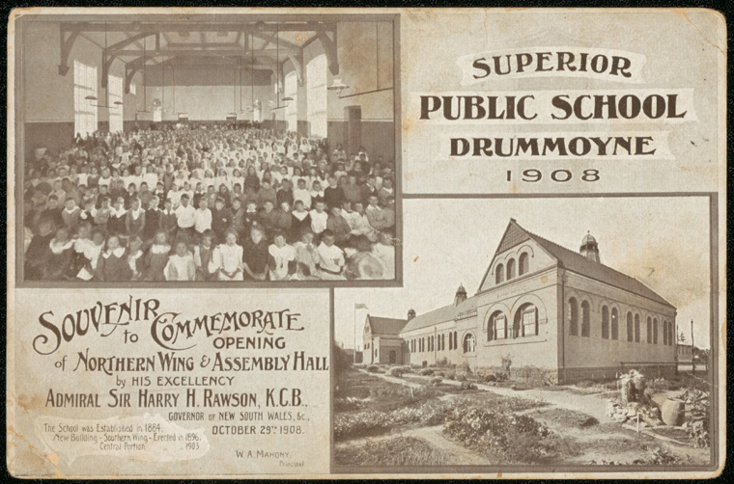
NSW State Archives and Records. CC BY 4.0
Students complete a see-think-wonder using the questions below to guide their examination.
See-think-wonder prompts
See
- Who is in the photograph?
- What is in the photograph?
Think
- Why was the photograph taken?
- Where was the photograph taken? How do you know?
- When was the photograph taken?
Wonder
- What do you wonder about when examining the photograph?

Historical inquiry step 1 – question
With reference to the discussions relating to source 3, develop a set of inquiry questions. For example:
- How can we find out about the past at the school?
- Who can tell us about the past? What can they tell us?
- Why are there similarities and differences between the past and the present?
Note – inquiry questions may need to be redesigned through the historical inquiry process.

Historical inquiry steps 2 and 3 – research and analyse
Discuss ways of finding answers to the inquiry questions, for example, primary sources such as photographs, objects and personal stories of parents or other community members (oral histories).
Guest presenters – oral history
Invite a previous principal, student or local historian to talk to the class about the history of the school. Ask them to show photos and relevant artefacts from the past to assist students to investigate how the school was similar and different in the past. Students listen and ask questions to clarify their understanding.
Using information obtained through the guest presenters students complete a quick write. Students are given ten minutes to describe how the school was similar and different in the past. Students share their description verbally.
Discuss the reliability of oral histories. Were the experiences of each guest presenter similar or different? Why should we listen to more than one oral history?
Past and present photo sorting
Find historic photographs of your school site. The NSW Department of Education photographic collection may help you find images of your school. Using the photographs of the original school buildings and a matching contemporary set taken now, students sort the images into past and present. They either use printed or digital photographs. Discuss what the photographs tell us about the past.
Comparing the past and the present
Using photographs from the previous activity students compare one contemporary school photograph to one showing the same image of the school from a past generation. They discuss the similarities and differences with a partner. Students then create a Venn diagram to explore the similarities and differences of the school from the past and present.

Historical inquiry step 4 – evaluate
Discuss the reliability of photographs and oral histories. Were there inconsistencies between the sources? Do the inquiry questions need to be redesigned as a result of analysing and evaluating sources?

Historical inquiry step 5 – communicate
Schools of the past
Students imagine their first day at school in the past. They write a narrative that describes the buildings, playgrounds and classrooms. Students use information provided by the guest presenters and the historic photographs of the school as stimulus to write their narrative.
Reflection
Students reflect on the historical inquiry process, reflecting on what they learnt, how they learnt it and what else they would like to find out.

Resources
Teacher resource
Guide to using picture books in History K–10, NSW Department of Education, 2017
Digital collections
NSW Department of Education photographic collection, NSW State Archives and Records
Historical photo sets on Flickr, State Library of NSW.
Trove, National Library of Australia

