Personal and family histories
HSIE history student workbook ES1
Name:
Class:

Overview
Early Stage 1 – Personal and family histories
You will:
- share stories of past celebrations and how you celebrate special events.
- use a variety of sources including stories, photographs and personal artefacts to investigate how stories can be communicated, how stories can differ depending on who is telling them and to identify and record information about significant events.

Resources

Activity 1
- help from an adult
lead pencils, coloured pencils
paper
- Photograph – Source 1: Children’s birthday party at home of Mrs Lucy Jane Moran 1930s, Sam Hood, circa 1930. State Library of New South Wales on Flickr.
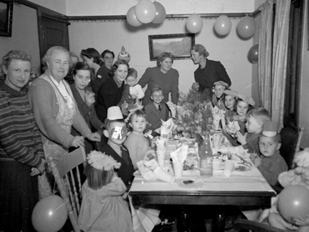

Activity 2
- help from an adult
- lead pencils, coloured pencils
paper

Activity 1
Sharing stories of past celebrations
During this activity you will share stories of past celebrations. People use photographs to remember events that happened in the past. Not all stories are written down but are remembered by passing on stories using photographs.
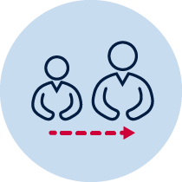Adult support
Resources – colour pencils, paper, photograph (Source 1)
This is a photograph from the early 1900s of a children’s birthday party.
Observe the photograph of the birthday party. What do you think is happening in the photograph?
Discuss
- Ask students:
  - What do you think is happening in the photograph?
  - How many people can you see?
  - Who do you think is in the photograph?
  - Where do you think they are?
  - When do you think this photograph was taken?
  - How is this birthday celebration of the past different to a birthday celebration today?
- Students will have varying ideas about what is happening in the photograph. With a parent or carer discuss how stories can change as they are passed on from person to person as they might have a different memory or point of view of the celebration.
Draw
- Draw a picture of a birthday celebration you went to (it may be your own) and discuss the similarities and differences to the birthday celebration in the photo.

A birthday celebration I have been to

Birthday celebration in the photograph 1930

Reflection
Think about what you have learnt in this activity. Use the two stars and a wish structure to guide your reflection.
Star  Something that went well! | Star  Something that went well! | Wish  A goal for next time…

Activity 2
Celebrating special events
During this activity you will share how you and your family and friends commemorate past events that are important to you. You will share experiences of family, school, and local events that are celebrated or observed.
Adult support
Resources – help from an adult, lead pencils, colour pencils, paper
Discuss the questions:
      - What special events does my family celebrate?
      - How does my family celebrate special events?
      - How do other families celebrate special events?
      - What are some special events that are celebrated in Australia and other countries?
      - Why are these events considered significant?
Draw and label at least 5 special events that you share with your family. Include a family, school and local event. Consider the significance of these events and dates.

Event 1:

Event 2:

Event 3:

Event 4:

Event 5:

Reflection
Think about what you have learnt in this activity. Use the two stars and a wish structure to guide your reflection.

Star  Something that went well! | Star  Something that went well! | Wish  A goal for next time…

Parent/carer advice
These activities require students to use a range of primary and secondary information sources. Assistance may be required to interpret and analyse primary and secondary sources of information and some language used in these resources. Parents can talk to their children about how they commemorate past events that are important to them. They can discuss how the stories of families and the past can be communicated, for example, through photographs, artefacts, books, oral histories, digital media and museums. Students are required to compose written work as part of these activities. Parents may need to provide support in drafting, proof-reading and editing.

