Personal and family histories 3
HSIE – history Early Stage 1 student workbook
Name:
Class:

Overview
Personal and family histories provides students with the opportunity to learn about their own history and that of their family; including stories from a range of other cultures and other parts of the world. As participants in their own history, students build on their knowledge and understanding of how the past is different to the present. Students use a variety of sources, including personal family photographs and written and oral stories, to investigate their family history and the different structures of families in their class.
Key inquiry questions:
What is my history and how do I know?
What stories do other people tell me about the past?
How can stories of the past be told and shared?

Resources
- pens, pencils
- paper
- this workbook
- photograph of family or friend’s experience or event
- school class photograph
- help from an adult

Activity 1
During this activity students are learning to:
- use a variety of sources including photographs or a treasured object from their homes, to recount stories about their families and discuss how sources are used to answer the question 'How do we know?'
- discuss then and now; past and present.
- share experiences of family, school and local events that are celebrated or observed.
Note – the definition of ‘family’ varies for each student. Be sensitive to the social and cultural backgrounds of the students and their concept of their family. In particular, be aware of the family structures and kinship system in Aboriginal and Torres Strait Islander families.
Resources – pens, pencils, paper, student workbook
Instructions
Students will need parent/carer guidance to support this learning sequence and historical inquiry process.
Discussion: What are some shared experiences with family and friends?
Brainstorm/think Observe

Source 1
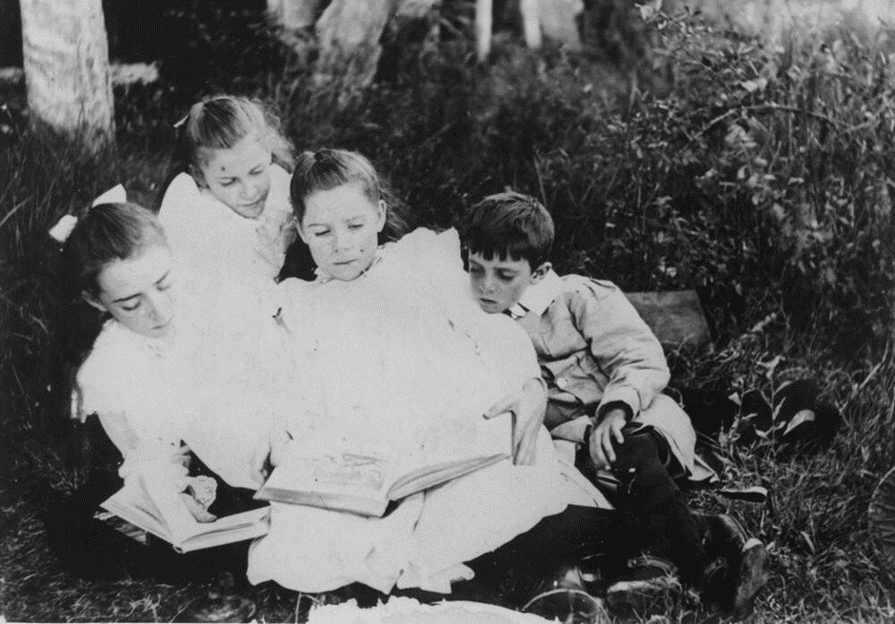
https://commons.wikimedia.org/wiki/File:Group_of_children_sitting_on_the_grass_reading_books,_1900-1910_(6752326963).jpg
State Library of Queensland Out of copyright
Discuss
Discussion: What are some shared experiences with family and friends?
Students look and examine the photograph from the early 1900s of a group of children sitting on grass reading some books.
With parent/carer support answer these questions:
- How many people can you see?
- Who is in the photograph?
- What do you think they are doing?
- How do you think they feel?
Draw and discuss
Source 2: student’s own personal photograph of a shared experience
Think of a shared experience with your family and a shared experience with your friends. Draw an illustration of these shared experiences and answer the questions below.

My shared experience with my family

With parent/carer support answer these questions:
- Who did you share this experience with?
- Where were you when you shared this experience?
- When did the experience happen?
- What were you doing? Why?
- Was it a happy/sad/annoying/scary experience? Why?
Draw and discuss

My shared experience with friends

With parent/carer support answer these questions:
- Who did you share this experience with?
- Where were you when you shared this experience?
- When did the experience happen?
- What were you doing? Why?
- Was it a happy/sad/annoying/scary experience? Why?

Activity 2
During this activity students are learning to:
- identify how the stories of families and the past can be communicated, for example through photographs, artefacts, books, oral histories, digital media and museums
- use a variety of sources including photographs or a treasured object from their homes, to recount stories about their families and discuss how sources are used to answer the question 'How do we know?'
- discuss then and now; past and present
- share experiences of family, school and local events that are celebrated or observed.
Resources – pens, pencils, paper, student workbook
Instructions
Students will need parent/carer guidance to support this learning sequence and historical inquiry process.
Observe Discuss

Source 3 – Description: School portrait of Kobble Creek State School, Queensland, 1914. The students are arranged in three rows with some younger boys sitting on the ground in front.
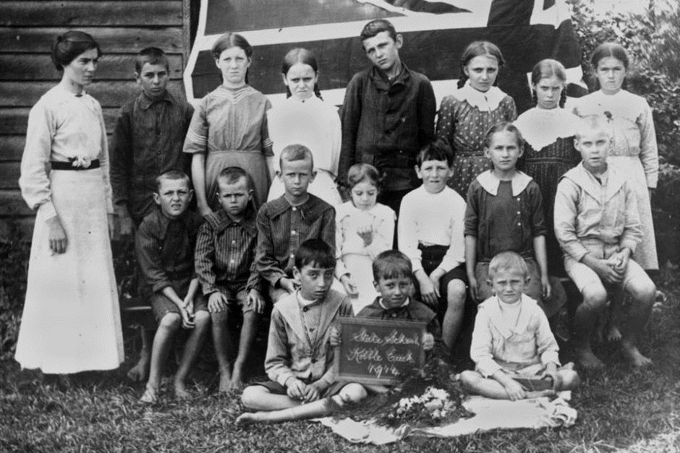
State Library of Queensland - Kobble Creek State School 1914
Source 4 – Description: Students from Bexley Public School, Class 2A, 1940
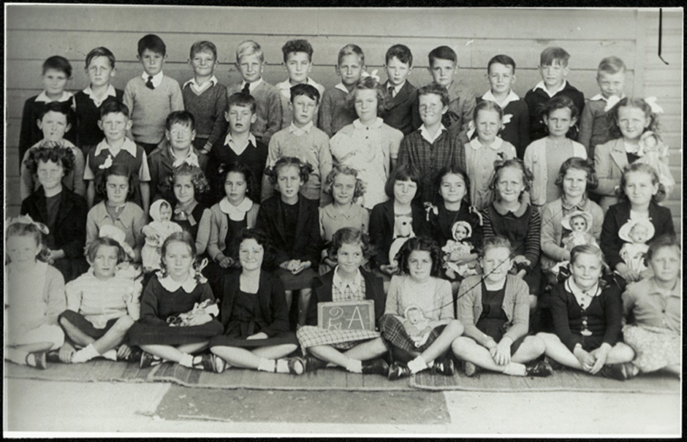
https://www.records.nsw.gov.au/image/15051_a047_001186

Parent/carer support
Discuss
Students discuss the terms ‘similar’ and ‘different’.
Using sources 3 and 4, students examine the two photographs of schools from the past.
Students discuss what they think is happening in the two photographs for example, annual school or class photo day.
Does this event still take place in your school today, in the present? Why or why not?
Students examine the photograph in source 3 and make comparisons to source 4.
How are the schools/classes different?
How are the schools/classes similar?
For example:
- the number of adults and children in each photograph
- what the children are wearing
- what the adults are wearing

Observe Discuss
Source 5: Students supply their own personal class photograph.
Students are asked to find a recent school class photograph and compare their school photograph with the school photographs in source 3 and 4.
After observing the photographs, in source 3 and 4, discuss these inquiry questions, for example:
- What can make schools similar or different?
- How is my class and school similar to the schools/classes in the photographs?
- How is my class and school different to the class and school in the photographs?
- What would I like to learn about the students and teachers from the past in the photographs that is different to mine?

Write

Opportunity for monitoring student learning
The families in our class
Create a picture that represents your school. You could create your school picture using digital technology, make a collage or draw a picture to portray this information.
You will share your school illustration on your class on-line platform or in a space in your classroom.
Observe Discuss Draw
Students examine the photographs of schools in sources 3 and 4 and make comparisons to their own class photograph (source 5).
Use the see-think-wonder prompts below to identify the similarities and difference between the three schools in the three sources and to guide their examination.
See-think-wonder prompts
See
- Who is in the picture?
- How many people are in the picture?
- What is something that is similar to your school/class?
- What is something that is different to your school/class?
Think
- What are the ages of the people in the picture?
- What are the relationships of the people to each other?
Wonder
- What do you wonder about the children and adults in the picture? Come up with a question that you would like to ask a student or adult to learn something about their experiences.
School photograph narratives
Using a school photograph from the past, students create either a written or oral story. The story takes the viewpoint of one person in the portrait to describe what is happening in the photograph, what event is taking place, who the members of their class are and how they are related. An adult may like to record the child’s story or assist them to write a simple sentence and draw a picture below.

School photograph narrative – draw a picture

Reflection
Think about what you have learnt in this activity. Use the two stars and a wish structure to guide your reflection.
Star  Something that went well! | Star  Something that went well! | Wish  A goal for next time…

