HSIE: History ES1 workbook
Name:
Class:

Overview
ES1 Stage – Personal and Family Histories
Personal and family histories provides students with the opportunity to learn about their own history and that of their family; including stories from a range of other cultures and other parts of the world. As participants in their own history, students build on their knowledge and understanding of how the past is different to the present. Students use a variety of sources, including personal family photographs and written and oral stories, to investigate their family history and the different structures of families in their class.

Key inquiry questions:
• What is my history and how do I know?
• What stories do other people tell me about the past?

Resources
- pens, pencils
- paper
- this workbook
- photograph of family
- help from an adult

Activity 1
During this activity students are learning to:
- identify people in their immediate families and show relationships between family members
- discuss where members of their families were born and locate countries of origin of students' families in the class
- use a variety of sources including photographs or a treasured object from their homes, to recount stories about their families and discuss how sources are used to answer the question 'How do we know?'
- discuss then and now; past and present.
Note – the definition of ‘family’ varies for each student. Be sensitive to the social and cultural backgrounds of the students and their concept of their family. In particular, be aware of the family structures and kinship system in Aboriginal and Torres Strait Islander families.
Resources – pens, pencils, paper, student workbook
Instructions
Students will need parent/carer guidance to support this learning sequence and historical inquiry process.
Discuss the term ‘family’.
Brainstorm/think Observe
Source 1 – Portrait of a family group of eleven people, Albert Jones, 1910-1918
Albert Jones views of the Diamond Creek and Hurstbridge areas
State Library of Victoria. Out of copyright
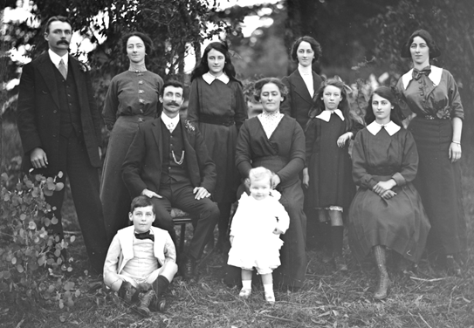
Discuss
Students look at the photograph from the early 1900s of a family of eleven. With parent/carer support answer these questions.
How many people can you see?
Who is in the photograph and what role do you think they play?
What is different and similar about this family in the past to families now?
Identify the key ideas about what makes a family.
Draw
Students create a drawing of their family and label each member.
They explain who the members of their family are and how they are related to each other.

My family
Discuss
After observing the photograph in source 1, and completing the picture of your family, answer the following questions. Have a discussion with your parents/carers or through your school’s online platform.
- Who are the members of my family and how are we related?
- How can I find out about where members of my family were born?
- Where does my family come from?
- How can I learn more about my past?
Read Write
Family photograph narratives
Using a family photograph from the past, students create either a written or oral story. The story takes the viewpoint of one person in the portrait to describe what is happening in the photograph, who the members of their family are and how they are related. An adult may like to record the child’s story or assist them to write a simple sentence and draw a picture below.

My Family Photograph Story
_______________________________________________
_______________________________________________
_______________________________________________
______________________________________________

_______________________________________________

Activity 2
During this activity students are learning to:
- Identify and record similarities and differences between families, e.g. the number of children in the family, family languages spoken at home, number of adults in the immediate family
- Compare and contrast various family groups through photographs and stories and identify differences between past and present.
Resources – pens, pencils, paper, student workbook
Observe Discuss
Source 2 – Family photograph taken on 1 January 1940
Northern Territory Library. Public domain
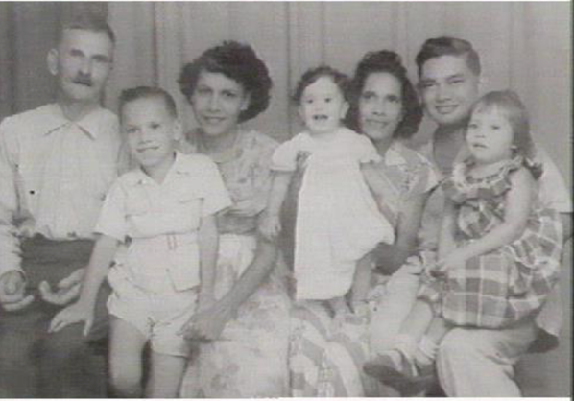
Source 3 – Family Christmas party, 2015
Flickr. Public domain
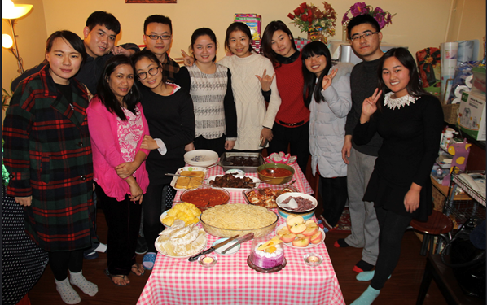
Discuss
Students discuss the terms ‘similar’ and ‘different’.
Students examine the photograph of a family in source 2. Discuss the possible relationships between the family members.
Students examine the photograph in source 3 and make comparisons to source 2.
How are the families different?
How are the families similar?
For example, the number of adults or children or the members of the family.
Observe Discuss
After observing the photographs, in source 2 and 3, discuss these inquiry questions, for example:
- What can make families similar or different?
- How is my family similar to my classmates?
- How is my family different to my classmates?
- What would I like to learn about a family that is different to mine?
Write

Opportunity for monitoring student learning
The families in our class
Create a picture that represents your family. You could create your family picture using digital technology, make a collage or draw a picture to portray this information.
You will share your family illustration on your class on-line platform or in a space in your classroom.
Observe Discuss
Observe all the different families that exist in your class.
Choose one family of a classmate to use a see-think-wonder strategy to identify the similarities and difference between the two families. Use the See, Think, Wonder prompts below to guide your examination.
See-think-wonder prompts
See
- Who is in the picture?
- How many people are in the picture?
- What is something that is similar to your family?
- What is something that is different to your family?
Think
- What are the ages of the people in the picture?
- What are the relationships of the people to each other?
Wonder
- What do you wonder about the family in the picture? Come up with a question that you would like to ask your classmate to learn something about their family.

Reflection
Think about what you have learnt in this activity. Use the two stars and a wish structure to guide your reflection.
Star  Something that went well! | Star  Something that went well! | Wish  A goal for next time…

