Mycenaean Weaponry Fresco Resource
Below are examples of Mycenaean weaponry frescoes. However, the teacher may go online and find other examples that they feel are more suitable or relevant to the topic.

Mycenaean Shield Fresco
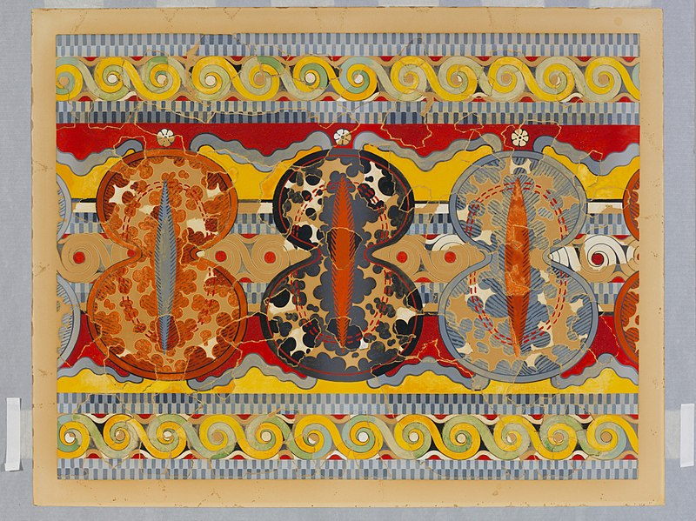
Reproduction of the "Shield frieze" fresco, metmuseum.org/, (CC0 1.0)

Tiryns chariot fresco
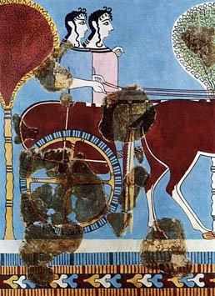
Fresco of two female charioteers from Tiryns 1200 BC, public domain

Pylos fresco

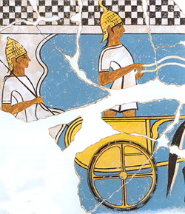
Two Mycenaean chariot warriors on a fresco from Pylos about 1350 BC, Public domain

