Tension image
Figure 1 Base jumper
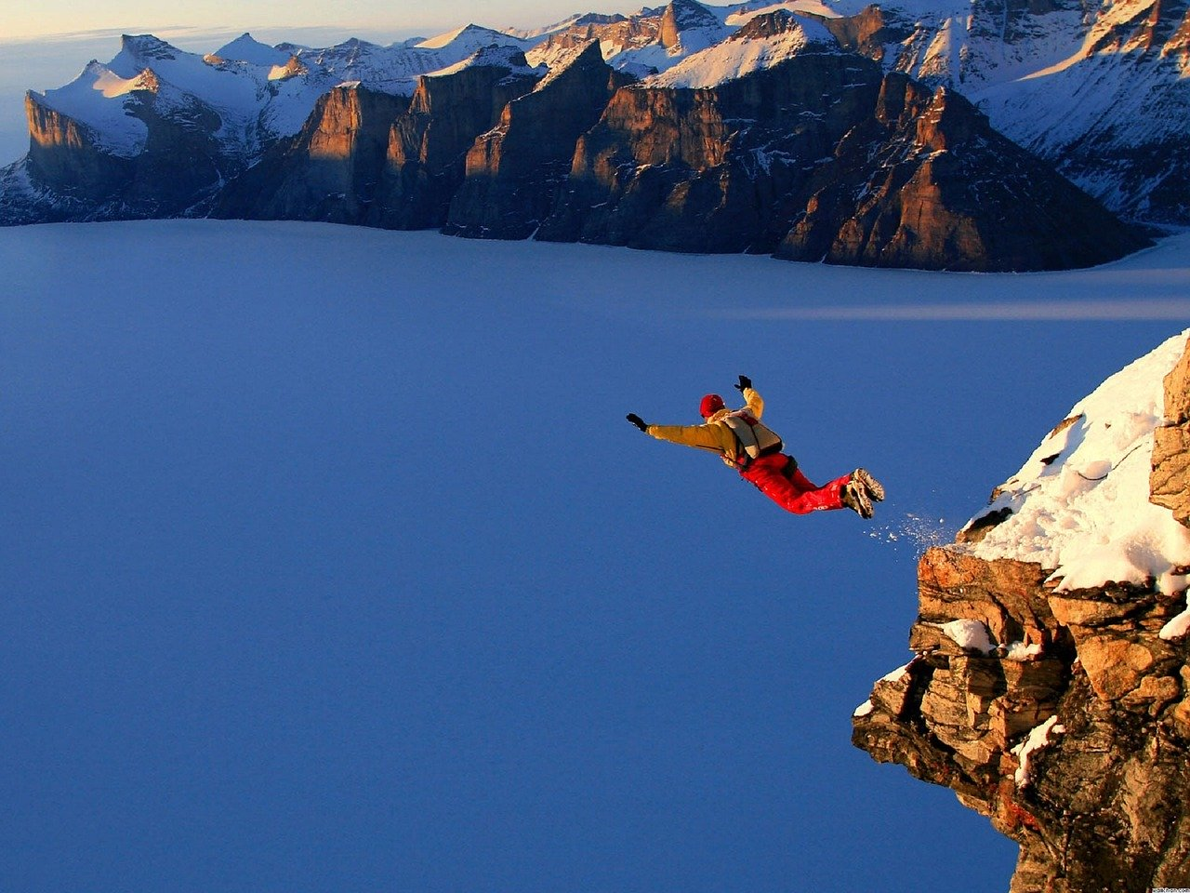
Image from pixabay

