Swap roles – images to describe
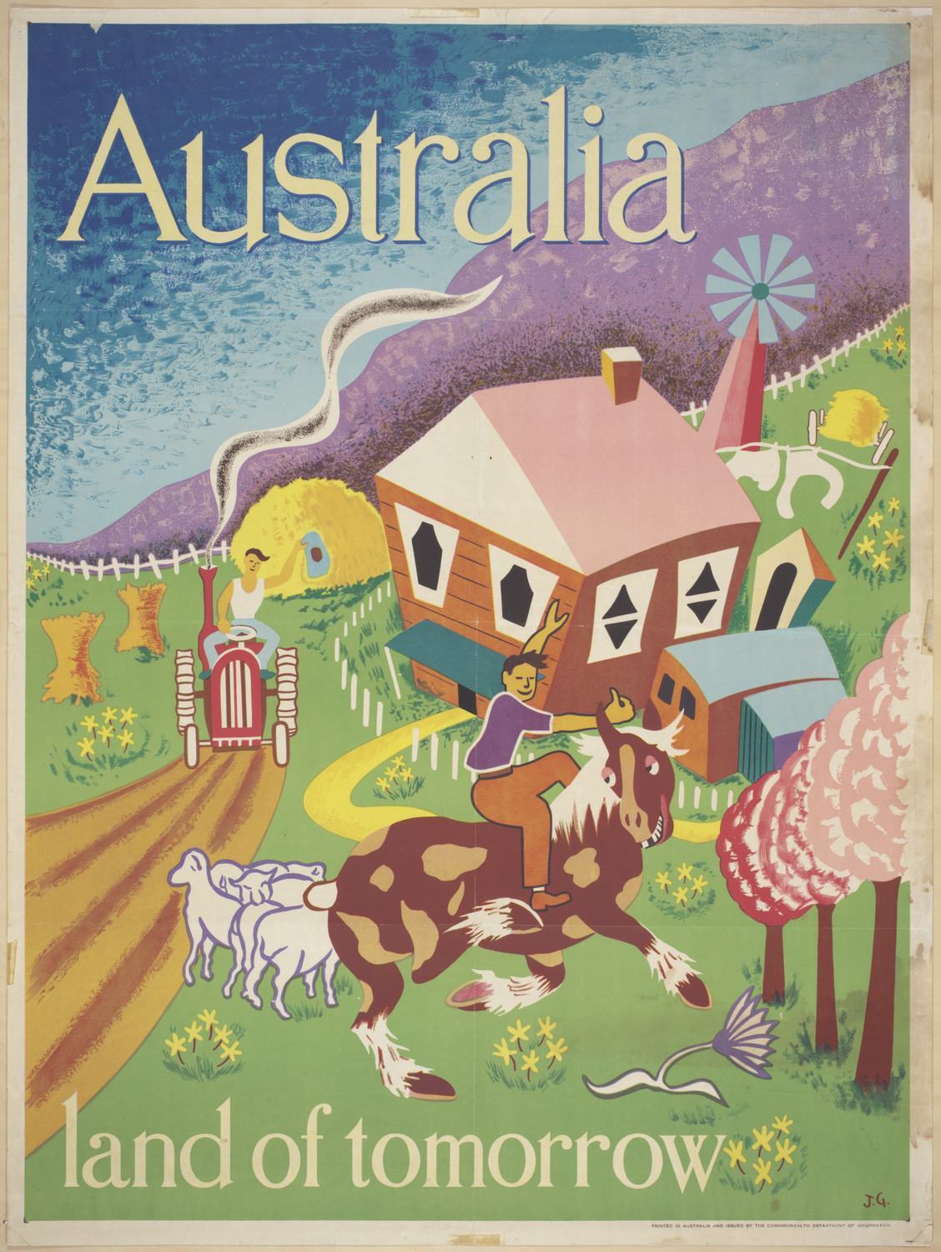
Poster - Australia Land of Tomorrow, Department of Immigration, circa 1948 from Museum of Victoria is licensed under CC BY 4.0.
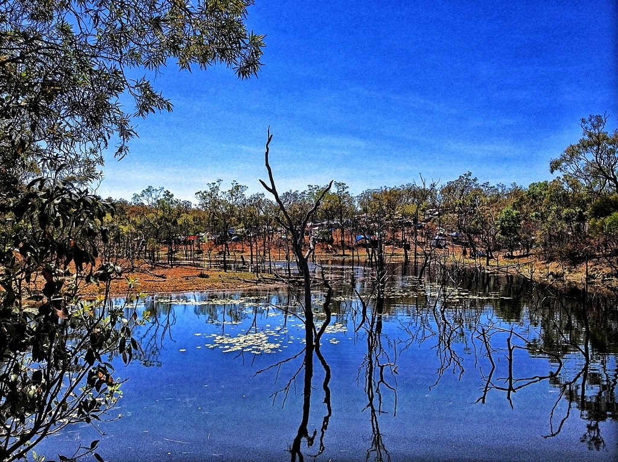
Eclips festival Cairns Australia by julia.chapple is licensed under CC BY 2.0

