Creative arts workbook S3
Name:
Class:

Overview
You will learn about the role of connotation, imagery and symbol in helping us learn more about the creative arts. These concepts help us to create meaning in songs and artworks.

Resources

Lesson 1
- ‘Dylaby’ – Robert Rauschenberg https://www.artgallery.nsw.gov.au/education/exhibition-kits/pop-to-popism/future-is-now/
- ‘The first real target’ – Peter Blake https://www.artgallery.nsw.gov.au/education/childrens-trails/pop-popism/first-real-target/
- ‘Football players’ – Konrad Lueg https://www.artgallery.nsw.gov.au/education/childrens-trails/pop-popism/football-players/
- ‘Triple fronted’ – Howard Arkley https://www.artgallery.nsw.gov.au/education/childrens-trails/pop-popism/triple-fronted/
- Information about the works of Marcel Duchamp https://www.artgallery.nsw.gov.au/exhibitions/essential-duchamp/
- Paintbrush
- Container of water
- Paver, plastic lid or cardboard
- Paper clay, airdrying clay, playdough, dough or blutak

Lesson 2
- ‘Solid rock’ by Street Warriors
https://safeyoutube.net/w/myDF
- James Ledger’s ‘Indian Pacific’
https://vimeo.com/190670376
- ‘Water walk’ by John Cage
https://safeyoutube.net/w/h6DF
‘4:33’ by John Cage
https://safeyoutube.net/w/d9DF
- A variety of household objects or instruments (if available)
- ‘The Typewriter’ by Leroy Anderson
https://safeyoutube.net/w/jTDF
- Ballet of the chicks in the shells’ by Mussorgsky
https://safeyoutube.net/w/qpwF
- Arnold Schoenberg’s ‘Three Piano Pieces’
https://safeyoutube.net/w/ieEF
- Kandinsky’s ‘Impressions III’
https://www.google.com/url?q=https%3A%2F%2Fwww.wikiart.org%2Fen%2Fwassily-kandinsky%2Fimpression-iii-concert-1911&sa=D&sntz=1&usg=AFQjCNG5_XLoiWfsf2bnstvNylfWdNDVxg
- Bach Concerto for oboe and violin, 2nd movement BWV1060R while viewing the computer animation by Stephen Malinowski
https://safeYouTube.net/w/PkEF
- SYN-Phon’ by Candas Sisman
https://csismn.com/SYN-Phon
- Chrome Music Lab
https://musiclab.chromeexperiments.com/Experiments

Lesson 1
Connotation, imagery and symbol in visual arts.
Resources
- Artworks as indicated above (your teacher may have downloaded and printed them)
- Paintbrush
- Container of water
- Paver, plastic lid or cardboard
- Paper clay, airdrying clay, playdough, dough or blutak
- Paints of different colours.

Acknowledgement of Country
Discuss with your class or household about how Aboriginal people in Australia are the original owners of the land in your community. They have looked after this land for a long time and we all have the responsibility to continue this practice.

Reflect and make symbolic art
Go outside to a special place within your school or local environment. Where possible take a plastic surface, some cardboard, a paver or alternatively find some concrete or into a tiled or paved area. Take some water in a container and a paintbrush.
Look around at the environment in silence. Find something important about the environment – either natural or man-made.
Create a quick symbol of something in this environment that is important to you. Take a photo for your teacher to look at. Once it has vanished, repeat with another symbol and take a photograph. Your teacher may want to check you can show a symbol through your artwork. You can put your photos on the page below or alternatively draw them onto the page instead.
Here is an example to look at. It is a symbol (umbrella) of a wet area:
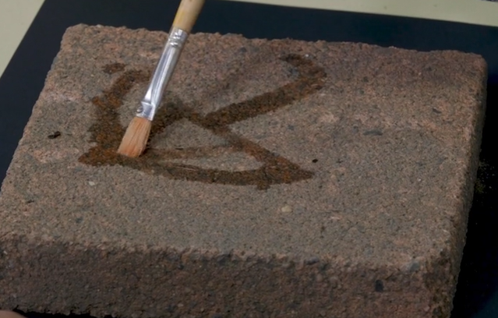

Your symbol of Australia
Think again your environment and consider an item that may be available to gather that symbolises Australia to you. Remember if you take something from nature such as shells from the beach, it must be returned once your artwork is complete.
Create a symbolic sculpture artwork and photograph it. For example, this may include leaves, shells or flowers and may also include cultural symbols important to your community or how you feel about Australia.
In the example below, a sculpture was created about a classic Australian symbol, the gum leaf, and was made from paper clay. Airdry clay is also a good alternative which can be handmade. Otherwise, use playdough, dough or blutak without painting it. Take a photo of your sculpture to share with your class. You can put your photo on the page below. Alternatively take the sculpture in to school or draw what you made.
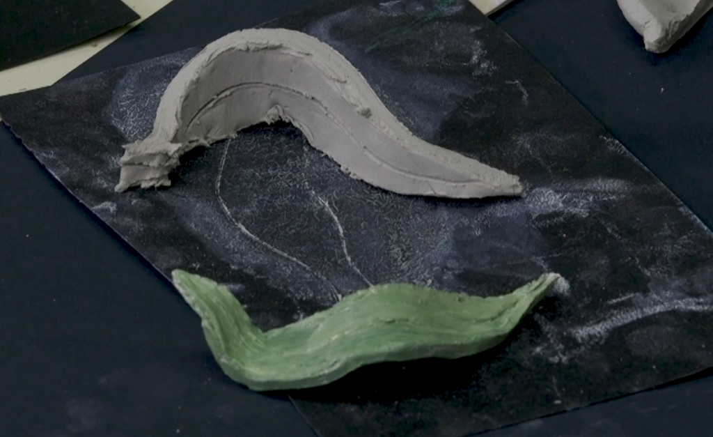

Blank page for your photographs

Look at some art
Artists represent ideas and meanings of their world through their artworks just like you did in your own symbolic works. Artists have been doing this throughout history.
Your teacher may have included these works for you as below from the Art Gallery of NSW:
- 'Dylaby’ by Robert Rauschenberg
- 'The first real target’ by Peter Blake
- 'Football players’ by Konrad Lueg
- 'Triple fronted’ by Howard Arkley
- a work by Duchamp.

Write about this art
Complete the information in the table below for 2-3 artworks you like or that your teacher suggests. This will show your understanding of the meaning of the artworks. Some have been done for you.
Artwork title and artist | What is its hidden meaning about culture or country? | How does it tell us that?
‘Dylaby’ by Robert Rauschenberg | The gap between life and art shouldn’t be huge. Art and real life should be together. Art is part of life. | Everyday objects presented artistically and with other artmaking practices.
‘The first real target’ by Peter Blake | Art can be about everyday objects.
‘Football players’ by Konrad Lueg
‘Triple fronted’ by Howard Arkley
A work by Duchamp

Lesson 2
Connotation, imagery and symbol in music and visual arts.
Resources
- Music and image links as indicated above
- Art paper and paintbrushes of a variety of tip sizes
- Watercolour paints, pencils or paints in pastel colours.
Learn about some music
Composers often use music to engage their audience and evoke particular feelings. There are several ways that this can be done either through words or through the way the instruments sound (their ‘tone colour’) and the music they play.
Listen to each piece (or a section of it) and complete the parts of the table below that your teacher suggests.
- Listen to ‘Solid rock’ by the Street Warriors.
  - What is this song telling you about?
  - What is the relationship to Aboriginal and Torres Strait Islander connection to the land?
  - What does the tone colour of the piece sound like?
  - How does the piece make you feel?
  - What does the clothing change represent?
  - How is colour used in the video clip?
  - How does this piece engage and inform the audience?
- Watch a video clip of John Cage’s ‘Water walk’ and ‘4:33’. How does the composer use his ‘instruments’? Through these pieces what is Cage trying to tell us about music?
- Listen to the ‘Typewriter’ by Leroy Anderson. What does the typewriter do to the rhythm?
- Listen to some of James Ledger’s ‘Indian Pacific’. This piece sounds like the journey of a train across the country. Close your eyes, keep the beat and imagine you are on the train looking out the window. How does the strong beat and rhythm make you feel?
- Listen to ‘Ballet of the chicks in the shells’ by Mussorgsky. Mussorgsky was trying to imitate chickens hatching, pecking at food and trying to fly. What do you hear in the music that gives you that mental image?

Table for you to write about what you hear.
Title of piece and composer | Musical concepts used and what are they trying to tell us symbolically?
‘Solid rock’ by the Street Warriors

‘Water walk’ and ‘4:33’ by John Cage
‘Typewriter’ by Leroy Anderson

‘Indian Pacific’ by James Ledger

‘Ballet of the chicks in the shells’ by Mussorgsky.

Think about and make sounds
Close your eyes and think of some sounds you can hear. How could you imitate that sound?
Some ideas might be:
- a whistle for a bird
- a glass like the wind
- hitting something strongly with your hands like a storm
- a paint brush on a table like sand or water
- a book slamming like thunder
- tissue coming out of a box like brushing your hair
- clicking a ring pull like a frog and so on.
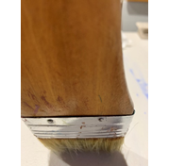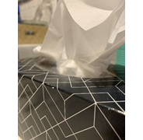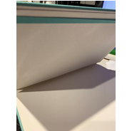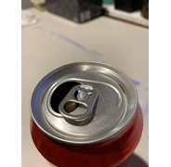
What sound is that?
Choose some of your favourite sounds and how you will represent it with an object. Think of a symbol you could use to represent that sound if you wanted to play it later on and needed to remember how it went. Write them down below:
Sound | Symbol

Look at the ’sounds’ of art
Artworks are sometimes inspired by pieces of music. Sometimes musicians get meaning from artworks and other times artists make artworks based upon what they hear in a composition.
In 1911 painter Wassily Kandinsky heard a concert that featured composer Arnold Schoenberg’s ‘Three Piano Pieces’. That night he went home and immediately sketched ‘Impressions III’.
In this painting the large black blob looks like a piano and we can roughly make out the shapes of the audience. They don’t look like you would imagine if you took a photograph. They are ‘abstract’ representations that are symbolic.
Think and write about art
Listen to the Bach ‘Concerto for Oboe and Violin’, 2nd movement BWV1060R while viewing the computer animation by Stephen Malinowski. This artwork is a computer animation of a piece by Johann Sebastian (J.S.) Bach, the ‘Concerto for Oboe and Violin’.
The artist shows the music from left to right using symbols to represent different things in the music. The notes of short durations are represented with diamonds. Lines show notes that have longer durations and are more like songs. Vertically, higher notes are up on the screen and lower notes are lower. Each instrument has its own line and colour. Rests (no sound on the beat) are represented with a faint red line when the violin is not playing at the beginning.
‘SYN-Phon’ by Candas Sisman also demonstrates graphical notation for pitch in a similar way to the work by Malinowski.
Write about something you noticed or found interesting when you listened to this piece of music:
________________________________________________________________________
________________________________________________________________________
________________________________________________________________________
Create your own audio-visual composition using colours, patterns, geometric shapes and symbols with the Chrome Music Lab. Save your work to share with others. Print out, photograph or draw your graphic notation from the Chrome Music Lab and paste it in the space on the next page. If this isn’t possible, just share it with your class later.
Experiment with the different functions, and especially the Kandinsky filter. Kandinsky was particularly interested in the link between colour and sound and believed that particular colours made different sounds. What do you notice about the sound through the changing of colours?
Write about one thing you observed when considering what particular colours mean for the sounds you heard.
________________________________________________________________________
________________________________________________________________________
Blank page for your ‘Music art’ graphic notation:

Write about what you learnt
Fill in your exit slip to tell your teacher about your learning.

Exit slip
Student name: ____________________________________ Date: _________________
One thing I now know better about the way artists share meaning through their artworks.
________________________________________________________________________
________________________________________________________________________One thing I am still puzzled about.
________________________________________________________________________
________________________________________________________________________
Something I still want to learn more about is:
________________________________________________________________________
________________________________________________________________________
________________________________________________________________________

