Creative arts workbook S2
Name:
Class:

Overview
You will learn about the role of connotation, imagery and symbol in helping us learn more about the creative arts. Connotation, imagery and symbol are the ways we make meaning out of artworks. These concepts can help to create meaning in songs and artworks.

Resources

Lesson 1
- Image of ‘Centrepoint Tower’ by Esme Timbery https://www.artgallery.nsw.gov.au/collection/works/214.2010/ (your teacher may have printed this up for you)
- ‘The future is now’ – Robert Rauschenberg https://www.artgallery.nsw.gov.au/education/exhibition-kits/pop-to-popism/future-is-now/
- ‘The first real target’ – Peter Blake https://www.artgallery.nsw.gov.au/education/childrens-trails/pop-popism/first-real-target/
- ‘Football players’ – Konrad Lueg https://www.artgallery.nsw.gov.au/education/childrens-trails/pop-popism/football-players/
- ‘Triple fronted’ – Howard Arkley https://www.artgallery.nsw.gov.au/education/childrens-trails/pop-popism/triple-fronted/
- Information about the works of Marcel Duchamp https://www.artgallery.nsw.gov.au/exhibitions/essential-duchamp/
- Paintbrush
- Container of water
- Paver, plastic lid or cardboard
- Paper clay, airdrying clay, playdough, dough or blutak

Lesson 2
- ‘My Island Home’ by the Warumpi Band
https://safeYouTube.net/w/qpHF
Excerpts from Biber’s ‘Sonata Representativa’ https://safeYouTube.net/w/sqHF:
- Nightingale
https://safeYouTube.net/w/iHFF
- Cuckoo
https://safeYouTube.net/w/srHF
- Frogs
https://safeYouTube.net/w/SrHF
- Chicken
https://safeYouTube.net/w/wsHF
- Cat
https://safeYouTube.net/w/MtHF
- James Ledger’s ‘Indian Pacific’
https://vimeo.com/190670376
- ‘Ballet of the chicks in the shells’ by Mussorgsky
https://safeyoutube.net/w/qpwF
- Rimsky-Korakov's ‘Flight of the Bumblebee’
https://safeYouTube.net/w/KuHF
- ‘Water walk’ by John Cage
https://safeyoutube.net/w/h6DF
- ‘4:33’ by John Cage
https://safeyoutube.net/w/d9DF
- John Williams ‘Tatooine theme’ from Star Wars
https://safeyoutube.net/w/0xwF
- A variety of items or instruments (if available)
- Art paper and paintbrushes of a variety of tip sizes
- Watercolour paints, pencils or paints in pastel colours

Lesson 1
Connotation, imagery and symbol in visual arts
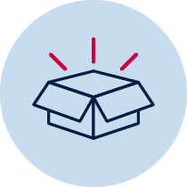 Resources
- Artworks as described above
- Paintbrush
- Container of water
- Paver, plastic lid or cardboard
- Paper clay, airdrying clay, playdough, dough or blutak
- Paints of different colours.
Acknowledgement of Country
Discuss with your class or household about how Aboriginal people in Australia are the original owners of the land in your community. They have looked after this land for a long time and we all have the responsibility to continue this practice.
Reflect and make symbolic art
Go outside to a special place within your school or local environment. Where possible take a plastic surface, some cardboard, a paver or alternatively find a concrete, tiled or paved area. Take some water in a container and a paintbrush.
Look around at the environment in silence. Find something important about the environment – either natural or man-made.
Create a quick symbol of something in this environment that is important to you. Take a photo for your teacher to look at. Once it has vanished, repeat with another symbol and take a photograph. Your teacher wants to check you can show a symbol through your artwork. You can put your photos on the page below.
Here is an example to look at. It is a symbol (umbrella) of a wet area:
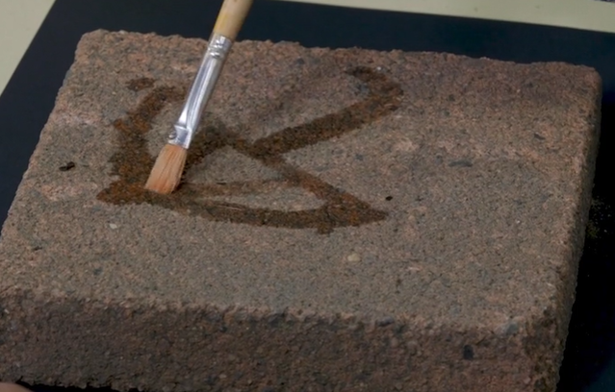
Look at some art
Look at the work ‘Centrepoint Tower’ by Aboriginal artist Esme Timbery from the collection at the Art Gallery of NSW. https://www.artgallery.nsw.gov.au/collection/works/214.2010/
Timbery is a Bidjigal artist whose family were shell workers from the Aboriginal mission community of La Perouse in Sydney.
How do you think this work was made?
Did you notice how the artist used traditional materials (the shells) that are important to Aboriginal culture to show a modern city symbol (the tower)?
Your symbol of Australia
Think again about your environment and look for an object that symbolises Australia to you. Remember if you take something from nature such as shells from the beach, it must be returned once your artwork is complete.
Create a symbolic sculpture artwork and photograph it. This may include leaves, shells or flowers and may also include cultural symbols important to your community or how you feel about Australia.
In the example below, a sculpture was created about a classic Australian symbol, the gum leaf, and was made from paper clay. Airdry clay is also a good alternative which can be handmade. Otherwise, use playdough, dough or blutak without painting it. Take a photo of your sculpture to share with your class. You can put your photo on the page below.
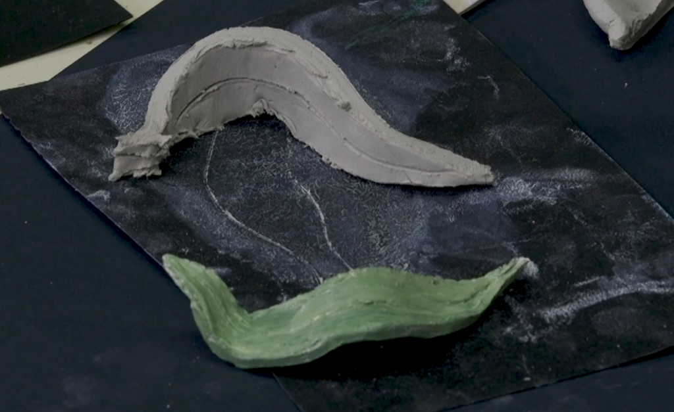

Blank page for your photographs

Look at some art
Artists represent ideas and meanings of their world through their artworks just like you did in your own symbolic works. Artists have been doing this throughout history. Many of these artworks are from the collections at the Art Gallery of NSW.
Your teacher may have shown you the works below:
- ‘Bailed up’ by Tom Roberts
- ‘The future is now’ by Robert Rauschenberg
- ‘The first real target’ by Peter Blake
- ‘Football players’ by Konrad Lueg
- ‘Triple fronted’ by Howard Arkley.
Write about this art
Complete the information in the table below for 2-3 artworks you like or that your teacher suggests. This will show your understanding of the meaning of the artworks. Some have been done for you.
Artwork title and artist | What is its hidden meaning about culture or country? | How does it tell us that?
‘Bailed up’ – Tom Roberts | Australia’s rugged bush, heat and bushrangers. | The choice of colours and images.
‘The future is now’ – Robert Rauschenberg
‘The first real target’ – Peter Blake
‘Football players’ – Konrad Lueg
‘Triple fronted’ – Howard Arkley

Lesson 2
Connotation, imagery and symbol in music and visual arts.
Resources
- music and image links as indicated above
- art paper and paintbrushes of a variety of tip sizes
- watercolour paints, pencils or paints in pastel colours
Learn about some music
Composers often use music to tell a story. Sometimes they do this through words. Sometimes they do this through the way the instruments sound (their ‘tone colour’) and the music they play.
Listen to each piece (or a section of it) and complete the parts of the table below that your teacher suggests.
- Listen to ‘My Island Home’ by the Warumpi Band. What do you think the song is about? How do you know?
- Heinrich Biber made the violin sound like animals in his ‘Sonata Representativa’. How does the composer make the instruments sound like these animals: a nightingale, a cuckoo bird, a frog, a chicken and a cat?
- Listen to the ‘Flight of the Bumblebee’ which is a piece for orchestra by Rimsky-Korsakov. Move around to the beat just like a bee flying and getting faster in speed (or tempo).
- Listen to some of James Ledger’s ‘Indian Pacific’. This piece sounds like the journey of a train across the country. Keep the beat and imagine you are on the train looking out the window. Does the strong beat remind you of that?
- Listen to ‘Ballet of the chicks in the shells’ by Mussorgsky. Mussorgsky was trying to imitate chickens hatching, pecking at food and trying to fly. Can you hear them?

Use this table to write about what you hear. Some answers have been done for you.
Title of piece and composer | Musical concepts used and what do they mean?
‘My Island Home’ by the Warumpi Band. | Introduction with the watery sounds and the folk style instruments throughout shows a deep connection to Country.  Tempo speeds up, the music sounds much brighter and the dynamics get louder like someone is happy to be going home.
‘Sonata Representativa’ by Heinrich Biber | Violin tone colour and sounds are like the animals he is portraying.
‘Flight of the Bumblebee’ by Sergei Rachmaninoff.

‘Indian Pacific’ by James Ledger
‘Ballet of the chicks in the shells’ by Mussorgsky. | High pitches like chicks.
Think about and make sounds
Think of one sound you can hear. What instruments or objects could you use to imitate that sound?
Some ideas might be:
- a whistle for a bird
- a glass like the wind
- hitting something strongly with your hands like a storm
- a paint brush on a table like sand or water
- a book slamming like thunder
- tissue coming out of a box like brushing your hair
- clicking a ring pull like a frog and so on.
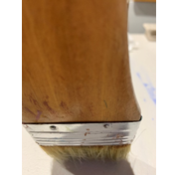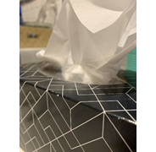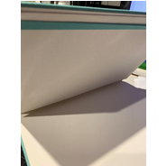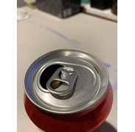
What sound is that?
Choose your sound and how you will represent it with an instrument or object. Record your sound or write about it:
The sound I chose is: _____________________________________________________
I can also make this sound by playing: ________________________________________
_______________________________________________________________________
Look at the sounds of art
Artworks are sometimes inspired by pieces of music. Sometimes musicians get meaning from artworks and other times artists make artworks based upon what they hear in a composition.
Watch ‘Water walk’ by John Cage. It uses images and sounds of familiar every-day objects as well as a piano. John Cage famously said, ‘Everything we hear is music’.
Cage’s intention was to try and make the audience realise that music is everywhere and does not have to be traditional music that you might hear in a concert hall. Why is the audience laughing?
One of Cage’s best-known pieces is ‘4:33’. Watch a video clip of this work being performed and think about how it is similar to ‘Water walk’.
Do some art
Listen to John Williams ‘Tatooine theme’ from Star Wars, which is about a desert city on a desert planet. Can you hear the violins and trumpets sounding like a baking hot sun? Can you picture the sand dunes and alien creatures scuttling across the hot sand looking for shade?
Listen again then paint or draw a picture about the music. You will probably want to use pastels and water colours if you can.
Your teacher may want to look at your artwork later and ask you about why you chose the colours and images that you did. Make sure your artwork is in landscape view and shows the hot sun, sand dunes and an alien desert creature looking for shade. The next page is left blank for your artwork.
Blank page for your ‘Tatooine’ painting:

Talk and write about your art
After painting your artwork, write about it below or tell your teacher about it.
In my artwork I have shown _________________________________________________
_______________________________________________________________________
_______________________________________________________________________
The way I did this was with _________________________________________________
_______________________________________________________________________
_______________________________________________________________________
Write about what you learnt
Fill in your exit slip to tell your teacher about your learning.

Exit slip
Student name: ____________________________________ Date: _________________
One thing I now know better about the way artists share meaning through their artworks.
________________________________________________________________________________________________________________________________________________One thing I am still puzzled about.
_______________________________________________________________________________________________________________________________________________

