Creative arts Stage 2 learning sequence – How does character inform the arts?
Learning sequence description
This lesson sequence enables students to explore character primarily in visual arts and music. Additional focus is on facial expression, movement, mime and non-locomotor body formation. Students will learn to sing a song about mythical creatures and create a composition about that character. Through an examination of figurative drawing and sculpting, students will also create their own mythical creature sculptures, explore shadows and movement, then create and draw ‘human’ action figures.

Syllabus outcomes and content

Visual arts

VAS2.1 - represents the qualities of experiences and things that are interesting or beautiful by choosing among aspects of subject matter.
  - focuses on details of subject matter and areas of beauty, interest, awe, wonder and delight, such as facial expressions, body positions and body angles.

VAS2.2 - uses the forms to suggest the qualities of subject matter.

experiments with techniques in painting, drawing, photography, digital and video to create particular effects to suggest such things as close-ups, middle distance and long distance views, mood and atmosphere, light and dark suited to how subject matter may be interpreted.

VAS2.4 - identifies connections between subject matter in artworks and what they refer to, and appreciates the use of particular techniques.

identifies resemblances between subject matter in artworks and the features of things as they exist in the world, recognising similarities and differences in how things are represented in the artworks.

Music

MUS2.1 - sings, plays and moves to a range of music, demonstrating a basic knowledge of musical concepts.
  - sings songs demonstrating a greater awareness of beat, pitch, tone colour and structure
  - moves to music maintaining a constant beat, identifying structure, identifying changes in pitch, elements of duration and dynamics.
  - plays music using body percussion, percussion instruments and other sound sources to explore and demonstrate the concepts of duration, tone colour, pitch, dynamics and structure explores basic aspects of musical concepts in their singing, playing and moving activities.

MUS2.2 - improvises musical phrases, organises sounds and explains reasons for choices.
  - explores ways of varying musical material.
  - organises own musical ideas into simple compositions.

MUS2.4 - identifies the use of musical concepts and musical symbols in a range of repertoire.

identifies basic musical features of the music that is performed and listened to, such as rhythm, tempo, pitch, structure, dynamics, tone colour.
Drama

DRAS2.2 - builds the action of the drama by using the elements of drama, movement and voice skills.
- devises the action through movement and voice by adapting stories such as a well-known cultural story, developing a particular character.
Dance

DAS2.2 - explores, selects and combines movement using the elements of dance to communicate ideas, feelings or moods.
- in response to a stimulus, thinks about a series of movements to reflect an idea and improvises confidently.
Creative Arts K-6 © 2006 NSW Education Standards Authority (NESA) for and on behalf of the Crown in right of the State of New South Wales.

Lesson 1 – how do mythical creatures show their character in music?
Students are learning to:
- sing a song about mythical creatures and follow melodic contour in a song by exploring the pitch
- create the characteristics of a mythical creature
- compose a soundscape about mythical creatures.
Item | Learning experience | Differentiation strategies and/or adjustments | Resources
1.1 | Listen to and follow the score of ‘Where the Creatures Roam’. Get to know the song using the animated score.  Keep the beat to reinforce the process of learning the song. Remember that the beat stays the same and is the pulse underneath the music.  Follow the melodic contour of ‘Where the Creatures Roam’ using movement to support the learning.  Learn to sing the song using the lyrics below. Use the animated score to assist and also to help with learning about the process of reading a musical score.  Identify the sounds of the instruments being played. Reflect on why the composer may have chosen these instruments to represent mythical African creatures.  Identify the mythical creatures used in ‘Where the Creatures Roam’. In Zulu mythology, Tikoloshe is a dwarf-like water sprite. A Ninki Nanka is a legendary creature in West African folklore that is reptilian and possibly dragon-like. Yumboes are a kind of fairy in the mythology of the Wolof people in Senegal, West Africa.  Who and what are these creatures? What do we know about their characters? Are they scary or kind, large or small, happy or sad? Write two adjectives to describe their appearance and their character.  Ask the students to think about a mythical creature they could create. Create a 2D artwork of a mythical creature of student choice. This can be done through drawing, painting or printmaking. Focus should be on the shapes and colours of these creatures.  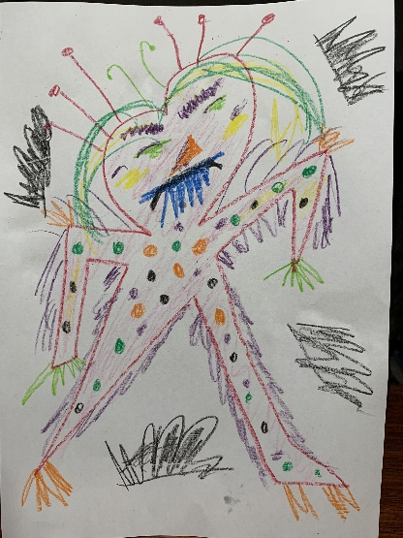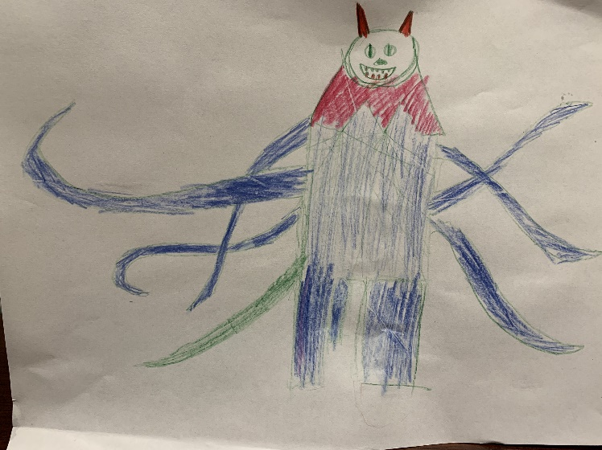  Care should be taken to show the character of the creature by giving them an expression. For example, are they scary or kind, happy or sad? Where possible, listen to a piece of music such as ‘In the Hall of the Mountain King’ by Edvard Grieg as stimulus to create creatures. | Follow the score and learn the notation of the song.  Think of other songs about mythical creatures.  Think about high sounds and low sounds and play them on instruments or listen to them in the environment. | Student workbooks with creature images such as:  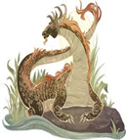  Ninki nanka  ‘Where the Creatures Roam’ score  Melodic contour footage  Musical equipment  Art supplies:  Paper and pencils
1.2 | Create a musical composition based on these creatures. This piece of music should be a soundscape, using sound to create a picture or to match a picture. There is no strict time limit on this soundscape but it must carefully consider musical concepts:  Structure – it must have a beginning, middle and an end with a climax somewhere in the composition.  Tone colour – what ‘instruments’ will be used? For example, kitchen items, furniture, homemade instruments, body percussion, vocal sounds, sound effects and so on:  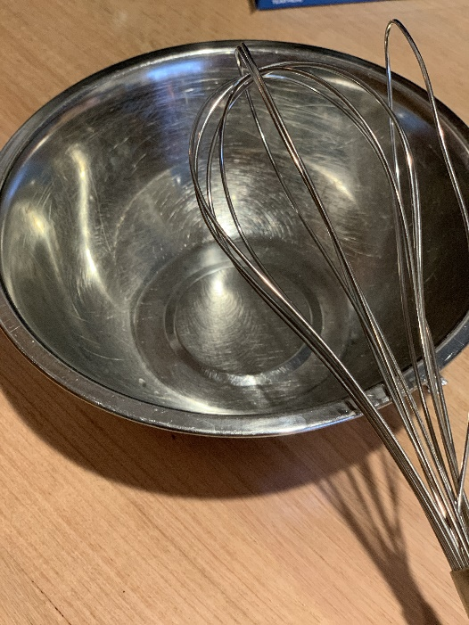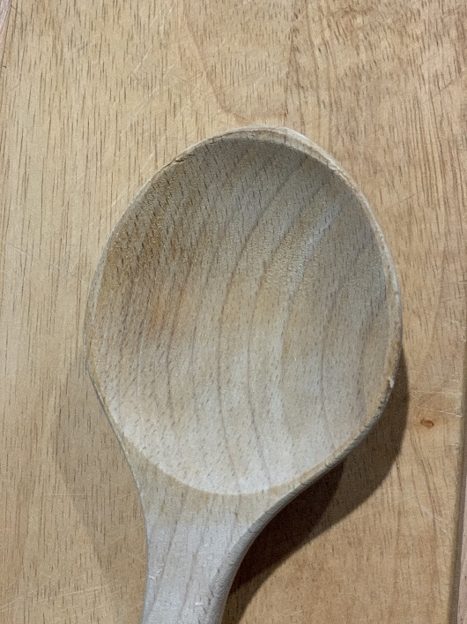  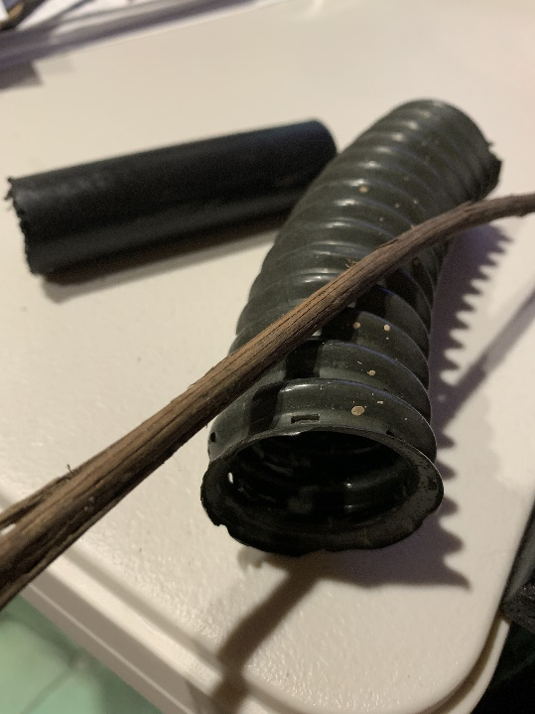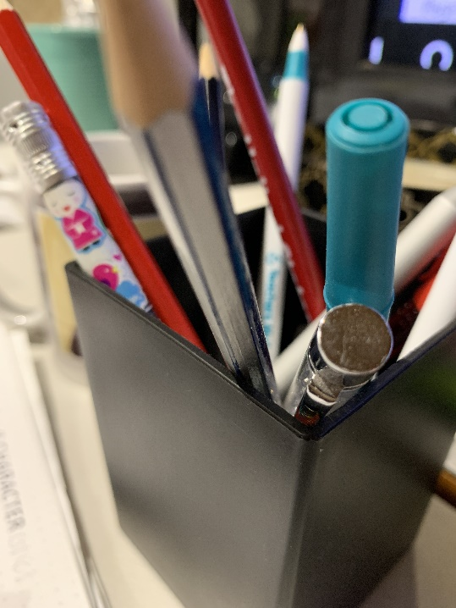  Duration – will it change tempo (speed)? Will it have a steady beat or rhythm or just be a series of sounds?  Pitch – will there be a melody, high or low pitched instruments and so on?  Dynamics – soft and loud sounds can be used to create tension or calm in the pieces.  Use this video to help identify which musical concepts should be considered when creating a composition about creatures. Get another household member to record or film the composition.  Consider how the creatures would sound if they were kind, scary or other characteristics for example. Use this video for inspiration on how to create a soundscape by watching this video as a guide. Use whatever items you have in your house to create a composition such as furniture or other objects.  Video or audio record the composition using a device or a Voice Memo recording system in a smartphone. Ask the students to be prepared to share this at a later stage. | Think about individual sounds and what creatures they could represent.  A variety of instruments can be made using varying techniques.  Sample the sounds of a mythical creature and arrange them in GarageBand as a composition. | Student workbook (DOCX 3.1MB)  Artwork previously created of a mythical creature  Household items that can make a sound for soundscape compositions  Device to record compositions  Musical concept video  Soundscape video
1.3 | Opportunity for monitoring student learning  Mythical creature soundscape composition – practical activity  Students use household items to create and record a soundscape composition of their own. These compositions are based around the mythical creature they created previously.  What to look for  - The composition reflects an understanding and incorporation of some of the musical concepts of pitch, duration, dynamics, tone colour and structure.  - The composition makes reference through sound to the mythical creature.  - The student has used a variety of found sounds to create their composition. |  | Video or audio recording of compositions

Lesson 2 – what different things can characters teach us about figurative art?
Students are learning to:
- create an abstract 3D figurative sculpture
- explore the relationship between their own body movements and figurative sculpture
- explore ways of drawing figures using the inspiration of shadows.
Item | Learning experience | Differentiation strategies and/or adjustments | Resources
2.1 | Replay the music of ‘Where the Creatures Roam’. Discuss the mythical creatures described in the song.  Examine the artwork created previously and ask the students to describe their mythical creature to a household member or peer. Play the composition about the mythical creature as well and discuss more of the creature’s features.  Sing through ‘Where the Creatures Roam’ following the animated score. Ask the students to consider what musical notation tips they have learnt through watching the score? For example, how many beats are in each bar?  Think about the characteristics of the mythical creature created earlier as a 2D artwork. Watch this video to get some ideas for a 3D artwork. This will be a figurative sculpture, or a sculpture of a figure.  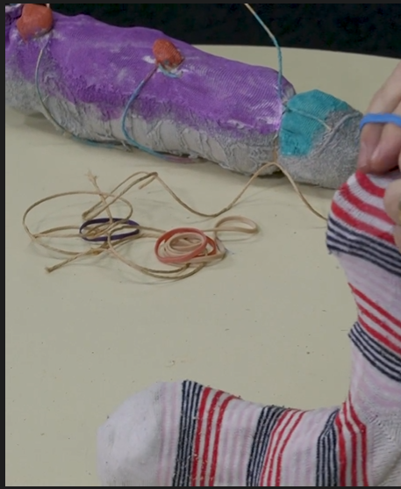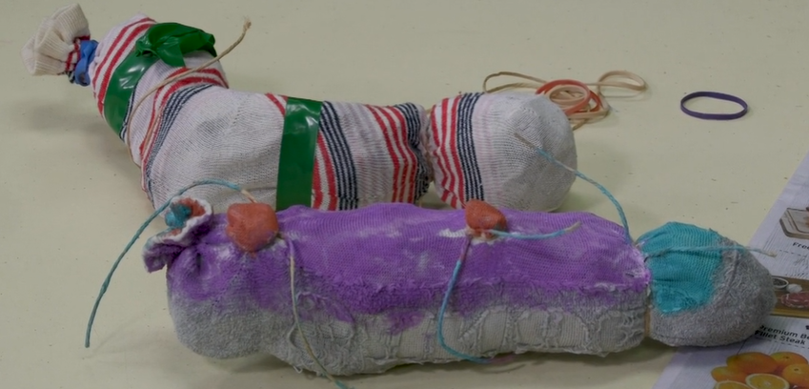  Create a mythical creature sculpture based upon the earlier creature or vary it if required to explore other options.  Ask the students to decorate their sculptures and take a photo of it. Some students may wish to consider ways that they could explore filters and backgrounds within a photo app to expand the creature’s environment.  Consider using these creatures as characters within an online chat or meeting. Alternatively, they could appear within a classroom discussion by having the students adopt the character of their creatures as though using them as puppets in role. | Create your mythical creature out of playdough or just by decorating the previously created artwork.  Create a habitat for the mythical creature perhaps as a diorama or a virtual background.  Explore Australian mythical creatures such as the ‘bunyip’. Create an artwork or composition to reflect these creatures.  Use an app such as Stop Motion to create an environment and short film for the mythical creature. Create a storyboard or a narrative (story) for the creature first. This may include an adventure it goes on or a problem it must solve. | Student workbook (DOCX 3.1MB)  ‘Where the Creatures Roam’ score  Figurative sculpture video  Old, clean and long sock  Electrical, duct or masking tape  Elastic bands  Old paper such as newspaper or magazine pages  Paints and paintbrushes
2.2 | Read the ‘Shadow party’ poem and discuss:  Copyright: The School Magazine, Blast Off, Issue 2, 2020  ‘Shadow party’  Poem by Sioban Timmer, illustrated by Christopher Nielsen  ‘People think that shadows go  Each time we lose the light  But that’s when shadows party—  When the daytime turns to night  We just assume our silhouette  Is waiting for our call  But when we close our eyes at night  Well, they’re not there at all  In sunshine they just copy (Which can really be a bore) But free to roam within the dark  They dance and fly and soar  The darkness makes it possible  For them to leave your side  And when our shadows get the chance  They wander far and wide  So every night while you’re in bed  And sleep is close to hand  You can dream about your shadow  Dancing free across the land.’  What does the poem mean? What do we know about shadows?  On a sunny day or in a dark room with a torch, use the creature sculptures to explore the shadows they can create. Trace these sculptures with chalk on the ground or using paper and pencils in indoors. Assistance from a peer or household member may be required to hold the creature in place.  Ask the students to create a pose with their bodies to represent some sort of movement. Using the environments used previously students should again explore their shadows. With assistance, take a photo or again trace the shadows where possible.  Using either Lego characters, a doll or any other figure item available (such as an action figure), model the body shape created earlier as exactly as possible. Replicate this using aluminium foil as a 3D sculpture.  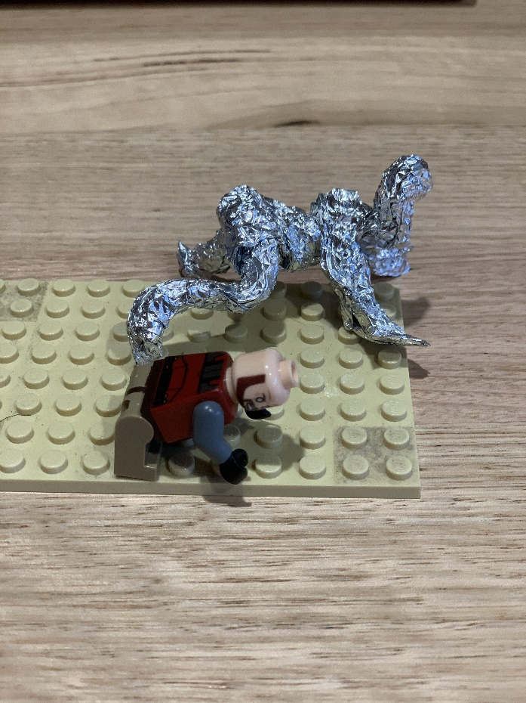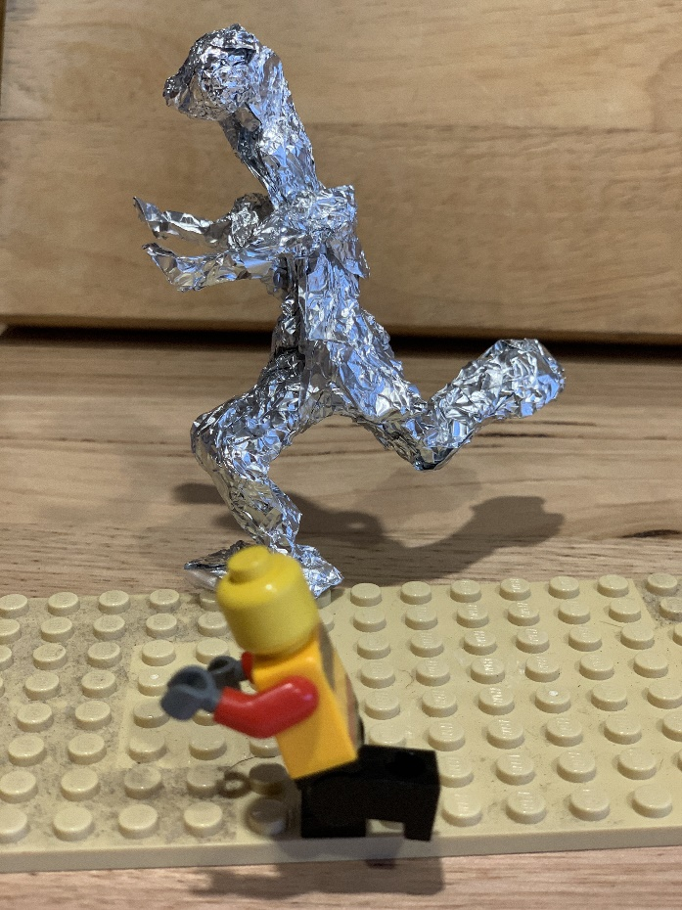  Use this sculpture to create a shadow. Draw or trace the shadow of the sculpture and fill in using black texta, pencil or paint. It may be beneficial to sticky tape or blutak the figure prior to this process.  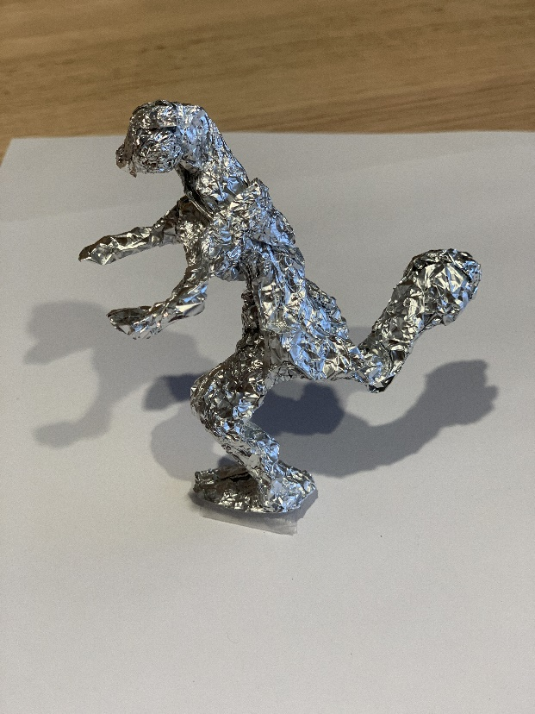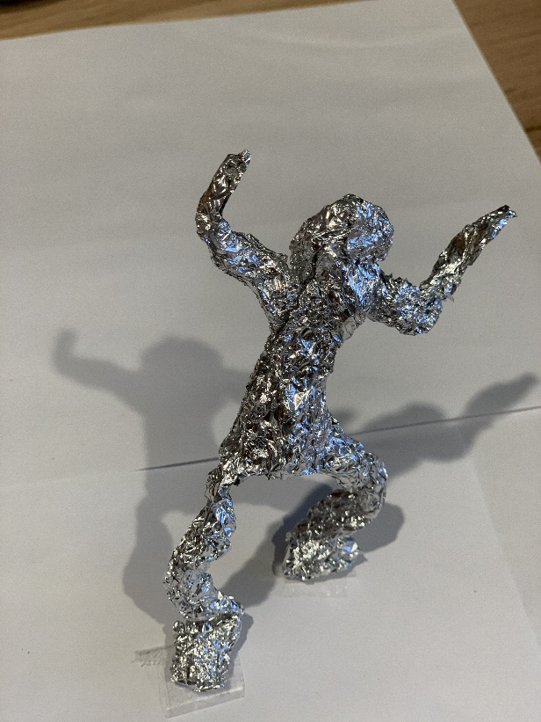  Using this footage of action figurative drawing may assist with this process or to take this activity further and draw the figures independently. Remember that the focus is on the shapes not the fine details. There is no need for a face. Unlike in previous activities on character, the central idea here is the body or figure.  Use this to create a variety of action figures or characters that may in turn be used to create sculptures.  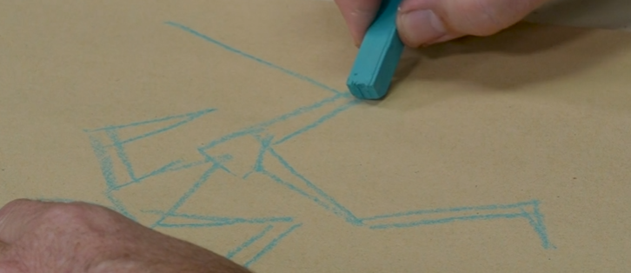  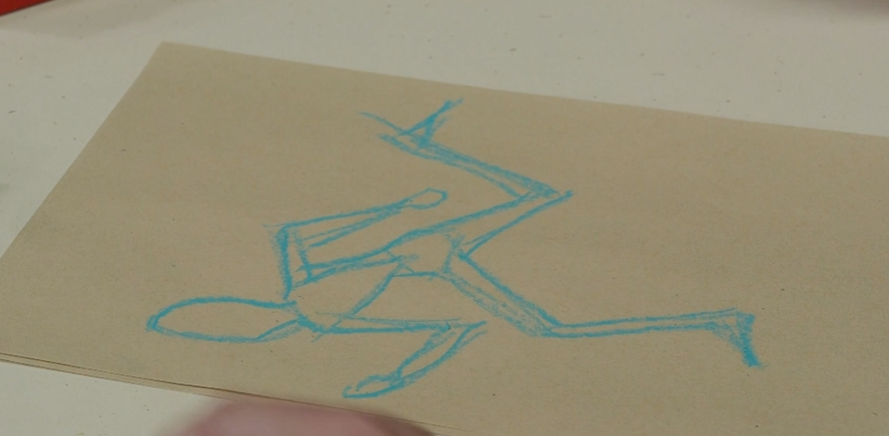 | Explore shadows and how they move.  Watch shadows move through the day.  Use figurines to explore body shapes and shadows. | Student workbook (DOCX 3.1MB)  ‘Shadow party’ poem  Poem by Sioban Timmer, illustrated by Christopher Nielsen:  Copyright: The School Magazine, Blast Off, Issue 2, 2020  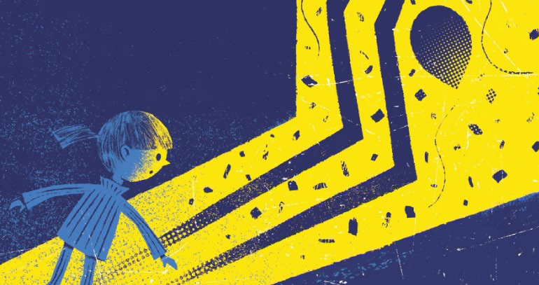Chalk  Paper and pencil, crayon or texta  Aluminium foil  Black texta, pencil or paint  Action figure drawing footage
2.3 | Opportunity for monitoring student learning  Create a 3D figurine and draw its shadow – presentation  Students create a figurative sculpture using aluminium foil. This figure is then used to draw a shadow or alternatively to draw its action.  What to look for  - Has the student used the foil to represent the action of a body?  - The action of the figure should represent the formation of a body shape and the stance that would be appropriate for this shape.  - The shadow should resemble the shape of the figure but may not necessarily be an exact replication. |  | Student workbook (DOCX 3.1MB)  Photograph or sculpture  Drawing of shadow of sculpture

Where the Creatures Roam

By Tracy and Paul Burjan
Chorus 1
Africa, where the great creatures roam,
We know about the lion and the big hippo.
But who has heard of Ninki Nanka?
Ninki Nanka who?
Get the medicine man, he’ll tell you what is true.
Verse 1
Down in the swamps of Gambia,
Lives the great dragon monster called Ninki Nanka.
So don’t go and play, don’t go and stray,
He has mirrored scales, a big long tail and gobbles up his prey.
Chorus 2
Africa, where the great creatures roam,
We know about the zebra and the big baboon,
But who has heard of Tikoleshe?
Tikoleshe who?
Get the medicine man, he’ll tell you what is true.
Verse 2
In the land of the Zulu, he sounds rather sweet.
Just 1 foot tall and hairy, but wait till you meet.
Whatever you do just don’t go to sleep,
Because that’s when he eats the toes right off your feet!
Chorus 3
Africa, where the great creatures roam,
We know the rhino, cheetah and giraffe call it home.
But what about the Yumboe?
Yumboe who?
Get the medicine man, he’ll tell you what is true.
Verse 3
Down beneath the Paps Hills of Senegal,
The silver haired Yumboe won’t eat your toes at all.
They dance by the moonlight and feast on fish.
And if you come across them they just might grant you a wish.
Chorus 4
Africa, where the great creatures roam,
Now you know about some creatures there that also call it home.
The Ninki Nanka of Gambia,
And the Tikoleshe of South Africa.
The Yumboe fairy of Senegal,
There are far too many more to name them all Africa, where the great creatures roam,
Africa, strange creatures call it home.

Reflection and evaluation
These simple questions may help you reflect on your students’ learning and plan for next steps.
What worked well and why?
What didn’t work and why?
What might I do differently next time?
What are the next steps for student learning based on the evidence gathered?

