Australian music

Teaching resources

Stage 5

Table of contents
Australian music 1
Teaching resources 1
Stage 5 1
Table of contents 2
The concepts of music checklist 5
Duration 5
Pitch 5
Structure 5
Texture 6
Tone colour 6
Dynamics and expressive techniques 6
Popular music 7
Missy Higgins 7
Listening 7
Performance and listening 7
Answers 9
Listening 9
Performance and listening 9
Children’s music 11
The Wiggles 11
Who are The Wiggles? 11
Performance - Five Little Ducks 11
Composition and performance - composing a children’s song 13
Listening 15
Extension 15
Answers Performance - Five Little Ducks 16
Musical Theatre – Fangirls (clean) 17
Fangirls (clean version) 17
Watch 18
Performance - ‘Justice’ 18
Listening 19
Composition 19
Activity 21
Additional resources 23
Answers 24
Listening 24
Musical Theatre – Fangirls (original) 26
Fangirls (original version) 26
Watch 27
Performance - ‘Justice’ 27
Listening 28
Composition 28
Activity 30
Additional resources 32
Answers 33
Listening 33
Musical theatre – Matilda the Musical 35
Listening 35
Performance 36
Rhythm one 36
Score reading - extension 37
Composition – extension 38
Watch 38
Answers 38
Listening 38
Performance 38
Score reading - extension 39
Using the score of ‘Revolting Children’ by Tim Minchin score, (date accessed 18/11/2020) answer the following in your books using full sentences: 39
Music for television 40
Performance 41
Listening 42
Composition 45
Choose one of the following activities to complete either by yourself or in small groups (no more than five in a group). 45
Answers 47
Performance 47
Opera 49
The Rabbits 49
Performance and literacy activity 49
Listening 50
Composition and performance 51
Activity 53
Glossary 54
Answers 55
Performance and literacy activity 55
Listening 55
Art Music 58
Sarah Hopkins 58
Composition and performance 58
Listening 59
Musicology - listening and musical literacy 60
Composition 62
Additional notes 62
Answers 63
Listening 63
Musicology - listening and musical literacy 63
Popular music by Aboriginal and Torres Strait Islander artists 65
Performance, listening, and literacy activity 65
Baker Boy - do you wanna rap? 66
Thelma Plum - fancy some uke? 66
Miiesha - can you acapella? 67
Yothu Yindi - Treaty 67
Reflection 68
Composition and performance - extension 68
Rock Music 69
Midnight Oil - The Makaratta Project 69
Listening 69
Performance and listening 70
Composition and performance 72
Comparative listening analysis 73
Additional resources 74
Listen and watch - contextual background information 74
Glossary 74
Answers 76
Comparative listening analysis 76
Listen and watch 77

The concepts of music checklist

Duration
- Tempo – Adagio/Lento/Moderato/Allegro?
- Tempo – changes/constant?
- Time signature – constant/multimeter?
- Rhythm is strict/rigid/free/indefinite?
- Syncopation/polyrhythms/cross rhythms?
- Ostinato/backbeat/anacrusis?
- Accelerando/ritardando/rubato?
- Note values – long/short/dotted?
- Repeated rhythms?
- Beat – strong/indefinite?
- Bar lengths – regular/irregular?

Pitch
- Tonality – major/minor/modal/atonal/pentatonic?
- Modulations/key changes?
- Rate of harmonic change?
- Arpeggios/triads/drone?
- Scales used – major/minor/chromatic/blues/mode?
- Harmony – consonant/dissonant?
- Melody – moves in steps/leaps?
- Melodic contour – ascending/descending?
- Range/intervals?
- Phrase lengths
- Imitation/repetition/ostinato/sequence?
- Ornamentation/improvisation?
- Counter melody/call & response/canon?
- Cadences – perfect/plagal/imperfect/interrupted?
- Tone clusters

Structure
- Binary/ternary/rondo
- Theme and variations
- Through composed
- Strophic form
- Verse/chorus form
- 12 bar blues form
- How can you tell when a new section begins?
- Identify the number of bars in each section.
- Macro (whole song) and micro (phrases) structure

Texture
- Thin/thick?
- Monophonic/homophonic/polyphonic?
- Roles of the instruments – melodic/harmonic/rhythmic?
- How many layers of sound are there?
- Changes in texture – sudden/gradual?
- Unison/doubling/imitation?
- Call and response/canon?
- Motion – similar/contrary?

Tone colour
- Performing media
- Aerophones/chordophones/membranophones/idiophones?
- Electronic sounds
- Range – narrow/medium/wide?
- Register – low/middle/high?
- Description of sound – adjectives!
- Role of each instrument
- Tone colour changes during the excerpt
- Describe the overall mood/atmosphere

Dynamics and expressive techniques
- Dynamics
- Sudden/gradual dynamic changes?
- Articulation - legato/tenuto/staccato/accents?
- Vibrato/tremolo/glissando/pizzicato?
- Muting/strumming/picking/pedals?
- Drum roll/distortion/amplification?
- Double stopping/note bending/multiphonics?
- Falsetto/scat/melisma?

Popular music

Missy Higgins
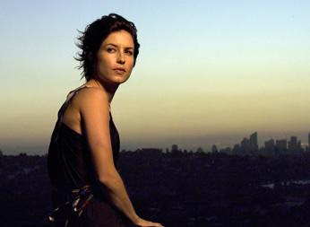
Image sourced from blogspot (date accessed 13/11/2020)
Missy Higgins biography (date accessed 23/11/2020)

Listening
Listen to ‘Scar’ by Missy Higgins (00:03:34) (date accessed 13/11/2020) and answer the questions below.
- What is the time signature of this piece?
- What is the tempo of this piece?
- What is the tonality of this piece? (major/minor?)
- Fill in the table below outlining the structure and performing media used:
Structure | Performing media

Performance and listening
- Using an instrument such as a keyboard or glockenspiel, outline the chord structure of the piece using the chords C, F, G, Am and Dm using the chord chart on the following page.
To do this, you can try the following:
  - listen to the bass note (the lowest note) you can hear in the excerpt.
  - hum or sing that note and try to find that note on your instrument.
  - check if you are accurate by playing along with the recording again.
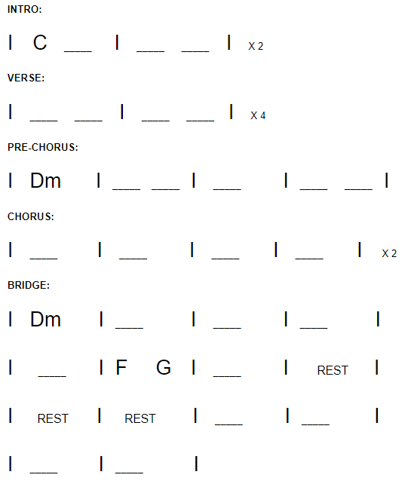
- Perform the piece as a class on classroom instruments. You can access the lyrics here: ‘Scar’ by Missy Higgins lyrics (date accessed 13/11/2020)
- Class discussion – what are some of the musical characteristics of this piece according to the concepts of music? For example, what is the texture like? What is the tempo and time signature? Write down these characteristics in your books under the heading ‘Pop Music Characteristics’.
- Homework: Write an extended response (up to a page) in paragraphs answering the following question: How is Missy Higgins' song ‘Scar’ characteristic of Australian Pop Music? Please provide examples from the music for each point discussed.

Answers

Listening
Listen to ‘Scar’ by Missy Higgins (00:03:34) (date accessed 13/11/2020) and answer the questions below.
- What is the time signature of this piece?
  - 4/4 - four crotchet beats per bar.
- What is the tempo of this piece?
  - Moderato
- What is the tonality of this piece? (major/minor?)
  - Major
- Fill in the table below outlining the structure and performing media used:
Structure | Performing media
- Intro – four bars  - Verse 1 – eight bars  - Pre-chorus – four bars  - Chorus – eight bars  - Instrumental break- four bars  - Verse 2 – eight bars  - Pre-chorus – four bars  - Chorus – eight bars  - Bridge – fourteen bars  - Chorus (extended) - sixteen bars | - Vocals (lead and backing vocals)  - Piano  - Drumkit  - Bass guitar  - Acoustic guitar  - Electric guitar  - Keyboard  - Tambourine  - Congas  - Trumpet/flugel horn

Performance and listening
- Chord structure answers (date accessed 4/12/2020)

Pop music characteristics:
- 4/4 time signature
- moderato - Allegro tempo
- simple note values that contain syncopation - especially in melodic lines
- regular bar lengths and a strong beat
- major or minor tonality
- simple chords
- use of hooks/ostinatos/riffs
- homophonic texture with the vocals providing the main melody and the rhythm section providing the harmonic and melodic accompaniment
- use of both acoustic and electronic instrumentation/performing media
- verse chorus form structure
- dynamics vary between sections with the chorus usually being the louder than the verses
- use of an Australian accent in the vocal part

Children’s music

The Wiggles
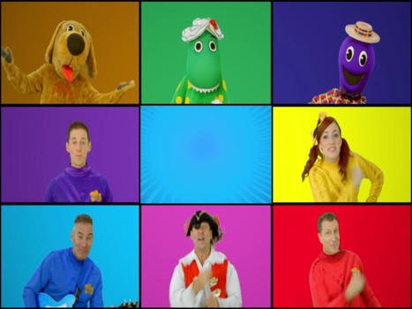
Image sourced from Wiggles image (date accessed 16/11/2020)

Who are The Wiggles?
The Wiggles are an Australian children’s entertainment group who have been entertaining and delighting children for decades. While the original line-up has changed, their popularity continues and the reason for this is simple: they see things from the perspective of the child. Because their performances are developmentally appropriate for their young audiences, they continue to attract and involve those audiences.
The Wiggles work continues to be based on current thinking in early childhood development and learning. Children need opportunities to develop a sense of their own identity, to become connected with their world and to contribute to it, to develop a strong sense of wellbeing, to become confident and involved learners and effective communicators. The Wiggles are aware of these desired outcomes and keep them in mind as they plan and perform.
Text sourced from The Wiggles (date accessed 16/11/2020)

Performance - Five Little Ducks
- Watch the performance of ‘Five Little Ducks’ (00:02:35) by the Wiggles (date accessed 16/11/2020) and follow along with the score provided.
- Using the score, perform ‘Five Little Ducks’ as a class on classroom instruments.

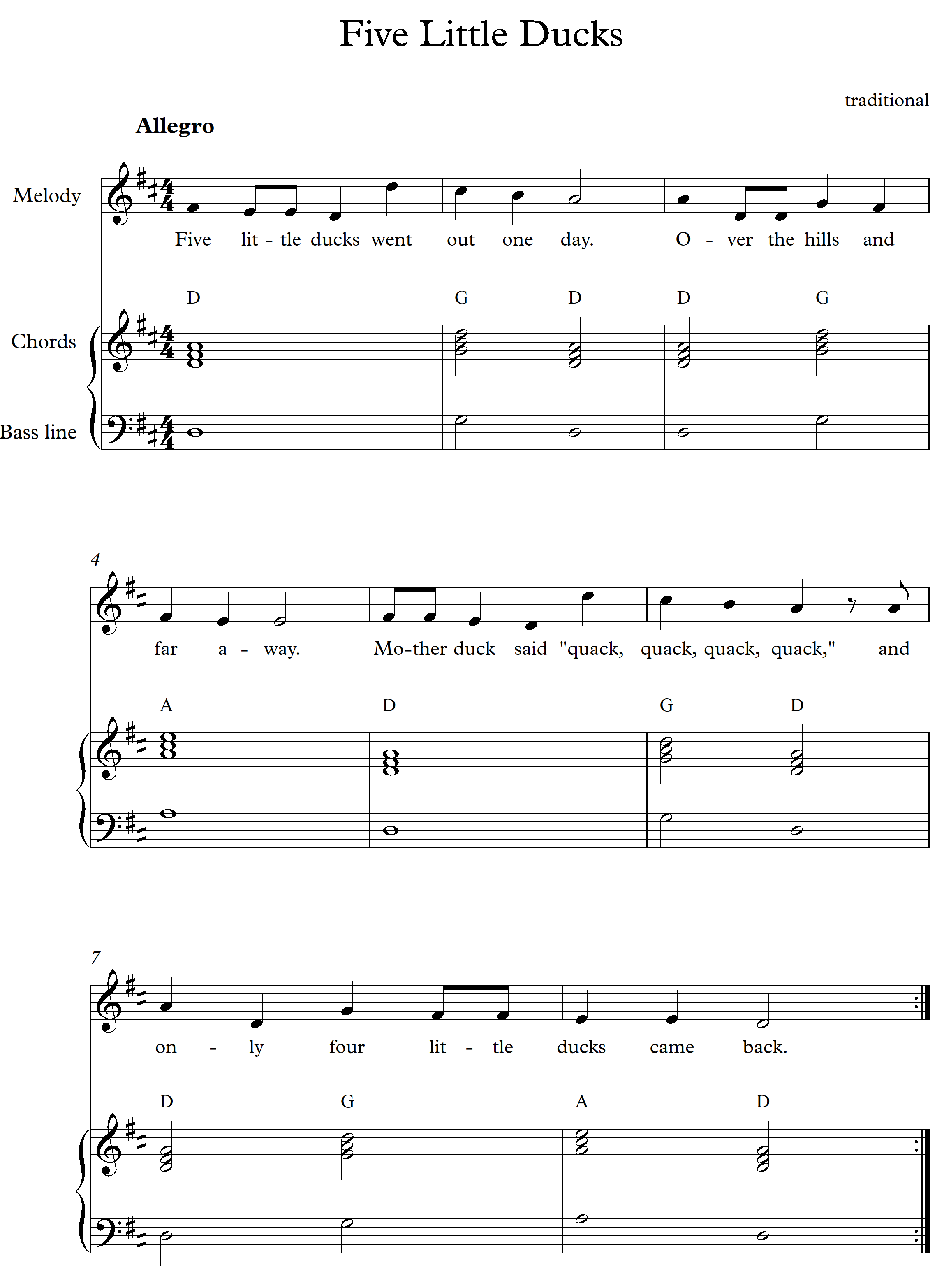
Repeat the lyrics by counting down until you get to one little duck. For example, ‘Four little ducks went out one day’.
- Discussion: what are some of the musical elements that make this a children’s song? Write this in your books in dot points.

Composition and performance - composing a children’s song

Steps
- In small groups, compose a children’s song by using some of the musical characteristics that were discussed above.
- As a stimulus, your group must choose a children’s book (distributed to you by your teacher). You may wish to use some of the words as your lyrics or you may choose to write the lyrics completely by yourself, with the book as inspiration only.
- Your piece must include one or two sections and contain a melody (voice with lyrics), harmonic accompaniment and rhythmic accompaniment. The total length of the composition must be at least 16 bars.
- Using the composition scaffold distributed to you, begin your composition by writing a chord progression using only three chords D, G and A. You will use the key of D major. Play this progression through as a group to check it sounds ok. (Hint: make bar 1 and 16, D major)
- Next, write your lyrics as a group - You will only need four sentences in total. (two sentences for each section) Copy the lyrics into your book.
- Improvise a melody using the lyrics over the top of your chord progression.
- Add rhythmic accompaniment and any additional layers to your melody and chords. Remember to keep the tone colour ‘bright’ in your choice of instruments!
- Consider the children’s music characteristics. Is there anything you could add to your group composition from this list? Which characteristics does your piece use?
- Name your piece.
- Perform it to the class and record your composition on your phone or device.

Composition scaffold
Key: D Major
Chords: D (D F# A), G (G B D), A (A C# E)
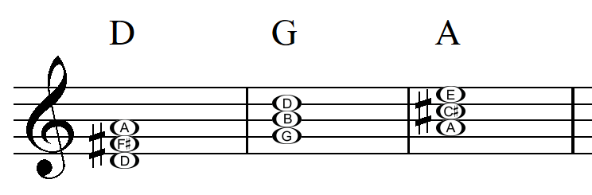

Title: ……………………………………………………

Section 1
Bar 1 | Bar 2 | Bar 3 | Bar 4
Bar 5 | Bar 6 | Bar 7 | Bar 8

Section 2
Bar 9 | Bar 10 | Bar 11 | Bar 12
Bar 13 | Bar 14 | Bar 15 | Bar 16

Listening
- Listen back to your composition on your phone or device. In your books, outline how your group composition reflects children’s music. Give examples from your own composition for each point you make.

Extension
- Using the score of ‘Five Little Ducks’, answer the questions below.
  - How many bars are in this piece?
  - What is the key signature of this piece of music?
  - What is the time signature of this piece and its definition?
  - What is the tempo of this piece (In Italian and English?)
  - What performing media/instruments is this piece written for?
  - What is the name and value of the rest found in bar six?
  - What are the main note values used in the vocal part throughout the entire piece and how many beats do they go for?
  - What note values does the piano play throughout the piece and how many beats do they go for?
  - What is the symbol found at the very end of the piece called and what does it mean?
  - In a paragraph, describe the melody according to the concept of pitch. For example: contour, range, register, steps/leaps.

Answers
Performance - Five Little Ducks
Discussion: question three

Children’s music characteristics
- lyrically based on age-appropriate events, characters or ideas and sometimes contain ‘nonsense’ syllables. Rhyming is a key feature.
- simple song structure - often in strophic form, binary form or simplified verse/chorus structure.
- major tonality and usually ‘happy’ sounding using ‘bright’ tone colours.
- catchy, simple rhythms.
- lyrics can often encourage physical movement.
- counting songs are a type of children’s music to teach numeracy skills.
- melodic and rhythmic repetition is featured.
- easy to sing melodies that use a narrow range of notes.
- simple chord progressions that often contain only three or four chords in the whole song. Rate of harmonic change is usually one to two chords per bar.
- homophonic texture with the vocals providing the melody.
- instruments include voice, harmonic accompaniment like piano or guitar and additional instruments with ‘bright’ sounding tone colours. These could include xylophones, glockenspiels, tambourines, shakers, ukulele etc.
- minimal dynamic variation with most of the piece remaining mezzo fo

Musical Theatre – Fangirls (clean)
The musical, songs and score addressed throughout this resource are suggestions only and implies no endorsement by the New South Wales Department of Education, of any writer, composer, or publisher. Suitability of repertoire intended to be staged or studied at a school for a public audience or syllabus implementation should be considered, and respectful of the local community's values and beliefs. This resource contains language and themes which may be confronting to students. Teachers should seek approval from their principal to determine the suitability of this resource and gain parental permission before delivery.
Teachers should note and complete the Audio Visual Materials in schools advice (DOCX 78.85KB) and the Controversial resource information and permission note (DOCX 73.05KB) before commencing the study of a controversial resource.

Fangirls (clean version)
Image sourced from pikist (date accessed 2/12/2020)
‘Fangirls’ is a musical written by a young Australian female writer called Yve Blake and was the winner of the 2019 Sydney Theatre Award for the Best Mainstage Musical. It is the story of a 14 year old girl 'Edna' who goes to an all girls private school but struggles with friendships. She is however, completely obsessed with 'Harry' who is a pop star in an all boy band. The story continues as Edna tries to meet Harry and declare her love for him which takes her on a journey of self-discovery.
‘Fangirls’’ overarching themes of addressing gender inequity and the stereotyping of female teenagers is both relevant and meaningful. It is masterfully written using teenage colloquial language which is cleverly impactful in its communication of the story and dramatic meaning and musical score. Having noticed that most popular musicals were written by men, Yve Blake's intention was to inspire girls to 'smash the glass ceiling' and to encourage girls to engage with writing, which is an incredibly important message for the youth of today. There is nothing quite like ‘Fangirls’ out there in the realm of Australian Musical Theatre, particularly written by such a young Australian woman.

Watch
- Yve Blake ABC The Mix (00:06:30) (date accessed 2/12/2020)

Performance - ‘Justice’
- Musical Theatre warm up activity (00:05:18) (date accessed 2/12/2020)
- Listen to ‘Justice’ using the link below and follow along with the score provided in this booklet. Discuss the dramatic context of the work outlined below.
- Perform the B section (bars 30 to 37) of ‘Justice’ from ‘Fangirls’ by Yve Blake using the recording and score provided in the score booklet. You may choose to do this either individually as a vocalist by singing with the backing track provided, or you may wish to arrange it for a small group or the class. Some rhythmic accompaniment parts are provided below.
Clicks
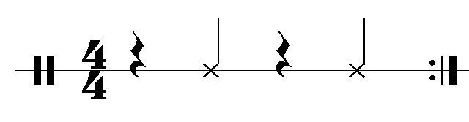
Tapping
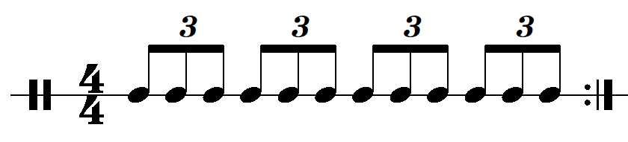
- ‘Justice’ by Yve Blake audio clean (00:05:50) (date accessed 12/12/2020)
- ‘Justice’ by Yve Blake backing track (00:05:50) (date accessed 11/12/2020)

Dramatic context - ‘Justice’
‘Justice’ is a song from the musical ‘Fangirls’. At this point of the story, the world's biggest pop star (Harry) has been missing for a whole two days, and as a result: his fans are furious. ‘Justice’ takes place at a 'vigil' that has been organised by some of Harry's teenage fans. Crowds of teenage fans gather in a park and unite over their shared desire to enact (violent) revenge on whoever has taken Harry. But soon, one fan interrupts the discussion and calls attention to a much bigger issue...
Meanwhile, at home, the show's protagonist (Edna, 14) debates what to do with the kidnapped pop star she has in her wardrobe...
“’Justice’ is a song I wrote when I noticed the gendered language that is often used to describe (and ridicule) fangirls. Why is it that the image of a young man screaming at the football would be read as 'passionate', 'loyal' ... but the image of a teenage girl screaming at a pop concert might be described as 'hysterical', 'crazy', 'hormonal', 'pathetic' or 'insane'? Why is it that the world tries to minimise and ridicule young feminine enthusiasm?” - Yve Blake 2020

Listening
- Listen to ‘Justice’ by Yve Blake (00:01:49 – 00:02:04) (date accessed 12/12/2020) and complete the texture graph below by colouring in when each instrument plays across the eight bars of this excerpt.
Layer | 1 | 2 | 3 | 4 | 5 | 6 | 7 | 8
Vocals
Synth strings
Electric guitar/bass
Drumkit/ percussion
- Describe the performing media and how it is used in each section. For example: What is its role? What is each layer playing in regards to rhythm and note values? Can you describe any other musical features about each layer of sound?
- Discussion – Are the instruments acoustic? How can you tell? What are some reasons as to why composers may choose to work with electronic performing media?

Composition
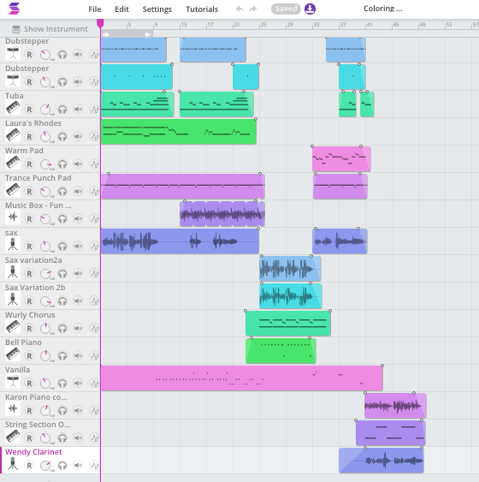
Image source (date accessed 2/12/2020)
Yve Blake uses several compositional and literacy techniques that are featured heavily in her writing.

Alliteration
Alliteration is the use of the same letter or sound at the beginning of consecutive words. This can be seen in the F section of ‘Justice’ from bars 72 – 73. (00:03:18 – 00:03:29)
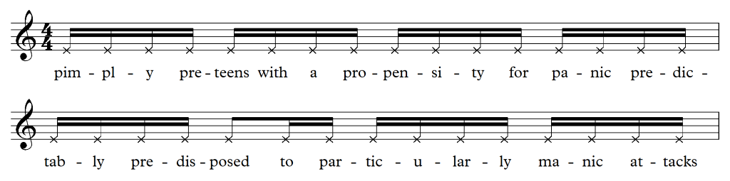
Can you write your own sentence completely made up of alliteration?

Speech rhythms
Yve Blake carefully studied how teenage girls talked as part of her research in writing ‘Fangirls’. She listened carefully to the speed, inflection, rhythm, pitch and how different syllables were accentuated. Many of her lyrics in ‘Justice’ are carefully notated to reflect the natural speech rhythms of particular words. For example: Section F bars 80 – 81. (00:03:38 – 00:03:44)
Say the sentence below and clap the rhythm. You will notice how the words’ natural rhythms are reflected in the written notation.
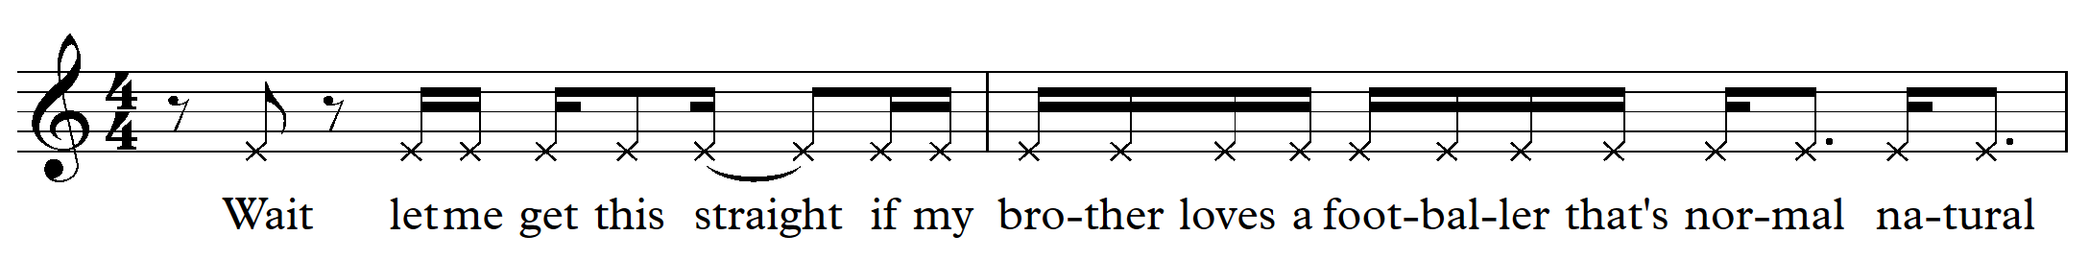
Now say your full name out loud. Can you attempt to notate the rhythm of your name?

Sprechstimme
German for ‘speak singing’, this is a cross between singing and speaking where the pitches of the speaking are heightened. This can be seen in the introduction of ‘Justice’ particularly in bars 19-29 which uses a mixture of singing and speaking. Sprechstimme is usually written with crossed note heads.
For example: (bars 43 to 45)
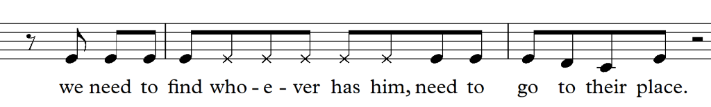
Perform the above example of sprechstimme in pairs.

Activity
The entire score of ‘Fangirls’ was composed by Yve Blake using computer software called ‘Ableton’ which is a digital audio workstation (DAW). This involved importing electronic sounds, samples and loops and combining them with pre-recorded material (like vocals). Yve Blake does not actually play a musical instrument and has had no extensive formal musical training. She learnt how to use the software by watching youtube videos and experimenting with the program to create all the music for ‘Fangirls’.
Individually, in pairs or small groups, you will be writing your own short musical theatre piece using a digital audio work station. There are many accessible DAW programs available such as Ableton Live, Soundtrap and Band Lab, however for this task, Soundtrap will be used for the example. Soundtrap is a cloud based program which allows multiple students to work on the file at the same time and is compatible with both Google Classroom and Microsoft Teams.
*Please note, the Department of Education does not endorse any software listed above. We recommend that teachers access free versions when available.

Steps
- Brainstorm and create a character for an imaginary musical. Write down your ideas in your book.
- Choose a topic that your character will sing about from the list of musical theatre songs below:
  - ‘I want song’ - this type of song expresses what the character is looking for or longing for and is often found at the beginning of a musical for audiences to connect with the main character and their anticipated journey.
  - ‘Ballad’ - a song with a slower tempo which is emotionally driven. It can often contain themes of love.
  - Charm song’ - a song where the character beguiles the audience.
  - Comedy song’ - A humorous, fast paced song to get the audience laughing.
  - Mission song’ - a song that communicates the plans of the characters within the storyline.
  - Eleven o’clock number’ – this number appears towards the end of the show and is usually a very emotionally charged number for the characters involved. ‘Justice’ is an example of this type of music.
- Create a verse of lyrics to reflect the topic using an imagined storyline or plot. You must include at least one of the compositional techniques that Yve Blake uses in ‘Fangirls’. For example: alliteration, speech rhythms or sprechstimme.
- The structure of your composition will consist of an introduction (instrumental) and a verse. You may wish to include more sections if you wish.
- The teacher will set up a free Soundtrap school account and provide you with login details. Soundtrap digital audio workstation (date accessed 4/12/2020)
- Once you have logged in, you need to press ‘enter studio’ then, ‘music’. This will take you to a project page which looks like this:
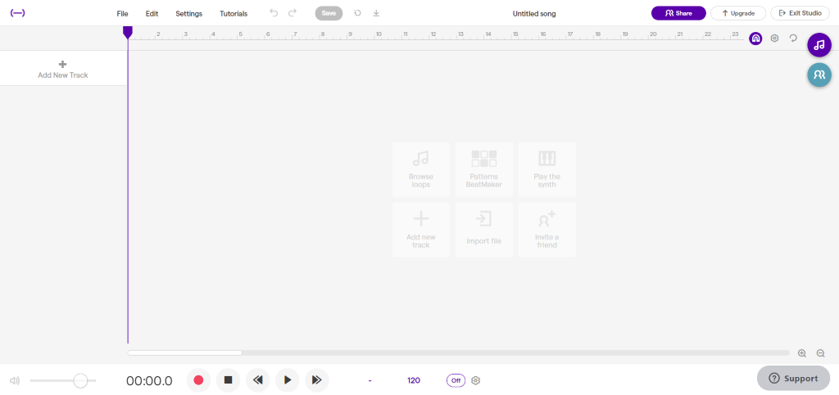
- On this page, you then need to set up your project. At the very top of the screen you need to name your project where it says ‘untitled song’. At the very bottom of the screen you can choose your key and tempo.
- It is now time to create music! To do this you will drag and drop a variety of loops/sounds to create your composition. When considering which loops to include, you will need to make sure that you have included the following parts:
  - harmonic accompaniment – this could include chords on guitars/keyboards or synth pads
  - bass line
  - rhythmic accompaniment
  - you can also add extra parts if you wish. For example, counter melodies, riffs, extra percussion features, electronic sound effects.
- There are two ways which you can import sound to create your track.
  - On the right hand side of the screen you will see a symbol which looks like this:
When you click on it, it will allow you to listen to, and select a range of loops. To listen to it, you click on it once, to select it, you click on it twice. You can then drag it into the main part of the page to include in your composition project. When you have added multiple parts to your composition it will look something like this:
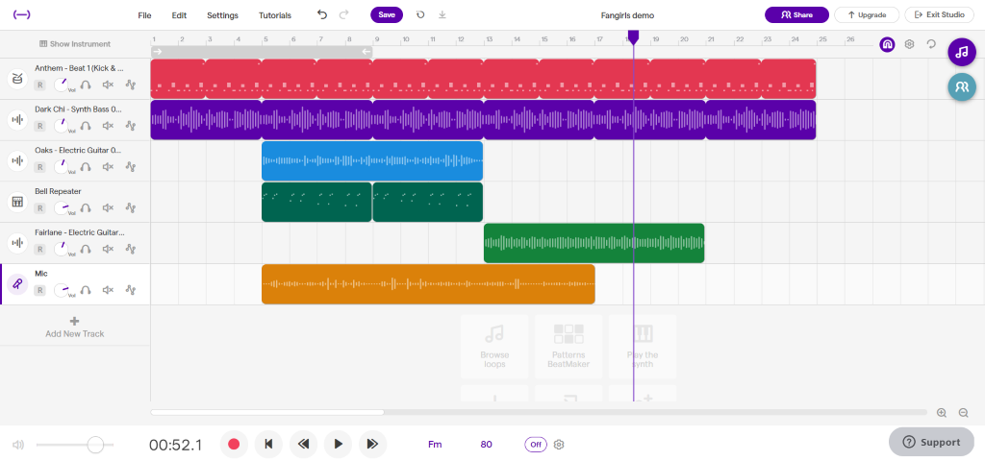
  - Another way to add sounds/instruments, is to use the ‘add new track’ function on the far left of the screen which looks like this:
This function will allow you to record the vocals once you have laid down your accompaniment parts. You can also record parts in this part of the program by playing the synthesizers and guitars manually on a computer keyboard.
- Experiment with the different loops by listening and layering them until you have achieved the sound you want. It is recommended that you record the accompaniment parts first before you record your vocal track. You can however always make changes or adapt your composition as needed.
- Once complete, save your project and upload it to google classroom or send it to your teacher.
Additional help in navigating Soundtrap can be found here: Get started with Soundtrap! (date accessed 4/12/2020).

Additional resources

Who is Yve Blake?
Yve Blake is a composer, lyricist, playwright and screenwriter. She is best known for writing the book, music and lyrics for the smash-hit musical ‘Fangirls’. In 2019, ‘Fangirls’ premiered at Queensland Theatre and Belvoir to multiple five-star reviews and sell-out crowds, and in 2021 it returned by popular demand for an Australian tour. ‘Fangirls’ was also awarded the 2019 Sydney Theatre Award for Best Mainstage Musical, the Matilda Award for Best Musical or Cabaret, and received an AWGIE nomination for best work of Musical Theatre. Yve started writing ‘Fangirls’ in 2016 when she became the inaugural recipient of the Rebel Wilson Theatre-maker scholarship at ATYP (the Australian Theatre for Young People). Her talk ‘For the love of Fangirls’ has received more than a million views on TED.com.

Watch
For the Love of Fangirls by Yve Blake TED Talk (date accessed 2/12/2020).

Listen
Creative Cast Industry Chat – Yve Blake (date accessed 15/12/2020)

Answers

Listening
- Listen to ‘Justice’ by Yve Blake (00:01:49 – 00:02:04) (date accessed 12/12/2020) and complete the texture graph below by colouring in when each instrument plays across the eight bars of this excerpt.
Layer | 1 | 2 | 3 | 4 | 5 | 6 | 7 | 8
vocals
synth strings
electric guitar/ bass
drumkit/percussion
- Describe the performing media and how it is used in each section. For example: What is its role? What is each layer playing in regards to rhythm and note values? Can you describe any other musical features about each layer of sound?
  - Vocals – melodic role. It uses mostly short note values including quavers and is sung in a rhythmic and percussive way. It also uses ‘sprechstimme’ which is a mixture of singing and speaking.
  - Synth strings – melodic and harmonic role. It doubles the melody at times and other times provides harmonic lines. It uses mostly short values and is played staccato.
  - Electric guitar/bass - harmonic role. It provides chords using distortion on the down beats of each bar.
  - Drumkit/percussion - Rhythmic role. It drives the feel using a triplet subdivision and a strong emphasis on the backbeat. Short note values.
- Discussion – Are the instruments acoustic? How can you tell? What are some reasons as to why composers may choose to work with electronic performing media?
  - The instruments are all electronic performing media except for the vocals. All instruments have been created in a DAW program and electronically manipulated, mixed and edited accordingly to create the desired effect.
  - One reason composers choose to use electronic performing media due to its versatility in relation to tone colour. The sounds can be manipulated and mixed with ease, and it is limitless in its textural and colour possibilities. It requires just one composer as opposed to multiple live musicians. Electronic music making it also very accessible for people with limited musical literacy skills to create music, as it does not involve reading traditional music notation.

Musical Theatre – Fangirls (original)
The musical, songs and score addressed throughout this resource are suggestions only and implies no endorsement by the New South Wales Department of Education, of any writer, composer, or publisher. Suitability of repertoire intended to be staged or studied at a school for a public audience or syllabus implementation should be considered, and respectful of the local community's values and beliefs. This resource contains language and themes which may be confronting to students. Teachers should seek approval from their principal to determine the suitability of this resource and gain parental permission before delivery.
Teachers should note and complete the Audio Visual Materials in schools advice (DOCX 78.85KB) and the Controversial resource information and permission note (DOCX 73.05KB) before commencing the study of a controversial resource.

Fangirls (original version)
Image sourced from pikist (date accessed 2/12/2020)
‘Fangirls’ is a musical written by a young Australian female writer called Yve Blake and was the winner of the 2019 Sydney Theatre Award for the Best Mainstage Musical. It is the story of a 14 year old girl 'Edna' who goes to an all girls private school but struggles with friendships. She is however, completely obsessed with 'Harry' who is a pop star in an all boy band. The story continues as Edna tries to meet Harry and declare her love for him which takes her on a journey of self-discovery.
‘Fangirls’’ overarching themes of addressing gender inequity and the stereotyping of female teenagers is both relevant and meaningful. It is masterfully written using teenage colloquial language which is cleverly impactful in its communication of the story and dramatic meaning and musical score. Having noticed that most popular musicals were written by men, Yve Blake's intention was to inspire girls to 'smash the glass ceiling' and to encourage girls to engage with writing, which is an incredibly important message for the youth of today. There is nothing quite like ‘Fangirls’ out there in the realm of Australian Musical Theatre, particularly written by such a young Australian woman.

Watch
Yve Blake ABC The Mix (00:06:30) (date accessed 2/12/2020)

Performance - ‘Justice’
- Musical Theatre warm up activity (00:05:18) (date accessed 2/12/2020)
- Listen to ‘Justice’ and follow along with the vocal score listed below. Discuss the dramatic context of the work outlined below.
- Perform the B section (bars 30 to 37) of ‘Justice’ from ‘Fangirls’ by Yve Blake using the recording and score provided in the score booklet. You may choose to do this either individually as a vocalist by singing with the backing track provided, or you may wish to arrange it for a small group or the class. Some rhythmic accompaniment parts are provided below:
Clicks
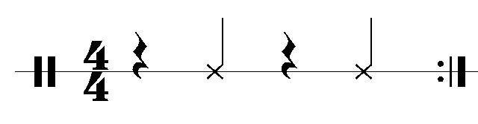
Tapping
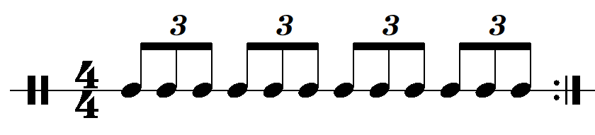

- ‘Justice’ by Yve Blake audio (00:05:50) (date accessed 11/12/2020)
- ‘Justice’ by Yve Blake backing track (00:05:50) (date accessed 11/12/2020)

Dramatic context – ‘Justice’
‘Justice’ is a song from the musical ‘Fangirls’. At this point of the story, the world's biggest pop star (Harry) has been missing for whole two days, and as a result: his fans are furious. ‘Justice’ takes place at a 'vigil' that has been organised by some of Harry's teenage fans. Crowds of teenage fans gather in a park and unite over their shared desire to enact (violent) revenge on whoever has taken Harry. But soon, one fan interrupts the discussion and calls attention to a much bigger issue...
Meanwhile, at home, the show's protagonist (Edna, 14) debates what to do with the kidnapped pop star she has in her wardrobe...
‘Justice’ is a song I wrote when I noticed the gendered language that is often used to describe (and ridicule) fangirls. Why is it that the image of a young man screaming at the football would be read as 'passionate', 'loyal' ... but the image of a teenage girl screaming at a pop concert might be described as 'hysterical', 'crazy', 'hormonal', 'pathetic' or 'insane'? Why is it that the world tries to minimise and ridicule young feminine enthusiasm?” - Yve Blake 2020

Listening
- Listen to ‘Justice’ by Yve Blake (00:01:49 – 00:02:04) (date accessed 12/12/2020) and complete the texture graph below by colouring in when each instrument plays across the eight bars of this excerpt.
Layer | 1 | 2 | 3 | 4 | 5 | 6 | 7 | 8
vocals
synth strings
Electric guitar/ bass
drumkit/percussion
- Describe the performing media and how it is used in each section. For example: What is its role? What is each layer playing in regards to rhythm and note values? Can you describe any other musical features about each layer of sound?
- Discussion – Are the instruments acoustic? How can you tell? What are some reasons as to why composers may choose to work with electronic performing media?

Composition
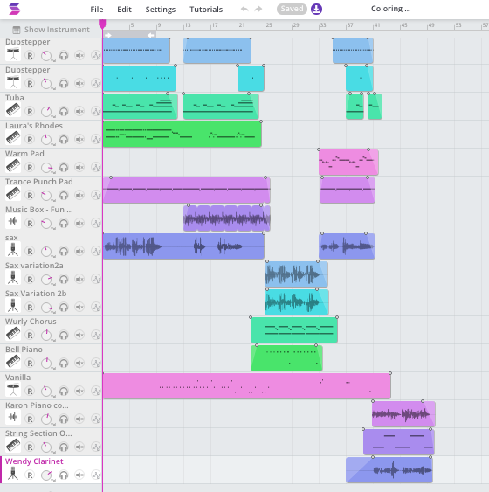
Image sourced from wikimedia (date accessed 2/12/2020)
Yve Blake uses several compositional and literacy techniques that are featured heavily in her writing.

Alliteration
Alliteration is the use of the same letter or sound at the beginning of consecutive words. This can be seen in the G section of ‘Justice’ from bars 72 – 73. (00:03:18 – 00:03:29)
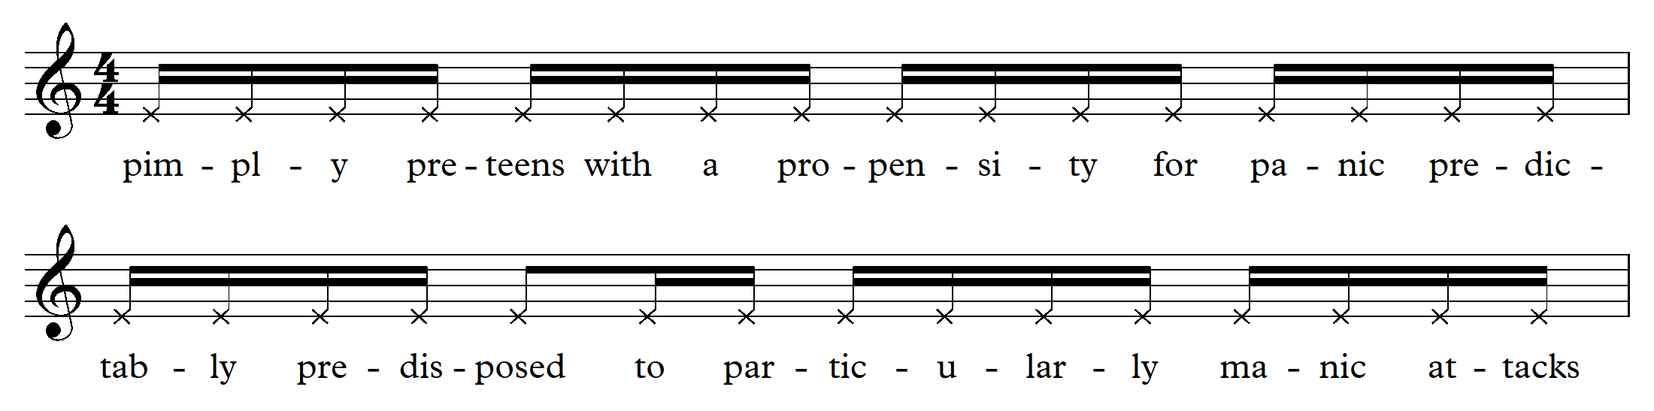
Can you write your own sentence completely made up of alliteration?

Speech rhythms
Yve Blake carefully studied how teenage girls talked as part of her research in writing ‘Fangirls’. She listened carefully to the speed, inflection, rhythm, pitch and how different syllables were accentuated. Many of her lyrics in ‘Justice’ are carefully notated to reflect the natural speech rhythms of particular words. For example: Section F bars 80 – 81. (00:03:38 – 00:03:44)
Say the sentence below and clap the rhythm. You will notice how the words natural rhythms are reflected in the written notation.
Now say your full name out loud. Can you attempt to notate the rhythm of your name?

Sprechstimme
German for ‘speak singing’, this is a cross between singing and speaking where the pitches of the speaking are heightened. This can be seen in the introduction of ‘Justice’ particularly in bars 18-30 which uses a mixture of singing and speaking. Sprechstimme is usually written with crossed note heads.
For example: (bars 43 to 45)
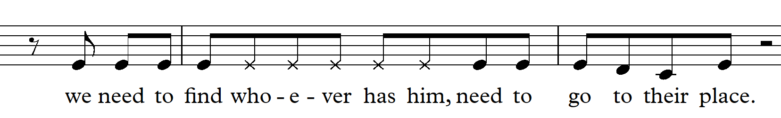
Perform the above example of sprechstimme in pairs.

Activity
The entire score of ‘Fangirls’ was composed by Yve Blake using computer software called ‘Ableton’ which is a digital audio workstation (DAW). This involved importing electronic sounds, samples and loops and combining them with pre-recorded material (like vocals). Yve Blake does not actually play a musical instrument and has had no extensive formal musical training. She learnt how to use the software by watching youtube videos and experimenting with the program to create all the music for ‘Fangirls’.
Individually, in pairs or small groups, you will be writing your own short musical theatre piece using a digital audio work station. There are many accessible DAW programs available such as Ableton Live, Soundtrap and Band Lab, however for this task, Soundtrap will be used for the example. Soundtrap is a cloud based program which allows multiple students to work on the file at the same time and is compatible with both Google Classroom and Microsoft Teams.
*Please note the Department of Education does not endorse any software listed above. We recommend that teachers access the free versions available.

Steps
- Brainstorm and create a character for an imaginary musical. Write down your ideas in your book.
- Choose a topic that your character will sing about from the list of musical theatre songs below:
  - ‘I want song’ - this type of song expresses what the character is looking for or longing for and is often found at the beginning of a musical for audiences to connect with the main character and their anticipated journey.
  - ‘Ballad’ - a song with a slower tempo which is emotionally driven. It can often contain themes of love.
  - ‘Charm song’ - a song where the character beguiles the audience.
  - ‘Comedy song’ - A humorous, fast paced song to get the audience laughing.
  - ‘Mission song’ - a song that communicates the plans of the characters within the storyline.
  - ‘Eleven o’clock number’ – this number appears towards the end of the show and is usually a very emotionally charged number at the characters lowest moment. ‘Justice’ is an example of this type of music.
- Create a verse of lyrics to reflect the topic using an imagined storyline or plot. You must include at least one of the compositional techniques that Yve Blake uses in ‘Fangirls’. For example: alliteration, speech rhythms or sprechstimme.
- The structure of your composition will consist of an introduction (instrumental) and a verse. You may wish to include more sections if you wish.
- The teacher will set up a free Soundtrap school account and provide you with login details. Soundtrap (date accessed 4/12/2020)
- Once you have logged in, you need to press ‘enter studio’ then, ‘music’. This will take you to a project page which looks like this:
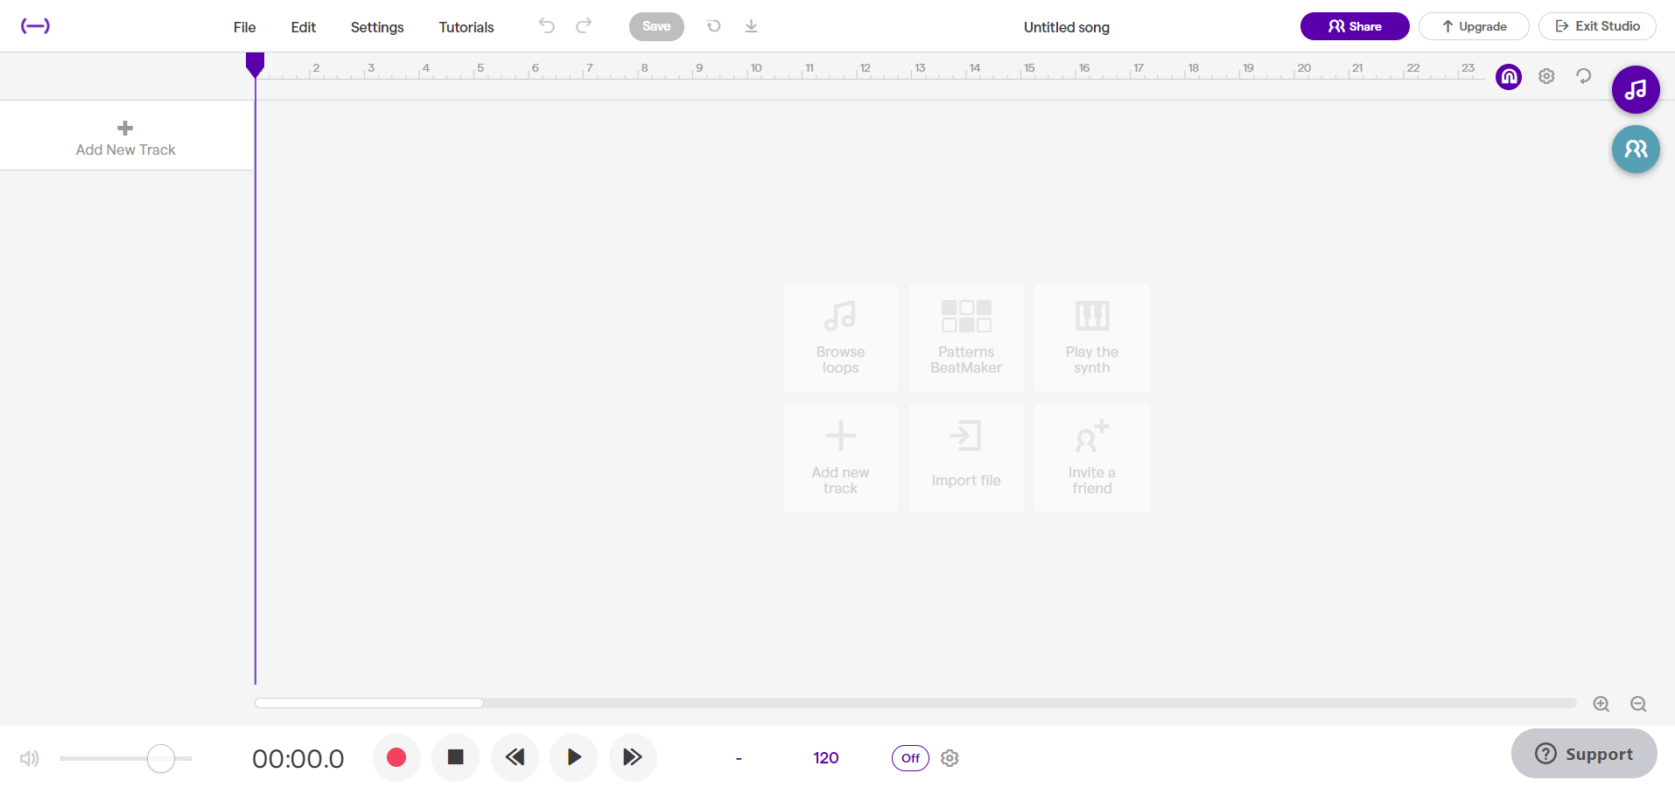
- On this page, you then need to set up your project. At the very top of the screen you need to name your project where it says ‘untitled song’. At the very bottom of the screen you can choose your key and tempo.
- It is now time to create music! To do this you will drag and drop a variety of loops/sounds to create your composition. When considering which loops to include, you will need to make sure that you have included the following parts:
  - harmonic accompaniment – this could include chords on guitars/keyboards or synth pads
  - bass line
  - rhythmic accompaniment
  - you can also add extra parts if you wish. For example, counter melodies, riffs, extra percussion features, electronic sound effects.
- There are two ways which you can import sound to create your track.
  - On the right hand side of the screen you will see a symbol which looks like this:
When you click on it, it will allow you to listen to, and select a range of loops. To listen to it, you click on it once, to select it, you click on it twice. You can then drag it into the main part of the page to include in your composition project. When you have added multiple parts to your composition it will look something like this:
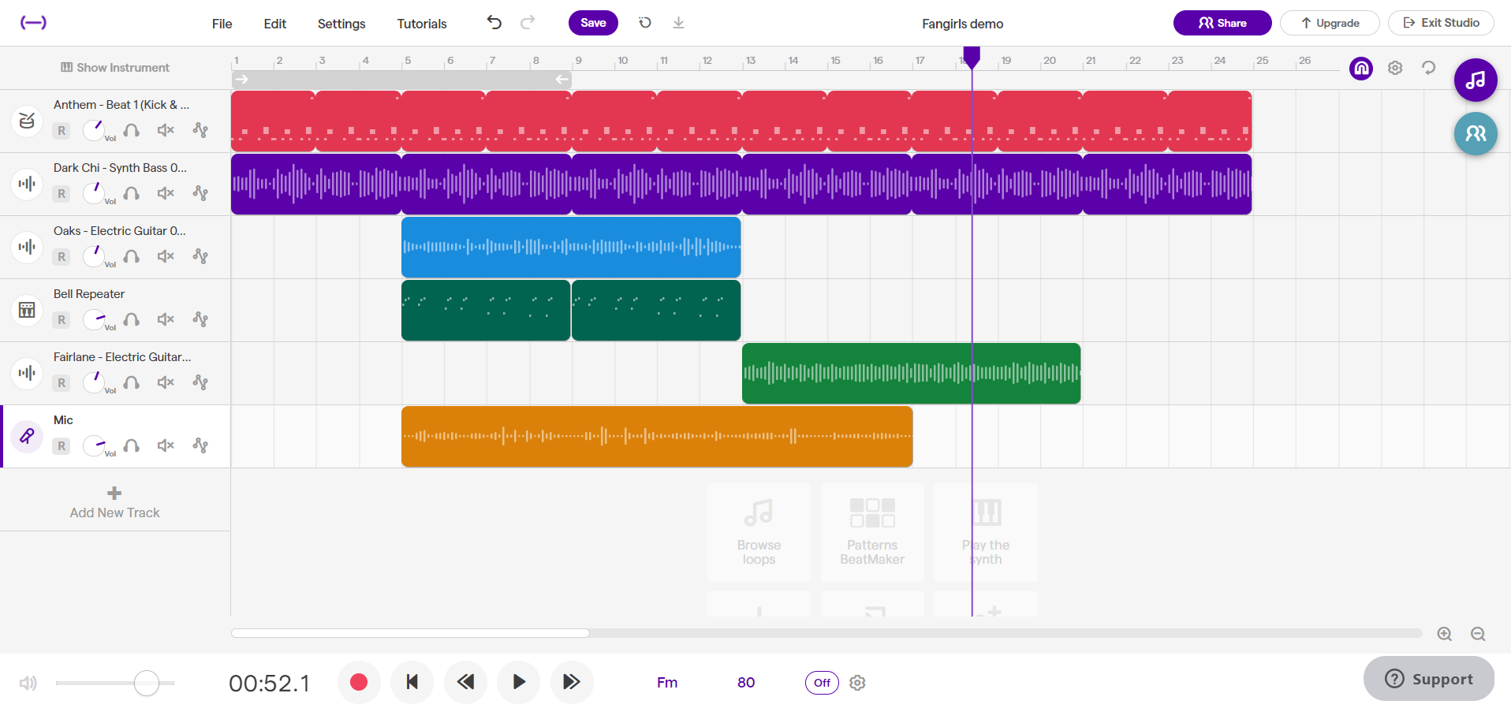
  - Another way to add sounds/instruments, is to use the ‘add new track’ function on the far left of the screen which looks like this:
This function will allow you to record the vocals once you have laid down your accompaniment parts. You can also record parts in this part of the program by playing the synthesizers and guitars manually on a computer keyboard.
- Experiment with the different loops by listening and layering them until you have achieved the sound you want. It is recommended that you record the accompaniment parts first before you record your vocal track. You can however always make changes or adapt your composition as needed.
- Once complete, save your project and upload it to google classroom or send it to your teacher.
Additional help in navigating Soundtrap can be found here: Get started with Soundtrap! (date accessed 4/12/2020).

Additional resources

Who is Yve Blake?
Yve Blake is a composer, lyricist, playwright and screenwriter. She is best known for writing the book, music and lyrics for the smash-hit musical ‘Fangirls’. In 2019, ‘Fangirls’ premiered at Queensland Theatre and Belvoir to multiple five-star reviews and sell-out crowds, and in 2021 it returned by popular demand for an Australian tour. ‘Fangirls’ was also awarded the 2019 Sydney Theatre Award for Best Mainstage Musical, the Matilda Award for Best Musical or Cabaret, and received an AWGIE nomination for best work of Musical Theatre. Yve started writing ‘Fangirls’ in 2016 when she became the inaugural recipient of the Rebel Wilson Theatre-maker scholarship at ATYP (the Australian Theatre for Young People). Her talk ‘For the love of Fangirls’ has received more than a million views on TED.com.

Watch
For the Love of Fangirls by Yve Blake TED Talk (date accessed 2/12/2020)

Answers

Listening
- Listen to ‘Justice’ by Yve Blake audio (00:01:49 - 00:02:04) (date accessed 11/12/2020) and complete the texture graph below by colouring in when each instrument plays across the eight bars of this excerpt.
Layer | 1 | 2 | 3 | 4 | 5 | 6 | 7 | 8
vocals
synth strings
electric guitar/ bass
drumkit/percussion
- Describe the performing media and how it is used in each section. For example: What is its role? What is each layer playing in regards to rhythm and note values? Can you describe any other musical features about each layer of sound?
  - Vocals – melodic role. It uses mostly short note values including quavers and is sung in a rhythmic and percussive way. It also uses ‘sprechstimme’ which is a mixture of singing and speaking.
  - Synth strings – melodic and harmonic role. It doubles the melody at times and other times provides harmonic lines. It uses mostly short values and is played staccato.
  - Electric guitar/bass - harmonic role. It provides chords using distortion on the down beats of each bar.
  - Drumkit/percussion - Rhythmic role. It drives the feel using a triplet subdivision and a strong emphasis on the backbeat. Short note values.
- Discussion – Are the instruments acoustic? How can you tell? What are some reasons as to why composers may choose to work with electronic performing media?
  - The instruments are all electronic performing media except for the vocals. All instruments have been created in a DAW program and electronically manipulated, mixed and edited accordingly to create the desired effect.
  - On reason composers choose to use electronic performing media due to its versatility in relation to tone colour. The sounds can be manipulated and mixed with ease, and it is limitless in its textural and colour possibilities. It requires just one composer as opposed to multiple live musicians. Electronic music making it also very accessible for people with limited musical literacy skills to create music, as it does not involve reading traditional music notation.

Musical theatre – Matilda the Musical
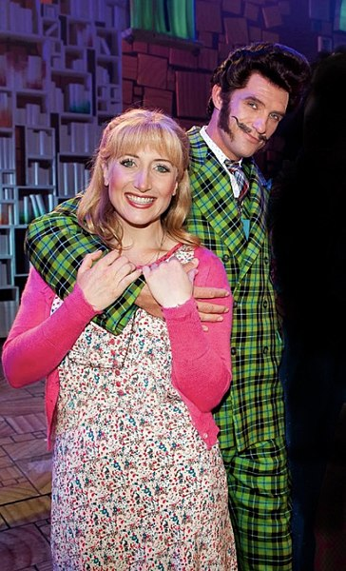
Image sourced from Wikimedia (date accessed 18/11/2020)
Matilda the Musical is a stage musical based on the 1988 children's novel of the same name by Roald Dahl. It was adapted by Dennis Kelly, with music and lyrics by Australian Tim Minchin and directed for the stage by Matthew Warchus. The musical's narrative centres on Matilda, a precocious five year old girl with the gift of telekinesis, who loves reading, overcomes obstacles caused by her family and school, and helps her teacher to reclaim her life.
Text sourced from Wikipedia (date accessed 18/11/2020)

Listening
- Watch the following performance of ‘Revolting Children’ by Tim Minchin (00:00:35 – 00:04:57) (date accessed 18/11/2020) from Matilda the Musical.
- Circle or highlight the musical elements below that can be heard in ‘Revolting Children’ by Tim Minchin according to the concepts of music. For each observation, give an example of where it can be heard and, if applicable, in which instrument part. For example, ‘trumpet, chorus.’ You can write this in the box you have circled or highlighted.
- Extension – colour code each box according to which concept of music it is. For example, colour all elements that are related to pitch in red.
Musical observations
thick texture | woodwind instruments | ¾ time signature | allegro tempo | polyphonic texture
drumkit | monophonic texture | minor tonality | brass instruments | 4/4 time signature
pianissimo dynamic | short note values | multimetre | homophonic texture | syncopation
5/4 time signature | andante tempo | major tonality | long note values | forte dynamic
accents | repeated rhythms | thin texture | bagpipes | crescendo

Performance
- Perform the following rhythms below on either chairs (sitting backwards on them) or bucket drums using drumsticks.

Rhythm one
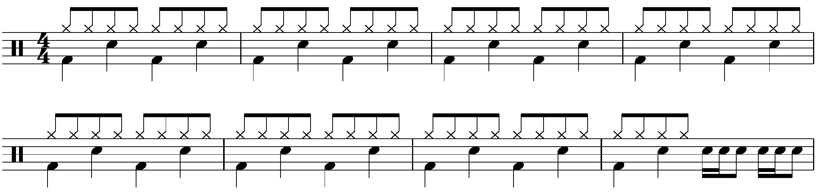

Rhythm two
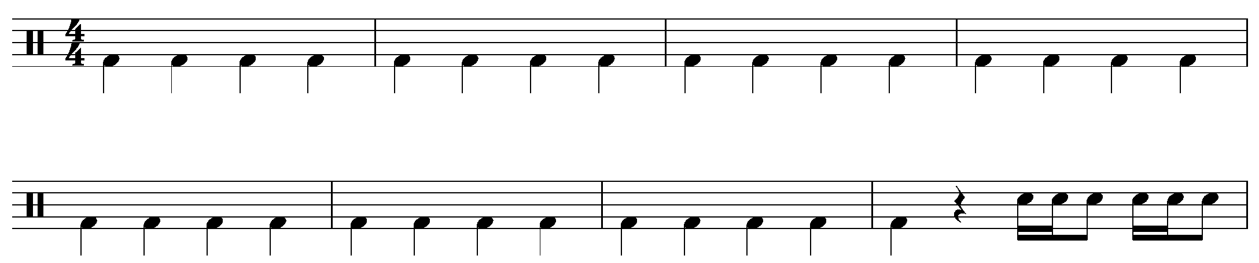

Rhythm three
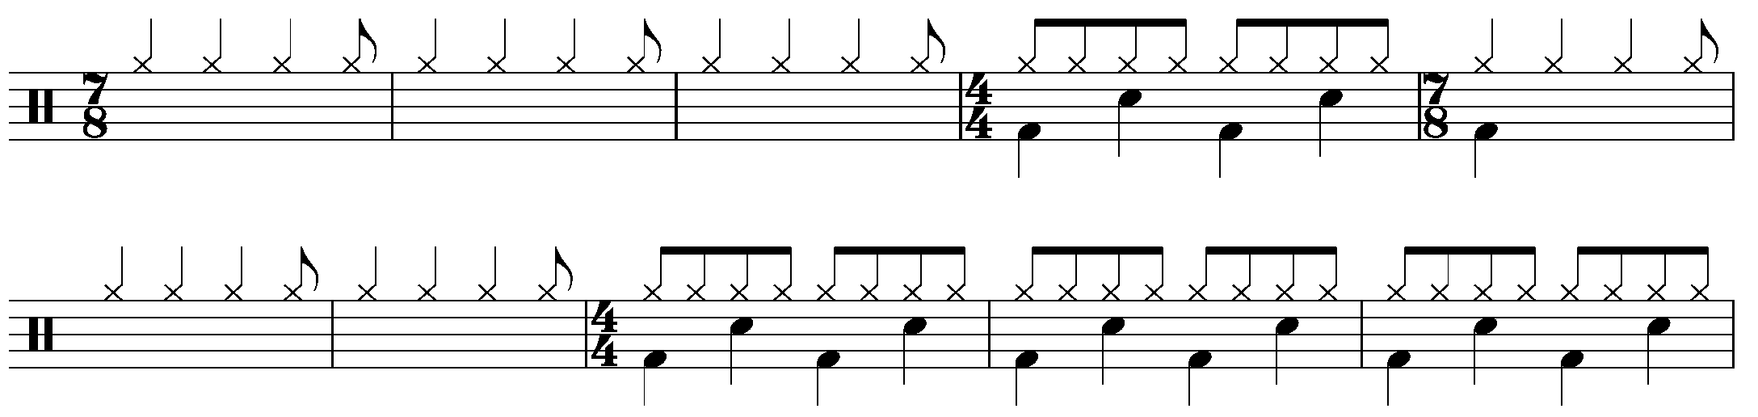
- Listen to ‘Revolting Children’ by Tim Minchin (00:02:31) (date accessed 18/11/2020) and see if you can match up which rhythm would best fit with each section of the piece. Can you find other songs that these rhythms may fit with? What is it called when the time signatures change like this?
Score reading - extension
Using the score of ‘Revolting Children’ by Tim Minchin score, (date accessed 18/11/2020) answer the following in your books using full sentences.
  - What is the key signature of this piece? (It is in a minor key)
  - What is the time signature of this piece?
  - Does the time signature stay the same? If not, what does it change to and what do we call it when the time signatures changes?
  - What performing media/instruments is this music written for?
  - What are the names and values of the notes found in the left hand of the piano part in bar six?
  - What is the shortest note value you can find and how many beats does it go for? (Make sure you identify the bar and instrumental part in your answer)
  - What does ‘a tempo’ mean at bar six? (Hint, look at how the music starts at the very beginning)
  - In bar 10, the notes written above ‘never again!’ have crosses instead of note heads. Why do you think this is?
  - Choose four chords (written above the vocal line) and write out the notes in that chord using manuscript and paste it in your book. (You may need to refer to the work we did earlier in the year on chords.)
  - Listen to the song and see if you can follow it along with the score OR try playing or singing along with the music.

Composition – extension
Watch this youtube clip of Australian composer Brendan Collins who will teach you how to write a composition in 7/8.
Brendan Collins – composing in 7/8 (date accessed 20/11/2020)
Watch
Interview with Tim Minchin (date accessed 18/11/2020) on Conan USA

Answers

Listening
Question 3 - Extension – colour code each box according to which concept of music it relates to. For example, colour all elements that are related to tone colour in red.
Music observations
thick texture | woodwind instruments | ¾ time signature | allegro tempo | polyphonic texture
drumkit | monophonic texture | minor tonality | brass instruments | 4/4 time signature
pianissimo dynamic | short note values | multimetre | homophonic texture | syncopation

Performance
Question two – rhythm one and rhythm two will fit with almost any pop genre which uses a fast tempo. Rhythm three will fit with the following pieces which use multimetre of 4/4 and 7/8.
- ‘Heaven on their Minds’ by Lloyd Webber (00:02:52 – 00:03:07) from Jesus Christ Superstar (date accessed 18/11/2020)
- ‘Meet Me Inside’ by Miranda (00:00:00-00:00:30) from Hamilton (date accessed 18/11/2020)
- ‘Who’s the Thief’ by Lloyd Webber (00:02:20) from Joseph and the Technicolour Dreamcoat (date accessed 20/11/2020)
- ‘Paranoid Android’ by Radiohead (00:02:11 – 00:02:34) (date accessed 18/11/2020)
- ‘Deliverance’ by Opeth (00:00:00 – 00:00:057) (date accessed 20/11/2020)
- ‘The Ocean’ by Led Zepplin (00:00:00 – 00:01:10) (date accessed 20/11/2020)
- ‘Them Bones’ by Alice in Chains (00:00:00 – 00:00:50) (date accessed 20/11/2020)

Score reading - extension

Using the score of ‘Revolting Children’ by Tim Minchin score, (date accessed 18/11/2020) answer the following in your books using full sentences:
  - What is the key signature of this piece?
  - D minor
  - What is the time signature of this piece?
  - 4/4 - four crotchets per bar
  - Does the time signature stay the same? If not what does it change to and what do we call it when the time signatures changes?
  - It changes between 4/4 and 7/8 throughout the piece. We call this multimetre.
  - What performing media/instruments is this music written for?
  - Voice, piano, guitar, (bass)
  - What are the names and values of the notes found in the left hand of the piano part in bar six?
  - Crotchets – one beat
  - What is the shortest note value you can find and how many beats does it go for? (Make sure you identify the bar and instrumental part in your answer)
  - Bar three: voice and right hand piano. Semiquavers triplet 1/6 beat per note.
  - What does ‘a tempo’ mean at bar 6? (Hint, look at how the music starts at the very beginning)
  - It means that you return to the original tempo or speed.
  - In bar 10, the notes written above ‘never again!’ have crosses instead of note heads. Why do you think this is?
  - This is to indicate that the words are spoken (or shouted) not sung.
  - Choose four chords (written above the vocal line) and write out the notes in that chord using manuscript and paste it in your book. (You may need to refer to the work we did earlier in the year on chords.)
  - Listen to the song and see if you can follow it along with the score OR try playing or singing along with the music.

Music for television
Image sourced from Wikimedia (date accessed 20/11/2020)
Bluey is an Australian animated television series for preschool children. The program was created by Joe Brumm with Queensland production group Ludo Studio. The show follows Bluey, a six-year-old blue heeler puppy who is characterised by her abundance of energy, imagination and curiosity of the world. The young dog lives with her father, Bandit; mother, Chilli; and younger sister, Bingo, who regularly joins Bluey on adventures as the pair embark on imaginative play together. Overarching themes include the focus on family, growing up and Australian culture. Joff Bush serves as one of the primary composers of ‘Bluey’ writing half of the soundtrack himself and leading a group of additional composers, including David Barber. Bush has stated that each episode has its own unique musical style and is individually scored, and he likes to become involved in the episodes as they are scripted. Live instruments are regularly played for the recordings.
Text sourced from Wikipedia (date accessed 20/11/2020)

Performance
- Perform the ‘Bluey’ theme song as a class using the audio and score provided in the score booklet and discuss its musical features: ‘Bluey’ theme song by Joff Bush (00:00:24) audio (date accessed 20/11/2020)
- Music is often a very significant part of a television program or film. Production companies, who produce these audio-visual works, sometimes hire a composer to write the music, an artist to reproduce a previously existing song, or seek the music rights to use a pre-existing recording.
There are many different types of music used in television shows which may include:
- teaser - a musical cue which scores a preview scene before the main title or theme song
- theme song - an opening or closing song that is associated with a TV show.
- underscore (background music) - music that is played in the background, often behind dialogue. It often sets the mood or atmosphere of the scene.
- bumper – a bumper is a musical transition consisting of a short musical piece that signals a change of scene.
- tracking - the use of pre-recorded music used in a TV show that was not originally created for the show.
- diegetic music: this is music that is happening within the scene itself. For example, music being played in a nightclub etc.
- mickey mousing: this is music that exactly matches the movement onscreen and is often found in cartoons.
- highlight - music that specifically highlights a character or item within the scene.
- foley sounds - everyday sound effects.
- end credits - music that is played behind the end credits.

Listening
- In audio visual production, the music producer will use a cue sheet to document the music to be used within the show. Watch the Bluey episode from Season 1 episode 7 titled ‘Bluey’ episode ‘BBQ’ (date accessed 23/08/2020) on the ABCiview website (date accessed 20/11/2020) and see if you can fill out the cue sheet below. If not available, use the answers as a guide, and move to question three.
- As a class, identify the type of music used at each timecode throughout the show using the table below. The types of music and their definitions are found above.
- Choose another Bluey episode of your choice and fill out a second cue sheet for that episode.

Bluey - BBQ episode
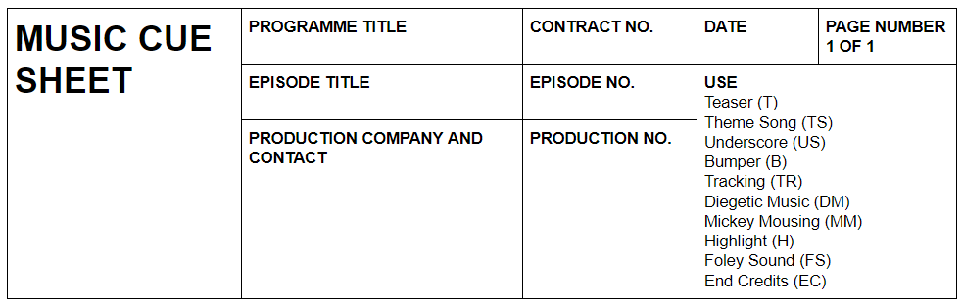
Time code | Music title/description | Composer/performer | Use
0:00 - 0:23 | Bluey theme song | Joff Bush | TS
0:25 - 0:47 | BBQ and bird sounds |  | FS
0:48 - 0:51 | Xylophone music |  | B
0:55 - 2:2
2:21 - 2:24
2:25 - 2:37
2:45 - 2:48
2:48 - end
2:57 - 3:18
3:49 - 5:02
6:46 - 7:00

Bluey — own choice episode
Time code | Music title/description | Composer/performer | Use

Composition

Choose one of the following activities to complete either by yourself or in small groups (no more than five in a group).

Option one
Compose a theme song for a show that you used to watch when you were a child. If it already has a theme song, you need to write a new theme song for the show. You must include the following:
- minimum of 8 bars
- it must contain a melody and harmonic accompaniment (chords) but doesn’t necessarily need to include lyrics or vocals. For example, you may wish to compose an instrumental.
- you must include the use of multimetre in your theme song.

Option two

Write some underscoring for a scene in an episode of Bluey. Follow the steps below.
- Choose an episode of Bluey from the ABCiview website (date accessed 20/11/2020) and select a scene that is approximately one minute long that has some underscoring in it.
- Identify the mood of the scene. Without being too influenced by the underscoring already created, brainstorm what types of musical elements you may like to include in your own group composition which reflect this mood according to the following:
  - performing media
  - tonality (major/minor)
  - note values
  - dynamics
- Create a composition that could be used as underscoring for that particular scene and perform it along with the visual on your phone/laptop. You could also choose to work with computer software to create your composition by exploring software such as:
  - Soundtrap (date accessed 20/11/2020)
  - Garageband (date accessed 20/11/2020)
  - Reaper (date accessed 20/11/2020)
  - Studio One Prime (date accessed 20/11/2020)

Option three
Recreate foley sounds for part of an episode of Bluey (your choice) the ABCiview website (date accessed 20/11/2020). Follow the steps below.
- Select a section of a Bluey episode that goes for two to three minutes.
- In your books, write down the exact time that each foley sounds occurs, along with a description of the sound that needs to be created. For example: 1:22 - 1:26 (bench seat being dragged)
- Experiment with creating the different sounds using items available to you and record each sound on your phone. Save it as an audio file in ‘voice memos’ or similar.
- Document what you used to make each sound in your books and give each sound a name.
- Once you have recorded all of your sounds, play them along with the Bluey episode from your phone or live, making sure that you play them at the correct times during performance. Alternatively, you could also choose to record them using one of the digital audio stations (DAWS) listed above.

Answers

Performance
Discuss the musical features of the song – these may include: use of multimetre through the use of 4/4 and 5/4, fast tempo, syncopation, short note values, major tonality, repetition, thick texture, catchy melody or hook.
Bluey - BBQ episode
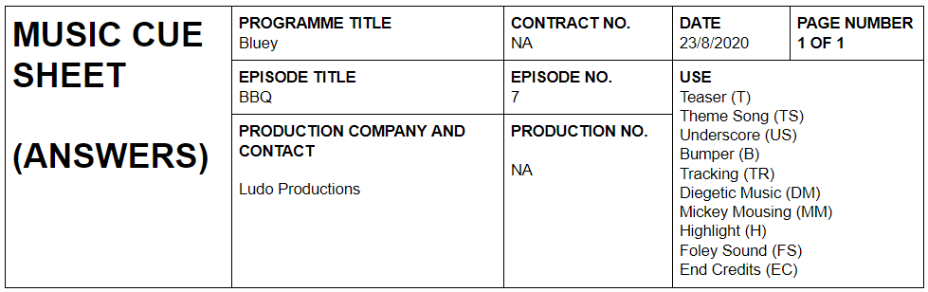

Time code | Music title/description | Composer/performer | Use
0:00 - 0:23 | Bluey theme song | Joff Bush | TS
0:25 - 0:47 | BBQ and bird sounds |  | FS
0:48 - 0:51 | xylophone music |  | B
0:55 - 2:2 | flute, guitar, harmonica and xylophone music |  | US
2:21 - 2:24 | flute trilling |  | MM
2:25 - 2:37 | flute, guitar, drums and xylophone music |  | US
2:45 - 2:48 | synthesizer and wind chimes |  | H
2:48 - end | flute, guitar, harmonica, guitar and xylophone music |  | US
2:57 - 3:18 | bench seat, beer can |  | FS
3:49 - 5:02 | tree seeds, rake, hose |  | FS

Opera

The Rabbits
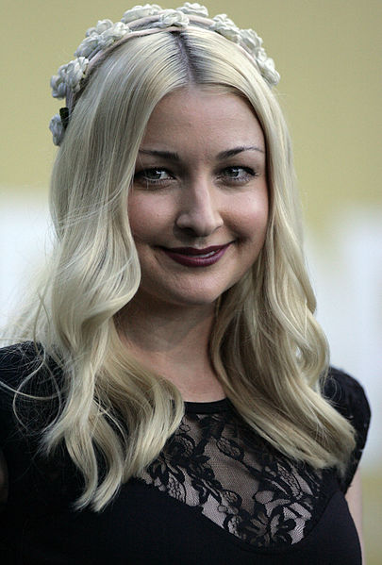
Image sourced from Wikimedia (date accessed 23/11/2020)

Performance and literacy activity
- Using the score of ‘Where?’ by Kate Miller-Heidke and Iain Grandage (date accessed 23/11/2020) learn to sing the melody of the verse with piano or chordal accompaniment as a class.
- Think, pair, share activity - Look at the lyrics of ‘Where?’ from The Rabbits by Kate Miller-Heidke and Iain Grandage lyrics (date accessed 23/11/2020). What do you think the lyrics are about? Some guiding questions may include: Why do you think the landscape is mentioned? Who are the mothers and fathers? Who needs saving? Who are the rabbits? Students are to share their ideas with a friend, and then discuss as a class.
- Watch the youtube clip of the book ‘The Rabbits’ by John Marsden and Shaun Tan (00:02:33). (date accessed 8/12/2020) Students are to answer the following questions in their book.
  - What is the book about?
  - Whose perspective is the book written from?
  - Who do the rabbits represent?
  - Why do you think John Marsden chose to use rabbits and marsupials?
  - What links can you make between the vocal lyrics and the book?
‘The Rabbits’ is a children’s book written by John Marsden and illustrated by Shaun Tan and is an allegory for the colonisation of Australia. It depicts the adverse effects that colonisation had on our First Nations people due to the European settlement. Issues surrounding conflict, the stolen generation, industrialisation and its effect on the environment, and loss of Aboriginal culture are addressed in the powerful text and imagery. The book is written from the First Nation’s point of view where they are portrayed as marsupials and the invaders are depicted as rabbits.
In 2015, it was reimagined as an opera, by Australian vocalist and composer Kate Miller-Heidke and writer Lally Katz and produced by Opera Australia.

Listening
- Watch the following interview with Kate Miller-Heidke (composer and performer) and John Sheedy (theatre company director) on the adaption of ‘The Rabbits’ as an Opera. ‘The Rabbits’ Opera interview (00:05:50) (date accessed 23/11/2020) Students are to complete the questions below in their books.
  - According to John Sheedy, what is one of the most wonderful things about John Marsden and Shaun Tan’s book?
  - What is the universal theme that John Sheedy describes?
  - How do you think John Marsden and Shaun Tan made the story accessible to young people?
  - Describe one experience that Kate had in writing music for the opera.
  - Kate describes the music as a ‘triangle’ of different styles with each representing different characters in the story. FiIl out the table below according to how Kate describes the musical styles of each character:
Image | Character | Musical Style
 | Rabbits
 | Marsupials
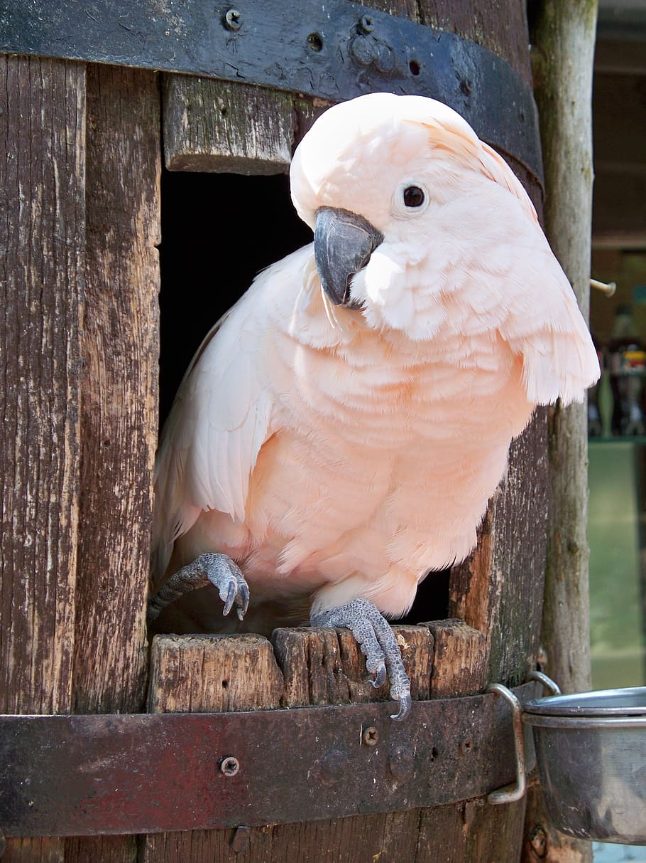 | Narrator (the bird)

Image sources - Rabbit image (date accessed 23/11/2020) Marsupial image (date accessed 23/11/2020) Bird image (date accessed 23/11/2020).
- Divide students into six small groups and allocate one concept of music per group. Using the concepts of music checklist sheet as a guide, students are then to listen to the audio of ‘Where?’ by Kate Miller-Heidke and Ian Grandage (00:05:00) (date accessed 23/11/2020) and fill in the following table with some musical observations according to that concept.
- Each group is then to share their observations with the class for all students to fill in the rest of the table.
Concept | Musical Observations
Structure
Duration
Pitch
Tone colour
Texture
Dynamics and expressive techniques

Composition and performance
There are several compositional techniques that Kate Miller-Heidke and Iain Grandage explore in the piece ‘Where?’ from ‘The Rabbits’. For each example, draw a visual representation of what the technique would look like using either traditional or graphic notation.

Technique | Description | Visual representation
Repeated broken chord with a moving bass line | The harmonic accompaniment played on piano in ‘Where?’, uses a type of oblique motion where the broken chord played in the right hand stays the same, but the second hand (acting as bass line) notes change. This type of chord is known as a slash chord. For example in bars 1 – 3 of ‘Where?’
Consecutive fifths | The bass line of ‘Where?’ relies heavily on the use of consecutive fifths to emphasise the tonic and dominant of the chord. Fifths typically provide an ‘open’ sound and are often used by composers to evoke the sound of music in exotic places. For example, in bars 9-15 of the left-hand part of the piano of ‘Where?’
Melisma | This is a vocal technique where multiple notes are sung on one syllable and is characteristic of most vocal music. In Opera, melisma is often extended through long phrases which emphasises the vowels and vocal tone of the performer, in addition to showcasing the performer’s technical and expressive ability. For example, this can be heard in the pre-chorus of ‘Where?’ on the words ‘wind’ and ‘plants.’
Wide vocal range | This is a technique which is characteristic of operatic works to demonstrate technical mastery and explore expressive elements within the piece. For example, this can be heard at the end of the pre-chorus of ‘Where?’ The overall vocal range in this piece spans two octaves:  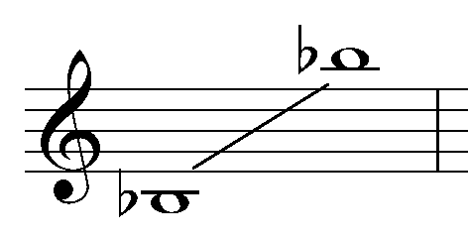

Activity
In small groups or individually, students are to compose a short, allegorical piece (one verse) about a topic that is important to them that has ethical, moral or political implications. It must include the following:
- students are to compose their piece in the style of either the rabbits, marsupials or narrator as described in the listening activity.
- students must incorporate at least two of the compositional techniques utilised in ‘Where?’ from ‘The Rabbits’ mentioned above. (Don’t forget that consecutive fifths are also used as power chords on guitar!)
- lyrics that represent a topic that is important to the student.
- two layers of sound consisting of a harmonic accompaniment and vocals. Other instruments may be added if desired.

Steps
- Students form small groups or work in pairs or individually.
- Choose one of the musical styles represented by either the rabbits, marsupials or narrator.
- Choose at least two compositional techniques that you wish to use in your composition from either broken chords and moving bass line, consecutive fifths, melisma or a wide vocal range.
- Brainstorm ideas as to what musical elements might best reflect the selected style. Considerations may include: the time signature, the ‘feel’ or ‘groove’, instrumentation, tonality, tempo.
- Research the topic, or brainstorm ideas in relation to the lyric content on your selected topic.
- Write the lyrics for approximately one verse.
- Start with composing the harmonic progression for your piece by following these steps:
  - Choose a key signature that you are comfortable performing in.
  - Next, you are going to write a four bar chord progression that can then be repeated.
  - Find the tonic chord as a starting point for your harmonic progression. For example, if you are in A minor, start with the Am chord.
  - Aim to just use one chord per bar and experiment with different chord progressions in that key. If you are not confident with this, you can use autochords which will generate some chord progression options for you.
  - Remember if you are using the broken chord over the moving bass line, that the broken chord will remain the same for at least four bars, as the bass line changes.
  - Once you have found a chord progression you like, play it repeatedly until you are confident.
  - Add a bass line by playing the tonic note of each chord, or consecutive fifths, or a moving bass line where the bass note doesn’t directly come from the chordal notes.
  - Now experiment by improvising a melody over the top of your chord progression using your lyrics.
  - Add additional instruments if required.
  - Perform to the class and record on your phone.

Homework reflection questions
- What makes you feel passionate about, or why are you interested in your particular topic?
- What do you think worked well musically in your composition?
- If you were to do the task again, what would you do differently and why?

Glossary
Word | Definition
allegory | A story, poem or picture that can be interpreted to reveal a hidden meaning, typically a moral or political one.
broken chord | When notes of a chord are played separately in succession.
oblique motion | When one part moves in motion, whilst the other part remains on the same pitch.
slash chord | A chord which is played with an inverted bass note, or bass note not related to the chord indicated by a slash between the chord name and bass note. For example: Am/C
consecutive fifths | The interval of a fifth played in harmony in succession.
melisma | This is a vocal technique where multiple notes are sung on one syllable.
tonic | The first note of a scale.
dominant | The fifth note of a scale.

Answers

Performance and literacy activity
- Watch the youtube clip of the book ‘The Rabbits’ by John Marsden and Shaun Tan (00:02:33). (date accessed 8/12/2020) Students are to answer the questions below in their books.
  - What is the book about?
  - The book follows the story of the European settlement in Australia and its devastating effects it had on the First Nations people.
  - Whose perspective is the book written from?
  - The Aboriginals.
  - Who do the rabbits represent?
  - The Europeans.
  - Why do you think John Marsden chose to use rabbits and marsupials?
  - The use of rabbits is significant as rabbits were an introduced species to Australia in 1859 with the European settlers which reinforces the infestation imagery that colonising creates. The marsupials represent the Aboriginals as they are native to Australia.
  - What links can you make between the vocal lyrics and the book?
  - The lyrics make a direct link to the book and depict the devastating impact that colonisation had on the Australian landscape and Aboriginal culture. It reflects on what one was and what now remains with reference to the land, environment and fauna.

Listening
- Watch the following interview with Kate Miller-Heidke (composer and performer) and John Sheedy (theatre company director) on the adaption of ‘The Rabbits’ as an Opera. ‘The Rabbits’ Opera interview (00:05:50) (date accessed 23/11/2020) Students are to complete the questions below in their books:
  - According to John Sheedy, what is one of the most wonderful things about John Marsden and Shaun Tan’s book?
  - One of the most wonderful things is that it’s so universal in its themes and approach.
  - What is the universal theme that John Sheedy describes?
  - It is a metaphor for any indigenous culture who have suffered due to the colonisation of Europeans.
  - How do you think John Marsden and Shaun Tan made the story accessible to young people?
  - Through the use of symbolism and imagery in the representation of the characters through animals.
  - Describe one experience that Kate had in writing music for the opera.
  - She found it enormously liberating to be able to write from the perspective of someone else and for the purpose of being able to tell a story. The writing process felt really fun and free.
  - Kate describes the music as a ‘triangle’ of different styles with each representing different characters in the story. FiIl out the table below according to how Kate describes the musical styles of each character:
Image | Character | Musical Style
 | Rabbits | operatic  British  19th century Gilbert and Sullivan like
 | Marsupials | naturalistic  interesting pop  music theatre
 | Narrator (the bird) | weird alien  angular  ‘other worldly’ thing
Image sources - Rabbit image (date accessed 23/11/2020) Marsupial image (date accessed 23/11/2020) Bird image (date accessed 23/11/2020)
- Students are to be divided into six small groups and allocated one concept of music per group. Using the concepts of music sheet as a guide, students are then to listen to the audio of ‘Where?’ by Kate Miller-Heidke and Ian Grandage (00:05:00) (date accessed 23/11/2020) and fill in the following table with some musical observations according to that concept. Answers may include:
Concept | Musical observation
Structure | verse/chorus form, 8 bar phrases.
Duration | ¾ time signature, allegro tempo, mixture of short and long note values with many quavers used.
Pitch | major tonality, consonant harmony, melody sung by using a large range of notes, melody follows an ascending followed by descending pattern mainly using steps, broken chords used in the piano part
Tone Colour | Female vocals sing the melody using a sweet and powerful timbre. The piano provides harmonic accompaniment using a sparkling timbre in the upper register and warm timbre in the mid to low register.
Texture | Homophonic and moderately thin. It does become slightly thicker due to the change in dynamics and register and range of notes in the second half of the song.
Dynamics and Expressive Techniques | The dynamic range is wide with ppp to f. Sudden changes such as crescendos and decrescendos are used to shape the phrases. Expressive techniques including pedalling on the piano, vibrato in the vocals and legato by both instruments.

Art Music

Sarah Hopkins
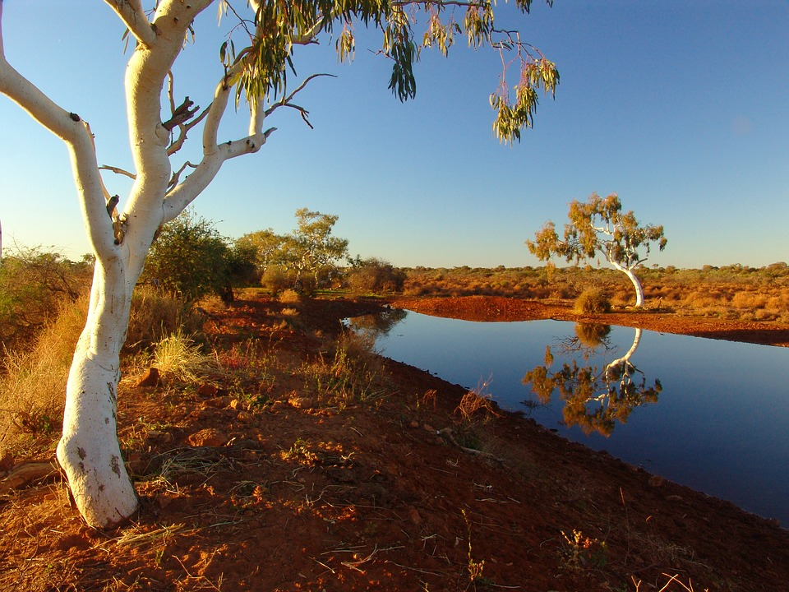
Image source pixaby (date accessed 24/11/2020)
Sarah Hopkins (b. 1958) is a unique Australian composer-performer, highly acclaimed for her visionary music and inspiring performances for cello, harmonic overtone singing, handbells, choir and her own invention of the ‘harmonic whirlies'. With a strong background and training in classical music, over the years she has moved into the realm of holistic music and developed a very distinctive compositional voice. Her solo, ensemble, choral and orchestral compositions demonstrate an expansive and pure musical style which resonates with the space and energy of the Australian landscape, as well as the inner landscape of the human psyche.
Her unique style of cello playing embraces many new and ancient sounds including musical bird calls, deep earthy drones, lush heartfelt melodies and the haunting rhythms of the didgeridoo.
"As a composer-performer my desire is to create music which resonates with the space & energy of the Australian landscape as well as the inner landscape of the human psyche. I want my music to move and inspire people and reconnect them with the heart of Life. My compositions grow from "hands-on" experience with the instruments: listening to them, playing them & developing the music in accord with the instrument's own potentiality, so that the essence of each instrument speaks forth. " - Sarah Hopkins, 1995.
Text source Sarah Hopkins website (date accessed 24/11/2020)

Composition and performance
- In small groups of three of four, create a short composition using classroom instruments/voice that reflects the natural environment of Australia whether it be flora, fauna or landscape. You must include the following:
  - two contrasting sections
  - one instrument must play a drone
  - textural variety

- Perform your compositions to the class and record it on your phone or device.

Listening
Watch Sarah Hopkin’s perform her own composition ‘Reclaiming the Spirit’ by Sarah Hopkins for solo cello (00:07:13) (date accessed 24/11/2020) and answer the questions below in their books.
- What is the instrument used in this piece and how is it used to represent the Australian landscape?
- How many layers of sound can you hear? Can you describe them and what they are playing?
- Describe the tone colour used in this piece. How does the timbre change throughout? Refer to the timbre words below if needed.
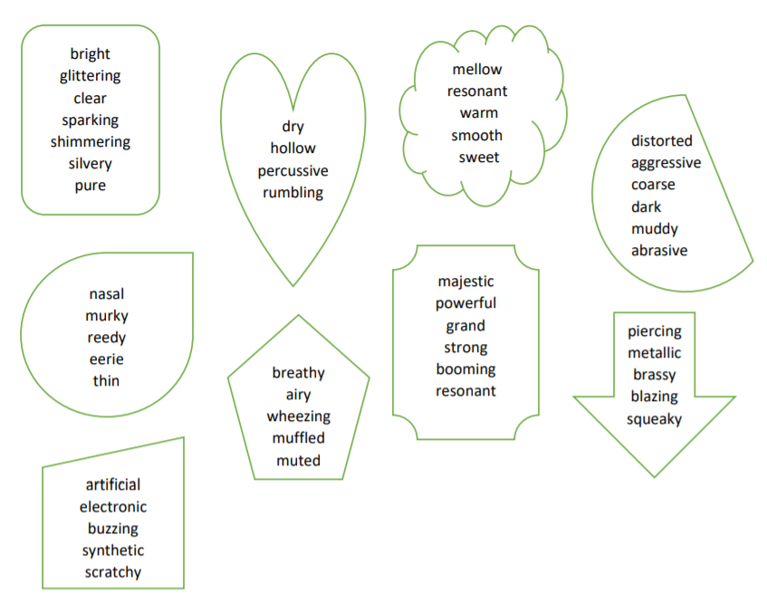

Musicology - listening and musical literacy
- Listen to the piece again whilst following along with the score below (bars 1 to 33). Answer the questions below.
  - How has Sarah notated the bird sounds in her piece?
  - Describe the time signature of this excerpt. Why do you think the Sarah has chosen to use multiple time signatures?
  - Which note acts as a drone in this piece?
  - Where is molto rubato found on the score and what does it mean?
  - Describe the dynamics and how they are used in this excerpt.

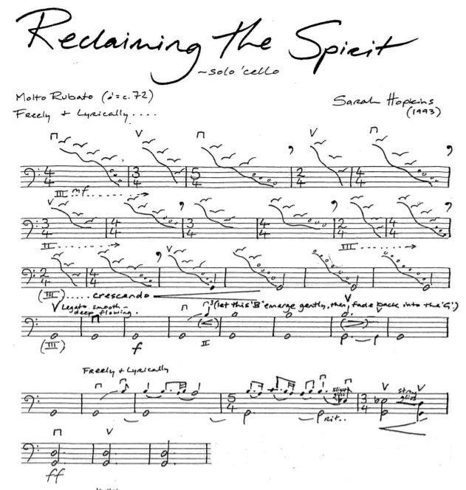
Excerpt of music composed & published by Sarah Hopkins: Music for the Soul. Print music used with permission and sourced from http://www.sarahhopkins.com.
- Many contemporary composers notate their music using a combination of traditional notation and graphic notation. Discuss what the definition of these terms might be as a class and write the definition below.
Term | Definition
Traditional notation
Graphic notation

- The opening section of ‘Reclaiming the Spirit’ uses multimetre as set out below. In each bar, write out the correct number of crotchets that corresponds to the time signature, placing an accent on the first beat of each bar. (The first bar has been done for you) Then, clap through the excerpt with a friend. How fast can you clap through it with accuracy?
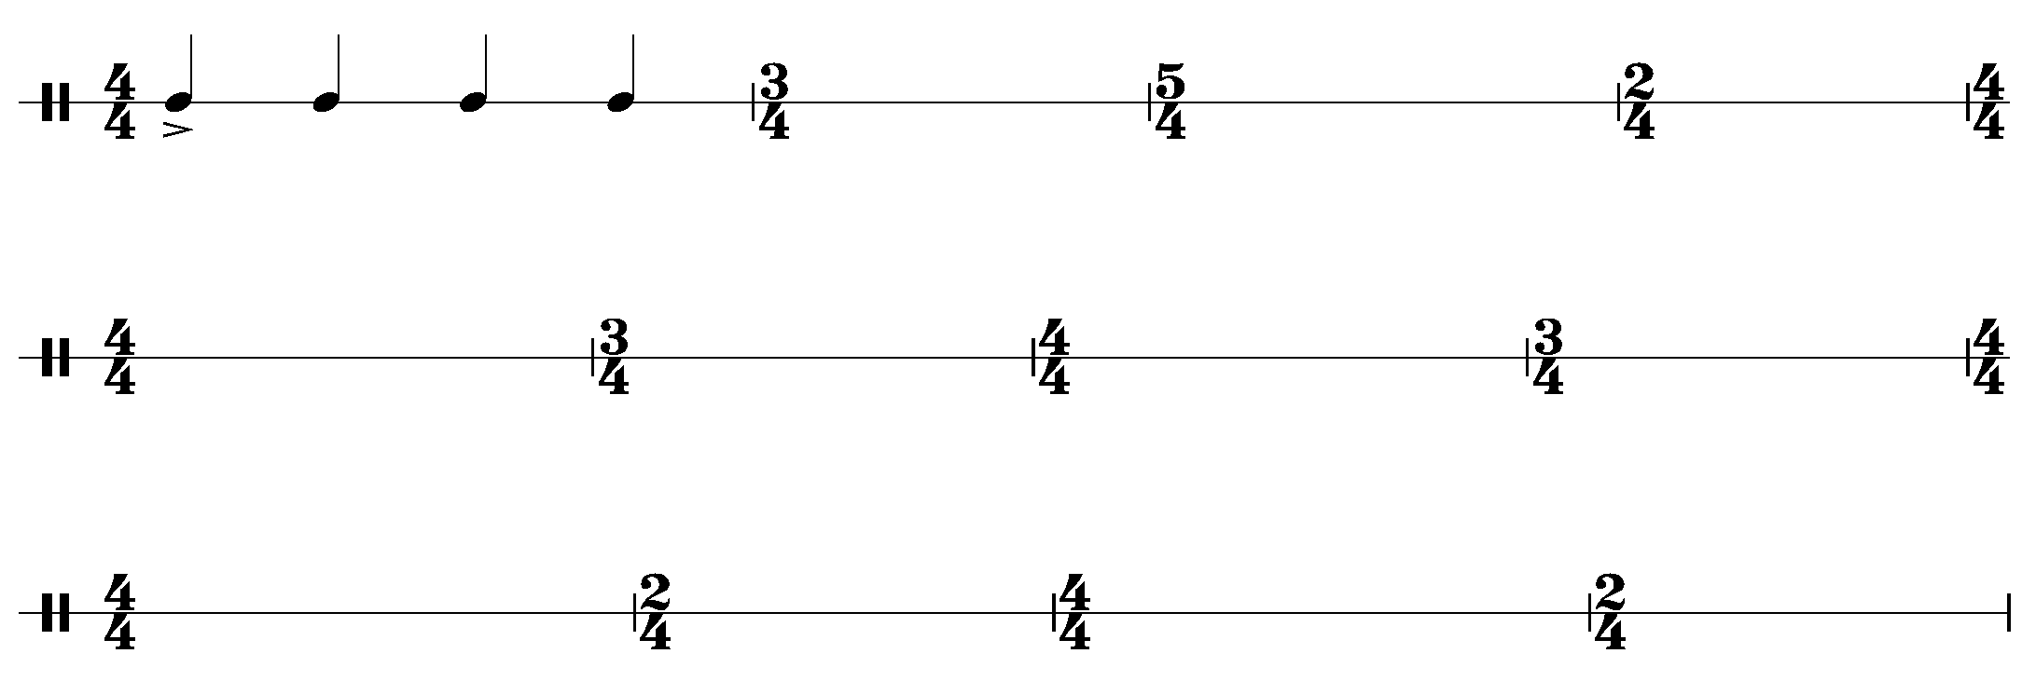

Composition
- Listen back to your group composition and brainstorm how your group could notate your composition using either traditional notation, graphic notation or a combination of both.
- Notate your composition.
- Each group is to play their composition to the class whilst the class follows along with your score.
- Discuss as a class if the score was successful in representing the composition. Why? Why not?

Additional notes
From the composer Sarah Hopkins on ‘Reclaiming the Spirit’.
“In 1993 the Director of Tall Poppies Records Belinda Webster invited me to compose a new solo cello work 'Reclaiming the Spirit' for cellist David Pereira to celebrate the 10th anniversary of the renaming of Uluru.
Having lived in the Northern Territory for nine years (1981-1990), and having spent time in Central Australia and at Uluru I was inspired by the idea. Given the deeply spiritual energy of Uluru & it's profound connection with the Aboriginal people in that area, I wanted to create a piece which honoured and celebrated this. For me, 'Reclaiming the Spirit' is like "musical alchemy". The opening 'cello bird calls' connect us to the beauty of nature, the flowering cello melody opens our hearts, the deep earthy drones anchor us to the heart of the Earth and the sound of the didgeridoo emulated by the cello, honours and celebrates Indigenous Australia. For me the sound of the didgeridoo is akin to the sound of the earth in the Northern Territory.
My compositional process in creating 'Reclaiming the Spirit' was very intuitive & holistic. I spent several days improvising meditatively on my cello ~ letting the music flow intuitively and allowing the melody to flower and crystallise. I recorded my 'work-in-progress' cello improvisations to listen back to as part of my compositional process. Once the piece was musically complete (and recorded with me playing it), I then notated the final score which many other cellists now play from.
Text source Sarah Hopkins website (date accessed 24/11/2020)

Answers

Listening
Watch Sarah Hopkin’s perform her own composition ‘Reclaiming the Spirit’ by Sarah Hopkins for solo cello (00:07:13) (date accessed 24/11/2020) and answer the questions below.
- What is the instrument used in this piece and how is it used to represent the Australian landscape?
  - The solo cello is used to represent the Australian landscape through its use of ‘bird calls’ using sweeping harmonics. The drone is reminiscent of a didgeridoo which represents the earth. At the end of the excerpt, a distinctive didgeridoo bowing technique can be heard.
- How many layers of sound can you hear? Can you describe them and what they are playing?
  - The piece starts with one layer of sound with the bird calls with a low bass note (G) appearing in between each bird call. The piece continues with the G drone and gradually a melody appears and evolves over the top of the drone resulting in two layers of sound.
- Describe the tone colour used in this piece. How does the timbre change throughout?
  - At the beginning of the excerpt the bird calls have a transparent, glistening sound. The timbre changes as the drone is introduced with its warm, full timbre and the melody has a warm and resonant timbre. The didgeridoo bowing at the end of the excerpt becomes percussive and strong.

Musicology - listening and musical literacy
Listen to the piece again whilst following along with the score below (bars 1 to 33). Answer the questions below in your book.
  - How has Sarah notated the bird sounds in her piece?
Sarah has notated the bird sounds by using graphic notation consisting of a descending curved line with small bird shapes above it. For extension students, the graphic notation in Bar 1 is for a 'harmonic glissando bird call followed by a natural glissando within one bow stroke'. The graphic notation used in bars 16 and 17 is for 'natural harmonic glissando on the G string'. Waterfall-like harmonic sweeps which gradually introduce the G drone.
  - Describe the time signature of this excerpt. Why do you think the composer has chosen to use multiple time signatures?
This piece incorporates multimetre through the implementation of 4/4, ¾, 2/4 and 5/4 time signatures. The multimetre in the opening section provides the musical phrasing so that the tempo is obscured to achieve an ambiguous pulse. This makes the piece more reflective of a natural soundscape due to the indefinite beat.
  - Which note acts as a drone in this piece?
The open G string.
  - Where is molto rubato found on the score and what does it mean?
It is found at the very beginning of the piece and means very rubato. Rubato means the performer manipulates the rhythmic elements of a piece for expressive purposes.
  - Describe the dynamics and how they are used in this excerpt.
The piece starts mezzo forte and then gradually crescendos throughout the excerpt to fortissimo as the pieces grows and evolves.
- Many contemporary composers notate their music using a combination of traditional notation and graphic notation. Discuss what the definition of these terms might be as a class and write the definition below:
Term | Definition
traditional notation | Traditional notation is notation which is consists of notes written on a stave using a clef.
graphic notation | Graphic notation is a type of non-traditional notation which uses symbols to represent sounds. It can be used in combination with traditional notation.

Popular music by Aboriginal and Torres Strait Islander artists
Image sourced from Pixy (date accessed 25/11/2020)
Australia is a country rich in diversity, culturally and geographically, a richness embodied in our music which embraces all genres and styles, is both steeped in tradition, and at the forefront of innovation and experimentation.
In the 20th and 21st centuries, indigenous musicians have played a vital role in defining Australia’s contemporary music identity, in building bridges with the broader Australian community, and in actively contributing to our cultural expression internationally. Contemporary indigenous music embraces all genres from folk and roots to blues, rock, pop, hip hop and classical forms.
Text sourced from Music Australia (date accessed 25/11/2020)

Performance, listening, and literacy activity
Either individually or in small groups, choose one of the artists on the following pages and complete the activities listed.

Baker Boy - do you wanna rap?
Image | Task
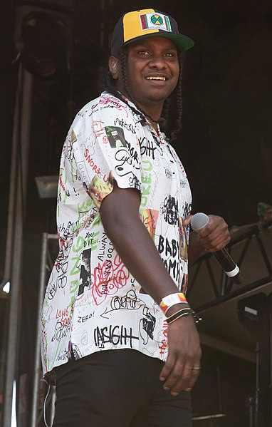  Image sourced from wikimedia (date accessed 25/11/2020) | - Practice rapping the words to ‘Meditjin’ by Baker Boy audio and lyrics (00:03:11) (date accessed 25/11/2020).  - Create a short slideshow about Baker Boy or write in your books a paragraph about him which includes the following information:  - short biography  - research which Aboriginal nation/s he comes from and identify the nation geographically on a map.  - Reflection: in your books or slideshow, answer the following:  - what are the lyrics are about?  - do you think these lyrics and/or the music identifies this song as being written by an Aboriginal or Torres Strait Islander artist? Why/why not?  - Present your slideshow and performance of ‘Meditjin’ along with the recording to the class.

Thelma Plum - fancy some uke?
Image | Task
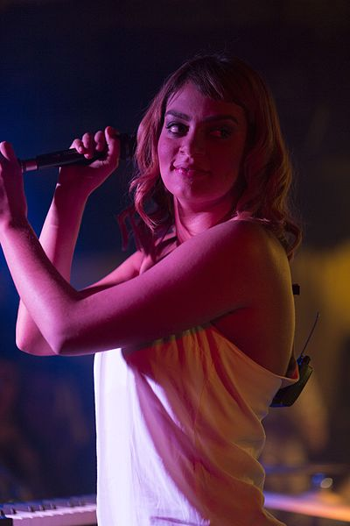  Image sourced from wikimedia (date accessed 25/11/2020) | - Perform the song ‘Nick Cave’ by Thelma Plum (00:02:45) (date accessed 25/11/2020) on ukulele/guitar and/or voice. Lyrics and chords are available here: ‘Nick Cave’ lyrics and chords (date accessed 25/11/2020)  - Create a short slideshow about Thelma Plum or write in your books a paragraph about her which includes the following information:  - short biography  - research which Aboriginal nation/s she comes from and identify the nation geographically on a map.  - Reflection: In your books or slideshow, answer the following:  - what are the lyrics are about?  - do you think these lyrics and/or the music identifies this song as being written by an Aboriginal or Torres Strait Islander artist? Why/why not?  - Present your slideshow and performance of ‘Nick Cave’ to the class.

Miiesha - can you acapella?
Image | Task
Image sourced from Pixaby (date accessed 25/11/2020) | - Perform the song ‘Caged Bird’ by Miiesha (00:01:34) (date accessed 25/11/2020) Lyrics are available here: ‘Caged Bird’ by Miiesha lyrics (date accessed 27/11/2020) You can do this as a small group of singers, or you can use the Acapella App (date accessed 27/11/2020) and record each part individually by yourself.  - Create a short slideshow about Miiesha or simply write in your books a paragraph about her which includes the following information:  - short biography  - identify which Aboriginal or Torres Strait nation/s she comes from and identify the nation geographically on a map.  - identify the flag on the left.  - Reflection: In your books or slideshow, answer the following:  - what are the lyrics are about?  - do you think these lyrics and/or the music identifies this song as being written by an Aboriginal or Torres Strait Islander artist? Why/why not?  - Present your slideshow and performance of ‘Caged Bird’ to the class.

Yothu Yindi - Treaty
Image | Task
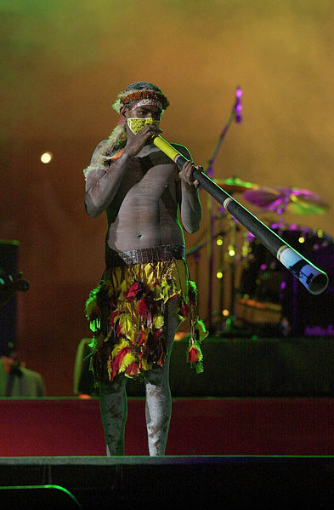  Image sourced from wikimedia (date accessed 25/11/2020) | - Perform the song ‘Treaty’ by Yothu Yindi (00:03:38) (date accessed 27/11/2020) either individually on guitar and/or voice, or in a rock band. Lyrics and chords are available here: ‘Treaty’ by Yothu Yindi lyrics and chords (date accessed 27/11/2020)  - Create a short slideshow about Yothu Yindi or write in your books a paragraph about the group which includes the following information:  - short biography  - research which Aboriginal nation/s they come from and identify the nation geographically on a map.  - Reflection: In your books or slideshow, answer the following:  - what are the lyrics are about?  - do you think these lyrics and/or the music identifies this song as being written by an Aboriginal or Torres Strait Islander artists? Why/why not?  - Present your slideshow and performance of ‘Treaty’ to the class.

Reflection
As a class, discuss the questions below.
- Which musical genres were represented today in the popular music of Aboriginal and Torres Strait Islander artists?
- Do you think that Aboriginal or Torres Strait Islander artists can have their heritage identified through their music? How? How not?
- Were there any common identifiable themes found within the lyric content across all four pieces? What were they? Why have these artists chosen to explore these themes in their music? What can it tell us about the history and culture of Australia?
- Think about what you knew prior to today’s lesson about the music of Aboriginal and Torres Strait Islander artists. Has today’s lesson changed your perspective? Why? Why not?

Composition and performance - extension
- Research some other Aboriginal and Torres Strait Islander artists on the website of NIMA (National Indigenous Music Awards) (date accessed 27/11/2020)
- Choose an artist and song that you would like to learn.
- Arrange this song for your own instrument or small group.
- Attempt to contact the artist to let them know you are learning the song and ask if they can provide more contextual information about the piece.

Rock Music

Midnight Oil - The Makaratta Project
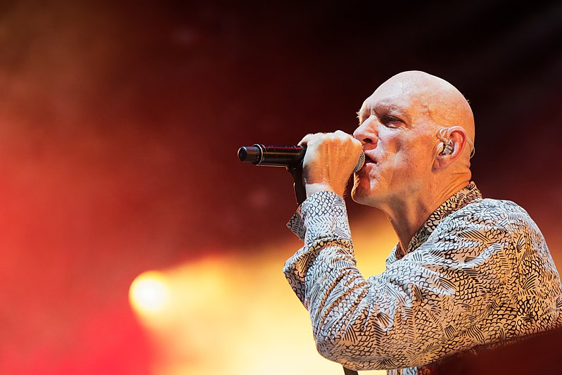
Image sourced from wikimedia (date accessed 27/11/2020)
Midnight Oil are an Australian rock band composed of Peter Garrett (vocals, harmonica), Rob Hirst (drums), Jim Moginie (guitar, keyboard) and Martin Rotsey (guitar) which formed in 1972. The band's music often broaches political subjects, and they have lent their support to multiple causes. They have recorded over twelve albums and have won eleven Australian Recording Industry Association (ARIA) Awards. In August 2020, Midnight Oil released their first album in 18 years titled ‘The Makaratta Project’ as a collaboration album with 18 Aboriginal artists.
Front man Peter Garrett said, ‘It's been 250 years since Cook landed, when Aboriginal and Islander peoples' children, land & waters were first taken away. Yet the impacts of the original dispossession are still widely felt. We urgently need to up the ante on Reconciliation generally and follow through on the ground-breaking Uluru Statement. These songs are about recognising that our shared history needs settlement, and that more than ever, as the Statement from the Heart proclaims, we need to walk together to create a better future.’
Biography Text sourced from Wikipedia (date accessed 27/11/2020)

Listening
- Read or listen to the Uluru statement by clicking on the link below (scroll to the bottom of the webpage) The Uluru Statement (00:04:40) (date accessed 27/11/2020)
- Discussion: As a class, discuss the statement below taken from the ‘Uluru Statement.’ Guiding questions may include: What do you think this statement means? What is the agenda? What is being referred to as a struggle? Why do we need a better future for our children?
‘Makaratta is the culmination of our agenda: the coming together after a struggle. It captures our aspirations for a fair and truthful relationship with the people of Australia and a better future for our children based on justice and self-determination.’
Text source from the Uluru Statement of the Heart. (date accessed 27/11/2020)

Performance and listening
Perform either ‘First Nation’ or ‘Gadigal Land’ by Midnight Oil in small groups or as a class. Resources for each song are below:

First Nation
’First Nation’ by Midnight Oil (00:04:55) audio and lyrics (date accessed 30/11/2020)
Listen to ‘First Nation’ by Midnight Oil and answer these questions:
- What is the time signature?
- How many chords are being used? What do we call this repeated pattern in rock music?

6/4 time signature
That’s right! This song has six crotchet beats per bar. Below is an example of a standard rock beat to play on drums which has four beats per bar. How could you adapt it to make six beats per bar to fit with ‘First Nation?’
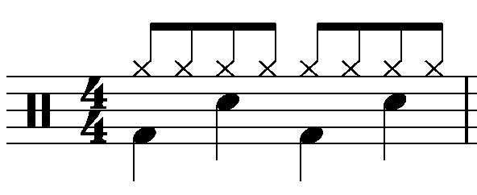

Riff
There are just three chords used in the riff of ‘First Nation’ by Midnight Oil. They are power chords using the chords A5, F5 and E5. Listen to ‘First Nation’ by Midnight Oil and see if you can work out the riff using these chords on either guitar or bass.
Guitar chords
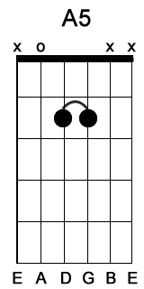 | 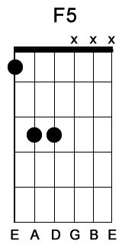 | 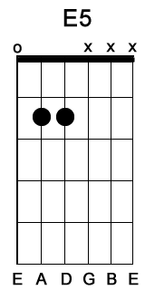
Power chords image sourced from free guitar source (date accessed 30/11/2020)

Gadigal Land
’Gadigal Land’ by Midnight Oil (00:04:44) audio and lyrics (date accessed 30/11/2020)
’Gadigal Land’ by Midnight Oil chords (date accessed 30/11/2020)
Listen to ‘Gadigal Land’ by Midnight Oil and answer these questions:
- List the instruments that you can hear played in the intro of this song.
- The intro contains a repeated melodic and chordal pattern played by the horns and guitar. What is this called?
- How many chords do you think are being used in this song?

Instrumentation
‘Gadigal Land’ uses a rock band (electric guitar, bass guitar, drums and voice) combined with a frontline consisting of a trumpet, trombone and bari sax. These instruments can collectively be called the ‘horns’ or ‘frontline.’

Riff
There are just three chords used in the riff of ‘Gadigal Land’ by Midnight Oil. They are D, G and A chord but can also be substituted using power chords. Listen to ‘Gadigal Land’ by Midnight Oil and see if you can work out the riff using these chords on either guitar or bass. The riff uses the following two rhythms:
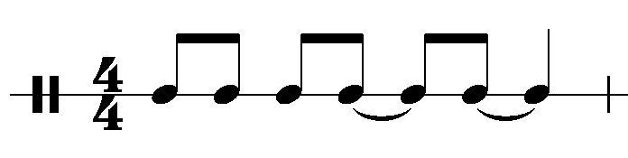
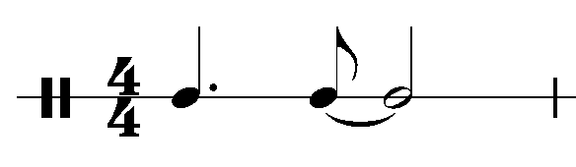
Guitar chords
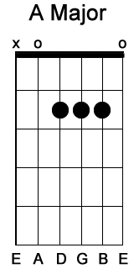 | 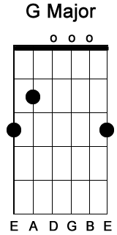 | 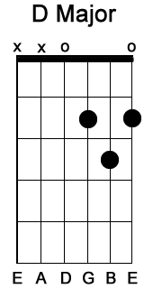
 | 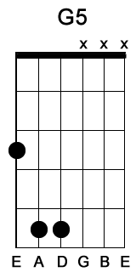 | 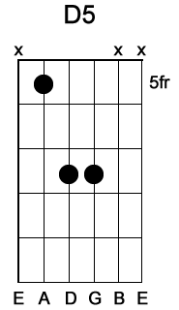
Major chords image sourced from free guitar source (date accessed 30/11/2020)
Power chords image sourced from free guitar source (date accessed 30/11/2020)

Composition and performance

Protest songs
A protest song is a song associated with a movement for social change. The entire ‘Makaratta Project’ by Midnight Oil can be considered to be a protest album.
Using the riff from either ‘Gadigal Land’ or ‘First Nation’ by Midnight Oil, compose your own protest song (at least 1 verse) based on a social issue that concerns you by following the steps below. You may do this in small groups or individually.

Steps
- Research a social change topic that interests you or that you feel passionate about.
- Brainstorm the main issues surrounding that particular topic.
- Write eight lines of lyrics that reflect your topic. Consider using rhyme in your lyrics by referring to how it is used in either ‘First Nation’ or ‘Gadigal Land’ by Midnight Oil.
- Play the chord progression/riff through and speak your lyrics over the top of the riff. Do the lyrics rhythmically fit into the riff pattern successfully? You may need to make changes if needed.
- Improvise a melody for the lyrics by experimenting with different notes.
- Put a bass line and drum beat to your song (if you haven't already) and perform it to the class.
- Add an introduction to your verse. You could choose to make it an instrumental or you could include vocals if you wish.
- Record the performance on your phone or device.

Comparative listening analysis
- Using the recording of your own protest song and either ‘Gadigal Land’ or ‘First Nation’, compare each song according to the concepts of music.
Concept of music | Midnight Oil song | My song
Duration
Time signature
Tempo
Drum beat
Note values
Pitch
Tonality
Riff
Chords used
Melodic contour
Texture
Thick/thin
Phonic
Roles of each instrument
Tone Colour
Instruments used
Timbre of each instrument

- Midnight Oil are known as one of Australia’s most iconic rock bands of all time. How do you think that the musical concepts of the Midnight Oil song and your song, represent rock music? (two paragraphs or dot points).

Additional resources

Listen and watch - contextual background information
Watch the video on the ulurustatement website from (00:00:00 – 00:13:06) (date accessed 27/11/2020) and answer questions below.

Questions
- What is the ‘Uluru Statement from the Heart?’
- What are the three themes of the statement?
- What happened in 1770?
- In 1901, mass celebrations took place in Sydney to celebrate the formation of the states into one federated government under the new Australian Constitution. However, the new constitution did not recognise Aboriginal people. How did it excluded Aboriginal people?
- The 1960’s was the beginning of significant change for the First Nations’ People with the 1967 Referendum put in place. What were some of the significant changes that resulted from this referendum?
- In 1977, the concept of ‘Makaratta’ was embraced by the National Aboriginal Conference. What did/does ‘Makaratta’ mean/involve?
- In 1988 the anniversary of 200 years of European occupation known as the ‘Bicentennial Celebrations’, the notion of a national Treaty had gathered real momentum. What did ‘The Burunga Statement’ call for?
- What historical event happened in1992?
- In 2000, what did the Australian Declaration of Reconciliation propose?

Glossary
Term | Definition
standard rock beat | A standard rock beat consists of beats 1 and 3 played on the bass drum, beats 2 and 4 played on the snare drum and quavers played consistently on the high hat. Beats 2 and 4 are to be emphasised.
riff | A riff is a short repeated melodic pattern often used in popular music.
power chord | A power chord is a chord that contains the first and fifth note of the chord. Power chords are commonly played on guitar.
frontline | The frontline refers to the musicians playing the lead parts that are not part of the rhythm section. This is a term often used in jazz and some other forms of popular music.
horns | Horns is a colloquial term referring to the frontline instruments such as saxophones and brass used in popular music.
protest song | A protest song is a song associated with a movement for social change.
social change | Social change involves alteration of the social order of society. It may include changes in social institutions, social behaviours or social relations.

Answers

Comparative listening analysis
Using the recording of your own protest song and either ‘Gadigal Land’ or ‘First Nation’, compare each song according to the concepts of music.
Concept of music | ‘First Nation’ | ‘Gagigal Land’
Duration  Time signature  Tempo  Drum beat  Note values | 6/4  Moderato tempo  Standard rock beat  Mainly short note values including quavers, semiquavers, crotchets with some longer note values such as minims and dotted minims used by the vocals. | 4/4  Allegro tempo  Standard rock beat  Mainly short notes including quavers and crotchets in all instruments with some dotted crotchets and minims.
Pitch  Tonality  Riff  Chords used  Melodic contour of the vocals | Minor tonality  Riff used throughout the entire song  Three chords used including A, F and E power chords.  The contour moves in both ascending and descending directions using mainly steps. | Major tonality  Riff used throughout the entire song  Three chords used including A, D and G. Power chords can be used.  The contour moves in both ascending and descending directions using mainly steps. Linear contour is featured on repeated notes.
Texture  Thick/thin  Phonic  Roles of each instrument | Thick texture  Homophonic texture  Male vocals provide the melody whilst remaining instruments provide the harmonic accompaniment using the riff and the drums provide the rhythmic accompaniment using a standard rock beat. | Thick texture  Homophonic texture  Male vocals provide the melody whilst remaining instruments provide the harmonic accompaniment using the riff and the drums provide the rhythmic accompaniment using a standard rock beat.
Tone Colour  Instruments used  Timbre of each instrument | Rock band instrumentation including an electric guitar, bass guitar, drumkit and vocals. Backing vocals, tambourine and synthesizer also feature in this piece.  The lead vocals and electric guitar timbre are distorted and scratchy. The bass is booming, the backing vocals warm, the rapping vocals, tambourine and drums are dry and percussive. The synthesizer sounds artificial and squeaky. | Rock band instrumentation including an electric guitar, bass guitar, drumkit and vocals. A frontline of horns is also used including trumpet, trombone and bari sax.  The vocals and electric guitar timbre are distorted and scratchy. The horns are blasting and bright, the bass is booming and the drums are booming and percussive.
Midnight Oil are known as one of Australia’s most iconic rock bands of all time. How do you think that the musical concepts of the Midnight Oil song and your song, represent rock music? (two paragraphs or dot points).
Suggested answers
- 4/4 time signature and a strong and driving rhythmic pulse.
- Moderate to fast tempo.
- Inclusion of a standard rock beat played on the drums.
- Rock band instrumentation including electric guitar, bass guitar, drumkit and vocals with additional instruments sometimes added such as horns, synthesizers and backing vocals.
- Riff based harmonic construction.
- A minimal number of chords used including simple chords such as power chords.
- Repetition of rhythmic, harmonic and melodic content.
- Mainly thick, homophonic texture with choruses usually being thicker in texture
- Mainly moderate to loud dynamic
- Verse/Chorus structure
- Use of distortion in the guitars and a scratchy, harsh timbre used in the vocals.

Listen and watch
Watch the video on the Uluru statement website from (00:00:00 – 00:13:06) (date accessed 27/11/2020) and answer the questions below.

Questions
- What is the ‘Uluru Statement from the Heart?’
  - It is a message written to the Australian people from Aboriginal Australians. It is a culmination of more than a decade's work and the largest deliberative process with Aboriginal people on Australia’s Constitution in our Nations’ history.
- What are the three themes of the statement?
  - Voice, treaty, truth
- What happened in 1770?
  - Cook claimed the east coast of Australia and all of the inhabitants were proclaimed as British subjects. Without their knowledge or agreement, they had come under the rule of British law and Government.
- In 1901, mass celebrations took place in Sydney to celebrate the formation of the states into one federated government under the new Australian Constitution. However, the new constitution did not recognise Aboriginal people. How did it exclude Aboriginal people?
  - They were not counted in the census
  - It didn’t allow the new government the power to make laws about Aboriginal people
  - All Aboriginal people were banned from voting.
- The 1960’s was the beginning of significant change for Aboriginal Peoples with the 1967 referendum put in place. What were some of the significant changes that resulted from this referendum?
  - The commonwealth was given the power to make laws for Aboriginal people
  - They were counted in the census.
- In 1977 the concept of ‘Makaratta’ was embraced by the National Aboriginal Conference. What did/does ‘Makaratta’ mean/involve?
  - Makaratta makes it clear this is intended to be an agreement within Australia by Australians. It captures the idea of two parties coming together after a struggle healing the divisions of the past. It is about acknowledging that something has been done wrong and it needs to be made right.
- In 1988 the anniversary of 200 years of European occupation known as the Bicentennial Celebrations, the notion of a national Treaty had gathered real momentum. What did The Burunga Statement call for?
  - (In summary) It called for the Australian government and people to recognise the rights of the traditional owners and occupiers of Australia.
- What historical event happened in1992?
  - The high court overturned the historical injustice that Aboriginal and Torres Strait Islanders had no rights to land known as the Mabo case.
- In 2000, what did the Australian Declaration of Reconciliation propose?
  - Each government and parliament recognises that this land and its waters were settled as colonies without treaty or consent and that to advance reconciliation it would be most desirable if there were agreements or treaties through which unresolved issues of reconciliation can be resolved.

