Aboriginal Music

Do Now literacy activities
Do Now literacy activities are designed to be a settling activity that students complete independently at the start of the lesson as the teachers marks the roll etc.
The activities should take approximately 10 minutes and require a short follow up discussion at the end.
The theme of the Do Now literacy activity connects with the theme of the lesson.

Characteristics of Aboriginal Music

Spelling and Punctuation
Add full stops and capital letters to create sentences within these paragraphs. There are also spelling mistakes in each paragraph to fix.

Music of the Aboriginal and Torres Strait Islander Peoples

(Paragraph 1, 3 sentences)
the indigenous people of australia celebrated their land, bleifs or their tribe by perofrming a corroboree this is often performed at a speshial time of day, such as sunrise or sunset the performance includes rhythmic music and denses performed to express the sorrow or joy
Correct spelling _____________ _______________ _______________ ________________

(Paragraph 2, 4 sentences)
a song cycle is the coleckshon of songs performed in a corrobboree each song has a strong use of melody, rhythm and instrumental accompaniement provided by manmade instruments the most popular Aboriginal instrument for men was the didgeridoo, which is a hollowed-out log thru which air is blown to create a rough, resonant sound other instrments often included clapping sticks, hunting weapons such as the boomerang and body percussion.
Correct Spelling ___________________ _________________ _______________ ________________

(Paragraph 3, 3 sentences)
the voice is also very important in Aboriginal moosic, however, it is mainly used by men the men create variety through using verried vocal tone colours within their voices the tone is mostly very naysal, which create a dramatic sound when combined with the didgeridoo and other accoompening instruments.
Correct spelling _____________ ________________ ______________ _________________

Picture sourced from pixabay.com date accessed 09/09/2020

The Dreaming-an introduction
The following lessons apply to The Dreaming-an introduction text on the next page.
Lesson 1 – Spelling and punctuation - Add full stops and capital letters to create sentences within the paragraphs. There are also spelling mistakes in each paragraph to fix.
Lesson 2 – Adjectives – highlight all of the adjectives. Adjectives are describing words, they can be describing (size, colour, shape, quality), numbering (one, ten, one hundred), possessive (his, hers, my, your), pointing (this, that, these, those), and classifying (cold-blooded).
Lesson 3 – Noun groups – these occur when there are adjectives (descriptions) either side of a noun. Eg that sleek, yellow fiberglass outboard ski boat that goes like the wind. Find the nouns in the text to see if there are any packed noun groups. Rewrite a packed noun group from the text here.
________________________________________________________________________
Lesson 4 – Verbs – underline all of the verbs (doing words)
Lesson 5 – The subject –think who or what is doing that verb. The who/what is the subject of each sentence, circle this.
Lesson 6 – Subject position – look at the subject in each sentence. Is it the first thing in the sentence? Effective writing uses theme position, putting the subject at the start of the sentence. Re write a sentence from this passage to put the subject in Theme Position.

________________________________________________________________________
________________________________________________________________________
________________________________________________________________________

The Dreaming – an introduction
Text from Indigenous Australia date accessed 14/10/2020

(Paragraph 1, 2 sentences)
the Dreaming tells of the jerney and the ackshons of Ancestral Beings who created the natural world the Dreaming is infinite and links the past with the present to determine the future It is the natural world, espeshly the land or country to which a person belongs, which provides the link between the peepull and The Dreaming.
Correct spelling __________________, __________________________, __________________, ______________
(Paragraph 2, 3 sentences)
dreaming stories carry the trooth from the past, together with the code for the Law, which oparates in the present each story belongs to a long complex storee some Dreaming stories diskuss consequences and our future being
Correct spelling _______________, ___________________, ___________________, ____________________
(Paragraph 3, 2 sentences)
wen a story is a component of an aboriginal Dreaming story and is toold outside of the country it belongs to, then it is respected as an aboriginal dreaming story from that area, however within its country it remains a significant, sakred Dreaming story it is important to give rekognition of the origins of the Dreaming Story
Correct spelling _________________, ____________________, ____________________, ____________________
(Paragraph 4, 5 sentences)
stories not acknoledged in books should be questioned for their authenticity some stories recorded by non-Aboriginal peeple over the years have lost their full translations in some early buks crude reproductions of stories were attempted to be transcribed some of these contained information deeling with sacred cultural practises if in doubt seek advice from local Aboriginal people when relevant to them.
Correct spelling ______________, _________________, _________________, _______________________

Contemporary Aboriginal Performers
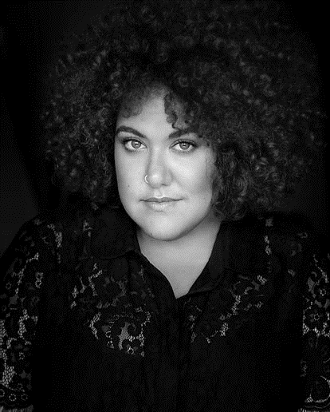
Read Casey Donovan’s biography below and complete the Reading Focus activities on the next page.

Casey Donovan
Text and image from Casey Donovan Website date accessed 03/11/2020
Casey Donovan is one of Australia’s most versatile Entertainers.
After a meteoric rise to fame at the age of 16, Casey became the youngest ever winner of Australian Idol in 2004. Over the last thirteen years, Donovan has made her mark not only as a musician, but also in the areas of stage, screen, presenting and writing. Casey is a multi-Award winner & nominee, including an ARIA No #1 Award for Listen with Your Heart and Deadly Awards for Best Album, Best Single and Most Promising New Talent.
After taking a break from music, Casey returned to the music arena with the release of her hotly anticipated single Big, Beautiful & Sexy. As a result of this inspirational song, she not only garnered new fans Australia-wide, but also became a poster girl for fuller-figured women. Casey took her Big, Beautiful & Sexy ethos further by touring in her own show, which has seen the remarkable singer perform to sellout crowds at some of the country’s most coveted venues and participate in events such as Adelaide Festival, Brisbane Festival, The Rocks Festival of the Voice, Tandanya National Aboriginal Cultural Institute’s Spirit Festival, Darwin Festival and Yabun Festival.
Casey has also headlined her own Mama Cass Tribute concerts and supported the legendary Cyndi Lauper on her Australian National Tour.
Under the direction of Rhoda Roberts, Casey made her theatrical debut in Miracle In Brisbane for the Brisbane Festival. This was to be the first of many acclaimed theatrical performances, including The Flowerchildren (Magnormos), As You Like It (Company B), Opera Yarrabah (Opera Australia) and The Sapphires (Company B / Black Swan State Theatre Company), RENT (Hayes Theatre) and in 2016 Donovan starred in We Will Rock You (Andrew Pole/Ben Elton) as Killer Queen. Casey’s stage credits have earned her respect from the industry, which has seen her receive a nomination for Best Newcomer and Best Performance by an Actress in a Musical in the Sydney Theatre Awards.
Lesson 1 –Summarising – complete a three-circle map summarising Casey Donovan’s career so far by drawing a picture of what happened at the beginning, middle and end of the text.
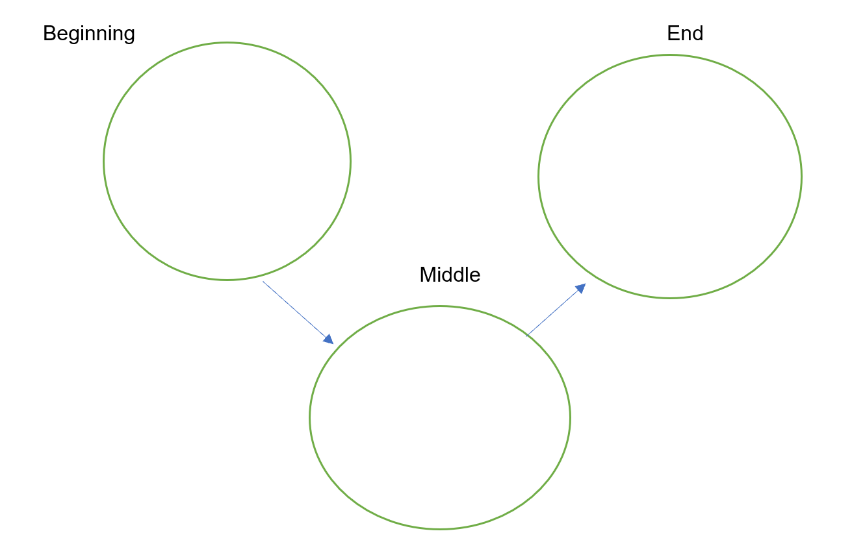
Lesson 2 – Questioning – write 3H Questions here based on the Casey Donovan Biography.
Here Question-a question that requires an answer that can be a sentence from the text.

Hidden Question- a question that requires an answer by joining information from two or more sections of the text.

Head Question- a question that requires an answer that comes from what the person answering already knows or thinks.

