School planning resource
Audience: School executive members
Purpose: Supporting the inclusion of student voice into 2021-2023 school plans in NSW schools.
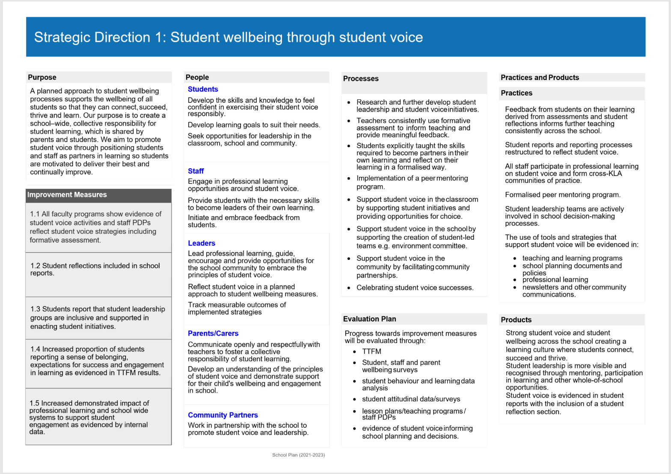Student voice can be a strategic direction for school plans by itself or fall within the wider strategic direction of student wellbeing. The following is a sample of what a school plan featuring student voice as a strategic direction could look like (Appendix A is an editable word version)
What is student voice?
Student voice is students actively participating in decision-making at school on things which shape their educational experiences. It is more than just students ‘having a say’ and ‘being heard’. To be successful, student voice must value the perspectives and opinions of students and act on them in a way that genuinely shapes learning and decision-making at the school.
What are the benefits of having a whole school approach to student voice?
Research shows that when children and young people participate in meaningful decision-making at school, they experience higher levels of wellbeing and empowerment and develop stronger relationships with adults and peers, which drive better learning outcomes. They develop a range of skills and capabilities to feel connected and successful at school and in life. The explicit teaching of the General Capabilities also promote skills for personal growth and good citizenship, and as partners in their own learning, student voice is a mechanism for increasing engagement, achievement and wellbeing (Gonski, D et al, 2018).
How does student voice link with Department and school priorities?
Every student is known, valued and cared for is a key goal for the Department’s Strategic Plan.
Through the Wellbeing Framework for Schools and School Excellence Framework (SEF) schools identify and plan for meaningful student participation and decision-making as indicators of school excellence. The SEF references student participation, voice and leadership throughout the Learning and Teaching domains. These have been summarised below.

School Excellence Framework – Version 2 | July 2017
LEARNING  DOMAIN | THEMES | EXCELLING
LEARNING CULTURE | High expectations | The whole school community demonstrates aspirational expectations of learning progress and achievement for all students, and is committed to the pursuit of excellence.  Effective partnerships in learning with parents and students mean students are motivated to deliver their best and continually improve.
WELLBEING | Individual learning needs | There is school-wide, collective responsibility for student learning and success, which is shared by parents and students. Planning for learning is informed by sound holistic information about each student’s wellbeing and learning needs in consultation with parents/carers.
CURRICULUM | Teaching and learning programs | Teaching and learning programs are dynamic, showing evidence of revisions based on feedback on teaching practices, consistent and reliable student assessment and continuous tracking of student progress and achievement.
CURRICULUM | Differentiation | Teaching and learning programs across the school show evidence that they are adjusted to address individual student needs, ensuring that all students are challenged and all adjustments lead to improved learning. Teachers involve students and parents in planning to support learning, and share expected outcomes.
ASSESSMENT | Formative assessment | Assessment is used flexibly and responsively as an integral part of daily classroom instruction. Formative assessment is practised expertly by teachers.
ASSESSMENT | Student engagement | Students and parents understand the assessment approaches used in the school and their benefits for learning.  Feedback from students on their learning derived from assessments informs further teaching.
TEACHING DOMAIN | THEMES | EXCELLING
EFFECTIVE CLASSROOM PRACTICE | Lesson planning | All lessons are systematically planned as part of a coherent program that has been collaboratively designed. Accommodations and adjustments are made to suit needs as they arise. Lesson planning references student information including progress and achievement data, curriculum requirements, and student feedback, and provides continuous improvement for all students, across the full range of abilities.
EFFECTIVE CLASSROOM PRACTICE | Feedback | Teachers routinely review learning with each student both in class and on work submitted, ensuring all students have a clear understanding of how to improve. Student feedback is elicited by teachers and informs their teaching. Student errors and misunderstandings are explicitly addressed until teachers and students are confident that mastery is demonstrated.
Student voice is also referenced throughout the Wellbeing Framework for Schools as summarised in the following.
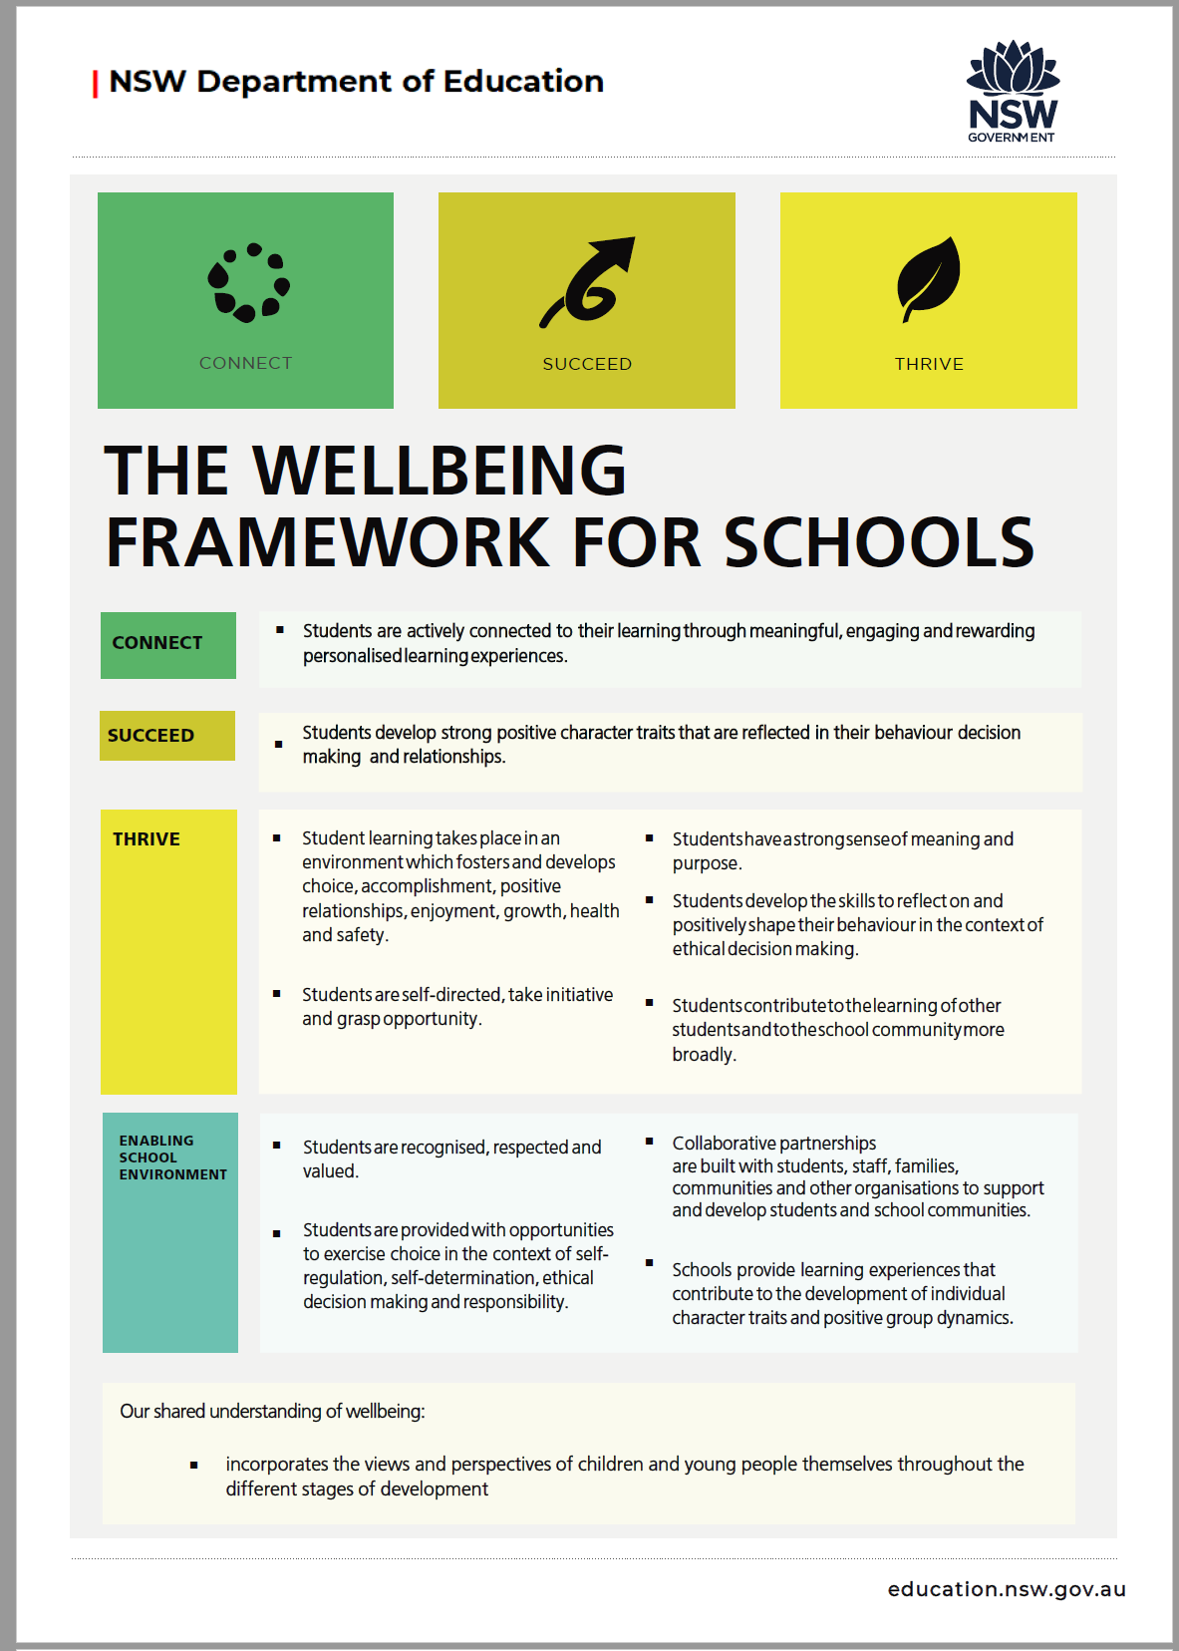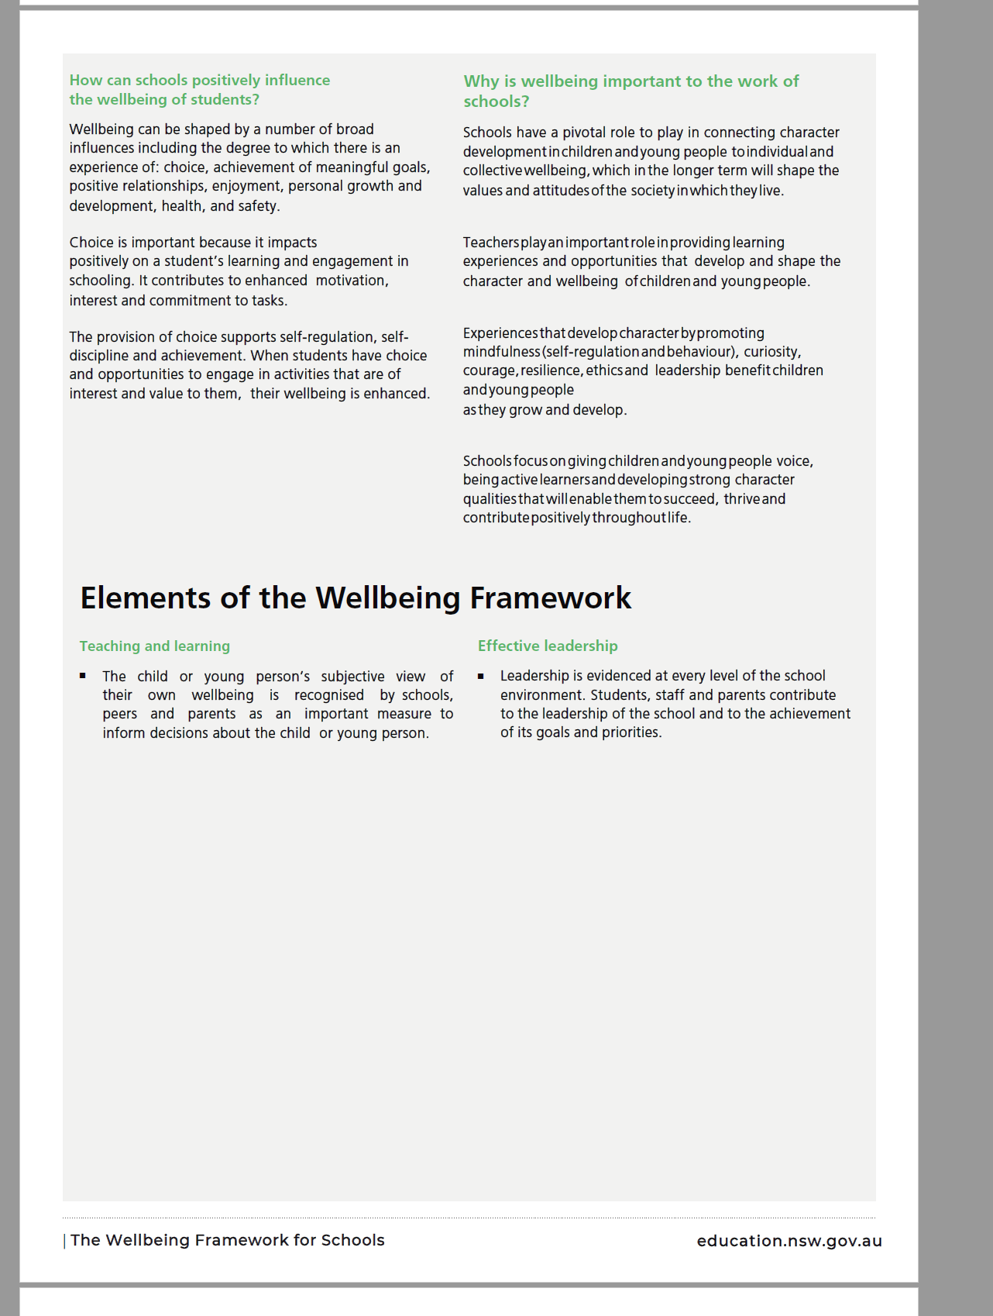

How can we support student voice across the school?
In our classrooms | In our schools | In our communities
How can our classrooms support students to actively participate and influence their own learning?  - Personal and social capabilities and skills for communication are explicitly taught.  - Positive, learning-focused relationships between students and teachers are supportive of collaborative learning and agency.  - Learning with and from students builds new connections as well as mutual respect.  - Consistently creating opportunities for feedback and reflection develops student voice and responsibility for learning. | How can our schools involve all students in decision-making to create a positive learning culture?  - A safe, supportive and inclusive environment sets high expectations for teaching and learning.  - Informal opportunities as well as formal channels for student voice and leadership build a sense of belonging and shared purpose.  - School planning and decisions are responsive to the voice and needs of all students.  - School wide systems and strategies promote student teacher relationships as partners in learning. | How can we support student voice to positively shape the future of our communities?  - Opportunities for ‘real world’ learning and partnerships with community organisations and members, allow students to practice and apply skills in agency and leadership.  - Students and adults are actively engaged in conversations to work toward shared goals and understanding.  - A sense of connection and community are achieved as students are both influenced by and have opportunity to shape their communities and future lives.
Examples of practice  - Exit cards for student feedback  - Inquiry or project based learning  - Entrepreneurial learning  - Student mentoring  - Students and staff co-construct course content / assessment modes  - Project or problem based learning and design thinking such as student initiated coding activity or personal inquiry project.  - Students work with teachers to develop learning goals or future learning. | Examples of practice  - Extra-curricular, interest groups  - Formal student-led leadership groups  - Engaging students in the governance and decision-making bodies of the school  - Engaging students in staff or school leadership appointment panels  - Enabling students to develop and implement projects to change and improve school operations, culture, climate or practices  - Student-led whole-of-school events with staff in advisory roles  - Student-led parent/teacher conferences  - Student reflections in reports | Examples of practice  - Social justice projects  - Community service and volunteering  - Invite and enable students to develop and implement community-based projects, possibly in partnership with other agencies, to enhance and support learning  - Invite and enable students to engage with local government and initiate community partnerships

Strategic Direction 1: Student wellbeing through student voice
Practices and Products
Purpose
A planned approach to student wellbeing processes supports the wellbeing of all students so that they can connect, succeed, thrive and learn. Our purpose is to create a school–wide, collective responsibility for student learning, which is shared by parents and students. We aim to promote student voice through positioning students and staff as partners in learning so students are motivated to deliver their best and continually improve.

People
Students
Develop the skills and knowledge to feel confident in exercising their student voice responsibly.
Develop learning goals to suit their needs.
Seek opportunities for leadership in the classroom, school and community.
Staff
Engage in professional learning opportunities around student voice.
Provide students with the necessary skills to become leaders of their own learning.
Initiate and embrace feedback from students.
Leaders
Lead professional learning, guide, encourage and provide opportunities for the school community to embrace the principles of student voice.
Reflect student voice in a planned approach to student wellbeing measures.
Track measurable outcomes of implemented strategies
Parents/Carers
Communicate openly and respectfully with teachers to foster a collective responsibility of student learning.
Develop an understanding of the principles of student voice and demonstrate support for their child's wellbeing and engagement in school.
Community Partners
Work in partnership with the school to promote student voice and leadership.

Processes
- Research and further develop student leadership and student voice initiatives.
- Teachers consistently use formative assessment to inform teaching and provide meaningful feedback.
- Students explicitly taught the skills required to become partners in their own learning and reflect on their learning in a formalised way.
- Implementation of a peer mentoring program.
- Support student voice in the classroom by supporting student initiatives and providing opportunities for choice.
- Support student voice in the school by supporting the creation of student-led teams e.g. environment committee.
- Support student voice in the community by facilitating community partnerships.
- Celebrating student voice successes.

Practices
Feedback from students on their learning derived from assessments and student reflections informs further teaching consistently across the school.
Student reports and reporting processes restructured to reflect student voice.

All staff participate in professional learning on student voice and form cross-KLA communities of practice.
Formalised peer mentoring program.
Student leadership teams are actively involved in school decision-making processes.
The use of tools and strategies that support student voice will be evidenced in:
- teaching and learning programs
- school planning documents and policies
- professional learning
- newsletters and other community communications.

Improvement Measures
1.1 All faculty programs show evidence of student voice activities and staff PDPs reflect student voice strategies including formative assessment.
1.2 Student reflections included in school reports.
1.3 Students report that student leadership groups are inclusive and supported in enacting student initiatives.
1.4 Increased proportion of students reporting a sense of belonging, expectations for success and engagement in learning as evidenced in TTFM results.
1.5 Increased demonstrated impact of professional learning and school wide systems to support student engagement as evidenced by internal data.

Evaluation Plan
Progress towards improvement measures will be evaluated through:
- TTFM
- Student, staff and parent wellbeing surveys
- student behaviour and learning data analysis
- student attitudinal data/surveys
- lesson plans/teaching programs / staff PDPs
- evidence of student voice informing school planning and decisions.

Products
Strong student voice and student wellbeing across the school creating a learning culture where students connect, succeed and thrive.
Student leadership is more visible and recognised through mentoring, participation in learning and other whole-of-school opportunities.
Student voice is evidenced in student reports with the inclusion of a student reflection section.

School Plan (2021-2023)

