Transdisciplinary learning skills
980 | 62 | 67
STUDENTS | LEARNING SPACES | TEACHERS

The Jannali High School and C.21st learning skills program
The Jannali High School is a comprehensive, co-educational 7-12 school in Sydney’s south. The success of its CARE wellbeing model, introduction and strengthening of its PBL-style challenge based learning, and diversification of co-curricular offerings in creative arts has led to significant rises in enrolments.
Why? | How?
The TJHS executive team engaged with research on the skills required of the 21st Century workforce that their graduates would need. This led them to identify that innovation in pedagogy, with a focus on wellbeing, ICT skills and building skills around the 4Cs was needed. So in 2015 The Jannali High School (TJHS) introduced a BYOD policy for iPad as catalyst for this innovation in practice.  Teachers took part in extensive Apple training over a number of years. The need to support students to best leverage ICT in their learning was identified. This led to the creation of the transdisciplinary 21st Century Learning Skills program. | In order to find time for the program, the principal conducted an audit of Stage 4 curriculum and NESA mandatory subject hours. An hour per cycle was identified as available to be used outside NESA requirements. This new period was combined with the existing allocated one Year Advisor period and one library period to enable three periods per cycle in Stage 4 for the new program.  The three periods were put onto the timetable, forming part of the Year Advisor and teacher librarian’s allocation of teaching periods.
“The use of technology in a futures learning classroom environment helps teachers to leverage improved outcomes for students as they create, collaborate, communicate and critically inquire to deepen their understanding of key ideas and concepts. At TJHS the consistent use of iPad technology across all KLAs enhances the learning process."
Rick Coleman, Principal, The Jannali High School

Research | What?
The HT TAL undertook research on innovative frameworks for transdisciplinary learning. The P21 Project from the US was identified as an appropriate potential model for TJHS aim of developing future-focussed skills that would transfer across learning, wellbeing and ICT.  The executive team explored the model. They decided that it would meet their needs to enhance student ability to succeed academically at school, develop social and emotional intelligence, and build desirable skills for post-school success.  Challenges faced  One challenge to address was that of equity. TJHS had to ensure that every student would be able to participate if a 1:1 device policy was introduced. This potentially posed a financial challenge to the school but feeder primary schools and community values supported the policy. Less than 10% of TJHS families requested an equity iPad.  Another challenge which was anticipated to be ongoing was ethical use of devices by students. The school designed iPad contracts, signed by every student and parent on entry into Year 7. Explicit guidelines regarding use of the devices is outlined in the contract but also taught as part of the 21st Learning Skills program. | TJHS’s program has three strands: social skills, information literacy, and pedagogical skills. Each strand is programmed as one period per cycle. The HT TAL led the year advisors and teacher librarian in co-creating expanded or new programs for each strand.  The social skills program includes learning around such skills as conflict resolution, resilience training, and ethical use of a digital device. One example is students engage with a role-playing, scenario-based video game called The Lost Summer. This game builds digital intelligence; students then write and share a critical reflection.  The information literacy program was expanded from the existing library program. Digital literacy skills such as how to effectively access and understand information on various digital platforms; and how to communicate using digital tools are included.  The HT TAL created a new unit for pedagogical skills focussed on the 4Cs. For example, the program seeks to build skills in critical reflection as students must sift through and evaluate readily accessible information, and then apply understanding to create new digital products to demonstrate learning.

The 21st Century learning skills program “has helped me have a growth mindset towards all subjects. It has also taught me how to be safe online and on social media.”  Student, The Jannali High School | 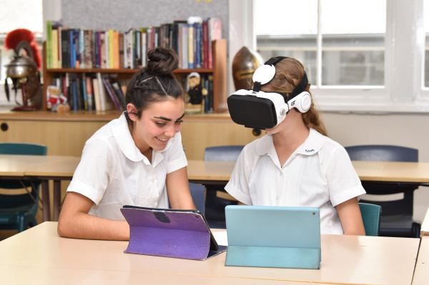

Supporting Year 7 transition | Outcomes
TJHS wanted to enhance their support structures for students transitioning from Year 6 to Year 7. The program enhances students’ ability to learn how to learn and talk about their learning using a common language.  Initially, TJHS BYOD policy created a need to upskill incoming Year 7 in basic ICT skills. Varying use of BYOD from feeder schools meant there was a wide variety of skills when students began at TJHS. As such the pedagogical skills strand of the program began with lessons on trouble shooting common hardware and software issues when using iPad, and raising awareness about how to use the accessibility tools in their device.  However, over time as feeder-school device use increased, the program no longer needed to incorporate basic use skills. This has enabled a shift in focus to building creativity and collaboration skills. | The program has been successful in building student skills to meet innovation in learning and teaching, catalysed by the BYOD policy. Based on student self-reflection, 65% of Year 7 students rated the program as valuable or very valuable to their learning.  There has been growth in all areas the program targets for skills development – collaboration, communication, social skills, information literacy and ICT literacy. The value added from the program has varied in degree from some improvement to significant improvement, in comparison to the starting skill level.  As a result, TJHS has seen a growth in:  - students’ enthusiasm for engaging with learning tasks,  - submission of learning tasks,  - demonstrating learning more consistently, and  - demonstrating learning in a greater variety of ways.

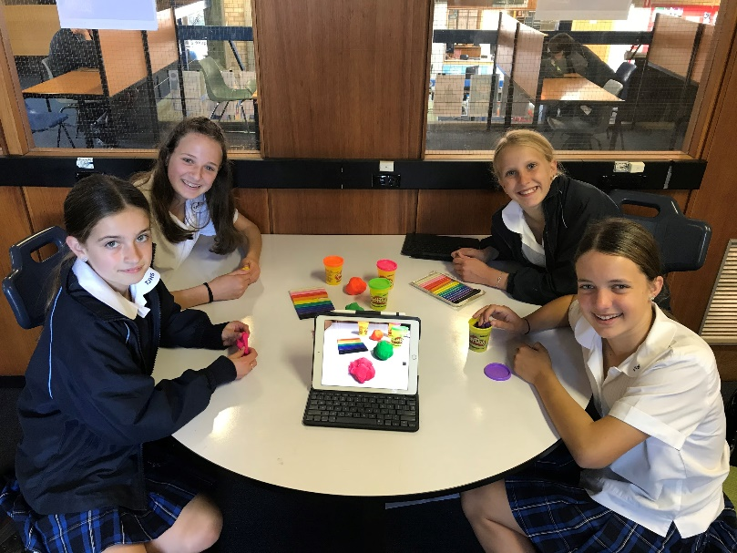
“In a career spanning 25 years, the introduction of the iPad 1:1 device policy along with the 21st Century Learning program I see as the greatest transformation in innovative teacher practice and the leveraging of technology to increase student ability to access and engage in their learning.”
Liz Graham, Head Teacher Teaching and Learning, The Jannali High School

