Transdisciplinary learning
407 | 69 | 39
STUDENTS | LEARNING SPACES | TEACHERS

Pride Projects at Riverstone High School
Riverstone HS is a 7-10 comprehensive, co-educational school (it will return to offering stage 6 from 2021). RHS uses the concept of PRIDE (Personal Responsibility In Delivering Excellence) to underpin all activity in supporting, encouraging and challenging every member of the school community. Pride Projects is an innovative transdisciplinary program launched in 2020.
Why? | confidence and capacity to create innovative learning environments (ILEs). This lay the foundation for building skills in staff to use PBL as one structure for learning and enhancing strategies to develop learning characteristics and general capabilities.  Local population growth, the re-offering of Stage 6 at RHS and the construction of an additional building designed as a flexible learning space (FLS) all prompted the need for revisiting operational matters such as rooming and timetable, along with PL opportunities opened up by the FLS.
There are a variety of reasons why Riverstone HS wanted to innovate their practice resulting in the introduction of Pride Projects. To begin, RHS were inspired by Google’s 20% time following a visit to the Sydney office and a desire to inspire innovation in learning and teaching to increase engagement, creativity and the general capabilities.
Throughout 2019 and 2020 RHS staff engaged in a variety of professional learning. RHS worked with SLEC to explore contemporary learning and teaching with the goal of building

“PRIDE Projects have certainly changed the atmosphere of Friday afternoons. It is wonderful to see students and staff working together, on authentic and community-minded projects.
As a school we have seen the benefit of this initiative in improved staff-student relationships and improved attendance. The expansion of the projects on offer to include student-driven initiatives has created another productive avenue for student voice and contribution.”
Karen Downie, Principal, Riverstone High School

How? | One DP conducted an audit of the number of minutes spent in each subject against NESA requirements identifying an available 2 hours in the week.  Construction of the timetable began with putting Pride Projects on for Friday’s periods 4 and 5. These two periods were included in each teacher’s allocated face to face teaching time. All subject periods were then placed on the timetable, ensuring correct indicative hours.  Senior executive created a framework for Pride Projects. All staff were asked to submit a project plan and had meetings with the DPs to refine their plans.
Building on SLEC’s PL on teaching and learning in innovative learning environments, senior executive engaged with ‘infinite possibility’ training as a staff and as an executive team. This was to open up thinking about the ideal school and what was important for students to understand and do in learning that would stand outside NESA requirements.
The executive team believed innovation was necessary to shift practice to an integration of knowledge to make learning less abstract, and more meaningful and relevant for student needs in the future.

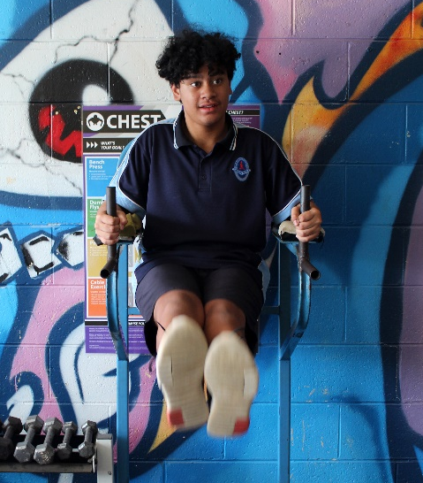 | 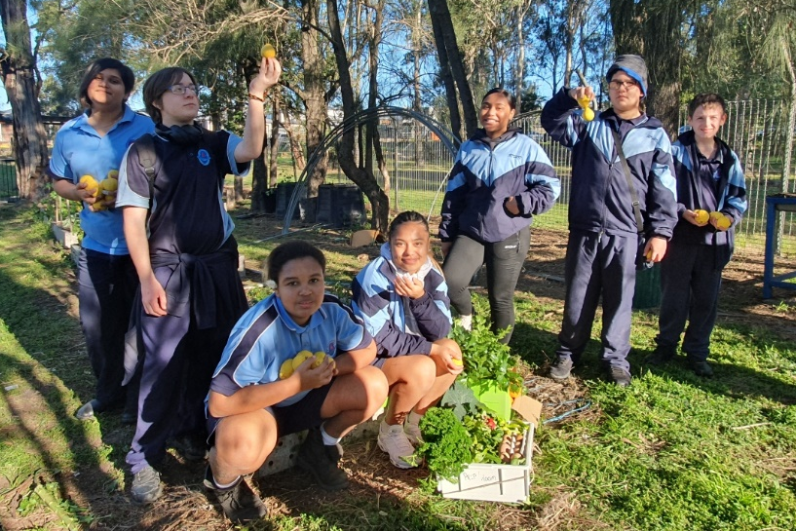

What? | Transdisciplinary learning
Pride Projects are a 2-hour weekly session in semester blocks run on Friday afternoons as ‘electives’ based on student interest, not stage or ability. Projects:  - foster a skill or passion,  - develop at least one General Capability,  - create a public product to benefit school or community,  - promote collaboration, and  - build pride in self and community.  Projects for 2020 included “Let’s Talk Footy (sports coaching), “Run Beyond” (marathon running), and “Lets Grow” (agriculture). | Pride Projects intentionally transcend subject-based knowledge classifications, making the learning transdisciplinary.  The RHS project design process and delivery is a conceptual framework shared across the whole school. The focus is on collectively developing General Capabilities in students in sustained weekly sessions.  There are high levels of student agency in these holistic learning experiences. Teachers and students work together to identify needs within the community and build skills to contribute to the betterment of their local community.

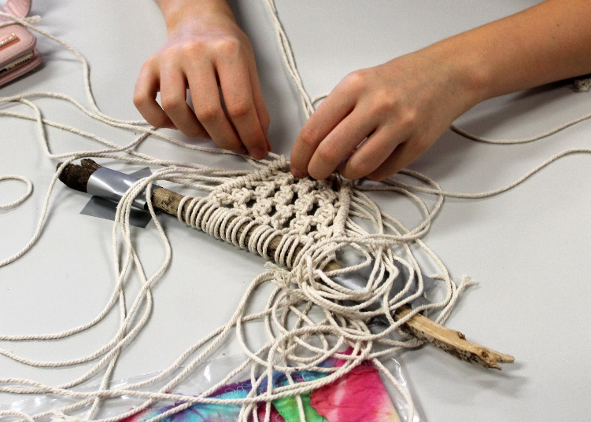 | Students “are interacting with students that they would normally have nothing to do with, and they are excited to not only learn a new skill, but to help others who are having difficulty.”  Sarah, Teacher Librarian

Challenges faced
Initially there was syllabus attachment from some teachers and so the initial buy-in from staff was not universal due to the perceived loss of subject time. However, once staff fully understood the very intentional separation of the Project time from the disciplines, almost all staff were extremely supportive.
Once the projects were underway, some teachers found it challenging to accurately plan how much time they needed for project completion and event management. This has seen some projects originally conceived of as 10 weeks long, become 20 weeks long; other projects have had to add to their original program. The most significant challenge was COVID19 impeding community connection, off-site visits and public sharing of products.
“Through my experience with Pride Projects I have found a passion that was once lost, allowing me to improve my creativeness.”  Earl, Student, School Captain | 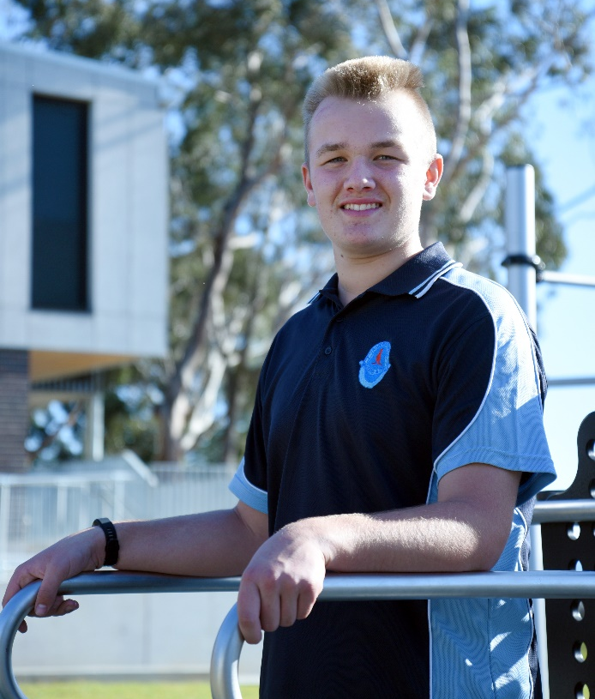

Outcomes  Benefits to student learning, teacher practice and overall wellbeing became evident in the first year of Pride Projects:  - the re-engagement with teaching and learning from both staff and students has been marked;  - there have been significant improvements in wellbeing: 40% improvement in Friday attendance, 100% improvement in Friday suspensions, 85% reduction in negative Sentral entries;  - both staff and students have increased self-efficacy and agency as a result of stepping up into leadership for the first time; and  - reconnecting parents with the high school as a community hub. | These outcomes reveal a re-energising of positive school culture. Relationships between all members of the school community have been enhanced as they learn more about each other outside of the syllabus.  Next steps
Future cycles of Pride Projects will seek to increase student-led projects and further encourage community partnerships. Student goal setting and self-reporting on learning characteristics via portfolios may be explored for future iterations.
Learnings from Pride Projects innovation in operational and pedagogical practices will be applied to taking a PBL approach for KLAs and exploring how the curriculum may be integrated.

