Confidence to Innovate

354 | 28 | 46
STUDENTS | LEARNING SPACES | TEACHERS

Lindfield Learning Village
As a new K-12 school housed on the site of a former university campus, Lindfield Learning Village (LLV) has strategically reimagined the concept of a school as a place of learning and the activities that occur there. The educational model focusses on creating a flexible environment conducive to personalised learning. The Village is based on empathy and trust. LLV is forging new educational pathways to nurture creativity and create independent, resilient learners.
Context | LLV’s educational model
Lindfield Learning Village has a very unique educational vision and school culture. A highly flexible school environment sees students experience personal learning that grows creativity and imagination, wellbeing and independence in stage-based groups co-taught by teams.  For Stages 4 and 5, LLV has intentionally integrated their curriculum using a combination of multi-disciplinary, interdisciplinary and transdisciplinary approaches (see figure 1).  The day is divided into three sessions of 105 minutes each. Students learn in groups based on stage, not age. All classes are co-taught, either within KLA or cross-KLA. | There are three key pedagogical modes (see figure 2):  - Masterclass - Teacher facilitated deep dives into subject-specific content; still focused on student agency.  - Pop up class - Initiated by learners during interdisciplinary unit (IDU) or transdisciplinary unit (TDU) sessions if they need a quick workshop so it is ‘just in time’ learning.  - Flow - Student-driven independent or collaborative deep learning building on content introduced in the masterclass. Students decide how they will learn in this mode; skills to succeed in this mode are taught explicitly.
NSW Syllabus content, knowledge, skills and understanding covered in mandatory hours + LLV Beyond the curriculum learning.

Figure 1: simplified LLV learning structure
“LLV as a school community has co-created values that ask our teams to hold their ideas lightly in order to co-create an innovative vision of what learning could look like. The gold is in the nexus of the in-between. Rather than adhering to any one particular model, we sought to create what would meet student need.”
Amy Murphy, HT Secondary Studies, LLV

What? | In stage 5 time is split evenly between IDU and masterclasses. In stage 4, slightly more time is allocated to IDU and TDU.  Stage teams have a common scope and sequence document for the masterclasses and IDUs/TDUs. This means that all teachers on the team have a clear understanding of what everyone else is doing and how they fit into the big picture. This enables a consistent student experience of the unit but a more granular understanding for teachers.  Each IDU or TDU has a syllabus-inspired focus, such as ‘influence’. Teachers work together to find natural connections in syllabus areas, design and teach an integrated program so students deeply explore the target focus.
For stages 4 and 5, teachers at LLV work in stage-based, cross-disciplinary teams to co-design 5-week programs and learning materials for interdisciplinary and transdisciplinary units of work.
They developed and subsequently use the concept of a T-model to describe the learning, enabled by the three pedagogical modes (described above). Transferable skills are imagined as overarching the learning with time allocated to dive deep down into subject-specific pedagogy, content and skills to ensure subject rigor. That learning then ‘floats up’ to contribute to the understanding of general learning, content and learning about learning.

Figure 2: icons for LLV’s pedagogical modes
“The pedagogical modes allow for differentiation and responsiveness to the needs of every child in the classroom. Due to the self-directed nature of the program design, the modes empower students to take agency over their own learning by giving them the tools to be successful. The pedagogical modes also facilitate successful co-teaching as they provide teachers with specific roles and responsibilities during the lessons.”
Elise Kovacs, HT Secondary Studies, LLV

Co-creating common purpose | Structure providing certainty
One challenge was breaking down individual or preconceived ideas of what innovation is and what innovative learning and teaching sequences within and across KLAs can look like.  At LLV, stage team members began with co-creating the purpose for the IDU program. All voices were enabled in an authentic way where risk taking was supported and encouraged by design thinking during define, ideate and prototype phases.  The team found that they all wanted to see similar outcomes – students who were literate and numerate, able to think critically and be effective problem-solvers, were self-starters and self-regulated young people.  This shared goal was a powerful driving force to bring the team together. In the process they learnt a lot more about other KLAs, were able to find meaningful and authentic connections between syllabuses, opening their eyes to new possibilities and strategies more commonly used in specific KLAs in new contexts. | As all classes are co-taught and materials are co-created, team members needed high levels of trust in order to feel professionally and psychologically safe to innovate.  One framework available to schools is CESE’s Logic Model (Department of Education, 2020). Some staff engaged in PL on this model which further developed their understanding of establishing effective goals, purpose and practices.  In sharing the responsibility for creating, delivering and evaluating innovative programs, teachers were more effectively able to balance longer-term innovation with immediate daily learning and teaching needs.  Clearly defined roles within the team and what each role needs and creates, provides structures for the team to be mutually supportive (see figure 3). The impact of rethinking and redefining the roles of teachers is the cognitive load of innovation is shared whilst also still being highly collaborative.
IDU content creators – all classroom teachers
- Co-construct lessons
- Mark assessment tasks – holistically or broken into KLA sections
- Organise incursions/excursions

IDU coordinator – creative
- Classroom teacher
- Leads synthesis of theme and common outcomes in program
- Assessment outlines
- Manages CANVAS site
IDU coordinator – data
- Classroom teacher
- Leads analysis of student data
- Leads recommendations for student learning and creates stage needs profile
- Manages CANVAS site
Senior Executive
- Drive priorities ensuring clear alignment with vision
- Communication across all stakeholders
- Manage complex timetable and organisational structures to support IDU development
- Produce themes to be explored to support whole school events
Head Teacher
- Lead and support staff in program development
- Relationship management and wellbeing for students, staff and parents
- Ensure NESA compliance
IDU coordinator – 2 teachers
- Promote clear communication (weekly bulletin) and inclusion of all team members in planning
- Create workflow (via a digital platform) & ensure timeframes
- Coordinate with HTs and external experts
Figure 3: simplified LLV IDU team role statements
Content confidence | using the terms "main challenges (every two weeks)" and “micro challenges (subject-specific when necessary)" helpful in designing IDUs to reduce cognitive load. This made using the LLV pedagogical modes, subject-specific outcomes and content, and transferrable skills with common outcomes component parts able to be effectively sequenced.  Teaching teams meet once a week to flesh out the IDU/TDU sessions. As each session has 4 teachers there needs to be a very clear understanding of the learning success criteria and how the lesson contributes to the learner as a whole person. As cross-curricular teams, individuals’ strengths can be leveraged, high levels of mutual support are available and highly effective PL in the form of observations or co-teaching approaches (such as one teach-one assist) mean teachers develop a deeper understanding of content and skills explored across the unit. Time for this to occur must be protected and prioritised for all the teachers in the team to work together in order for the lesson to succeed. In this way the impact is the team is stronger as they work together to co-create, have generative dialogue and co-problem solve.
Each stage team has a common scope and sequence document for IDU/TDU and masterclasses. This means all the teachers have a clear understanding of what everyone else is doing and how they fit into the big picture.
One framework drawn on by the Stage 5 team is the common collaborative assessment framework (Erkens, 2017). Team members were supported in the co-construction of summative and formative student assessment points, leading to deep understanding for all team members. This enables effective backward mapping of KLA-specific needs and opportunities into IDU/TDU, masterclass, pop up and deep learning.
Team members have felt empowered to really understand what they are doing and how they are implementing processes. At LLV, co-creation makes everyone feel safe and confident, even if they’re not an expert in a particular content area included in the IDU/TDU. The impact is the team know exactly what the teaching group are doing and how they’re going to measure the success of that unit and the learning and teaching which occurred in it.
The Stage 4 IDU/TDU team has found
“All learning at LLV will ultimately be designed and experienced as transdisciplinary. Our teachers are intrinsically aware of maintaining a balance between the explicit teaching of new learning and supporting students as independent learners. Teachers engage in regular self-reflective practices and embed the evaluation of pedagogy into practice. We are excited by the challenge of designing meaningful, connected learning experiences to better meet the learning needs of students and enable them to thrive in their life beyond school.”
Stephane McConnell, Principal, LLV

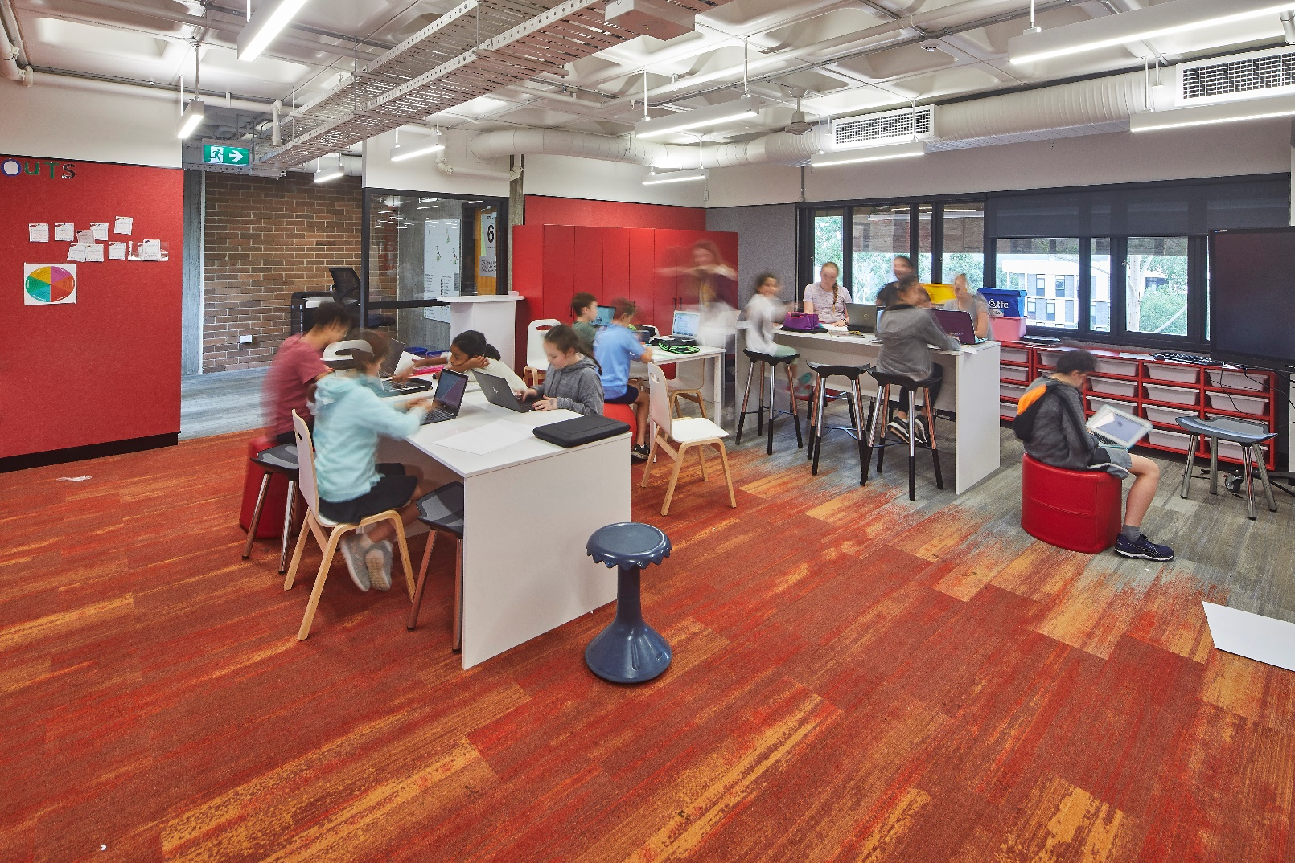

Parent confidence
LLV’s educational vision is strongly supported by parents and community. However, LLV’s redefinition of the nature of schooling also challenges the usual sense of security that being part of a well-known, large system gives a school community. The structure of Masterclass, IDU/TDU and Beyond is very different to other DoE schools. LLV staff found that parents value both information about their child’s development in LLV’s learning characteristics and curriculum outcomes.
As a result, LLV is developing an online platform named the Octopus dashboard. Teachers will use this will track student progress through their learning journey. When launched, it will provide real-time continuous data on student progress in syllabus outcomes, assessment and LLV Learning Characteristics. It will also track students’ critical reflections and their personal learning goals. The transparency of this platform aims to enable parents to feel empowered to take a more active role in supporting their child’s learning as the learning is occurring, rather than at the end of a learning sequence. In addition, this project prioritises parent wellbeing as they can feel confident their child is making progress both in LLV’s learning characteristics as well as in curriculum skills and understanding.

https://education.nsw.gov.au/teaching-and-learning/professional-learning/evaluation-resource-hub/logic-modelling
https://www.hbe.com.au/collaborative-common-assessments-teamwork-instruction-results.html, more information http://solutiontree.s3.amazonaws.com/solutiontree.com/media/pdfs/Reproducibles_CCA/The%20Main%20Idea,%20Coll%20Comm%20Assess.pdf

