Snowball
Snowball activities help learners build understanding of a topic using discussion. Learners build upon one another’s ideas or perspectives to enhance the collective understanding of the group.

Snowball discussions
- Learners independently reflect on a new topic, text, artwork, problem or challenge. They develop their own ideas or solutions.
- Learners move into pairs and discuss the topic, sharing their ideas or solutions. They could comment on one another’s ideas to improve them or use this discussion to reach a consensus.
- Two pairs connect, creating groups of four. Each group member shares their ideas and repeats Step 2.
- Two groups of four connect, creating groups of eight. Step 2 is repeated again.
- This process of group doubling and discussion continues until all learners are combined in a single group.
- The final collection of ideas or solutions is presented and recorded. If appropriate, the teacher can scaffold a process of reaching a final consensus.

Snowball writing
Snowball writing follows the same structure but the sharing of ideas is facilitated through writing rather than discussion.
- Learners sit in a circle and record their initial ideas or solutions on paper.
- Each learner passes their paper to the right. Their peer reviews their idea or solution and adds a comment, suggestion or new idea,
- This process continues until all learners have contributed to all pages.
- Learners review their original work and update their ideas or solutions, considering the feedback of their peers.

Snowball adapted for students learning from home
Snowball activities can keep learners connected while remaining physically distant. The following modifications can enable snowball activities to succeed while students are learning from home:
- Teachers set up a Google Doc or Microsoft Word Online document with a page designated for each learner. Consider using a scaffold like that displayed in Figure 3 to guide learners through the activity.
- Teachers share the problem, challenge or question, along with the document link, with learners.
- Learners record their initial ideas or solutions in their page of the document.
- When signalled (consider using the Chat function in Google Docs) learners move through the pages assigned to their peers to add comments or suggestions.
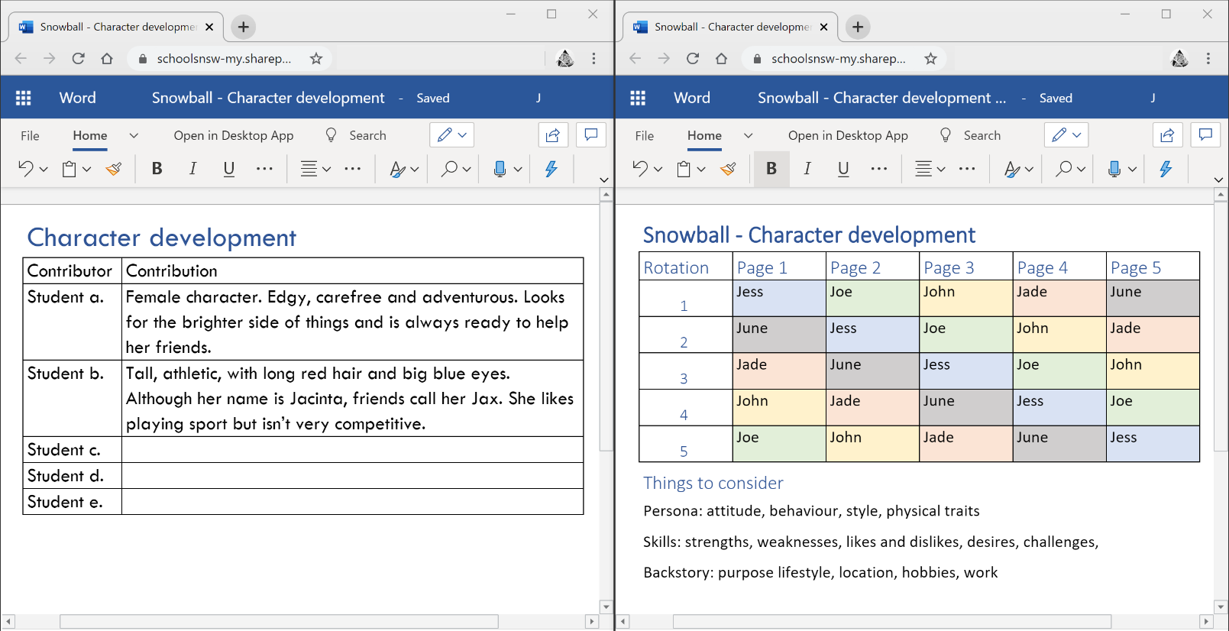
Figure 3 Examples of Snowball scaffolds
Alternative digital tools
- Learners could use a Google Slides or Microsoft PowerPoint Online presentation to record their ideas and review the ideas of their peers.
- Teachers could use Zoom’s breakout rooms to facilitate snowball discussions while students are learning from home. Student groups for each stage of the task would need to be carefully planned by the teacher prior to the activity, and time limits set on breakout rooms.

