Gallery Walk
A gallery walk is a strategy that enables peer reflection on student work. Learners are taught how to give constructive, direct feedback to their peers and each learner uses this to reflect on and improve their own work.
- Teacher presents a task to students. The task should require students to produce something: a product, an artwork, a piece of writing, a digital presentation.
- Learners and teacher collaborate to develop a set of success criteria.
- Conduct a collaborative brainstorm to develop a list of phrases, words and strategies for offering constructive feedback to peers using the success criteria.
- Learners produce a first draft of their piece of work.
- Learners’ work is displayed gallery-style. This could be a digital display; it could make use or writable surfaces, or work could be posted around the classroom.
- Learners circulate, view, and comment on their peers’ work. They can use post-it-notes; write on the writable surfaces or post digital comments. All comments should refer to the success criteria and use the brainstormed phrases and words from Step 3.
- Learners review the comments on their own work and ask clarifying questions if necessary.
- Learners revise their work using their peer feedback.

Gallery walk adapted for students learning from home
A gallery walk is a useful strategy for ensure learners continue to connect and collaborate while they are learning from home. The following modifications can enable successful gallery walks when students are learning from home:
- Learners and teachers can collaborate to develop success criteria and a list of phrases, words and strategies for offering constructive feedback to peers using online word processors such as Google Docs or Microsoft Word Online. Teachers can post a draft version of success criteria and suggested phrases. Learners can use the Comments function to suggest alterations and additions.
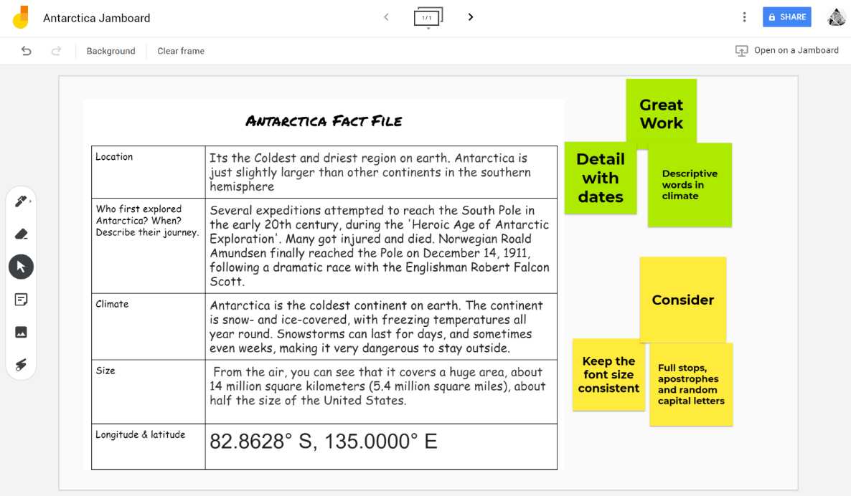
- Learners can display their work for the gallery walk on a collaborative virtual whiteboard such as Google Jamboard. Learners can take a screen shot of digital work or use Microsoft Office Lens to photograph hard copies, then paste the images into their own page of a collaborative Jamboard.
- Peers can post comments or suggestions on the Jamboard using digital sticky notes.
Figure 1 Work presented on Jamboard for feedback.
Alternative digital tools
Learners could share their work on their own slides within a collaborative Microsoft PowerPoint Online presentation.
Non-digital alternative
Learners can produce pieces of work at home and submit them to their teacher in hard copy. Teachers can photocopy and redistribute pieces of work amongst a group of learners and invite learners to add comments and suggestions before returning to the teacher. Pieces of work with new comments are then returned to their creators, who revise and update their work using the feedback from their peers.

