Conscience Alley
Conscience alley is an adaptation of the classic class debate that engages students in argument development, persuasive communication and critical thinking.
- Teacher gives learners a topic to debate.
- Teacher selects one learner to serve as debate adjudicator – this student will hear each side of the debate and select the most compelling argument
- Remaining learners are divided into two equal groups, and one side of the debate assigned to each group
  - Allowing learners to choose their ‘side’ can engage student voice and build purpose.
  - Alternatively, designating ‘sides’ for each learner can encourage the consideration of different perspectives and the control of biases.
- Each team prepares an argument that can be communicated verbally. Each learner should take responsibility for developing one point that will support their team’s argument. They should consider carefully what they will say and how they will say it to grab the adjudicator’s attention. They should also consider the order in which points will be presented.
- Learners form an alley with one team lined up on each side, facing one another. This step is best facilitated outside.
- The adjudicator walks slowly down the alley while learners from both teams present their arguments. As the adjudicator walks past each learner, they should present their point. Encourage the adjudicator to move slowly to enable each learner to present their point.
- As the adjudicator reaches the end of the alley, they consider both sides of the argument and select the more compelling side.
- The adjudicator presents their decision to their peers and justifies their choice.
- Teacher debriefs with both teams, discussing strengths and weaknesses of their arguments and techniques.

Conscience alley adapted for students learning from home
Conscience alley can be adapted for remote learning, engaging learners in the same collaborative development and delivery of compelling arguments using an online word processor. The following modifications will enable teachers to facilitate this activity while students are learning from home:
- Set up a Google doc or Microsoft Word Online document and share with all learners. In this debate document, record the topic and the roles of each learner.
- Set up separate online word processor documents for each team. Share links to these working documents with all team members.
- Learners use their working documents to develop an overall argument, three strong points to support it and three potential rebuttals for the opposing team (this simplifies the argument development process for an online environment).
- Each team presents their arguments and three points in the debate document. They could use a table or create a collaborative piece of writing.
- Once both teams have presented their points in the debate document, their rebuttal points can be added to the opposing team’s argument.
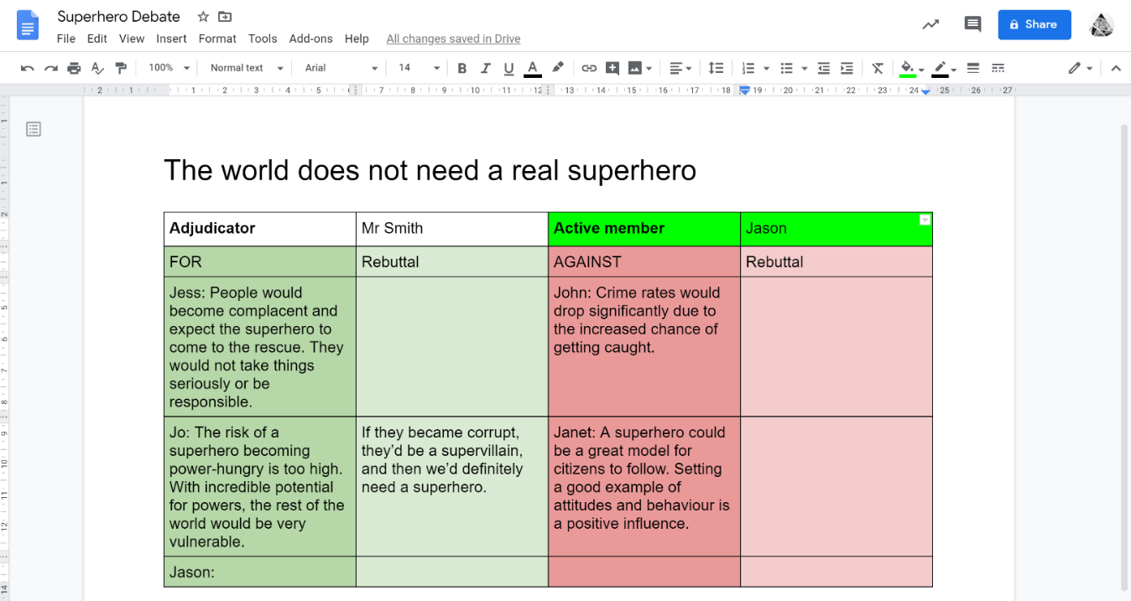
- The adjudicator reviews each argument in the online document and selects the most compelling.
Figure 2 Online conscience alley example using Google Docs
Alternative digital tools
- For older students, teams could use a video conferencing tool such as Zoom to communicate as they co-develop their argument.
- Learners could film themselves presenting their points verbally using Flipgrid and the adjudicator could review videos rather than a written document.

