Main idea and theme
Stage 5

Overview

Purpose
This literacy teaching strategy supports teaching and learning for Stage 5 students across all key learning areas. It targets specific literacy skills and suggests a learning sequence to build skill development. Teachers can select individual tasks, or a sequence, and embed into their teaching and learning program according to their students’ needs. While exemplar texts are provided throughout this resource, it is recommended that teachers select texts which are relevant to their students and curriculum.

Learning intention
Students will learn to identify the main idea and theme in a range of texts.

Syllabus outcomes
The following teaching and learning strategy will assist in covering elements of the following outcomes:
- EN5-RVL-01: uses a range of personal, creative and critical strategies to interpret complex texts
- EN5-URA-01: analyses how meaning is created through the use and interpretation of increasingly complex language forms, features and structures
- EN5-URB-01: evaluates how texts represent ideas and experiences, and how they can affirm or challenge values and attitudes
- EN5-2A: effectively uses and critically assesses a wide range of processes, skills, strategies and knowledge for responding to and composing a wide range of texts in different media and technologies
- EN5-3B: selects and uses language forms, features and structures of texts appropriate to a range of purposes, audiences and contexts, describing and explaining their effects on meaning
NSW English Syllabus K-10 2022
Visit the Leading curriculum K-12 website for more information on the syllabus implementation timeline.

Success criteria
The following Year 9 NAPLAN item descriptors may guide teachers to co-construct success criteria for student learning.
- links the main idea to the title of a text
- identifies a key idea in an information text
- identifies the main argument in a persuasive text
- identifies the main idea of a paragraph in a text
- identifies the main idea of a paragraph in an information text
- identifies the main idea of a section of a text
- identifies the main idea of a text
- identifies the main idea of an information text
- infers a key idea in a narrative
- infers a key idea in an information text
- links the central theme to a quotation in a narrative
- identifies a central theme in a narrative
- identifies a central theme in a poem
- identifies the central theme of a conversation
- identifies the central theme of a narrative extract

National Literacy Learning Progression guide

Understanding Texts (UnT9-UnT11)
Key: C=comprehension P=process V=vocabulary

UnT9
- reads and views complex texts (see Text complexity) (C)
- identifies the main themes or concepts in complex texts by synthesising key ideas or information (C)
- summarises the text identifying key details only (C)
- draws inferences, synthesising clues and evidence across a text (C)
- identifies techniques used to obscure author’s purpose (e.g. inclusion or omission of content) (C)
- selects reading/viewing strategies appropriate to reading purpose (e.g. scans text for evidence) (P)

UnT10
- reads and views complex or some highly complex texts (see Text complexity) (C)
- interprets abstract concepts integrating complex ideas (C)
- analyses how text features are used to support or conflate the point of view in the text (e.g. the strategic use of images such as a cartoon in an editorial) (C)
- integrates automatically a range of processes such as predicting, confirming predictions, monitoring, and connecting relevant elements of the text to build meaning (P)

UnT11
- reads and views highly complex texts (see Text complexity) (C)
- judiciously selects and synthesises evidence from multiple texts to support ideas and arguments (C)
- strategically adjusts the processes of reading and viewing to build meaning according to the demands of tasks and texts (P)
National Literacy Learning Progression

Evidence base
- Centre for Education Statistics and Evaluation (2017). Effective reading instruction in the early years of school, literature review.
- Oakhill, J., Cain, K. & Elbro, C. (2015). Understanding and teaching reading comprehension: A handbook. Routledge.
- Quigley, A. (2020). Closing the reading gap. Routledge.
- Scarborough, H.S. (2001). Connecting early language and literacy to later reading (dis)abilities: Evidence, theory and practice. In S. Neuman & D. Dickson (Eds.), Handbook for research in early literacy (pp. 97-110). New York, NY: Guilford Press.

Alignment to system priorities and/or needs: Five priorities for Literacy and Numeracy, Our Plan for NSW Public Education, School Excellence Policy (nsw.gov.au).
Alignment to School Excellence Framework: Learning domain: Curriculum, Teaching domain: Effective classroom practice and Professional standards
Consulted with: Strategic Delivery, Teaching Quality and Impact
Author: Literacy and Numeracy
Reviewed by: Literacy and Numeracy, Teaching Quality and Impact
Created/last updated: January 2024
Anticipated resource review date: January 2025
Feedback: Complete the online form to provide any feedback

Copyright
Section 113P Notice
Texts, Artistic Works and Broadcast Notice
Some of this material has been copied and communicated to you in accordance with the statutory licence in section 113P of the Copyright Act. Any further reproduction or communication of this material by you may be the subject of copyright protection under the Act. Do not remove this notice.

Teaching strategies
Task | Appendices
Finding the main idea | Appendix 1 – information text  Appendix 2 - ‘Get the GIST’ Explicit Instruction – worked example  Appendix 3 - ‘Get the GIST’ scaffold  Appendix 4 - Newsflash! scaffold
Theme | Appendix 5 - Identifying theme in texts  Appendix 6 - Identifying theme in inspirational quotes
Compare and contrast theme and main idea | Appendix 7 - Identifying theme and main idea in texts
Identifying main idea across texts. | Appendix 8 - Identifying main idea across texts

Background information

Main idea
Being able to determine the main idea helps readers to recall important information. Locating the main idea and significant details helps the reader understand the points the writer is attempting to express. Identifying the relationship between the main idea and significant details can improve comprehension.
Reference: Comprehension strategies, NSW Centre for Effective Reading (Middle Years).
To find the main idea, the following process can help students develop their understanding:
Gather: background knowledge and vocabulary
Identify the topic
Summarise the text
Top and Tail sentences will often reinforce the main idea.

Theme
An overarching or recurring idea that describes attitudes or values that are perceived in a text. A theme may range from the understood ‘moral’ of a text to philosophical observations that the audience makes about the events, characters and experiences depicted in a text. A text may have more than one theme.
Reference: English K-10 Syllabus © NSW Education Standards Authority (NESA) for and on behalf of the Crown in right of the State of New South Wales, 2012 and 2022.

Where to next?
- Literal comprehension
- Inference
- Text structure and features

Overview of teaching strategies

Access points
The resources can be accessed from:
- NAPLAN App in Scout using the teaching strategy links from NAPLAN items
- NSW Department of Education literacy and numeracy website.
What works best
Explicit teaching practices involve teachers clearly explaining to students why they are learning something, how it connects to what they already know, what they are expected to do, how to do it and what it looks like when they have succeeded. Students are given opportunities and time to check their understanding, ask questions and receive clear, effective feedback.
This resource reflects the latest evidence base and can be used by teachers as they plan for explicit teaching.
Teachers can use classroom observations and assessment information to make decisions about when and how they use this resource as they design teaching and learning sequences to meet the learning needs of their students.
Further support with What works best is available.
Differentiation
When using these resources in the classroom, it is important for teachers to consider the needs of all students, including Aboriginal and EAL/D learners.
EAL/D learners will require explicit English language support and scaffolding, informed by the EAL/D enhanced teaching and learning cycle and the student’s phase on the EAL/D Learning Progression. Teachers can access information about supporting EAL/D learners and literacy and numeracy support specific to EAL/D learners.
Learning adjustments enable students with disability and additional learning and support needs to access syllabus outcomes and content on the same basis as their peers. Teachers can use a range of adjustments to ensure a personalised approach to student learning.
Assessing and identifying high potential and gifted learners will help teachers decide which students may benefit from extension and additional challenge. Effective strategies and contributors to achievement for high potential and gifted learners helps teachers to identify and target areas for growth and improvement. A differentiation adjustment tool can be found on the High potential and gifted education website.

Using tasks across learning areas
This resource may be used across learning areas where it supports teaching and learning aligned with syllabus outcomes.
Literacy and numeracy are embedded throughout all syllabus documents as general capabilities. As the English and mathematics learning areas have a particular role in developing literacy and numeracy, NSW English and Mathematics syllabus outcomes aligned to literacy and numeracy skills have been identified.

Text selection
Example texts are used throughout this resource. Teachers can adjust activities to use texts which are linked to their unit of learning.
Further support with text selection can be found within the National Literacy Learning Progression Text Complexity appendix.
The NESA website has additional information on text requirements within the NSW English syllabus.

Teaching strategies

Finding the main idea
- Discuss what the main idea of a text is, reinforcing the difference between main idea and supporting ideas. Using an information text relevant to a current unit of learning, or the extract below (refer to Appendix 1 – information text for the full text), model how to identify the main idea by first looking at the title of the text and the opening paragraph. Then identify any initial supporting ideas in the opening section of the text. Use the think aloud strategy and annotate the text before recording ideas on a graphic organiser or table.
Think aloud: Today we are going to look at an information text and identify the main idea and any other supporting ideas, these are the ideas or details that reinforce or contribute to the main idea. We can often find the main idea in the title and in topic sentences, particularly in an information text. When we look at the title ‘Understanding emotions is nearly is nearly as important as IQ for students’ academic success’ we can see that the topic is on contributors to student academic success. I will compare it to the first line of the article to see if I can add to my understanding of the main idea. The opening sentence reinforces the idea in the heading – that the ability to understand emotions is almost as important to student academic success as IQ. If I skim and scan the remainder of this opening section, I note evidence from past studies which reveal that IQ (15%) is important to academic success, but I can also find supporting ideas, or details from ‘recent’ research, that the ability to understand emotions is almost as important (12%).
Understanding emotions is nearly as important as IQ for students’ academic success
The ability to understand emotions contributes almost as much to students’ grades as their IQ.
Past studies show two personal qualities are important for student academic success – intelligence and conscientiousness.
IQ scores explain about 15% of the differences between students’ grades. Conscientiousness, such as having the diligence to do enough study, explains about 5%.
Our recent research has found emotional intelligence explains 4% of differences between students’ achievement. But the ability to understand emotions, a component of emotional intelligence, explains about 12% of differences in students’ grades.
Extract from: Carolyn MacCann, Amirali Minbashian, and Kit Double March, 3 March 2020, Understanding emotions is nearly as important as IQ for students’ academic success, The Conversation.

Main idea | Supporting ideas
The ability to understand emotions contributes almost as much to students’ grades as their IQ. | - IQ scores explain about 15% of the differences between students’ grades.  - emotional intelligence explains 4% of differences between students’ achievement  - the ability to understand emotions explains about 12% of differences in students’ grades

- Source a range of complex, or highly complex, persuasive, imaginative and informative text excerpts relevant to a current unit of learning. Using one text as an exemplar, model using the ‘Get the GIST’ graphic organiser to determine the main idea or main argument; this structured approach supports students to gather information (important vocabulary and background knowledge), identify the topic, summarise the text, and ‘top and tail’ (check the first and last sentences) to make sure they have accurately identified the main idea. Appendix 2 - ‘Get the GIST’ Explicit Instruction – worked example.
Get the GIST:
Gather information about background knowledge and key vocabulary:
Colour 1: Important vocabulary to understand which is pertinent to the text
Colour 2: Unfamiliar vocabulary
Colour 3: Repeated vocabulary
Identify the topic: Use vocabulary to guide ideas and refine to a word, for example, dragonflies or a phrase, for example, The assassination of Archduke Franz Ferdinand
Summarise the text by placing vocabulary into key points
Top and Tail sentences- check first and last sentences as these may reinforce main idea.
- Think Pair Share - in pairs, students apply the ‘Get the GIST’ process to identify the main idea and supporting ideas in the text excerpts sourced above. (Appendix 3 - ‘Get the GIST’ scaffold.) Alternatively, each pair could be allocated a section from a whole text. (Refer to Appendix 1 – information text for an exemplar text.) Students annotate the text before sharing their ideas with the whole class.
- Inferring the main idea: explicit instruction. Teacher explains how informative texts such as newspapers and feature articles often use persuasive devices. Meaning can be inferred through headlines, images/graphics, by-lines, and the type of evidence used to support ideas, such as data or direct quotes selected from experts or eye-witnesses. Using the GIST process and the ‘think aloud’ strategy, the teacher models how to infer the main idea in an information text relevant to a current unit of learning. Using the ‘Newsflash’ graphic organiser the teacher writes a succinct summary of the main idea in the article, locates an image from the article that supports the main idea and includes supporting ideas from the article. (Refer to Appendix 4 - Newsflash! scaffold) These supporting ideas may be directly stated or inferred from text features.
For higher order thinking, teacher discusses how omissions can also infer meaning and persuade a reader. By choosing to only represent, or favour, one side of an argument, a writer can persuade by omission.
- Think-Pair-Share: Students complete the Newsflash! (Appendix 4 - Newsflash! scaffold), on an additional text relevant to a current unit of learning, as outlined in Activity 4.
For challenge, students could locate their own images to infer the main idea in the newspaper article. Students then justify why their images may be more effective than the original, or how their image might change the focus of the main idea and persuade readers to hold a different perspective.

Theme
- Review theme as the central or one of the main underlying ideas or messages of a text. Theme refers to the central idea or one of the main underlying ideas or the moral of a text. For example, ‘family is the most important thing in life’, ‘friends are people who are kind to each other’, ‘if you work hard you will succeed’, ‘being sustainable is good for business’, ‘don’t underestimate things that you don’t know about’. Sometimes we may need to infer meaning to determine the theme. For example, if a character in a text has to overcome a number of hardships before succeeding, the theme may be that courage and tenacity always pays off. Discuss some examples of themes from previously studied or known texts. Discuss major and minor themes, particularly in more sustained texts like a novel. Create a class mind map with examples of themes and texts where the theme was represented. (For sample texts refer to Appendix 5 - Identifying theme in texts.)
- Inspirational quotes are placed on posters around the classroom. Students walk around and add ideas to a T-Chart to brainstorm ideas for theme, what it might mean and examples of texts where this theme is evident (refer to Appendix 6 - Identifying theme in inspirational quotes). This strategy can be replicated with art and music.
- Compare and contrast theme and main idea. Explain to students that like imaginative texts, informative and persuasive texts may also have themes. For example, a text with the main idea that ‘pollution is damaging the environment’ and supporting idea that ‘recycling is important’ may have an underlying theme of ‘sustainability’. Students create a T-Chart detailing the difference between theme and main idea. For example,
Theme | Main idea
The theme is the underlying idea or message. What the author wants us to think about or what idea stays with us | The main idea of a text tells what it is mostly about
- Actions speak louder than words  - Teamwork  - Envy | - Emotions are as important as IQ for academic success.  - The team won the game when they embraced their differences.
Using texts relevant to a current unit of learning, or refer to Appendix 7 - Identifying theme and main idea in texts, students determine the main idea or argument and theme for each text.

Identifying main idea across texts
This task supports student’s ability to compare and contrast information across texts and synthesize information. Teachers can use texts relevant to a current unit of learning or refer to the extracts from Appendix 8 - Identifying main idea across texts.
- Explain that while texts may hold information on a general topic, not all texts need to be read in full to find specific information. Teacher discusses skimming and scanning for meaning across multiple texts using the think aloud strategy. For example: ‘If I were looking for information on life on an Antarctic Expedition ship, which text(s) would I need to read more fully? I might scan the texts initially looking for clues. The heading ‘icebergs’ from extract 1 suggests that the focus is on the icebergs themselves, so perhaps not relevant for my research. Scanning the first line of extract 2 I note that this focuses on the photography taken from an aerial flight, not an expedition ship, so not what I am looking for. Extract 3 looks more promising. As I skim through the text looking for key words I note ‘We need to do sighting surveys...’ which suggests you would have to be on some sort of vessel, but I can’t find any references to life on board a ship. Extract 4’s heading seems more relevant as I know that Mawson was an Antarctic explorer. If I scan the first line of each paragraph, I notice that paragraph 2 begins with ‘For on board that ship...’ I will read further to discover more information about life on an Antarctic Expedition Ship.’
- Think-Pair-Share: Students conduct purposeful skimming and scanning to locate specific information. In pairs, scan the four extracts and highlight/take notes on the formation of icebergs. Students share their notes, using the think aloud strategy to explain their choice of texts and the information they identified. Teacher reinforces the idea that not all texts are 'equal' in extracting information for a particular purpose.
For complexity: teachers could plan future teaching and learning to include the students collecting text extracts and creating questions for each other. To support them in this, teachers could refer to the Text Complexity appendix from the National Literacy Learning Progression.
- Provide students with a range of complex and/.or highly complex persuasive, informative and imaginative texts on the same topic or concept. comparing and contrasting the main idea and supporting ideas in each text. For example, on the topic of climate change students could compare texts from a range of perspectives and in different forms, noting the main idea, supporting ideas and how they are represented in different forms of texts. They might also note and evaluate the type of evidence that is used to support ideas in each text. Observations could be recorded on a graphic organiser and students could collate these as a class or discuss and evaluate their findings through a gallery walk.

Appendix 1

Information text: Understanding emotions is nearly as important as IQ for students’ academic success.
Carolyn MacCann (University of Sydney), Amirali Minbashian (UNSW) and Kit Double March (University of Oxford), 3 March 2020, The Conversation. (Full text with images and hyperlinks.)
The ability to understand emotions contributes almost as much to students’ grades as their IQ.
Past studies show two personal qualities are important for student academic success – intelligence and conscientiousness.
IQ scores explain about 15% of the differences between students’ grades. Conscientiousness, such as having the diligence to do enough study, explains about 5%.
Our recent research has found emotional intelligence explains 4% of differences between students’ achievement. But the ability to understand emotions, a component of emotional intelligence, explains about 12% of differences in students’ grades.
What is emotional intelligence?
Different researchers use slightly different definitions of emotional intelligence.
Some define emotional intelligence as the ability to perceive, use, understand and manage your own and other people’s emotions. This is called “ability emotional intelligence”.
Others also include character traits such as optimism, impulse control and the ability to motivate yourself. This is called “mixed emotional intelligence” because it is a mix of abilities and character traits.
We examined the findings of more than 150 studies on the link between emotional intelligence and academic performance. These studies included more than 42,000 students and 1,246 different estimations of the size of the relationship between emotional intelligence and academic performance.
Some of the studies in our analysis used rating scales to assess emotional intelligence. Here, test-takers might rate their emotional abilities with items like “I am aware of the non-verbal messages other people send” or rate their mixed emotional intelligence with items like “I am motivated to succeed”.
Others tested emotional intelligence directly by measuring participants’ emotional abilities with skill-based tasks. For example, test takers might be asked to identify which emotion is expressed in a face.
We found that, overall, emotional intelligence explained about 4% of differences in students’ academic achievement. But some emotional intelligence types were more important than others.
Skill-based emotional intelligence, such as reading people’s faces, explained 6% of differences in academic achievement, but self-ratings of emotional abilities explained 1% of differences. So, emotional skills assessed from the outside are more important for students’ academic performance than students’ self-ratings (or self-beliefs) about their emotional skills.
But some emotional skills were more important than others. The two most important emotional skills for academic success were understanding emotions and managing emotions.
Students who can understand emotions can accurately label their own and others’ emotions. They know what causes emotions, how emotions change and how they combine. Students who can manage emotions know how to regulate their emotions in a stressful situation. They also know what to do to maintain good social relationships with others.
Emotion management skills accounted for 7% of differences in academic performance. Emotion understanding skills accounted for 12%. That is, understanding emotions is more important for student success than conscientiousness (5%) and almost as important as students’ IQ (15%).
Emotionally intelligent students tend to be more intelligent as well as more conscientious. But our study found it wasn’t just that emotionally intelligent students were also more likely to be intelligent and conscientious.
We applied a statistical technique called meta-regression to examine what the effect of emotional intelligence would be if everyone had the same level of conscientiousness and intelligence.
For students who had the same levels of conscientiousness and intelligence, emotional intelligence was still linked with higher academic performance.
For students with the same levels of intelligence and conscientiousness:
- self-ratings of mixed emotional intelligence (the one involving both skills and character traits) explained 2.3% of differences in performance
- emotion understanding skills explained 3.9% of differences in performance
- emotion management skills explained 3.6% of differences in performance.
Why is emotional intelligence linked to good grades?
There are at least three reasons why we believe emotional intelligence relates to higher academic performance.
First, students with higher emotional intelligence can regulate their “academic emotions”. Students may feel anxious about tests and performance. They may feel bored when learning required but dull material. And they may feel frustrated or disappointed when they try their hardest but still can’t quite get the hang of a task.
Students who can regulate these tough emotions will achieve more. Anxiety will not impair the test performance. They can push through the boredom and frustration to master dull or difficult material. They can learn from negative feedback or failure rather than be derailed by disappointment.
Second, students with higher emotional intelligence can form better social relationships with their classmates and teachers. They can get help with schoolwork or with social and emotional needs when they need it.
Third, many non-technical academic subjects require an understanding of human emotions and social relations as an inherent part of the subject matter. Analysing universal themes of love and betrayal in Shakespeare plays requires not just verbal skills but emotional knowledge and skill. Analysing the role of charismatic leaders in the rise of fascist regimes likewise requires social knowledge and analysis.
Our results show that teachers, parents and students should focus on student’s emotional skills not just for student’s well-being, but for their ability to succeed academically.
Copied under the statutory licence in s113P of the Copyright Act
Carolyn MacCann, Amirali Minbashian and Kit Double, 3 March 2020, Understanding emotions is nearly as important as IQ for students’ academic success. The Conversation, 1 March 2022
Section 113P Warning Notice

Appendix 2

‘Get the GIST’ Explicit Instruction – worked example

Get the GIST

Gather information  Background knowledge and key vocabulary:  Colour 1: Important vocabulary  Colour 2: Unfamiliar vocabulary  Colour 3: Repeated vocabulary  Island, disco, uploaded, sensation  Perform, Indigenous, dance  Festivals, cultural events, Yolngu  traditional, global  success, upbeat version | Identify the topic  Use vocabulary to guide ideas and refine to a word, for example, dragonflies or a phrase, for example, The assassination of Archduke Franz Ferdinand  Indigenous dance group success story  International, multicultural, outback youth success story
Summarise text by placing vocabulary into key points:  An indigenous dance group has found global success  After uploading a performance, now performing globally  Perform upbeat versions of multicultural dances | Top and Tail sentences- check first and last sentences as these may reinforce main idea:  Top: Local children enjoying dancing  Tail:

Main idea:
The Internet helped start the trajectory of success for a local group of Indigenous students who share their connection and love of dance and culture across the globe.

Appendix 3

‘Get the GIST’ Student Scaffold

Get the GIST

Gather information  background knowledge and key vocabulary:  Colour 1: Important vocabulary  Colour 2: Unfamiliar vocabulary  Colour 3: Repeated vocabulary | Identify the topic  Use vocabulary to guide ideas and refine to a word, for example, dragonflies or a phrase, for example, The assassination of Archduke Franz Ferdinand
Summarise text by placing vocabulary into key points | Top and Tail sentences- check first and last sentences as these may reinforce main idea.

Appendix 4

Newsflash!
Headline (a succinct and catchy version of the main idea)

Visual Representation | Supporting Details

Appendix 5

Identifying theme in texts
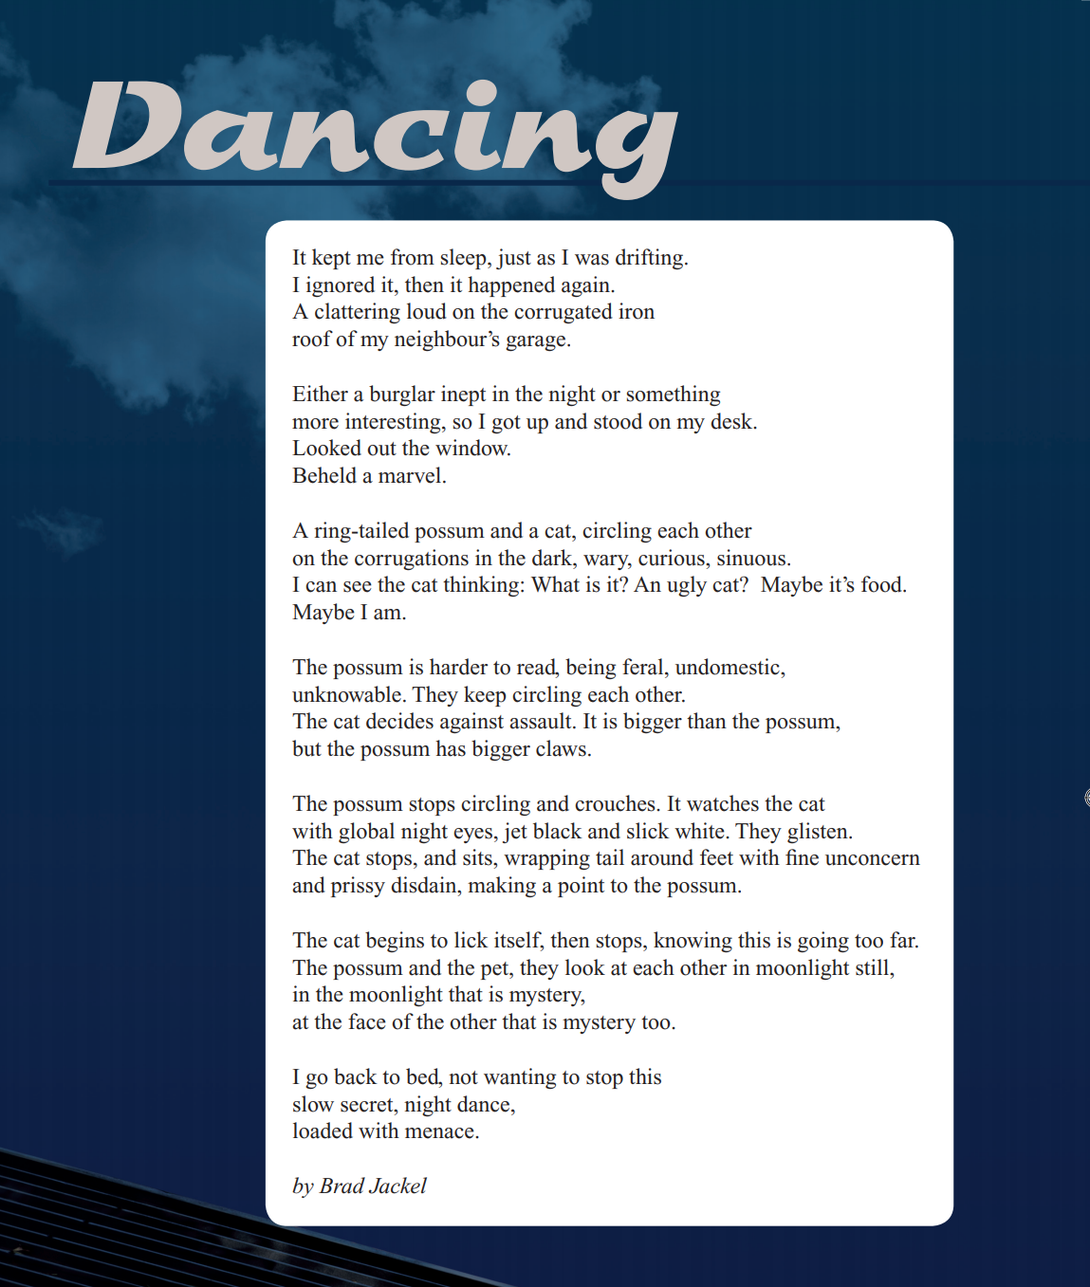

Year 9 NAPLAN Reading magazine, 2012 ACARA

Identifying theme in texts- accessible version
Dancing
It kept me from sleep, just as I was drifting.
I ignored it, then it happened again.
A clattering loud on the corrugated iron
roof of my neighbour’s garage.

Either a burglar inept in the night or something
more interesting, so I got up and stood on my desk.
Looked out the window.
Beheld a marvel.

A ring-tailed possum and a cat, circling each other
on the corrugations in the dark, wary, curious, sinuous.
I can see the cat thinking: What is it? An ugly cat? Maybe it’s food.
Maybe I am.

The possum is harder to read, being feral, undomestic,
unknowable. They keep circling each other.
The cat decides against assault.
It is bigger than the possum, but the possum has bigger claws.

The possum stops circling and crouches. It watches the cat
with global night eyes, jet black and slick white. They glisten.
The cat stops, and sits, wrapping tail around feet with fine unconcern
and prissy disdain, making a point to the possum.

The cat begins to lick itself, then stops, knowing this is going too far.
The possum and the pet, they look at each other in moonlight still,
in the moonlight that is mystery,
at the face of the other that is mystery too.

I go back to bed, not wanting to stop this
slow secret, night dance,
loaded with menace.
By Brad Jackel
Year 9 NAPLAN Reading magazine, 2012 ACARA.

Identifying theme in texts
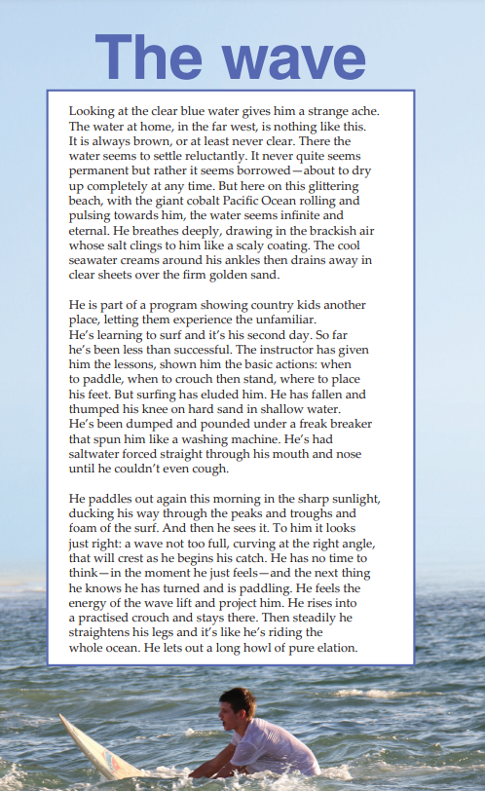

Year 9 NAPLAN Reading magazine, 2016 ACARA.

Identifying theme in texts – accessible version

The wave
Looking at the clear blue water gives him a strange ache. The water at home, in the far west, is nothing like this. It is always brown, or at least never clear. There the water seems to settle reluctantly. It never quite seems permanent but rather it seems borrowed—about to dry up completely at any time. But here on this glittering beach, with the giant cobalt Pacific Ocean rolling and pulsing towards him, the water seems infinite and eternal. He breathes deeply, drawing in the brackish air whose salt clings to him like a scaly coating. The cool seawater creams around his ankles then drains away in clear sheets over the firm golden sand.
He is part of a program showing country kids another place, letting them experience the unfamiliar. He’s learning to surf and it’s his second day. So far he’s been less than successful. The instructor has given him the lessons, shown him the basic actions: when to paddle, when to crouch then stand, where to place his feet. But surfing has eluded him. He has fallen and thumped his knee on hard sand in shallow water. He’s been dumped and pounded under a freak breaker that spun him like a washing machine. He’s had saltwater forced straight through his mouth and nose until he couldn’t even cough.
He paddles out again this morning in the sharp sunlight, ducking his way through the peaks and troughs and foam of the surf. And then he sees it. To him it looks just right: a wave not too full, curving at the right angle, that will crest as he begins his catch. He has no time to think—in the moment he just feels—and the next thing he knows he has turned and is paddling. He feels the energy of the wave lift and project him. He rises into a practised crouch and stays there. Then steadily he straightens his legs and it’s like he’s riding the whole ocean. He lets out a long howl of pure elation.
Year 9 NAPLAN Reading magazine, 2016 ACARA.

Identifying theme in texts
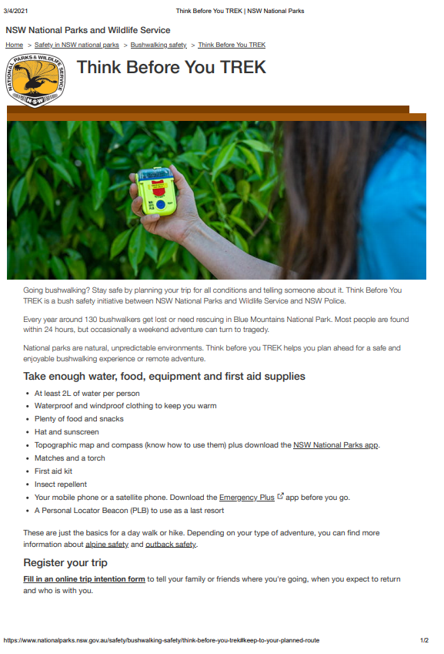
Copied under the statutory licence in s113P of the Copyright Act
Think before you trek, from www.nationalparks.nsw.gov.au 4 March 4, 2021.
Section 113P Warning Notice

Identifying theme in texts

Think before you trek
Going bushwalking? Stay safe by planning your trip for all conditions and telling someone about it. Think Before You TREK is a bush safety initiative between NSW National Parks and Wildlife Service and NSW Police.
Every year around 130 bushwalkers get lost or need rescuing in Blue Mountains National Park. Most people are found within 24 hours, but occasionally a weekend adventure can turn to tragedy.
National parks are natural, unpredictable environments. Think before you TREK helps you plan ahead for a safe and enjoyable bushwalking experience or remote adventure.

Take enough water, food, equipment and first aid supplies
- At least 2L of water per person Waterproof and windproof clothing to keep you warm
- Plenty of food and snacks
- Hat and sunscreen
- Topographic map and compass (know how to use them) plus download the NSW National Parks app. Matches and a torch
- First aid kit Insect repellent
- Your mobile phone or a satellite phone. Download the Emergency Plus app before you go.
- A Personal Locator Beacon (PLB) to use as a last resort
These are just the basics for a day walk or hike. Depending on your type of adventure, you can find more information about alpine safety and outback safety. Register your trip Fill in an online trip intention form to tell your family or friends where you're going, when you expect to return and who is with you.

Copied under the statutory licence in s113P of the Copyright Act
Think before you trek, from www.nationalparks.nsw.gov.au 4 March 4, 2021.
Section 113P Warning Notice

Appendix 6

Identifying theme in inspirational quotes
“The Pessimist Sees Difficulty In Every Opportunity. The Optimist Sees Opportunity In Every Difficulty.” – Winston Churchill | “The Way Get Started Is To Quit Talking And Begin Doing.” – Walt Disney
“You Learn More From Failure Than From Success. Don’t Let It Stop You. Failure Builds Character.” – Unknown | “If You Are Working On Something That You Really Care About, You Don’t Have To Be Pushed. The Vision Pulls You.” – Steve Jobs
“Entrepreneurs Are Great At Dealing With Uncertainty And Also Very Good At Minimizing Risk. That’s The Classic Entrepreneur.” – Mohnish Pabrai | “We May Encounter Many Defeats But We Must Not Be Defeated.” – Maya Angelou
“Whether You Think You Can Or Think You Can’t, You’re Right.” – Henry Ford | “Security Is Mostly A Superstition. Life Is Either A Daring Adventure Or Nothing.” – By Helen Keller
“The Man Who Has Confidence In Himself Gains The Confidence Of Others.” – Hasidic Proverb | “The Only Limit To Our Realization Of Tomorrow Will Be Our Doubts Of Today.” – Franklin D. Roosevelt
“Creativity Is Intelligence Having Fun.” – Albert Einstein | “Do What You Can With All You Have, Wherever You Are.” – Theodore Roosevelt
“You Are Never Too Old To Set Another Goal Or To Dream A New Dream.” – C.S. Lewis | “One Of The Lessons That I Grew Up With Was To Always Stay True To Yourself And Never Let What Somebody Else Says Distract You From Your Goals.” – Michelle Obama
“All our best heroes are losers.” -Richard Glover - radio presenter | “I've never seen anyone rehabilitated by punishment” -Henry Lawson - poet
“A Platypus is a duck designed by a committee.” - Anon | “It's no good crying over spilt milk; all we can do is bail up another cow” (Ben Chifley – Australian Prime Minister)
There is nothing so costly to the state as a ruined life (Catherine Spence - Social and political reformer, writer and teacher) | “Those who lose dreaming are lost.” - (Australian Aboriginal proverb)
“Out in the bush, the tarred road always ends just after the house of the local mayor.” -Australian observation | “We cultivated our land, but in a way different from the white man. We endeavoured to live with the land; they seemed to live off it.” Tom Dystra - Aboriginal man
“A truly happy person is one who can enjoy the scenery on a detour.” Anon | “I say to the young blokes, when you get asked for an autograph, don't knock it back because there'll be a time where no one will ask you.” Brett Kenny - footballer

Appendix 7

Identifying theme and main idea in texts
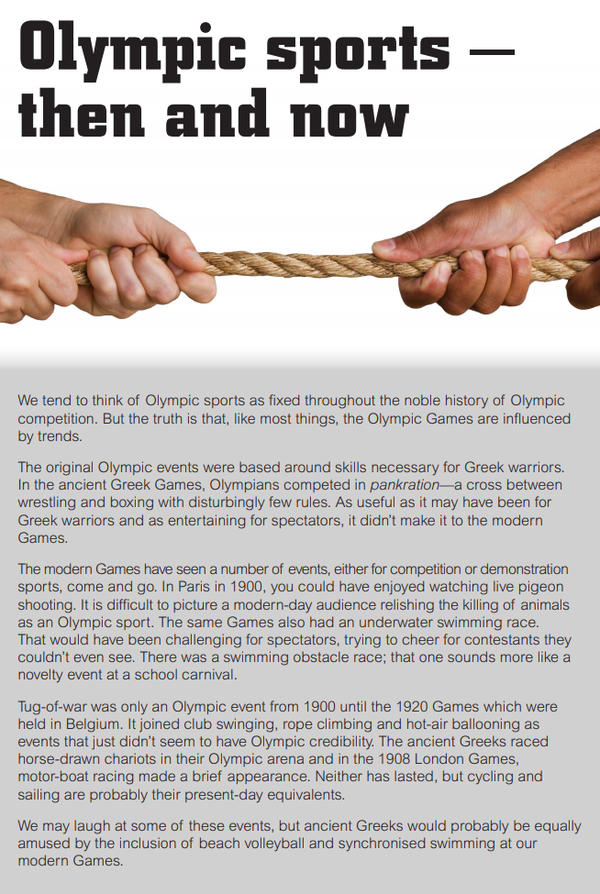 | Theme:  Main idea or main argument:
Year 9 NAPLAN Reading magazine, 2014 ACARA

Identifying theme and main idea in texts – accessible version
Olympic sports — then and now
We tend to think of Olympic sports as fixed throughout the noble history of Olympic competition. But the truth is that, like most things, the Olympic Games are influenced by trends.
The original Olympic events were based around skills necessary for Greek warriors. In the ancient Greek Games, Olympians competed in pankration—a cross between wrestling and boxing with disturbingly few rules. As useful as it may have been for Greek warriors and as entertaining for spectators, it didn’t make it to the modern Games.
The modern Games have seen a number of events, either for competition or demonstration sports, come and go. In Paris in 1900, you could have enjoyed watching live pigeon shooting. It is difficult to picture a modern-day audience relishing the killing of animals as an Olympic sport. The same Games also had an underwater swimming race. That would have been challenging for spectators, trying to cheer for contestants they couldn’t even see. There was a swimming obstacle race; that one sounds more like a novelty event at a school carnival.
Tug-of-war was only an Olympic event from 1900 until the 1920 Games which were held in Belgium. It joined club swinging, rope climbing and hot-air ballooning as events that just didn’t seem to have Olympic credibility. The ancient Greeks raced horse-drawn chariots in their Olympic arena and in the 1908 London Games, motor-boat racing made a brief appearance. Neither has lasted, but cycling and sailing are probably their present-day equivalents.
We may laugh at some of these events, but ancient Greeks would probably be equally amused by the inclusion of beach volleyball and synchronised swimming at our modern Games.
Year 9 NAPLAN Reading magazine, 2014 ACARA

Identifying theme and main idea in texts
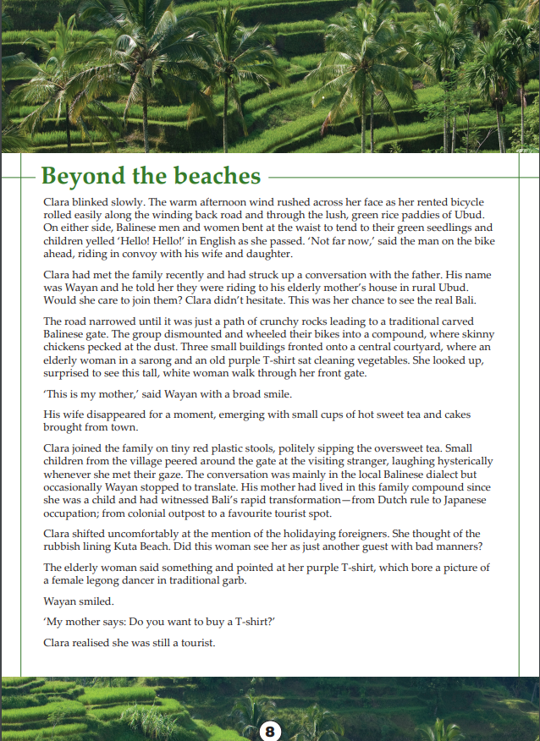
Year 9 NAPLAN Reading magazine, 2014 ACARA

Identifying theme and main idea in texts – accessible version
Beyond the beaches
Clara blinked slowly. The warm afternoon wind rushed across her face as her rented bicycle rolled easily along the winding back road and through the lush, green rice paddies of Ubud. On either side, Balinese men and women bent at the waist to tend to their green seedlings and children yelled ‘Hello! Hello!’ in English as she passed. ‘Not far now,’ said the man on the bike ahead, riding in convoy with his wife and daughter.
Clara had met the family recently and had struck up a conversation with the father. His name was Wayan and he told her they were riding to his elderly mother’s house in rural Ubud. Would she care to join them? Clara didn’t hesitate. This was her chance to see the real Bali.
The road narrowed until it was just a path of crunchy rocks leading to a traditional carved Balinese gate. The group dismounted and wheeled their bikes into a compound, where skinny chickens pecked at the dust. Three small buildings fronted onto a central courtyard, where an elderly woman in a sarong and an old purple T-shirt sat cleaning vegetables. She looked up, surprised to see this tall, white woman walk through her front gate.
‘This is my mother,’ said Wayan with a broad smile.
His wife disappeared for a moment, emerging with small cups of hot sweet tea and cakes brought from town.
Clara joined the family on tiny red plastic stools, politely sipping the oversweet tea. Small children from the village peered around the gate at the visiting stranger, laughing hysterically whenever she met their gaze. The conversation was mainly in the local Balinese dialect but occasionally Wayan stopped to translate. His mother had lived in this family compound since she was a child and had witnessed Bali’s rapid transformation—from Dutch rule to Japanese occupation; from colonial outpost to a favourite tourist spot.
Clara shifted uncomfortably at the mention of the holidaying foreigners. She thought of the rubbish lining Kuta Beach. Did this woman see her as just another guest with bad manners?
The elderly woman said something and pointed at her purple T-shirt, which bore a picture of a female legong dancer in traditional garb.
Wayan smiled.
‘My mother says: Do you want to buy a T-shirt?’
Clara realised she was still a tourist.
Year 9 NAPLAN Reading magazine, 2014 ACARA

Appendix 8

Identifying main idea across texts
Extract 1
Icebergs
The appearance of an iceberg is affected by the type of ice it is made from and the shape of the land that the ice formed over. Antarctic icebergs generally break off from large ice sheets and form tabular icebergs that are broad and flat. Pinnacle, or castle, icebergs are steep peaks of ice and form in the Arctic where they are calved from steep-sided mountain glaciers. The largest observed northern iceberg towered 168 meters above sea level.
From Year 9 NAPLAN Reading magazine, 2014 ACARA
Extract 2
How a near perfect rectangular iceberg formed. Sue Cook (University of Tasmania) October 2018
NASA scientist Jeremy Harbeck was on a surveying flight over the Antarctic Peninsula earlier this month when he spotted an iceberg that looked like no other. It was almost perfectly rectangular, with square sides and a flat top that made it look more human-made than natural.
“I thought this rectangular iceberg was visually interesting and fairly photogenic so, on a lark, I just took a couple photos,” Harbeck said. These photos have since been shared around the globe.
Despite its eerily perfect shape, this iceberg is completely natural, and in fact not even that unusual. Ice has a crystal structure that means it prefers to break along straight lines. In the northern hemisphere, ice sheets sit on bedrock, and the friction between the ice and the ground means icebergs form in the irregular shapes that most of us picture when thinking of an iceberg.
Copied under the statutory licence in s113P of the Copyright Act
Copied under the statutory licence in s113P of the Copyright Act. Sue Cook, How a near perfect rectangular iceberg formed. The Conversation, 29 October 2018. Section 113P Warning Notice
Extract 3
Transcript
Antarctic Animals, Emma Davis, ABC, Behind the News, March 2019
When you think of Antarctica you probably think of, well, ice mostly. But your second thought might be these guys. Yep the Antarctic region is home to many interesting animal species, ranging from the very small to the biggest on Earth. And that's what these scientists are here to study. They've spent weeks following the movements of Antarctic blue whales.
DR VIRGINIA ANDREWS-GOFF, WHALE RESEARCHER: We need to do sighting surveys for blue whales to work out their numbers which is quite tricky.
Despite being the biggest animal that's ever lived, whales can be really hard to track because they live underwater and they swim really fast. But scientists have a few tricks up their sleeves, like listening for their songs.
Copied under the statutory licence in s113P of the Copyright Act. Emma Davis, Antarctic Animals, ABC, Behind the News, 26 March 2019. Section 113P Warning Notice

Extract 4
Mawson: And the Ice Men of the Heroic Age: Scott, Shackleton and Amundsen
by Peter Fitzsimmons, Random House, 2014
In 1884, the two-year-old Douglas first came from England to Australia aboard the clipper ship Ellora with his older brother, William, and their parents, Robert and Margaret. The Mawsons were fleeing the economic depression that had gripped their native Yorkshire. As the favourite family story goes, Douglas has shown his wherewithal and derring-do from the first.
For on board that ship, somewhere out upon the seven seas on their way to their new home, the little one slipped unnoticed from the comfort of his mother’s side in the galley and decided to go exploring…soon enough making his way into the glorious sunshine and the refreshing sea breeze.
But if it was wonderful down here on the deck, where sill no one had spotted him, how much better and brighter might it be up there…? Up in the rigging. And off he went. Hand over hand up the rat-lines, getting higher now, his feet gamely gripping the spot where his hands had just been.
Copied under the statutory licence in s113P of the Copyright Act. Peter Fitzsimmons, Mawson: And the Ice Men of the Heroic Age: Scott, Shackleton and Amundsen, Random House, 2014. Section 113P Warning Notice.

