Inference
Stage 5

Overview

Purpose

This literacy teaching strategy supports teaching and learning for Stage 5 students across all key learning areas. It targets specific literacy skills and suggests a learning sequence to build skill development. Teachers can select individual tasks, or a sequence, and embed into their teaching and learning program according to their students’ needs. While exemplar texts are provided throughout this resource, it is recommended that teachers select texts which are relevant to their students and curriculum.

Learning intention
Students will learn to use background information and clues in the text to make inferences.

Syllabus outcome
The following teaching and learning strategy will assist in covering elements of the following outcome:
- EN5-RVL-01: uses a range of personal, creative and critical strategies to interpret complex texts
- EN5-URA-01: analyses how meaning is created through the use and interpretation of increasingly complex language forms, features and structures
- EN5-2A: effectively uses and critically assesses a wide range of processes, skills, strategies and knowledge for responding to and composing a wide range of texts in different media and technologies.
NSW English K-10 Syllabus (2022)
Visit the Leading curriculum K-12 website for more information on the syllabus implementation timeline.

Success criteria
The following Year 9 NAPLAN item descriptors may guide teachers to co-construct success criteria for student learning.
- interprets the meaning of a description in a narrative
- interprets the meaning of a description in a narrative extract
- interprets the meaning of a description in an information text
- interprets the meaning of a metaphor in a narrative
- interprets the meaning of a phrase from context in an information text
- interprets the meaning of a phrase in a narrative
- interprets the meaning of a phrase in an information text
- interprets the meaning of a phrase in context in a text
- interprets the meaning of a sentence in a narrative
- interprets the meaning of an idiom in a narrative
- interprets the meaning of an idiom in an information text
- interprets the meaning of figurative language in a text
- analyses the tone of an imaginative text.

National Literacy Learning Progression guide

Understanding Texts (UnT9-UnT11)
Key: C=comprehension P=Process V=Vocabulary

UnT9
- draws inferences, synthesising clues and evidence across a text (C)
- uses processes such as predicting, confirming predictions, monitoring, and connecting relevant elements of the text to build or repair meaning (P)

UnT10
- interprets abstract concepts integrating complex ideas (C)
- draws inferences using evidence from the text and discounting possible inferences that are not supported by the text (C)
- integrates automatically a range of processes such as predicting, confirming predictions, monitoring, and connecting relevant elements of the text to build meaning (P)

UnT11
- interprets symbolism in texts, providing evidence to justify interpretation (C)
- strategically adjusts the processes of reading and viewing to build meaning according to the demands of tasks and texts (P)
National Literacy Learning Progression

Evidence base
- Centre for Education Statistics and Evaluation (2017). Effective reading instruction in the early years of school, literature review.
- Oakhill, J., Cain, K. & Elbro, C. (2015). Understanding and teaching reading comprehension: A handbook. Routledge.
- Quigley, A. (2020). Closing the reading gap. Routledge.
- Scarborough, H.S. (2001). Connecting early language and literacy to later reading (dis)abilities: Evidence, theory and practice. In S. Neuman & D. Dickson (Eds.), Handbook for research in early literacy (pp. 97-110). New York, NY: Guilford Press.
Alignment to system priorities and/or needs: Five priorities for Literacy and Numeracy, Our Plan for NSW Public Education, School Excellence Policy (nsw.gov.au).
Alignment to School Excellence Framework: Learning domain: Curriculum, Teaching domain: Effective classroom practice and Professional standards
Consulted with: Strategic Delivery, Teaching Quality and Impact
Author: Literacy and Numeracy
Reviewed by: Literacy and Numeracy, Teaching Quality and Impact
Created/last updated: January 2024
Anticipated resource review date: January 2025
Feedback: Complete the online form to provide any feedback

Copyright
Section 113P Notice
Texts, Artistic Works and Broadcast Notice
Some of this material has been copied and communicated to you in accordance with the statutory licence in section 113P of the Copyright Act. Any further reproduction or communication of this material by you may be the subject of copyright protection under the Act. Do not remove this notice.

Teaching strategies
Task | Appendices
What is inference?
Using an image to infer | Appendix 1 - Inference images
Inference table | Appendix 2 - Inference table
Making inferences from text | Appendix 3 - Inferring meaning from text
Interpreting meaning in an imaginative text | Appendix 4 - ‘Anne of Green Gables’ extract Appendix 5 - Implicit and subtle meaning in an imaginative text

Background information

Inference
Inference is a conclusion reached on the basis of evidence and reasoning.
The conclusions a reader draws from a text needs to be substantiated by evidence from the text and should be supported by the readers’ prior knowledge, learning or personal experiences and/or other familiar texts.
Local inferencing requires the reader to comprehend implied information from within relatively small sections of text, such as 2 adjacent sentences.
Global inferencing requires the reader to comprehend implied information from across relatively larger sections of text and is supported by the reader’s depth of vocabulary and background knowledge.

Inferential understanding and explicit teaching
The development of inferential understanding of texts requires explicit teaching. Modelling the ‘think aloud’ strategy whilst working with texts enables the students to ‘hear’ the thinking process an accomplished reader undertakes when reading or viewing material. Students require multiple opportunities to work with diverse texts to be able to develop and apply inferential understanding and generalise the skill to other learning experiences. Inference is also essential for any kind of deep understanding and higher-order analysis.

Making inferences enables the students to:
- provide explanations for ideas that are presented in the text that are not explicitly stated
- offer details or reasons for events that have occurred throughout the text
- recognise the author's point of view or bias
- interpret the language choices (technical and figurative) and how they shape the meaning of the text
- consider and evaluate content that is presented as visuals within the text (where applicable)
- offer conclusions from facts presented in the text
- connect content and meaning of the text to prior knowledge and/or similar texts support inferences with evidence from the text.
Reference: English K-10 Syllabus © NSW Education Standards Authority (NESA) for and on behalf of the Crown in right of the State of New South Wales, 2012 and 2022.

Where to next?
- Author bias and perspective
- Literary devices
- Connecting ideas

Overview of teaching strategies

Purpose
These literacy teaching strategies support teaching and learning from Stage 2 to Stage 5. They are linked to NAPLAN task descriptors, syllabus outcomes and literacy and numeracy learning progressions.
These teaching strategies target specific literacy and numeracy skills and suggest a learning sequence to build skill development. Teachers can select individual tasks or a sequence to suit their students.

Access points
The resources can be accessed from:
- NAPLAN App in Scout using the teaching strategy links from NAPLAN items
- NSW Department of Education literacy and numeracy website.

What works best
Explicit teaching practices involve teachers clearly explaining to students why they are learning something, how it connects to what they already know, what they are expected to do, how to do it and what it looks like when they have succeeded. Students are given opportunities and time to check their understanding, ask questions and receive clear, effective feedback.
This resource reflects the latest evidence base and can be used by teachers as they plan for explicit teaching.
Teachers can use classroom observations and assessment information to make decisions about when and how they use this resource as they design teaching and learning sequences to meet the learning needs of their students.
Further support with What works best is available.

Differentiation
When using these resources in the classroom, it is important for teachers to consider the needs of all students, including Aboriginal and EAL/D learners.
EAL/D learners will require explicit English language support and scaffolding, informed by the EAL/D enhanced teaching and learning cycle and the student’s phase on the EAL/D Learning Progression. Teachers can access information about supporting EAL/D learners and literacy and numeracy support specific to EAL/D learners.
Learning adjustments enable students with disability and additional learning and support needs to access syllabus outcomes and content on the same basis as their peers. Teachers can use a range of adjustments to ensure a personalised approach to student learning.
Assessing and identifying high potential and gifted learners will help teachers decide which students may benefit from extension and additional challenge. Effective strategies and contributors to achievement for high potential and gifted learners helps teachers to identify and target areas for growth and improvement. A differentiation adjustment tool can be found on the High potential and gifted education website.

Using tasks across learning areas
This resource may be used across learning areas where it supports teaching and learning aligned with syllabus outcomes.
Literacy and numeracy are embedded throughout all syllabus documents as general capabilities. As the English and mathematics learning areas have a particular role in developing literacy and numeracy, NSW English and Mathematics syllabus outcomes aligned to literacy and numeracy skills have been identified.

Text selection
Example texts are used throughout this resource. Teachers can adjust activities to use texts which are linked to their unit of learning.
Further support with text selection can be found within the National Literacy Learning Progression Text complexity appendix.
The NESA website has additional information on text requirements within the NSW English syllabus.

Teaching strategies

What is inference?
- Discuss inference: inference is the process of drawing conclusions using evidence in texts. We use clues and background knowledge to make an inference.
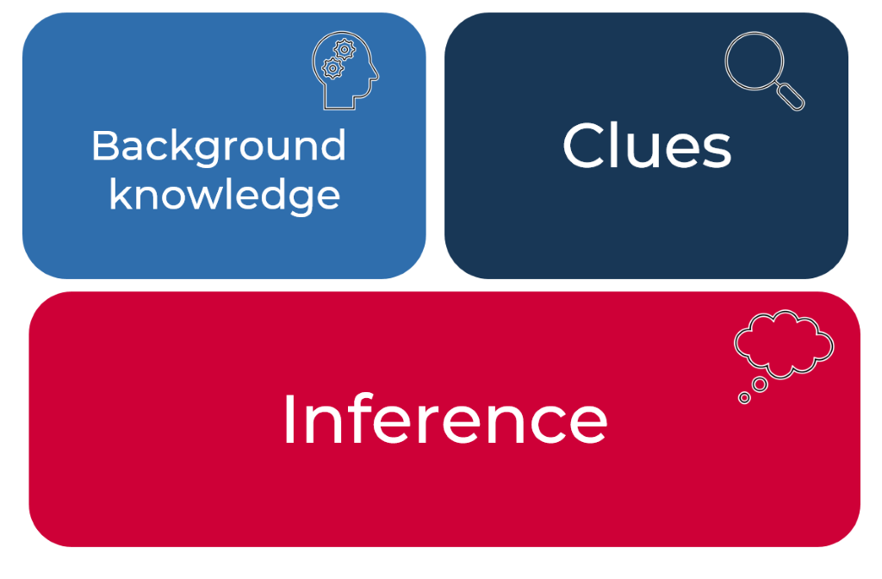
- Review background knowledge: brainstorm elements that make up background knowledge. Ideas include vocabulary, travel destinations, places visited, interests and hobbies, subject-knowledge, relationships, education, childhood/family experiences, environment, personal context and so on. Students create a mind map detailing things that make up their background knowledge.
- Review clues: clues can be found in both images and texts. Both will be explored in the following tasks.

Using an image to infer
- Discuss what clues we can gather from an image, for example, objects, positioning of objects and characters, facial expressions, setting, lines and vectors, character, character physical features, colours, symbols and modality of image.
- Gallery walk: Display images suitable for current unit of learning or the images from Appendix 1 - Inference images around the room. Students complete a gallery walk with students contributing on sticky notes, answering the question ‘What do you notice about the image?’
- Students then use a different coloured sticky note to walk around and add to people’s ideas about what might this mean, for example, if they have noticed a single red rose, this might symbolise love or new growth. The first sticky notes capture observations while the second captures inferences. Discuss findings as a class, revising the definition of inference.
- Graffiti grabs: in groups, students determine predictive inferences of what the figures in each image are thinking and adjectives to describe them, building a word cloud or brainstorm. Students display this information in thought bubbles or speech bubbles near the figures. Students move in groups around each image to add further thoughts and adjectives. Present to class and discuss choices. The teacher asks the students what objects and features they have noticed within the image and how they have used these to infer what the figures are thinking.

Inference table
- Review inference: inference is the process of drawing conclusions using evidence in texts. We use clues and background knowledge to make an inference.
- “He slammed the door behind him, making a huge racket! “
- The evidence in the text includes: ‘slammed’ and ‘huge racket’ as well as an exclamation mark.
- We can infer that the person is angry.
- Discuss that when we infer, we are making a conclusion based on something that might not be explicitly stated and may be referred to as ‘reading between the lines’.
- Students are provided with inference table (Appendix 2 - Inference table ). Teacher guides students through the first row by defining and discussing glaucoma: where have you seen this word? What clues from the text indicate what it means? Discuss how this impacts the meaning of the text.
- In pairs or individually, students complete the ‘what do we need to know’ and ‘what can we infer’ columns using dictionaries to build understanding of definition. Discuss findings as a class.
- Discuss the steps in answering inferential questions. These steps include:
- identifying what the question is asking (highlight key words and vocabulary that needs to be understood – these can be used for scanning text to locate information in paragraphs)
- finding where the information which supports the answer by scanning for key clues
- re-reading paragraphs and sections
- reconsidering potential answers, eliminating responses and choosing between remaining ideas.

Making inferences from text
- Students respond to the title of the text ‘The Road’. Could the title generate an inference? What might the title symbolise? What can we infer? Then predict what this text might be about, and discuss the connections with other texts and vocabulary they would expect to see in imaginative and informative types of texts. Predictive inference is a type of inference which will be answered when reading. An inference, however, may not be resolved. A reader continuously validates their inferences while reading to reorient themselves with the plot and characters.
- Teacher models reading ‘The Road’ text passage aloud. (Refer to Appendix 3 - Inferring meaning from text ) Once finished, students write down “I like” and “I wonder’ feedback about the text. ‘I wonder’ statements may be based on inferences made after hearing the text. Share with a partner and discuss similarities in ideas.
- Students re-read the passage, highlighting key vocabulary needed to understand the text, as well as highlighting any unfamiliar terms, discussing and clarifying meaning in pairs.
- Students then discuss their initial inference making. Were any of the initial inferences supported by evidence from the text? Can any be discounted after reading this excerpt? Students re-read the text and identify any sections which may generate further inferences about the plot, characters, setting or themes.
- Discuss and compare inferences with a partner, then in quads. Discuss why inference making may be different due to background knowledge, prior reading, familiarity with language and context.
- Students predict the plot of the text, share with a partner and compare and contrast similarities and differences in a Venn diagram.

Interpreting meaning in an imaginative text
The purpose of this task is for students to analyse language and structural elements within a text in order to understand how the author infers meaning.
- Students will be reading an extract from ‘Anne of Green Gables.’ The teacher builds context knowledge for students by showing pictures of Nova Scotia Canada (where the story extract is set). Explain to students that they will be reading an extract from a story set in this location, in 1870. Therefore, the story might include vocabulary words and contextual details that are unfamiliar to them. (This activity can be adapted to a text relevant to a current unit of learning.)
- Students read the ‘Anne of Green Gables’ extract (Appendix 4 - ‘Anne of Green Gables’ extract) independently and/or as a class. Once students have finished reading, the teacher should gauge their initial impression of the text. The teacher might ask students what they found difficult about the language and what they found interesting.
- Draw/project a visual representation of water with both the SURFACE and UNDER THE SURFACE areas indicated/labelled. Pose the following inquiry questions to students:
- What is surface level information in a text?
- What is information that exists under the surface of a text?
- Record students’ ideas in each section of the diagram.
- Explain to students that today they will be learning about implicit and subtle meaning in a text. Provide the following definitions for students:
- Inference, or subtle meaning refers to something that is not directly said (something that is only hinted at) in a text. The word ‘implicit’ is similar to the word ‘subtle’ and means something that is subtlety communicated in a text.
- Explicit meaning refers to something that is clear and directly stated in a text.
- The teacher should use real life examples to make these concepts meaningful for students. For example: When I say “are you sure you want to throw that pencil across the room?” I really mean “Don’t throw that pencil across the room.” When you give me your exercise book and all the ‘supposedly’ glued in worksheets fall out, my facial expression infers that I am not very happy with you. I don’t need to state this directly for you to understand how I am feeling.
- Explain to students that implicit and subtle meaning often provides more information about a character’s personality, actions, feelings and attitude. Subtle and implied meaning might also reveal information about the narrator’s opinion & attitude towards characters and events within a story. As a reader, you will often be asked to look beyond the surface of a text to discover its inferred and/or subtle meaning. In order to find the inferred and more subtle meaning of a text you will need to consider language, context and structure and how they work together to achieve a particular purpose.
- Think-Pair-Share: Students complete the ‘Implicit and subtle meaning in an imaginative text’ activity (Appendix 5 - Implicit and subtle meaning in an imaginative text). Students are required to infer the implicit meaning from each example taken from the text. (Note: these examples are not direct extracts).
- Ask the students to examine the implicit or inferred meaning they have unpacked about Mrs Rachel Lynde and Matthew Cuthbert. After considering all the information, prompt students to convey their overall impression of each character. They need to decide:
- What do I think about the character?
- What does the narrator think about the character?
- Is this character a potential protagonist or antagonist?
- Are these characters creating any conflict within the story?
- Are these characters creating any tension/mystery within the story?
- Why does the author focus on the character of Mrs. Rachel Lynde in the introduction of this story? (How does she function as a character? What purpose does she serve?)
- Students answer the questions from the ‘Anne of Green Gables’ extract and questions resource (Appendix 4 - ‘Anne of Green Gables’ extract). To consolidate learning, draw student attention back to the following inquiry questions:
- What is surface level information in a text?
- What is information that exists under the surface of a text?
- Students should be encouraged to expand/change/clarify their initial thinking based on a new understanding about how language forms and features, and structure interrelate to create meaning for audiences. Link this learning to creative writing, where students are encouraged to ‘show, don’t tell”.
- To increase abstraction, students create an analogy for ‘surface level’ and ‘under the surface’ information. The teacher can use the example of an iceberg and the students should be encouraged to be creative and original.

Appendix 1

Image 1: Wanderer above the Sea of Fog – Caspar David Friedrich, 1818
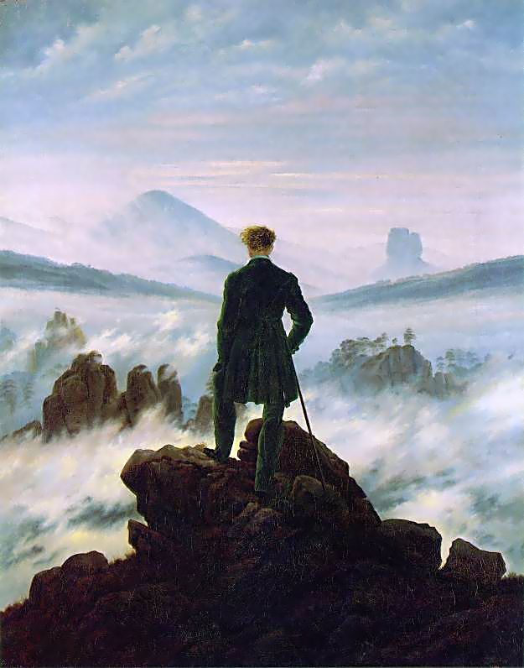
Wanderer above the Sea of Fog by Caspar David Friedrich (1818), photographed by CEA, is licensed under CC BY 2.0.

Image 2: The Sleep of Reason Produces Monsters - Francisco de Goya Y Lucientes, 1797-1798, Spain
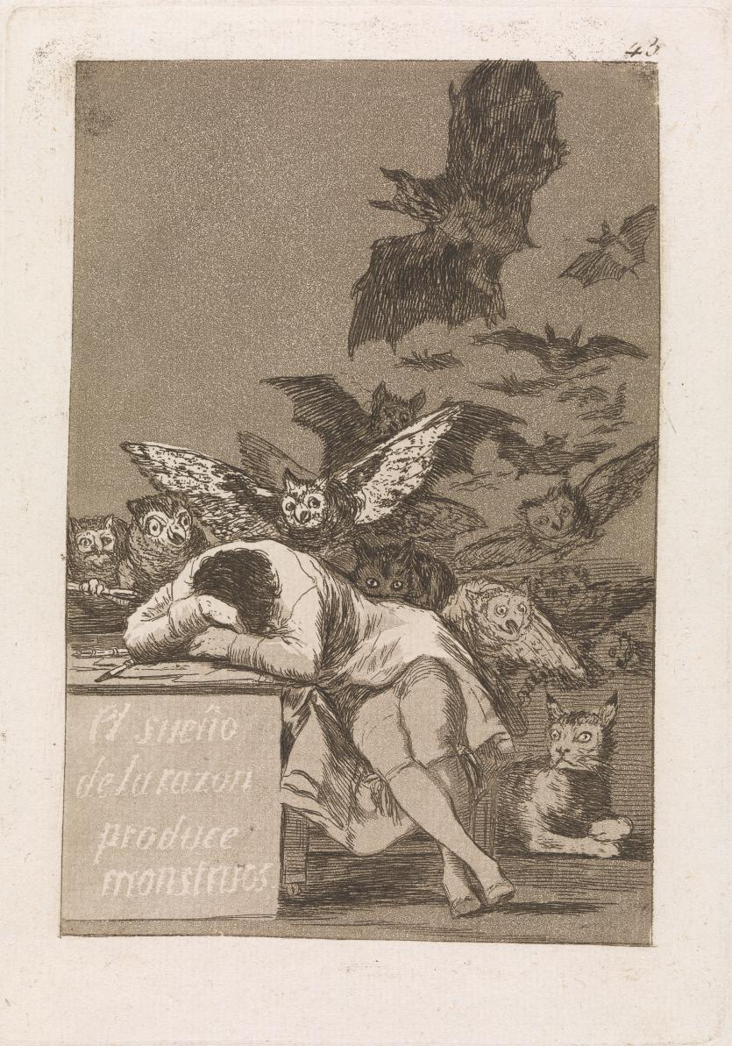
‘Image from Wikipedia’ The Sleep of Reason Produces Monsters by Francisco de Goya Y Lucientes is licensed under a Creative Commons CCO Universal (CCO 1.0).

Appendix 2

Inference table
Evidence from text | Background knowledge | What we can infer
Like the onset of some cold glaucoma dimming away the world. | Glaucoma is…
Their light playing over the wet flowstone walls. | Flowstone is…
In response to the need for a greener solution, some alternatives have appeared. | Greener solution is…
[Trapped in amber] with its belly full of the blood of ancient animals, the 100-million-year-old mosquito was like a tiny window peering back through time. | What is amber? How does it preserve organisms?
Tony’s teeth clenched, fists forming like stones. | Body language
Elvis has left the building. | Who is Elvis?
Sarah crossed her fingers behind her back as she watched her mum walk out the door. | What does crossing your fingers infer?
This business-as-usual approach has not halted the upward trajectory of bushfire ignitions. | What is a trajectory?  What does business-as usual mean?

Appendix 3

Inferring meaning from texts
The Road – Cormac McCarthy | Inference
When he woke in the woods in the dark and the cold of the night he'd reach out to touch the child sleeping beside him. Nights dark beyond darkness and the days more grey each one than what had gone before. Like the onset of some cold glaucoma dimming away the world. His hand rose and fell softly with each precious breath. He pushed away the plastic tarpaulin and raised himself in the stinking robes and blankets and looked toward the east for any light but there was none. In the dream from which he'd wakened he had wandered in a cave where the child led him by the hand. Their light playing over the wet flowstone walls. Like pilgrims in a fable swallowed up and lost among the inward parts of some granitic beast. Deep stone flues where the water dripped and sang. Tolling in the silence the minutes of the earth and the hours and the days of it and the years without cease. Until they stood in a great stone room where lay a black and ancient lake. And on the far shore a creature that raised its dripping mouth from the rimstone pool and stared into the light with eyes dead white and sightless as the eggs of spiders. It swung its head low over the water as if to take the scent of what it could not see. Crouching there pale and naked and translucent, its alabaster bones cast up in shadow on the rocks behind it. Its bowels, its beating heart. The brain that pulsed in a dull glass bell. It swung its head from side to side and then gave out a low moan and turned and lurched away and loped soundlessly into the dark.  With the first grey light he rose and left the boy sleeping and walked out to the road and squatted and studied the country to the south. Barren, silent, godless. He thought the month was October but he wasn't sure. He hadn’t kept a calendar for years. They were moving south. There'd be no  surviving another winter here. | - Predict why he was asleep in the woods at night.  - What is the relationship between the man and the child?  - Infer what has occurred to make each day more grey than the previous one.  - Why is the breath precious?  - Why would his robes and blankets stink?  - What is the meaning of the pilgrim simile? What can you infer about the characters based on this?  - Identity the recount of the dream.  - What can you infer about the man’s mental state from the contents of his dream?  - What can you infer about the setting based on the chosen adjectives?  - What do you think has happened in the character’s world? Why doesn’t he know the date?

Appendix 4

‘Anne of Green Gables’ by L.M Montgomery, Harper Collins Australia, 2017- extract and questions
Chapter 1- Mrs Rachel Lynde is surprised
MRS. Rachel Lynde lived just where the Avonlea main road dipped down into a little hollow, fringed with alders and ladies’ eardrops and traversed by a brook that had its source away back in the woods of the old Cuthbert place; it was reputed to be an intricate, headlong brook in its earlier course through those woods, with dark secrets of pool and cascade; but by the time it reached Lynde’s Hollow it was a quiet, well-conducted little stream, for not even a brook could run past Mrs. Rachel Lynde’s door without due regard for decency and decorum; it probably was conscious that Mrs. Rachel was sitting at her window, keeping a sharp eye on everything that passed, from brooks and children up, and that if she noticed anything odd or out of place she would never rest until she had ferreted out the whys and wherefores thereof.
There are plenty of people in Avonlea and out of it, who can attend closely to their neighbor’s business by dint of neglecting their own; but Mrs. Rachel Lynde was one of those capable creatures who can manage their own concerns and those of other folks into the bargain. She was a notable housewife; her work was always done and well done; she “ran” the Sewing Circle, helped run the Sunday-school, and was the strongest prop of the Church Aid Society and Foreign Missions Auxiliary. Yet with all this Mrs. Rachel found abundant time to sit for hours at her kitchen window, knitting “cotton warp” quilts—she had knitted sixteen of them, as Avonlea housekeepers were wont to tell in awed voices—and keeping a sharp eye on the main road that crossed the hollow and wound up the steep red hill beyond. Since Avonlea occupied a little triangular peninsula jutting out into the Gulf of St. Lawrence with water on two sides of it, anybody who went out of it or into it had to pass over that hill road and so run the unseen gauntlet of Mrs. Rachel’s all-seeing eye.
She was sitting there one afternoon in early June. The sun was coming in at the window warm and bright; the orchard on the slope below the house was in a bridal flush of pinky-white bloom, hummed over by a myriad of bees. Thomas Lynde—a meek little man whom Avonlea people called “Rachel Lynde’s husband”—was sowing his late turnip seed on the hill field beyond the barn; and Matthew Cuthbert ought to have been sowing his on the big red brook field away over by Green Gables. Mrs. Rachel knew that he ought because she had heard him tell Peter Morrison the evening before in William J. Blair’s store over at Carmody that he meant to sow his turnip seed the next afternoon. Peter had asked him, of course, for Matthew Cuthbert had never been known to volunteer information about anything in his whole life.
And yet here was Matthew Cuthbert, at half-past three on the afternoon of a busy day, placidly driving over the hollow and up the hill; moreover, he wore a white collar and his best suit of clothes, which was plain proof that he was going out of Avonlea; and he had the buggy and the sorrel mare, which betokened that he was going a considerable distance. Now, where was Matthew Cuthbert going and why was he going there?
Had it been any other man in Avonlea, Mrs. Rachel, deftly putting this and that together, might have given a pretty good guess as to both questions. But Matthew so rarely went from home that it must be something pressing and unusual which was taking him; he was the shyest man alive and hated to have to go among strangers or to any place where he might have to talk. Matthew, dressed up with a white collar and driving in a buggy, was something that didn’t happen often. Mrs. Rachel, ponder as she might, could make nothing of it and her afternoon’s enjoyment was spoiled.
“I’ll just step over to Green Gables after tea and find out from Marilla where he’s gone and why,” the worthy woman finally concluded. “He doesn’t generally go to town this time of year and he never visits; if he’d run out of turnip seed he wouldn’t dress up and take the buggy to go for more; he wasn’t driving fast enough to be going for a doctor. Yet something must have happened since last night to start him off. I’m clean puzzled, that’s what, and I won’t know a minute’s peace of mind or conscience until I know what has taken Matthew Cuthbert out of Avonlea today.
Questions:
- What type of text is this?
- List the structural elements which helped you to identify the text type.
- What is the purpose of this text?
- What narrative perspective is this text written in? How do you know?
- In the sentence “Thomas Lynde—a meek little man whom Avonlea people called “Rachel Lynde’s husband”—was sowing his late turnip seed on the hill field” the dash is used to reveal additional information about both characters and their relationship. Explain what is being implied by the author.
- What does the use of a dash (in the sentence above) reveal about the tone/attitude of the narrator?
- The author uses dashes twice within the story. What kind of information is being revealed through the use of this punctuation?
- What is a brook? What context clues can help you infer the meaning of this word?
- The author asserts the following about the brook: “by the time it reached Lynde’s Hollow it was a quiet, well-conducted little stream, for not even a brook could run past Mrs. Rachel Lynde’s door without due regard for decency and decorum”.
  - Why does the author personify the brook?
  - How does this use of personification contribute to the characterisation of Mrs. Rachel Lynde?
- In paragraph two, Mrs Lynde is described as a ‘capable creature’ who concerns herself with everyone’s business. Does this set her up to be a protagonist or antagonist in this story? Explain.
- In paragraph two, why does the author list the multiple activities Mrs Lynde is involved in?
- In paragraph four, the coordinating conjunction ‘And yet’ is used to suggest something about Matthew Cuthbert’s actions in this paragraph. What is the author implying?
- How is the setting of this story described in paragraph three? What is the effect of this?
- What is the effect of using a rhetorical question at the end of paragraph four?
- Why does the author use alliteration in the following descriptions of Rachel Lynde: “clever creature” and “worthy woman”? (Hint: consider how the sound creates the tone/attitude of the narrator).
- List TWO examples of both explicit and implicit information in the text.

Appendix 5

Implicit and subtle meaning in an imaginative text
Identify the implied meaning from the textual evidence below. The first one has been completed for you.
Textual evidence | Implicit meaning
Mrs Lynde needs to know everyone’s business. | Mrs Lynde is very nosey and does not understand boundaries.
Matthew Cuthbert is dressed in his finest clothing. He doesn’t usually wear this clothing.
People don’t refer to Mr Lynde by his actual name. They call him “Rachel Lynde’s husband”.
Mathew rarely leaves his home.
Rachel knitted a total of 16 quilts as she sat by her kitchen window.
Mrs Lynde kept a sharp eye on everything happening outside her window.
Rachel won’t feel peaceful unless she knows what Matthew is up to.
Passers by need to run the gauntlet of Rachel’s all-seeing eye.

