Compare and contrast
Stage 5

Overview

Purpose
This literacy teaching strategy supports teaching and learning for Stage 5 students across all key learning areas. It targets specific literacy skills and suggests a learning sequence to build skill development. Teachers can select individual tasks, or a sequence, and embed into their teaching and learning program according to their students’ needs. While exemplar texts are provided throughout this resource, it is recommended that teachers select texts which are relevant to their students and curriculum.

Learning intention
Students will learn the difference between comparing and contrasting texts as well as applying these understandings in text analysis and creation.

Syllabus outcomes
The following teaching and learning strategies will assist in covering elements of the following outcomes:
- EN5-RVL-01: uses a range of personal, creative and critical strategies to interpret complex texts
  - EN5-URB-01: evaluates how texts represent ideas and experiences, and how they can affirm or challenge values and attitudes
- EN5-2A: effectively uses and critically assesses a wide range of processes, skills, strategies and knowledge for responding to and composing a wide range of texts in different media and technologies
- EN6-6C: investigates the relationships between and among texts
- EN5-8D: questions, challenges and evaluates cultural assumptions in texts and their effects on meaning.
NSW English K-10 Syllabus (2022)
Visit the Leading curriculum K-12 website for more information on the syllabus implementation timeline.

Success criteria
The following Year 9 NAPLAN item descriptors may guide teachers to co-construct success criteria for student learning.

- categorises information from different sections of an information text
- analyses a comparison in a text
- analyses the interrelationship of two texts on a similar theme
- compares information across two texts on a similar theme
- contrasts an argument with an opposing argument in a text

- identifies a comparison in an information text
- identifies a contrast in a narrative
- identifies a similarity between characters in a narrative extract
- interprets the reason for a comparison in an information text

National Literacy Learning Progression guide

Understanding Texts (UnT9-UnT11)
Key: C=comprehension P=process V=vocabulary

UnT9
- distils information from a number of texts according to task and purpose (e.g. uses graphic organisers) (C)
- analyses texts which have more than one purpose and explain how parts of the text support a particular purpose (C)
- analyses the use of language appropriate to different types of texts (e.g. compare the use of pun in imaginative and persuasive texts) (C)
- selects reading/viewing strategies appropriate to reading purpose (e.g. scans text for evidence) (P)

UnT10
- analyses how text features are used to support of conflate the point of view in a text (e.g. strategic use of images such as a cartoon in an editorial) (C)
- applies and articulates criteria to evaluate the language structures, and features for relevance to purpose and audience (C)
- explains how context (e.g. time, place, situation) influences interpretations of a text (C)

UnT11
- analyses the cumulative impact of use of language features and vocabulary across texts (C)
- identifies subtle contradictions and inconsistencies in texts (P)
National Literacy Learning Progression

Evidence base
- Centre for Education Statistics and Evaluation (2017). Effective reading instruction in the early years of school, literature review.
- Oakhill, J., Cain, K. & Elbro, C. (2015). Understanding and teaching reading comprehension: A handbook. Routledge.
- Quigley, A. (2020). Closing the reading gap. Routledge.
- Scarborough, H.S. (2001). Connecting early language and literacy to later reading (dis)abilities: Evidence, theory and practice. In S. Neuman & D. Dickson (Eds.), Handbook for research in early literacy (pp. 97-110). New York, NY: Guilford Press.
Alignment to system priorities and/or needs: Five priorities for Literacy and Numeracy, Our Plan for NSW Public Education, School Excellence Policy (nsw.gov.au).
Alignment to School Excellence Framework: Learning domain: Curriculum, Teaching domain: Effective classroom practice and Professional standards
Consulted with: Strategic Delivery, Teaching Quality and Impact
Author: Literacy and Numeracy
Reviewed by: Literacy and Numeracy, Teaching Quality and Impact
Created/last updated: January 2023
Anticipated resource review date: January 2024
Feedback: Complete the online form to provide any feedback

Copyright
Section 113P Notice
Texts, Artistic Works and Broadcast Notice
Some of this material has been copied and communicated to you in accordance with the statutory licence in section 113P of the Copyright Act. Any further reproduction or communication of this material by you may be the subject of copyright protection under the Act. Do not remove this notice.

Teaching strategies
Task | Appendices
Comparing images
Categorising information from an informative text | Appendix 1 - Categorising information texts
Comparing and contrasting content | Appendix 2 - ‘Four corners’ graphic organiser  Appendix 3 - Comparing and contrasting texts with similar topic: ‘Into the Blue’
Comparing and contrasting language features and structure
Evaluating comparing and contrasting

Background information

Contrast
Show how things are different or opposite. Contrasting involves examining something to determine the differences.

Compare
Show how things are similar or different. Comparing involves examining both the similarities and differences.
Reference: English K-10 Syllabus © NSW Education Standards Authority (NESA) for and on behalf of the Crown in right of the State of New South Wales, 2012 and 2022

Where to next?
- Text structure and features
- Literal comprehension
- Main idea and theme

Overview of teaching strategies

Purpose
These literacy teaching strategies support teaching and learning from Stage 2 to Stage 5. They are linked to NAPLAN task descriptors, syllabus outcomes and literacy and numeracy learning progressions.
These teaching strategies target specific literacy and numeracy skills and suggest a learning sequence to build skill development. Teachers can select individual tasks or a sequence to suit their students.

Access points
The resources can be accessed from:
- NAPLAN App in Scout using the teaching strategy links from NAPLAN items
- NSW Department of Education literacy and numeracy website.
What works best
Explicit teaching practices involve teachers clearly explaining to students why they are learning something, how it connects to what they already know, what they are expected to do, how to do it and what it looks like when they have succeeded. Students are given opportunities and time to check their understanding, ask questions and receive clear, effective feedback.
This resource reflects the latest evidence base and can be used by teachers as they plan for explicit teaching.
Teachers can use classroom observations and assessment information to make decisions about when and how they use this resource as they design teaching and learning sequences to meet the learning needs of their students.
Further support with What works best is available.
Differentiation
When using these resources in the classroom, it is important for teachers to consider the needs of all students, including Aboriginal and EAL/D learners.
EAL/D learners will require explicit English language support and scaffolding, informed by the EAL/D enhanced teaching and learning cycle and the student’s phase on the EAL/D Learning Progression. Teachers can access information about supporting EAL/D learners and literacy and numeracy support specific to EAL/D learners.
Learning adjustments enable students with disability and additional learning and support needs to access syllabus outcomes and content on the same basis as their peers. Teachers can use a range of adjustments to ensure a personalised approach to student learning.
Assessing and identifying high potential and gifted learners will help teachers decide which students may benefit from extension and additional challenge. Effective strategies and contributors to achievement for high potential and gifted learners helps teachers to identify and target areas for growth and improvement. A differentiation adjustment tool can be found on the High potential and gifted education website.

Using tasks across learning areas
This resource may be used across learning areas where it supports teaching and learning aligned with syllabus outcomes.
Literacy and numeracy are embedded throughout all syllabus documents as general capabilities. As the English and mathematics learning areas have a particular role in developing literacy and numeracy, NSW English and Mathematics syllabus outcomes aligned to literacy and numeracy skills have been identified.

Text selection
Example texts are used throughout this resource. Teachers can adjust activities to use texts which are linked to their unit of learning.
Further support with text selection can be found within the National Literacy Learning Progression Text Complexity appendix.
The NESA website has additional information on text requirements within the NSW English syllabus.

Teaching strategies

Comparing images
- Give students 2 or more photographs or pictures to compare, relevant to a current unit of learning. For example, this might be two historical photographs based around the same event or images of a natural phenomenon. Using images from different perspectives adds an additional layer for critical analysis. In pairs, students work together to identify the similarities and differences in the photographs and they then record their findings, noting who took the photographs, when and where they were taken and where they are published. Students may wish to conduct further research into the context in which the images were created. The comparisons can be put into a table or graphic organiser, such as a Venn diagram.
Questions | Photograph 1 | Photograph 2
What: event/subject matter
Who: photographer/ context
When/where: location/ setting
Published:
when/where

- Gallery walk: Students display their images and table/graphic organiser. They discuss their observations with the class, noting the similarities and differences between how the event or subject matter is depicted. They should consider how the context of the photographer, or where the photograph was published, may have shaped the depiction of the subject matter.
(This activity could be adapted to any pair of texts relevant to a current unit of learning.)

Categorising information from an informative text
- Students are given an informative text linked to current unit of learning, or, alternatively, refer to Appendix 1 - Categorising information texts. Students work in teams to skim and scan texts for headings, sub-headings, and other key elements including diagrams, photographs and maps to determine some key categories. For example, students might categorise information about Australian Aboriginal people and culture into land use, food sources, arts and culture and customs.
Additional task: Once information is categorised, the group then must decide on new ways to categorise the information and repeat the process.
- Students are given information on two or three content areas to be categorised, for example, ancient civilisations. Students skim and scan text for key information and add ideas onto a table. Alternately, students are given one content area to become experts in and add their information to a class table. This can be compared before students complete their own versions.
Ancient civilisations:
 | Near East | Egypt | Peru
Monumental architecture |  | Pyramid temples | Pyramid terraces
Writing |  |  | None
Political leaders

Comparing and contrasting content
- Four Corners: Students use two ideas currently being explored in class to compare and contrast. Model using a range of sources to build information and understanding on a topic using four corners graphic organiser (refer to Appendix 2 - ‘Four corners’ graphic organiser).
History example: Four corners graphic organiser
First-hand account | Second-hand account
Both first-hand and second-hand account | Neither first nor second-hand account
- Discuss the importance of cross-examining sources to ensure valid information. With two or more texts, students could use strategies such as highlighting key words, skimming and scanning and underlining key information in the text to extract information which could be compared. This information is best summarised into bullet points and presented in a graphic organiser such as a Venn diagram or T chart, allowing the students to visually represent the comparison between the information conveyed in the texts.
- Students compare texts with similar topics on the Blue Mountains called ‘Into the Blue’ using the four corners chart. (Appendix 3 - Comparing and contrasting texts with similar topic: ‘Into the Blue’.)

Comparing and contrasting language features and structure
This activity is best completed after students have reviewed the text structures and language features of the three broad purposes of texts: to mostly inform, persuade and to entertain.
- Discuss importance of analysing questions to determine what exactly needs to be compared or contrasted; a student might be asked to compare a specific part of a text, for example, the persuasive devices in a poster and newspaper article, not the entire text.
- Students are given two texts from the same genre (or on the same topic) to compare structural elements and/or content.
Some suggestions:
- sentence and paragraph structure
- progression of ideas and arguments
- tone of the text (Informative? Humorous? Emotional?)
- use of language devices, such as irony, simile and hyperbole, across different text forms
- setting, characters, and plot in fiction
- use of facts and statistics in nonfiction
- authors’ perspective/point of view
- use of images, or other text features, to support or challenge opinion
- use of persuasive devices in different forms of texts.
- Divide the class into smaller groups and give each of them one of the chapters, sections, or extracts that are being compared and contrasted in a current unit of learning. Groups scan their text and note the features they identify according to points above. Groups can then combine their findings in a graphic organiser, displaying the similarities and differences between each text.
- To add complexity, students compare and contrast a third text and represent their findings in their own graphic organiser. Limiting structures with graphic organisers and encouraging students to generate their own representations can help with ideation.
(Lesson adapted from Shane MacDonnchaidh from literacyideas.com)

Evaluating comparing and contrasting
- Discuss the importance of the information that can be discovered from comparing and contrasting texts. For example, students might find that different types of texts have similar values or concepts at their core such as an information text, poetry or a persuasive article all on the language of Mathematics. By exploring different types of texts linked to the area of study, students build vocabulary and explore text and language features they may not usually see if simply using informative texts.
- Discuss why it is important to compare and contrast. Why might we need to do this? How can this help us to evaluate a source? What ways can we compare and contrast?
- Discuss and brainstorm what things can be compared and contrasted, for example, layout, use of figurative language, vocabulary, use of diagrams, use of persuasive devices and so on. Record and display ideas so students can refer to them when making their own comparisons.
- Select a range of texts on the same topic, such as ‘Food safety’. Texts could be subject specific or could include a song, a webpage, an article, a podcast, a narrative (extract), poem, advertisement, or other text that may be relevant to the content focus for the learning.
- Students choose two or more of the texts to compare and contrast or perhaps add texts they have previously used or read.
- Students analyse the texts using a graphic organiser such as a Venn diagram or the four quadrants graphic organiser explored in ‘Comparing and contrasting content’ task. This can be done in pairs or small groups to promote dialogue.
- Students then analyse language use (as they did in ‘Comparing and contrasting language features and structure’ task) in both texts and choose examples of textual evidence from both texts that reflect the themes, ideas, or the author’s purpose.
- Students then evaluate how similar or different the main message and values in these texts is. To do this, teachers lead a discussion that investigates: Why would the authors have this perspective? What was happening in the context of the wider world when each text was written? What is each author trying to achieve (change, action, awareness, empathy, other) by creating this text?

Appendix 1

Categorising information texts
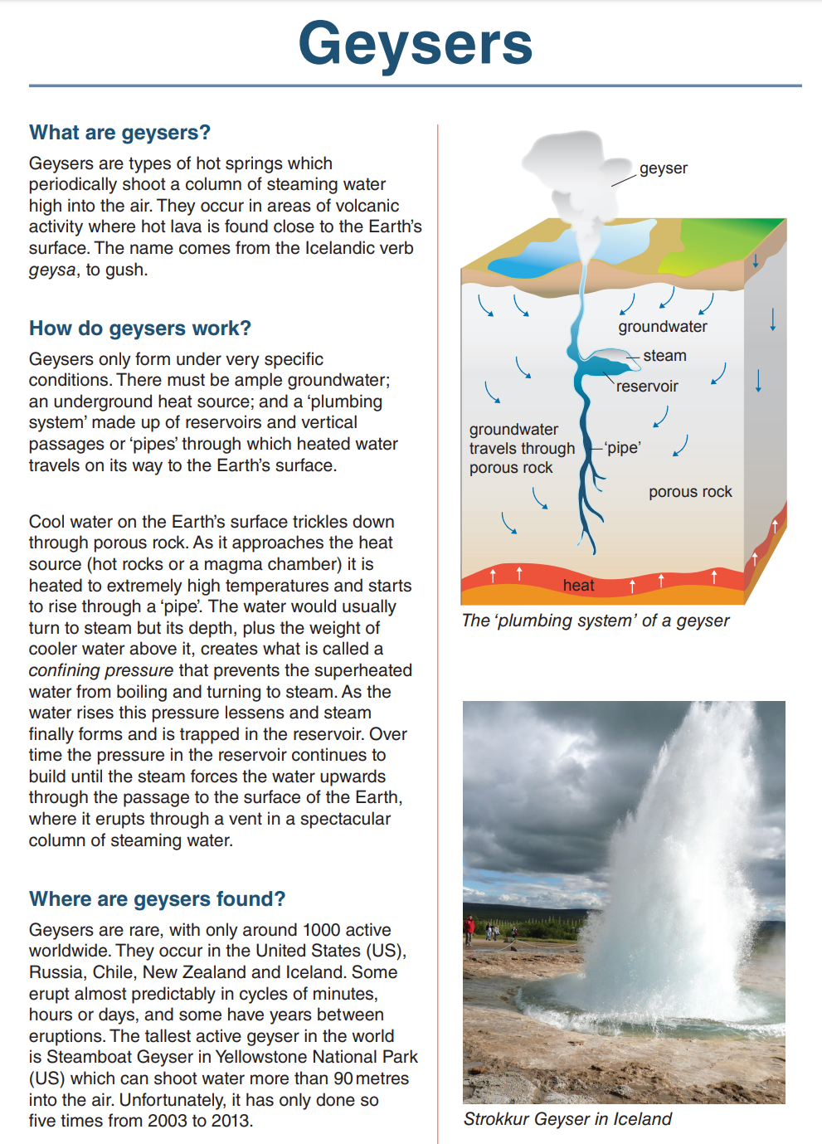
Year 9 NAPLAN reading magazine, 2016, ACARA.

Compare and contrast texts – accessible version

Geysers
  - What are geysers?
Geysers are types of hot springs which periodically shoot a column of steaming water high into the air. They occur in areas of volcanic activity where hot lava is found close to the Earth’s surface. The name comes from the Icelandic verb geysa, to gush.
  - How do geysers work?
Geysers only form under very specific conditions. There must be ample groundwater; an underground heat source; and a ‘plumbing system’ made up of reservoirs and vertical passages or ‘pipes’ through which heated water travels on its way to the Earth’s surface.
Cool water on the Earth’s surface trickles down through porous rock. As it approaches the heat source (hot rocks or a magma chamber) it is heated to extremely high temperatures and starts to rise through a ‘pipe’. The water would usually turn to steam but its depth, plus the weight of cooler water above it, creates what is called a confining pressure that prevents the superheated water from boiling and turning to steam. As the water rises this pressure lessens and steam finally forms and is trapped in the reservoir. Over time the pressure in the reservoir continues to build until the steam forces the water upwards through the passage to the surface of the Earth, where it erupts through a vent in a spectacular column of steaming water.
  - Where are geysers found?
Geysers are rare, with only around 1000 active worldwide. They occur in the United States (US), Russia, Chile, New Zealand and Iceland. Some erupt almost predictably in cycles of minutes, hours or days, and some have years between eruptions. The tallest active geyser in the world is Steamboat Geyser in Yellowstone National Park (US) which can shoot water more than 90metres into the air. Unfortunately, it has only done so five times from 2003 to 2013.
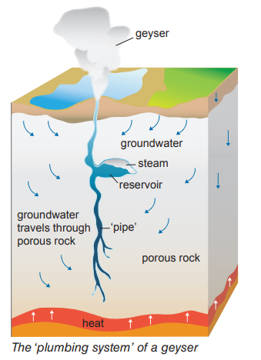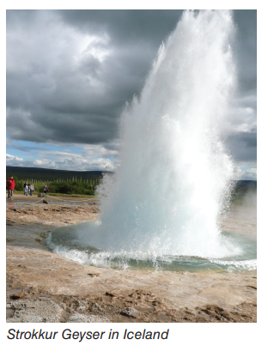
Year 9 NAPLAN reading magazine, 2016, ACARA

Appendix 2

Four corners graphic organiser
Concept 1 | Concept 2
Both concept 1 and concept 2 | Neither concept 1 nor concept 2

Appendix 3

Comparing and contrasting texts with similar topic
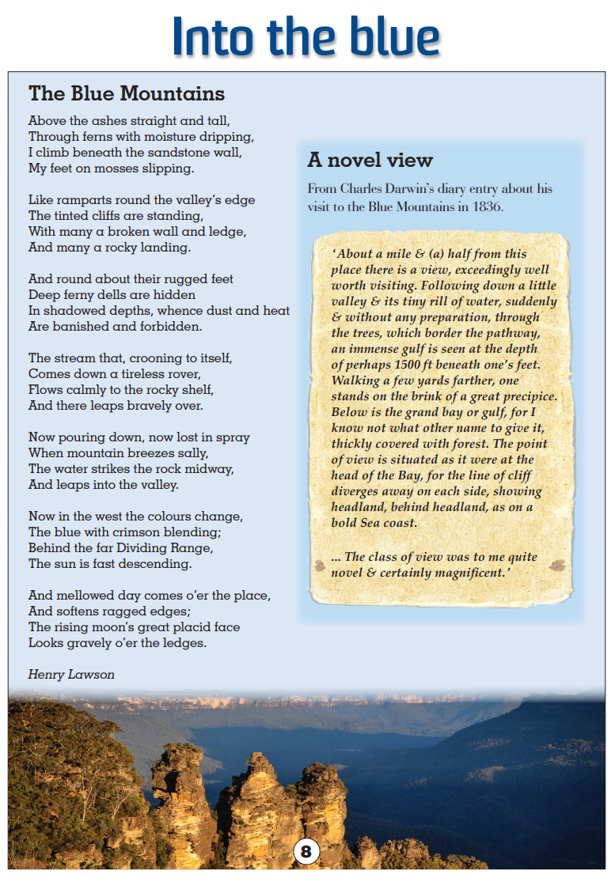
Year 9 NAPLAN reading magazine, 2016, ACARA

Comparing and contrasting text with similar topic – accessible version

Text 1 - The Blue Mountains
Above the ashes straight and tall,
Through ferns with moisture dripping,
I climb beneath the sandstone wall,
My feet on mosses slipping.
Like ramparts round the valley’s edge
The tinted cliffs are standing,
With many a broken wall and ledge,
And many a rocky landing.
And round about their rugged feet
Deep ferny dells are hidden
In shadowed depths, whence dust and heat
Are banished and forbidden.
The stream that, crooning to itself,
Comes down a tireless rover,
Flows calmly to the rocky shelf,
And there leaps bravely over.
Now pouring down, now lost in spray
When mountain breezes sally,
The water strikes the rock midway,
And leaps into the valley.
Now in the west the colours change,
The blue with crimson blending;
Behind the far Dividing Range,
The sun is fast descending.
And mellowed day comes o’er the place,
And softens ragged edges;
The rising moon’s great placid face
Looks gravely o’er the ledges.
- Henry Lawson
Year 9 NAPLAN reading magazine, 2016, ACARA

Text 2 - A novel view
From Charles Darwin’s diary entry about his visit to the Blue Mountains in 1836.
‘About a mile & (a) half from this place there is a view, exceedingly well worth visiting. Following down a little valley & its tiny rill of water, suddenly & without any preparation, through the trees, which border the pathway, an immense gulf is seen at the depth of perhaps 1500 ft beneath one’s feet. Walking a few yards farther, one stands on the brink of a great precipice. Below is the grand bay or gulf, for I know not what other name to give it, thickly covered with forest. The point of view is situated as it were at the head of the Bay, for the line of cliff diverges away on each side, showing headland, behind headland, as on a bold Sea coast.
... The class of view was to me quite novel & certainly magnificent.’
Year 9 NAPLAN reading magazine, 2016, ACARA

