Analysing characters
Stage 5

Overview

Purpose
This literacy teaching strategy supports teaching and learning for Stage 5 students across all key learning areas. It targets specific literacy skills and suggests a learning sequence to build skill development. Teachers can select individual tasks, or a sequence, and embed into their teaching and learning program according to their students’ needs. While exemplar texts are provided throughout this resource, it is recommended that teachers select texts which are relevant to their students and curriculum.

Learning intention
Students will learn to identify how a character is portrayed in a narrative. Students will learn to infer reasons for actions and behaviours of characters.

Syllabus outcomes
The following teaching and learning strategy will assist in covering elements of the following outcomes:
- EN5-URA-01: analyses how meaning is created through the use and interpretation of increasingly complex language forms, features and structures
- EN5-URB-01: evaluates how texts represent ideas and experiences, and how they can affirm or challenge values and attitudes
- EN5-2A: effectively uses and critically assesses a wide range of processes, skills, strategies and knowledge for responding to and composing a wide range of texts in different media and technologies
- EN5-7D: understands and evaluates the diverse ways texts can represent personal and public worlds.
- EN5-8D: questions, challenges and evaluates cultural assumptions in texts and their effects on meaning
NSW English K-10 Syllabus (2022)
Visit the Leading curriculum K-12 website for more information on the syllabus implementation timeline.

Success criteria
The following Year 9 NAPLAN item descriptors may guide teachers to co-construct success criteria for student learning.

- analyses how a character is portrayed across two texts on a similar theme
- analyses how a character is portrayed in a narrative
- identifies changes in a character across the text in a narrative
- identifies changes in a character's perspective of a narrative
- identifies how a character is portrayed in a narrative
- identifies the reason for a character's actions in a narrative
- identifies the reason for a character's feelings in a narrative
- infers the reason for a character's actions in a conversation
- infers the reason for a character's actions in a narrative
- infers a character's perspective in a narrative
- analyses a character's perspective in a narrative
- identifies a character's perspective in a narrative
- infers the reason for a character's perspective in a narrative
- infers the reason for a character's perspective in a text
- interprets a character's feelings in a narrative

National Literacy Learning Progression guide

Understanding Texts (UnT9-UnT11)
Key: C=comprehension P=process V=vocabulary

UnT9
- draws inferences, synthesising clues and evidence across a text (C)
- distils information from a number of texts according to task and purpose (e.g. uses graphic organisers) (C)
- uses processes such as predicting, confirming predictions, monitoring, and connecting relevant elements of the text to build or repair meaning (P)
- selects reading/viewing strategies appropriate to reading purpose (e.g. scans text for evidence) (P)

UnT10
- reads and views complex or some highly complex texts (see Text complexity) (C)
- draws inferences using evidence from the text and discounting possible inferences that are not supported by the text (C)
- analyses the techniques authors use to position readers (C)
- integrates automatically a range of processes such as predicting, confirming predictions, monitoring and connecting relevant elements of the text to build meaning (P)
- identifies language used to create tone or atmosphere (V)

UnT11
- interprets symbolism in text, providing evidence to justify interpretation (C)
- analyses the cumulative impact of use of language features and vocabulary across texts (C)
National Literacy Learning Progression

Evidence base
- Centre for Education Statistics and Evaluation (2017). Effective reading instruction in the early years of school, literature review.
- Oakhill, J., Cain, K. & Elbro, C. (2015). Understanding and teaching reading comprehension: A handbook. Routledge.
- Quigley, A. (2020). Closing the reading gap. Routledge.
- Scarborough, H.S. (2001). Connecting early language and literacy to later reading (dis)abilities: Evidence, theory and practice. In S. Neuman & D. Dickson (Eds.), Handbook for research in early literacy (pp. 97-110). New York, NY: Guilford Press.
Alignment to system priorities and/or needs: Five priorities for Literacy and Numeracy, Our Plan for NSW Public Education, School Excellence Policy (nsw.gov.au)
Alignment to School Excellence Framework: Learning domain: Curriculum, Teaching domain: Effective classroom practice and Professional standards
Consulted with: Strategic Delivery, Teaching Quality and Impact
Author: Literacy and Numeracy
Reviewed by: Literacy and Numeracy, Teaching Quality and Impact
Created/last updated: January 2024
Anticipated resource review date: January 2025
Feedback: Complete the online form to provide any feedback

Copyright
Section 113P Notice
Texts, Artistic Works and Broadcast Notice
Some of this material has been copied and communicated to you in accordance with the statutory licence in section 113P of the Copyright Act. Any further reproduction or communication of this material by you may be the subject of copyright protection under the Act. Do not remove this notice.’

Teaching strategies

Overview of tasks
Task | Appendices
Creative characterisation | Appendix 1 - Emotion brainstorm  Appendix 2 - Cartoon graffiti
Voice | Appendix 3 - Comparing first and third person narrative voice
Identify and infer character traits | Appendix 4 - Tim Winton ‘Neighbours’ extract
Interpreting a character’s feelings through motif
Elements of characterisation | Appendix 5 - Zadie Smith ‘Swing Time’ extract  Appendix 6 - ‘What’s the Deal?’
Inferring from implicit characterisation | Appendix 7 - Visual: Hemmingway’s principle of the iceberg  Appendix 8 - Extract “The Name of the wind’  Appendix 9 - Character analysis using icerberg table  Appendix 10 - Template : Character analysis using iceberg table

Background information
The following information from the English Textual Concepts can further support understanding of point of view and perspective.
Further information on English textual concepts can be found on the curriculum textual concepts web page.

Character
Character is traditionally viewed as a description of a fictional person. As a construct, it is made up of verbal or visual statements about what that fictional person does, says and thinks and what other fictional characters and the author of the text say about him or her. The reader, listener or viewer fleshes out these statements to imagine a person-like character, sufficiently individualised and coherent to establish the sense of an identity. In this way, representation of a ‘real’ person invites personal identification and judgements about the character’s morality and value to their society. This kind of analysis can contribute to shaping one’s own sense of a moral and ethical self and so becoming a way of enculturation.
Characters may also be created and/ or read as representations of ideas, of groups of people or of types that serve a function in a narrative genre. Questions of characterisation then focus on the ways a character is constructed both by the responder and the composer and its function in the text.
Character is an important concept in narrative as a driver of the action, a function in the plot, a way of engaging or positioning a reader or as a way of representing its thematic concerns. The way character is read is an indication of particular approaches to texts, be it through personal engagement or critical response.

Point of view
Point of view in a text is the position from which the subject matter of a text is designed to be perceived. In defining a point of view the writer, speaker or director of the text controls what we see and how we relate to the situation, characters or ideas in the text. Point of view may be expressed through a narrator or through a character (focaliser in a novel, persona in a poem) and because we are invited to adopt this point of view we often align ourselves with the character or narrator. The point of view constructed in a text cannot be assumed to be that of the composer.
Composers can privilege certain points of view by choosing a particular narrative stance including omniscient, limited, 1st, 2nd or 3rd person narrator. In visual, film and digital texts, point of view is indicated through such devices as foregrounding in visual images, types of camera shots or guiding a pathway of navigation through a web site. In spoken and audio texts the tone and accompanying sounds convey a point of view. Point of view therefore constructs an attitude towards the subject matter in a text which the reader, listener or viewer is invited to adopt.
Understanding point of view is a critical reading practice because point of view is often inferred rather than explicitly expressed and its exploration leads to an appreciation of the constructed nature of the text. It is a device which allows subject matter to be foregrounded or distanced and therefore it invites certain attitudes and feelings in response to the text.
Experimenting with point of view allows students to explore other ways of seeing the text.

Perspective
Perspective is a lens through which we learn to see the world; it shapes what we see and the way we see it. The lens can clarify, magnify, distort or blur what we see. By changing the position of the lens, different aspects of the text may be foregrounded. In this way, perspective provides a dynamic basis for the relationship between composer, text and responder.
Perspective includes the values that the responder and composer bring to a text. In a text these values are expressed and/or implied through the composer’s language and structure which may position the responder to accept them. By adopting different perspectives, a responder can bring to light underlying values in the text and construct meanings which may challenge, confirm or modify the original reading of a text. Applying different perspectives may also challenge, confirm or modify the responder’s own values.
To become critical thinkers and insightful readers, listeners and viewers, students need to understand that neither texts nor they themselves are neutral. We all operate through cultural and ideological frames that position us to accept certain views of the world. We need to recognise how these lenses are working so that we can choose to accept or dismiss the values that they entail.

Where to next?
- Inference
- Author bias and perspective
- Main idea and theme

Overview of teaching strategies

Purpose
These literacy teaching strategies support teaching and learning from Stage 2 to Stage 5. They are linked to NAPLAN task descriptors, syllabus outcomes and literacy and numeracy learning progressions.
These teaching strategies target specific literacy and numeracy skills and suggest a learning sequence to build skill development. Teachers can select individual tasks or a sequence to suit their students.

Access points
The resources can be accessed from:
- NAPLAN App in Scout using the teaching strategy links from NAPLAN items
- NSW Department of Education literacy and numeracy website.
What works best
Explicit teaching practices involve teachers clearly explaining to students why they are learning something, how it connects to what they already know, what they are expected to do, how to do it and what it looks like when they have succeeded. Students are given opportunities and time to check their understanding, ask questions and receive clear, effective feedback.
This resource reflects the latest evidence base and can be used by teachers as they plan for explicit teaching.
Teachers can use classroom observations and assessment information to make decisions about when and how they use this resource as they design teaching and learning sequences to meet the learning needs of their students.
Further support with What works best is available.
Differentiation
When using these resources in the classroom, it is important for teachers to consider the needs of all students, including Aboriginal and EAL/D learners.
EAL/D learners will require explicit English language support and scaffolding, informed by the EAL/D enhanced teaching and learning cycle and the student’s phase on the EAL/D Learning Progression. Teachers can access information about supporting EAL/D learners and literacy and numeracy support specific to EAL/D learners.
Learning adjustments enable students with disability and additional learning and support needs to access syllabus outcomes and content on the same basis as their peers. Teachers can use a range of adjustments to ensure a personalised approach to student learning.
Assessing and identifying high potential and gifted learners will help teachers decide which students may benefit from extension and additional challenge. Effective strategies and contributors to achievement for high potential and gifted learners helps teachers to identify and target areas for growth and improvement. A differentiation adjustment tool can be found on the High potential and gifted education website.
Using tasks across learning areas
This resource may be used across learning areas where it supports teaching and learning aligned with syllabus outcomes.
Literacy and numeracy are embedded throughout all syllabus documents as general capabilities. As the English and mathematics learning areas have a particular role in developing literacy and numeracy, NSW English and Mathematics syllabus outcomes aligned to literacy and numeracy skills have been identified.

Text selection
Example texts are used throughout this resource. Teachers can adjust activities to use texts which are linked to their unit of learning.
Further support with text selection can be found within the National Literacy Learning Progression Text Complexity appendix.
The NESA website has additional information on text requirements within the NSW English syllabus.

Teaching strategies

Creative characterisation
- Students are shown a range of images and brainstorm words that connect with the image i.e. anger, happiness, fear, frustration, disappointment. The image can relate to a current unit of learning, or use images in Appendix 1 - Emotional brainstorm.
- As in ‘Celebrity Heads’, a student is given an emotion and this is written behind them where only the class can see. Teacher also adds three words connected with the emotion that are ‘banned’. The student asks questions about the emotion but the students are not allowed to respond to any of the questions using the three banned words.
- Cartoon Graffiti: Students are given an image with a range of characters. (Appendix 2 - Cartoon graffiti). Students add thought bubbles to the image to articulate predicted thoughts and ideas, then shares with the class, justifying why they matched the thoughts to the character.

Voice
- Review understanding of narrative and character voice. Discuss understanding of first, second, and third person voice as ways of describing points of view (second person voice is rarely used in narrative). First person is the I/we perspective, second person is the ‘you’ perspective and third person is the he/she/it/they perspective.
- First person examples include: “I prefer to leave early next time.” and “The shoe is mine!”
- Second person examples include: “Rebecca angers you...” and “The shoe is yours.
- Third person examples include: “...he prefers to leave early” and “The shoe was his.”
Students use Appendix 3 - Comparing first and third person narrative voice to compare how first and third person is presented.
Differentiation: Students can delve deeper into third person narrator by exploring third person limited and third person omniscient.
- Create a class anchor chart, or a simple graphic organiser, for students to help distinguish between first, second and third person.
- Students read excerpts from a range of texts relevant to a current unit of learning. Students discuss with partner whose voice(s) can be identified in the text: first person/third person narrator and/or character.
- Discuss techniques authors use to distinguish between the two voices (italics, dialogue and so on) It is important to note that the narrator’s voice is not the author’s voice (necessarily). The narrator is a character who the author controls. An important consideration is that if you are trying to determine whether a text is first or third person, students need to look beyond the dialogue. There may be confusion if students forget that characters can speak in the first person yet text is written in the third.

Identify and infer character traits
- Racing stripe gallery walk: Teacher displays blank character posters horizontally across the classroom. Each poster represents a different character (might be a different colour to easily locate).
- Read an excerpt from the text to class, pausing for students to describe a character through inference. Throughout the read aloud, the teacher models inference by discussing literal and inferred meaning. For example, in Tim Winton’s ‘Neighbours’: “The Macedonian family “shouted, ranted, screamed’ so you might infer they are angry, however, after reading the whole paragraph we can infer that they were “not murdering each other, merely talking.” Discuss with students the point of view of the characters involved. (Appendix 4 - Tim Winton ‘Neighbours’ extract.)
- Students write precise, rich adjectives on their sticky notes and place on the relevant character poster.
- Students complete a gallery walk and pose questions about the characters. As a class, discuss each question, aslign students to justify their responses by answering ‘Why di dyou think that?’

Interpreting a character’s feelings through motif
- In triads, students highlight all references to a particular character or historical figure in a range of excerpts from a text (or texts) relevant to a current unit of learning. Students have one minute to think about what each reference shows about the feelings or emotions of the person.
To support higher order thinking, provide a range of examples which show different aspects of the character or person. This will allow students to consider how their character may respond or act in different scenes or settings and provide details for a more complex character profile.
- Structured discussion round 1: The first student has one minute to speak about their findings with no interruptions. The second student re-voices the first student’s perspective and adds on using the phrases
“I agree with you because…” OR
“ I disagree with you because…”
Then the third student takes their turn.
- Structured discussion round 2: triads have one minute to refine their opinion. Use the following statements to prompt.
“Can you rephrase what _______said about ______”
“I think we should go back to what ________said about…Can you repeat what you said please?”
- Whole class discussion: use the following prompts:
“Has anyone revised their thinking? Why?”
“Would anyone change their thinking now? Why?”
“How has your thinking/ understanding changed? What was your ah-ha moment?

Elements of characterisation
- Revise ways that characters can be represented in texts (description, emotion, actions, language). Read an excerpt from a text relevant to a current unit of learning and use the think aloud strategy to note how language and key vocabulary may be used across a text to build a character. In pairs, students code another excerpt, identiying the language and vocabulary used for characterisation.
- Discuss how characters can be represented explicitly “Ayden was greedy and cunning” or implicitly “Ayden took relish in taking only the best jewellery when visiting the hospital – he knew a sly slip of the wrist and a diversion was all that was needed.” Students colour code examples of explicit and implicit characterisation in a range of excerpts relevant to a current unit of learning, recording their ideas on a graphic organiser and sharing their findings with the class.
- Using Appendix 5 - Zadie Smith ‘Swing Time’ extract students work in triads, each group assumes the role of one of the characters and completes Appendix 6 - ‘What’s the Deal?’ scaffold.
- Jigsaw groups: Each student leads the group in a discussion of their character.
- Students use ‘Appendix 6 - ‘What’s the Deal?’ to guide unpacking and comparing the 2 texts: ‘Neighbours’ and ‘Swing Time’, or, alternatively, 2 texts linked to current unit of learning.

Inferring from implicit characterisation
- Build students’ background knowledge: Explain to students the 1954 Nobel Prize in Literature was awarded to Ernest Hemingway "for his mastery of the art of narrative…and for the influence that he has exerted on contemporary style." (The Nobel Prize in Literature,1954)
- Discuss the following Ernest Hemingway quote with students “I always try to write on the principle of the iceberg. There is seven eights of it underwater for every part that shows”. Explain that Hemingway uses the analogy of an iceberg to demonstrate the choices a writers need to make to develop a character. Hemingway believed a story can be strengthened by not revealing every detail of a character or action. He believed writers should focus on “showing, don’t tell”. This then results in the reader having to infer and work out the meaning of the subtext, the thoughts, motives and beliefs of a character that are unspoken but are underneath what a character says or does (refer to Appendix 7 - Visual: Hemmingway’s principle of the iceberg).
- Using Appendix 8 - Extract ‘The Name of the wind’ explain how authors ‘show don’t tell’ when creating characters. Read text aloud to students and they follow along with their own copy. Referring to Hemingway’s ‘iceberg’ throughout the discussion, pause and identify key lines and deconstruct their explicit and implicit/inferred meaning.
- Explain authors use the character’s actions and dialogue to reveal both explicit and inferred meaning, as well as the setting. Even the most mundane of tasks, such as clearing up a room, can infer character traits.
- Record responses on Appendix 9 - Character analysis using icerberg table. Provide background context to the excerpt to support student inference, for example, ‘The Name of the Wind by Patrick Rothfuss is the first in a triology of fantasy novels. In this text we meet the protagonist Kvothe. Although, in this extract we only will know him as Kote, the Inn Keeper. Alternately, use any relevant text from a current unit of work using the blank template to record analysis (Appendix 10 - Template : Character analysis using icerberg table).

Appendix 1

Emotion brainstorm
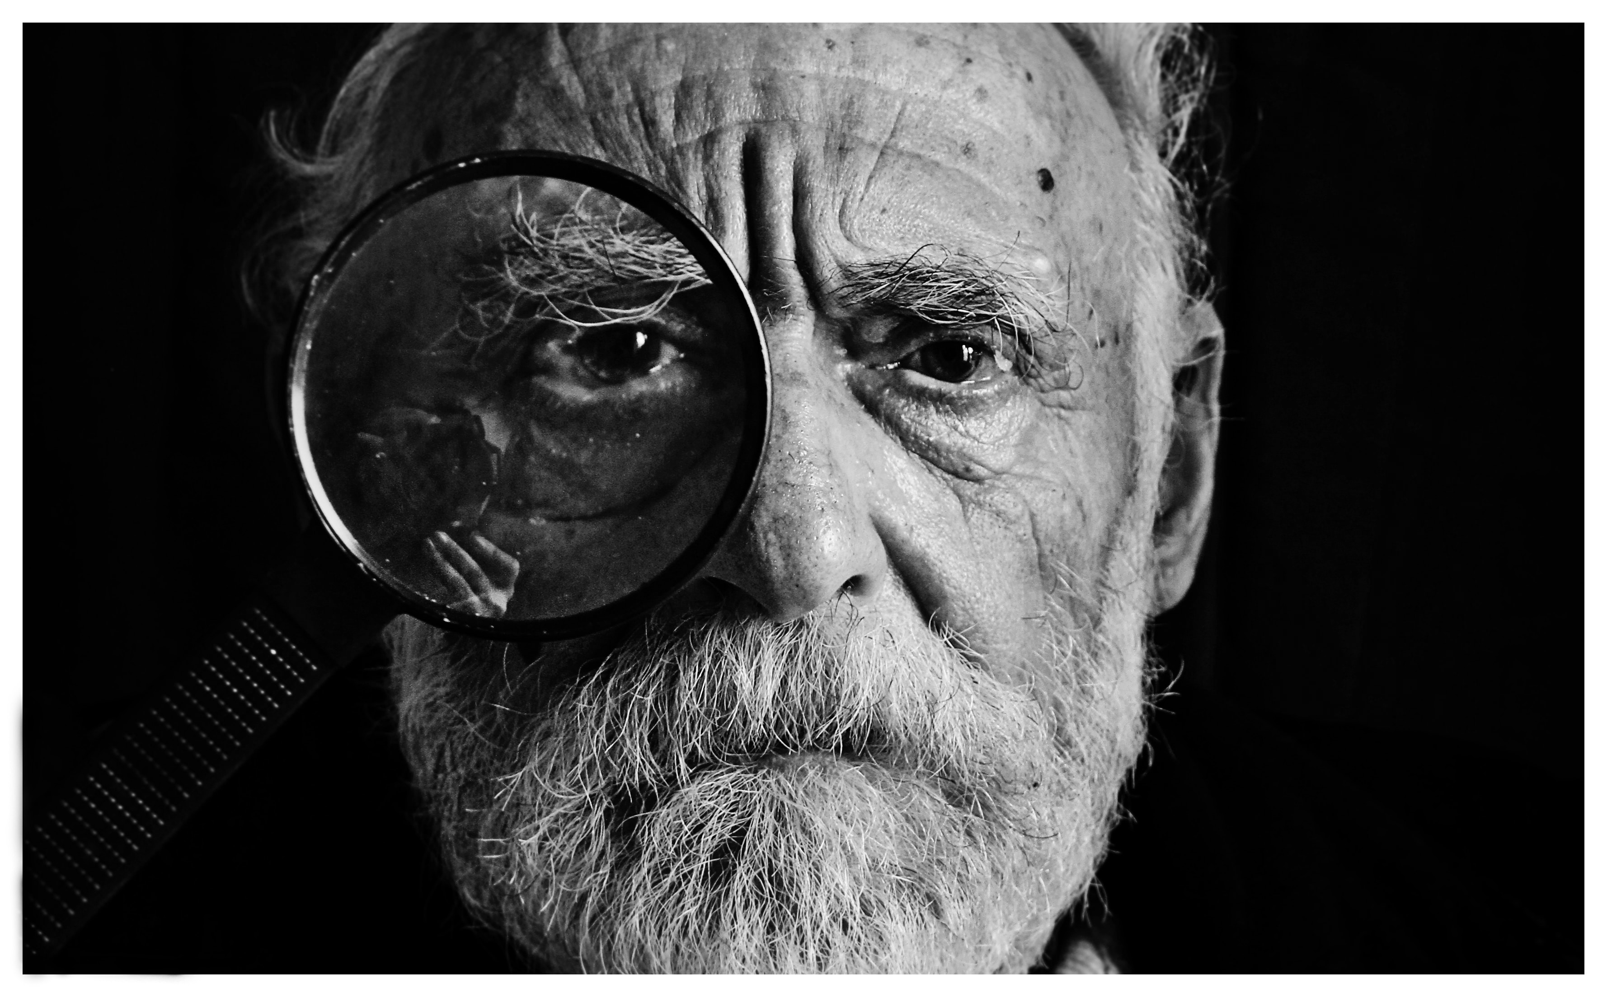
Photo: Mari Lezhava from Unsplash.com
Photo: Arnel Hasanovic from Unsplash.com

Emotion brainstorm
Photo: J'Waye Covington from Unsplash.com
Photo: Sandeep Kr Yadav from Unsplash.com

Emotion brainstorm
Photo: Anh Nguyen from Unsplash.com
Photo: Nick Grant from Unsplash.com

Appendix 2

Cartoon graffiti
Photo: Christopher Burns on Unsplash.com

Cartoon graffiti
Photo: Toa Heftiba on Unsplash.com

Cartoon graffiti

Photo: Ben White on Unsplash.com

Appendix 3

Comparing first and third person narrative voice
Extract from Joseph Conrad’s Heart of Darkness, 1899 | Extract from Jane Austen’s Pride and Prejudice, 1813
The Nellie, a cruising yawl, swung to her anchor without a flutter of the sails, and was at rest. The flood had made, the wind was nearly calm, and being bound down the river, the only thing for it was to come to and wait for the turn of the tide.  The sea-reach of the Thames stretched before us like the beginning of an interminable waterway. In the offing the sea and the sky were welded together without a joint, and in the luminous space the tanned sails of the barges drifting up with the tide seemed to stand still in red clusters of canvas sharply peaked, with gleams of varnished sprits. A haze rested on the low shores that ran out to sea in vanishing flatness. The air was dark above Gravesend, and farther back still seemed condensed into a mournful gloom, brooding motionless over the biggest, and the greatest, town on earth.  The Director of Companies was our captain and our host. We four affectionately watched his back as he stood in the bows looking to seaward. On the whole river there was nothing that looked half so nautical. He resembled a pilot, which to a seaman is trustworthiness personified. It was difficult to realize his work was not out there in the luminous estuary, but behind him, within the brooding gloom. | It is a truth universally acknowledged, that a single man in possession of a good fortune, must be in want of a wife.  However little known the feelings or views of such a man may be on his first entering a neighbourhood, this truth is so well fixed in the minds of the surrounding families, that he is considered the rightful property of some one or other of their daughters.  “My dear Mr. Bennet,” said his lady to him one day, “have you heard that Netherfield Park is let at last?”  Mr. Bennet replied that he had not.  “But it is,” returned she; “for Mrs. Long has just been here, and she told me all about it.”  Mr. Bennet made no answer.  “Do you not want to know who has taken it?” cried his wife impatiently.  “You want to tell me, and I have no objection to hearing it.”  This was invitation enough.  “Why, my dear, you must know, Mrs. Long says that Netherfield is taken by a young man of large fortune from the north of England; that he came down on Monday in a chaise and four to see the place, and was so much delighted with it, that he agreed with Mr. Morris immediately; that he is to take possession before Michaelmas, and some of his servants are to be in the house by the end of next week.”  “What is his name?”  “Bingley.”

Appendix 4

Neighbours extract
by Tim Winton in Australian Short Stories No.10, Pascoe Publishing, Carlton, Victoria, 1985
The young man and women had lived all their lives in the expansive outer suburbs where good neighbours were seldom seen and never heard. The sounds of spitting and washing and daybreak watering came as a shock. The Macedonian family shouted, ranted, screamed. It took six months for the newcomers to comprehend the fact that their neighbours were not murdering each other, merely talking. The old polish man spent most of his day hammering nails into the wood only to pull them out again. His yard was stacked with salvaged lumber. He added to it, but he did not build with it.

Appendix 5

Swing Time

‘Swing Time’, Zadie Smith, 2016 Hamish Hamilton pp16-17
At this early stage Tracey and I were not friends or enemies or even acquaintances: we barely spoke. Yet there was always this mutual awareness, an invisible band strung between us, connecting us and preventing us from straying too deeply into relations with others. Technically, I spoke more to Lily Bingham – who went to my school – and Tracey’s own standby was sad old Danika Babic, with her ripped tights and thick accent, she lived on Tracey’s corridor. But though we giggled and joked with these white girls during class, and although they had every right to assume that they were our focus, our central concern – that we were, to them, the good friends that we appeared to be – as soon as it came to break-time and squash and biscuits Tracey and I lined up next to each other, every time, it was almost unconscious, two iron filings drawn to a magnet.
It turned out Tracey was as curious about my family as I was about hers, arguing, with certain authority, that we had things “the wrong way round”. I listened to her theory one day during break, dipping a biscuit anxiously into my orange squash. ‘With everyone else it’s the dad,’ she said, and because I knew this to be more or less accurate I could think of nothing more to say. ‘When your dad’s white it means – ‘she continued, but at that moment Lily Bingham came and stood next to us and I never did learn what it meant when you dad was white. Lily was gangly, a foot taller than everyone else. She had long, perfectly straight blonde hair, pink cheeks and a happy, open nature that seemed, both to Tracey and me, the direct consequence of 29 Exeter Road, a whole house, to which I had been recently invited, eagerly reporting back to Tracey – who had never been – a private garden, a giant jam-jar full of ‘spare change’ and a Swatch watch as big as a human man hanging on a bedroom wall. There were, consequently, things you couldn’t discuss in front of Lily Bingham, and now Tracey shut her mouth, stuck her nose in the air and crossed the room to ask her mother for her ballet shoes.

Appendix 6

Analysing: What’s the deal?
D  Description | What descriptive words did the author choose to tell us about the traits of the character?
E  Emotion | What words and phrases represent the emotions of the characters?
A  Action | What do the actions and reactions of the character reveal?
L  Language | How are we positioned by the author or narrator to understand the character?

Appendix 7

Visual of Hemmingway’s principle of the iceberg
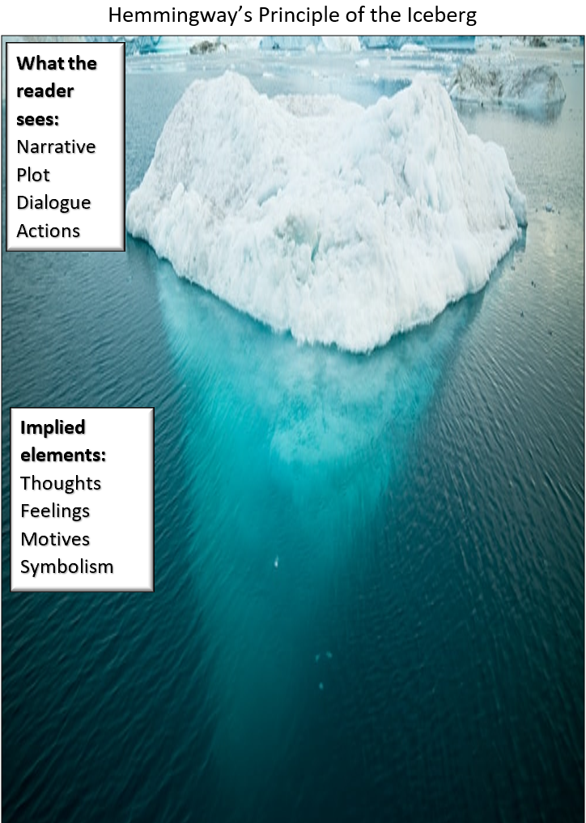
Image adapted from Photo: Alexander Hafemann Unsplash.com

Appendix 8

The Name of the Wind
‘The Name of the Wind’, Patrick Rothfuss, 2008, Gollancz, pp 10-11
Hours later, the innkeeper stood in the doorway of the Waystone and let his eyes relax to the darkness. Footprints of lamplight from the inn's windows fell across the dirt road and the doors of the smithy across the way. It was not a large road, or well travelled. It didn't seem to lead anywhere, as some roads do. The innkeeper drew a deep breath of autumn air and looked around restlessly, as if waiting for something to happen.
He called himself Kote. He had chosen the name carefully when he came to this place. He had taken a new name for most of the usual reasons, and for a few unusual ones as well, not the least of which was the fact that names were important to him.
Looking up, he saw a thousand stars glittering in the deep velvet of a night with no moon. He knew them all, their stories and their names. He knew them in a familiar way, the way he knew his own hands.
Looking down, Kote sighed without knowing it and went back inside. He locked the door and shuttered the wide windows of the inn, as if to distance himself from the stars and all their varied names.
He swept the floor methodically, catching all the corners. He washed the tables and the bar, moving with a patient efficiency. At the end of an hour's work, the water in his bucket was still clean enough for a lady to wash her hands in.
Finally, he pulled a stool behind the bar and began to polish the vast array of bottles nestled between the two huge barrels. He wasn't nearly as crisp and efficient about this chore as he had been with the others, and it soon became obvious the polishing was only an excuse to touch and hold. He even hummed a little, although he did not realise it, and would have stopped himself if he had known.
As he turned the bottles in his long, graceful hands the familiar motion eased a few tired lines from his face, making him seem younger, certainly not yet thirty. Not even near thirty. Young for an innkeeper. Young for a man with so many tired lines remaining on his face.

Appendix 9

Character analysis using iceberg
‘The Name of the Wind’, Patrick Rothfuss, 2008, Gollancz, pp 10-11
Above the water  Use evidence from the text that shows:  - Narrative  - Actions  - Plot  - Dialogue | Below the water  What can you infer about the characters:  - Thoughts  - Feelings  - Motives  - Symbolism
It was not a large road, or well travelled. It didn't seem to lead anywhere, as some roads do. | The setting is quiet, with few travellers and it is unlikely that strangers would pass through the town. This infers that Kote has chosen to live in a secluded place, away from people. Perhaps he is hiding from someone or hiding something that he does not wish to be found?
The innkeeper drew a deep breath of autumn air and looked around restlessly, as if waiting for something to happen. | Kote is unsettled which is inferred by ‘restless’. By taking a ‘deep breath’ he may be trying to calm himself. He is looking around outside, as if expecting someone or something is out there.
He called himself Kote. He had chosen the name carefully when he came to this place. He had taken a new name for most of the usual reasons, and for a few unusual ones as well… | By changing his name, the author infers that Kote is hiding from someone or something. The audience is left to speculate why – ‘usual reasons’ suggest he may have wanted to change his identity, to start a new life, whereas ‘unusual reasons’ suggest that he has had a unique and hidden past.
He swept the floor methodically, catching all the corners. He washed the tables and the bar, moving with a patient efficiency.
At the end of an hour's work, the water in his bucket was still clean enough for a lady to wash her hands in.
He even hummed a little, although he did not realise it, and would have stopped himself if he had known.
As he turned the bottles in his long, graceful hands the familiar motion eased a few tired lines from his face, making him seem younger, certainly not yet thirty. Not even near thirty.
Not even near thirty. Young for an innkeeper. Young for a man with so many tired lines remaining on his face.

Appendix 10

Character analysis using iceberg – template
Above the water  Use evidence from the text that shows:  - Narrative  - Actions  - Plot  - Dialogue | Below the water  What can you infer about the characters:  - Thoughts  - Feelings  - Motives  - Symbolism

