Vocabulary in context
Stage 4

Overview

Purpose
This literacy teaching strategy supports teaching and learning for Stage 4 students across all key learning areas. It targets specific literacy skills and suggests a learning sequence to build skill development. Teachers can select individual tasks, or a sequence, and embed into their teaching and learning program according to their students’ needs. While exemplar texts are provided throughout this resource, it is recommended that teachers select texts which are relevant to their students and curriculum.

Learning intention
Students explore and use precise vocabulary in a wide range of contexts. Students examine vocabulary elements such as morphology, and how nuance and connotation can impact meaning

Syllabus outcomes
The following teaching and learning strategies will assist in covering elements of the following outcomes:
- EN4-RVL-01: uses a range of personal, creative and critical strategies to read texts that are complex in their ideas and construction
- EN4URA-01: analyses how meaning is created through the use of and response to language forms, features and structures
- EN4-URB-01: examines and explains how texts represent ideas, experiences and values
- EN4-1A: responds to and composes texts for understanding, interpretation, critical analysis, imaginative expression and pleasure
- EN4-2A: effectively uses a widening range of processes, skills, strategies and knowledge for responding to and composing texts in different media and technologies
- EN4-3B: uses and describes language forms, features and structures of texts appropriate to a range of purposes, audiences and contexts
NSW English K-10 Syllabus (2022)
Visit the Leading curriculum K-12 website for more information on the syllabus implementation timeline.

Success criteria
The following Year 7 NAPLAN item descriptors may guide teachers to co-construct success criteria for student learning.
- analyses the effect of vocabulary choices in a text
- analyses the effect of vocabulary choices in an information text
- analyses the effect of vocabulary choices in the title of a text
- identifies synonyms in a blog post
- interprets a technical term in an information text
- interprets the meaning of vocabulary from context in an information text
- interprets the meaning of vocabulary in a narrative
- interprets the meaning of vocabulary in a persuasive text
- interprets the meaning of vocabulary in context in a narrative
- interprets the meaning of vocabulary in context in an information text
- interprets the significance of a detail in a persuasive text

National Literacy Learning Progression guide

Understanding Texts (UnT9-UnT11)
Key: C=comprehension P=process V=vocabulary

UnT9
- applies knowledge of root words and word origins to understand the meaning of unfamiliar, discipline specific words (V)
- uses a range of context and grammatical cues to understand unfamiliar words (V)

UnT10
- demonstrates an understanding of nuances and subtleties in words of similar meaning (e.g. frustrated, discouraged, baffled) (V)
- verifies interpretations of unfamiliar words using grammatical and contextual cues (V)

UnT11
- interprets complex, formal and impersonal language in academic texts (V)
- demonstrates self-reliance in exploration and application of word learning strategies (V)
National Literacy Learning Progression

Evidence base
- Beck, McKeown and Kucan, (2013). Bringing words to life. The Guilford Press.
- Konza, D. (2011). Research into practice: Vocabulary.
- Quigley, A. (2018). Closing the vocabulary gap. Routledge
Alignment to system priorities and/or needs: Five priorities for Literacy and Numeracy, Our Plan for NSW Public Education, School Excellence Policy (nsw.gov.au).
Alignment to School Excellence Framework: Learning domain: Curriculum, Teaching domain: Effective classroom practice and Professional standards
Consulted with: Strategic Delivery, Teaching Quality and Impact
Author: Literacy and Numeracy
Reviewed by: Literacy and Numeracy, Teaching Quality and Impact
Created/last updated: January 2024
Anticipated resource review date: January 2025
Feedback: Complete the online form to provide any feedback

Copyright
Section 113P Notice
Texts, Artistic Works and Broadcast Notice
Some of this material has been copied and communicated to you in accordance with the statutory licence in section 113P of the Copyright Act. Any further reproduction or communication of this material by you may be the subject of copyright protection under the Act. Do not remove this notice.

Teaching strategies
Tasks | Appendices
SEEC
Morphology | Appendix 1 - Vocabulary wheel  Appendix 2 - ‘Race off the base’ prefix, suffix, root cards
Synonyms and antonyms | Appendix 3 - Synonym and antonym pairs  Appendix 4 - What in the word?  Appendix 5 - Odd one out
Nuance | Appendix 6 - Which word? Text extract and table  Appendix 7 - Nuance in vocabulary
Word clines | Appendix 8 - Word clines  Appendix 9 - Visual word cline
Connotation
Context clues | Appendix 10 - Contextual clues
Cloze passage | Appendix 11 - Cloze passage
Using words | Appendix 12 - Vocabulary map
Vocabulary in context | Appendix 13 - Vocabulary check-in  Appendix 14 - Vocabulary check-in text

Background information

The three tiers of vocabulary
The three-tiered model of vocabulary development, described by Beck, McKeown and Kucan in ‘Bringing words to life (2013) is a framework to classify words.
Tier 1: These are common, everyday words that most children enter school knowing already, either in English or their first language. These words will continue to be acquired from everyday life including through school. These words are readily learned as they are used frequently in conversation and are concrete. For example, book, girl, sad, baby, clock, dog and orange.
Tier 2: These words appear more frequently in text than in oral language, so children are less likely to learn them without assistance. They add precision by providing new ways to express concepts that are already understood. (For example, stale, awful, snuggle, twitch). These words require explicit teaching as they may not be part of children’s everyday oral language. Tier 2 words:
- usually have multiple meanings,
- are essential for building formal academic language across subject areas
- are necessary for reading comprehension
- are characteristic of a mature language user, and
- are descriptive words that add detail.
Tier 3: These have a low user frequency often limited to specific topics and domains. ​Tier 3 words are likely to be new for all students. ​ Some examples of Tier 3 words might be filibuster, pantheon and epidermis. These words are probably best learned when there is a specific need in a subject area. (Beck, McKeown and Kucan, (2013) Bringing words to life, page 9.)

Vocabulary and culture
Including Aboriginal language or Aboriginal English vocabulary, as well as reflecting cultural language from student ethnic backgrounds, adds significance and meaning to the learning. Contact your local Aboriginal Education Consultative Group (AECG) representatives and Aboriginal community members for information about the local language or Aboriginal English.
The following is a list of strategies that may help to build vocabulary:
- Oral language – a strong foundation in oral language assists students with reading.
- Explicit teaching with repeated exposure – targeted teaching at the right level. Students need to see, hear and use the words repeated times, in different contexts.
- Word Consciousness – building a classroom culture of “awareness and interest in words and their meaning” (Graves & Watts-Taffe, 2008).
- Link words to images – introduce new vocabulary with visual representations.
- Reading a range of books – read a range of texts that include a range of Tier 2 and 3 vocabulary.
- Morphology – A critical element of vocabulary development that looks at the structure of the word according to base word, roots, prefixes and suffixes.
- Word walls – displaying and building upon Tier 2 and Tier 3 words from discussions and text exposure. Additionally, using colour coding to highlight parts of word such as suffixes/prefixes.
- Glossaries, dictionaries and thesauruses – using these as part of daily practice and sharing.
Everyday classroom activities:
- Brainstorm and predict vocabulary with each text or concept and further build understanding.
- Accountable talk - introduce phrases for students to use in discussions “building on to that idea…”and “I agree with …but would like to add another point of view.”
- Cloze – students need to use contextual clues to determine an appropriate word choice or choose from a selection of vocabulary presented.
- Word clines – select words that have similar meanings and have students arrange the words in graduating intensity according to the word that is being used and the scale being used.
- Word maps – students use four quadrant questions to build an understanding of a word.
- Make a word - students are given a group of consonants and vowels to create words.
- Six-word skit – students are given six ‘target’ words to devise a skit to present to class.
- Words in words - students are given a long word to find smaller words within it.
- Word chains – students offer word associations as a chain for example, eating, health, exercise.

Where to next?
- Inference
- Literary devices
- Text features

Overview of teaching strategies

Purpose
These literacy teaching strategies support teaching and learning from Stage 2 to Stage 5. They are linked to NAPLAN task descriptors, syllabus outcomes and literacy and numeracy learning progressions.
These teaching strategies target specific literacy and numeracy skills and suggest a learning sequence to build skill development. Teachers can select individual tasks or a sequence to suit their students.

Access points
The resources can be accessed from:
- NAPLAN App in Scout using the teaching strategy links from NAPLAN items
- NSW Department of Education literacy and numeracy website.
What works best
Explicit teaching practices involve teachers clearly explaining to students why they are learning something, how it connects to what they already know, what they are expected to do, how to do it and what it looks like when they have succeeded. Students are given opportunities and time to check their understanding, ask questions and receive clear, effective feedback.
This resource reflects the latest evidence base and can be used by teachers as they plan for explicit teaching.
Teachers can use classroom observations and assessment information to make decisions about when and how they use this resource as they design teaching and learning sequences to meet the learning needs of their students.
Further support with What works best is available.
Differentiation
When using these resources in the classroom, it is important for teachers to consider the needs of all students, including Aboriginal and EAL/D learners.
EAL/D learners will require explicit English language support and scaffolding, informed by the EAL/D enhanced teaching and learning cycle and the student’s phase on the EAL/D Learning Progression. Teachers can access information about supporting EAL/D learners and literacy and numeracy support specific to EAL/D learners.
Learning adjustments enable students with disability and additional learning and support needs to access syllabus outcomes and content on the same basis as their peers. Teachers can use a range of adjustments to ensure a personalised approach to student learning.
Assessing and identifying high potential and gifted learners will help teachers decide which students may benefit from extension and additional challenge. Effective strategies and contributors to achievement for high potential and gifted learners helps teachers to identify and target areas for growth and improvement. A differentiation adjustment tool can be found on the High potential and gifted education website.

Using tasks across learning areas
This resource may be used across learning areas where it supports teaching and learning aligned with syllabus outcomes.
Literacy and numeracy are embedded throughout all syllabus documents as general capabilities. As the English and mathematics learning areas have a particular role in developing literacy and numeracy, NSW English and Mathematics syllabus outcomes aligned to literacy and numeracy skills have been identified.

Text selection
Example texts are used throughout this resource. Teachers can adjust activities to use texts which are linked to their unit of learning.
Further support with text selection can be found within the National Literacy Learning Progression Text Complexity appendix.
The NESA website has additional information on text requirements within the NSW English syllabus.

Teaching strategies
The following SEEC process can be used to explicitly teach vocabulary:
S  Select | Select 2-4 words to specifically target during teaching and learning.
E  Explain | Define and explain the words.
E  Explore | Explore words with a range of teaching strategies.
C  Consolidate | Contextualise and consolidate knowledge of the new vocabulary.
Adapted from the work of Quigley, A. Closing the vocabulary gap (2018)

Select
Selecting words in texts is an important part of vocabulary teaching and learning. Prior to learning, preview material and identify 2-4 target words for explicit instruction. Teachers need to be able to revoice these terms into student-friendly definitions and for students to understand word meanings in different contexts.
Some considerations:
- Which words are most important to understanding the text or situation?
- Which words will help build important concept knowledge?
- Which words will be encountered frequently outside this particular context?
- Which words have multiple meanings?
- Which words can be figured out from the context?
- Which words provide an opportunity to use morphology to determine the meaning?
(Konza, D., 2011)

Explain
After selecting words to target, teachers move into explicit instruction and explanation of the word. Strategies to explain can include: using word walls, using graphic organisers and modelling how to define a word.
When introducing new words, teachers might:
Say | - Say the word carefully and with clear articulation.  - Say the word individually and in a sentence.  - Draw attention to syllables.  - Notice the phonemes
Write | - Write the word  - Notice suffixes, prefixes and root words  - Notice common graphemes and phonemes
Define | - Provide a definition  - Provide a student-friendly definition
Demonstrate | - Give meaningful examples in different contexts
Clarify | - Ask students to provide further examples  - Clarify meanings  - Clarify misconceptions
Adapted from the work of Beck L. et al. Bringing words to life (2013) and Quigley, A. Closing the vocabulary gap (2018).

Explore
Some graphic organisers and strategies to explore and define words include:
- Frayer model
- Word web
- Vocabulary map
- Highlighting key vocabulary and using dictionaries and glossaries to define.
- Reword definition into own words

Morphology
- Review and model key terms in morphology:
Affix – Any part that is added to a word; a prefix or a suffix
Base word: A word that can stand alone and to which affixes can be added
Prefix – A word part that is attached to the beginning of a word
Suffix – A word part that is attached to the end of a word
Base and Root words– Roots/Base words are morphemes that form the base of a word, and usually carry its meaning. Generally, base words are free morphemes that can stand by themselves (for example, cycle as in bicycle/cyclist, and form as in transform/formation. Whereas root words are often bound morphemes that cannot stand by themselves (for example, -ject as in subject/reject, and -volv as in evolve/revolve). (education.vic.gov.au)
Prefix, Base-words, Suffix table:
Prefix | Base word | Suffix
un | comfort | able
ir | regular | ly
dis | respect | fully
dis | honest | ly

- Vocabulary wheel: Revise Greek and Latin roots and the idea that much of our language is based on these language systems. Introduce the root ‘autos’ as Greek meaning ‘self’ or ‘same’. Students brainstorm words that have ‘autos’ in them (automatic, autobiography, autocratic) and present in vocabulary wheel (Appendix 1 - Vocabulary wheel). Students then select another root and brainstorm some words that have this root in them.

R

auta
automobile
autocratic
autos
- Students work in teams with a base word in ‘word play’ – determine as many new words as possible using the base words, prefixes, suffixes and Greek and Latin root guides (Appendix 2 - ‘Race off the base’ prefix, suffix, root cards).

Synonyms and antonyms
- Revise the term ‘synonym’ as: a word or word group with the same or similar meaning as another word or word group, for example want (desire), get away (leave) (NSW English K-10 Syllabus glossary, 2012).
- Headlines: Students read the headlines below and consider ways to enhance with antonyms, synonyms, verbs and adjectives. For example, with the headline: Cows missing from farm, a more interesting headline might be: Bovines say bon voyage to farm and cause bedlam!
- Schools buy new furniture
- No take-away coffee cups allowed
- Plane lands in pineapple field
- Diamonds were not real
- Cats can hear well
- Synonym and antonym pairs: Students are each given a card from a selection of synonyms and antonyms (Appendix 3 - Synonym and antonym pairs). Allocate time for students to define their word with a partner and use a dictionary, applying the ‘What in the word?’ word guide (Appendix 4 - What in the word?) Once students are comfortable with the definition of their word, students are given tasks to find people meeting criteria:
Find someone who has a synonym for your word. |  | Find someone who has your word’s antonym. |  | Make a sentence that is nonsensical with your partner’s and your own word.
Find someone who has a connection with your word. |  | Make a joke that is hilarious with your partner’s and your own word. |  | Create three freeze frames to act out a scenario with both your words.
Persuade your partner why your word is more important to learn than their word. |  | Make a sentence that is thought-provoking with your partner’s and your own word. |  | Find someone whose word has the same number of syllables as your word.
Find someone whose word is the same part of speech as yours…adjective, noun, verb |  | Find someone who has a different part of speech to you…adjective, noun, verb |  | Create a newspaper headline using both your, and your partner’s, words.
- Odd one out: Students work in pairs on the ‘odd one out’ worksheet (Appendix 5 - Odd one out). Students identify the word that does not belong, explain why and provide a substitute word. Students engage in a Think-Pair-Share activity and share their answers with a partner.
- Students design their own ‘odd one out’ category lists. These can be distributed to the class for feedback.

Nuance
- Ask students to brainstorm different words for the word ‘sad’. Write their responses on the board. Discuss the differences (or nuances) between the words on the board. Ask students to consider when they would use particular words over other words.
- Explain to students that there are many words in the English language that are used to convey precise meanings and whilst a lot of words have similar meanings to other words, there are slight and subtle differences in meaning. These are called ‘nuances’.
- Students read the extract from ‘The Hobbit’ (Appendix 6 - Which word? Text extract and table) and consider the nuances between words that would be most appropriate to maintain the meaning of the text. Students highlight or circle the word that they think best fits with the rest of the extract. Engage in a Think-Pair-Share activity where students compare their responses with a partner.
- Students complete the ‘which word?’ table that goes with the extract. Students identify the word that they have selected and explain why they think it best fits with the extract. Again, students engage in a Think-Pair-Share and discuss why they think a particular word is more appropriate than the other.
- Students complete the ‘Nuance in vocabulary’ worksheet (Appendix 7 - Nuance in vocabulary) to identify the nuances between words and which would be the most appropriate choice in a sentence.

Word clines
- Teacher leads brainstorm for synonyms for the word ‘said’. Another example could be the word ‘smell’ ranging from pleasant to horrible.
replied  questioned  yelled  whispered  exclaimed | called  argued  mumbled  cried  whimpered | demanded  reprimanded  stated  squeaked  whined
- Place words on sticky notes and have students assist in ordering words along an incline, or word cline:
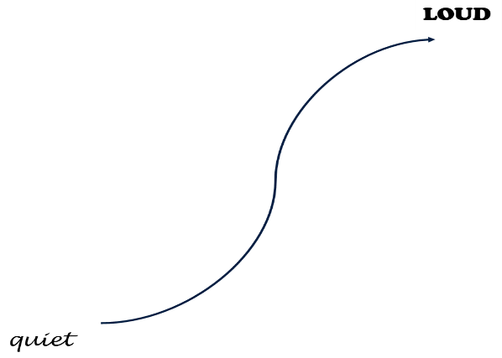
- Students work in small groups to rotate between word collections (Appendix 8 - Word clines) and place terms along an incline representing the subtle differences between words. The bold word indicates the theme.
- Students can make their own examples by brainstorming synonyms and placing these along a continuum. Using images linked to the words may support students.
- A range of images linked to current unit of learning are placed in work stations around the classroom. Students brainstorm vocabulary using sticky notes. Students rotate around the posters and add more ideas on sticky notes. When students are back at their original poster, students work together to categorise words then place on an incline as a word cline. (Refer to Appendix 9 - Visual word cline.)

Connotation
- Word association: Teacher reads aloud words and has students think of a word they associate with it, for example: funeral, sad, family, celebration of life, reflection. Discuss how people attach feelings and experiences, cultural backgrounds and generational contexts to how they imagine a word. We call this ‘connotation’. Connotation can differ between a reader depending on their own personal backgrounds and experiences. Some other words to explore connotation may include: clown, school, game, family, power.
- Discuss with students that connotation can be more subjective, while many words have widely held connotations or associations, you may associate a word with a pleasant memory or feeling but the next person might have a negative response; a reader brings some of the meaning beyond the literal meaning or definition.

Context clues
- Distribute the ‘using context clues’ task (Appendix 10 - Contextual clues) and read through the extract as a class. Students use context clues in the extract to help them determine the meaning of unknown words. The extract could provide clues about the meaning of word through:
- a definition or restatement of the word
- an example of the word
- a synonym of the word
- a contrast of the word
- cause and effect
- the topic and subject of the text
- how the word is used in the text
- Students identify the context clues they used to help them understand the meaning of the words and write down the meaning of the word sharing and discussing with a partner or small team.
- Engage in a ‘think-pair-share’ activity where students share their work with a partner. Students should discuss and edit their work as necessary.

Cloze passage
- Introduce topic of text to be shared and determine background knowledge. This could be a short news report or documentary, or even an extract from a movie study or novel.
- Teacher reads aloud/ views text linked to unit of learning. During read, teacher pauses at some words, having students predict vocabulary choices. Brainstorm synonyms that could also be possible suggestions, displaying for students.
- Students use Appendix 11 - Cloze passage to select words in cloze passage, working in pairs to Think-Pair-Share and discuss word choice. Students design their own cloze passage, focusing on a target, for example, nouns, adjectives or technical terms.

Using words
- Modelled teaching: Teacher selects a word suitable for class, for example, ‘pedantic’ and models using this word to complete the vocabulary map (refer to Appendix 12 - Vocabulary map).
- Jigsaw activity: Using an enlarged version of the vocabulary map or word web, students become experts in one part of the vocabulary map (rotate over learning experiences to ensure students develop an understanding in all areas to be able to complete a vocabulary map or word web individually). Teacher chooses one word and students work in their expert groups to complete their component (definition, part of the word, using in a sentence and so on) on a sticky note to add to the class display. Repeat with additional words.
- Speed Dating: Students are each given a word to define linked to current unit of learning, for example, ‘superfluous’. Students face each other at a table and are given one minute to share words and terms and determine a sentence. For example:

- Students need to determine a connection between the two words for example, both use a prefix, same number of syllables.

Consolidation

Vocabulary in context
- Introduce process ‘Vocabulary check in’ (Appendix 13 - Vocabulary check-in) or a class-determined process for reviewing vocabulary in text.
- Model process and demonstrate alongside students, using a text linked to current unit of learning.
- Students then read another text and apply the same procedure. Discuss and share.
- The teacher reads a passage of descriptive writing and the students draw what they hear. (Refer to Appendix 14 - Vocabulary check-in text). The focus is on the precise vocabulary. Slowing down the description is important to allow time for students to visualise and represent what they have heard.
- Students then choose an image and use similar descriptive language either verbally or written to demonstrate how precise vocabulary can enhance reader understanding and enjoyment.

Appendix 1

Blank vocabulary wheel

Appendix 2

‘Race off the base’ – suffixes
ac  (pertaining to) | acity/ocity  (quality of) | ant  (a person who) | ary  (of or relating to)
s  (plural) | ion  (act or process) | al  (having characteristics of) | en  (made of)
ed  (past tense) | tion  (act or process) | ial  (having characteristics of) | ic  (having characteristics of)
ing  (present tense) | ible  (can be done) | ness  (state of) | ive  (adjective form of noun)
ly  (characteristic of) | able  (can be done) | ous  (having qualities of) | eous  (having qualities of)
er  (person) | y  (characterised by) | ious  (having qualities of) | ative  (adjective form of noun)
or  (person) | ful  (full of) | ment  (action or process) | itive  (adjective form of noun)
cy  (state/condition of) | est  (most) | ward  (in the direction of) | ine  (relating to)
ian  (relating to) | ing  (materials or action/process) | ist  (a person/one who performs an action) | ant  (a person who)

‘Race off the base’ – prefixes
uni  (one, single) | up  (to the top, higher/better) | sym/  (same time/together) | syn  (same time/together)
un  (not, opposite of) | dis  (not, opposite of) | im  (in or into) | trans  (across)
re  (again) | en  (put into, cover with) | in  (in or into) | super  (above)
in  (not) | em  (cause to) | mis  (wrongly) | semi  (half)
im  (not) | non  (not) | sub  (under) | inter  (between, among)
ir  (not) | under  (too little) | pre  (before) | mid  (middle)
il  (not) | over  (too much) | inter  (between) | mono  (one)
a, an-  (without) | anti  (opposite of) | bi  (two) | mono  (one)
ante  (before) | auto  (self) | super  (more, better) | post  (after)
ex  (out of) | de  (down, off, away from) | dis  (not, apart, away) | tri  (three)

‘Race off the base’ – base words
believe | adjust | judge | behave
attain | scribe | think | sense
force | position | again | kind
prevent | take | before | write
change | present | honest | appear
agree | learn | polite | heat
use | clear | mature | comfort
order | act | employ | manage

Word play – Greek roots
A root is a part of a word that carries meaning but may not always stand alone. Roots such as ‘graph’ and ‘photo’ are examples of these roots that can stand alone.
anti  (against) | ast  (star) | aqu  (water) | auto  (self)
biblio  (book) | bio  (life) | chrome  (colour) | doc  (teach)
dyna  (power) | geo  (earth) | graph  (write) | hydr  (water)
logos  (study of) | spect  (see – Latin) | tele  (from afar – Greek) | tract  (pull – Latin)
logos  (together) | tele  (far) | photo  (light) | path  (feel)

Word play – Latin roots
A root is a part of a word that carries meaning but may not always stand alone. Roots such as ‘graph’ and ‘photo’ are examples of these roots that can stand alone.
ab  (to move away from) | audi  (hear) | bene  (good) | circ  (round)
duc  (lead/make) | fund  (bottom) | gen  (to birth) | jur  (law)
lev  (lift) | log/logue  (thought) | luc/lum  (light) | manu  (hand)
mis/mit  (send) | omni  (all) | pac  (peace) | port  (carry)
sens  (to feel) | terr  (earth) | vac  (empty) | vid/vis  (to see)

Appendix 3

Synonym and antonym pairs
Cut up cards and allocate one per student.
challenging | achievable | problematic | straightforward
amenable | unaccommodating | distinguished | lowly
audacious | timid | examine | ignore
palpable | intangible | euphoric | wretchedness
irksome | agreement | progressive | reactionary
uproarious | docile | domesticated | untamed
dilapidated | intact | credible | untrustworthy
outlandish | ordinary | petulant | affable
morose | cheerful | staunch | inconstant
unnerving | heartening | fraught | calming
reticent | garrulous | lickety-split | unhurried

Appendix 4

What in the Word? Word guide
Word | Found in | Sentence used

I think it means
Clues I used
Dictionary definition
It makes me think of
New sentence

Word | Found in | Sentence used

I think it means
Clues I used
Dictionary definition
It makes me think of
New sentence

Appendix 5

Odd one out
Which word does not belong in these groups? Can you re-categorise in a different way?
Words | Odd one out | Reason | Substitution
ravenous
malnourished
famished
satisfied
bewildered
addled
coherent
unhinged
apathetic
eager
anxious
impatient
agree
concur
differ
sympathise
dejected
sorrowful
wretched
comic
apathetic
profound
fervent
fervid
irreproachable
iniquitous
righteous
ethical

Appendix 6

Text extract: Which word?
Extract (The Hobbit, J. R. R. Tolkien, Allen & Unwin, 1937)
In a hole in the ground there lived a hobbit. Not a nasty, dirty, old / wet hole, filled with the ends of worms and an oozy smell, nor yet a dry, bare / basic, sandy hole with nothing in it to sit down on or to eat: it was a hobbit-hole, and that means comfort / relief.
It had a perfectly round door like a porthole, painted green, with a shiny / glittery yellow brass knob in the exact corner / middle. The door opened on to a tube-shaped hall like a tunnel / road: a very comfortable tunnel without smoke, with panelled walls, and floors tiled and carpeted, provided with polished / refined chairs, and lots and lots of pegs for hats and coats – the hobbit was excited / fond of visitors. The tunnel wound on and on, going fairly but not quite straight into the side of the hill – The Hill, as all the people for many miles round called it – and many little round doors opened out of it, first on one side and then on another. No going upstairs for the hobbit: bedrooms, bathrooms, cellars, pantries (lots of these), wardrobes (he had whole rooms devoted to fashion / clothes), kitchens, dining rooms, all were on the same floor, and indeed on the same passage. The best rooms were all on the left-hand side (going in), for these were the only ones to have windows, deep-set round windows looking over his grass / garden, and meadows beyond, sloping down to the river.
This hobbit was a very well-to-do hobbit, and his name was Baggins. The Bagginses have lived in the neighbourhood of The Hill for time out of mind, and people considered them very respectable / reliable, not only because most of them were rich, but also because they never had any journeys / adventures or did anything unexpected: you could tell what a Baggins would say on any question without the bother of asking him. This is a story of how a Baggins had an adventure / voyage, and found himself doing and saying things altogether spontaneous / unexpected. He may have lost the neighbours’ admiration / respect, but he gained – well, you will see whether he gained everything / anything in the end.
Copied under the statutory licence in s 113P of the Copyright Act.
J.R.R Tolkien, ‘The Hobbit’, 1937, Allen & Unwin
Section 113P Warning Notice

Text extract answers: Which word?
Extract (The Hobbit, J. R. R. Tolkien, Allen & Unwin, 1937)
In a hole in the ground there lived a hobbit. Not a nasty, dirty, old / wet hole, filled with the ends of worms and an odd / oozy smell, nor yet a dry, bare / basic, sandy hole with nothing in it to sit down on or to eat: it was a hobbit-hole, and that means comfort / relief.
It had a perfectly round door like a porthole, painted green, with a shiny / glittery yellow brass knob in the exact corner / middle. The door opened on to a tube-shaped hall like a tunnel / road: a very comfortable tunnel without smoke, with panelled walls, and floors tiled and carpeted, provided with polished / refined chairs, and lots and lots of pegs for hats and coats – the hobbit was excited / fond of visitors. The tunnel wound on and on, going fairly but not quite straight into the side of the hill – The Hill, as all the people for many miles round called it – and many little round doors opened out of it, first on one side and then on another. No going upstairs for the hobbit: bedrooms, bathrooms, cellars, pantries (lots of these), wardrobes (he had whole rooms devoted to fashion / clothes), kitchens, dining rooms, all were on the same floor, and indeed on the same passage. The best rooms were all on the left-hand side (going in), for these were the only ones to have windows, deep-set round windows looking over his grass / garden, and meadows beyond, sloping down to the river.
This hobbit was a very well-to-do hobbit, and his name was Baggins. The Bagginses have lived in the neighbourhood of The Hill for time out of mind, and people considered them very respectable / reliable, not only because most of them were rich, but also because they never had any journeys / adventures or did anything unexpected: you could tell what a Baggins would say on any question without the bother of asking him. This is a story of how a Baggins had an adventure / voyage, and found himself doing and saying things altogether spontaneous / unexpected. He may have lost the neighbours’ admiration / respect, but he gained – well, you will see whether he gained everything / anything in the end.
Copied under the statutory licence in s 113P of the Copyright Act.
J.R.R Tolkien, ‘The Hobbit’, 1937, Allen & Unwin
Section 113P Warning Notice

Student copy: Which word?
Word 1 | Word 2 | Which word is more appropriate and why?
old | wet | Wet is more appropriate as the hole is described as ‘nasty’ and ‘dirty’. The word ‘wet’ fits better with the rest of the description, as it can be unpleasant like the other adjectives in the sentence.
bare | basic
comfort | relief
shiny | glittery
corner | middle
tunnel | road
polished | refined
excited | fond
fashion | clothes
grass | garden
respectable | reliable
journeys | adventures
admiration | respect
everything | anything

Appendix 7

Nuance in vocabulary
Nuance in vocabulary
Nuance means ‘a subtle difference in meaning or expression’. Many words have synonyms that convey similar meanings. However, each word has a very specific meaning which is why we need to think about the specific vocabulary we use in our writing so that it best conveys our intended meaning.
Look up ‘Kaitlin Robbs’ vocabulary wheel’ and use the vocabulary wheel for this activity.
Look at the table below. Two words with similar meanings have been placed in the table (insecure and inferior). The different sections of the table will help you determine the difference between the two words so that you know when to use one over the other.
Word | insecure | inferior
Definition | What is the definition of the word?  Insecure means to be unsure, uncertain or anxious about yourself. It is another way of saying that someone is not confident about themselves. | What is the definition of the word?  Inferior means to be lower in rank or status than someone else. It is another way of saying that someone is less powerful than another person.

Difference | What is the difference between the two words?  The difference is that ‘insecure’ refers to someone feeling that they are not capable of doing something. It has a lot to do with having a lack of skills and confidence.  ‘Inferior’ refers to someone that feels that they are less than another person. It has a lot to do with status and the way others are perceived.

Use | Use the word in a sentence.  After finding the right group of friends, she was no longer insecure about who she was. | Use the word in a sentence.  Dean always felt inferior to his brother, despite being just as a successful.

Student copy: Nuance in vocabulary
Select two words that are side by side in the vocabulary wheel and complete the tables below. You should select the words that you need clarification on or find confusing.
Word
Definition | What is the definition of the word? | What is the definition of the word?

Difference | What is the difference between the two words?

Use | Use the word in a sentence. | Use the word in a sentence.

Appendix 8

Word clines
forage | hunt
scavenge | search
look | exploration
quest | scout
probe | ferret
rummage | scour

decay | decompose
degenerate | degrade
collapse | wane
fester | spoil
decline | retrogress

tragic | disastrous
catastrophic | calamitous
cataclysmic | ruinous
dire | devastating
woeful | abominable
heinous | wretched

confused | demented
perplexed | bewildered
baffled | flummoxed
stupefied | nonplussed
befuddled | dumbfounded
disconcerted | discombobulated

intriguing | fascinating
absorbing | compelling
tantalising | interesting
thought-provoking | stimulating
gripping | riveting
captivating | enthralling

dishonest | fraudulent
swindling | cunning
devious | treacherous
unprincipled | deceptive
roguish | disreputable
perfidious | unethical

Appendix 9

Visual word cline
- Create a word cline that describes the following images, for example, you might choose happy to despondent or meek to aggressive.
- Think about what the images convey and the different ways you could express it
- Organise the words into an order that shows the progression of that vocabulary so that the final word in the word cline best represents the image.
Image 1
Photo by Zahra Amiri from Unsplash.com
Image 2
Photo by Jean Wimmerlin on Unsplash.com

Visual word cline
- Create a word cline that describes the following images, for example, you might choose dark to light or calm to stormy
- Think about what the images convey and the different ways you could express it
- Organise the words into an order that shows the progression of that vocabulary so that the final word in the word cline best represents the image.
Image 3
Photo by Greg Rakozy from Unsplash.com
Image 4
Photo by Jonathan Bowers from Unsplash.com

Appendix 10

Background information: Context clues
There are many words in the English language that may be unfamiliar to us. To understand a word and its meaning, we need to consider the context that the word is used in.
Context refers to the information provided around the use of the word. That means we need to look at the sentences or paragraphs surrounding an unfamiliar word and look for clues that can help us understand the meaning of a word.
Context clues such as the ones below can help us understand an unfamiliar word.
- Definition or restatement of the word
- An example of the word
- A synonym of the word
- A contrast/antonym of the word
- Cause and effect
- The topic and subject of the text
- How the word is used in the text
Have a look at the words in the list below. Do you know what they mean? Highlight or put a tick next to the words that you know the meaning of.
vehemence | trite | recant | paucity
irascible | immured | frond | erudite
corpulent | cloche | austere | abase
garrulous | mellifluous | venerate | specious
skein | canard | attrition | wraithlike

Worksheet: Context clues
See if you can understand the meaning of the words when they are used in a sentence. Use the ‘context clues’ to help you understanding the meaning of each word and complete the table.
Sentence | What I think the word means | What context clues I used
The vehemence of his anger could not be controlled.
It was a highly irascible animal, always irritable.
He was a corpulent man, a plump and pudgy man.
She could talk under water, that garrulous woman.
The tangled skein of wool made her knitting quite difficult.
It is said so often, but it’s not trite: be true to who you are.
He was immured in his cell for the crime that he committed.
He used a cloche to protect his plants from insects.
The mellifluous sound of her voice was lovely to listen to.
Everyone knew it was a canard, a rumour, a lie, but people still believed it.
He asked if he could recant his statement as he no longer held that belief.
The frond of the tree snapped in the wind.
Her austere expression made everyone avoid her.
I venerate him as an ideal leader.
The company will lose 10% of staff through attrition.
The paucity of fruit was caused by the drought.
The erudite student knew how to get good marks in his subjects.
She was a bully that continued to abase the other students.
His argument was specious, so he couldn’t comment any further.
She floated wraithlike through the empty room.

Using context clues in text

Narrative extract

(Divergent, Veronica Roth, Katherine Tegen Books, 2011)
There is one mirror in my house. It is behind a sliding panel in the hallway upstairs. Our faction allows me to stand in front of it on the second day of every third month, the day my mother cuts my hair.
I sit on the stool and my mother stands behind me with the scissors, trimming. The strands fall on the floor in a dull, blond ring. When she finishes, she pulls my hair away from my face and twists it into a knot. I note how calm she looks and how focused she is. She is well-practiced in the art of losing herself. I can’t say the same of myself.
I sneak a look at my reflection when she isn’t paying attention—not for the sake of vanity, but out of curiosity. A lot can happen to a person’s appearance in three months. In my reflection, I see a narrow face, wide, round eyes, and a long, thin nose—I still look like a little girl, though sometime in the last few months I turned sixteen. The other factions celebrate birthdays, but we don’t. It would be self-indulgent.
“There,” she says when she pins the knot in place. Her eyes catch mine in the mirror. It is too late to look away, but instead of scolding me, she smiles at our reflection.
I frown a little. Why doesn’t she reprimand me for staring at myself?
“So today is the day,” she says.
“Yes,” I reply.
“Are you nervous?”
I stare into my own eyes for a moment. Today is the day of the aptitude test that will show me which of the five factions I belong in. And tomorrow, at the Choosing Ceremony, I will decide on a faction; I will decide the rest of my life; I will decide to stay with my family or abandon them.
Copied under the statutory licence in s 113P of the Copyright Act.
Veronica Roth, ‘Divergent’, 2011, Katherine Tegen Books
Section 113P Warning Notice

Using context clues in text
Complete the table below for the following words in the extract. Explain the context clues you used to help determine the meaning of the word in the extract. In the space provided, add in other words that you are unfamiliar with and complete the rest of the table.
Word | Context clues | Meaning
panel
faction
trimming
vanity
self-indulgent
scolding
reprimand
aptitude

Appendix 11

Whole text: cloze passage
The Innovation Formula – Dr Amanda Imber (2016). Published by John Wiley and Sons Australia.
Chapter 6: Collaboration – How to get people working with the un-usual suspects
If you suffer from dry lips you have probably, at some point in your life, purchased a ChapStick. ChapStick is a brand that is synonymous with chapped lips. In fact, the ChapStick brand has been so successful that it has a generic trademark (This happens when a brand name has become synonymous with the product or service category it sits within.) However, in 2013 Eos lip balm overtook the seemingly unbeatable ChapStick to become America’s best-selling lip balm.
Eos lip balm was created not by a large cosmetics company, but by an advertising agency called Anomaly – although referring to it as an advertising agency feels like a significant misrepresentation.
Anomaly certainly lives up to its name, and its achievements extends way beyond the lip balm space. You might have seen the agency’s 2013 Budweiser Super Bowl commercial, about a Clydesdale coming-of-age story. This ad was the third most shared Super Bowl spot in history. Or perhaps you have watched Anomaly’s collaboration with chef Eric Rippert in the Emmy-winning show Avec Eric.
Anomaly’s business model is very different from other agencies. Partner Stuart Smith describes it like this: ‘We are incentivised differently. We never charge for time. It incentivises the wrong things (i.e. to take longer and put more people on the project). Instead, we have a value-based compensation model, and aim to have a significant component of this compensation be aligned to the commercial success of our clients. Skin in the game, basically. IT breeds a different kind of innovation with consequence. It means our thinking is not just about creativity for the sake of creativity, but for the commercial sake of creativity.
Collaboration is one of the key parts of Anomaly’s model and it’s why it is able to create projects as diverse as lip balm, award winning TV advertisements and Emmy-award winning shows. ‘The most important thing we do is to bring in the right kind of team members, explains Smith. ‘Our model fundamentally requires collaboration. It can only work if we have people open to, and supportive of, new ideas. All agencies talk about this, but our model necessitates it. Our model is to surround the business challenge with a mix of highly-talented people, with different backgrounds and skills, and open minds. Because we surround the business challenge, the answer can be whatever the answer is to make ads. To achieve that, our team members need to have high talent and low ego, people who will happily give up their open idea if someone else has a better one. If you have people who believe in that, and naturally work like that, then you’re more than halfway there.
Copied under the statutory licence in s 113P of the Copyright Act.
Dr Amanda Imber ‘The Innovation Formula’, 2016, John Wiley and Sons
Section 113P Warning Notice

Student copy: cloze passage
The Innovation Formula – Dr Amanda Imber (2016). Published by John Wiley and Sons Australia.
Chapter 6: Collaboration – How to get people working with the un-usual suspects
If you suffer from dry lips you have probably, at some point in your life, purchased a ChapStick. ChapStick is a brand that is ________________ with chapped lips. In fact, the ChapStick brand has been so successful that it has a generic trademark (This happens when a brand name has become synonymous with the product or service category it sits within.) However, in 2013 Eos lip balm overtook the seemingly ________________ ChapStick to become America’s best-selling lip balm.
Eos lip balm was created not by a large cosmetics company, but by an advertising agency called Anomaly – although referring to it as an advertising agency feels like a significant ________________.
Anomaly certainly lives up to its name, and its achievements ________________ way beyond the lip balm space. You might have seen the agency’s 2013 Budweiser Super Bowl commercial, about a Clydesdale coming-of-age story. This ad was the third most shared Super Bowl spot in history. Or perhaps you have watched Anomaly’s ________________ with chef Eric Rippert in the Emmy-winning show Avec Eric.
Anomaly’s business model is very different from other agencies. Partner Stuart Smith describes it like this: ‘We are incentivised differently. We never charge for time. It ________________ the wrong things (i.e. to take longer and put more people on the project). Instead, we have a value-based compensation model, and aim to have a significant ________________ of this compensation be aligned to the commercial success of our clients. Skin in the game, basically. IT breeds a different kind of innovation with consequence. It means our thinking is not just about creativity for the sake of creativity, but for the commercial sake of creativity.
Collaboration is one of the key parts of Anomaly’s model and it’s why it is able to create projects as ________________ as lip balm, award winning TV advertisements and Emmy-award winning shows. ‘The most important thing we do is to bring in the right kind of team members, explains Smith. ‘Our model fundamentally requires collaboration. It can only work if we have people open to, and ________________ of, new ideas. All agencies talk about this, but our model ________________ it. Our model is to surround the business challenge with a mix of highly-talented people, with different backgrounds and skills, and open minds. Because we ________________ the business challenge, the answer can be whatever the answer is to make ads. To achieve that, our team members need to have high talent and low ego, people who will happily give up their open idea if someone else has a better one. If you have people who believe in that, and naturally work like that, then you’re more than halfway there.’
Copied under the statutory licence in s 113P of the Copyright Act.
Dr Amanda Imber ‘The Innovation Formula’, 2016, John Wiley and Sons
Section 113P Warning Notice

Appendix 12

Vocabulary map
(Guided Comprehension, McLaughlin & Allen, 2009)
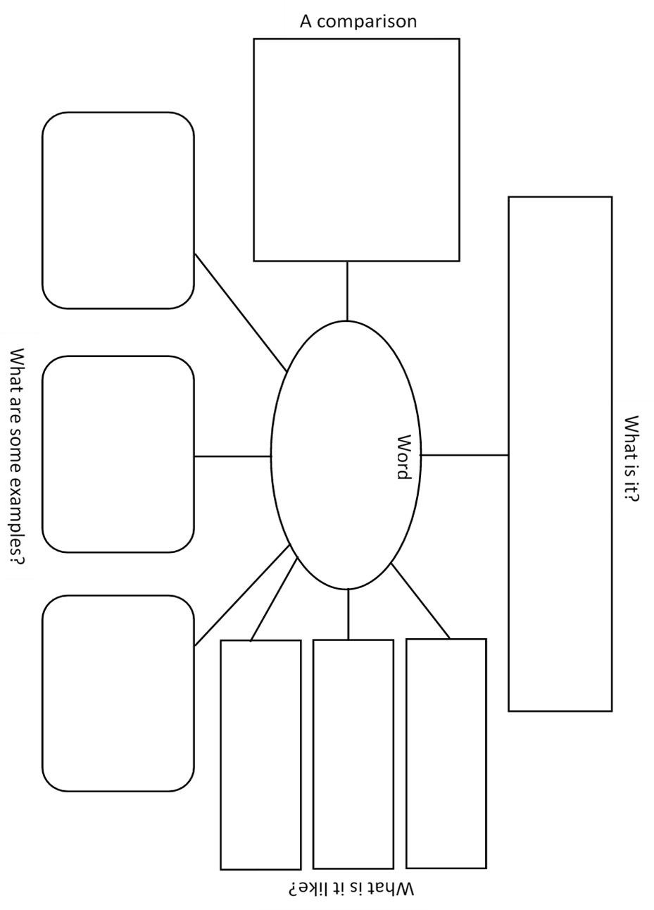
Copied under the statutory licence in s 113P of the Copyright Act.
Maureen McLaughlin and Mary Beth Allen ‘Guided Comprehension’, 2009, International reading Association. Section 113P Warning Notice.

Vocabulary map examples
(Guided Comprehension, McLaughlin & Allen, 2009)
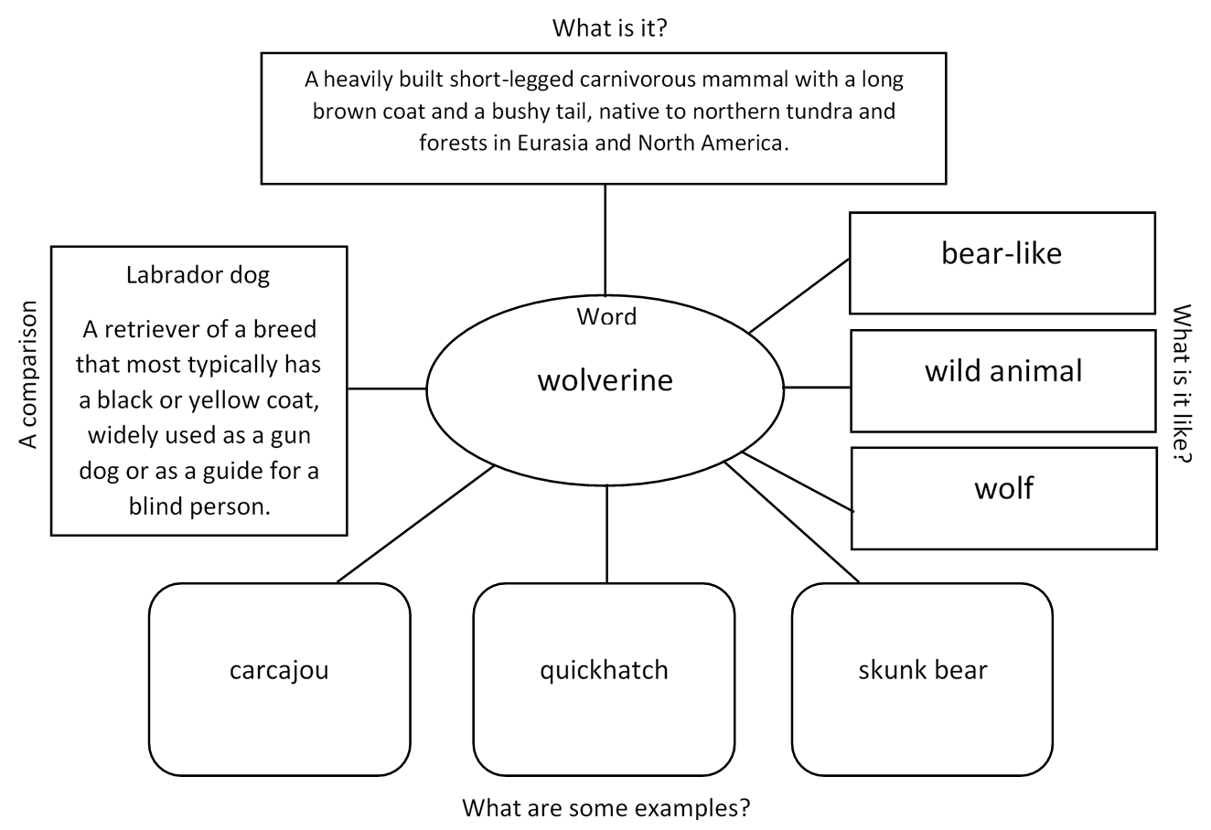
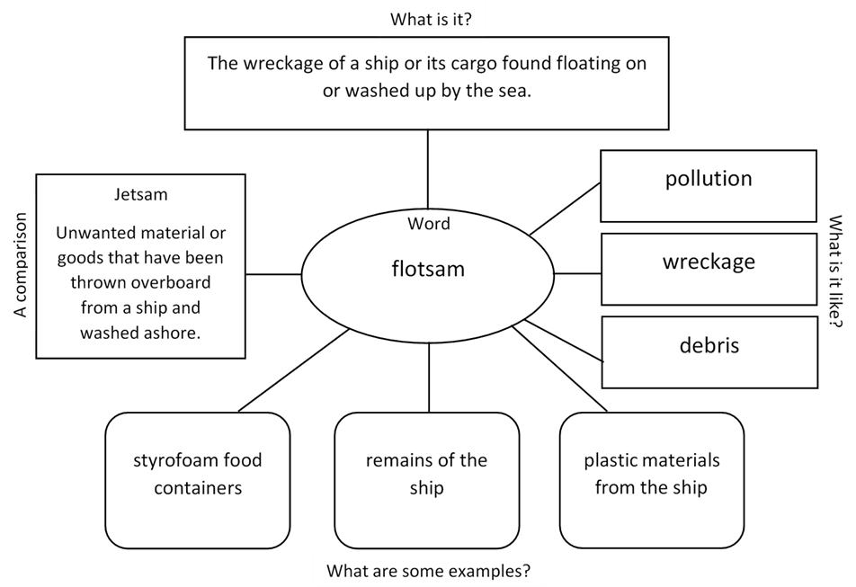
Copied under the statutory licence in s 113P of the Copyright Act.
Maureen McLaughlin and Mary Beth Allen ‘Guided Comprehension’, 2009, International reading Association. Section 113P Warning Notice.

Alternative to Vocabulary map: Word webs
Word
Definition

Synonyms
Parts of word
Part of speech
Antonym

Appendix 13

Vocabulary Check-in
- Predict vocabulary you think will be in this text. Use your background knowledge to help. | Photo by Jon Tyson
- Read the whole text, including headings, sub-headings and images. | Photo by Thought Catalog
- Re-read text and highlight any words that are repeated.  - Re-read text and highlight 6-8 words you think might be important to understand in this text – they might be technical terms or unfamiliar words. | Photo by Kasturi Roy
- Add a potential synonym above the unfamiliar words. | Photo by Brett Jordan
- Discuss with a partner the unfamiliar word and your synonym swap. Is there a more suitable option? Is the meaning maintained? | Photo by Alexis Brown
- Use a thesaurus and dictionary to help.  Add to word wall or on sticky notes to use again! | 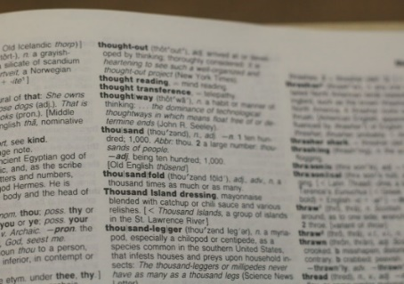Photo by Joshua Hoehne
All images: Unsplash.com

Appendix 14

Student copy: vocabulary check in text

The Starless Sea
by Erin Morgenstern (2019) Penguin Random House
Back in his den with the cocoa he settles into the beanbag chair bequeathed to him by a departing student the year before. It is a garish neon green in its natural state, but Zachary draped it with a tapestry that was too heavy to hang on the wall, camouflaging it in shades of brown and grey and violet. He aims the space heater at his legs and opens Sweet Sorrows back to the page the unreliable library lightbulb had stranded him on and begins to read.
He wonders if it will return and loop back to the previous part. Then it changes again.
Zachary Ezra Rawlins’s hands begin to shake.
Because while the first part of the book is a somewhat romantic bit about a pirate, and the second involves a ceremony with an acolyte in a strange underground library, the third part is something else entirely.
The third part is about him.
The boy is the son of the fortune-teller.
A coincidence, he thinks, but as he continues reading the details are too perfect to be fiction. Sage may permeate the shoelaces of many sons of fortune-tellers but he doubts that they also took shortcuts through alleyways on their routes home from school.
When he reaches the part about the door he puts the book down.
He feels light-headed. He stands up, worried he might pass out and thinking he might open the window and instead he kicks over his forgotten mug of cocoa.
Automatically, Zachary walks down the hall to the kitchenette to get paper towels. He mops up the cocoa and goes back to the kitchenette to throw away the sopping towels. He rinses his mug in the sink. The mug has a chip he is not certain was there before. Laughter echoes up the stairwell, far away and hollow.
Zachary returns to his room and confronts the book again, staring at it as it rests nonchalantly on the beanbag chair.
He locks his door, something he rarely does.
He picks up the book and inspects it more thoroughly than he had before. The top corner of the cover is dented, the cloth starting to fray. Tiny flecks of gold dot the spine.
Zachary takes a deep breath and opens the book again. He turns to the page where he left off and forces himself to read the words as they unfold precisely the way he expects them to.
His memory fills in the details left off the page: the way the whitewash reached halfway up the wall and then the bricks turned red again, the dumpsters at the other end of the alley, the weight of his schoolbook-stuffed backpack on his shoulder.
He has remembered that day a thousand times but this time it is different. This time his memory is guided along by the words on the page and it is clear and vibrant. As though the moment only just happened and is not more than a decade in the past.
He can picture the door perfectly. The precision of the paint. The trompe l'oeil effect he couldn't name at the time. The bee with its delicate gold stripes. The sword pointed upright toward the key.
He goes back and rereads the pages about the boy. About him.
About the place he did not find behind the door, whatever a Starless Sea is supposed to be. His hands have stopped shaking but he is light-headed and hot, he remembers now that he never opened the window but he cannot stop reading. He pushes his eyeglasses farther up the bridge of his nose so he can focus better.
He doesn’t understand. Not only how someone could have captured the scene in such detail but how it is here in a book that looks much older than he is. He rubs the paper between his fingers and it feels heavy and rough, yellowing to near brown around the edges.
Could someone have predicted him, down to his shoelaces? Does that mean the rest of it could be true? That somewhere there are tongueless acolytes in a subterranean library? It doesn’t seem fair to him to be the solitary real person in a collection of fictional characters, though he supposes the pirate and the girl could be real. Still, the very idea is so ludicrous that he laughs at himself.
He wonders if he is losing his mind and then decides that if he is able to wonder about it he probably isn’t, which isn’t particularly comforting.
He looks down at the last two words on the page.
Not yet.
Those two words swim through a thousand questions flooding his mind.
Then one of those questions floats to the surface of his thoughts, prompted by the repeated bee motif and his remembered door.
Is this book from that place?
He inspects the book again, pausing at the barcode stuck to the back cover.
Zachary looks closer, and sees that the sticker is obscuring something written or printed there. A spot of black ink peeks out from the bottom of the sticker.
He feels mildly guilty about prying it off. The barcode was faulty, anyway, and likely needs to be replaced. Not that he has any intention of returning the book, not now. He peels the sticker off slowly and carefully, trying to remove it in one piece and attempting not to rip the paper below it. It comes off easily and he sticks it to the edge of his desk before turning back to what is written below it.
There are no words, only a string of symbols that have been stamped or otherwise inscribed onto the back cover, faded and smudged but easily identifiable.
The exposed dot of ink is the hilt of a sword.
Above it is a key.
Above the key is a bee.
Zachary Ezra Rawlins stares at the miniature versions of the same symbols he once contemplated in an alleyway behind his mother’s store and wonders how, exactly, he is supposed to continue a story he didn’t know he was in.
Copied under the statutory licence in s 113P of the Copyright Act.
Erin Morgenstern ‘The Starless Sea’, 2019, Penguin Random House
Section 113P Warning Notice

