Text structure
Stage 4

Overview

Purpose
This literacy teaching strategy supports teaching and learning for Stage 4 students across all key learning areas. It targets specific literacy skills and suggests a learning sequence to build skill development. Teachers can select individual tasks, or a sequence, and embed into their teaching and learning program according to their students’ needs. While exemplar texts are provided throughout this resource, it is recommended that teachers select texts which are relevant to their students and curriculum.

Learning intention
Students will learn to identify and analyse specific structural features within different types of text.

Syllabus outcomes
The following teaching and learning strategies will assist in covering elements of the following outcomes:
- EN4-RVL-01: uses a range of personal, creative and critical strategies to read texts that are complex in their ideas and construction
- EN4-URA-01: analyses how meaning is created through the use of and response to language, forms, features and structures
- EN4-URB-01: examines and explains how texts represent ideas, experiences and values
- EN4-1A: responds to and composes texts for understanding, interpretation, critical analysis, imaginative expression and pleasure
- EN4-3B: uses and describes language forms, features and structures of texts appropriate to a range of purposes, audiences and contexts
NSW English K-10 Syllabus (2022)
Visit the Leading curriculum K-12 website for more information on the syllabus implementation timeline.

Success criteria
The following Year 7 NAPLAN item descriptors may guide teachers to co-construct success criteria for student learning.
- analyses the structure of a persuasive text
- interprets the effect of text layout in a persuasive text
- identifies the purpose of a convention on a website
- identifies supporting evidence in a persuasive text identifies the purpose of a map in an information text
- identifies the purpose of an image in an information text
- identifies the purpose of a diagram in an information text
- identifies the purpose of an introductory sentence in an information text
- identifies the main purpose of a paragraph in an information text

National Literacy Learning Progression guide

Understanding Texts (UnT9-UnT11)
Key: C=comprehension P=process V=vocabulary

UnT9
- reads and views complex texts (see Text complexity) (C)
- evaluates text features for relevance to purpose and audience (C)
- uses knowledge of a broader range of cohesive devices to track meaning (e.g. word associations) (see Grammar) (P)
- selects reading/viewing strategies appropriate to reading purpose (e.g. scans text for evidence) (P)

UnT10
- applies and articulates criteria to evaluate the language structures and features for relevance to purpose and audience (C)
- integrates automatically a range of processes such as predicting, confirming predictions, monitoring, and connecting relevant elements of the text to build meaning (P)
UnT11
- strategically adjusts the processes of reading and viewing to build meaning according to the demands of tasks and texts (P)
National Literacy Learning Progression

Evidence base
- Centre for Education Statistics and Evaluation (2017). Effective reading instruction in the early years of school, literature review.
- Oakhill, J., Cain, K. & Elbro, C. (2015). Understanding and teaching reading comprehension: A handbook. Routledge.
- Quigley, A. (2020). Closing the reading gap. Routledge.
- Scarborough, H.S. (2001). Connecting early language and literacy to later reading (dis)abilities: Evidence, theory and practice. In S. Neuman & D. Dickson (Eds.), Handbook for research in early literacy (pp. 97-110). New York, NY: Guilford Press.
Alignment to system priorities and/or needs: Five priorities for Literacy and Numeracy, Our Plan for NSW Public Education, School Excellence Policy (nsw.gov.au).
Alignment to School Excellence Framework: Learning domain: Curriculum, Teaching domain: Effective classroom practice and Professional standards
Consulted with: Strategic Delivery, Teaching Quality and Impact
Author: Literacy and Numeracy
Reviewed by: Literacy and Numeracy, Teaching Quality and Impact
Created/last updated: January 2024
Anticipated resource review date: January 2025
Feedback: Complete the online form to provide any feedback

Copyright
Section 113P Notice
Texts, Artistic Works and Broadcast Notice
Some of this material has been copied and communicated to you in accordance with the statutory licence in section 113P of the Copyright Act. Any further reproduction or communication of this material by you may be the subject of copyright protection under the Act. Do not remove this notice.

Teaching strategies
Task | Appendices
Structural features of imaginative texts | Appendix 1 - Match and sort: purpose and structural elements of narratives  Appendix 2 - Structural elements clues  Appendix 3 - Identifying features within a narrative
Analysing language and structure in an imaginative text | Appendix 4 – ‘Briar Rose’ Narrative structure activity  Appendix 5 - ‘Briar Rose’  Appendix 6 - Sequencing and temporal connectives
Structural features of informative texts | Appendix 6 - Sequencing and temporal connectives  Appendix 7 - Match and sort: purpose and structural elements of non-fiction
Structural features of persuasive texts | Appendix 8 - Analysing persuasive texts

Background information

Types of text
Classifications according to the particular purposes texts are designed to achieve. These purposes influence the characteristic features the texts employ. In general, texts can be classified as belonging to one of three types (imaginative, informative or persuasive), although it is acknowledged that these distinctions are neither static nor watertight and particular texts can belong to more than one category.

Imaginative texts
Texts that represent ideas, feelings and mental images in words or visual images. Imaginative texts entertain or provoke thought through their creative use of literary elements and make connections between ideas and experiences. These texts include novels, traditional tales, poetry, stories, plays, fiction for young adults and children, including picture books and multimodal texts such as film.

Informative texts
Texts whose primary purpose is to provide information through explanation, description, argument, analysis, ordering and presentation of evidence and procedures. These texts include texts which are valued for their informative content, as a store of knowledge and for their value as part of everyday life. These include information reports, recipes and explanatory texts.

Persuasive texts
A text designed to convince a reader of a particular opinion or way of thinking on an issue. A persuasive text may express an opinion while discussing, analysing and/or evaluating an issue. These texts include student essays, debates, arguments, discussions, polemics, advertising, propaganda, influential essays and articles.

Text structure
Predicting and recognising structure of text helps students to see the ‘big picture’ of a text, rather than focusing on just the words (Symock, S & Nicholson, T (1999) Reading Comprehension, What is it? How do you teach it? NCER Press). Recognising text structure enhances a student’s ability to comprehend and recall information (Ambruster, Anderson & Ostertag, 1989 in readingrockets.org).
The ways information is organised in different types of texts, for example chapter headings, subheadings, tables of contents, indexes and glossaries, overviews, introductory and concluding paragraphs, sequencing, topic sentences, taxonomies, cause and effect. Choices in text structures and language features together define a text type and shape its meaning (see language features).

Textual form
The conventions specific to a particular type of text, often signalling content, purpose and audience, for example letter form, drama script, blog.
‘English K-10 Syllabus © NSW Education Standards Authority (NESA) for and on behalf of the Crown in right of the State of New South Wales, 2022.’

Where to next?
- Text features
- Audience and purpose
- Main idea

Overview of teaching strategies

Purpose
These literacy teaching strategies support teaching and learning from Stage 2 to Stage 5. They are linked to NAPLAN task descriptors, syllabus outcomes and literacy and numeracy learning progressions.
These teaching strategies target specific literacy and numeracy skills and suggest a learning sequence to build skill development. Teachers can select individual tasks or a sequence to suit their students.

Access points
The resources can be accessed from:
- NAPLAN App in Scout using the teaching strategy links from NAPLAN items
- NSW Department of Education literacy and numeracy website.
What works best
Explicit teaching practices involve teachers clearly explaining to students why they are learning something, how it connects to what they already know, what they are expected to do, how to do it and what it looks like when they have succeeded. Students are given opportunities and time to check their understanding, ask questions and receive clear, effective feedback.
This resource reflects the latest evidence base and can be used by teachers as they plan for explicit teaching.
Teachers can use classroom observations and assessment information to make decisions about when and how they use this resource as they design teaching and learning sequences to meet the learning needs of their students.
Further support with What works best is available.
Differentiation
When using these resources in the classroom, it is important for teachers to consider the needs of all students, including Aboriginal and EAL/D learners.
EAL/D learners will require explicit English language support and scaffolding, informed by the EAL/D enhanced teaching and learning cycle and the student’s phase on the EAL/D Learning Progression. Teachers can access information about supporting EAL/D learners and literacy and numeracy support specific to EAL/D learners.
Learning adjustments enable students with disability and additional learning and support needs to access syllabus outcomes and content on the same basis as their peers. Teachers can use a range of adjustments to ensure a personalised approach to student learning.
Assessing and identifying high potential and gifted learners will help teachers decide which students may benefit from extension and additional challenge. Effective strategies and contributors to achievement for high potential and gifted learners helps teachers to identify and target areas for growth and improvement. A differentiation adjustment tool can be found on the High potential and gifted education website.

Using tasks across learning areas
This resource may be used across learning areas where it supports teaching and learning aligned with syllabus outcomes.
Literacy and numeracy are embedded throughout all syllabus documents as general capabilities. As the English and mathematics learning areas have a particular role in developing literacy and numeracy, NSW English and Mathematics syllabus outcomes aligned to literacy and numeracy skills have been identified.

Text selection
Example texts are used throughout this resource. Teachers can adjust activities to use texts which are linked to their unit of learning.
Further support with text selection can be found within the National Literacy Learning Progression Text Complexity appendix.
The NESA website has additional information on text requirements within the NSW English syllabus.

Teaching strategies

Structural features of imaginative texts
- Brainstorm different textural forms that fall under the imaginative text umbrella: short story, diary, novel, poetry, fairy tales, plays, picture books and so on.
- Students Think-Pair-Share what are the elements that is similar to imaginative texts: orientation, complication, resolution, dialogue, title, rising action, climax, falling action, epilogue, coda and so on. Discuss how these are clues to indicate the purpose of a text.
- Structure and layout: Students match and sort the purpose with the structural elements of narrative texts (Appendix 1 - Match and sort: purpose and structural elements of narratives). Students use these to create their own visual representation or narrative graphic organiser.
- Teacher introduces a short narrative and have students notice the title/front cover and any illustrations to predict its purpose and audience. Model skimming and scanning the text for structural clues and signal words to indicate the text is imaginative, including clues for an orientation (setting, character description), a complication (sequencing with connectives such as firstly, afterwards, in the end and temporal connectives such as in the afternoon, after he woke and so on). Have students use Appendix 2 - Structural elements clues to guide the analysis.
- Teacher displays a range of imaginative texts around the classroom (Appendix 3 - Identifying features within a narrative). Working in small groups, each group is given one of the structural elements of a narrative to then find in the displayed imaginative texts. Students colour code their structural element they have identified in the text and rotate to the next to find it again. On the final rotation, students should see a text that has been analysed. Share with whole class. Structural elements students might be allocated could be: orientation, complication, resolution, dialogue, title, rising action, climax, falling action and coda.

Analysing language and structure in an imaginative text
Students will engage with an imaginative text ‘Briar Rose’ containing language that might be contextually unfamiliar. Teachers may need to spend time building background and vocabulary knowledge to ensure students can effectively access this text. This text also has complex sentences, complex punctuation and longer passages of detailed description that some students might find challenging.
- Teacher leads a class brainstorm on fairy tales. Use the following questions to guide their thinking towards structural features as well as common genre conventions.
- Is a fairy tale persuasive, informative or imaginative?
- What makes a text imaginative?
- What is the structure of a narrative?
- Do you think all fairy tales follow a narrative structure?
- Who do you think fairy tales are written for (audience)? Why do you think this?
- What is the purpose of a fairy tale text?
- Jigsaw: In pairs, students sort the different sections into chronological order. (Appendix 4 – ‘Briar Rose’ Narrative structure activity.)
Students should be prompted to think about orientation and complication to help guide their decision making. Inform them that there might not be a resolution as this is just an extract from a larger story.
- Double Think-Pair-Share: After students have finished arranging the text, students use the think aloud strategy to answer the following questions, discussing their choices with another pair.
- How did you organise the sections? What were you looking for? (sequencing connectives/ narrative structure elements)
- How did you identify the orientation and complication? (setting description/ rising action)
- This extract has three paragraphs in total. Can you indicate (label) where the paragraphs will begin and end?
- Teacher displays the story (Appendix 5 - ‘Briar Rose’) so that students can correct/check their own arrangement.
- Teacher reads aloud the text using questioning to prompt thinking when noticing significant structural features throughout. For example, do you notice how the author uses the opening lines to engage the reader? An author would like to make a story interesting straight away so that the audience keeps reading. The first two sentences introduce/orientate me to the world of this story. The author lets me know that this story is not about ordinary people. It is about a king, queen and fairies. This immediately piques my interest because these people are very different compared to individuals I might meet in real life. The author also immediately introduces me to a complication/crisis: the king and queen are very sad because they can’t have children. This makes me wonder what they are going to do about this problem. So, the opening two sentences engage the reader by introducing them to interesting and unique characters, and by immediately revealing a complication.” Other ideas to discuss could include:
- Why does the author use the phrase ‘once upon a time’?
- What does the connecting adverb ‘however’ suggest about the king’s acceptance of the situation.
- What do you think the moral of this story might be? Do we have enough of the text to predict the coda?
- Students are each given a ‘Briar Rose’ extract (Appendix 5 - ‘Briar Rose’). Students highlight/underline and label the following structural features of an imaginative text (narrative):
- Title
- Orientation
- Complication
- Rising action
- Students to identify one structural feature/element from the text and explain how it impacted their understanding of the story. Examples:
- The ORIENTATION introduced me to the characters, setting and created interest.
- The COMPLICATION created suspense and made me curious as to what might happen next.
- The use of DIALOGUE gave me some insight about how characters were feeling and their intentions.
To increase challenge, explain to students that changing the order of events in a narrative can affect the way audiences understand and respond to the story. Using the segmented sections from the Narrative structure activity (refer to Appendix 4 above) students restructure the events in the narrative. To complete this task students are allowed to remove and add new sentences to help the story flow, however, most of the content should remain the same. For example, the story might begin when the evil fairy curses the baby. Think about the effect of starting the story here. What happens when the story is not told in chronological order? How does this alter the way the reader engages with the text? Does it create more intrigue and suspense?The teacher should make sure students are using sequencing connectives such as firstly, afterwards, in the end and temporal connectives such as in the afternoon, after she woke and so on to ensure the events are restructured in a logical manner (refer to Appendix 6 - Sequencing and temporal connectives). Students should share their new arrangements with the class when finished.

Structural features of informative texts
- Review purpose of informative texts: to explain or inform the reader with factual information. It is important to note that some informative texts will include elements from imaginative and persuasive. texts and we need to look for the overall purpose to determine the type of text and vice versa.
- Model skimming and scanning the text for structural clues and signal words (firstly, afterwards, in the end). Use a ‘think aloud’ to model the process of identifying structural elements. (refer to Appendix 6 - Sequencing and temporal connectives)
Discuss different structure and styles of nonfiction text. Students use these to classify a range of non-fiction texts linked to current unit of learning. (Appendix 7 - Match and sort: purpose and structural elements of non-fiction)
Organisation style | Features
Style 1: Description/categorisation | - The author describes the topic by listing characteristics, features and examples.  - There is a focus on one thing and its components.  - May focus on how something looks, moves, works.
Style 2: Sequence | - The author introduces items or events in numerical order or in chronological order (think a method in a recipe or science experiment).  - The author then describes the order of events or how to do or make something.
Style 3: Compare and contrast | - The author describes how 2 or more things are alike or different.
Style 4:  Cause and effect | - Effect = what happened Cause = What made it happen  - The author lists one or more causes and the resulting effect/s.  - The purpose is to explain why or how something happened, works or exists
Style 5: Problem-solution | - The author states one or more problems and one or more possible solutions.  - What’s wrong and how to fix it  - It may also include the advantages or disadvantages of each solution
Organisation style 6: Position-reason | - State an opinion, theory or hypothesis and offer evidence to support it.  - Why a point of view should be supported/what’s wrong with an idea
- Structure and layout: Students use any relevant text from a current unit of learning to match and sort the purpose with the structural elements of non-fiction texts.
- Students are given one of the structural elements of an informative text (title, description, headings and sub-headings, diagram, map, image, introductory sentence) to identify and evaluate in a range of texts linked to current unit of learning, student work samples or past NAPLAN examples which are enlarged on A3 and placed around the classroom in stations. Students are given a structural element and a coloured highlighter to colour code their structural elements of a narrative, giving detail on each rotation as to the purpose of the element in the texts. On the final rotation, students should see a text that has been analysed by all students and can discuss any discrepancies or interesting notes. Share with whole class.

Structural features of persuasive texts
- Gone in 60 seconds: A student is given sixty seconds to verbally persuade others of their point of view on a subject.
Additional task: Students are timed and stop watches stopped when ‘umm’, ‘err’ or ‘like’ (out of context) is used – the goal is to make the longest time without repetition of ideas.
- Model skimming and scanning a text for structural clues and signal words (firstly, afterwards, in the end). Use a ‘think aloud’ to model the process of identifying structural elements.
- Students are given a topic linked to current unit of learning, such as ‘the victor writes the history books’ and have students write a headline that gives an insight into what their point of view on the topic is.
- Discuss the purpose of a persuasive text: to persuade an audience to agree with a point of view or opinion. Where do we find these? What forms do they take? What clues do you look for to determine whether a text is trying to persuade or just inform? Discuss how persuasive texts can use elements of informative and imaginative texts.
- Review persuasive devices – modal language, causal connectives and conjunctions, rhetorical questions, title/headline, using references (quotes, statistics, experts) repetition and emotive language. Students are split into teams of four, with one of the elements of persuasive texts to discuss and explore, using a Frayer diagram to present their findings to the class.
For challenge: teacher provides students with a range of persuasive texts, including multi-modal texts. In pairs (from the original team of 4), students locate and evaluate the effect of any persuasive devices within their allocated texts. Then, in their group of 4, they collate their findings into a table and share with the class, discussing examples from the texts and explaining how and why authors have used devices to persuade their audience.
- Review structural elements of a persuasive text: title, opening statement, arguments, conclusion and concluding statement. Students use Appendix 8 - Analysing persuasive texts to colour code informative and persuasive elements of the text and determine overall purpose. Students provide excerpts from the text to justify their conclusions. This can be repeated with nonfiction texts linked to current unit of learning or refer to Appendix 8 - Analysing persuasive texts.

Appendix 1

Teacher copy: Match and sort imaginative texts (narrative)
Purpose of imaginative texts | To entertain and or inform
Examples of imaginative texts | Fables, legends, fantasies, folktales, plays, mysteries, myths, fiction, historical fiction
Title | A short phrase of word that captures the theme or premise of the text.
Orientation or beginning | Introduces characters, setting and background
Setting | Sets the time and place, the historical, physical and or geographical location
Characters | People, animals or other entities in the text. Minor and major. Protagonist and antagonist.
Plot | Sequence of events with an orientation and crisis or complication to be resolved.
Complication or crisis | Problem, rising action and climax – moment of high tension.
Internal conflict | A character’s struggle with themselves
External conflict | A character’s struggle with another character or situation.
Rising action | Events leading to the climax - trying to solve the problem.
Climax | Point in the story with most tension – the conflict or complication is addressed and decisive action is planned.
Falling action | Consequences or events in the story which are caused by the climax.
Resolution | Final outcome
Copied and adapted under the statutory licence in s 113P of the Copyright Act. NSW Centre for Effective Reading Comprehension Handbook. Section 113P Warning Notice

Match and sort imaginative texts (narrative)
1. Purpose of imaginative texts | A) People, animals or other entities in the text. Minor and major. Protagonist and antagonist
2. Examples of imaginative texts | B) Fables, legends, fantasies, folktales, plays, mysteries, myths, fiction, historical fiction
3. Title | C) Problem, rising action and climax – moment of high tension
4. Orientation or beginning | D) To entertain and or inform
5. Setting | E) Point in the story with most tension – the conflict or complication is addressed and decisive action is planned
6. Characters | F) A character’s struggle with themselves
7.Plot | G) Events leading to the climax - trying to solve the problem.
8. Complication or crisis | H) Sequence of events with an orientation and crisis or complication to be resolved
9. Internal conflict | I) A character’s struggle with another character or situation
10. External conflict | J) Introduces characters, setting and background
11. Rising action | K) A short phrase of word that captures the theme or premise of the text
12. Climax | L) Consequences or events in the story which are caused by the climax
13. Falling action | M) Final outcome
14. Resolution | N) Sets the time and place, the historical, physical and or geographical location
Copied and adapted under the statutory licence in s 113P of the Copyright Act. NSW Centre for Effective Reading Comprehension Handbook. Section 113P Warning Notice

Appendix 2

Structural elements clues
Structural element: | Example: | Clues to look for in the text:
Purpose of imaginative texts | People, animals or other entities in the text. Minor and major. Protagonist and antagonist
Examples of imaginative texts | Fables, legends, fantasies, folktales, plays, mysteries, myths, fiction, historical fiction
Title | Problem, rising action and climax – moment of high tension
Orientation or beginning | To entertain and or inform
Setting | Point in the story with most tension – the conflict or complication is addressed and decisive action is planned
Characters | A character’s struggle with themselves
Plot | Events leading to the climax - trying to solve the problem.
Complication or crisis | Sequence of events with an orientation and crisis or complication to be resolved
Internal conflict | A character’s struggle with another character or situation
External conflict | Introduces characters, setting and background
Rising action | A short phrase of word that captures the theme or premise of the text
Climax | Consequences or events in the story which are caused by the climax
Falling action | Final outcome
Resolution | Sets the time and place, the historical, physical and or geographical location
Copied and adapted under the statutory licence in s 113P of the Copyright Act. NSW Centre for Effective Reading Comprehension Handbook. Section 113P Warning Notice

Appendix 3

Identifying features within a narrative
The mission
I knew there had been a mistake. Although Bella had assured me that the house was empty, a dog bark, followed swiftly by unwelcome lights glimpsed between twitching curtains, suggested otherwise. I signalled to indicate it was time to abandon the operation.
We melted soundlessly into the shadows of the garden, gathering at the meeting point to consider our options. Ty was angry. ‘You have to face it, Sam. She didn’t analyse the intelligence properly,’ he seethed. ‘How could anyone make such a fundamental error again?’
‘Let’s not waste our energy blaming Bella,’ I said, asserting my authority. Ty’s negative feelings towards Bella had already threatened to disrupt the mission. I’d been in Bella’s position myself and knew: sometimes there simply wasn’t enough time to recheck intelligence. You hoped it was accurate, but sometimes hope wasn’t enough. ‘Let’s concentrate on what to do next,’ I said to the whole team while looking directly at Ty.
Organising another ‘visit’ was out of the question. We were here, the file had to be retrieved, and it was our task to do so. We needed to abandon our existing strategy and come up with something new.
Ty looked doubtful when I mentioned the idea of improvising. He was still a novice and floundered for a minute or two when operations varied from the expected. Strange, considering nothing had really gone to plan for days now. He’d learn. I quickly outlined my idea.
Ty’s expression changed from doubt to intrigue, ‘I can’t believe I’m saying this, but it might just work. It’s better than doing nothing.’
As the suburban street came alive with morning activity, we shed our night-time black, put on the uniforms, and marched boldly up to the front door to finish the job.
Year 7 NAPLAN Reading Magazine, 2015 ACARA

Identifying features within a narrative
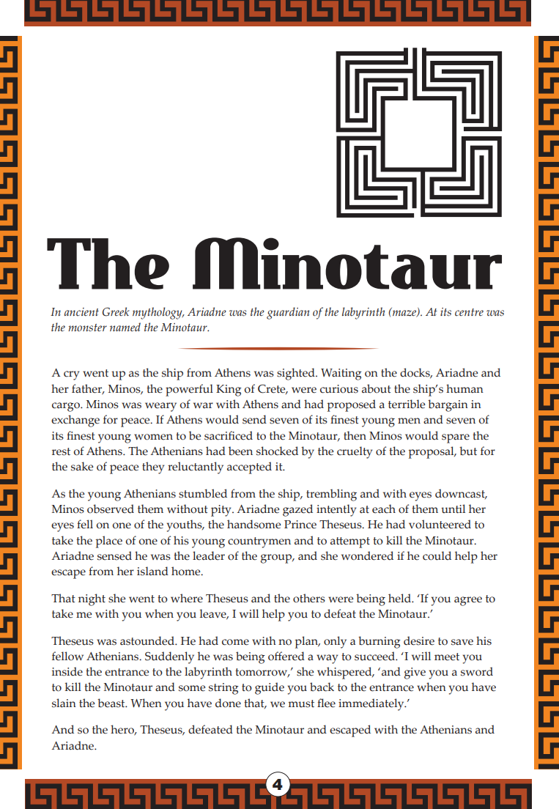
Year 7 Reading Magazine, 2015 ACARA

Identifying elements within a narrative - accessible version

The Minotaur
In ancient Greek mythology, Ariadne was the guardian of the labyrinth (maze). At its centre was the monster named the Minotaur.
A cry went up as the ship from Athens was sighted. Waiting on the docks, Ariadne and her father, Minos, the powerful King of Crete, were curious about the ship’s human cargo. Minos was weary of war with Athens and had proposed a terrible bargain in exchange for peace. If Athens would send seven of its finest young men and seven of its finest young women to be sacrificed to the Minotaur, then Minos would spare the rest of Athens. The Athenians had been shocked by the cruelty of the proposal, but for the sake of peace they reluctantly accepted it.
As the young Athenians stumbled from the ship, trembling and with eyes downcast, Minos observed them without pity. Ariadne gazed intently at each of them until her eyes fell on one of the youths, the handsome Prince Theseus. He had volunteered to take the place of one of his young countrymen and to attempt to kill the Minotaur. Ariadne sensed he was the leader of the group, and she wondered if he could help her escape from her island home.
That night she went to where Theseus and the others were being held. ‘If you agree to take me with you when you leave, I will help you to defeat the Minotaur.’
Theseus was astounded. He had come with no plan, only a burning desire to save his fellow Athenians. Suddenly he was being offered a way to succeed. ‘I will meet you inside the entrance to the labyrinth tomorrow,’ she whispered, ‘and give you a sword to kill the Minotaur and some string to guide you back to the entrance when you have slain the beast. When you have done that, we must flee immediately.’
And so the hero, Theseus, defeated the Minotaur and escaped with the Athenians and Ariadne.
Year 7 Reading Magazine, 2015 ACARA

Appendix 4
Briar Rose: Narrative structure activity
Now there were thirteen fairies in the kingdom; but as the king and queen had only twelve golden dishes for them to eat out of, they were forced to leave out one of the fairies without asking her. So twelve fairies came, each with a high red cap on her head, and red shoes with high heels on her feet, and a long white wand in her hand: and after the feast was over they gathered round in a ring and gave all their best gifts to the little princess. One gave her goodness, another beauty, another riches, and so on till she had all that was good in the world.
But one day as the queen was walking by the side of the river, at the bottom of the garden, she saw a poor little fish, that had thrown itself out of the water, and lay gasping and nearly dead on the bank. Then the queen took pity on the little fish, and threw it back again into the river; and before it swam away it lifted its head out of the water and said, ‘I know what your wish is, and it shall be fulfilled, in return for your kindness to me—you will soon have a daughter.’
Just as eleven of them had done blessing her, a great noise was heard in the courtyard, and word was brought that the thirteenth fairy was come, with a black cap on her head, and black shoes on her feet, and a broomstick in her hand: and presently up she came into the dining-hall.
However, the king hoped still to save his dear child altogether from the threatened evil; so he ordered that all the spindles in the kingdom should be bought up and burnt. But all the gifts of the first eleven fairies were in the meantime fulfilled; for the princess was so beautiful, and well behaved, and good, and wise, that everyone who knew her loved her.
What the little fish had foretold soon came to pass; and the queen had a little girl, so very beautiful that the king could not cease looking on her for joy, and said he would hold a great feast and make merry, and show the child to all the land. So he asked his kinsmen, and nobles, and friends, and neighbours. But the queen said, ‘I will have the fairies also, that they might be kind and good to our little daughter.’
A king and queen once upon a time reigned in a country a great way off, where there were in those days fairies. Now this king and queen had plenty of money, and plenty of fine clothes to wear, and plenty of good things to eat and drink, and a coach to ride out in every day: but though they had been married many years they had no children, and this grieved them very much indeed.
Now, as she had not been asked to the feast she was very angry, and scolded the king and queen very much, and set to work to take her revenge. So she cried out, ‘The king’s daughter shall, in her fifteenth year, be wounded by a spindle, and fall down dead.’
Then the twelfth of the friendly fairies, who had not yet given her gift, came forward, and said that the evil wish must be fulfilled, but that she could soften its mischief; so her gift was, that the king’s daughter, when the spindle wounded her, should not really die, but should only fall asleep for a hundred years.
Copied under the statutory licence in s 113P of the Copyright Act. Grimms' Fairy Tales, by The Brothers Grimm sourced from The Project Gutenberg EBook. Section 113P Warning Notice

Appendix 5

Briar Rose: Extract and questions

Briar Rose by The Brothers Grimm
A king and queen once upon a time reigned in a country a great way off, where there were in those days fairies. Now this king and queen had plenty of money, and plenty of fine clothes to wear, and plenty of good things to eat and drink, and a coach to ride out in every day: but though they had been married many years they had no children, and this grieved them very much indeed. But one day as the queen was walking by the side of the river, at the bottom of the garden, she saw a poor little fish, that had thrown itself out of the water, and lay gasping and nearly dead on the bank. Then the queen took pity on the little fish, and threw it back again into the river; and before it swam away it lifted its head out of the water and said, ‘I know what your wish is, and it shall be fulfilled, in return for your kindness to me—you will soon have a daughter.’ What the little fish had foretold soon came to pass; and the queen had a little girl, so very beautiful that the king could not cease looking on her for joy, and said he would hold a great feast and make merry, and show the child to all the land. So he asked his kinsmen, and nobles, and friends, and neighbours. But the queen said, ‘I will have the fairies also, that they might be kind and good to our little daughter.’ Now there were thirteen fairies in the kingdom; but as the king and queen had only twelve golden dishes for them to eat out of, they were forced to leave out one of the fairies without asking her. So twelve fairies came, each with a high red cap on her head, and red shoes with high heels on her feet, and a long white wand in her hand: and after the feast was over they gathered round in a ring and gave all their best gifts to the little princess. One gave her goodness, another beauty, another riches, and so on till she had all that was good in the world.
Just as eleven of them had done blessing her, a great noise was heard in the courtyard, and word was brought that the thirteenth fairy was come, with a black cap on her head, and black shoes on her feet, and a broomstick in her hand: and presently up she came into the dining-hall. Now, as she had not been asked to the feast she was very angry, and scolded the king and queen very much, and set to work to take her revenge. So she cried out, ‘The king’s daughter shall, in her fifteenth year, be wounded by a spindle, and fall down dead.’ Then the twelfth of the friendly fairies, who had not yet given her gift, came forward, and said that the evil wish must be fulfilled, but that she could soften its mischief; so her gift was, that the king’s daughter, when the spindle wounded her, should not really die, but should only fall asleep for a hundred years.
However, the king hoped still to save his dear child altogether from the threatened evil; so he ordered that all the spindles in the kingdom should be bought up and burnt. But all the gifts of the first eleven fairies were in the meantime fulfilled; for the princess was so beautiful, and well behaved, and good, and wise, that everyone who knew her loved her.
Copied under the statutory licence in s 113P of the Copyright Act. Grimms' Fairy Tales, by The Brothers Grimm sourced from The Project Gutenberg EBook. Section 113P Warning Notice

Appendix 6

Sequencing and temporal connectives
Sequencing Connectives | Temporal Connectives
First/ Firstly | In the afternoon
Next | Before the feast
Then | After she woke
Later | From the beginning
In the end | At the end of the day
Eventually | Last week
Now | This morning
Meanwhile | Soon afterward

Appendix 7

Match and sort: purpose and structural elements of non-fiction
Purpose | To inform
Examples | Newspaper articles, brochures, reports, explanation of how things work, magazine articles, blogs, websites, recipe, instructions.
Layout features | Titles, tables, headings, diagrams, subheadings, graphics, bold, italics, inverted commas, contents, glossary, index
Organisation | Can be organised in many structures.
Organisation style 1: Description/categorisation | - The author describes the topic by listing characteristics, features and examples.  - There is a focus on one thing and its components.  - May focus on how something looks, moves, works.
Organisation style 2: Sequence | - The author introduces items or events in numerical order or in chronological order (think a method in a recipe or science experiment).  - The author then describes the order of events or how to do something or make something.
Organisation style 3: Compare and contrast | - The author describes how 2 or more things are alike or different.
Organisation style 4:  Cause and effect | - Effect = what happened Cause = What made it happen  - The author lists one or more causes and the resulting effect/s.  - The purpose is to explain why or how something happened, works or exists
Organisation style 5: Problem-solution | - The author states one or more problems and one or more possible solution to the problem.  - What’s wrong and how to fix it  - It may also include the advantages or disadvantages of each solution
Organisation style 6: Position-reason | - State an opinion, theory or hypothesis and offer evidence to support it.  - Why a point of view should be supported/what’s wrong with an idea
Copied and adapted under the statutory licence in s 113P of the Copyright Act. NSW Centre for Effective Reading Comprehension Handbook. Section 113P Warning Notice.
Appendix 8

Analysing persuasive texts
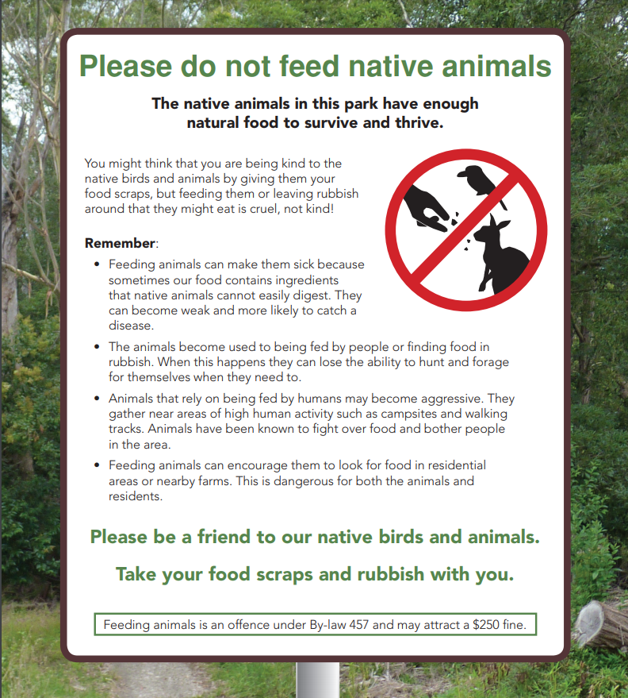
Year 7 NAPLAN Reading Magazine, 2016 ACARA

Analysing persuasive texts – accessible version

Please do not feed native animals
The native animals in this park have enough natural food to survive and thrive.
You might think that you are being kind to the native birds and animals by giving them your food scraps, but feeding them or leaving rubbish around that they might eat is cruel, not kind!
Remember:
- Feeding animals can make them sick because sometimes our food contains ingredients that native animals cannot easily digest. They can become weak and more likely to catch a disease.
- The animals become used to being fed by people or finding food in rubbish. When this happens they can lose the ability to hunt and forage for themselves when they need to.
- Animals that rely on being fed by humans may become aggressive. They gather near areas of high human activity such as campsites and walking tracks. Animals have been known to fight over food and bother people in the area.
- Feeding animals can encourage them to look for food in residential areas or nearby farms. This is dangerous for both the animals and residents.
Please be a friend to our native birds and animals.
Take your food scraps and rubbish with you.
Feeding animals is an offence under By-law 457 and may attract a $250 fine.
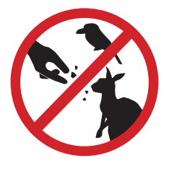
Year 7 NAPLAN Reading Magazine, 2016 ACARA

Analysing persuasive texts

Clean Up Australia website
Copied under the statutory licence in s 113P of the Copyright Act. Clean up Australia. ‘How will you step-up?’ Accessed 21/6/2021 Clean Up Australia website– Section 113P Warning Notice

Analysing persuasive texts – accessible version

Clean up Australia website
HOW WILL YOU STEP UP?
Will you make a pledge towards reducing your own waste contribution?
Could you Step Up by saying no to straws? To bringing your own water bottle? To composting? To buying recycled, to choosing not to buy fast fashion or refusing to purchase fruit and vegetables pre-wrapped in plastic?
There are so many ways to Step Up! And thousands of small steps together, make a big difference! Together we can all be part of the solution.
"We don't need a handful of people doing zero waste perfectly. We need millions of people doing it imperfectly." (Anne Marie Bonneau, the Zero-Waste Chef)
Inspire your family and friends to help make a change by sharing your personal pledge on social media and tagging @CleanUpAustralia #StepUptoCleanUp
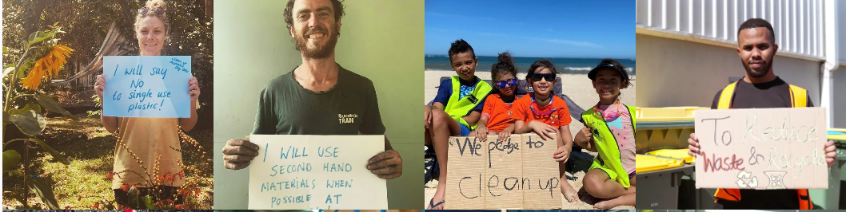
Image set 1
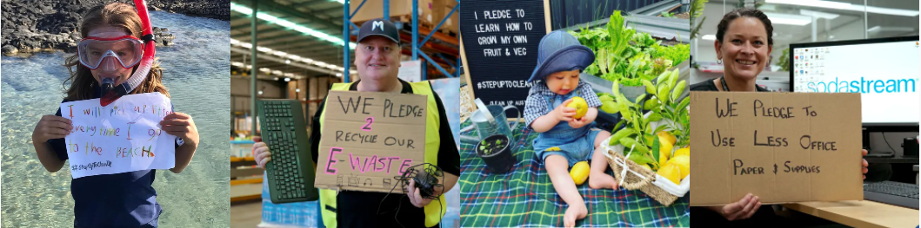
Image set 2
Copied under the statutory licence in s 113P of the Copyright Act. Clean up Australia. ‘How will you step-up?’ Accessed 21/6/2021 Clean Up Australia website– Section 113P Warning Notice

