Text features
Stage 4

Overview

Purpose
This literacy teaching strategy supports teaching and learning for Stage 4 students across all key learning areas. It targets specific literacy skills and suggests a learning sequence to build skill development. Teachers can select individual tasks, or a sequence, and embed into their teaching and learning program according to their students’ needs. While exemplar texts are provided throughout this resource, it is recommended that teachers select texts which are relevant to their students and curriculum.

Learning intention
Students will learn to identify and analyse specific language features within different types of text.

Syllabus outcomes
The following teaching and learning strategies will assist in covering elements of the following outcomes:
- EN4-RVL-01: uses a range of personal, creative and critical strategies to read texts that are complex in their ideas and construction
- EN4-URA-01: analyses how meaning is created through the use of and response to language forms, features and structures
- EN4-1A: responds to and composes texts for understanding, interpretation, critical analysis, imaginative expression and pleasure
- EN4-3B: uses and describes language forms, features and structures of texts appropriate to a range of purposes, audiences and contexts
NSW English K-10 Syllabus (2022)
Visit the Leading curriculum K-12 website for more information on the syllabus implementation timeline.

Success criteria
The following Year 7 NAPLAN item descriptors may guide teachers to co-construct success criteria for student learning.
- identifies the purpose of punctuation in a blog post
- identifies the purpose of bracketed information in an information text
- identifies the purpose of inverted commas in a narrative
- identifies the use of a persuasive device in a persuasive text
- identifies an example of modal language in an information text
- links a visual feature with information in an informative text
- sequences the order of events in an informative text
- analyses the use of persuasive devices in a persuasive text
- identifies the significance of the title using information from a narrative

Literacy Learning Progression guide

Understanding Texts (UnT9-UnT11)
Key: C=comprehension P=process V=vocabulary

UnT9
- reads and views complex texts (see Text complexity) (C)
- evaluates text features for relevance to purpose and audience (C)
- uses knowledge of a broader range of cohesive devices to track meaning (e.g. word associations) (see Grammar) (P)
- selects reading/viewing strategies appropriate to reading purpose (e.g. scans text for evidence) (P)

UnT10
- applies and articulates criteria to evaluate the language structures and features for relevance to purpose and audience (C)
- integrates automatically a range of processes such as predicting, confirming predictions, monitoring, and connecting relevant elements of the text to build meaning (P)

UnT11
- strategically adjusts the processes of reading and viewing to build meaning according to the demands of tasks and texts (P)
National Literacy Learning Progression

Evidence base
- Centre for Education Statistics and Evaluation (2017). Effective reading instruction in the early years of school, literature review.
- Oakhill, J., Cain, K. & Elbro, C. (2015). Understanding and teaching reading comprehension: A handbook. Routledge.
- Quigley, A. (2020). Closing the reading gap. Routledge.
- Scarborough, H.S. (2001). Connecting early language and literacy to later reading (dis)abilities: Evidence, theory and practice. In S. Neuman & D. Dickson (Eds.), Handbook for research in early literacy (pp. 97-110). New York, NY: Guilford Press.
Alignment to system priorities and/or needs: Five priorities for Literacy and Numeracy, Our Plan for NSW Public Education, School Excellence Policy (nsw.gov.au).
Alignment to School Excellence Framework: Learning domain: Curriculum, Teaching domain: Effective classroom practice and Professional standards
Consulted with: Strategic Delivery, Teaching Quality and Impact
Author: Literacy and Numeracy
Reviewed by: Literacy and Numeracy, Teaching Quality and Impact
Created/last updated: January 2024
Anticipated resource review date: January 2025
Feedback: Complete the online form to provide any feedback

Copyright

Section 113P Notice

Texts, Artistic Works and Broadcast Notice

Some of this material has been copied and communicated to you in accordance with the statutory licence in section 113P of the Copyright Act. Any further reproduction or communication of this material by you may be the subject of copyright protection under the Act. Do not remove this notice.

Teaching strategies
Task | Appendices
Brackets | Appendix 1 - Brackets match: student and teacher copy
Punctuation in context | Appendix 2 - Analysing punctuation in context
Font choice
Identifying features of types of text | Appendix 3 - Match and sort text features  Appendix 4 - Modelled example: Identifying text feature clues  Appendix 5 - Student copy: Identifying text feature clues
Text features analysis | Appendix 6 - Snack attack ideas

Background information
Text features are the structural or stylistic components that combine to construct meaning and achieve purpose. Text features can be recognisable as characterising particular types of texts.

Types of text
Classifications according to the particular purpose texts are designed to achieve. These purposes influence the characteristic features the texts employ. In general, texts can be classified as belonging to one of three types (imaginative, informative or persuasive), although it is acknowledged that these distinctions are neither static nor watertight, and particular texts can belong to more than one category.
- Imaginative texts - Texts that represent ideas, feelings and mental images in words or visual images. Imaginative texts entertain or provoke thought through their creative use of literary elements and make connections between ideas and experiences. These texts include novels, traditional tales, poetry, stories, plays, fiction for young adults and children, including picture books and multimodal texts such as film.
- Informative texts - Texts whose primary purpose is to provide information through explanation, description, argument, analysis, ordering and presentation of evidence and procedures. These texts include information reports, recipes and explanatory texts.
- Persuasive texts - A text designed to convince a reader of a particular opinion or way of thinking on an issue. A persuasive text may express an opinion while discussing, analysing and/or evaluating an issue. These texts include student essays, debates, arguments, discussions, polemics, advertising, propaganda, influential essays and articles.

Exclamation marks
A punctuation marker used at the end of a sentence to emphasise the emotion or feeling that is contained in the sentence. In some forms, such as personal letters, it may be used to strengthen the humorous element in a sentence, for example 'We found the cat asleep in the rubbish bin!' Exclamation marks are used at the end of sentences containing a command – Go!

Quotation marks ('...' or "...")
Punctuation markers used to indicate:
- quoted or direct speech, for example 'I am Arno's brother,' he said. A new paragraph and separate quotation marks are used for each speaker being quoted
- in formal writing, the actual words quoted from another source. For example, Shakespeare is using dramatic irony when Lady Macbeth says, 'A little water clears us of this deed.'
- the titles of poems, songs, short stories or articles, for example the well-known song, 'Waltzing Matilda'
- that attention is being drawn to an unusual or particular sense or usage of a word, for example Wombats are 'sociable' creatures.
Quotation marks are not used for the speech of characters in a drama script.

Inverted commas
Inverted commas are sometimes used around the titles of publications such as books and songs. They can also be used to draw the reader’s attention to a particular word or phrase.
Reference: English K-10 Syllabus © NSW Education Standards Authority (NESA) for and on behalf of the Crown in right of the State of New South Wales, 2012 and 2022.

Where to next?
- Purpose and audience
- Main idea
- Text structure

Overview of teaching strategies

Purpose
These literacy teaching strategies support teaching and learning from Stage 2 to Stage 5. They are linked to NAPLAN task descriptors, syllabus outcomes and literacy and numeracy learning progressions.
These teaching strategies target specific literacy and numeracy skills and suggest a learning sequence to build skill development. Teachers can select individual tasks or a sequence to suit their students.

Access points
The resources can be accessed from:
- NAPLAN App in Scout using the teaching strategy links from NAPLAN items
- NSW Department of Education Literacy and numeracy website.

What works best
Explicit teaching practices involve teachers clearly explaining to students why they are learning something, how it connects to what they already know, what they are expected to do, how to do it and what it looks like when they have succeeded. Students are given opportunities and time to check their understanding, ask questions and receive clear, effective feedback.
This resource reflects the latest evidence base and can be used by teachers as they plan for explicit teaching.
Teachers can use classroom observations and assessment information to make decisions about when and how they use this resource as they design teaching and learning sequences to meet the learning needs of their students.
Further support with What works best is available.

Differentiation
When using these resources in the classroom, it is important for teachers to consider the needs of all students, including Aboriginal and EAL/D learners.
EAL/D learners will require explicit English language support and scaffolding, informed by the EAL/D enhanced teaching and learning cycle and the student’s phase on the EAL/D Learning Progression. Teachers can access information about supporting EAL/D learners and literacy and numeracy support specific to EAL/D learners.
Learning adjustments enable students with disability and additional learning and support needs to access syllabus outcomes and content on the same basis as their peers. Teachers can use a range of adjustments to ensure a personalised approach to student learning.
Assessing and identifying high potential and gifted learners will help teachers decide which students may benefit from extension and additional challenge. Effective strategies and contributors to achievement for high potential and gifted learners helps teachers to identify and target areas for growth and improvement. A differentiation adjustment tool can be found on the High potential and gifted education website.

Using tasks across learning areas
This resource may be used across learning areas where it supports teaching and learning aligned with syllabus outcomes.
Literacy and numeracy are embedded throughout all syllabus documents as general capabilities. As the English and mathematics learning areas have a particular role in developing literacy and numeracy, NSW English and Mathematics syllabus outcomes aligned to literacy and numeracy skills have been identified.

Text selection
Example texts are used throughout this resource. Teachers can adjust activities to use texts which are linked to their unit of learning.
Further support with text selection can be found within the National Literacy Learning Progression Text complexity appendix.
The NESA website has additional information on text requirements within the NSW English syllabus.

Teaching strategies

Brackets
- Bracketed information: Teacher models reading aloud using brackets to indicate author’s voice and to add detail. It is important students hear it read as an aside to the audience:
- Matilda was the Assistant Principal (AP) of the primary school.
Brackets are used to indicate initialism.
- An Open Swimmer (1982) was written by Tim Winton.
Brackets are used to indicate the year the book was published.
- I ran to stand next to my best friend (Julie).
Brackets are used to indicate additional information.
- Discuss: Brackets and parentheses are used infrequently to separate a set of characters, a word, phrase or a sentence from those on either side. These punctuation marks show the reader the fine details. They allow the reader to hear what the author would have said if the text was being read aloud. Brackets (parentheses) are punctuation markers used to enclose an explanatory word, phrase or sentence, an aside or a commentary, for example 'She was referring to her friend (Shirley) again'. If you remove the information that is inside the parentheses, the sentence must still make sense.
The two most commonly used forms are round brackets (parentheses) ( ) and square brackets [ ].
Full stops, question marks or exclamation marks are usually put outside the brackets (unless the brackets enclose a complete sentence).
- Students complete a brackets match activity, linking definition/use and example. (Refer to Appendix 1 - Brackets match: student and teacher copy).

Punctuation in context
- Revise purpose and role of key punctuation: full stop, comma, ellipsis, colon, semi-colon, question mark and exclamation mark. Discuss when they are used and how this impacts voice and meaning when reading. Students might create a poster for each punctuation with an explanation of how it is used, when it should be used and an example.
Alternative Task: Students create a ‘This is your Life’ style 2-3 minutes skit or presentation on the punctuation mark to explain where it is found, how it is used, where it has been used throughout history, current examples, how it originated and so on.
- Students analyse Appendix 2 - Analysing punctuation in context and highlight and annotate punctuation and how it is used to impact meaning for the reader. To increase, complexity students argue for the omission of a particular punctuation mark due to its non-essential nature OR for the increased use of an essential punctuation mark.
- Think-Pair-Share: students write a short piece of dialogue using a variety of punctuation to create tone. Students read/act out their dialogue, using correct tone, then provide peer feedback. Students could change punctuation to shift tone and discuss how meaning was created/altered.

Font choice
- Review common ways to draw a reader’s attention to a word (bold, italics, underline, capital letters – refer to Stage 2 Text Features resource). Explain the author may also draw a reader’s attention to a word or phrase by using inverted commas, for example:
- This process is called ‘photosynthesis’.
Show the following sentence:
- The robot can ‘smell’ the fire and will alert the fire brigade.
Discuss: why is the word ‘smell’ in inverted commas? What does this tell the reader? Jointly construct additional examples.

Identifying features of types of text
- Review features of imaginative, informative and persuasive texts. What clues do each of these have that signal to the reader the purpose of the text? Have students work in teams to create a poster of clues or features they would expect to see in one of the three types of texts. Have students share with the class. Continue to add to team posters to help form a collective understanding.
- Students complete a match and sort activity (Appendix 3 - Match and sort text features) to match the type of text with its purpose, features and some examples.
- Teacher models using Appendix 4 - Modelled example: Identifying text feature clues to read a text and identify key features and the supporting evidence. Using a range of texts linked to current unit of learning, or using Appendix 5 - Student copy: Identifying text feature clues, students annotate texts for key and supporting evidence.

Text features analysis
- Teacher reviews features of imaginative, informative and persuasive texts. What clues do each of these have that signal to the reader the purpose of the text?
- Students are provided with a text linked to a current unit of learning, or alternatively, use fact sheet ‘Snack attack ideas’. (Appendix 6 – Snack attack ideas.)
- Students skim and scan the content, looking for text features that show it is an information text. Teacher could suggest visual elements, layout, headings and punctuation. Encourage students to use a ‘think aloud’ to explain how they scan a text for any organisational features.
- Teacher prompts students with the following questions:
- What is the purpose of the text? How do you know?
- What is the purpose of the sub-headings?
- Are there examples of technical language?
- Why has the author used brackets?
- Describe the uses of the various punctuation used.
- How has authority been brought to the text?
- Is there an opinion within the text?
- Why is some text in boxes?
- Students annotate their copy of the fact sheet using highlighters, circles, arrows.

Appendix 1

Student copy: Brackets match
Match the type of use of brackets and examples
1.Clarify meaning by providing a comment or additional information and separate information that isn't essential to the meaning of the rest of the sentence. |  | A) Students must bring pen(s), pencil(s) and writing paper with them.
2. Indicate an aside or comment revealing a character's point of view in narratives. |  | B) I love youse (sic) all!
3.Introduce an acronym, initialism or abbreviation, or the expansion of an acronym, which will be used independently later in the text. |  | C)  - My “add(ing) curry powder to taste' was different to everyone else's taste. “  - (T)he former vice president's accusations of criminal behaviour against ...
4.Enclose the name and date of a letter to the editor or an article that a writer is responding to. |  | D)  - ACARA (Australasian Curriculum Assessment and Certification Authority) has developed syllabus documents for Australia  - The Assistant Principal (AP) supports the grade.
5.Enclose optional additions |  | E) He called me shorty (he should talk!) and then offered to stack the top shelves.
6.Indicate in quotes the insertion of a word, prefix, suffix or capitalisation in order to fit the quote into the sentence so it will flow. |  | F)  - The fee for my services will be two thousand dollars ($2,000.00).  - Blueback (2004) was written by Tim Winton.
7.Use brackets around the italicised word sic (from Latin, meaning 'thus,' or 'thus it is,') to indicate that an error or peculiarity in a quotation is being reproduced exactly as it was originally said or written |  | G) The article ('Plummeting Penguin Numbers', 13/1/96) signified a dramatic shift ...
8.Use brackets around in text lists (numbers). |  | H)  - I will meet John (who went to school with me)  - ... spent rockets, redundant satellites (over 200!), metal fragments (many of which are the results of collisions) ...
9.Use brackets to enclose figures following and confirming written-out numbers, especially in legal and business documents. |  | I)  - Here are the rules: (1) Keep your room tidy, (2) do your homework, (3) be ready for school on time.  - Phone number additions and clarification (02) 5555 5555

Teacher copy: Brackets match
Clarify meaning by providing a comment or additional information and separate information that isn't essential to the meaning of the rest of the sentence. | - I will meet John (who went to school with me)  - ... spent rockets, redundant satellites (over 200!), metal fragments (many of which are the results of collisions) ...
Indicate an aside or comment revealing a character's point of view in narratives. | He called me shorty (he should talk!) and then offered to stack the top shelves.
Introduce an acronym, initialism or abbreviation, or the expansion of an acronym, which will be used independently later in the text. | - ACARA (Australian Curriculum Assessment and Certification Authority) has developed syllabus documents for Australia  - The Assistant Principal (AP) supports the grade.
Enclose the name and date of a letter to the editor or an article that a writer is responding to. | The article ('Plummeting Penguin Numbers', 13/1/96) signified a dramatic shift ...
Enclose optional additions | Students must bring pen(s), pencil(s) and writing paper with them.
Indicate in quotes the insertion of a word, prefix, suffix or capitalisation in order to fit the quote into the sentence so it will flow. | - My “add(ing) curry powder to taste' was different to everyone else's taste. “  - (T)he former vice president's accusations of criminal behaviour against ...
Use brackets around the italicised word sic (from Latin, meaning 'thus,' or 'thus it is,') to indicate that an error or peculiarity in a quotation is being reproduced exactly as it was originally said or written | - I love youse (sic) all!
Use brackets around in text lists (numbers). | - Here are the rules: (1) Keep your room tidy, (2) do your homework, (3) be ready for school on time.  - Phone number additions and clarification (02) 5555 5555
Use brackets to enclose figures following and confirming written-out numbers, especially in legal and business documents. | - The fee for my services will be two thousand dollars ($2,000.00).  - Blueback (2004) was written by Tim Winton.

Appendix 2

Analysing punctuation in context

Outside the triangle
Holly swung her school bag onto her back, feeling pleased. She liked walking home alone. Her brother Tom was staying back for football practice and her sister Trish was nowhere to be seen.
But then she heard Trish’s voice. ‘Holl-eee! Wait!’
Holly groaned. Trish arrived, panting beside her. Holly strode off, knowing that Trish would struggle to keep up.
Holly glanced at her sister; Trish had that pleading look. And sure enough …
‘Holly, you should go on Tuesday. He just … made a mistake.’
Holly flinched. Such a convenient way to put it. Just a mistake.
‘This award means a lot to him. You have to go.’
‘Really?’ said Holly, maintaining her pace.
‘Best and fairest player.’
‘So what? It’s only a school competition. You’re going to need a better reason.’
‘How about because he’s our brother?’ Trish panted.
‘He is. He’s a brother who reads his sister’s diary and shares his findings with the world.’
Trish grabbed Holly’s bag and forced her to stop. ‘You know he didn’t mean to hurt you.’
Despite her anger, Holly had to hide a smile as she turned to face her sister. Trish loved casting herself as the peacemaker but it was a role she never actually wanted to succeed in. Trish would already be rehearsing her response to Tom—‘I tried everything but Holly … she’s so stubborn …’ Holly studied Trish’s face. Yes, she was wearing the mask of the injured again.
They faced each other in silence. Images of her brother began to come unbidden into Holly’s mind: his first clumsy attempts to control the ball, his pride at being able to explain the intricate rules of the game, the hours of practice to perfect his skills.
Holly sighed. She was bored she realised; bored with the intrigues, the stupid alliances that formed and just as quickly disintegrated in their sibling trio.
What if she just stepped outside the triangle? Left them to themselves? What surprised her was that as she imagined that first step she did not feel, as she might have expected, more alone. Rather, it was as if Tom was already waiting for her outside. And suddenly it was obvious: of course she would go.
‘Actually Trish, you’re right. Let’s go to the awards night.’
‘Really?’ Holly saw the disappointment flicker across her sister’s face.
‘Sure,’ she said, resuming her walk home but more slowly now. ‘What are sisters for?’
Year 9 NAPLAN Reading Magazine, 2014 ACARA

Appendix 2

Analysing punctuation in context – accessible version

Outside the triangle
Analyse the punctuation in context:
Example from text | Punctuation | Analysis
But then she heard Trish’s voice. ‘Holl-eee! Wait!’ | Exclamation marks
Holly glanced at her sister, Trish had that pleading look. And sure enough… | ellipsis
‘He just…made a mistake.’ | ellipsis
Trish would already be rehearsing her response to Tom – ‘I tried everything but Holly…she’s so stubborn…’ | Dash/ellipsis
What if she just stepped outside the triangle? Left them to themselves? | Question marks
Year 9 NAPLAN Reading Magazine, 2014 ACARA

Identify punctuation marks and annotate how they impact a reader’s understanding – page 1

Bushfires and bushfire smoke
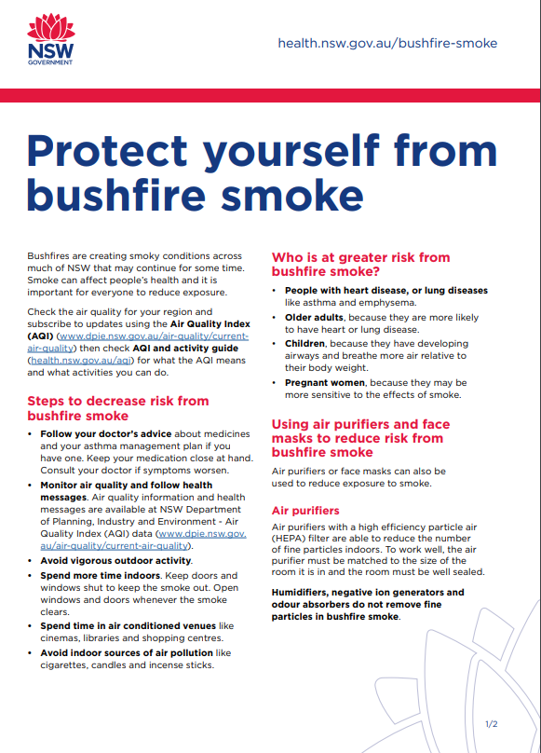

Identify punctuation marks and annotate how they impact a reader’s understanding

Bushfires and bushfire smoke – page 2
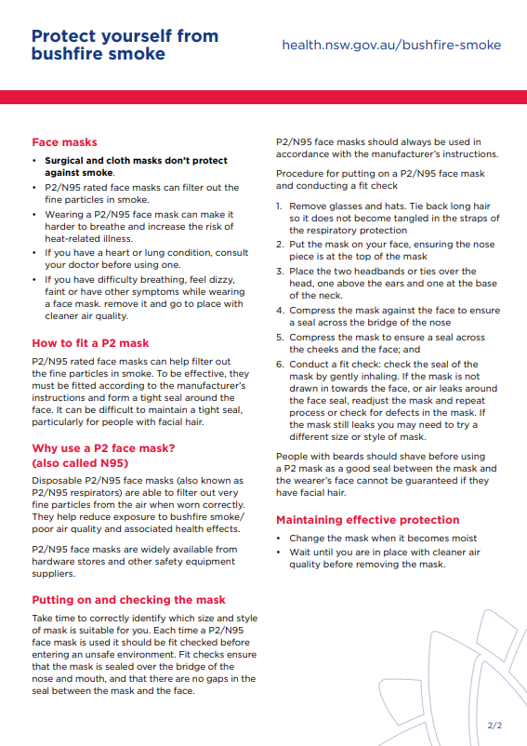
Copied under the statutory licence in s 113P of the Copyright Act. ‘Bushfires and bushfire smoke’ NSW Department of health website. Accessed March 1st, 2021. Section 113P Warning Notice

Identify punctuation marks and annotate how they impact a reader’s understanding

Bushfires and bushfire smoke - accessible version
Protect yourself from bushfire smoke.
Bushfires are creating smoky conditions across much of NSW that may continue for some time. Smoke can affect people’s health and it is important for everyone to reduce exposure.
Check the air quality for your region and subscribe to updates using the Air Quality Index (AQI) (www.dpie.nsw.gov.au/air-quality/currentair-quality) then check AQI and activity guide (health.nsw.gov.au/aqi) for what the AQI means and what activities you can do.
Steps to decrease risk from bushfire smoke
• Follow your doctor’s advice about medicines and your asthma management plan if you have one. Keep your medication close at hand. Consult your doctor if symptoms worsen.
• Monitor air quality and follow health messages. Air quality information and health messages are available at NSW Department of Planning, Industry and Environment - Air Quality Index (AQI) data (www.dpie.nsw.gov. au/air-quality/current-air-quality).
• Avoid vigorous outdoor activity.
• Spend more time indoors. Keep doors and windows shut to keep the smoke out. Open windows and doors whenever the smoke clears.
• Spend time in air conditioned venues like cinemas, libraries and shopping centres.
• Avoid indoor sources of air pollution like cigarettes, candles and incense sticks.
Who is at greater risk from bushfire smoke?
• People with heart disease, or lung diseases like asthma and emphysema.
• Older adults, because they are more likely to have heart or lung disease.
• Children, because they have developing airways and breathe more air relative to their body weight.
• Pregnant women, because they may be more sensitive to the effects of smoke.
Using air purifiers and face masks to reduce risk from bushfire smoke
Air purifiers or face masks can also be used to reduce exposure to smoke.
Air purifiers
Air purifiers with a high efficiency particle air (HEPA) filter are able to reduce the number of fine particles indoors. To work well, the air purifier must be matched to the size of the room it is in and the room must be well sealed.
Humidifiers, negative ion generators and odour absorbers do not remove fine particles in bushfire smoke.
Face masks
- Surgical and cloth masks don’t protect against smoke.
- P2/N95 rated face masks can filter out the fine particles in smoke.
- Wearing a P2/N95 face mask can make it harder to breathe and increase the risk of heat-related illness.
- If you have a heart or lung condition, consult your doctor before using one.
- If you have difficulty breathing, feel dizzy, faint or have other symptoms while wearing a face mask. remove it and go to place with cleaner air quality.
How to fit a P2 mask
P2/N95 rated face masks can help filter out the fine particles in smoke. To be effective, they must be fitted according to the manufacturer’s instructions and form a tight seal around the face. It can be difficult to maintain a tight seal, particularly for people with facial hair.
Why use a P2 face mask? (also called N95)
Disposable P2/N95 face masks (also known as P2/N95 respirators) are able to filter out very fine particles from the air when worn correctly. They help reduce exposure to bushfire smoke/ poor air quality and associated health effects.
P2/N95 face masks are widely available from hardware stores and other safety equipment suppliers.
Putting on and checking the mask
Take time to correctly identify which size and style of mask is suitable for you. Each time a P2/N95 face mask is used it should be fit checked before entering an unsafe environment. Fit checks ensure that the mask is sealed over the bridge of the nose and mouth, and that there are no gaps in the seal between the mask and the face.
P2/N95 face masks should always be used in accordance with the manufacturer’s instructions.
Procedure for putting on a P2/N95 face mask and conducting a fit check
- Remove glasses and hats. Tie back long hair so it does not become tangled in the straps of the respiratory protection
- Put the mask on your face, ensuring the nose piece is at the top of the mask
- Place the two headbands or ties over the head, one above the ears and one at the base of the neck.
- Compress the mask against the face to ensure a seal across the bridge of the nose
- Compress the mask to ensure a seal across the cheeks and the face; and
- Conduct a fit check: check the seal of the mask by gently inhaling. If the mask is not drawn in towards the face, or air leaks around the face seal, readjust the mask and repeat process or check for defects in the mask. If the mask still leaks you may need to try a different size or style of mask.
People with beards should shave before using a P2 mask as a good seal between the mask and the wearer’s face cannot be guaranteed if they have facial hair.
Maintaining effective protection
- Change the mask when it becomes moist
- Wait until you are in place with cleaner air quality before removing the mask.
Copied under the statutory licence in s 113P of the Copyright Act. ‘Bushfires and bushfire smoke’ NSW Department of health website. Accessed March 1st, 2021. Section 113P Warning Notice

Appendix 3

Match and sort features of factual texts
Factual texts inform, instruct or persuade by giving facts and information. Persuasive texts give a point of view. They are used to influence or persuade others.
Type of text | Purpose | Features | Examples or textual form
Factual description | Describes a place or thing using facts | - begins with an introductory statement  - systematically describes different aspects of the subject  - may end with a concluding statement  - Punctuation such as colons, semi-colons and hyphenated words | Description of a volcano
Factual recount | Retells events which have already happened in time order | - begins with background information (who, when, where)  - describes the series of events in time order – uses temporal connectives and conjunctions  - may end with a personal comment | Historical report
Information report | Classifies, describes and gives factual information about people, animals, things or phenomena | - begins with a general classification or definition  - lists a sequence of related information about the topic  - ends with a concluding comment  - Uses topic-specific and subject-specific language  - Punctuation such as colons, semi-colons and hyphenated words | Fact sheet about whales
Procedure | Gives instructions on how to make or do something | - begins with a statement of goal (could be the title)  - lists materials needed in order of use  - gives a series of steps (instructions) in order  - instructions usually begin with a verb in the present tense | Recipes, instructions or manuals
Procedural recount | Tells how something was made or done in time order and with accuracy | - begins with a statement of what was made or done  - tells what was made in order  - written in the past tense  - uses causal and temporal connectives | Documentaries  Science experiment
Explanation | Explains how or why something happens | - technical language and terms with definitions  - describes items related to the topic in order  - explains how items relate to each other and the topic  - may end with a concluding statement  - may include visual images, for example, flow charts  - written in the present tense  - punctuation such as colons, semi-colons and hyphenated words  - punctuation such as question marks, colons, semi-colons and hyphenated words | The life cycle of a butterfly  How gears work  Labelled diagrams
Exposition | Gives reasons for a point of view to try and convince others of it | - subjective and opinion-based  - opening statement which exposes point of view  - lists arguments- giving reasons and evidence  - uses convincing language/modality/rhetorical devices  - punctuation such as question marks, colons, semi-colons and hyphenated words | A debate  Newspaper article or letter to editor
Discussion | Gives different points of view in order to make an informed decision | - begins with background information on issue  - lists arguments for and against, giving evidence for different points of view  - conclusion might sum up both sides or recommend one point of view.  - uses devices, for example, rhetorical questions | Should trucks be banned from inner city suburbs?
NSW Department of Education, ‘School A-Z’, 2011

Match and sort features of literary texts
Literary texts entertain or elicit an emotional response by using language to create mental images.
Type of text | Purpose | Features | Examples or textual form
Literary description | Describes people, characters, places, events and things in an imaginative way | - describes characteristic features of the subject, for example, physical appearance, behaviour  - often forms parts of other writing  - uses literary devices  - extensive use of adjectives and adverbial phrases  - Punctuation such as ellipsis, exclamation marks, question marks, dashes and hyphens | Description of a character or a setting in a story
Literary recount | Retells events from novels, plays, films and personal experiences to entertain others | - begins with background information on character, time and place  - Describes the events in time order  - May end with a personal comment Temporal connectives and conjunctions, adverbial phrases | A recount of fairy tale  A humorous interpreted recount of an ordinary incident that took place.
Personal response | Gives a personal opinion on a novel, play or film, referring to parts within the passage | - Emotional language to indicate preference “I enjoyed”  - Mention what did and did not appeal and why – evidence  - May comment on features of the writing | Review of a piece of artwork
Review | Summarises analyses and assesses the appeal of a novel, play or film to a wider audience | - Subject-specific language, for example, review techniques of a director or lighting and so on  - Describes how features (character, plot, language features, humour.) may or may not appeal  - Temporal connectives and conjunctions “next, finally” | Commentary on a film, play, book
Narrative | Tells a story using a series of events | - Interesting title linked to event, time or character  - Orientation to set time, place and introduce characters  - Complication that needs to be addressed  - May contain a message for a reader  - Resolution or coda  - Uses description (adjectives, adjectival phrases, noun groups)  - Uses literary devices (simile, personification, metaphor, hyperbole and so on)  - Sequencing events with temporal connectives and conjunctions  - Usually written in first person narrator or third person.  - May use humour or satire to engage an audience and convey author perspective  - Punctuation such as ellipsis, exclamation marks, question marks, dashes and hyphens | Picture books, cartoons, mystery, fantasy, adventure, science fiction, historical fiction, fairy tales, myths, legends, fables, plays.
NSW Department of Education, ‘School A-Z’, 2011

Appendix 4

Modelled example: Identifying text feature clues
Read and annotate this text for any clues that indicate whether this is imaginative, persuasive or informative. In your annotations, identify the feature and give evidence. Use Appendix 3 to help guide annotations.
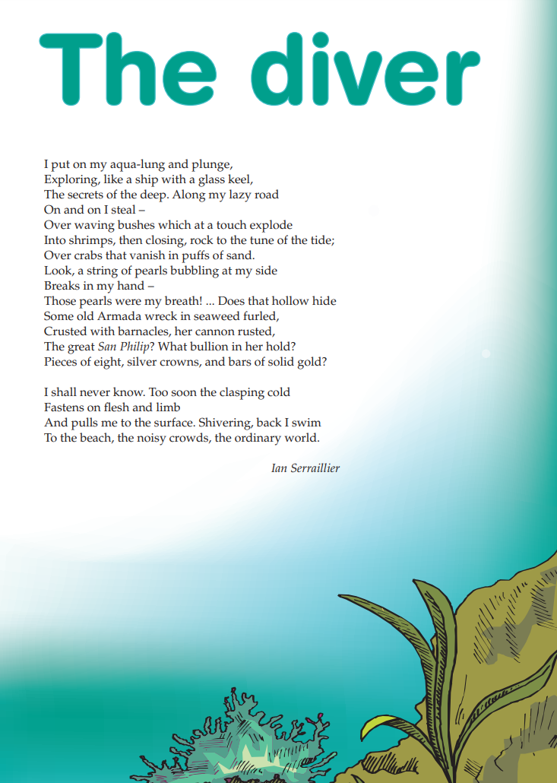
Sophisticated vocabulary
Some old Armada wreck in seaweed furled, crusted with barnacles, her cannon rusted.”
Title linked to the main character of the text. Whilst the word ‘diver’ is never used, we infer this from phrases such as “I put on my aqua-lung and plunge” and “And pulls me to the surface”.
Literary device evidence: personification.
“Along my lazy road”, “…over wavering bushes” and “...her cannon rusted.”

Structure of imaginative:
Orientation: “I put on my aqua-lung and plunge.”
Complication: “Too soon the clasping cold fastens on flesh and limb.”
Re-emerge: “…back I swim to the beach, the noisy crowds, the ordinary world.
Year 7 NAPLAN Reading Magazine, 2011 ACARA

Modelled example: Identifying text feature clues – accessible version
The diver
I put on my aqua-lung and plunge,
Exploring, like a ship with a glass keel,
The secrets of the deep. Along my lazy road
On and on I steal –
Over waving bushes which at a touch explode
Into shrimps, then closing, rock to the tune of the tide;
Over crabs that vanish in puffs of sand.
Look, a string of pearls bubbling at my side
Breaks in my hand –
Those pearls were my breath! ... Does that hollow hide
Some old Armada wreck in seaweed furled,
Crusted with barnacles, her cannon rusted,
The great San Philip? What bullion in her hold?
Pieces of eight, silver crowns, and bars of solid gold?
I shall never know. Too soon the clasping cold
Fastens on flesh and limb
And pulls me to the surface. Shivering, back I swim
To the beach, the noisy crowds, the ordinary world.
Ian Serraillier
Year 7 NAPLAN Reading Magazine, 2011 ACARA

Appendix 5

Student copy: Identifying text feature clues
Merchant, T. (2021) The hatmakers. Penguin, Australia.

Extract from ‘The Hatmakers’
It was a wild and lightning-struck night. The kind of night that changes everything.
Jagged forks of light ripped across the sky and thunder rolled in tidal waves over the rooftops and spires of London. With the rain lashing down and the clouds crashing above, it felt like the whole city was under the sea.
But Cordelia Hatmaker was not afraid. In her candle-lit room at the very top of Hatmaker House, she was pretending to be aboard the Jolly Bonnet. The ship was being tossed by massive waves as she staggered across the deck (really her hearthrug), fighting a howling wind.
BOOM.
‘Batten down those hatches, Fortescue!’ she yelled. ‘I’ve got to lash myself to the wheel!’
A tin soldier stared blankly from the mantel. ‘Aye, aye, Cap’n!’ Cordelia squeaked, out of the corner of her mouth.
BOOM.
‘Enemy fire!’ Cordelia cried, seizing the back of her wooden chair and heaving. Under her hands it became a great ship’s wheel.
BOOM.
A violent gust of wind blew the window open. The candle sputtered out and Cordelia was plunged into darkness.
BOOM, BOOM, BOOM.
Echoing up the five storeys of Hatmaker House came the sound of somebody pounding on the front door.
- - -
Cordelia scrambled down the ladder from her bedroom and galloped along the top corridor. Aunt Ariadne emerged from her chamber, wrapped in a plum-coloured velvet dressing gown. Uncle Tiberius appeared, grizzle-headed from sleep.
‘Father!’ Cordelia cried, skidding past them. ‘My father’s home!’
BOOM, BOOM, BOOM.
Cordelia raced down the spiral staircase that twisted through the middle of Hatmaker House. She hurtled past Great-aunt Petronella, snoozing in front of the flickering lilac fire in her Alchemy Parlour. She rushed past the tall doors of the Hatmaking Workshop and, deciding that sliding down the corkscrew banister would be quickest, in three heartbeats she reached the bottom floor.
Her bare feet slapped the cold tiles of the hallway. She shook her head to chase away the dizziness and ran (in not quite a straight line because she was still a little giddy) across the wide hall to the door.
Copied under the statutory licence in s 113P of the Copyright Act. T. Merchant. ‘The hatmakers’. 2021. Penguin. Section 113P Warning Notice

Student copy: Identifying text feature clues

Avatar
Below are two reviews of the science-fiction film, Avatar, written and directed by James Cameron and starring Sam Worthington.

Review 1
There’s no argument that, as a showcase for the immersive potential of 3D visual effects technology, James Cameron’s long-awaited $300 million sci-fi epic Avatar is an unqualified triumph.
But as a story designed to engage, enthral and entertain adult audiences for almost three hours, it is a major disappointment, strewn with weak characters, environmental platitudes and anti-progress clichés.
Set on the distant, forest-covered moon of Pandora, the story tells of Jake Sully (Sam Worthington), a paraplegic former marine recruited by the heavily-militarised security division of an interplanetary mining corporation that is having trouble with the natives, an aggressive blue-skinned race known as the Na’vi, who look like they have spent too long at the gym.
The lush alien world Cameron creates is a magnificent, photo-realistic landscape of multicoloured dinosaurs, waterfalls and floating mountains. But with its patronising, predictable images of noble savages, evil technology and gigantic bulldozers crunching their way through precious rainforests, the film often feels like a megalithic piece of green propaganda.
A compulsive envelope-pusher, Cameron invented ground-breaking visual processing techniques for the film, but perhaps he should have spent a little less time obsessing over the technology and a tad more developing the story beyond the compendium of clichés it regrettably is.

Review 2

The good news is that the most costly film ever made is one of the best films of the year; not because the plotting is original, but because of the sheer film-making skills, soaring imagination and technical expertise that James Cameron brings to a timeless story of good and evil.
Much in the film may not be very new (though the film is spectacularly three-dimensional, the plotting constantly threatens to lapse into two dimensions), but somehow it all works wonderfully well, thanks mainly to Cameron’s storytelling skills and to the movie’s fantastically detailed vision, including six-legged horses and futuristic war machines.
Sam Worthington acquits himself extremely well as the hero, even though he’s transformed and unrecognisable as the avatar Jake for much of the time. Stephen Lang and Giovanni Ribisi are wonderfully hissable villains. However, Avatar succeeds not so much because of its cast and narrative, but for the amazing world created by Cameron and his designers and special effects wizards.
Year 7 NAPLAN Reading Magazine (2011) ACARA.
Review 1: Adapted extract from review of ‘Avatar’ by Jim Schembri, The Age, 12 December 2009. Reproduced with permission of Jim Schembri, courtesy of The Age.
Review 2: Adapted extract from review of ‘Avatar’ by David Stratton, The Australian, 15 December 2009. Reproduced with permission of David Stratton.

Student copy: Identifying text feature clues

Curious Kids: How much does a cloud weigh?
By Rob Thomson, postdoctoral Research Scientist in Meteorology, University of Reading. The Conversation website.
We see clouds often: fluffy clouds on a nice summer's day, towering thunderstorms, wispy high clouds or even grey clouds that cover the whole sky for days.
Clouds seem to be floating in the air, which might make you think that they don't weigh very much at all — but you would be wrong.
We can use our knowledge of different types of cloud and what clouds are made of, as well as some maths, to work out how much they weigh.

Water and air
We first need to think about what clouds are made of. Clouds are actually mostly made from air, plus small water droplets (which might be frozen into small ice crystals). When we think about how much a cloud weighs, we need to measure both the weight of the water and the weight of the air.
The next question is what type of cloud we are weighing. There are lots of different types of cloud, all with their own names. The fluffy clouds that drift across the sky in summer are called cumulus clouds.
Fluffy cumulus clouds (Unsplash - Cristina Anne Costello)
To start with, we will think about that fluffy summer cloud, the cumulus cloud. A cumulus has approximately a quarter of a gram of water for every cubic metre of cloud. A quarter of a gram of water, all together, would make a drop of about the size of a marble. But really in our cubic metre there would be around 1 million drops, so they are very tiny, too small to see.

How big?
The next thing to consider is the size of the cloud. You can see how big cumulus clouds really are if you look at their shadow on the ground from a high view point on a sunny summer day.
Summer cumulus clouds vary in size, but a typical one would be about one kilometre across and about the same tall. This means we can consider it to be a cube, with each side measuring 1km across. That means our cloud is 1,000 x 1,000 x 1,000 cubic metres in size — and this makes 1 billion cubic metres.
Our cloud had only a quarter of a gram of water per cubic metre, but that's going to work out as rather a lot now there's a billion of them. The weight of the water in the cumulus cloud is 250,000,000 grams — 250 tonnes. This is about the same as two adult blue whales.
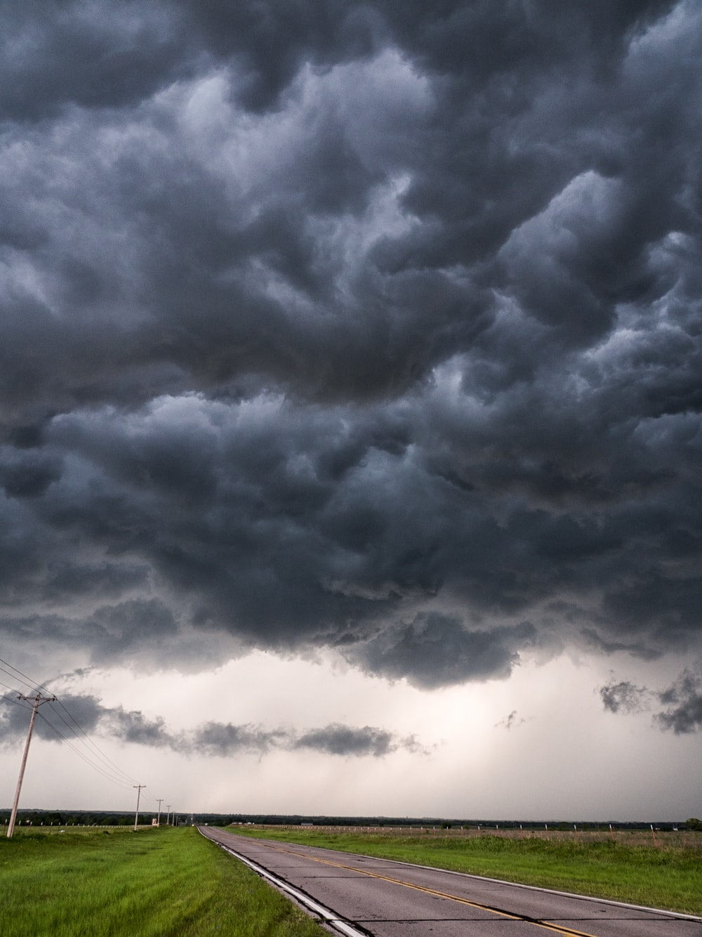
Thunderstorm clouds approaching. (Unsplash - Raychel Sanner)
What about the other cloud types? A thunderstorm cloud is bigger, measuring about 10 km tall and the same across. They also contain much more water, which is why they rain so hard: about two grams per cubic metre. Do the maths again and we have 2 million tonnes of water.
Then there's that grey sky cloud layer. This has about the same amount of water per cubic metre as the cumulus cloud, but they cover the whole sky. They are often very shallow — perhaps 200 metres thick — but they could easily be 500 km across. This makes them 50,000 times bigger than the cumulus, so that's somewhere around 10 million tonnes of water.
Finally, we need to add the weight of the water in the cloud to the weight of the air. Let us return to our summer cumulus cloud. Where these low clouds are, the air weighs around one kilogram for every cubic metre — 4,000 times more than the water did.
Given the volume of our cumulus cloud, that's 1 billion kg, or one million tonnes. That is why the cloud can stay up in the air — the tiny water drops are held up by all that air.
If we do the same maths for a thunderstorm cloud, we get one billion tonnes of air. For the grey sky cloud layer, it's 50 billion tonnes.
If we add together the weight of the water and the air in a cumulus cloud, then, it weighs a total of 1,000,250 tonnes. You could say, though, that maybe the air doesn't count as part of the cloud's weight, as it would have been there anyway. Either way, clouds are heavier than you might think.
Copied under the statutory licence in s 113P of the Copyright Act. Rob Thomson ‘Curious Kids: How much does a cloud weigh?’ July 24, 2020 . The Conversation website. Section 113P Warning Notice

Appendix 6

Snack attack ideas – page 1
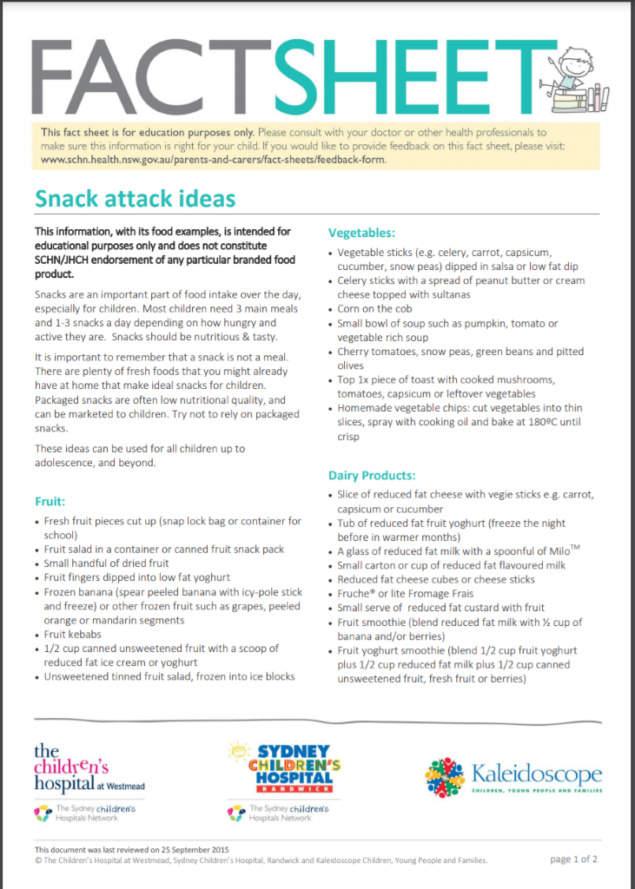

Snack attack ideas – page 2
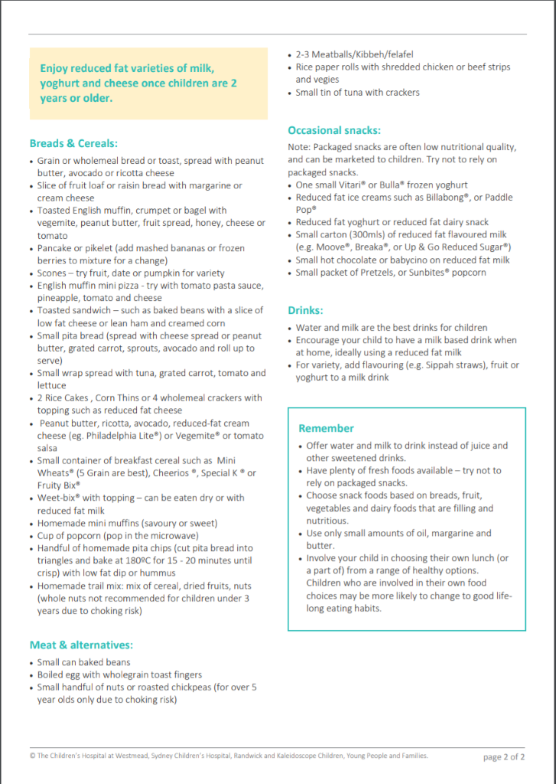
Copied under the statutory licence in s 113P of the Copyright Act. The Children’s Hospital at Westmead, Sydney Children’s Hospital, Randwick and Kaleidoscope Children, Young People and Families. ‘Food healthy snack choices factsheet.’ NSW department of health website. 2015. Section 113P Warning Notice

Snack attack ideas – accessible version

Snack attack ideas
Snacks are an important part of food intake over the day, especially for children. Most children need 3 main meals and 1-3 snacks a day depending on how hungry and active they are. Snacks should be nutritious and tasty.
It is important to remember that a snack is not a meal. There are plenty of fresh foods that you might already have at home that make ideal snacks for children.
Packaged snacks are often low nutritional quality and can be marketed to children. Try not to rely on packaged snacks.
These ideas can be used for all children up to adolescence, and beyond.

Fruit
- Fresh fruit pieces cut up (snap lock bag or container for school)
- Fruit salad in a container or canned fruit snack pack
- Small handful of dried fruit
- Fruit fingers dipped into low fat yoghurt
- Frozen banana (spear peeled banana with icy-pole stick and freeze) or other frozen fruit such as grapes, peeled orange or mandarin segments
- Fruit kebabs
- 1/2 cup canned unsweetened fruit with a scoop of reduced fat ice cream or yoghurt
- Unsweetened tinned fruit salad, frozen into ice blocks

Vegetables
- Vegetable sticks (for example, celery, carrot, capsicum, cucumber, snow peas) dipped in salsa or low fat dip
- Celery sticks with a spread of peanut butter or cream cheese topped with sultanas
- Corn on the cob
- Small bowl of soup such as pumpkin, tomato or vegetable rich soup
- Cherry tomatoes, snow peas, green beans and pitted olives
- Top 1x piece of toast with cooked mushrooms, tomatoes, capsicum or leftover vegetables
- Homemade vegetable chips: cut vegetables into thin slices, spray with cooking oil and bake at 180ºC until crisp

Dairy Products
- Slice of reduced fat cheese with vegie sticks, for example, carrot, capsicum or cucumber
- Tub of reduced fat fruit yoghurt (freeze the night before in warmer months)
- A glass of reduced fat milk with a spoonful of Milo
- Small carton or cup of reduced fat flavoured milk
- Reduced fat cheese cubes or cheese sticks
- Fruche® or lite Fromage Frais
- Small serve of reduced fat custard with fruit
- Fruit smoothie (blend reduced fat milk with ½ cup of banana and/or berries)
- Fruit yoghurt smoothie (blend 1/2 cup fruit yoghurt plus 1/2 cup reduced fat milk plus 1/2 cup canned unsweetened fruit, fresh fruit or berries)
Enjoy reduced fat varieties of milk, yoghurt and cheese once children are 2 years or older.

Breads and cereals:
- Grain or wholemeal bread or toast, spread with peanut butter, avocado or ricotta cheese
- Slice of fruit loaf or raisin bread with margarine or cream cheese
- Toasted English muffin, crumpet or bagel with vegemite, peanut butter, fruit spread, honey, cheese or tomato
- Pancake or pikelet (add mashed bananas or frozen berries to mixture for a change)
- Scones – try fruit, date or pumpkin for variety
- English muffin mini pizza - try with tomato pasta sauce, pineapple, tomato and cheese
- Toasted sandwich – such as baked beans with a slice of low fat cheese or lean ham and creamed corn
- Small pita bread (spread with cheese spread or peanut butter, grated carrot, sprouts, avocado and roll up to serve)
- Small wrap spread with tuna, grated carrot, tomato and lettuce
- 2 Rice Cakes, Corn Thins or 4 wholemeal crackers with topping such as reduced fat cheese
- Peanut butter, ricotta, avocado, reduced-fat cream cheese (for example, Philadelphia Lite®) or Vegemite® or tomato salsa
- Small container of breakfast cereal such as Mini Wheats® (5 Grain are best), Cheerios ®, Special K ® or Fruity Bix®
- Weet-bix® with topping – can be eaten dry or with reduced fat milk
- Homemade mini muffins (savoury or sweet)
- Cup of popcorn (pop in the microwave)
- Handful of homemade pita chips (cut pita bread into triangles and bake at 180ºC for 15 - 20 minutes until crisp) with low fat dip or hummus
- Homemade trail mix: mix of cereal, dried fruits, nuts (whole nuts not recommended for children under 3 years due to choking risk)

Meat and alternatives:
- Small can baked beans
- Boiled egg with wholegrain toast fingers
- Small handful of nuts or roasted chickpeas (for over 5-year olds only due to choking risk)
- 2-3 Meatballs/Kibbeh/felafel
- Rice paper rolls with shredded chicken or beef strips and vegies
- Small tin of tuna with crackers

Occasional snacks:
Note: Packaged snacks are often low nutritional quality, and can be marketed to children. Try not to rely on packaged snacks.
- One small Vitari® or Bulla® frozen yoghurt
- Reduced fat ice creams such as Billabong®, or Paddle Pop®
- Reduced fat yoghurt or reduced fat dairy snack
- Small carton (300mls) of reduced fat flavoured milk (for example, Moove®, Breaka®, or Up & Go Reduced Sugar®)
- Small hot chocolate or babycino on reduced fat milk
- Small packet of Pretzels, or Sunbites® popcorn

Drinks
- Water and milk are the best drinks for children
- Encourage your child to have a milk based drink when at home, ideally using a reduced fat milk
- For variety, add flavouring (for example, Sippah straws), fruit or yoghurt to a milk drink

Remember
- Offer water and milk to drink instead of juice and other sweetened drinks.
- Have plenty of fresh foods available – try not to rely on packaged snacks.
- Choose snack foods based on breads, fruit, vegetables and dairy foods that are filling and nutritious.
- Use only small amounts of oil, margarine and butter.
- Involve your child in choosing their own lunch (or a part of) from a range of healthy options.
Children who are involved in their own food choices may be more likely to change to good lifelong eating habits.
Copied under the statutory licence in s 113P of the Copyright Act. The Children’s Hospital at Westmead, Sydney Children’s Hospital, Randwick and Kaleidoscope Children, Young People and Families. ‘Food healthy snack choices factsheet.’ NSW department of health website. 2015. Section 113P Warning Notice

