Main idea
Stage 4

Overview

Purpose
This literacy teaching strategy supports teaching and learning for Stage 4 students across all key learning areas. It targets specific literacy skills and suggests a learning sequence to build skill development. Teachers can select individual tasks, or a sequence, and embed into their teaching and learning program according to their students’ needs. While exemplar texts are provided throughout this resource, it is recommended that teachers select texts which are relevant to their students and curriculum.

Learning intention
Students will learn to identify the main idea using the GIST process with increasingly complex imaginative, persuasive and informative texts.

Syllabus outcomes
The following teaching and learning strategies will assist in covering elements of the following outcomes:
- EN4-RVL-01: uses a range of personal, creative and critical strategies to read texts that are complex in their ideas and construction
- EN4-URA-01: analyses how meaning is created through the use of and response to language forms, features and structures
- EN4-URB-01: examines and explains how texts represent ideas, experiences and values
- EN4-1A: responds to and composes texts for understanding, interpretation, critical analysis, imaginative expression and pleasure
- EN4-2A: effectively uses a widening range of processes, skills, strategies and knowledge for responding to and composing texts in different media and technologies.
- EN4-3B: uses and describes language forms, features and structures of texts appropriate to a range of purposes, audiences and contexts.
NSW English Syllabus K-10 2022
Visit the Leading curriculum K-12 website for more information on the syllabus implementation timeline.

Success criteria
The following Year 7 NAPLAN item descriptors may guide teachers to co-construct success criteria for student learning.
- identifies a key idea in an information text
- identifies the main argument in a persuasive text
- identifies the main argument of a paragraph in a persuasive text
- identifies the main idea of a paragraph in a blog post
- identifies the man idea of a paragraph in a text
- identifies the main idea of a paragraph in an information text
- identifies the main idea of an information text
- identifies the main idea of each paragraph in an information text
- identifies the main idea of the first paragraph of an information text
- identifies the purpose of repeated language in a text

National Literacy Learning Progression guide

Understanding Texts (UnT9-UnT11)
Key: C=comprehension P=process V=vocabulary

UnT9
- reads and views complex texts (see Text complexity) (C)
- identifies the main themes or concepts in complex texts by synthesising key ideas or information (C)
- summarises the text identifying key details only (C)
- selects reading/viewing strategies appropriate to reading purpose (e.g. scans text for evidence) (P)

UnT10
- reads and views complex or some highly complex texts (See Text complexity) (C)
- interprets abstract concepts integrating complex ideas (C)
- integrates automatically a range of processes such as predicting, confirming predictions, monitoring, and connecting relevant elements of the text to build meaning (P)

UnT11
- reads and views highly complex texts (see Text complexity) (C)
- explains assumptions, beliefs and implicit values in texts (e.g. economic growth is always desirable) (C)
- strategically adjusts the processes of reading and viewing to build meaning according to the demands of tasks and texts (P)
National Literacy Learning Progression

Evidence base
- Centre for Education Statistics and Evaluation (2017). Effective reading instruction in the early years of school, literature review.
- Oakhill, J., Cain, K. & Elbro, C. (2015). Understanding and teaching reading comprehension: A handbook. Routledge.
- Quigley, A. (2020). Closing the reading gap. Routledge.
- Scarborough, H.S. (2001). Connecting early language and literacy to later reading (dis)abilities: Evidence, theory and practice. In S. Neuman & D. Dickson (Eds.), Handbook for research in early literacy (pp. 97-110). New York, NY: Guilford Press.
Alignment to system priorities and/or needs: Five priorities for Literacy and Numeracy, Our Plan for NSW Public Education, School Excellence Policy (nsw.gov.au).
Alignment to School Excellence Framework: Learning domain: Curriculum, Teaching domain: Effective classroom practice and Professional standards
Consulted with: Strategic Delivery, Teaching Quality and Impact
Author: Literacy and Numeracy
Reviewed by: Literacy and Numeracy, Teaching Quality and Impact
Created/last updated: January 2023
Anticipated resource review date: January 2025
Feedback: Complete the online form to provide any feedback
Copyright
Section 113P Notice
Texts, Artistic Works and Broadcast Notice
Some of this material has been copied and communicated to you in accordance with the statutory licence in section 113P of the Copyright Act. Any further reproduction or communication of this material by you may be the subject of copyright protection under the Act. Do not remove this notice.

Teaching strategies
Task | Appendices
What is a main idea? | Appendix 1a - Main idea, secondary ideas  Appendix 1b - Main idea, secondary ideas – accessible version  Appendix 2 - Lexical chains  Appendix 3 - Newsflash! scaffold
Identifying main idea in informative texts | Appendix 3 - Newsflash! scaffold  Appendix 4 - ‘Chooky Dancers go global’  Appendix 5 - ‘Get the GIST’ worked example  Appendix 6 - ‘Get the GIST’ student scaffold  Appendix 7 - ‘Get the GIST’ text examples
Identifying main argument in a persuasive text | Appendix 8 - Persuasive Text  Appendix 9a –Identifying argument in persuasive texts – analysis table  Appendix 9b – Identifying argument in persuasive texts – analysis table template
Generalisations and assumptions | Appendix 10a - Generalisations match-and-sort (teacher copy)  Appendix 10b – Generalisations match-and-sort (student copy)  Appendix 10c – Generalisations match template  Appendix 11 - Generalisations and assumptions match table
Identifying theme in a text | Appendix 3 - Newsflash! scaffold

Background information

Main idea
Being able to determine the main idea helps readers to recall important information. Locating the main idea and significant details helps the reader understand the points the author is attempting to express. Identifying the relationship between the main idea and significant details can improve comprehension.
Students need to develop a main idea statement based on the following information:
- who or what the paragraph is about (the topic of the paragraph, which will usually be the subject of the main idea statement).
- the most important information about the ‘who’ or ‘what’
Reference: Comprehension strategies, NSW Centre for Effective Reading (Middle Years).
To find the main idea, the following process can help students develop their understanding:
Gather background knowledge and vocabulary
Identify the topic
Summarise the text
Top and Tail sentences will often reinforce the main idea (the first and last sentences in a paragraph)

Theme
An overarching or recurring idea that describes attitudes or values that are perceived in a text. A theme may range from the understood ‘moral’ of a text to philosophical observations that the audience makes about the events, characters and experiences depicted in a text. A text may have more than one theme.
Reference: English K-10 Syllabus © NSW Education Standards Authority (NESA) for and on behalf of the Crown in right of the State of New South Wales, 2012 and 2022.

Where to next?
- Literal comprehension
- Inference
- Text structure
- Connecting ideas

Overview of teaching strategies

Purpose
These literacy teaching strategies support teaching and learning from Stage 2 to Stage 5. They are linked to NAPLAN task descriptors, syllabus outcomes and literacy and numeracy learning progressions.
These teaching strategies target specific literacy and numeracy skills and suggest a learning sequence to build skill development. Teachers can select individual tasks or a sequence to suit their students.

Access points
The resources can be accessed from:
- NAPLAN App in Scout using the teaching strategy links from NAPLAN items
- NSW Department of Education literacy and numeracy website.
What works best
Explicit teaching practices involve teachers clearly explaining to students why they are learning something, how it connects to what they already know, what they are expected to do, how to do it and what it looks like when they have succeeded. Students are given opportunities and time to check their understanding, ask questions and receive clear, effective feedback.
This resource reflects the latest evidence base and can be used by teachers as they plan for explicit teaching.
Teachers can use classroom observations and other assessment information to make decisions about when and how they use this resource as they design teaching and learning sequences to meet the learning needs of their students.
Further support with What works best is available.
Differentiation
When using these resources in the classroom, it is important for teachers to consider the needs of all students, including Aboriginal and EAL/D learners.
EAL/D learners will require explicit English language support and scaffolding, informed by the EAL/D enhanced teaching and learning cycle and the student’s phase on the EAL/D Learning Progression. Teachers can access information about supporting EAL/D learners and literacy and numeracy support specific to EAL/D learners.
Learning adjustments enable students with disability and additional learning and support needs to access syllabus outcomes and content on the same basis as their peers. Teachers can use a range of adjustments to ensure a personalised approach to student learning.
Assessing and identifying high potential and gifted learners will help teachers decide which students may benefit from extension and additional challenge. Effective strategies and contributors to achievement for high potential and gifted learners helps teachers to identify and target areas for growth and improvement. A differentiation adjustment tool can be found on the High potential and gifted education website.

Using tasks across learning areas
This resource may be used across learning areas where it supports teaching and learning aligned with syllabus outcomes.
Literacy and numeracy are embedded throughout all syllabus documents as general capabilities. As the English and mathematics learning areas have a particular role in developing literacy and numeracy, NSW English and Mathematics syllabus outcomes aligned to literacy and numeracy skills have been identified.

Text selection
Example texts are used throughout this resource. It is recommended that teachers adjust activities to use texts which are linked to their unit of learning.
Further support with text selection can be found within the National Literacy Learning Progression Text Complexity appendix.
The NESA website has additional information on text requirements within the NSW English syllabus.

Teaching strategies

What is a main idea?
- Discuss what the main idea of a text is, reinforcing the difference between main idea and supporting ideas. Explicitly model how to identify main idea and supporting ideas, using any relevant text from a current unit of learning or refer to Appendix 1 - Main idea, secondary ideas.
- Lexical chains: lexical chains are a sequence of related words in writing; these are a useful way of alerting learners to the key role that lexis has in binding a text together. Students analyse a text relevant to a current unit of learning (or refer to Appendix 2 - Lexical chains), to determine repetitive vocabulary. Using this information, students create a vocabulary mind map, and subsequently determine the main idea from this vocabulary. (For more on lexical chains refer to Stage 4 – Connecting ideas.)
- Teacher led discussion. As a class, discuss the following questions: What is the main idea of a text? What is the difference between a topic sentence and a main idea? What are some challenges of finding the main idea of a text? How could visuals support or communicate the main idea?
For example, 'The main idea is what the sentence, paragraph or whole text is about. A topic sentence includes the main idea of a paragraph and is usually the first sentence in a paragraph. Supporting ideas are outlined in following sentences. In an extended text, topic sentences may introduce different aspects of the whole text’s main idea in each new paragraph.'
- Think aloud: using the think aloud strategy and text annotations, model how to find the main idea in a text, or excerpt from a text, relevant to a current unit of learning. Note topic sentences, and, where relevant, sub-headings, images that reinforce the main idea and any supporting details for the main idea.
- Newsflash: issue students with a text excerpt or whole text relevant to a current unit of learning. (It is important that this excerpt has no heading or image.) In pairs or small groups, students identify the main idea using the ‘Newsflash’ graphic organiser (Appendix 3 - Newsflash! scaffold) to synthesise ideas. Students create a headline that summarises the main idea, locate an image that supports the main idea and identify and record any supporting details that may be essential to understand the main idea. Students present their visual representation to the class, justifying their choice of headline and image.
Headline
A succinct and catchy summary sentence of the main idea

Visual representation  An image that represents the main idea or a key element of the text | Supporting details  Dot points

Identifying main idea in informative texts
- Explicit instruction: teacher displays the informative text ‘Chooky Dancers’ (Appendix 4 - ‘Chooky Dancers go global’) and uses ‘Get the Gist’ (Appendix 5 - ‘Get the GIST’ worked example) to model the GIST process to identify the main idea of a text.
Get the GIST:
Gather information about background knowledge and key vocabulary, identifying:
1: Essential vocabulary needed to comprehend the text
2: Unfamiliar vocabulary
3: Repeated vocabulary
Identify the topic - use vocabulary to determine the main idea. Try to summarise the main idea to one word or a short phrase. For example, ‘dragonflies’ or a phrase, ‘The assassination of Archduke Franz Ferdinand.’
Summarise the text using key vocabulary.
Top and Tail sentences - check first and last sentences of each paragraph as these may reinforce the main idea.
- Students apply the GIST process to identify the main idea in a range of informative, persuasive and imaginative texts (Appendix 6 - ‘Get the GIST’ student scaffold). Teachers can use any suitable text relevant to a current unit of learning, or alternatively refer to Appendix 7 - ‘Get the GIST’ text examples.
- Gallery Walk: students add their information onto a class gallery. Students could determine the product or mode of presentation. If support is needed, use Appendix 4 - ‘Chooky Dancers go global’ as the stimulus after explicit instruction. Using the GIST mnemonic and scaffold is supportive of all learners.

Identifying main argument in persuasive texts
- Discussion: explain that information texts have main ideas and supplementary ideas, while persuasive texts have main arguments and supplementary arguments. In a persuasive text, authors try to persuade their audience to a particular way of thinking and/or to take action. For example, the writer of a feature article on the impacts of climate change might challenge an audience to reduce their carbon emissions or sign up to a climate action group, whereas the creator of an advertisement might prompt the reader to buy a particular product. A range of literary devices, such as inclusive language, personal pronouns, rhetorical questions and emotive language as well as visual devices may be used to persuade the intended audience. When exploring texts, it is important to be alert to these devices, and consider if the text is simply providing information (idea), or persuading you to think in a particular way (argument). Sometimes a writer of a persuasive text may even ‘hide’ their own argument behind an idea!
- Explicit instruction: Using a persuasive text relevant to a current unit of learning (or refer to Appendix 8 - Persuasive Text) model how to identify main and supplementary arguments and analyse how persuasive devices are used to influence an audience’s way of thinking. Using the ‘think aloud’ strategy, annotate the text and record ideas on the analysis table. (Refer to Appendix 9a - Identifying argument in persuasive texts – analysis table to support this process.)
‘Today we are going to identify the main and supplementary arguments in a persuasive text from the Clean Up Australia website. We will read through the text closely to identify how the author of this text tries to persuade us to take action and reduce waste. Let’s look at the opening heading and the first paragraph: ‘HOW WILL YOU STEP UP? Will you make a pledge towards reducing your own waste contribution?’ Initially there doesn’t seem to be an argument, it is just a couple of questions. But, these aren’t just any questions, they are rhetorical questions, which are designed to make me think about the answer. The writer is asking me to think about how I will ‘step up’, and if I will make a ‘pledge’, which is a commitment to reducing my personal waste. I also notice inclusive language. The pronouns ‘you’ and ‘your’ are used four times in two sentences. These devices are used to really persuade and pressure me to make a decision and feel responsible. The idiom ‘Step up’, is also a common phrase used to imply that you need to act to improve on your performance, which makes me feel that somehow, I am not doing enough. So, even though it doesn’t seem like there is an obvious argument in these two sentences and the author doesn’t explicitly state what they think, the author is definitely inferring that individuals need to ‘step up’ or take responsibility for their own actions and commit to reducing their waste. These persuasive devices provide some strong clues that even if the argument isn’t stated overtly, there is probably an argument ‘hidden’ in the text.’
HOW WILL YOU STEP UP?  Will you make a pledge towards reducing your own waste contribution? | Individuals need to ‘step up’ and take responsibility and commit to reducing their waste. | - Inclusive language  - Rhetorical question –appeal to persuade individuals to act.  - Personal pronouns, you, your  - Idiom ‘Step Up’ implies it is something you need to do to prove yourself.
Differentiation: after modelling the first section, the teacher guides students through an analysis of the next section of the text before students analyse the remainder of the text in pairs or independently. (Appendix 9b - Identifying argument in persuasive texts – analysis table template) Students discuss and identify both the argument and the persuasive devices used to support this argument, before sharing their ideas with the class.
For challenge: students annotate and complete an analysis table on another persuasive text relevant to a current unit of learning. Through a gallery walk, students present and justify their findings to the class.
- Provide students with a range of persuasive texts which are relevant to a current unit of learning, such as advertisements, blog posts, websites or feature articles (or refer to Appendix 8 - Persuasive Text). Students apply the GIST process (Identifying main idea in informative texts) to identify the main argument in a persuasive text. (Appendix 6 - ‘Get the GIST’ student scaffold).

Generalisations and assumptions
- Characterisation: provide and discuss examples of character behaviours/traits we might find in texts or in real life. For example, telling the truth and handing in a lost item. How could we describe this character? We can make a generalisation that the character is honest as they are behaving in a trustworthy manner.
- Discuss the meaning of generalisation. The word generalisation comes from the word general, which means the main features or elements of something, rather than exact or detailed elements. So, to make a generalisation we make a general statement about someone or something based on only a few people or things, for example, ‘most kids prefer fruit to vegetables’. We can make generalisations in both fiction and non-fiction texts. In non-fiction texts generalisations can be made by authors to support or extend on their main idea or to persuade an audience. Where the main idea might be that ‘ensuring students eat fruit and vegetables can be a struggle’, the generalisation might be ‘most children prefer fruit to vegetables’. These generalisations may need supporting evidence to be seen as valid by the reader.
- Complete Appendix 10b-Generalisations match-and-sort (student copy) with the class. This activity will support students to identify generalisations made in texts in activity 4. Teachers refer to Appendix 10a - Generalisations match-and-sort (teacher copy).
- Discuss that there are often clues or signal words that might indicate a generalisation such as: all, none, most, many, always, everyone, in general, overall, usually, sometimes, some, few and so on. These are modality words and they are used to show a level of certainty. For example, ‘most children would prefer to eat junk food over vegetables’. Modality words are excellent tools for persuasion and can be used to influence an audience’s understanding of the main idea or issue in a text.
- Display a range of short text extracts around the classroom. Students use sticky notes to summarise with dot points, find the main idea by using the GIST process (Appendix 6 - ‘Get the GIST’ student scaffold), then determine a generalisation using the signal words. Students then rotate texts and either agree or disagree with the generalisation and add a new one if there is evidence to support it. Students can record their ideas using the blank template Appendix 10c - Generalisations match.
- Discuss: are generalisations true? Can you think of a generalisation that does not apply to everyone? Are generalisations misleading? Or dangerous? Explain that authors may use generalisations to support their main ideas as a way to persuade an audience to their way of thinking. However, generalisations can lead to assumptions. An assumption is when we believe something is true or certain, without evidence. For example, if the main idea is that ‘ensuring students eat fruit and vegetables can be a struggle’, then the generalisation might be ‘most children prefer fruit to vegetables’, but the assumption may be that ‘most children are unhealthy’ or ‘most children are malnourished’. Assumptions may be based on evidence and could be accurate, but they may also be misleading and false.
- For abstraction: Think-Pair-Share. Using the ideas generated in the match-and-sort activity, make some assumptions based on the generalisation and evidence. (Appendix 11 – Assumptions table) Model the first example with students. In pairs, students complete the remainder of the examples. Then, students apply their knowledge to one of the sample texts they explored in activity 5. Students justify to the class why they made their assumption(s), citing evidence from their chosen text.

Identifying theme in a text
- Teacher explains that theme is not explicitly stated in the text, but it is the big idea about life that the writer would like to communicate to the reader. Theme refers to the central idea or one of the main underlying ideas or the moral of a text. For example, ‘family is the most important thing in life’, ‘friends are people who are kind to each other’, ‘if you work hard you will succeed’, ‘being sustainable is good for business’, ‘don’t underestimate things that you don’t know about’. Discuss some examples of themes from previously studied or known texts.
- Using any imaginative text studied from a current unit of work conduct a class brainstorm on the main idea and theme(s) of this text and the textual evidence that supports the main idea and theme. Teacher to explicitly note how recurring or repeated language may reinforce the theme and create a class word bank. For example, theme of friendship – best friends, connection, mateship, sharing.
- Think-Pair-Share: Students select another relevant text and work with a partner to identify one or more themes in that text. Students could use Appendix 3 - Newsflash! scaffold to summarise the theme and create their own word bank of repeated language.
- Teacher asks students to remember a text that they wrote last week or last month and, if possible, to find it and have it in front of them. Did the students have a main message/ theme in mind when they were writing the text? If they did, what was it and do they feel that they communicated it? Can they explain how they communicated it by discussing specific examples from their work? If they didn’t have a theme in mind when they wrote it and they look back at it now can they see a theme that emerges from their work? Can they explain this by discussing specific examples from their work? Students can work in pairs to support each other and re-read texts with fresh eyes.
For critical and creative thinking: Author hot seat. Using their own text, or a text studied in class, a student adopts the persona of the writer. The class questions the author about the main ideas and themes in their text, asking them to explain how and why they explored the theme, citing examples from the text.

Appendix 1a

Main idea, secondary ideas.
‘Teens with at least one close friend can better cope with stress than those without.’
Tracey Evans-Whipp Australian Institute of Family Studies & Constantine Gasser Australian Institute of Family Studies, November 25, 2019, theconversation.com/au.
Teenagers who have at least one close friendship are better able to bounce back from stress. This is one of the latest findings from the ‘Growing Up in Australia’ study.
‘Growing Up in Australia’ has been following the lives of around 10,000 children since 2004. In 2016, the older children in the study were aged 16–17. We asked them about aspects of their lives including their peers, school environment and mental health.
One aspect of teen well-being we looked at was resilience. This is the ability to bounce back from stressful life events and to learn and grow from them.
Stressful life events may include arguments with friends, sporting losses and disappointing test results. A more serious setback may be family breakdown, the illnesses or death of a family member, or being the victim of bullying.
Overall, teens said they displayed characteristics of resilience often, but boys significantly more so than girls. Our findings also show a strong relationship between not having a close friend and a low resilience score.

Suggested ideas:
‘Teens with at least one close friend can better cope with stress than those without.’
Teenagers who have at least one close friendship are better able to bounce back from stress. This is one of the latest findings from the Growing Up in Australia study.
Growing Up in Australia has been following the lives of around 10,000 children since 2004. In 2016, the older children in the study were aged 16–17. We asked them about aspects of their lives including their peers, school environment and mental health.
One aspect of teen well-being we looked at was resilience. This is the ability to bounce back from stressful life events and to learn and grow from them.
Stressful life events may include arguments with friends, sporting losses and disappointing test results. A more serious setback may be family breakdown, the illnesses or death of a family member, or being the victim of bullying.
Overall, teens said they displayed characteristics of resilience often, but boys significantly more so than girls. Our findings also show a strong relationship between not having a close friend and a low resilience score.
Key:
Main idea
Supporting ideas
Full text and images available at The Conversation website.
Copied under the statutory licence in s113P of the Copyright Act.
Tracey Evans-Whipp Australian Institute of Family Studies & Constantine Gasser Australian Institute of Family Studies, ‘Teens with at least one close friend can better cope with stress than those without.’ The Conversation, November 25, 2019, Section 113P Warning Notice

Appendix 1b

Main idea, secondary ideas – accessible version.
‘Teens with at least one close friend can better cope with stress than those without.’
Tracey Evans-Whipp Australian Institute of Family Studies & Constantine Gasser Australian Institute of Family Studies, November 25, 2019, theconversation.com/au
Teenagers who have at least one close friendship are better able to bounce back from stress. This is one of the latest findings from the ‘Growing Up in Australia’ study.
‘Growing Up in Australia’ has been following the lives of around 10,000 children since 2004. In 2016, the older children in the study were aged 16–17. We asked them about aspects of their lives including their peers, school environment and mental health.
One aspect of teen well-being we looked at was resilience. This is the ability to bounce back from stressful life events and to learn and grow from them.
Stressful life events may include arguments with friends, sporting losses and disappointing test results. A more serious setback may be family breakdown, the illnesses or death of a family member, or being the victim of bullying.
Overall, teens said they displayed characteristics of resilience often, but boys significantly more so than girls. Our findings also show a strong relationship between not having a close friend and a low resilience score.

Suggested ideas:
Main idea
- ‘Teenagers who have at least one close friendship are better able to bounce back from stress.’
Supporting ideas:
- ‘following the lives of around 10,000 children since 2004’
- ‘aspects of their lives including their peers, school environment and mental health’
- ‘One aspect of teen well-being we looked at was resilience’
- ‘Stressful life events may include arguments with friends, sporting losses and disappointing test results’
- ‘family breakdown, the illnesses or death of a family member, or being the victim of bullying’
- ‘boys significantly more so than girls’
- ‘strong relationship between not having a close friend and a low resilience score.’
Full text and images available at The Conversation website.
Copied under the statutory licence in s113P of the Copyright Act.
Tracey Evans-Whipp Australian Institute of Family Studies & Constantine Gasser Australian Institute of Family Studies, ‘Teens with at least one close friend can better cope with stress than those without.’ The Conversation, November 25, 2019, Section 113P Warning Notice

Appendix 2

Lexical chains

What are lost continents, and why are we discovering so many?
Maria Seton University of Sydney, Joanne Whittaker University of Tasmania & Simon Williams University of Sydney
November 25, 2019. The Conversation.
For most people, continents are Earth’s seven main large landmasses.
But geoscientists have a different take on this. They look at the type of rock a feature is made of, rather than how much of its surface is above sea level.
In the past few years, we’ve seen an increase in the discovery of lost continents. Most of these have been plateaus or mountains made of continental crust hidden from our view, below sea level.
One example is Zealandia, the world’s eighth continent that extends underwater from New Zealand.
Several smaller lost continents, called microcontinents, have also recently been discovered submerged in the eastern and western Indian Ocean.
But why, with so much geographical knowledge at our fingertips, are we still discovering lost continents in the 21st century?
We may have found another
In August, we undertook a 28-day voyage on the research vessel RV Investigator to explore a possible lost continent in a remote part of the Coral Sea. The area is home to a large underwater plateau off Queensland, called the Louisiade Plateau, which represents a major gap in our knowledge of Australia’s geology.
On one hand, it could be a lost continent that broke away from Queensland about 60 million years ago. Or it could have formed as a result of a massive volcanic eruption taking place around the same time. We’re not sure, because nobody had recovered rocks from there before - until now.
We spent about two weeks collecting rocks from this feature, and recovered a wide variety of rock types from parts of the seafloor as deep as 4,500m.
Most were formed through volcanic eruptions, but some show hints that continental rocks are hiding beneath. Lab work over the next couple of years will give us more certain answers.
Down to the details
There are many mountains and plateaus below sea level scattered across the oceans, and these have been mapped from space. They are the lighter blue areas you can see on Google Maps.
However, not all submerged features qualify as lost continents. Most are made of materials quite distinct from what we traditionally think of as continental rock, and are instead formed by massive outpourings of magma.
A good example is Iceland which, despite being roughly the size of New Zealand’s North Island, is not considered continental in geological terms. It’s made up mainly of volcanic rocks deposited over the past 18 million years, meaning it’s relatively young in geological terms.
The only foolproof way to tell the difference between massive submarine volcanoes and lost continents is to collect rock samples from the deep ocean.
Finding the right samples is challenging, to say the least. Much of the seafloor is covered in soft, gloopy sediment that obscures the solid rock beneath.
We use a sophisticated mapping system to search for steep slopes on the seafloor, that are more likely to be free of sediment. We then send a metal rock-collecting bucket to grab samples.
The more we explore and sample the depths of the oceans, the more likely we’ll be to discover more lost continents.
The ultimate lost continent
Perhaps the best known example of a lost continent is Zealandia. While the geology of New Zealand and New Caledonia have been known for some time, it’s only recently their common heritage as part of a much larger continent (which is 95% underwater) has been accepted.
This acceptance has been the culmination of years of painstaking research, and exploration of the geology of deep oceans through sample collection and geophysical surveys.
New discoveries continue to be made.
During a 2011 expedition, we discovered two lost continental fragments more than 1,000km west of Perth.
The granite lying in the middle of the deep ocean there looked similar to what you would find around Cape Leeuwin, in Western Australia.
Other lost continents
However, not all lost continents are found hidden beneath the oceans.
Some existed only in the geological past, millions to billions of years ago, and later collided with other continents as a result of plate tectonic motions.
Their only modern-day remnants are small slivers of rock, usually squished up in mountain chains such as the Himalayas. One example is Greater Adria, an ancient continent now embedded in the mountain ranges across Europe.
Due to the perpetual motion of tectonic plates, it’s the fate of all continents to ultimately reconnect with another, and form a supercontinent.
But the fascinating life and death cycle of continents is the topic of another story.
Full text and images available at The Conversation website
Copied under the statutory licence in s113P of the Copyright Act
Maria Seton, Joanne Whittaker and Simon Williams, What are lost continents, and why are we discovering so many? The Conversation, 25 November 2019. Section 113P Warning Notice

Appendix 3

Student copy: Newsflash!
Headline (a succinct and catchy version of the main idea)

Visual Representation | Supporting Details

Appendix 4

Chooky Dancers go global
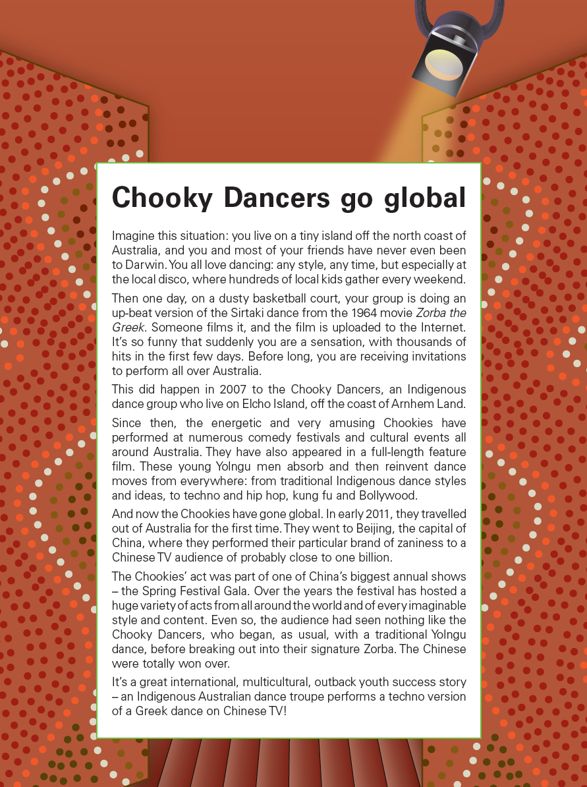
Year 7 NAPLAN Reading Magazine, 2012 ACARA

Chooky Dancers go global – accessible version
Imagine this situation: you live on a tiny island off the north coast of Australia, and you and most of your friends have never even been to Darwin. You all love dancing: any style, any time, but especially at the local disco, where hundreds of local kids gather every weekend.
Then one day, on a dusty basketball court, your group is doing an up-beat version of the Sirtaki dance from the 1964 movie Zorba the Greek. Someone films it, and the film is uploaded to the Internet. It’s so funny that suddenly you are a sensation, with thousands of hits in the first few days. Before long, you are receiving invitations to perform all over Australia.
This did happen in 2007 to the Chooky Dancers, an Indigenous dance group who live on Elcho Island, off the coast of Arnhem Land.
Since then, the energetic and very amusing Chookies have performed at numerous comedy festivals and cultural events all around Australia. They have also appeared in a full-length feature film. These young Yolngu men absorb and then reinvent dance moves from everywhere: from traditional Indigenous dance styles and ideas, to techno and hip hop, kung fu and Bollywood.
And now the Chookies have gone global. In early 2011, they travelled out of Australia for the first time. They went to Beijing, the capital of China, where they performed their particular brand of zaniness to a Chinese TV audience of probably close to one billion.
The Chookies’ act was part of one of China’s biggest annual shows – the Spring Festival Gala. Over the years the festival has hosted a huge variety of acts from all around the world and of every imaginable style and content. Even so, the audience had seen nothing like the Chooky Dancers, who began, as usual, with a traditional Yolngu dance, before breaking out into their signature Zorba. The Chinese were totally won over.
It’s a great international, multicultural, outback youth success story – an Indigenous Australian dance troupe performs a techno version of a Greek dance on Chinese TV!
Year 7 NAPLAN Reading Magazine (2012) ACARA

Appendix 5

‘Get the GIST’ Explicit instruction – worked example

Get the GIST

Gather information  background knowledge and key vocabulary:  1: Essential vocabulary  2: Unfamiliar vocabulary  3: Repeated vocabulary  Island, disco, uploaded, sensation  Perform, Indigenous, dance  Festivals, cultural events, Yolngu  traditional, global  success, upbeat version | Identify the topic  Use vocabulary to guide ideas and refine to a word or phrase. For example, ‘dragonflies’ or ‘The assassination of Archduke Franz Ferdinand’  Indigenous dance group success story  International, multicultural, outback youth success story
Summarise text using key vocabulary  An indigenous dance group has found global success  After uploading a performance, now performing globally  Perform upbeat versions of multicultural dances | Top and Tail sentences- check first and last sentences as these may reinforce main idea.  Top: Local children enjoying dancing  Tail: Invited to perform all over Australia

Main idea:
The Internet helped start the trajectory of success for a local group of Indigenous students who share their connection and love of dance and culture across the globe.

Appendix 6

Student copy: ‘Get the GIST’ student scaffold

Get the GIST

Gather information  background knowledge and key vocabulary:  1: Essential vocabulary  2: Unfamiliar vocabulary  3: Repeated vocabulary | Identify the topic  Use vocabulary to guide ideas and refine to a word or phrase. For example, ‘dragonflies’ or ‘The assassination of Archduke Franz Ferdinand’
Summarise the text using key vocabulary | Top and Tail sentences- check first and last sentences as these may reinforce main idea.

Appendix 7

‘Get the Gist’ - Text examples to find main idea
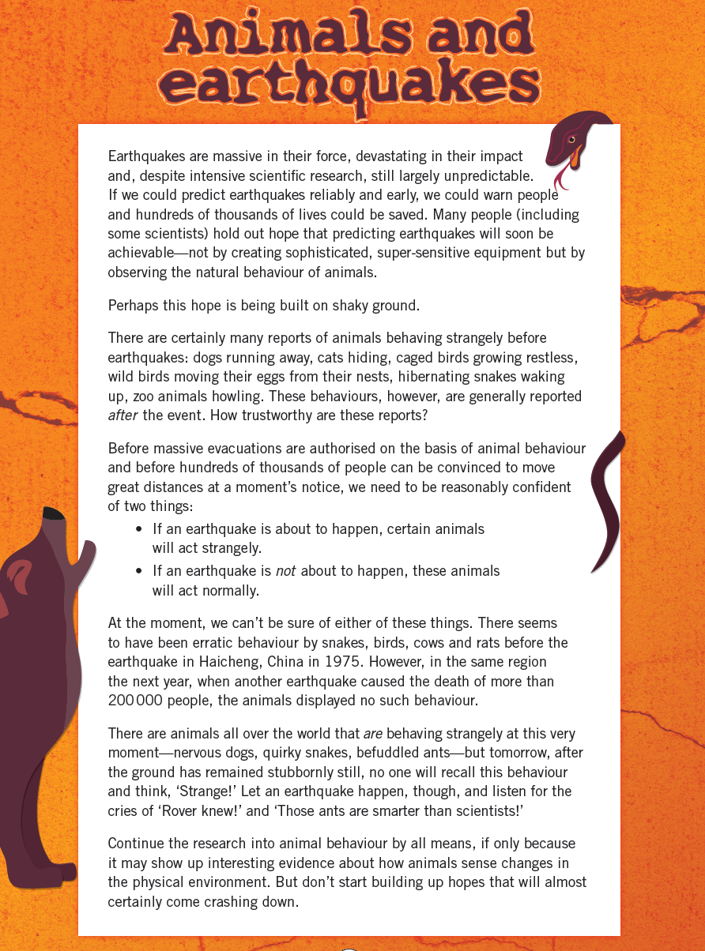
Year 7 NAPLAN Reading Magazine, 2014 ACARA

‘Get the Gist’ - Text examples to find main idea - accessible version

Animals and earthquakes
Earthquakes are massive in their force, devastating in their impact and, despite intensive scientific research, still largely unpredictable. If we could predict earthquakes reliably and early, we could warn people and hundreds of thousands of lives could be saved. Many people (including some scientists) hold out hope that predicting earthquakes will soon be achievable – not by creating sophisticates, super-sensitive equipment, but by observing the natural behaviour of animals.
Perhaps this hope is being built on shaky ground.
There are certainly many reports of animals behaving strangely before earthquakes: dogs running away, cats hiding, caged birds growing restless, wild birds moving their eggs from their nests, hibernating snakes waking up, zoo animals howling. These behaviours, however, are generally reported after the event. How trustworthy are these reports?
Before massive evacuations are authorised on the basis of animal behaviour and before hundreds of thousands of people can be convinced to move great distances at a moment’s notice, we need to be reasonably confident of two things:
- If an earthquake is about to happen, certain animals will act strangely
- If an earthquake is not about the happen, these animals will act normally.
At the moment, we can’t be sure of either of these things. There seems to have been erratic behaviour by snakes, birds, cows and rats before the earthquake in Haicheng, China in 1975. However, in the same region the next year, when another earthquake caused the death of more than 200 000 people, the animals displayed no such behaviour.
There are animals all over the world that are behaving strangely at this very moment – nervous dogs, quirky snakes, befuddled ants – but tomorrow, after the ground has remained stubbornly still, no one will recall this behaviour and think, ‘Strange!’ Let an earthquake happen, though, and listen for the cries of ‘Rover knew!’ and ‘Those ants are smarter than scientists!’
Continue the research into animal behaviour by all means, if only because it may show up interesting evidence about how animals sense changes in the physical environment. But don’t start building up hopes that will almost certainly come crashing down.
Year 7 NAPLAN Reading Magazine, 2014 ACARA

‘Get the Gist’ - Text examples to find main idea
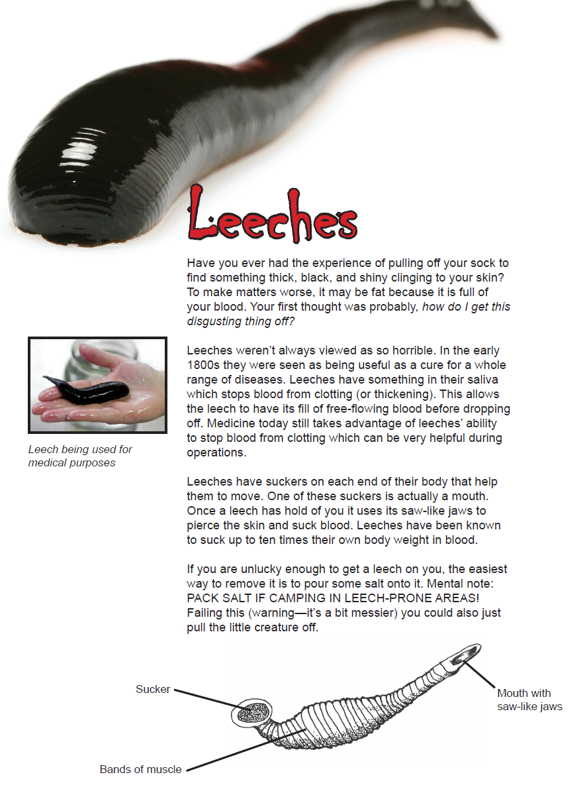
Year 7 NAPLAN Reading Magazine, 2014 ACARA

‘Get the Gist’ - Text examples to find main idea – accessible version

Leeches
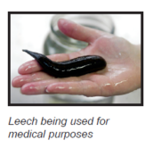
Have you ever had the experience of pulling off your sock to find something thick, black, and shiny clinging to your skin? To make matters worse, it may be fat because it is full of your blood. Your first thought was probably, how do I get this disgusting thing off?
Leeches weren’t always viewed as so horrible. In the early 1800s they were seen as being useful as a cure for a whole range of diseases. Leeches have something in their saliva which stops blood from clotting (or thickening). This allows the leech to have its fill of free-flowing blood before dropping off. Medicine today still takes advantage of leeches’ ability to stop blood from clotting which can be very helpful during operations.
Leeches have suckers on each end of their body that help them to move. One of these suckers is actually a mouth. Once a leech has hold of you it uses its saw-like jaws to pierce the skin and suck blood. Leeches have been known to suck up to ten times their own body weight in blood.
If you are unlucky enough to get a leech on you, the easiest way to remove it is to pour some salt onto it. Mental note: PACK SALT IF CAMPING IN LEECH-PRONE AREAS! Failing this (warning—it’s a bit messier) you could also just pull the little creature off
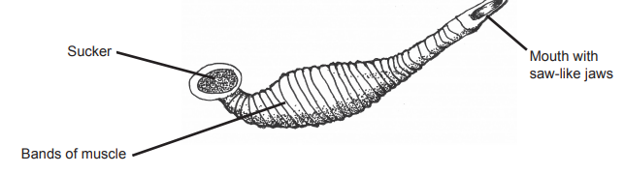Year 7 NAPLAN Reading Magazine, 2014 ACARA

‘Get the Gist’ - Text examples to find the main idea

This 17,500-year-old kangaroo in the Kimberley is Australia’s oldest Aboriginal rock painting
By Damien Finch, Andrew Gleadow, Janet Hergt The University of Melbourne & Sven Ouzman The University of Western Australia. February 22, 2021, theconversation.com/au
(Full text and images available at The Conversation.)
In Western Australia’s northeast Kimberley region, on Balanggarra Country, a two-metre-long painting of a kangaroo spans the sloping ceiling of a rock shelter above the Drysdale River.
In a paper published today in Nature Human Behaviour, we date the artwork as being between 17,500 and 17,100 years old — making it Australia’s oldest known in-situ rock painting.
We used a pioneering radiocarbon dating technique on 27 mud wasp nests underlying and overlying 16 different paintings from 8 rock shelters. We found paintings of this style were produced between 17,000 and 13,000 years ago.
Our work is part of Australia’s largest rock art dating initiative. The project is based in the Kimberley, one of the world’s premier rock art regions. Here, rock shelters have preserved galleries of paintings, often with generations of younger artwork painted over older work.
By studying the stylistic features of the paintings and the order in which they were painted when they overlap, a stylistic sequence has been developed by earlier researchers based on observations at thousands of Kimberley rock art sites.
They identified five main stylistic periods, of which the most recent is the familiar Wanjina period.
Styles in rock art
The oldest style, which includes the kangaroo painting we recently dated, often features life-sized animals in outline form, infilled with irregular dashes. Paintings in this style are said to belong to the “Naturalistic” stylistic period.
The ochre used is an iron oxide in a red-mulberry colour. Unfortunately, no current scientific dating method can determine when this paint was applied to the rock surface.
A different approach is to date fossilised insect nests or mineral accretions on the rock surfaces that happen to be overlying or underlying rock art pigment. These dates provide a maximum (underlying) or minimum (overlying) age range for the painting.
Our dating suggests the main period for Naturalistic paintings in the Kimberley spanned from at least 17,000 to 13,000 years ago.
The oldest known Australian rock painting
Very rarely, we’ll find mud wasp nests both overlying and underlying a single painting. This was the case with the painting of the kangaroo, made on the low ceiling of a well-protected Drysdale River rock shelter.
We were able to date three wasp nests underlying the painting and three nests built on top of it. With these ages, we determined confidently the painting is between 17,500 and 17,100 years old; most likely close to 17,300 years old.
Our quantitative ages support the proposed stylistic sequence that suggests the oldest Naturalistic style was followed by the Gwion style. This style featured paintings of decorated human figures, often with headdresses and holding boomerangs.
From animals and plants to people
Research we published last year shows Gwion paintings flourished about 12,000 years ago — some 1,000-5,000 years after the Naturalistic period.
With these dates, we can also partially reconstruct the environment in which the artists lived 600 generations ago. For example, much of the Naturalistic period coincided with the end of the last ice age when the environment was cooler and drier than now.
During the Naturalistic period, 17,000 years ago, sea levels were a staggering 106 metres below today’s and the Kimberley coastline was about 300 kilometres further away, more than half the distance to Timor.
Aboriginal artists at this time often chose to depict kangaroos, fish, birds, reptiles, echidnas and plants (particularly yams). As the climate warmed, ice caps melted, the monsoon was re-established, rainfall increased and sea levels rose, sometimes rapidly.
By the Gwion period around 12,000 years ago, sea levels had risen to 55m below today’s. This would undoubtedly have prompted long-term adjustment to territories and social relations.
This is when Aboriginal painters depicted highly decorated human figures, bearing a striking resemblance to early 20th-century photographs of Aboriginal ceremonial dress. While plants and animals were still painted, human figures were clearly the most popular subject.
Reaching into the past
While we now have age estimates for more paintings than ever before, more work is continuing to find out, more accurately, when each art period began and ended.
For example, one minimum age on a Gwion painting suggests it may be more than 16,000 years old. If so, Gwion art would have overlapped with the Naturalistic period but further dates are required to be more certain.
Moreover, it’s highly unlikely the oldest known Naturalistic painting we dated is the oldest surviving one. Future research will almost certainly locate even older works.
For now, however, the 17,300-year-old kangaroo is a sight to marvel at.
Acknowledgements: we would like to thank the Balanggarra Aboriginal Corporation, the Australian National Science and Technology Organisation, Rock Art Australia and Dunkeld Pastoral Co for their collaboration on this work.
Copied under the statutory licence in s113P of the Copyright Act
Damien Finch, Andrew Gleadow, Janet Hergt & Sven Ouzman, This 17500 year old kangaroo in the Kimberley is Australia’s oldest Aboriginal rock painting The Conversation, 22 February 2021.
Section 113P Warning Notice

‘Get the Gist’ - Text examples to find the main idea
Great Moments in Science with Dr Karl Kruszelnicki, 'Bacteria of Champions' (transcript), ABC Radio, 5 November 2019
Dr Karl: G'day, Dr Karl here.
Now if you've been following the latest trends in Science for a while, you might remember that about a decade ago, there was a sudden spike of interest in gut bacteria. We had begun to realise just how important the bacteria that live on us, and inside us, actually were.
And now, the latest surprising research suggests that these gut bacteria can even help you win a marathon!
But first, a bit of background.
You probably know by now that you started off when an egg cell was fertilized by a sperm cell. And by now, there are about 37 trillion cells in your body that all arose from that first fertilized egg cell! Now 37 trillion is a lot of cells -- but your body is also home to even more bacterial cells! That's right - about 40 trillion bacteria live on your skin, inside your gut, and in a few other places. These bacteria are a lot smaller than your human cells, so in total, they weigh only a kilogram or so.
Now don't fall for the misguided propaganda that all bacteria are evil, and should be killed.
No, these bacteria on and inside you are mostly your friends, and are often absolutely essential for your good health. If you had absolutely no bacteria in your gut at all, you would probably eat twice as much food, weigh about two-thirds as much, and you would be very sickly and weak, with a much-impaired immune system. You need these guys!
So now back to our marathon runners. How can gut bacteria help marathon runners run faster? The answer is that these athletes have slightly different gut bacteria from regular people, and these special bacteria give them an energy boost.
To understand this, you need to know a little bit about how you get energy, and how this energy is carried around.
In your body, the energy molecule is called ATP, which stands for Adenosine TriPhosphate.
Whenever you blink an eyelid, or make some urine with your kidneys, or move your leg muscles, you burn up some ATP.
In this process, you turn Adenosine TriPhosphate (with three Phosphates) into the less energetic version - Adenosine DiPhosphate (with just two Phosphates). And then, inside your cells, the low energy ADP is recycled back into the high energy version, ATP.
At any given moment, you are carrying about one quarter of a kilogram of ATP, scattered across your body.
But it's continually being broken down to ADP to provide energy, and shortly after, is then built up to ATP again. The cycle is continuous, for every single second that you are alive -- even when you're asleep. Over a whole day, you will break down, and then rebuild, some 40 kilograms of ATP.
And where does the external energy come from, to rebuild your ATP? Mostly, from the sugars in the food that you eat.
Now suppose that you have a nice robust blood supply that can deliver lots of oxygen to the muscles in your legs. Then you can use one molecule of glucose and six molecules of oxygen to change 36 molecules of low-energy ADP into high-energy ATP. Along the way you make 6 molecules of carbon dioxide, which you breathe out.
But if your blood vessels and lungs can't deliver quite enough oxygen, one molecule of glucose gets turned into just two lousy molecules of ATP -- not 36. And even worse, instead of making 6 molecules of carbon dioxide, you make two molecules of lactic acid, which can give the burning sensation of lactic acidosis in your muscles.
Now having lactic acid in your blood stream is usually only a disadvantage, and never an advantage.
But in elite marathon champions it can have an upside.
As well as affecting your muscles, lactic acid can leave the blood stream and do a little tour of duty of the gut. And this is where it helps marathon runners out.
Compared to average sedentary humans, marathon runners have lots more of a special type of unusual bacteria, called Veillonella, in their gut. These bacteria break down the lactic acid, and turn it into fatty acids - which in turn can be used to make more energy in the lungs and the legs.
So these gut bacteria actually give extra energy to the athletes.
Now we're not exactly sure yet which came first -- did having Veillonella bacteria give the marathon runners an extra advantage, or was it the hard training that flooded the gut with lactic acid, which the Veillonella bacteria came to eat.
One thing is for sure -- we're just beginning to understand all the things those 40 trillion bacteria living in and on us do. Especially the ones in the gut.
Who'd have thought there was so much to learn from our poo.

Copied under the statutory licence in s 113P of the Copyright Act
Great Moments in Science with Dr Karl Kruszelnicki, 'Bacteria of Champions' (transcript), ABC Radio, 5 November 2019. Section 113P Warning Notice

Appendix 8
Persuasive text – website
Clean up Australia website
Source: Clean Up Australia – Step Up
Copied under the statutory licence in s 113P of the Copyright Act
Clean Up Australia, How will you step up? Clean up Australia website, accessed 5 June 2022.
Section 113P Warning Notice

Persuasive text – website accessible version

Clean up Australia website
HOW WILL YOU STEP UP?
Will you make a pledge towards reducing your own waste contribution?
Could you Step Up by saying no to straws? To bringing your own water bottle? To composting? To buying recycled, to choosing not to buy fast fashion or refusing to purchase fruit and vegetables pre-wrapped in plastic?
There are so many ways to Step Up! And thousands of small steps together, make a big difference! Together we can all be part of the solution.
"We don't need a handful of people doing zero waste perfectly. We need millions of people doing it imperfectly." (Anne Marie Bonneau, the Zero-Waste Chef)
Inspire your family and friends to help make a change by sharing your personal pledge on social media and tagging @CleanUpAustralia #StepUptoCleanUp
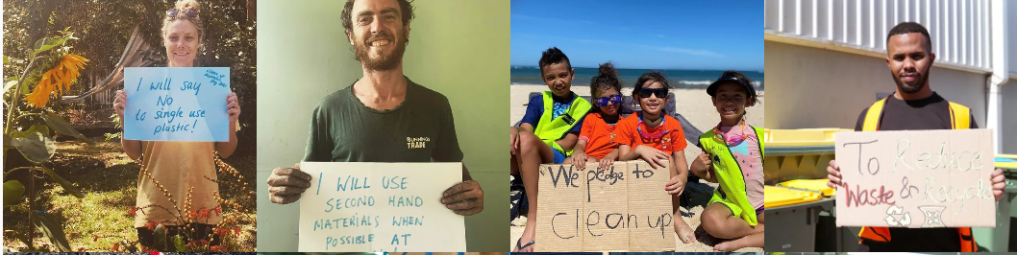
Image set 1
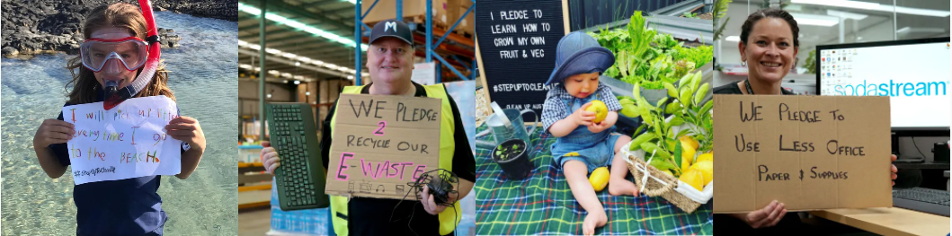
Image set 1
Source: Clean Up Australia – Step Up
Copied under the statutory licence in s 113P of the Copyright Act
Clean Up Australia, How will you step up? Clean up Australia website, accessed 5 June 2022.
Section 113P Warning Notice

Appendix 9a
Identifying argument in persuasive texts – analysis table
Clean up Australia website
Text Extract | What is the argument? | Persuasive devices to support the argument
HOW WILL YOU STEP UP?  Will you make a pledge towards reducing your own waste contribution? | Individuals need to commit to reducing their waste. | - Inclusive language ‘you’ and  rhetorical question – direct, personal, appeal to persuade individuals to act.  - Idiom - ‘Step Up’ implies it is something you need to do, to take responsibility.
Could you Step Up by saying no to straws? To bringing your own water bottle? To composting? To buying recycled, to choosing not to buy fast fashion or refusing to purchase fruit and vegetables pre-wrapped in plastic? | It isn’t difficult to reduce plastic waste. | - Series of rhetorical questions – builds pressure.  - Personal pronoun ‘you’ places responsibility on reader.
There are so many ways to Step Up! And thousands of small steps together, make a big difference! Together we can all be part of the solution.  "We don't need a handful of people doing zero waste perfectly. We need millions of people doing it imperfectly." (Anne Marie Bonneau, the Zero-Waste Chef) | Millions of people need to make small changes to have any impact. | - Exclamation marks – emphasise how easy, yet important, it is to make these small changes.  - Inclusive language ‘together’ and ‘we’ makes individuals feel part of something bigger than themselves.  - Direct quote – adds authority
Inspire your family and friends to help make a change by sharing your personal pledge on social media and tagging @CleanUpAustralia #StepUptoCleanUp | Making a public commitment via social media will influence other people to act. | - Emotive language - ‘inspire’, ‘sharing’  - inclusive language ‘your’
 | Making a public pledge to reduce waste will make you feel good. | - Visual - Photos - range of images – appeal to a broad range of people, most could identify with one of the people pictured. Happy faces – reinforces argument.  - Visual - Hand written signs on cardboard – reinforces how easy it is, adds personal element.
Copied under the statutory licence in s 113P of the Copyright Act
Clean Up Australia, How will you step up? Clean up Australia website, accessed 5 June 2022.
Section 113P Warning Notice

Appendix 9b
Identifying argument in persuasive texts – analysis table template
Text extract | Argument | Persuasive elements to support argument

Appendix 10a

Generalisations match-and-sort (teacher copy)
Match the evidence to support a generalisation.
Generalisation | Evidence in a text
Most people are honest | - Telling the truth  - Returning a lost item  - Telling someone how they feel
Generally, climate change is seen as a real threat to the globe. | - Temperature and water increasing  - Glaciers disappearing at a faster rate  - Change in animal hibernation patterns
Some dog breeds are dangerous | - Increase in dog attacks by certain breeds  - Examples of behaviour patterns in particular dog breeds
Most people believe that learning to ride a bike is easy | - Balancing on a bike is simple  - Very young children can ride bikes  - Once you learn to ride a bike you can pick it up again quickly
Your own:
Your own:

Appendix 10b

Generalisations match-and-sort (student copy)
Match the evidence from the text to support a generalisation.
Generalisation | Evidence in a text
Most people are honest
Generally, climate change is seen as a real threat to the globe.
Some dog breeds are dangerous
Most people believe that learning to ride a bike is easy
Your own:
Your own:

Appendix 10c

Generalisations match template
Locate generalisations and supporting evidence in the text.
Generalisation | Evidence in the text

Appendix 11

Generalisations and assumptions match
Make an assumption based on the generalisation and evidence.
Generalisation | Evidence in a text | Challenge: Assumptions
Most people are honest | - Telling the truth  - Returning a lost item  - Telling someone how they feel | Most people:  - Are always trustworthy  - Can keep a secret/confidence  - Won’t betray you  - Don’t lie
Generally, climate change is seen as a real threat to the globe. | - Temperature and water increasing  - Glaciers disappearing at a faster rate  - Change in animal hibernation patterns
Some dog breeds are dangerous | - Increase in dog attacks by certain breeds  - Examples of behaviour patterns in particular dog breeds
Most people believe that learning to ride a bike is easy | - Balancing on a bike is simple  - Very young children can ride bikes  - Once you learn to ride a bike you can pick it up again quickly
Your own text:
Your own text:
Your own text:

