Inference
Stage 4

Overview

Purpose
This literacy teaching strategy supports teaching and learning for Stage 4 students across all key learning areas. It targets specific literacy skills and suggests a learning sequence to build skill development. Teachers can select individual tasks, or a sequence, and embed into their teaching and learning program according to their students’ needs. While exemplar texts are provided throughout this resource, it is recommended that teachers select texts which are relevant to their students and curriculum.

Learning intention
Students will learn to use background information and clues to infer in both written and visual texts.

Syllabus outcomes
The following teaching and learning strategies will assist in covering elements of the following outcomes:
- EN4-RVL-01: uses a range of personal, creative and critical strategies to read texts that are complex in their ideas and construction
- EN4-1A: responds to and composes texts for understanding, interpretation, critical analysis, imaginative expression and pleasure.
- EN4-2A: effectively uses a widening range of processes, skills, strategies and knowledge for responding to and composing texts in different media and technologies.

NSW English K-10 Syllabus (2022)
Visit the Leading Curriculum K-12 website for more information on the syllabus implementation timeline.

Success criteria
The following Year 7 NAPLAN item descriptors may guide teachers to co-construct success criteria for student learning.
- infers the key idea in an information text
- infers a key idea in a persuasive text
- infers the writer’s intentions in a persuasive text
- infers the reason for a character’s actions in a narrative
- infers the reason for a character’s actions in a text
- interprets a character’s motivations in an imaginative text
- interprets the meaning of vocabulary in an informative text
- interprets the meaning of a description in a narrative
- interprets the meaning of a description in an information text
- interprets the meaning of a description in context in a narrative
- interprets the meaning of a phrase in context in a blog post
- interprets the meaning of a phrase in context in a narrative
- interprets the meaning of a phrase in context in an information text
- interprets the meaning of a sentence in a text
- interprets the meaning of a sentence in context in a narrative
- interprets the meaning of a technical term from context in an information text

National Literacy Learning Progression guide

Understanding Texts (UnT9-UnT11)
Key: C=comprehension P=process V=vocabulary

UnT9
- draws inferences, synthesising clues and evidence across a text (C)
- distils information from a number of texts according to task and purpose (e.g. uses graphic organisers) (C)
- identifies different interpretations of the text citing evidence from a text (C)
- uses knowledge of a broader range of cohesive devices to track meaning (e.g. word associations) (see Grammar) (P)
- selects reading/viewing strategies appropriate to reading purpose (e.g. scans text for evidence) (P)

UnT10
- reads and views complex or some highly complex texts (see Text complexity) (C)
- draws inferences using evidence from the text and discounting possible inferences that are not supported by the text (C)
- evaluates the reasoning and evidence in a persuasive text (C)
- integrates automatically a range of processes such as predicting, confirming predictions, monitoring, and connecting relevant elements of the text to build meaning (P)
- verifies interpretations of unfamiliar words using grammatical and contextual cues (V)

UnT11
- interprets symbolism in texts, providing evidence to justify interpretation (C)
- strategically adjusts the process of reading and viewing to build meaning according to the demands of tasks and texts (P)
National Literacy Learning Progression

Evidence base
- Centre for Education Statistics and Evaluation (2017). Effective reading instruction in the early years of school, literature review.
- Oakhill, J., Cain, K. & Elbro, C. (2015). Understanding and teaching reading comprehension: A handbook. Routledge.
- Quigley, A. (2020). Closing the reading gap. Routledge.
- Scarborough, H.S. (2001). Connecting early language and literacy to later reading (dis)abilities: Evidence, theory and practice. In S. Neuman & D. Dickson (Eds.), Handbook for research in early literacy (pp. 97-110). New York, NY: Guilford Press.
Alignment to system priorities and/or needs: Five priorities for Literacy and Numeracy, Our Plan for NSW Public Education, School Excellence Policy (nsw.gov.au).
Alignment to School Excellence Framework: Learning domain: Curriculum, Teaching domain: Effective classroom practice and Professional standards
Consulted with: Strategic Delivery, Teaching Quality and Impact
Author: Literacy and Numeracy
Reviewed by: Literacy and Numeracy, Teaching Quality and Impact
Created/last updated: January 2024
Anticipated resource review date: January 2025
Feedback: Complete the online form to provide any feedback

Copyright

Section 113P Notice

Texts, Artistic Works and Broadcast Notice

Some of this material has been copied and communicated to you in accordance with the statutory licence in section 113P of the Copyright Act. Any further reproduction or communication of this material by you may be the subject of copyright protection under the Act. Do not remove this notice.

Teaching strategies
Task | Appendices
Ignition task for inference
What is inference?
What’s going on in this picture? | Appendix 1 - Film analysis recording sheet
Using texts to infer | Appendix 2 - Inference tags  Appendix 3 - Inference match and sort  Appendix 4 - Example texts
Answering inference questions
Temporal and causal relationships

Background information

Inference
Inference is the process of drawing conclusions based on evidence and reasoning (NSW English K-10 Syllabus, 2022). The conclusions a reader draws from a text needs to be substantiated by evidence from the text and should be supported by the readers’ prior knowledge, learning or personal experiences and/or other familiar texts.
Local inferencing requires the reader to comprehend implied information from within relatively small sections of text, such as 2 adjacent sentences.
Global inferencing requires the reader to comprehend implied information from across relatively larger sections of text and is supported by the reader’s depth of vocabulary and background knowledge.

Inferential understanding and explicit teaching
The development of inferential understanding of texts requires explicit teaching. Modelling the ‘think aloud’ strategy whilst working with texts enables the students to ‘hear’ the thinking process an accomplished reader undertakes when reading or viewing material. Students require multiple opportunities to work with diverse texts to be able to develop and apply inferential understanding and generalise the skill to other learning experiences. Inference is also essential for any kind of deep understanding and higher-order analysis.

Making inferences enables the students to:
- provide explanations for ideas that are presented in the text that are not explicitly stated
- offer details or reasons for events that have occurred throughout the text
- recognise the author's point of view or bias
- interpret the language choices (technical and figurative) and how they shape the meaning of the text
- consider and evaluate content that is presented as visuals within the text (where applicable)
- offer conclusions from facts presented in the text
- connect content and meaning of the text to prior knowledge and/or similar texts support inferences with evidence from the text.
Reference: ‘English K-10 Syllabus © NSW Education Standards Authority (NESA) for and on behalf of the Crown in right of the State of New South Wales, 2012 and 2022.

Where to next?
- Literal comprehension
- Author perspective and bias
- Audience and purpose

Overview of teaching strategies

Purpose
These literacy teaching strategies support teaching and learning from Stage 2 to Stage 5. They are linked to NAPLAN task descriptors, syllabus outcomes and literacy and numeracy learning progressions. These teaching strategies target specific literacy and numeracy skills and suggest a learning sequence to build skill development. Teachers can select individual tasks or a sequence to suit their students.

Access points
The resources can be accessed from:
- NAPLAN App in Scout using the teaching strategy links from NAPLAN items
- NSW Department of Education literacy and numeracy website.
What works best
Explicit teaching practices involve teachers clearly explaining to students why they are learning something, how it connects to what they already know, what they are expected to do, how to do it and what it looks like when they have succeeded. Students are given opportunities and time to check their understanding, ask questions and receive clear, effective feedback.
This resource reflects the latest evidence base and can be used by teachers as they plan for explicit teaching.
Teachers can use classroom observations and other assessment information to make decisions about when and how they use this resource as they design teaching and learning sequences to meet the learning needs of their students.
Further support with What works best is available.
Differentiation
When using these resources in the classroom, it is important for teachers to consider the needs of all students, including Aboriginal and EAL/D learners.
EAL/D learners will require explicit English language support and scaffolding, informed by the EAL/D enhanced teaching and learning cycle and the student’s phase on the EAL/D Learning Progression. Teachers can access information about supporting EAL/D learners and literacy and numeracy support specific to EAL/D learners.
Learning adjustments enable students with disability and additional learning and support needs to access syllabus outcomes and content on the same basis as their peers. Teachers can use a range of adjustments to ensure a personalised approach to student learning.
Assessing and identifying high potential and gifted learners will help teachers decide which students may benefit from extension and additional challenge. Effective strategies and contributors to achievement for high potential and gifted learners helps teachers to identify and target areas for growth and improvement. A differentiation adjustment tool can be found on the High potential and gifted education website.

Using tasks across learning areas
This resource may be used across learning areas where it supports teaching and learning aligned with syllabus outcomes.
Literacy and numeracy are embedded throughout all syllabus documents as general capabilities. As the English and mathematics learning areas have a particular role in developing literacy and numeracy, NSW English and Mathematics syllabus outcomes aligned to literacy and numeracy skills have been identified.

Text selection
Example texts are used throughout this resource. Teachers can adjust activities to use texts which are linked to their unit of learning.
Further support with text selection can be found within the National Literacy Learning Progression Text complexity appendix.
The NESA website has additional information on text requirements within the NSW English syllabus.

Teaching strategies

Ignition task for inference
- Teacher explains that the class is going to read a very challenging text – it may look strange and unusual! However, even though it may seem very challenging to read, students will be using their background knowledge and clues in the text to interpret and infer meaning. Display and read the following passage to the class:
- The snables tramped the mengs to the swip. The swip fropped.
- The mengs clambed a sib boogle. The snables gicked and gicked.
In small groups, students then answer the following questions and discuss:
- What did the snables do to the mengs?
- What happened to the swip?
- What kind of boogle did the mengs clamb?
- What did the snables eventually do?
Students then answer the following questions:
- How did the snables feel?
- Predict what might happen next?
These questions require students to use their background knowledge to infer. It is important to use this task to reinforce the importance of vocabulary and background knowledge to be able to make predictive inferences and inferences.
To support learners, teacher guides students through the questions, modelling how to overcome any barriers to comprehension posed by the challenging text.
Reference: Task adapted from Kilpatrick, D. (2015) Essentials of Assessing, Preventing and Overcoming Reading Difficulties. John Wiley and Sons, New Jersey.

What is inference?
- Discuss inference: inference is the process of drawing conclusions using evidence in texts. We use clues and background knowledge to make an inference.
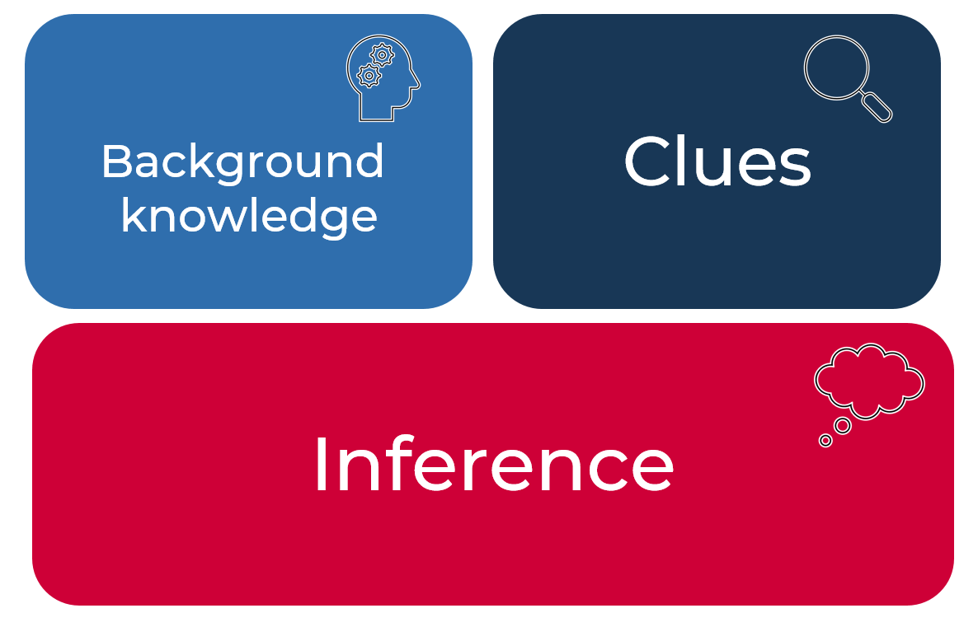
- Reverse charades: This game of charades uses non-verbal communication to which students apply background information to infer meaning. One student stands at the front of the room, facing the class. On the board, a noun, verb or adjective is displayed for the class to act out. The student at the front does not see this word and must guess from the actions of the class what the word is. For example, the proper noun Harry Potter may have the whole class pretend to hold wands, or, if the word was snow, students may all pretend to be skiing down a mountain, being cold, or building a snowman. The class then debriefs and discusses what visual clues / actions were most helpful for a student to make the inference, how that relates to the student’s background knowledge and how each different action provides a clue that helps the other actions make sense and become more useful.
- Teacher leads discussion that we infer every day – if we walk outside and all the chairs are upturned and leaves everywhere, we would infer there has been a storm or it has been extremely windy. When we smell smoke, we infer there is a bushfire nearby, if someone comes to school with a bandaged arm, we infer they have been in an accident. Discuss similar scenarios and what we can infer from these.
- Review background knowledge: Brainstorm elements that make up background knowledge, ideas include: vocabulary, travel destinations, places visited, interests and hobbies, subject-knowledge, relationships and family experiences and so on. Students create a mind-map detailing things that make up their background knowledge.
- Review clues: clues can be found in both images and texts. Both will be explored in the following tasks.
- Newsflash!: Students use the newsflash strategy to synthesise their understanding of inference.
Headline

Visual representation | Key points

What’s going on in this picture?
- Explain to students that when examining an image, information or clues can be gathered and used to make inferences about the subject matter (a person, an event, a setting) and even an author’s point of view. For example, we can find clues in images from objects, positioning of objects and characters, facial expressions, setting, lines and vectors, character, physical features, colours, symbolism and modality of image. We combine our knowledge of visual texts with clues from the image, as well as our background knowledge, to make inferences. Teachers choose a range of images, with various levels of complexity, to support and challenge students. For example, choose images which include symbols or which could infer symbolic meaning.
Think-Pair-Share: in pairs students discuss their image or images, making inferences about the subject matter (people/places/event), purpose, audience and context of the image as well as the author’s intent or perspective. Students then share their ideas in a class discussion. A graphic organiser such as a concept map can be used to collate ideas.
- The teacher logs on to the New York Times’ ‘What’s Going on in This Picture?’ website (www.nytimes.com/column/learning-whats-going-on-in-this-picture). Ensure the images are checked prior to teaching to make sure they are appropriate. Updated regularly throughout each week, a range of images without captions are available for students to use for inference.
- Think-Pair-Share: what is going on in this picture? What evidence do you see that supports this? What more can you find? Students use the Newsflash strategy to create a headline, a visual representation and what vocabulary and key points are expected in the article. Alternate task: use images from Australian news items or images linked to a current unit of learning.
- Students view Pixar short film ‘For the Birds.’ (pixar.com) or any other short film that relates to a current unit of learning. Teacher pauses throughout film to give opportunities for students to ask and answer questions, and infer what is happening using predictive inferences, background knowledge, and clues from the film. Suggestion: teachers should view film and establish key places to pause before showing students. Students can record findings in Appendix 1 - Film analysis recording sheet.

Using texts to infer
- Review inference: inference is the process of drawing conclusions using evidence in texts. We use clues and background knowledge to make an inference.
- “He slammed the door behind him, making a huge racket! “
- The evidence in the text includes: ‘slammed’ and ‘huge racket’ as well as an exclamation mark.
- We can infer that the person is angry.
Discuss that when we infer, we are making a conclusion based on something that might not be explicitly stated and may be referred to as ‘reading between the lines’.
- Teacher shows inference tags (refer to Appendix 2 - Inference tags) to infer meaning. For example, ’I didn’t do it’. This is a phrase that will often indicate that, in fact, the character did do it. Discuss types of texts each of these inference tags might be found and infer the story behind them using prior knowledge and predictions.
- Review the kinds of evidence that might be found in texts that we can make inferences from, including, quotes, information and visuals. Inferences are conclusions drawn from text details, quotes, information and visuals based on the reader's consideration and background knowledge of the world. Inference is directly connected to information found in the text and uses a process of reasoning to draw logical conclusions regarding 'hidden' meaning or themes.
- Students work in pairs to fill in missing elements from the ‘Inference match and sort’ (Appendix 3 - Inference match and sort). When finished, these are cut up and given to another pair to connect.
- Students are given a range of texts to create their own ‘Inference match and sort’ inference activity for another pair to complete. Appendix 4 - Example texts has a variety of text excerpts that can be used, or, alternatively, teachers can source persuasive, informative and imaginative texts relevant to a current unit of learning. An important discussion point is the difference in inferring across imaginative, informative and persuasive texts.

Answering inference questions
- Teacher chooses a text which provides opportunities for inference level questioning and is relevant to a current unit of learning. Teacher uses a think aloud to model how to answer inferential questions by:
- identifying what the question is asking (highlight key words and vocabulary that needs to be understood – these can be used for scanning the text to locate information in paragraphs)
- finding where the answer will be located by scanning for key words, explaining that when making an inference we may need to read across a text to find the answer
- rereading paragraphs and sections
- rereading potential answers, eliminating responses and choosing between remaining ideas
- explaining assumptions, beliefs and values in the text that may shape the answer.

Temporal and causal relationships
- Inferring temporal relationships: Ask students to highlight the words in a text linked to the current unit of learning which show order of events. Students list the events that occurred in chronological order, and compose a series of sentences that combine this information using conjunctions of time such as before, previously, after, subsequently, when, just as, although, while, or adverbs such as later, afterwards, then, at that juncture, ensuing, next, before, previously, after, subsequently, when, just as, although, while, or adverbs such as later, afterwards, then, at that juncture, ensuing, next.
- Students review causal vocabulary and how they are used: as a result of, consequently, leading to and so on. Discuss how these are used to show the connection between a cause and its effect. Students might colour code the cause and effect within a range of texts linked to current unit of learning.
- Inferring causal relationships: When causal words are not evident, students will need to ask themselves why and how questions to be able to infer reasons for characters' actions and events that take place in texts. Students work in pairs to highlight cohesive links such as pronouns, different names for the same person or object, collocations (words that commonly go together) or other ways in which the ideas in the text are unified.
- Students then look at the text around those words to see whether one action is causing another. Students will need to draw on personal experiences and be given any background knowledge which is outside their experience.

Appendix 1

Film analysis recording sheet
# | Evidence in film | What we know | Inference | Predictive inference
1
2
3
4
5

Appendix 2

Inference tags
I didn’t do it!
The clock had stopped at exactly midnight.
You won’t find a better buy!
Call now, limited stock!
You don’t know what you’re missing.
Call 000!
It is time to renew.
Buy one, get one free!

Appendix 3

Inference match and sort
Evidence from text | Background knowledge | What we can infer
The boat limped into the harbour. | - Limping means to go slowly as there may be a wound | - The boat is damaged and is likely to sink
There were at least six pairs of sunglasses in the house…somewhere…she was sure…kind of. | - Most people only have one or two pairs or sunglasses
 | - Garbage bins go out once per week | - He forgot to take the bins out.
- It takes one hour to bake the cake
- If you use too much heat, it will burn
The bank’s board decided to take action.
 |  | - There was a newborn baby in the house.
 | - The Berlin Wall came down in 1989
All plants go through a process of photosynthesis. Except for fungi.
This is honestly the best hair conditioner I have ever used. | - Blog posts can be written by anyone  - People use hair conditioner

Blank inference match and sort
Evidence from text | Background knowledge | What we can infer

Appendix 4

Student copy: example texts
A Pocketful of Rye by Agatha Christie
Harper Publishing
First published 1953

Chapter two
Inspector Neele sat in Mr Fortescue’s sanctum behind Mr Fortescue’s vast sycamore desk. One of his underlings with a notebook sat unobtrusively against the wall near the door.
Inspector Neele had a smart soldierly appearance with crisp brown hair growing back from a rather low forehead. When he uttered the phrase ‘just a matter of routine’ those addressed were wont to think spitefully: ‘And routine is about all you’re capable of!’ They would have been quite wrong. Behind his unimaginative thinking, and one of his methods of investigation was to propound to himself fantastic theories of guilt which he applied to such persons as he was interrogating at the time.
Miss Griffith, whom he had once picked out with an unerring eye as being the most suitable person to give him a succinct account of the events which had led to his being seated where he was, had just left the room having given him an admirable resume of the morning’s happenings. Inspector Neele propounded to himself three separate highly coloured reasons why the faithful doyenne of the typists’ room should have poisoned her employer’s mid-morning cup of tea, and rejected them as unlikely.
He classified Miss Griffith as (a) Not the type of a poisoner, (b) Not in love with her employer, (c) No pronounced mental instability, (d) Not a woman who cherished grudges. That really seemed to dispose Miss Griffith except as a source of accurate information.
Inspector Neele glanced at the telephone. He was expecting a call from St Jude’s Hospital at any moment now.
It was possible, of course, that Mr Fortescue’ sudden illness was due to natural causes, but Dr Isaacs of Bethnal Green had not thought so and Sir Edwin Sandeman of Harley Street had not thought so.
Inspector Neele pressed a buzzer conveniently situated at his left hand and demanded that Mr Fortescue’s personal secretary should be sent to him.
Miss Grosvenor had recovered a little of her poise, but not much. She came in apprehensively, with nothing like the swanlike glide about her motions, and said at once defensively:
‘I didn’t do it!’

Student copy: example texts
Jane Eyre by Charlotte Bronte
Penguin Books
First Published in 1847

Chapter 1
THERE was no possibility of taking a walk that day. We had been wandering, indeed, in the leafless shrubbery an hour in the morning; but since dinner (Mrs Reed, when there was no company, dined early) the cold winter wind had brought with it clouds so sombre, and a rain so penetrating, that further outdoor exercise was now out of the question.
I was glad of it; I never liked long walks, especially on chilly afternoons; dreadful to me was the coming home in the raw twilight, with nipped fingers and toes, and a heart saddened by the chidings of Bessie, the nurse, and humbled by the consciousness of y physical inferiority to Eliza, John and Georgiana Reed.
The said Eliza, John, and Georgiana were now clustered round their mamma in the drawing-room: she lay reclined on a sofa by the fireside, and with her darlings about her (for the time neither quarrelling nor crying) looked perfectly happy. Me, she had dispensed from joining the group, saying, ‘She regretted to be under the necessity of keeping me at a distance; but that until she heard from Bessie, and could discover her own observation that I was endeavouring in good earnest to acquire a more sociable and childlike disposition, a more attractive and sprightly manner – something lighter, franker, more natural, as it were- she really must exclude me from privileges intended only for contented, happy little children.
‘What does Bessie say I have done?’ I asked.
‘Jane, I don’t like cavillers or questioners; besides, there is something truly forbidding in a child taking up her elders in that manner. Be seated somewhere; and until you can speak pleasantly, remain silent.’
A small breakfast-room adjoined the drawing-room, I slipped in there. It contained a bookcase; I soon possessed myself of a volume, taking care that it should be one stored with pictures. I mounted into the window-seat: gathering up my feet, I sat cross-legged, like a Turk; and, having drawn the red moreen curtain nearly close, I was shrined in double retirement.

Student copy: example texts
In the blood: An excerpt from: Moths that drink elephants’ tears and other zoological curiosities – Matt Walker Portrait Publishing – 2006
Domestic cats have three different types of blood group, A, B and AB. But they lack the equivalent of the human blood group O. By far the most common blood type in domestic cars is blood type A, but the prevalence of different blood types varies with geographical location. For instance, all cats in Finland have blood type A, whereas only three-quarters of Australian cats are blood type A. The prevalence of different blood types also varies with breed.
Country | % of cats that are type A | % of cats that are type B
Finland | 100 | 0
USA | 99 | 1
England | 97 | 3
Germany | 93 | 7
Italy | 89 | 11
France | 85 | 15
Australia | 73 | 26
Transfusion Medicine Reviews, vol. 18, 2004, p.117

Pure cat breeds in USA | % frequency of type B cats
Siamese | 0
Oriental shorthair | 0
Burmese | 0
Tonkinese | 0
Russian Blue | 0
Maine Coon | Less than 5
Norwegian forest cat | Less than 5
Blood type in cats has no effect on coat colour or gender. But it can affect survival of kittens. For instance, if a female cat of blood type B is bred with a male of blood type A, between 75% to 100% of their offspring will be blood group A. But if these kittens nurse milk from their mother within 24 hours of birth, they may die. This is because kittens of type A or AB that nurse from a type B other ingest antibodies against type A blood in their mother’s milk. About a day after ingestion, these antibodies are absorbed by the kitten’s stomach and gastrointestinal tract. Hemolysis, or the breaking open of blood cells, ensues, which can be fatal. A vet can tell when this may have happened to an otherwise healthy-looking kitten by looking at the cat’s tail. Necrosis at the tip of the tail is a sign that hemolysis has taken place. However, after 24 hours have passes, antibodies do not cross the kitten’s intestinal lining and the youngster can safely drink its mother’s milk.

Student copy: example texts
The barber shop scissor twister
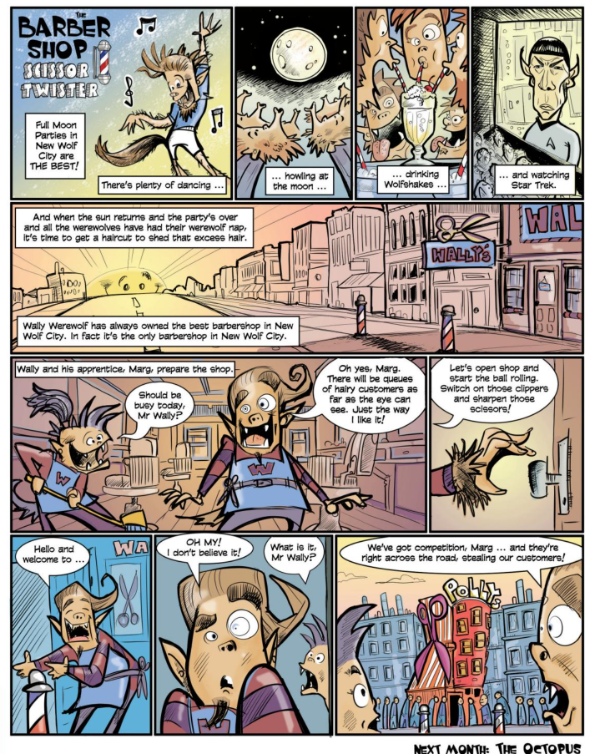
The School Magazine © State of New South Wales (Department of Education). By Andrew Cranna. Issue 1, 2019.

Student copy: example texts. Accessible version.
The barber shop scissor twister
Full moon parties in New Wolf City are THE BEST. There’s plenty of dancing...
...howling at the moon...
...drinking Wolfshakes...
...and watching Star Trek...
...And when the sun returns and the party’s over and all the werewolves have had their werewolf nap, it is time to get a haircut to shed that extra hair.
Wally Werewolf has always owned the best barbershop in New Wolf City. In fact, it’s the only barbershop in New Wolf city.
Wally and his apprentice, Marg, prepare the shop.
“Should be busy today Mr Wally?”
“Oh yes, Marg. There will be queues of hairy customers as far as the eye can see. Just the way I like it!”
“Let’s open shop and start the ball rolling. Switch on those clippers and sharpen those clippers.”
“Hello and welcome to...”
“OH MY. I don’t believe it.”
“What is it, Mr Wally?”
“We’ve got competition, Marg...and they’re right across the road, stealing our customers!”
The School Magazine © State of New South Wales (Department of Education). By Andrew Cranna. Issue 1, 2019.

Student copy: example texts
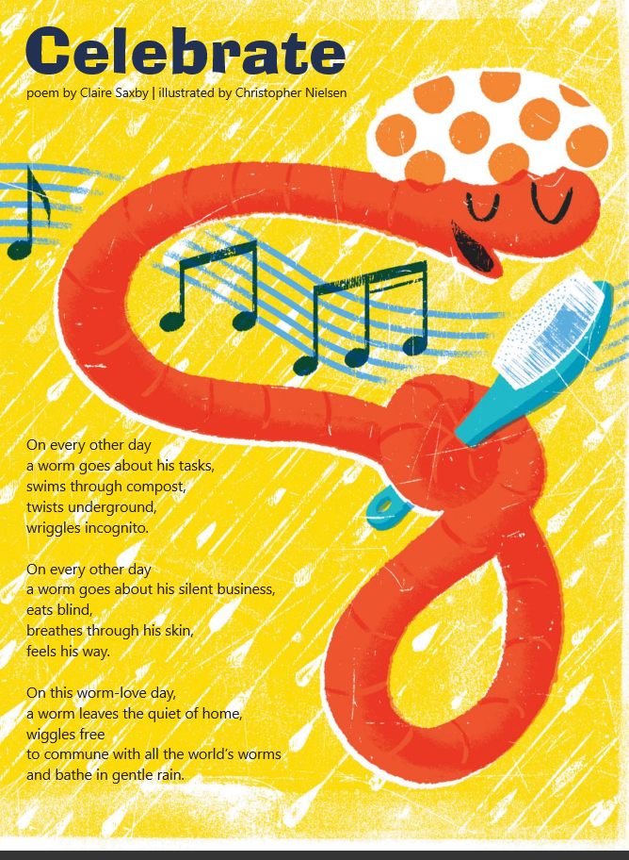
The School Magazine © State of New South Wales (Department of Education). By Claire Saxby, illustrated by Christopher Nielsen. Issue 1, 2019.

Student copy: example texts - accessible version
Celebrate
poem by Claire Saxby, illustrated by Christopher Nielsen
On every other day
a worm goes about his tasks,
swims through compost,
twists underground,
wiggles incognito.
On every other day
a worm goes about his silent business,
eats blind,
breathes through his skin,
feels his way
On this worm-love day,
a worm leaves the quiet of home,
wiggles free
to commune with the all the world’s worms
and bathe in gentle rain.
The School Magazine © State of New South Wales (Department of Education). By Claire Saxby, illustrated by Christopher Nielsen. Issue 1, 2019.

