Evaluating sources
Stage 4

Overview

Purpose
This literacy teaching strategy supports teaching and learning for Stage 4 students across all key learning areas. It targets specific literacy skills and suggests a learning sequence to build skill development. Teachers can select individual tasks, or a sequence, and embed into their teaching and learning program according to their students’ needs. While exemplar texts are provided throughout this resource, it is recommended that teachers select texts which are relevant to their students and curriculum.

Learning intention
Students will learn to evaluate the accuracy of sources. Students will explore the tools and techniques used to add authority to texts and what to look for to assess credibility.

Syllabus outcomes
The following teaching and learning strategies will assist in covering elements of the following outcomes:
- EN4-RVL-01: uses a range of personal, creative and critical strategies to read texts that are complex in their ideas and construction
- EN4-URC-01: identifies and explains ways of valuing texts and the connections between them
- EN4-URA-01: analyses how meaning is created through the use of and response to language forms, features and structures
- EN4-1A: responds to and composes texts for understanding, interpretation, critical analysis, imaginative expression and pleasure
- EN4-2A: effectively uses a widening range of processes, skills, strategies and knowledge for responding to and composing texts in different media and technologies
- EN4-3B: uses and describes language forms, features and structures of texts appropriate to a range of purposes, audiences and contexts
NSW English Syllabus K-10 2022
Visit the Leading curriculum K-12 website for more information on the syllabus implementation timeline.

Success criteria
The following Year 7 NAPLAN item descriptors may guide teachers to co-construct success criteria for student learning.
- identifies the effect of a sentence in an information text
- evaluates the accuracy of statements using information from a speech
- evaluates the accuracy of statements using information from a text
- evaluates the accuracy of statements using information from an information text
- evaluates the presence of information in a persuasive text
- evaluates the presence of information in the orientation for a narrative

National Literacy Learning Progression guide

Understanding Texts (UnT9-UnT11)
Key: C=comprehension P=process V=vocabulary

UnT9
- identifies the main themes or concepts in complex texts by synthesising key ideas or information(C)
- summarises the text identifying key details only (C)
- selects reading/viewing pathways appropriate to reading purpose (e.g. scans text for evidence ) (P)

UnT10
- synthesises information from a variety of complex texts (C)
- reads and views complex or some highly complex texts (See Text complexity) (C)
- draws inferences using evidence from the text and discounting possible inferences that are not supported by the text (C)
- recognises when ideas or evidence have been omitted from a text to position the reader (C)

UnT11
- analyses the credibility and validity of primary and secondary sources (C)
- explains assumptions, beliefs and implicit values in texts (e.g. economic growth is always desirable) (C)
- evaluates the social, moral and ethical positions taken in texts (C)
- identifies subtle contradictions and inconsistencies in texts (P)
National Literacy Learning Progression

Evidence base
- Centre for Education Statistics and Evaluation (2017). Effective reading instruction in the early years of school, literature review.
- Oakhill, J., Cain, K. & Elbro, C. (2015). Understanding and teaching reading comprehension: A handbook. Routledge.
- Quigley, A. (2020). Closing the reading gap. Routledge.
- Scarborough, H.S. (2001). Connecting early language and literacy to later reading (dis)abilities: Evidence, theory and practice. In S. Neuman & D. Dickson (Eds.), Handbook for research in early literacy (pp. 97-110). New York, NY: Guilford Press.
Alignment to system priorities and/or needs: Five priorities for Literacy and Numeracy, Our Plan for NSW Public Education, School Excellence Policy (nsw.gov.au).
Alignment to School Excellence Framework: Learning domain: Curriculum, Teaching domain: Effective classroom practice and Professional standards
Consulted with: Strategic Delivery, Teaching Quality and impact
Author: Literacy and Numeracy
Reviewed by: Literacy and Numeracy, Teaching Quality and impact
Created/last updated: January 2024
Anticipated resource review date: January 2025
Feedback: Complete the online form to provide any feedback

Copyright
Section 113P Notice
Texts, Artistic Works and Broadcast Notice
Some of this material has been copied and communicated to you in accordance with the statutory licence in section 113P of the Copyright Act. Any further reproduction or communication of this material by you may be the subject of copyright protection under the Act. Do not remove this notice.

Teaching strategies
Task | Appendices
What is fact and what is fiction? | Appendix 1 - Informative vs persuasive analysis
Evaluating sources | Appendix 2 - Is it credible?
Evaluating web sources
Critically evaluating a web source | Appendix 3 - Critically evaluating a web source

Background information

Author
The composer or originator of a work (for example a novel, play, poem, film, website, speech, essay, autobiography). Author is most commonly used in relation to novels

Authority
authority of a text - How trustworthy, authentic or valid an audience may find the representation of ideas, experiences, perspectives and arguments in a text.
authority over a text - The varying degrees to which the meaning of a text is controlled or constructed by its creator(s) and by its audience.

Bias
In argument or discussion, to favour one side or viewpoint by ignoring or excluding conflicting information; a prejudice against something
Evaluative language
Positive or negative language that judges the worth of something. It includes language to express feelings and opinions, to make judgements about aspects of people such as their behaviour, and to assess the quality of objects such as literary works. It includes evaluative words. The language used by a speaker or writer to give a text a particular perspective (for example judgemental, emotional, critical) in order to influence how the audience will respond to the content of the text.

Fact and Opinion
Facts can be based on an observation and can be validated through testing whereas opinion is an assumption or belief.
Introduce terms of ‘subjective’ and ‘objective’ and how these connect with fact and opinion; encourage students to use this vocabulary where appropriate.
Objective language is language that is fact-based, measurable and observable, verifiable and unbiased. It does not include a speaker or writer’s point of view, interpretation or judgement.
Subjective language includes words used to communicate based on opinion, feelings or personal biases.

Perspective
A lens through which the author perceives the world and creates a text, or the lens through which the reader or viewer perceives the world and understands a text. Readers may also temporarily adopt the perspectives of others as a way of understanding texts.

Point of view
The position from which the information and events of a text are intended to be perceived by its audience. Point of view is constructed through the narrator, voice or images of the text and by characters or voices presented within it.
Point of view should not be confused with the term ‘perspective’ or with notions of opinion.

Positioning
The composing technique of causing the responder to adopt a particular point of view and interpret a text in a particular way. Composers position responders by selectively using detail or argument, by carefully shaping focus and emphasis and by choosing language that promotes a particular interpretation and reaction.
Reference: ‘English K-10 Syllabus © NSW Education Standards Authority (NESA) for and on behalf of the Crown in right of the State of New South Wales, 2012 and 2022.

Where to next?
- Text features
- Author perspective and bias
- Audience and purpose

Overview of teaching strategies

Purpose
These literacy teaching strategies support teaching and learning from Stage 2 to Stage 5. They are linked to NAPLAN task descriptors, syllabus outcomes and literacy and numeracy learning progressions.
These teaching strategies target specific literacy and numeracy skills and suggest a learning sequence to build skill development. Teachers can select individual tasks or a sequence to suit their students.

Access points
The resources can be accessed from:
- NAPLAN App in Scout using the teaching strategy links from NAPLAN items
- NSW Department of Education literacy and numeracy website.
What works best
Explicit teaching practices involve teachers clearly explaining to students why they are learning something, how it connects to what they already know, what they are expected to do, how to do it and what it looks like when they have succeeded. Students are given opportunities and time to check their understanding, ask questions and receive clear, effective feedback.
This resource reflects the latest evidence base and can be used by teachers as they plan for explicit teaching.
Teachers can use classroom observations and assessment information to make decisions about when and how they use this resource as they design teaching and learning sequences to meet the learning needs of their students.
Further support with What works best is available.
Differentiation
When using these resources in the classroom, it is important for teachers to consider the needs of all students, including Aboriginal and EAL/D learners.
EAL/D learners will require explicit English language support and scaffolding, informed by the EAL/D enhanced teaching and learning cycle and the student’s phase on the EAL/D Learning Progression. Teachers can access information about supporting EAL/D learners and literacy and numeracy support specific to EAL/D learners.
Learning adjustments enable students with disability and additional learning and support needs to access syllabus outcomes and content on the same basis as their peers. Teachers can use a range of adjustments to ensure a personalised approach to student learning.
Assessing and identifying high potential and gifted learners will help teachers decide which students may benefit from extension and additional challenge. Effective strategies and contributors to achievement for high potential and gifted learners helps teachers to identify and target areas for growth and improvement. A differentiation adjustment tool can be found on the High potential and gifted education website.

Using tasks across learning areas
This resource may be used across learning areas where it supports teaching and learning aligned with syllabus outcomes.
Literacy and numeracy are embedded throughout all syllabus documents as general capabilities. As the English and mathematics learning areas have a particular role in developing literacy and numeracy, NSW English and Mathematics syllabus outcomes aligned to literacy and numeracy skills have been identified.

Text selection
Example texts are used throughout this resource. Teachers can adjust activities to use texts which are linked to their unit of learning.
Further support with text selection can be found within the National Literacy Learning Progression Text Complexity appendix.
The NESA website has additional information on text requirements within the NSW English syllabus.

Teaching strategies

What is fact and what is fiction?
- Venn diagram: Teacher leads a discussion on the differences between fact and opinion. Students add ideas into a Venn diagram to determine similarities and differences. Using this information, co-design a set of criteria to determine a fact or opinion.
- Students use a nonfiction text that has elements of both informative and persuasive text features and colour-code what is fact and what is fiction (refer to Appendix 1 - Informative vs persuasive analysis). Students identify five key points from each text and find evidence to support each point.

Evaluating sources
- Students research the phenomena of "Fake News". Students work in teams to find an example of “Fake News’ and explore how the topic is being sold as credible. Is it the language used? The experts used? Using statistics? What is being omitted? Students report back to class on their findings. Some examples which students might research could be climate change statistics and people claiming to have recovered from diseases to sell their ‘medicine’. This research will form the basis for a class discussion on the importance of evaluating a source for credibility and validity.
To increase complexity, teacher leads a class deconstruction of a “Fake News” text, discussing the relationship between audience and the purpose of the text. Students to consider why “Fake News” is created for this particular audience. This may include consideration of cultural, historical and social contexts and perspectives.
- Using a Venn diagram, students explore the differences between credibility and validity – are they interchangeable? Students research both terms and discuss differences and similarities between the two. Students might suggest texts that are both credible and valid, or perhaps might be valid but not credible and so on.
- Using source evaluation checklist (Appendix 2 - Is it credible?) as a guide, in groups, students determine their own criteria to determine credibility of a source. Share ideas with the class and brainstorm a list of key features to ensure criteria have been met. The features might include:
- Composer’s authority (For example, being an expert in a given field)
- Text structure
- Currency (date published or updated)
- Syntax and punctuation
- Using quotes, references, experts, organisation names and reputations
- Supporting images (diagrams, maps, photographs)
- Captions
4. Students analyse a range of text samples to determine credibility using a different group’s criteria.

Evaluating web sources
- Discuss who can create information on the web. Review looking at the URL to help determine credibility. Have students give these sources a ranking out of 5 and discuss possible bias and considerations on authority and validity.
.org: an advocacy website, such as a not-for-profit organisation
.com: a business or commercial site
.net: a site from a network organization or an Internet service provider
.edu: a site affiliated with a higher education institution
.gov: an official government site
- The teacher will introduce an online scavenger hunt activity and explain how it will be used to analyse websites used for research on a current unit of learning. The ‘Scavenger Hunt Record Sheet’ can be accessed via the link ‘Become an Online Sleuth’ on the Google Digital Literacy Citizenship Curriculum page. (https://ikeepsafe.org/google-digital-literacy-citizenship-curriculum/) This document, produced by Google and iKeepSafe, contains valuable information and activities that support students in developing awareness around evaluating web sources and staying safe online. Using a relevant website, the teacher models how to gather evidence and review a site for credibility and reliability.
For challenge, students choose their own website for review and complete the ‘Scavenger Hunt Record Sheet’ in pairs, before justifying their evaluation of the website to the class.

Critically evaluating a web source
- Ask students to go to one of the websites below and evaluate its reliability as a source of information. (Context: Both sites warn of the dangers of dihydrogen monoxide (water). Don’t tell the students! They provide an excellent opportunity to explore how authors can use language, text features and evidence to persuade an audience.)
Ensure the sites are checked prior to teaching to make sure they are appropriate.
- http://www.dhmo.org/
- http://descy.50megs.com/descy/webcred/webcred/dhmo.html
- Students work in pairs to evaluate their website using Appendix 3 - Critically evaluating a web source.
- Some students may quickly work out that dihydrogen monoxide is, of course, H2O (water). Warn them before beginning the task to not share their answers with other groups. Ask students to focus on how exactly they know that the website’s information is unreliable (many statements on the websites are in fact true, for example that DHMO contributes to the erosion of our natural landscape, but are written to obscure wider truths and manipulate).
- Provide opportunities for discussion about the purpose of this website and how students can learn from this when approaching and evaluating other resources.
To support higher order thinking, students could consider how evidence, including primary and secondary sources, has been used to support the moral and ethical positions taken in texts. They should consider: Is the source of evidence reliable? Has evidence been omitted? How does inclusion/exclusion shape an audience’s understanding of the issue(s) in the text?

Appendix 1

Informative vs persuasive text analysis
- Colour code language and text features which are typically persuasive and those which are informative.
- What is the purpose of this text? How do you know this?
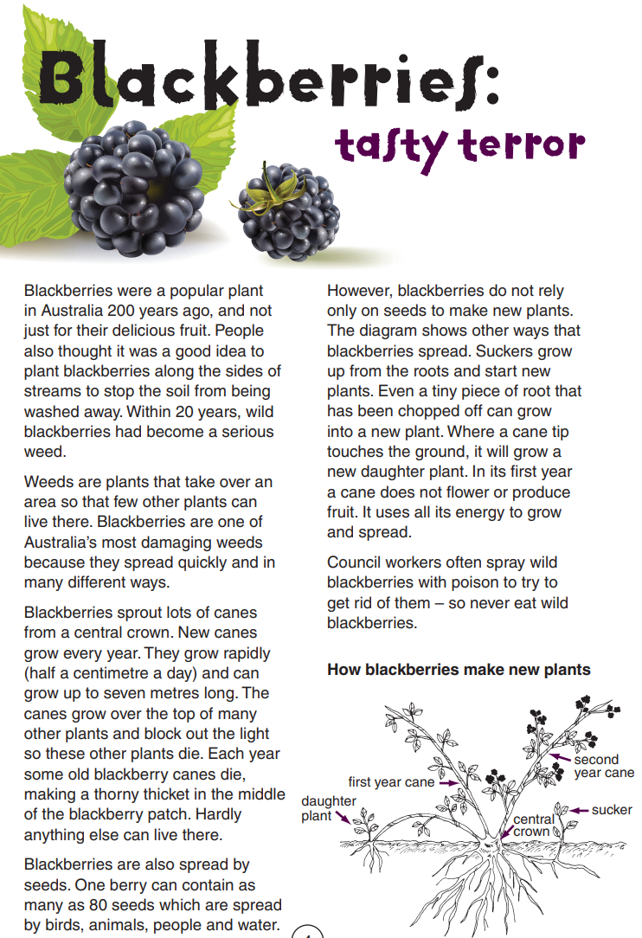
Year 7 NAPLAN Reading Magazine, 2011 ACARA

Informative vs persuasive text analysis – accessible version
- Colour code language and text features which are typically persuasive and those which are informative.
- What is the purpose of this text? How do you know this?

Blackberries: Tasty Terrors
Blackberries were a popular plant in Australia 200 years ago, and not just for their delicious fruit. People also thought it was a good idea to plant blackberries along the sides of streams to stop the soil from being washed away. Within 20 years, wild blackberries had become a serious weed.
Weeds are plants that take over an area so that few other plants can live there. Blackberries are one of Australia’s most damaging weeds because they spread quickly and in many different ways.
Blackberries sprout lots of canes from a central crown. New canes grow every year. They grow rapidly (half a centimetre a day) and can grow up to seven metres long. The canes grow over the top of many other plants and block out the light so these other plants die. Each year some old blackberry canes die, making a thorny thicket in the middle of the blackberry patch. Hardly anything else can live there.
Blackberries are also spread by seeds. One berry can contain as many as 80 seeds which are spread by birds, animals, people and water.
However, blackberries do not rely only on seeds to make new plants. The diagram shows other ways that blackberries spread. Suckers grow up from the roots and start new plants. Even a tiny piece of root that has been chopped off can grow into a new plant. Where a cane tip touches the ground, it will grow a new daughter plant. In its first year a cane does not flower or produce fruit. It uses all its energy to grow and spread.
Council workers often spray wild blackberries with poison to try to get rid of them – so never eat wild blackberries.
How blackberries make new plants
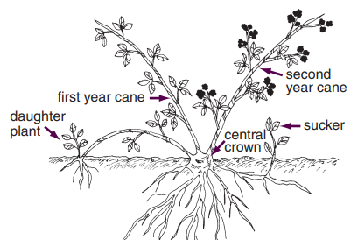
Daughter plant First year cane Second year cane Sucker Central growth
Year 7 NAPLAN Reading Magazine, 2011 ACARA

Informative vs persuasive text analysis
- Colour code language and text features which are typically persuasive and those which are informative.
- What is the purpose of this text? How do you know this?
Year 7 NAPLAN Reading Magazine, 2011 ACARA

Informative vs persuasive text analysis – accessible version
- Colour code language and text features which are typically persuasive and those which are informative.
- What is the purpose of this text? How do you know this?
Read books – and change lives!
Read books for Book Aid International.
Every $4 you raise will help send one brand new book to a library in Sub-Saharan Africa, where books really can change lives.
How can you help?
1 Register on the Internet.
2 Find sponsors. Ask friends and family to give you money for every book you read.
3 Read as many books as you can in one month.
4 Collect the money from your sponsors.
5 Send the money you raise to Book Aid International.
Register now at www.bookaid.org
Why should you help?
Many adults and children in Sub-Saharan Africa cannot read very well. Families often do not have money to pay for books of their own. Book Aid International helps to provide books and libraries. Without this help, many African children might not see or read a book during their childhood.
“I am a Maasai boy and one day our school was invited to a reading tent in Vigwaza. We walked for almost three hours to reach the main road. From there we boarded a bus to Vigwaza. There were many other children from other schools there. I chose a book called Mgabga Pazi. The story was very, very nice and I enjoyed it. In our school there were no such books. When we arrived home everybody was exhausted, but we were very excited to tell our parents what we had seen. The reading tent made me see these books for the first time in my life, so I will always remember it.”
Year 7 NAPLAN Reading Magazine, 2011 ACARA

Appendix 2

Is it credible?
Accuracy
Does it have facts? Statistics? Does it use quotes? Is it factual or an opinion piece?
Purpose
Is the purpose to inform, persuade/sell or to entertain?
Author
Who wrote the text? Are they an expert? Is there bias in the text? Who benefits from this text? Are there authorities on this topic?
Currency
How recently was the text written? When was it last updated?
Authority
Is the syntax correct? What technical language is used? Subject-specific language? Are there referenced facts and data?

How credible is it?

Appendix 3

Critically evaluating a web source
Website evaluation | Student responses
Name of site:
Site author(s):
Credentials of the author(s):
Purpose of site:
Is the site regularly updated?
Does the site use credible references? How do you know?
Is the site affiliated with other credible organisations?
Do the links work? Do they take you to reliable sources?
Can you contact the site’s authors easily?
What else do you notice about the site? URL address, use of language devices…
When you look at other credible sources of information, what do they suggest about the information on this site?
Are there obvious omissions from this site? (Evidence missing, only one side presented.)
Is this site a reliable source of information? Why/why not?

