Author perspective and bias
Stage 4

Overview

Purpose
This literacy teaching strategy supports teaching and learning for Stage 4 students across all key learning areas. It targets specific literacy skills and suggests a learning sequence to build skill development. Teachers can select individual tasks, or a sequence, and embed into their teaching and learning program according to their students’ needs. While exemplar texts are provided throughout this resource, it is recommended that teachers select texts which are relevant to their students and curriculum.

Learning intention
Students will learn to identify author perspective in texts. Students will learn to find evidence in the text to understand author perspective.

Syllabus outcome
The following teaching and learning strategies will assist in covering elements of the following outcomes:
- EN4-RVL-01: uses a range of personal, creative and critical strategies to read texts that are complex in their ideas and construction
- EN4-URA-01: analyses how meaning is created through the use of and response to language forms, features and structures
- EN4-URB-01: examines and explains how texts represent ideas, experiences and values
- EN4-2A: effectively uses a widening range of processes, skills, strategies and knowledge for responding to and composing texts in different media and technologies
NSW English K-10 Syllabus (2022)
Visit the Leading curriculum K-12 website for more information on the syllabus implementation timeline.

Success criteria
The following Year 7 NAPLAN item descriptors may guide teachers to co-construct success criteria for student learning.
- analyses the author's intentions in a quotation
- analyses the author's perspective in a blog post
- analyses the author's perspective in a text
- analyses the author's perspective in an information text
- analyses the author's perspective on a website
- analyses the style of writing in an information text
- identifies an author's assumption in an information text
- identifies the intended audience for an information text

National Literacy Learning Progression guide

Understanding Texts (UnT9-UnT11)
Key: C=comprehension P=process V=vocabulary

UnT9
- identifies the main themes or concepts in complex texts by synthesising key ideas or information (C)
- evaluates text features for relevance to purpose and audience (C)
- analyses texts which have more than one purpose and explains how parts of the text support a particular purpose (C)
- identifies different interpretations of the text citing evidence from a text (C)
- uses processes such as predicting, confirming predictions, monitoring, and connecting relevant elements of the text to build or repair meaning (P)
- identifies language used to create tone or atmosphere (V)

UnT10
- applies and articulates criteria to evaluate the language structures and features for relevance to purpose and audience (C)
- evaluates the reasoning and evidence in a persuasive text (C)
- analyses the author’s perspectives in complex or some highly complex texts (C)
- integrates automatically a range of processes such as predicting, confirming predictions, monitoring, and connecting relevant elements of the text to build meaning (P)

UnT11
- analyses the credibility and validity of primary and secondary sources (C)
- identifies subtle contradictions and inconsistencies in texts (P)
National Literacy Learning Progression

Evidence base
- Centre for Education Statistics and Evaluation (2017). Effective reading instruction in the early years of school, literature review.
- Oakhill, J., Cain, K. & Elbro, C. (2015). Understanding and teaching reading comprehension: A handbook. Routledge.
- Quigley, A. (2020). Closing the reading gap. Routledge.
- Scarborough, H.S. (2001). Connecting early language and literacy to later reading (dis)abilities: Evidence, theory and practice. In S. Neuman & D. Dickson (Eds.), Handbook for research in early literacy (pp. 97-110). New York, NY: Guilford Press.
Alignment to system priorities and/or needs: Five priorities for Literacy and Numeracy, Our Plan for NSW Public Education, School Excellence Policy (nsw.gov.au).
Alignment to School Excellence Framework: Learning domain: Curriculum, Teaching domain: Effective classroom practice and Professional standards
Consulted with: Strategic Delivery, Teaching Quality and Impact
Author: Literacy and Numeracy
Reviewed by: Literacy and Numeracy, Teaching Quality and Impact
Created/last updated: January 2023
Anticipated resource review date: January 2024
Feedback: Complete the online form to provide any feedback

Copyright
Section 113P Notice
Texts, Artistic Works and Broadcast Notice
Some of this material has been copied and communicated to you in accordance with the statutory licence in section 113P of the Copyright Act. Any further reproduction or communication of this material by you may be the subject of copyright protection under the Act. Do not remove this notice.

Teaching strategies
Task | Appendices
Identifying author perspective | Appendix 1 - Identifying perspective in texts
Author purpose and audience | Appendix 2 - Michael Leunig cartoons
Selling to audiences
Tone | Appendix 3 - Identifying tone in text extracts
Identifying tone in text | Appendix 4 - ‘Holes’ extract - identifying tone in text
Mood | Appendix 5 - Evoking mood image stimulus
Theme
Bias | Appendix 6 – Cloze: identifying bias

Background information

Perspective
A lens through which the author perceives the world and creates a text, or the lens through which the reader or viewer perceives the world and understands a text. Readers may also temporarily adopt the perspectives of others as a way of understanding texts.
Author perspective is often conveyed through some combinations of the following features:

Tone
The voice adopted by a particular speaker to indicate emotion, feeling or attitude to subject matter. The author's attitude towards the subject and audience, for example playful, serious, ironic, formal, etc.

Mood
In literature, the emotive attitude or feeling carried by a particular text, for example happiness, excitement, doom. It has much in common with tone.

Theme
An overarching or recurring idea that describes attitudes or values that are perceived in a text. A theme may range from the understood ‘moral’ of a text to philosophical observations that the audience makes about the events, characters and experiences depicted in a text. A text may have more than one theme.

Bias
In argument or discussion, to favour one side or viewpoint by ignoring or excluding conflicting information; a prejudice against something.

Text features.
Structural or stylistic components that combine to construct meaning and achieve purpose. Can be recognisable as characterising particular types of texts.

Text structure
The ways information is organised in different types of texts, for example chapter headings, subheadings, tables of contents, indexes and glossaries, overviews, introductory and concluding paragraphs, sequencing, topic sentences, taxonomies, cause and effect. Choices in text structures and language features together define a text type and shape its meaning (see language features).

Textual form
The conventions specific to a particular type of text, often signalling content, purpose and audience, for example letter form, drama script, blog.

Visual literacy
The ability to decode, interpret, create, question, challenge and evaluate texts that communicate with visual images as well as, or rather than, words. Visually literate people can read the intended meaning in a visual text such as an advertisement or a film shot, interpret the purpose and intended meaning, and evaluate the form, structure and features of the text. They can also use images in a creative and appropriate way to express meaning.
Reference: English K-10 Syllabus © NSW Education Standards Authority (NESA) for and on behalf of the Crown in right of the State of New South Wales, 2012 and 2022.

Where to next?
- Audience and purpose
- Text structure
- Analysing character

Overview of teaching strategies

Purpose
These literacy teaching strategies support teaching and learning from Stage 2 to Stage 5. They are linked to NAPLAN task descriptors, syllabus outcomes and literacy and numeracy learning progressions.
These teaching strategies target specific literacy and numeracy skills and suggest a learning sequence to build skill development. Teachers can select individual tasks or a sequence to suit their students.

Access points
The resources can be accessed from:
- NAPLAN App in Scout using the teaching strategy links from NAPLAN items
- NSW Department of Education Literacy and numeracy website.
What works best
Explicit teaching practices involve teachers clearly explaining to students why they are learning something, how it connects to what they already know, what they are expected to do, how to do it and what it looks like when they have succeeded. Students are given opportunities and time to check their understanding, ask questions and receive clear, effective feedback.
This resource reflects the latest evidence base and can be used by teachers as they plan for explicit teaching.
Teachers can use classroom observations and assessment information to make decisions about when and how they use this resource as they design teaching and learning sequences to meet the learning needs of their students.
Further support with What works best is available.
Differentiation
When using these resources in the classroom, it is important for teachers to consider the needs of all students, including Aboriginal and EAL/D learners.
EAL/D learners will require explicit English language support and scaffolding, informed by the EAL/D enhanced teaching and learning cycle and the student’s phase on the EAL/D Learning Progression. Teachers can access information about supporting EAL/D learners and literacy and numeracy support specific to EAL/D learners.
Learning adjustments enable students with disability and additional learning and support needs to access syllabus outcomes and content on the same basis as their peers. Teachers can use a range of adjustments to ensure a personalised approach to student learning.
Assessing and identifying high potential and gifted learners will help teachers decide which students may benefit from extension and additional challenge. Effective strategies and contributors to achievement for high potential and gifted learners helps teachers to identify and target areas for growth and improvement. A differentiation adjustment tool can be found on the High potential and gifted education website.

Using tasks across learning areas
This resource may be used across learning areas where it supports teaching and learning aligned with syllabus outcomes.
Literacy and numeracy are embedded throughout all syllabus documents as general capabilities. As the English and mathematics learning areas have a particular role in developing literacy and numeracy, NSW English and Mathematics syllabus outcomes aligned to literacy and numeracy skills have been identified.

Text selection
Example texts are used throughout this resource. Teachers can adjust activities to use texts which are linked to their unit of learning.
Further support with text selection can be found within the National Literacy Learning Progression Text Complexity appendix.
The NESA website has additional information on text requirements within the NSW syllabus.

Teaching strategies

Identifying author perspective
- Introduce to students that they will be exploring a range of texts with a focus on author perspective. There are many things that contribute to identifying an author perspective including tone, mood, theme, assumptions, audience and so on. Perspective is the values and life experience an author brings to a text – the reader can look for clues in the text to try to determine an author’s perspective.
- Create a class display with each aspect explored in these teaching strategy tasks: tone, mood, theme, bias, assumptions, audience and have students jointly contribute to explain what each means at the completion of each task.
- Teachers might select one text from a unit of learning and use it to explore the following aspects, or, alternatively, use Appendix 1 - Identifying perspective in texts to fill in along the way. Appendix 1 may also be used as a culminating activity to gauge understanding of students.

Author purpose and audience
- Review three key purposes of text: to entertain, to persuade and to inform.
- In small groups, students are presented with one of a range of texts linked to the current unit of learning, including websites, newspaper articles, novels and picture books. Students determine the purpose of the text by looking at key features, including text structure, vocabulary and text layout elements such as headings, sub-headings and diagrams. Students explore if the text has a dual purpose, for example, does it both inform and persuade?
- Discuss the idea of assumptions: that whenever an author composes something, they will make assumptions about the reader. A writer will be making assumptions about the kind of reader who will read their work. Common assumptions include reader background knowledge about the author, topic and text, reader attitude towards the content, as well as information about the author and their perspective.
- Cartoon graffiti: Students are given Michael Leunig cartoons and work in teams to add ideas in the form of a mind map or dialogue/speech bubbles around the image to answer what Michael Leunig thinks his reader’s background knowledge is, what he thinks your attitude towards the content might be and what you know about him as a cartoonist. (Appendix 2 - Michael Leunig cartoons.)

Selling to audiences
- Students brainstorm a range of audiences for products. The class then brainstorms products to sell; these can be made up or can be actual products. For example, an audience may be young working professionals and a product might be self-zipping jeans. Both audiences and products are written on paper and then placed in different containers for students to draw out, one of each.
- With their target audience and product, students design an advertisement. Students will need to consider factors such as: vocabulary, sentence complexity and the selling ‘pitch’ that will best appeal to their audience. This can be presented through a range of products, including as short film and advertisement, a live performance, jingle or a poster. To support students, give an existing ad with the text removed and ask students to consider what they would need to say to sell it. Alternatively, they could have the whole ad and create alternative or additional text to sell the same product. Students could annotate visual and language techniques, explaining how they have been used to persuade the audience.
- Share with class and have class members guess the target audience, citing evidence.

Tone
- Survey the class and ask if they have ever emailed or texted someone meaning one thing, but the person took it to mean something else. Explain that when it comes to emails or texts you don’t have your voice to help convey the tone of your message, so those on the other side of the screen will read tone into your email/text based on the words, formatting, punctuation, and other choices you make.
- Discuss tone and what evidence might be found in a text to indicate the tone of an author. Tone is the voice adopted by a particular speaker to indicate emotion, feeling or attitude to subject matter.
Students identify tone and complete Appendix 3 - Identifying tone in text extracts (leaving ‘mood’ column for later task).
- Brainstorm a list of words that describe an emotion (noun)/tone (adjective), for example, annoyed, happiness, unconcerned, sadness, bitter, joyful, direct. Categorise the words into three groups:
- Positive tone words – happiness, joyful
- Neutral tone words – unconcerned, direct
- Negative tone words – sadness, bitter
To increase complexity, students compose their own text utilising the positive/neutral/negative tone words. In pairs, students experiment with language, making subtle changes to language to change meaning. Students then read aloud their sentences to their peers, testing the impact of these subtle shifts in language.

Identifying tone in text
- Divide students into groups of 3 or 4. Give each group one of the following tone words: sad, regretful, courageous, tense, sympathetic, loving/romantic, happy, proud, sarcastic, excited, fearful, anxious and nostalgic.
- Each group composes a short description of a dog walking in the park, conveying the attitude on the card. Have students consider type of language, punctuation and vocabulary choices. Each group shares their descriptions with the rest of the class. Have the class guess the tone of each description, citing evidence.
- Students are given a novel extract to read. (Appendix 4 - ‘Holes’ extract - identifying tone in text). Students work in teams to discuss and identify the tone of each section within the text. This task can be done with any text linked with current unit of learning.
- Students track how the tone changes throughout the text and visually represent the changes. Students discuss how this support author perspective; for example, the beginning of an article might state facts and statistics and be quite formal yet end with an emotional appeal indicating the author’s perspective. The author is controlling the tone to support them to convey their message.

Mood
- Teacher shows an image (Appendix 5 - Evoking mood image stimulus) for students to brainstorm the mood it evokes for the viewer. Discuss the idea that mood is the feeling of the viewer and reader and this is impacted by the author’s tone. Mood is about the feeling the reader gets when reading. It is the atmosphere the author creates using descriptive language and also through the setting, actions of the characters, and language choices. To increase complexity, discuss how authors rely on stereotypes and connotations to create mood and tone. How might a reader’s experiences/ assumptions/ background knowledge influence the interpretation of mood and tone in a text?
- Students revisit ‘Tone -Task 2’ and complete the ‘mood’ column from. Appendix 3 - Identifying tone in text extracts
- Create Opposites: Students are divided into small groups. Assign each group a tone and mood scenario, such as:
- Angry tone with a humorous mood
- Humorous tone with an angry mood
- Neutral tone with an angry mood
- Neutral tone with a humorous mood
- Give the class a single topic/theme and instruct groups to work together to create a paragraph in the tone and mood assigned. Alternatively, students might use an image to respond to. Students discuss the language and punctuation required to build mood and tone in the paragraph. For complexity, students could create a ‘mood board’ to visually capture the mood and tone, a word bank and/or word cline to support their writing
- To add an element of competition to the activity, have each group read their paragraph to the class. After each reading, instruct the other groups to rate the story on how well it met the required tone and mood (ratings from 1-10 for tone and 1-10 for mood). The winning group is the one with the highest combined ratings for both tone and mood.

Theme
- Review idea of ‘theme’ as a central message of a text. It is what the author wants you to learn or know and is a broad idea about life. The theme is usually not stated and must be inferred from vocabulary, text structure, purpose, tone, mood and bias, as well as more concrete aspects, such as plot, topic, character and setting, topic, character and setting.
- Have students develop a list of topics (usually one word) that are explored in a text currently being read or film being viewed. For example, some common topics in literature are family, loyalty, identity, ambition, guilt, fear, power, sacrifice, love, trust, ignorance, freedom.
- Students write a responsive sentence about what the author thinks about the topic: “The author thinks that… love is a powerful force that is pivotal to happiness”. Teachers then model removing the lead-in statement:” The author thinks…” and we are left with the theme of the text.
- Read or view a range of short texts and model identifying the central theme. Using short films such Pixar shorts (pixar.com) are a great way to see a whole text to identify the theme. Using the film, students can identify the tone, mood and subsequently, the theme of each movie. Ask key questions to illicit the theme: What did the author want us to think about? What idea stays with you? What will you remember about the story a year from now?
- Students explore what their view of the theme is, for example, their view on the theme of family. Students use their ideas to create a paragraph or poem where this theme is shown but not directly stated.

Bias
- KWL: Complete a KWL chart on current understanding of bias. English syllabus glossary defines bias as: in argument or discussion, to favour one side or viewpoint by ignoring or excluding conflicting information; a prejudice against something.
- Prompt a whole class or small group, student-led discussion with questions such as:
- What do you think bias is?
- Where have you seen examples?
- What are some of your own bias?
- How do author’s show or hide their bias?
- Why is it important to know if someone has a bias?
- How can we check if there is bias?
- Exploring personal bias: Students complete cloze passage independently (Appendix 6 – Cloze: identifying bias). This cloze activity is a way of seeing their own personal bias. It is important that it is completed without discussion so students can answer with their own bias. Students then share in a group of three and need to debate which word best suits and how this affected the text (refer to Vocabulary in context resource for more support). Discuss the importance of acknowledging bias in texts, and that each responder brings their own judgements.
(Lesson idea adapted from Jacquelyn Whiting ‘Everyone has invisible bias’, 2019
- Finding the gaps: Discuss that when authors compose a text, they are choosing what they put in and leave out of their writing. For example, an author would not talk about disliking vegetables if the text was promoting healthy food choices. Have students read a range of newspaper articles from kidsnews.com.au which are linked to current unit of learning. Students read the headline and brainstorm what ideas they are expecting to find in the text, as well as ideas that might not be presented in the text in the following format:
Headline:

Predicted ideas that support headline | Predicted ideas that do not support the headline:

Questions:
As students are reading the text, colour-code whether the information is for or against the article. Students then brainstorm a list of questions they would want to ask the author or an expert who has a different perspective to the one presented.
- Experts and stats: Have students identify and research names and titles of the people cited in an article. Students research the experts and discuss with a partner how credible they are. Students work in partners to identify statistics, images, facts, graphics, to help ascertain the author’s perspective. Using the statistics and information, students answer the following: what does the author want readers to learn or know? What was included? What wasn’t included?

Appendix 1

Identifying author perspective
Two craggy ﬁsts of land, joined by a long, thin neck of sand, made up the island of Lunawanna Alonnah, the country of the Nuenonne clan. An extensive coastline facing into the ocean provided nesting burrows for the inexhaustible supply of mutton birds that migrated every year from Siberia. Rocky outcrops were perfect nesting sites for equally numerous penguins that migrated from the sub-Antarctic. Undulating forests of bull kelp sprouting from rock ledges along the shore gave protection and nutrition to crayﬁsh and abalone, while oysters and mussels grew in the myriad tidal rock pools. Further out to sea, tiny, barren islands were nurseries for the fur seals the Nuenonne would hunt in ocean-going canoes they constructed from rolled bark bound together with reeds.
On the western side, an extensive, deep channel separated the island from the much larger landmass Abel Tasman had named Van Diemen’s Land. On the sandy coves of the western side, scallops, oysters and mussels were easily harvested, while sheltered lagoons and inlets were nesting sites for the black swans whose eggs were considered a great delicacy. Such abundant food sources supplied the varied Nuenonne diet. They did not bother to harvest scaleﬁsh, which they regarded with revulsion.
Cassandra Pybus ‘Truganini: Journey through the apocalypse’ (2020) Allen and Unwin.
Tone | Mood | Theme
Assumptions | Author perspective | My perspective

Identifying author perspective
I love the snow gum. Its stout trunk strong. . . beautiful coloured patterns appear when wet; a gift from God. The sturdy tree’s limbs outstretched, waiting to take the weight of winter. . . the weight of you.
Oh, to see these trees after an autumn shower….it’s this rare beauty that reminds me why I stay…
Late one evening Daniel Johnson sits alone on the verandah of a newly renovated homestead, reading from a tatty notebook, his lantern light low. The notebook is sixteen years old now – a collection of sketches, poems and memories. He knew he had to put it all down somehow. From the moment that spurred the four of them – Danny, Joe Junior, Henry James and little Delphi – to run into the mountains to be with them, and everything he learnt in those four short years. Their knowledge ancient beyond comprehension, and there was only so much they could share. Time and society were against them.

Tone | Mood | Theme
Assumptions | Author perspective | My perspective
Copied under the statutory licence in s113P of the Copyright Act. Leah Purcell ‘The Drover’s Wife’ (2019) Penguin. Section 113P Warning Notice

Appendix 2

Identifying author assumption
Michael Leunig cartoons
- What does Michael Leunig think his reader’s background knowledge is?
- What does Michael Leunig think your attitude towards the content might be?
- What does Michael Leunig think you know about him as a cartoonist?
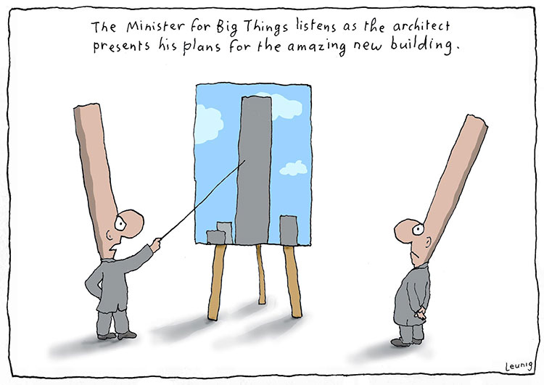
Image courtesy of Michael Leunig. Leunig website (2018)

Identifying author assumption
Michael Leunig cartoons
- What does Michael Leunig think his reader’s background knowledge is?
- What does Michael Leunig think your attitude towards the content might be?
- What does Michael Leunig think you know about him as a cartoonist?
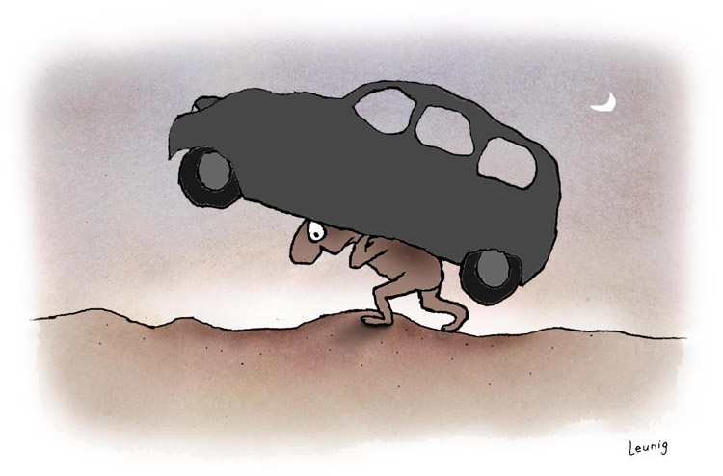
Image courtesy of Michael Leunig. Leunig website (2018)

Identifying author assumption
Michael Leunig cartoons
- What does Michael Leunig think his reader’s background knowledge is?
- What does Michael Leunig think your attitude towards the content might be?
- What does Michael Leunig think you know about him as a cartoonist?
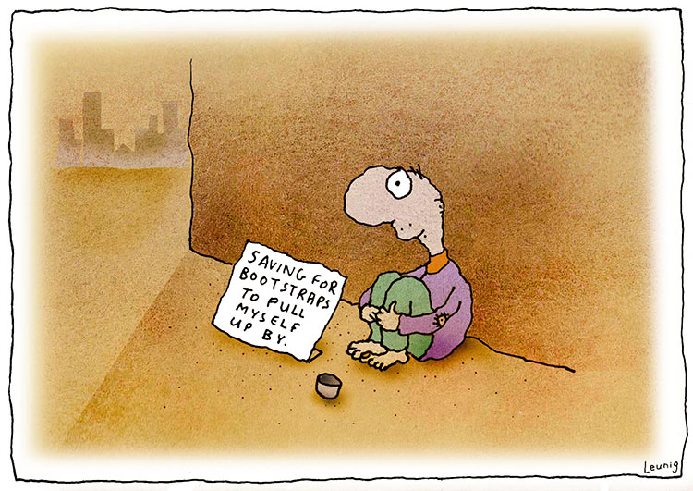
Image courtesy of Michael Leunig. Leunig website (2018)

Identifying author assumption
Michael Leunig cartoons
- What does Michael Leunig think his reader’s background knowledge is?
- What does Michael Leunig think your attitude towards the content might be?
- What does Michael Leunig think you know about him as a cartoonist?
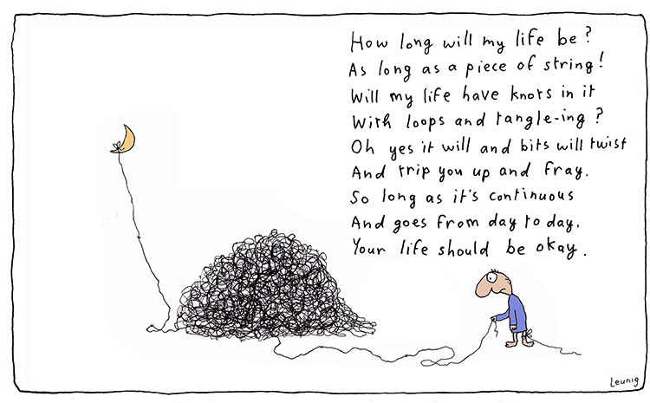
Image courtesy of Michael Leunig. Leunig website (2018)

Appendix 3

Student copy: Identifying tone in text extracts
Sentence | Tone – what is the author’s feeling? | Evidence | Mood – What feelings did it create for the reader?
This meeting was a complete waste of my time.
I felt like I was being suffocated by the smoke - I was struggling to breathe.
Tim Foote, editor of In Your Face News, has retired aged 74.
Of course I want to listen to your completely unrelated ideas!
I was happy to go along with it…for the moment.
The staff common room was filled with smoke, the brownies burnt and the children had to quickly take cover outside.
Tilly’s room was covered with everything she loved! She couldn’t wait to add the newest toy to her collection!
Their mouths were open and their eyes glanced sidewards at each other – could this actually be happening?
The pasta was ruined! It was a travesty to her family’s heritage!

Appendix 4

Identifying tone in text

‘Holes’ by Louis Sachar (2000) Bloomsbury
Stanley Yelnats was the only passenger on the bus, not counting the driver or the guard. The guard sat next to the driver with his seat turned around facing Stanley. A rifle lay across his lap.
Stanley was sitting about ten rows back, handcuffed to his armrest. His backpack lay on the seat next to him. It contained his toothbrush, toothpaste, and a box of stationary his mother had given him. He’d promised to write to her at least once a week.
He looked out the window, although there wasn’t much to see—mostly fields of hay and cotton. He was on a long bus ride to nowhere. The bus wasn’t air-conditioned, and the hot heavy air was almost as stifling as the handcuffs.
Stanley and his parents had tried to pretend that he was just going away to camp for a while, just like rich kids do. When Stanley was younger he used to play with stuffed animals, and pretend the animals were at camp. Camp Fun and Games he called it. Sometimes he’d have them play soccer with a marble. Other times they’d run an obstacle course, or go bungee jumping off a table, tied to broken rubber bands. Now Stanley tried to pretend he was going to Camp Fun and Games. Maybe he’d make some friends, he thought. At least he’d get to swim in the lake.
He didn’t have any friends at home. He was overweight and the kids at his middle school often teased him about his size. Even his teachers sometimes made cruel comments without realizing it. On his last day of school, his math teacher, Mrs. Bell, taught ratios. As an example, she chose the heaviest kid in the class and the lightest kid in the class, and had them weigh themselves. Stanley weighed three times as much as the other boy. Mrs. Bell wrote the ratio on the board, 3:1, unaware of how much embarrassment she had caused both of them.
Stanley was arrested later that day.
He looked at the guard who sat slumped in his seat and wondered if he had fallen asleep. The guard was wearing sunglasses, so Stanley couldn’t see his eyes. Stanley was not a bad kid. He was innocent of the crime for which he was convicted. He’d just been in the wrong place at the wrong time.
It was all because of his no-good-dirty-rotten-pig-stealing-great-great-grandfather! He smiled. It was a family joke. Whenever anything went wrong, they always blamed Stanley’s no-good-dirty-rotten-pig-stealing-great-great-grandfather!
Supposedly, he had a great-great-grandfather who had stolen a pig from a one-legged Gypsy, and she put a curse on him and all his descendants. Stanley and his parents didn’t believe in curses, of course, but whenever anything went wrong, it felt good to be able to blame someone. Things went wrong a lot. They always seemed to be in the wrong place at the wrong time.
Copied under the statutory licence in s113P of the Copyright Act. Louis Sacher, Holes, Bloomsbury, 2000. Section 113P Warning Notice

Appendix 5

Evoking mood image stimulus
Photo by Milan Popovic on Unsplash.com

Appendix 6

Cloze: identifying bias
All students are capable of _______________, but we cannot expect all students to _______________ when far too many are ______________ houses without electricity and enough food.

Without _______________, we are putting our world at risk. It is up to _______________ to make changes and put plans into action.

_______________ is the most important part of Australian sporting culture. Whilst some think _______________ is the epitome of sportsmanship, others would not look past _______________ as the future.

A prolific author, _______________ has changed the literacy landscape for _______________. Up and coming authors look no further to see _______________.

_______________ should be the next Prime Minister of Australia due to _______________.

