Audience and Purpose
Stage 4

Overview

Purpose
This literacy teaching strategy supports teaching and learning for Stage 4 students across all key learning areas. It targets specific literacy skills and suggests a learning sequence to build skill development. Teachers can select individual tasks, or a sequence, and embed into their teaching and learning program according to their students’ needs. While exemplar texts are provided throughout this resource, it is recommended that teachers select texts which are relevant to their students and curriculum.

Learning intention
Students will have opportunities to identify the purpose and audience of a range of texts.

Syllabus outcomes
The following teaching and learning strategies will assist in covering elements of the following outcomes:
- EN4-RVL-01: uses a range of personal, creative and critical strategies to read texts that are complex in their ideas and construction
- EN4-URA-01: analyses how meaning is created through the use of and response to language forms, features and structures
- EN4-URB-01: examines and explains how texts represent ideas, experiences and values
- EN4-1A: responds to and composes texts for understanding, interpretation, critical analysis, imaginative expression and pleasure
- EN4-2A: effectively uses a widening range of processes, skills, strategies and knowledge for responding to and composing texts in different media and technologies
- EN4-3B: uses and describes language forms, features and structure of texts appropriate to a range of purposes, audiences and contexts
NSW English Syllabus K-10 (2022)
Visit the Leading curriculum K-12 website for more information on the syllabus implementation timeline.

Success criteria
The following Year 7 NAPLAN item descriptors may guide teachers to co-construct success criteria for student learning.

- identifies the purpose of an orientation for a narrative extract
- identifies the purpose of repeated language in a text
- identifies the main purpose of a paragraph in an information text
- identifies the main purpose of an information text
- interprets directly stated information in a narrative
- identifies the purpose of a convention on a website
- identifies the purpose of a description in an information text
- identifies the purpose of a diagram in an information text
- identifies the purpose of a map in an information text
- identifies the purpose of an image in an information text
- identifies the purpose of an introductory sentence in an information text
- identifies the main purpose of persuasive text
- identifies the main purpose of a reference in a persuasive text
- identifies the purpose of a rhetorical question in a text
- identifies the purpose of a statement in a persuasive text
- identifies the purpose of supporting evidence in a persuasive text
- identifies the purpose of the opening paragraph of a persuasive text

National Literacy Learning Progression guide

Understanding Texts (UnT9-UnT11)
Key: C=comprehension P=process V=vocabulary

UnT9
- evaluates text features for relevance to purpose and audience (C)
- analyses texts which have more than one purpose and explain how parts of the text support a particular purpose (C)
- distils information from a number of texts according to task and purpose (e.g. uses graphic organisers) (P)
- analyses language and visual features in texts using metalanguage (e.g. cohesion, interpretation, figurative) (V)

UnT10
- reads and views moderately complex or some highly complex texts (see Text complexity) (C)
- applies and articulates criteria to evaluate the language structures and features for relevance to purpose and audience (C)
- analyses the techniques authors use to position readers (C)

UnT11
- interprets symbolism in texts, providing evidence to justify interpretation (C)
- analyses the cumulative impact of use of language features and vocabulary across texts (C)
National Literacy Learning Progression

Evidence base
- Centre for Education Statistics and Evaluation (2017). Effective reading instruction in the early years of school, literature review.
- Oakhill, J., Cain, K. & Elbro, C. (2015). Understanding and teaching reading comprehension: A handbook. Routledge.
- Quigley, A. (2020). Closing the reading gap. Routledge.
- Scarborough, H.S. (2001). Connecting early language and literacy to later reading (dis)abilities: Evidence, theory and practice. In S. Neuman & D. Dickson (Eds.), Handbook for research in early literacy (pp. 97-110). New York, NY: Guilford Press.
Alignment to system priorities and/or needs: Five priorities for Literacy and Numeracy, Our Plan for NSW Public Education, School Excellence Policy (nsw.gov.au).
Alignment to School Excellence Framework: Learning domain: Curriculum, Teaching domain: Effective classroom practice and Professional standards
Consulted with: Strategic Delivery, Teaching Quality and Impact
Author: Literacy and Numeracy
Reviewed by: Literacy and Numeracy, Teaching Quality and Impact
Created/last updated: January 2024
Anticipated resource review date: January 2025
Feedback: Complete the online form to provide any feedback

Copyright
Section 113P Notice
Texts, Artistic Works and Broadcast Notice
Some of this material has been copied and communicated to you in accordance with the statutory licence in section 113P of the Copyright Act. Any further reproduction or communication of this material by you may be the subject of copyright protection under the Act. Do not remove this notice.

Teaching strategies
Task | Appendices
Know your audience - book cover analysis | Appendix 1 – ‘Hitler’s daughter’ book covers  Appendix 2 – Audience and purpose quadrant analysis
Purpose and audience
Text analysis | Appendix 2 – Audience and purpose quadrant analysis  Appendix 3 - Drought  Appendix 4 – On the Making of Drought
Entertain, persuade and inform in action | Appendix 5 – Audience and Purpose Example Texts
Paragraph detectives | Appendix 6 - Information text  Appendix 7 - Information text with missing paragraphs  Appendix 8 - Paragraph bank  Appendix 9 – Paragraph Detective Matrix
The measurement mission | Appendix 10 - Example of statistical display

Background information

Purpose

To entertain, to inform or to persuade different audiences in different contexts. Composers use a number of ways to achieve these purposes: persuading through emotive language, analysis or factual recount; entertaining through description, imaginative writing or humour, and so on.

Audience
Readers, listeners or viewers who engage with a text.
Reference: English K-10 Syllabus © NSW Education Standards Authority (NESA) for and on behalf of the Crown in right of the State of New South Wales, 2022.

Where to next?
- Author bias and perspective
- Text structure
- Inference

Overview of teaching strategies

Purpose
These literacy teaching strategies support teaching and learning from Stage 2 to Stage 5. They are linked to NAPLAN task descriptors, syllabus outcomes and literacy and numeracy learning progressions.
These teaching strategies target specific literacy and numeracy skills and suggest a learning sequence to build skill development. Teachers can select individual tasks or a sequence to suit their students.

Access points
The resources can be accessed from:
- NAPLAN App in Scout using the teaching strategy links from NAPLAN items
- NSW Department of Education literacy and numeracy website.
What works best
Explicit teaching practices involve teachers clearly explaining to students why they are learning something, how it connects to what they already know, what they are expected to do, how to do it and what it looks like when they have succeeded. Students are given opportunities and time to check their understanding, ask questions and receive clear, effective feedback.
This resource reflects the latest evidence base and can be used by teachers as they plan for explicit teaching.
Teachers can use classroom observation and other assessment information to make decisions about when and how they use this resource as they design teaching and learning sequences to meet the learning needs of their students.
Further support with What works best is available.
Differentiation
When using these resources in the classroom, it is important for teachers to consider the needs of all students, including Aboriginal and EAL/D learners.
EAL/D learners will require explicit English language support and scaffolding, informed by the EAL/D enhanced teaching and learning cycle and the student’s phase on the EAL/D Learning Progression. Teachers can access information about supporting EAL/D learners and literacy and numeracy support specific to EAL/D learners.
Learning adjustments enable students with disability and additional learning and support needs to access syllabus outcomes and content on the same basis as their peers. Teachers can use a range of adjustments to ensure a personalised approach to student learning.
Assessing and identifying high potential and gifted learners will help teachers decide which students may benefit from extension and additional challenge. Effective strategies and contributors to achievement for high potential and gifted learners helps teachers to identify and target areas for growth and improvement. A differentiation adjustment tool can be found on the High potential and gifted education website.

Using tasks across learning areas
This resource may be used across learning areas where it supports teaching and learning aligned with syllabus outcomes.
Literacy and numeracy are embedded throughout all syllabus documents as general capabilities. As the English and mathematics learning areas have a particular role in developing literacy and numeracy, NSW English and Mathematics syllabus outcomes aligned to literacy and numeracy skills have been identified.

Text selection
Example texts are used throughout this resource. Teachers can adjust activities to use texts which are linked to their unit of learning.
Further support with text selection can be found within the National Literacy Learning Progression Text complexity appendix.
The NESA website has additional information on text requirements within the NSW English syllabus.

Teaching strategies

Know your audience - book cover analysis
- Display the book covers Appendix 1 – ‘Hitler’s daughter’ book covers around the room (book covers can be replaced with texts appropriate to the current unit of learning). Students select the cover they connect with the most and explain why.
- Class discussion: whilst this is the same text for the same audience, what are the characteristics of the audience that each different cover is trying to appeal to? Enlarge Appendix 2 – Audience and purpose quadrant analysis and use to support discussion.
- Have students discuss their findings and possible influences and impact on an illustrator’s designs. Students should use evidence from the text to justify their response. Share and reflect.
  - Possible considerations for discussion: font (style, size, position), symbols, layout such as salient image, background and foreground choices, framing, colour, lines and vectors.
- Students might then use a targeted audience to design their own cover and justify decisions on layout and design.

Purpose and audience
- KWL: Review purpose and audience – students create a KWL chart on what they currently know and what they want to know at the beginning of the activity. Students then add what was learnt at the end of the activity.
Purpose is the reason for communicating with someone. We can understand the purpose when we can satisfy through the following questions whether it is trying to inform, persuade or entertain:
- What is the author trying to achieve?
- What does the author want the reader to do with the text?
- Concept Map: students work in small groups to determine what an author might want to know about their audience before starting to compose a text. Ideas include cultural background; age; geographical location; level of education; current knowledge on the topic; background information the audience might need; interests; and what might affect their positions and feelings, for example, their beliefs on climate change.
- Designate three zones in the classroom: ‘To persuade the reader’; ‘To inform the reader;’ and ‘To entertain the reader.’ Labels could be set up beforehand. Select a range of texts that students are familiar and unfamiliar with. Ask students what they think the author’s purpose for the texts might be. Students go to the zone that they think is the best answer. Select students from each zone to indicate why they chose that zone and purpose.

Text analysis
- Word chain: Focus on building precise vocabulary as a whole class or in groups, students say aloud the first word that comes to mind when prompted by the previous word. For example, the word chain starts with the word ‘drought’. The next student may say ‘dry’, followed by the next student saying ‘dirt’. Scribe vocabulary on the board. Review vocabulary and add other terms to build vocabulary, for example, stemming from the word ‘dirt’ might be soil, landscape, parched land and so on.
- Read aloud and display text excerpt:
I remember when the rain stopped,
When day by day
the water dropped…
All across a sun-bleached land,
Drought spread its withered,
deadly hand.
- Think-Pair-Share: Discuss with pairs then fours, the purpose of this excerpt of poetry. Allow time for rigorous discussion to build understanding. Is the purpose to inform, persuade or to entertain? Students also might discuss what message the author is making. Discuss the context of this text in Australia and that it is part of a series of books with other titles including ‘Flood’ and ‘Drought’.
  - What is the effect of the ellipsis?
  - Can you identify the personification? What effect does this have on the audience?
  - What are the connotations of the word ‘withered’? How is this word a clue to the purpose of this text?
- Show cover from Jackie French and Bruce Whatley’s ‘Drought’ (Appendix 3 - Drought). Students discuss predictions for vocabulary and subject matter connecting to drought. Students read Jackie French and Bruce Whatley’s ‘On the Making of Drought’ to help determine the audience for the text (Appendix 4 – On the Making of Drought).
- Read text aloud, drawing attention to language and text structural features that indicate purpose and audience. Students add to their copy of Appendix 3 throughout the reading.
- Students are given multiple texts on the same topic, for example, floods. Texts need to cover a range of points of view or perspectives on the one topic, including articles showing impact on farmers, crops and livestock, people from towns in rural communities, newspaper articles detailing floods locally, nationally and globally, historical texts as well as artwork, poetry and picture books. Using these texts, students complete Appendix 2 – Audience and purpose quadrant analysis to determine the purpose and audience. Criteria developed in the previous activity should be used to guide justification.

Entertain, persuade and inform in action
- Using texts from Appendix 5 – Audience and Purpose Example Texts, groups of students are given a section to determine the purpose using the quadrant analysis (Appendix 2 – Audience and purpose quadrant analysis). Students work in groups to analyse their sections, then bring ideas to the overall text as a class. Discuss whether there are any discrepancies between the purpose and audience within the sections and whether this has an overall impact on the whole text.
- Repeat for the three broad purposes, entertain, persuade and inform. Appendix 5 contains a collection of resources to support this task, however, teachers may find texts, including multimodal, cultural and Aboriginal and Torres Strait Islander texts that better support their students and current learning.

Paragraph detectives
- Use Think-Pair-Share or a brainstorming tool, to allow students to review the features of an information text.
- What is the purpose of an information text?
- Who might read an information text?
- Ask students to identify different audiences for information texts on different topics.
- Discuss: What kinds of language features would they expect in an information text? Teacher can use text currently being explored in unit of learning, or use the text in Appendix 6 - Information text on cockatoos.
- descriptive language such as using adjectives and noun groups – for example: large white bird with a raucous call
- facts and statistics – for example: there are over 10 million cockatoos in Australia, living in all rural and urban areas
- sub-headings
- statistical displays
- rhetorical questions – for example: “…ever thought about what cockies eat?”
- scientific language – scientific names and scientific information – For example: “…the habitat of these birds includes” and “Cacatua galerita.”
- Distribute text ‘Don’t disturb the cockatoos on your lawn, they’re probably doing all your weeding for free’ (Appendix 7 - Information text with missing paragraphs) pointing out that 3 paragraphs have been removed, indicated by the feature box. Students are going to be paragraph detectives and identify the paragraphs which have been removed. Explain that students will receive a paragraph bank (Appendix 8 - Paragraph bank) to choose from. Just like a police detective, students will need to closely examine the evidence to gain clues as to which paragraph from the paragraph bank is the one which solves the puzzle and correctly contributes to the purpose of the text. Students use Appendix 9 – Paragraph Detective Matrix to record their ideas.
- Using the think aloud strategy, teacher models how to follow the clues and identify the missing paragraph, talking through Appendix 9 – Paragraph Detective Matrix and recording ideas.
- Groups or pairs to report back on their paragraph choice. To promote abstraction, if students’ choice of paragraph differs from the original text students could justify why their choice of paragraph is more appropriate to the purpose of the section and the entire text.

The measurement mission
- Explain that the information text ‘Don’t disturb the cockatoos on your lawn, they’re probably doing all your weeding for free’ (Appendix 6 - Information text) contains a number of paragraphs which cite statistical information. The students’ mission is to reduce the number of paragraphs overall in the text, and replace paragraphs which contain statistical information with some sort of statistical display. This activity can be replicated for any text connected to current unit of learning.
- Brainstorm the range of statistical displays students may be able to use. Examples include:
- Pie charts
- Vertical or horizontal column graphs
- Scatter graphs
- Picture graphs
- Model how a paragraph containing statistical information could be replaced with a statistical display. An example is Appendix 10 - Example of statistical display in which a vertical column graph has been used to visually represent some of the information in the paragraph at the top of the page.
- Students will justify how their statistical display captures the information previously conveyed discursively, using these sentence stems:
- We have chosen this type of statistical display for this paragraph because…
- The statistical display is a more effective representation of the statistical information in the article because…
- A statistical display benefits the reader of the information text in these ways…
- To increase abstraction, students may challenge the use of visually representing statistics over discursive representation, and you may wish to offer an opportunity for these students to justify their argument.
- To increase complexity, students could work in small teams with the aim to remove as much statistical information as possible, striving to create an information text with the least amount of paragraphs while still retaining its integrity, meaning and purpose.

Appendix 1

Jackie French ‘Hitler’s Daughter’ book covers
Copied under S113P of the Copyright Act, Jackie French, ‘Hitler’s Daughter’, Harper Collins, 1999, 9780207198014. | Copied under S113P of the Copyright Act, Jackie French, ‘Hitler’s Daughter’, Harper Collins, 2003, 9780060086527 | Copied under S113P of the Copyright Act, Jackie French, ‘Hitler’s Daughter’, Harper Collins, 2001, 9780007122721.
Copied under S113P of the Copyright Act, Jackie French, ‘Hitler’s Daughter’, Harper Collins, 1999, 9780207198014.
Images are front covers from Jackie French’s ‘Hitler’s Daughter’ (1999) published by HarperCollins, Australia.

Appendix 2

Audience and purpose quadrant analysis
Text:__________________________________________
Purpose  Does it inform, persuade or entertain?  What type of text is this? | Audience  Who is this written for?
Vocabulary  Vocabulary evidence of purpose and audience | Subject matter  What is the text about?

Appendix 3

Drought – Jackie French and Bruce Whatley
Vocabulary Subject matter
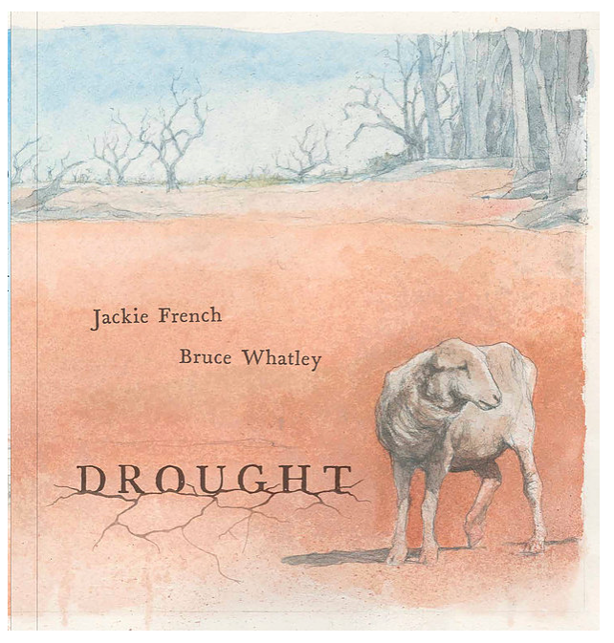
Purpose Audience
‘Drought’ Front cover image by Bruce Whatley, 2018 is licensed under CCBY-ND 2.0 and has been copied under the statutory licence in s113P of the Copyright Act.

Appendix 4

On the making of ‘Drought’ – Jackie French and Bruce Whatley
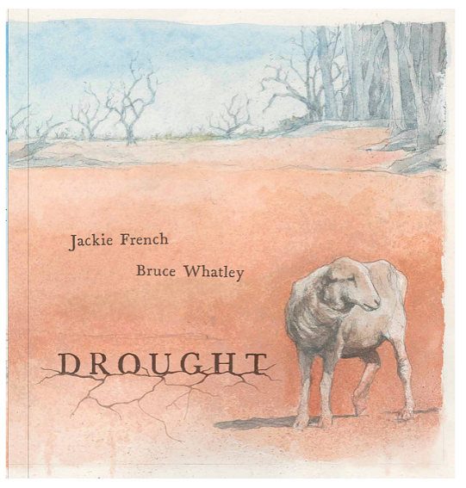
‘Drought’ image by Bruce Whatley, 2018 is licensed under CCBY-ND 2.0 and has been copied under the statutory licence in s113P of the Copyright Act.
Jackie French: It was a workshop of kids out west who accidentally showed me how bad drought can be.
‘Dad just sits by the radio and cries,’ said one.
‘Mine sits out in the paddock looking at the sky,’ said another.
Kid after kid casually told me of the endurance of living with drought.
I’ve lived through six droughts. At the end of the second one, I was no longer a farmer, reliant on the weather.
When it doesn’t rain now, I can write about it. But that doesn’t make the death of wildlife as waterholes dry up, and grass vanishes, easier to bear. If you only knew when a drought would end, you could plan. But so far, here, the wombats are more accurate in their predictions of the next years’ rain than the weather bureau.
Yet some of my most cherished memories are of that second drought: the dusty ute-load of second-hand donated toys for the local kids for Christmas, the bring-a-plate musical evenings.
You’re all in it together during a drought, and if you stick together life can be good. There is no malice in a drought. It is perhaps the way the Australian bush prunes itself down to the toughest and hardiest, recycling nutrients for new growth.
And these days, I also know that one day the air will thicken with moisture once again, and the drought will end.
Bruce Whatley: The visual elements of drought can be deceivingly beautiful. Amazing patterns in cracked soil, the extraordinary reds of the earth contrasting with the grey and whites of dead sun-bleached trees, the breathtaking sunsets and vast blue skies over flat treeless horizons . . . These are iconic images of Australia. Unfortunately, they mask the brutality of the elements that create it.
The illustrations were created with graphite pencil and an acrylic wash.

Appendix 5

Audience and purpose example texts

In the blood
Domestic cats have three different types of blood group, A, B and AB. But they lack the equivalent of the human blood group O. By far the most common blood type in domestic cats is blood type A, but the prevalence of different blood types varies with geographical location. For instance, all cats in Finland have blood type A, whereas only three-quarters of Australian cats are blood type A. The prevalence of different blood types also varies with breed.
Country | % of cats that are type A | % of cats that are type B
Finland | 100 | 0
USA | 99 | 1
England | 97 | 3
Germany | 93 | 7
Italy | 89 | 11
France | 85 | 15
Australia | 73 | 26
Transfusion Medicine Reviews, vol. 18, 2004, p.117
Pure cat breeds in USA | % frequency of type B cats
Siamese | 0
Oriental shorthair | 0
Burmese | 0
Tonkinese | 0
Russian Blue | 0
Maine Coon | Less than 5
Norwegian forest cat | Less than 5
Blood type in cats has no effect on coat colour or gender. But it can affect survival of kittens. For instance, if a female cat of blood type B is bred with a male of blood type A, between 75% to 100% of their offspring will be blood group A. But if these kittens nurse milk from their mother within 24 hours of birth, they may die. This is because kittens of type A or AB that nurse from a type B mother ingest antibodies against type A blood in their mother’s milk. About a day after ingestion, these antibodies are absorbed by the kitten’s stomach and gastrointestinal tract. Hemolysis, or the breaking open of blood cells, ensues, which can be fatal. A vet can tell when this may have happened to an otherwise healthy-looking kitten by looking at the cat’s tail. Necrosis at the tip of the tail is a sign that hemolysis has taken place. However, after 24 hours have passed, antibodies do not cross the kitten’s intestinal lining and the youngster can safely drink its mother’s milk.
An excerpt from: Walker, M. (2006). Moths that drink elephants’ tears and other zoological curiosities. Little, Brown book group, London.

Audience and purpose example texts
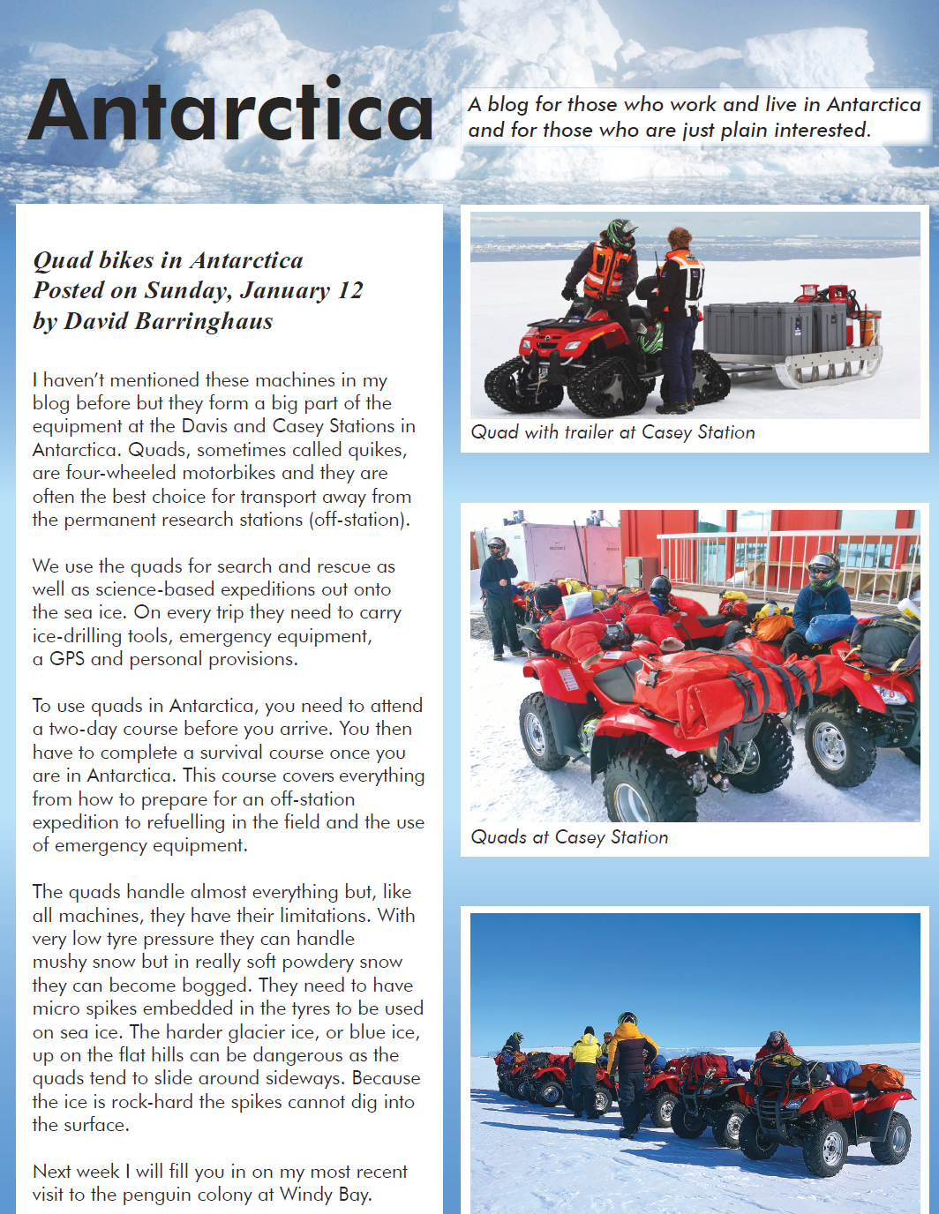
Year 7 NAPLAN reading magazine, 2016 ACARA

Audience and purpose example texts - accessible version

Antarctica
A blog for those who work and live in Antarctica and for those who are plain interested.

Quad bikes in Antarctica
Posted on Sunday, January 12 by David Barringhaus
I haven’t mentioned these machines in my blog before but they form a big part of the equipment at the Davis and Casey Stations in Antarctica. Quads, sometimes called quikes, are four-wheeled motorbikes and they are often the best choice for transport away from the permanent research stations (off-station).
We use the quads for search and rescue as well as science-based expeditions out onto the sea ice. On every trip they need to carry ice-drilling tools, emergency equipment, a GPS and personal provisions.
To use quads in Antarctica, you need to attend a two-day course before you arrive. You then have to complete a survival course once you are in Antarctica. This course covers everything from how to prepare for an off-station expedition to refuelling in the field and the use of emergency equipment.
The quads handle almost everything but, like all machines, they have their limitations. With very low tyre pressure they can handle mushy snow but in really soft powdery snow they can become bogged. They need to have micro spikes embedded in the tyres to be used on sea ice. The harder glacier ice, or blue ice, up on the flat hills can be dangerous as the quads tend to slide around sideways. Because the ice is rock-hard the spikes cannot dig into the surface.
Next week I will fill you in on my most recent visit to the penguin colony at Windy Bay.
Image: Quad with trailer at Casey Station
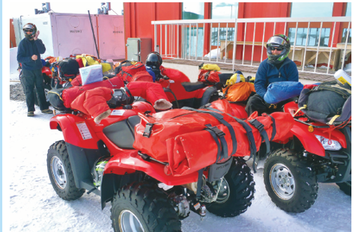
Image: Quads at Casey Station
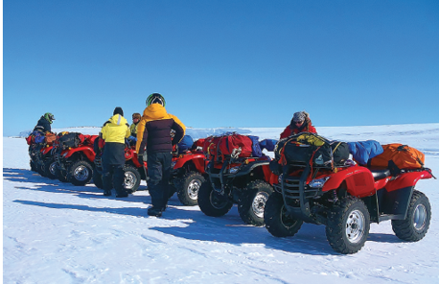
Image: Quads out in the field
Year 7 NAPLAN reading magazine, 2016 ACARA

Audience and purpose example texts
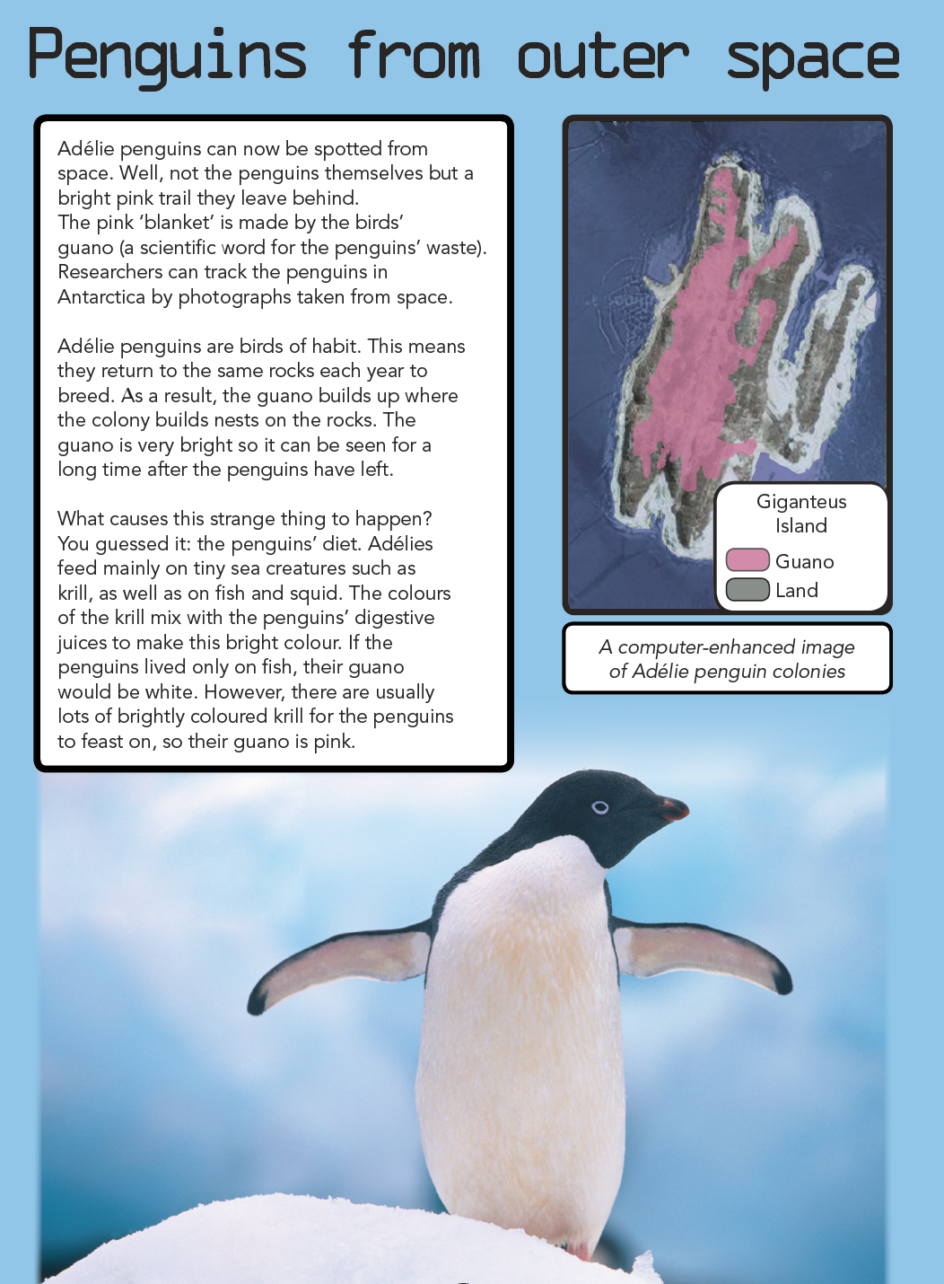
Year 7 NAPLAN reading magazine, 2016 ACARA

Audience and purpose example texts – accessible version

Penguins from outer space
Adélie penguins can now be spotted from space. Well, not the penguins themselves but a bright pink trail they leave behind. The pink ‘blanket’ is made by the birds’ guano (a scientific word for the penguins’ waste). Researchers can track the penguins in Antarctica by photographs taken from space.
Adélie penguins are birds of habit. This means they return to the same rocks each year to breed. As a result, the guano builds up where the colony builds nests on the rocks. The guano is very bright so it can be seen for a long time after the penguins have left.
What causes this strange thing to happen? You guessed it: the penguins’ diet. Adélies feed mainly on tiny sea creatures such as krill, as well as on fish and squid. The colours of the krill mix with the penguins’ digestive juices to make this bright colour. If the penguins lived only on fish, their guano would be white. However, there are usually lots of brightly coloured krill for the penguins to feast on, so their guano is pink.
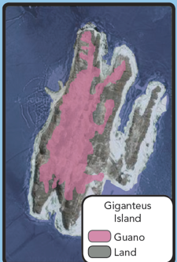
Image: A computer-enhanced image of Adélie penguin colonies.
Image Photo of a penguin
Year 7 NAPLAN reading magazine, 2016 ACARA

Audience and purpose example texts
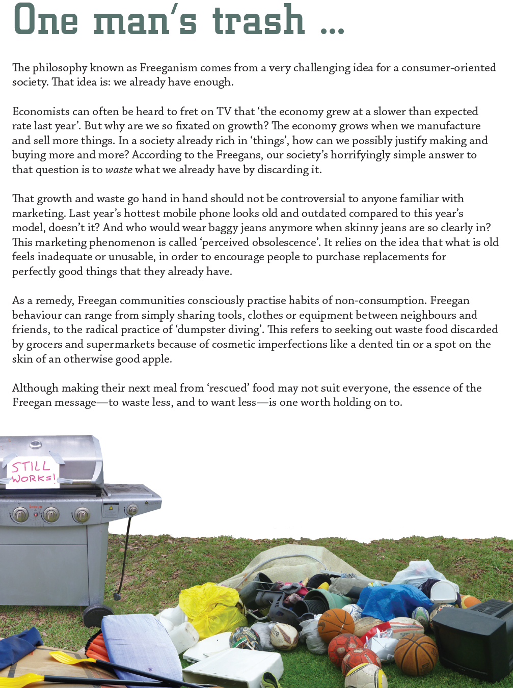
Year 7 NAPLAN reading magazine, 2016 ACARA

Audience and purpose example texts – accessible version

One man’s trash
The philosophy known as Freeganism comes from a very challenging idea for a consumer-oriented society. That idea is: we already have enough.
Economists can often be heard to fret on TV that ‘the economy grew at a slower than expected rate last year’. But why are we so fixated on growth? The economy grows when we manufacture and sell more things. In a society already rich in ‘things’, how can we possibly justify making and buying more and more? According to the Freegans, our society’s horrifyingly simple answer to that question is to waste what we already have by discarding it.
That growth and waste go hand in hand should not be controversial to anyone familiar with marketing. Last year’s hottest mobile phone looks old and outdated compared to this year’s model, doesn’t it? And who would wear baggy jeans anymore when skinny jeans are so clearly in? This marketing phenomenon is called ‘perceived obsolescence’. It relies on the idea that what is old feels inadequate or unusable, in order to encourage people to purchase replacements for perfectly good things that they already have.
As a remedy, Freegan communities consciously practise habits of non-consumption. Freegan behaviour can range from simply sharing tools, clothes or equipment between neighbours and friends, to the radical practice of ‘dumpster diving’. This refers to seeking out waste food discarded by grocers and supermarkets because of cosmetic imperfections like a dented tin or a spot on the skin of an otherwise good apple.
Although making their next meal from ‘rescued’ food may not suit everyone, the essence of the Freegan message—to waste less, and to want less—is one worth holding on to.
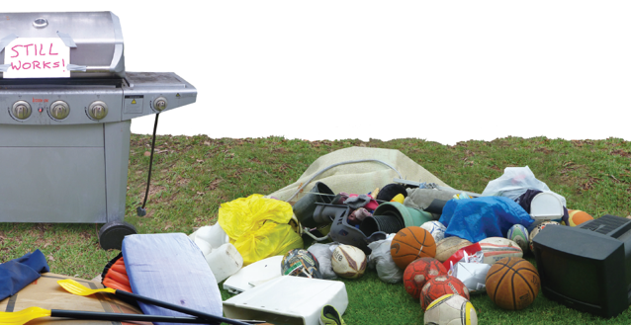
Year 7 NAPLAN reading magazine, 2016 ACARA

Appendix 6

Information text
Don’t disturb the cockatoos on your lawn, they’re probably doing all your weeding for free
Gregory Moore University of Melbourne, February 18, 2021. The Conversation.
Australians have a love-hate relationship with sulphur-crested cockatoos, Cacatua galerita. For some, the noisy parrots are pests that destroy crops or the garden, damage homes and pull up turf at sports ovals. For others, they’re a bunch of larrikins who love to play and are quintessentially Australian.
Along with other scientists, I had a unique opportunity during the COVID-19 lockdowns to study things that had intrigued me closer to home, perhaps for years. While isolating in the suburbs of Melbourne, I wanted to find out why cockatoos return to the same places, and what they’re after.
The answer? Onion grass, reams of it.
Onion grass is a significant weed, and I estimated in a recent paper that one bird gorges on about 200 plants per hour. A flock of about 50 birds can consume 20,000 plants in a couple of hours.
This significantly reduces the weed level and may make expensive herbicide use unnecessary. So if you have a large amount of onion grass on your property and are regularly visited by sulphur-crested cockatoos, it would be wise to let them do their weeding first.
When play verges on vandalism
Most of us see cockies whether we live in rural communities or major cities, but how much do you really know about them?
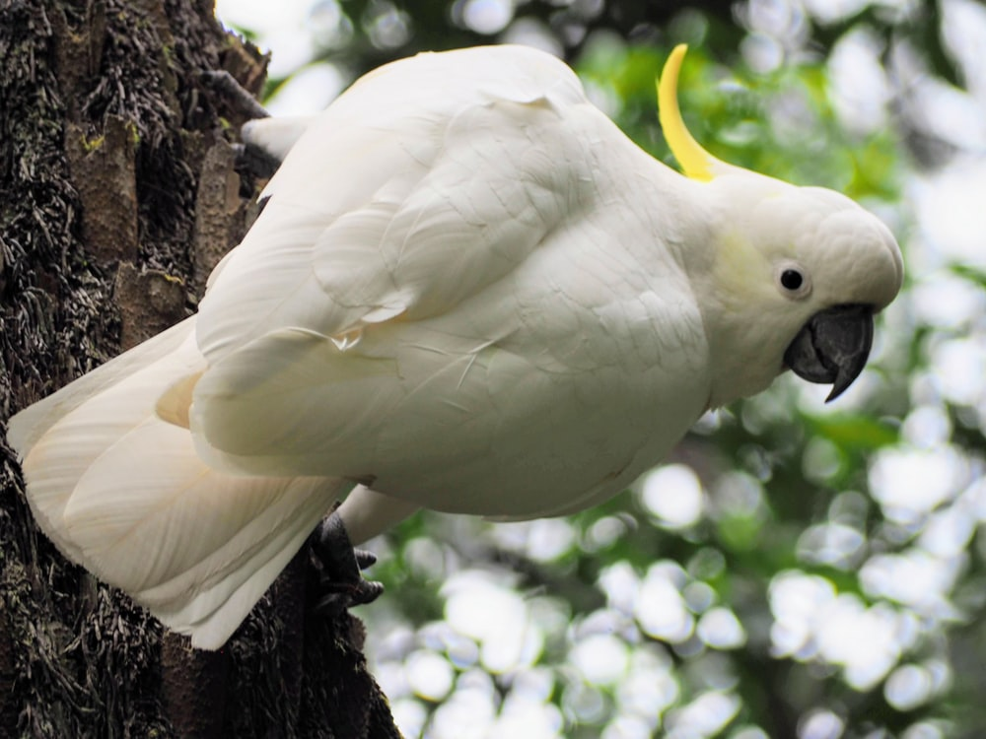
Sulphur-crested cockatoos nest in old hollow trees. Photo by Kunal Kalra Unsplash.com
In late winter and early spring in many parts of Australia, flocks of sulphur–crested cockatoos can be seen grazing on the ground. They’re usually found close to water, nesting in woodlands with old hollow trees, such as river red gums, Eucalyptus camaldulensis.
Where these forests and trees are being cleared, the number of cockies falls. But they are resilient and adaptable birds, and have spread their range to cities and the urban fringe, where numbers are increasing.
The birds are known to play with fruits, hang upside down on branches or perform flying cartwheels by holding a small branch or powerline with their feet, flapping their wings as they do loop after loop.
Sometimes their play verges on vandalism as they follow tree planters, deftly pulling up just-planted trees and laying them neatly beside the hole.
While cockatoos feed on the fruits and seed of native species, they’ve adapted very quickly to the introduction of exotic species, such as onion grass from South Africa, which is plentiful and easy to harvest.
I observed flocks ranging from nine to 63 cockatoos at seven sites along the Maribyrnong River in Keilor last July and August. Onion grass was the only item on their menu.
A pest for humans, a feast for birds
Onion grass (Romulea rosea) is small and usually inconspicuous with grass-like leaves. It’s typically only noticed when it flowers in spring, producing pretty, pink and yellow-throated flowers.
Onion grass comes from South Africa, and is a big problem for native grasslands.
Onion grass can be a serious weed that’s very difficult to control. It’s not only a problem for agricultural land, but also for recreational turf and native grasslands.
In some areas, there are nearly 5,000 onion grass plants per square metre. This is a massive number requiring costly control measures, such as spraying or scraping away the upper layer of top soil.
Onion grass gets its name from its onion-like leaves. At the base is a small bulb, which works as a modified underground stem called a “corm”. The corm is what cockatoos will travel many kilometres for, to dig up and return to for days on end.
When cockatoos eat onion grass corm, it prevents the weed from regenerating.
Their super weeding effort
Like other native parrots, sulphur-crested cockatoos are famously left-footed. So it was interesting to observe them primarily use their powerful beaks to pull onion grass plants from the ground and dig up corms, using their left foot only occasionally to manipulate the plant.
The cockatoos fed for between 30 minutes and two and a half hours. At each feed, one or two sentry (or sentinel) birds, depending on the flock size, would keep watch and give raucous warning should danger threaten.
The cockies could remove a plant and corm from the ground in as little as six seconds, but sometimes it could take up to 30 seconds. They then removed and consumed a corm every 14 seconds on average in wet soil and every 18 seconds from harder, dry soil.
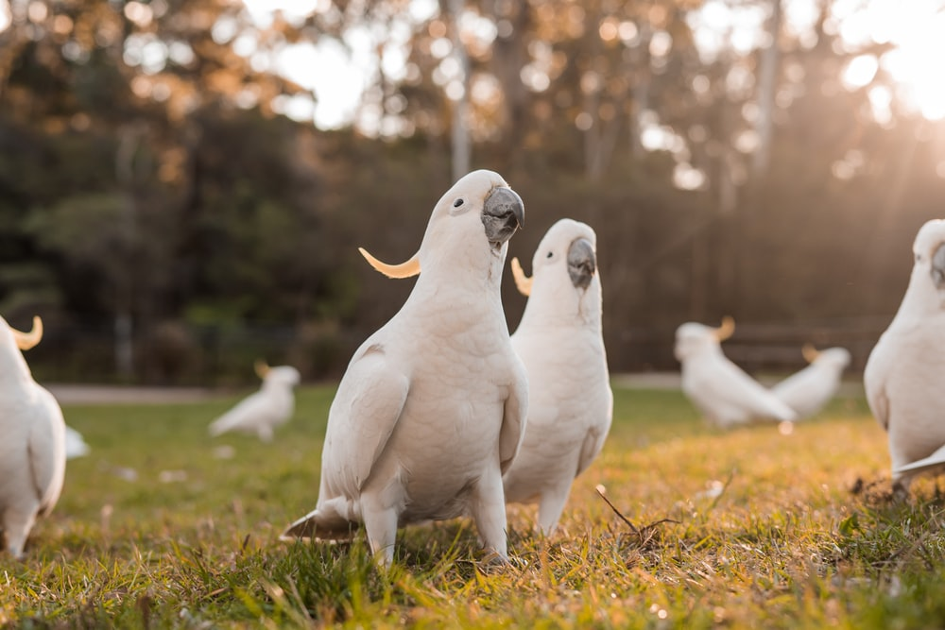
When flocks feed, one or two sentinel birds keep watch for danger. Photo by Kelli McClintock Unsplash.com
This means a flock of 63 birds could remove more than 35,400 onion grass plants in a feeding session lasting two and half hours. This is a super weeding effort by any standard!
Future partnerships
My further investigation revealed most of the corms were within 20 millimetres of the soil surface, so the holes left in the soil by the birds extracting the onion grass were shallow and quite small. This shouldn’t give seeds from onion grass any great advantage.
And they’re very efficient: the birds eat over 87% of the corms they lift, which then won’t get a chance to generate in future years. So, if we’re going to try to eradicate onion grass, it may be better to let the cockies do their work first before we humans take a turn.
We have a lot to learn about how our native species interact with introduced weeds, and more research might reveal some very useful future partnerships. They might be birdbrains, but sulphur-crested cockatoos really know their onions when it comes to, well, onion grass.
Full text with images available at The Conversation website.
Copied under the statutory licence in s 113P of the Copyright Act.
Gregory Moore University of Melbourne ‘Don’t disturb the cockatoos on your lawn, they’re probably doing all your weeding for free.’ The Conversation, February 18, 2021, Section 113P Warning Notice

Appendix 7

Information text with missing paragraphs

Don’t disturb the cockatoos on your lawn, they’re probably doing all your weeding for free
Gregory Moore University of Melbourne, February 18, 2021. The Conversation.
Australians have a love-hate relationship with sulphur-crested cockatoos, Cacatua galerita. For some, the noisy parrots are pests that destroy crops or the garden, damage homes and pull up turf at sports ovals. For others, they’re a bunch of larrikins who love to play and are quintessentially Australian.
Along with other scientists, I had a unique opportunity during the COVID-19 lockdowns to study things that had intrigued me closer to home, perhaps for years. While isolating in the suburbs of Melbourne, I wanted to find out why cockatoos return to the same places, and what they’re after.
The answer? Onion grass, reams of it.

Which paragraph belongs here?

This significantly reduces the weed level and may make expensive herbicide use unnecessary. So if you have a large amount of onion grass on your property and are regularly visited by sulphur-crested cockatoos, it would be wise to let them do their weeding first.
When play verges on vandalism
Most of us see cockies whether we live in rural communities or major cities, but how much do you really know about them?
Sulphur-crested cockatoos nest in old hollow trees. Photo by Kunal Kalra Unsplash.com
In late winter and early spring in many parts of Australia, flocks of sulphur–crested cockatoos can be seen grazing on the ground. They’re usually found close to water, nesting in woodlands with old hollow trees, such as river red gums, Eucalyptus camaldulensis.
Where these forests and trees are being cleared, the number of cockies falls. But they are resilient and adaptable birds, and have spread their range to cities and the urban fringe, where numbers are increasing.
The birds are known to play with fruits, hang upside down on branches or perform flying cartwheels by holding a small branch or powerline with their feet, flapping their wings as they do loop after loop.
Sometimes their play verges on vandalism as they follow tree planters, deftly pulling up just-planted trees and laying them neatly beside the hole.

Which paragraph belongs here?

I observed flocks ranging from nine to 63 cockatoos at seven sites along the Maribyrnong River in Keilor last July and August. Onion grass was the only item on their menu.
A pest for humans, a feast for birds
Onion grass (Romulea rosea) is small and usually inconspicuous with grass-like leaves. It’s typically only noticed when it flowers in spring, producing pretty, pink and yellow-throated flowers.
Onion grass comes from South Africa, and is a big problem for native grasslands.
Onion grass can be a serious weed that’s very difficult to control. It’s not only a problem for agricultural land, but also for recreational turf and native grasslands.
In some areas, there are nearly 5,000 onion grass plants per square metre. This is a massive number requiring costly control measures, such as spraying or scraping away the upper layer of top soil.
Onion grass gets its name from its onion-like leaves. At the base is a small bulb, which works as a modified underground stem called a “corm”. The corm is what cockatoos will travel many kilometres for, to dig up and return to for days on end.
When cockatoos eat onion grass corm, it prevents the weed from regenerating.
Their super weeding effort
Like other native parrots, sulphur-crested cockatoos are famously left-footed. So it was interesting to observe them primarily use their powerful beaks to pull onion grass plants from the ground and dig up corms, using their left foot only occasionally to manipulate the plant.
The cockatoos fed for between 30 minutes and two and a half hours. At each feed, one or two sentry (or sentinel) birds, depending on the flock size, would keep watch and give raucous warning should danger threaten.
When flocks feed, one or two sentinel birds keep watch for danger. Photo by Kelli McClintock Unsplash.com

Which paragraph belongs here?

This means a flock of 63 birds could remove more than 35,400 onion grass plants in a feeding session lasting two and half hours. This is a super weeding effort by any standard!
Future partnerships
My further investigation revealed most of the corms were within 20 millimetres of the soil surface, so the holes left in the soil by the birds extracting the onion grass were shallow and quite small. This shouldn’t give seeds from onion grass any great advantage.
And they’re very efficient: the birds eat over 87% of the corms they lift, which then won’t get a chance to generate in future years. So, if we’re going to try to eradicate onion grass, it may be better to let the cockies do their work first before we humans take a turn.
We have a lot to learn about how our native species interact with introduced weeds, and more research might reveal some very useful future partnerships. They might be birdbrains, but sulphur-crested cockatoos really know their onions when it comes to, well, onion grass.
Full text with images available at The Conversation website.
Copied under the statutory licence in s 113P of the Copyright Act.
Gregory Moore University of Melbourne ‘Don’t disturb the cockatoos on your lawn, they’re probably doing all your weeding for free.’ The Conversation, February 18, 2021, Section 113P Warning Notice

Appendix 8

Paragraph bank

Don’t disturb the cockatoos on your lawn, they’re probably doing all your weeding for free
Gregory Moore University of Melbourne, February 18, 2021. The Conversation.
Full text with images available at The Conversation website.
Onion weed is a significant problem, and I estimated in a recent paper that one bird nibbles on about one plant per day. A flock of about 50 birds can consume 50 plants in a full day’s grazing. | While cockatoos feed on the fruits and seed of native species, they’ve adapted very quickly to the introduction of exotic species, such as onion grass from South Africa, which is plentiful and easy to harvest. | The cockies could remove a plant and corm from the ground in as little as six seconds, but sometimes it could take up to 30 seconds. They then removed and consumed a corm every 14 seconds on average in wet soil and every 18 seconds from harder, dry soil.
Onion grass is a significant weed, and I estimated in a recent paper that one bird gorges on about 200 plants per hour. A flock of about 50 birds can consume 20,000 plants in a couple of hours. | Cockatoos feed on the fruits and seed of native species, and they haven’t adapted to the introduction of exotic species, such as onion weed from South Africa, which is plentiful and for other birds easy to harvest. | It could take as much as six minutes for the cockies to remove a plant and corm from the ground, and sometimes it could take up to 30 minutes. They then removed and consumed a corm every 14 minutes on average in wet soil and every 18 minutes from harder, dry soil.
Onion weed is a significant weed, and I estimated in a recent paper that one bird gorges on about 200 different types of weeds. A flock of 50 birds can consume 20,000 weeds in a couple of hours. Their feeding makes little difference to the control of onion weed. | While cockatoos feed on the fruits and seed of native species, they’ve adapted very slowly to the introduction of exotic species, such as onion grass from South Africa, which is not plentiful and difficult to harvest. | Soil wetness determines how efficient cockies were in removing corms. The drier the soil, the longer it took the cockies to extract the corm from the soil.

Appendix 9

Paragraph detective matrix
Clues | Missing paragraph 1 | Missing paragraph 2 | Missing paragraph 3
What is the purpose of the paragraph prior to this missing one?
It uses these language features and words (quotes from the paragraph):
What is the purpose of the paragraph after this missing one?
It uses these language features and words (quotes from the paragraph):
Therefore, the missing paragraph should have this purpose:
Therefore, the missing paragraph should include these language features and words:

Appendix 10

Example of statistical display
Onion grass is a significant weed, and I estimated in a recent paper that one bird gorges on about 200 plants per hour. A flock of about 50 birds can consume 20,000 plants in a couple of hours.
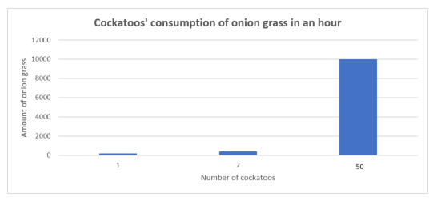
Text source: ‘Don’t disturb the cockatoos on your lawn, they’re probably doing all your weeding for free.’
Gregory Moore University of Melbourne, February 18, 2021. The Conversation.
Full text with images available at The Conversation website.

