Text structure
Stage 3

Overview

Purpose
This literacy teaching strategy supports teaching and learning for Stage 3 students across all key learning areas. It targets specific literacy skills and suggests a learning sequence to build skill development. Teachers can select individual tasks, or a sequence, and embed into their teaching and learning program according to their students’ needs. While exemplar texts are provided throughout this resource, it is recommended that teachers select texts which are relevant to their students and curriculum.

Learning intention
Students will learn to identify specific structural and language features within types of text. Students will learn to identify genre in a range of imaginative, persuasive and informative texts.

Syllabus outcomes
The following teaching and learning strategy will assist in covering elements of the following outcomes:
- EN3-RECOM-01: fluently reads and comprehends texts for wide purposes, analysing text structures and language, and by monitoring comprehension
- EN3-UARL-01: analyses representations of ideas in literature through narrative, character, imagery, symbol and connotation, and adapts these representations when creating texts
NSW English K-10 Syllabus (2022)

Success criteria
The following Year 5 NAPLAN item descriptors may guide teachers to co-construct success criteria for student learning.
- identifies the moral underlying a narrative
- identifies the purpose of a paragraph in a text
- analyses the effect of a description in a narrative
- identifies a central theme in a narrative
- identifies the setting of a narrative
- analyses the structure of a narrative
- identifies the main purpose of a paragraph in an information text
- identifies the main purpose of a website
- identifies the main purpose of an information text
- identifies the purpose of a diagram in a text
- identifies the purpose of a sentence in a text
- analyses the effect of modal language in an information text
- analyses potential modifications for an information text
- evaluates potential modifications for an information text
- identifies the most appropriate publication for a text
- identifies the main purpose of a persuasive text
- identifies the purpose of a reference in a persuasive text
- identifies the purpose of a rhetorical question in a text
- analyses the use of persuasive devices in a persuasive text
- evaluates potential modifications to a text
- analyses the structure of a persuasive text
- interprets the significance of the title of a persuasive text

National Literacy Learning Progression guide

Understanding Texts (UnT8-UnT10)
Key: C=comprehension P=process V=vocabulary

UnT8
- explains how textual features support the text’s purpose (P)
- uses knowledge of the features and conventions of the type of text to build meaning (e.g. recognises that the beginning of a persuasive text may introduce the topic and the line of argument) (P)
- identifies language features used to present opinions or points of view (P)

UnT9
- distils information from a number of texts according to task and purpose (e.g. uses graphic organisers) (C)
- uses knowledge of a broader range of cohesive devices to track meaning (e.g. word associations) (see Grammar) (P)
- evaluates text features for relevance to purpose and audience (P)
- identifies language used to create tone or atmosphere (V)
- analyses language and visual features in texts using metalanguage (e.g. cohesion, interpretation, figurative) (V)

UnT10
- applies and articulates criteria to evaluate the language structures and features for relevance to purpose and audience (C)
National Literacy Learning Progression

Evidence base
- Centre for Education Statistics and Evaluation (2017). Effective reading instruction in the early years of school, literature review.
- Konza, D. (2014). Teaching Reading: Why the “Fab Five” should be the “Big Six”. Australian Journal of Teacher Education, 39(12).
- Oakhill, J., Cain, K. & Elbro, C. (2015). Understanding and teaching reading comprehension: A handbook. Routledge.
- Quigley, A. (2020). Closing the reading gap. Routledge.
- Scarborough, H.S. (2001). Connecting early language and literacy to later reading (dis)abilities: Evidence, theory and practice. In S. Neuman & D. Dickson (Eds.), Handbook for research in early literacy (pp. 97-110). New York, NY: Guilford Press.
Alignment to system priorities and/or needs: Five priorities for Literacy and Numeracy, Our Plan for NSW Public Education, School Excellence Policy (nsw.gov.au).
Alignment to School Excellence Framework: Learning domain: Curriculum, Teaching domain: Effective classroom practice and Professional standards
Consulted with: Strategic Delivery, Teaching Quality and Impact
Author: Literacy and Numeracy
Reviewed by: Literacy and Numeracy, Teaching Quality and Impact
Created/last updated: January 2024
Anticipated resource review date: January 2025
Feedback: Complete the online form to provide any feedback

Copyright
Section 113P Notice
Texts, Artistic Works and Broadcast Notice
Some of this material has been copied and communicated to you in accordance with the statutory licence in section 113P of the Copyright Act. Any further reproduction or communication of this material by you may be the subject of copyright protection under the Act. Do not remove this notice.

Teaching strategies
Task | Appendices
Analysing imaginative texts: Purpose, audience and effect | Appendix 1 - Purpose, audience and effect
Analysing imaginative texts: Structure of narratives | Appendix 2 - Fiction text structure guide  Appendix 3 - Analysing narrative texts
Analysing informative texts | Appendix 4 - Non-fiction text structure guide  Appendix 5 - ‘Spud’: analysing informative texts  Appendix 6 - Student informative text examples
Analysing persuasive texts | Appendix 7 - Headlines  Appendix 8 - Student persuasive text example  Appendix 9 - Reviewing curious children: persuasive text comparison
Identifying types of texts | Appendix 10 - Which text? Match and sort  Appendix 11 - Identifying features of texts  Appendix 12 - Persuasive/informative text example  Appendix 13 - Responding to texts graphic organiser
Identifying purpose, audience, form and tone | Appendix 14 - PAFT matrix  Appendix 15 - PAFT- sample questions and answers

Background information

Text
Any written, spoken/signed, nonverbal, visual, auditory or multimodal communication. Texts may be extended unified works, a series of related pieces or a single, simple piece of communication.

Types of text
Classifications according to the particular purposes texts are designed to achieve. These purposes influence the characteristic features the texts employ. In general, texts can be classified as belonging to one of three types (imaginative, informative or persuasive), although it is acknowledged that these distinctions are neither static nor watertight and particular texts can belong to more than one category.

Imaginative texts
These texts include novels, traditional tales, poetry, stories, plays, fiction for young adults and children, including picture books and multimodal texts such as film.

Informative texts
These texts include those which are valued for their informative content, as a store of knowledge and for their value as part of everyday life.

Persuasive texts
These texts include student essays, debates, arguments, discussions, polemics, advertising, propaganda, influential essays and articles.

Theme
Refers to the central or one of the main underlying ideas or messages of a text.

Genre
The categories into which texts are grouped. The term has a complex history within literary and linguistic theory and is often used to distinguish texts on the basis of, for example, their subject matter (detective fiction, romance, science fiction, fantasy fiction) and form and structure (poetry, novels, short stories).

Text structure
The ways information is organised in different types of texts, for example chapter headings, subheadings, tables of contents, indexes and glossaries, overviews, introductory and concluding paragraphs, sequencing, topic sentences, taxonomies, cause and effect. Choices in text structures and language features together define a text type and shape its meaning (see language features).

Textural form
The conventions specific to a particular type of text, often signalling content, purpose and audience, for example letter form, drama script, blog.

Text features
Structural or stylistic components that combine to construct meaning and achieve purpose. Can be recognisable as characterising particular types of texts.

Language features
The features of language that support meaning, for example sentence structure, vocabulary, illustrations, diagrams, graphics, punctuation, figurative language. Choices in language features and text structures together define a type of text and shape its meaning (see structures of texts). These choices vary according to the purpose of a text, its subject matter, audience and mode or media of production.
Reference: English K-10 Syllabus © NSW Education Standards Authority (NESA) for and on behalf of the Crown in right of the State of New South Wales, 2012 and 2022.

Where to next?
- Text features
- Audience and purpose
- Understanding perspective

Overview of teaching strategies

Purpose
These literacy teaching strategies support teaching and learning from Stage 2 to Stage 5. They are linked to NAPLAN task descriptors, syllabus outcomes and literacy and numeracy learning progressions.
These teaching strategies target specific literacy and numeracy skills and suggest a learning sequence to build skill development. Teachers can select individual tasks or a sequence to suit their students.

Access points
The resources can be accessed from:
- NAPLAN App in Scout using the teaching strategy links from NAPLAN items
- NSW Department of Education literacy and numeracy website.

What works best
Explicit teaching practices involve teachers clearly explaining to students why they are learning something, how it connects to what they already know, what they are expected to do, how to do it and what it looks like when they have succeeded. Students are given opportunities and time to check their understanding, ask questions and receive clear, effective feedback.
This resource reflects the latest evidence base and can be used by teachers as they plan for explicit teaching.
Teachers can use classroom observations and other assessment information to make decisions about when and how they use this resource as they design teaching and learning sequences to meet the learning needs of their students.
Further support with What works best is available.

Differentiation
When using these resources in the classroom, it is important for teachers to consider the needs of all students, including Aboriginal and EAL/D learners.
EAL/D learners will require explicit English language support and scaffolding, informed by the EAL/D enhanced teaching and learning cycle and the student’s phase on the EAL/D Learning Progression. Teachers can access information about supporting EAL/D learners and literacy and numeracy support specific to EAL/D learners.
Learning adjustments enable students with disability and additional learning and support needs to access syllabus outcomes and content on the same basis as their peers. Teachers can use a range of adjustments to ensure a personalised approach to student learning.
Assessing and identifying high potential and gifted learners will help teachers decide which students may benefit from extension and additional challenge. Effective strategies and contributors to achievement for high potential and gifted learners helps teachers to identify and target areas for growth and improvement. A differentiation adjustment tool can be found on the High potential and gifted education website.

Using tasks across learning areas
This resource may be used across learning areas where it supports teaching and learning aligned with syllabus outcomes.
Literacy and numeracy are embedded throughout all syllabus documents as general capabilities. As the English and mathematics learning areas have a particular role in developing literacy and numeracy, NSW English and Mathematics syllabus outcomes aligned to literacy and numeracy skills have been identified.

Text selection
Example texts are used throughout this resource. Teachers can adjust activities to use texts which are linked to their unit of learning.
Further support with text selection can be found within the National Literacy Learning Progression Text Complexity appendix.
The NESA website has additional information on text requirements within the NSW English syllabus.

Teaching strategies

Analysing imaginative texts

Purpose, audience and effect
- Purpose and effect: Review student understanding of purpose and audience (refer to Stage 3 Audience and Purpose for further activities). Teacher models analysing a text extract for purpose, audience and genre:
Orphans of the Tide by Struan Murray, 2020 Puffin
Chapter 1 – Its Last Song
The City was built on a sharp mountain that jutted improbably from the sea, and the sea kept trying to claim it back. When the tide rose, it swallowed up the City’s lower streets. When the tide fell, it spat them back out again but left its mark. Fresh mussels clung to windowsills. Fish flailed on the cobblestones. That grey morning, once the tide had retreated, a whale was found on a rooftop.
A crowd gathered along the top of the sea wall, to gape at the roof below.
‘It’s an evil omen!’ yelled the old preacher, his breath steaming in the air.
‘The Enemy didn’t do this,’ snorted a sailor. ‘It must have got stuck there at high tide.’
‘It’s dead,’ said a merchant. ‘Do you think we can sell it for meat?’
The whale lay on its belly, stretched from one end of the roof to the other. It had beached itself on the Chapel of St Bartholomew, whose rooftop poked above the waves at low tide. Four stone gargoyles stood at each corner, two of them digging sharply into the whale’s skin. Hungry seagulls screeched overhead.
The crowd were so engrossed that none of them noticed the girl’s arrival. She had tired eyes and tangled, dirty blonde hair, mussed‑up from a night of broken sleep. She leaned over the sea wall and bit her lip.
‘It’s too big to be out of the water,’ she said, speaking more to herself than anyone else. ‘It’ll have crushed its lungs just by lying there.’
Orphans of the Tide by Struan Murray, 2020, Puffin
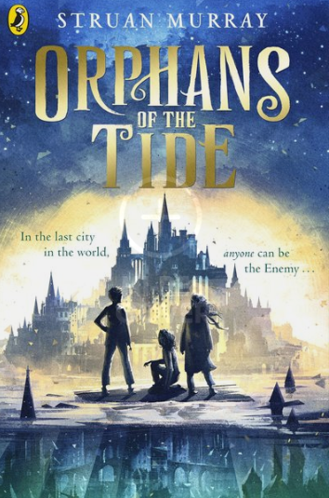

Purpose | Audience | Effect of a paragraph:
To entertain through a narrative  What is the genre?  Adventure | Looking at the front cover, children are featured, so perhaps young adults. | Brings an additional character into the story – she seems to be an important character and cares about the whale.  The reader is interested in who she is, why she is looking dishevelled and what role she will play in the story.
- Students are given example extracts of a range of texts relevant to a current unit of learning (or refer to Appendix 1 - Purpose, audience and effect) to determine the purpose, audience and the effect on the reader.

Structure of narratives
- Teacher provides an imaginative text/narrative and guides students around the text, examining the title, front cover and any illustrations to predict the type of text. The class discusses their ‘noticings’ and predictions.
- Model skimming and scanning the text for structural clues and signal words (firstly, afterwards, in the end). Use a ‘think aloud’ to model the process of identifying structure.
- Using these predictions and a narrative text structure graphic organiser, review the key elements of a narrative text and display on a mind map (use Appendix 2 - Fiction text structure guide and Appendix 3 - Analysing narrative texts to guide).
- Students are given a range of narratives to identify the structural and text elements of: orientation, complication, resolution, coda, setting, character description, theme, moral. Compare and contrast what students found and draw attention to elements that are consistent in all examples and which ones may differ, for example, not all may have a moral.

Analysing informative texts
- Review the purpose of informative texts: to explain or inform the reader with factual information. It is important to note that some informative texts will include elements from imaginative and persuasive texts and we need to look for the overall purpose to determine the type of text (use Appendix 4 - Non-fiction text structure guide to guide).
- Teacher models reading an informative text linked to a current unit of learning or use Appendix 5 - ‘Spud’: analysing informative texts. Teacher uses a ‘think aloud’ process to highlight how an expert reader processes the information, for example, I can see this text is a non-fiction text as it has a heading, sub-heading and lots of factual information. I can see that there is a map and a diagram which helps me understand the more complex information in the text.
- Students are given a copy of an informative text and allocated a section to determine the purpose. For example, students might be given a paragraph, a diagram, a website or a sentence and will determine purpose after reading the whole text (refer to Appendix 6 - Student informative text examples).

Analysing persuasive texts
- Gone in 60 seconds: A student is given sixty seconds to verbally persuade others to agree with their point of view on a subject, for example: all plastics must stop being used.
Additional task: Students are timed and stop watches stopped when ‘umm’, ‘err’ or ‘like’ (out of context) is used – the goal is to reach the longest time without repeating ideas.
- Students use a range of newspaper headlines to predict what the text might be about (Appendix 7 - Headlines).
- Discuss the purpose of a persuasive text: to persuade an audience to agree with a point of view or opinion. Where do we find these? What forms do they take?
- Students are given a copy of Appendix 8 - Student persuasive text example to make a prediction about what the text will be about, determine signal words, observe text structure and language features and determine the type of text.
- Review structural elements of a persuasive text: title, opening statement, arguments, conclusion and concluding statement.
- Students brainstorm language features that are found in a persuasive text: rhetorical question, modality, using references (quotes, statistics, expert) repetition of an opinion, emotive language.
- Jigsaw groups: Students are given a number 1-5 and each number is given one of the five language elements listed above. Students research and find examples in texts (use newspapers or sourced texts linked to a current unit of learning). Once students are ‘experts’ in their area, each group reconfigures with a representative from each number to share their understanding.
- Students create a graphic organiser which shows structural elements of an argument.
- Comparing views: Students are given a copy of a persuasive text (refer to Appendix 9 - Reviewing curious children: persuasive text comparison) to read as a whole text. Discuss: what is the main idea of the text? What is the author trying to persuade you to do? What tools is the author using to persuade you? What is the purpose of the: reference, rhetorical question? What is the significance of the title? Why are there two opinions?
To increase higher order thinking, students use their conclusions to evaluate the effectiveness of the text in persuading its audience, using a PMI chart or other graphic organiser to record their ideas.

Identifying types of texts
- Students complete a match and sort activity (Appendix 10 - Which text? Match and sort) to organise key structural and text features of informative, persuasive and imaginative texts (this could be done as a formative assessment as well as a summative assessment).
- Students are given one of the cards from Appendix 11 - Identifying features of texts to persuade the class as to what type of text this belongs to. This can be presented as a short skit, poster or other product suitable for the class.
- Review Appendix 12 - Persuasive/informative text example and discuss which type of text this could be, based on information learnt so far. Discuss that this text has features from both persuasive and imaginative texts. Ask students to take time to notice the text structure and language features and decide what would be an ‘overall’ purpose for the text; is it to persuade or to inform? Does it want to change your mind or give you more information?
- Students use Appendix 13 - Responding to texts graphic organiser as a scaffold to respond to a range of texts linked to a current unit of learning by answering the following questions:
- What type of text is this text? How do you know? (Ideas: Imaginative, informative or persuasive?)
- This text mostly helps me to...?(Understand? Explain? Choose? Find out about?)
- The main purpose of this text is to…? (Encourage me to…give interesting facts about…outline where…show me…)
- What genre is this text? (Adventure? Science-fiction? Letter? Recipe?)
- What is the purpose of first paragraph?
- What question does this text answer?
- Is there a problem in the text? If so what is it?
- Do you think the end of the text is effective? Why/why not?

Identifying purpose, audience, form and tone
- Teacher discussion. ‘To enhance our understanding of a text it is helpful to first identify the purpose, audience, form and tone. Once identified we can consider how they work together to create meaning.’ Explore each word through a class brainstorm, prompting students to engage with their prior knowledge and learning. Use guiding questions such as:
- What do I mean when I say ‘the purpose of a text’? Can you think of a synonym for purpose?
- Who is the audience of a text? Does the text change and/or look different depending on who the audience is?
- What comes to mind when I say the word ‘form’? What does it mean to ‘form’ something?
- What comes to mind when I say the word ‘tone’? Where have you heard this word used before? What did it describe?
- Students will independently, or in pairs, analyse a variety of texts, identifying purpose, audience, form and tone, using the PAFT matrix. (Appendix 14 - PAFT matrix). Teacher guides students through the matrix and informs them that some texts might have more than one word to describe the PAFT. For example, the tone could be both persuasive and optimistic, the form could be both an informative text and an article, the audience could be teenagers interested in sport and the purpose could be to both influence and entertain.
- Teacher to model how to use the matrix with a text studied in class. Students then unpack a variety of texts and share their findings with the class. (Refer to Appendix 15 - PAFT- sample questions and answers for discussion questions and modelled responses.)
- Students should engage with a combination of texts. (Refer to Appendix 6 Text Complexity, National Literacy Learning Progressions australiancurriculum.edu.au/media/3629/literacy-appendix-6.pdf

Using structural elements to infer the author
- Using Appendix 16 - ‘Who wrote the Letter?’, explain to students that they need to predict who wrote the letter. They have been provided with 6 signature options. Students will need to examine the author profile, salutation, text layout and content details in order to form an accurate inference (note: not all details in each text and author profile will be relevant. Students will need to decide which details are useful.)
- Students share their prediction with the class. They should be encouraged to identify, explain and justify their choices by referring to specific evidence from the text. The following examples can be used to help scaffold verbal discussion:
- The salutation ‘My dearest husband’ tells me that the author must be __________
  - Additionally, the names of the children make me think that__________
- The salutation ‘To whom this may concern’ suggests that there is no personal_________
  - Additionally, the reference to illness and injury make me think that_____________

Appendix 1

Purpose, audience and effect
Look, I didn’t want to be a half-blood.
If you’re reading this because you think you might be one, my advice is: close this book right now. Believe whatever lie your mom or dad told you about your birth, and try to lead a normal life.
Being a half-blood is dangerous. It’s scary. Most of the time, it gets you killed in painful, nasty ways. If you’re a normal kid, reading this because you think it’s fiction, great. Read on. I envy you for being able to believe that none of this ever happened. But if you recognize yourself in these pages – if you feel something stirring inside – stop reading immediately. You might be one of us. And once you know that, it’s only a matter of time before they sense it too, and they’ll come for you.
Don’t say I didn’t warn you.
My name is Percy Jackson.
Percy Jackson and The Lightning Thief (Book 1) by Rick Riordan, 2013 Penguin
What is the purpose? What is the genre? | Who is the intended audience? | What effect does it have on the reader?
A low, soft hooting came from a dark shop with a sign saying Eeylops Owl Emporium—Tawny, Screech, Barn, Brown and Snowy. Several boys of about Harry's age had their noses pressed against a window with broomsticks in it. "Look," Harry heard one of them say, " the new Nimbus Two Thousand—fastest ever," There were shops selling robes, shops selling telescopes and strange silver instruments Harry had never seen before, windows stacked with barrels of bat spleens and eels' eyes, tottering piles of spell books, quills and rolls of parchment, potion bottles, globes of the moon...
"Gringotts," said Hagrid.
Harry Potter and the Philosopher’s Stone by J.K. Rowling, 2014 Bloomsbury
What is the purpose? What is the genre? | Who is the intended audience? | What effect does it have on the reader?

Purpose, audience and effect
The grade-six teacher at Barringa East Primary was Miss Belmont. She was terrifying, but very stylish. She had a lovely figure, and her hair was silvery grey tipped with blonde streaks. Her face was smooth and tanned because she played a lot of sport. She didn’t smoke, so her teeth looked like television-ad teeth. I liked carrying her bag from her car each morning because both were expensive looking, and I liked to pretend that they belonged to me.
Hating Alison Ashley by Robin Klein, 1984 Puffin
What is the purpose? What is the genre? | Who is the intended audience? | What effect does it have on the reader?
By the morning recess we all had writer’s cramp and mental exhaustion, but Miss Belmont looked quite calm and relaxed as she sailed into the staffroom for coffee. I’d never cared to associate with the riff-raff in the playground at Barringa East Primary. I went into the office and asked Mrs Orlando, the school secretary, if I could lie down during recess because I had a headache. On my medical card in the office it said I was prone to nervous headaches, rhinitis, sinusitis, bee-sting allergy, rheumatism; suspected hypersensitivity to wattle pollen, horsehair, dust mite, clover and Clag glue; tested for diabetes, arthritis, gallstones and hiatus hernia and that I didn’t have to put my head under water when we went swimming because of a punctured eardrum. Mum didn’t write all that information on the sheet they’d sent home for parents to fill in; I’d supplied it to Mrs Orlando over the six years I’d been going to Barringa East Primary.
Hating Alison Ashley by Robin Klein, 1984 Puffin
What is the purpose? What is the genre? | Who is the intended audience? | What effect does it have on the reader?

Appendix 2

Fiction text structure guide
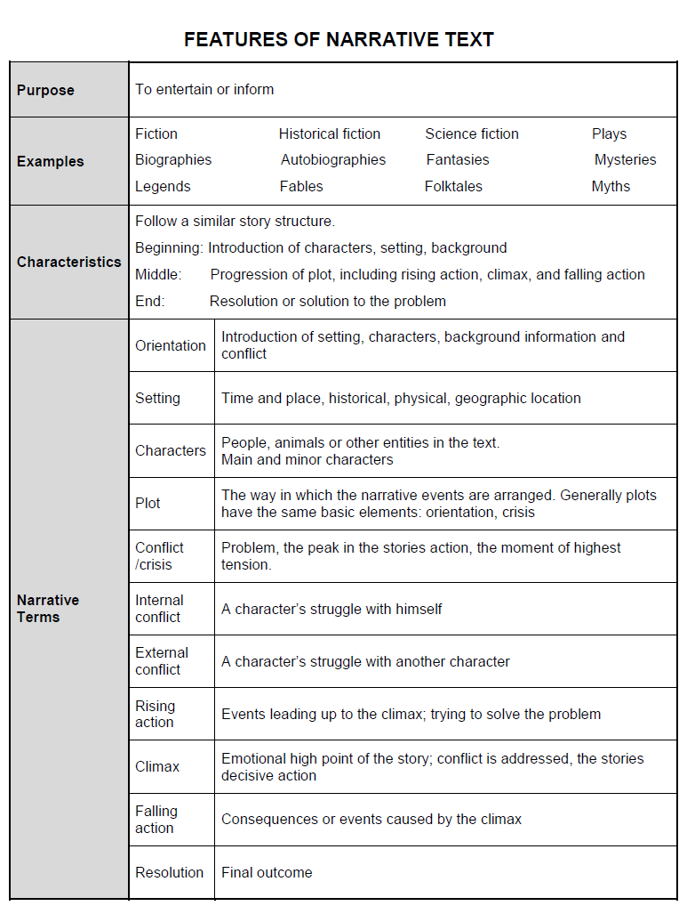
NSW Centre for Effective Reading Comprehension Handbook, p.41

Appendix 3

Analysing narrative texts
Devise a coding system to identify any of the following elements in this narrative:
- Orientation
- Complication
- Resolution
- Coda
- Setting
- Character description
- Theme
- Moral
- Protagonist
- Antagonist
- Narrator
- Moral
- Protagonist
- Antagonist

The Stranger
Buck, a sled dog that has been treated badly by humans in the past, is drawn to life in the wild. One night he hears the call of a timber wolf and goes to investigate.
As he drew closer to the cry he went more slowly, with caution in every movement, till he came to an open place among the trees, and looking out saw, erect on haunches, with nose pointed to the sky, a long, lean, timber wolf.
He had made no noise, yet it ceased from its howling and tried to sense his presence. Buck stalked into the open, half crouching, body gathered compactly together, tail straight and stiff, feet falling with unwonted care(1). Every movement advertised both a threat and an overture of friendliness. It was the menacing truce that marks the meeting of wild beasts that prey. But the wolf fled at the sight of him. He followed, with wild leapings, in a frenzy to overtake. He ran him into a blind channel, in the bed of the creek where a timber jam barred the way.
Buck did not attack, but circled him about and hedged him in with friendly advances. The wolf was suspicious and afraid; for Buck made three of him in weight, while his head barely reached Buck’s shoulder. Watching his chance, he darted away, and the chase was resumed. Time and again he was cornered, and the thing repeated, though he was in poor condition, or Buck could not so easily have overtaken him. He would run till Buck’s head was even with his flank, when he would whirl around at bay, only to dash away again at the first opportunity.
But in the end Buck’s persistence was rewarded; for the wolf, finding that no harm was intended, finally sniffed noses with him. Then they became friendly, and played about in the nervous, half-coy way with which fierce beasts belie their fierceness. After some time of this the wolf started off at an easy lope in a manner that plainly showed he was going somewhere. He made it clear to Buck that he was to come, and they ran side by side through the sombre twilight, straight up the creek bed, into the gorge from which it issued, and across the bleak divide where it took its rise.
(1) feet falling with unusual care
Year 5 NAPLAN Reading Magazine, 2016 ACARA

Analysing narrative texts
Devise a coding system to identify any of the following elements in this narrative:

- Orientation
- Complication
- Resolution
- Coda
- Setting
- Character description
- Theme
- Moral
- Protagonist
- Antagonist
- Narrator
- Moral
- Protagonist
- Antagonist

Learning to track
Sarah was determined to learn to track, and if her father couldn’t teach her, she’d teach herself. She borrowed a book on animal signs and tracking from the mobile library and memorised every word and illustration in it.
To the annoyance of everyone in both families, she borrowed all their shoes and, in the old sandpit, taught herself everyone’s footprints. Shoes, sandals, thongs, gumboots, all ended up in the yard. More than once her father or her uncle Charlie came outside shouting, ‘Sarah, where are you? Bring me back my boots.’
Sarah developed the habit of walking with her eyes fixed on the ground in front of her, tracking the comings and goings of every person in the place.
She also developed the annoying habit of questioning everyone. ‘What were you doing down at the dam, Jack? You’re not allowed to play with the pump. Did you find what you were looking for in the garage, Auntie Mai?’ and ‘Don’t swing on the clothes hoist, Jack, you’ll bend it,’ or ‘Who was the strange person, a man I think, who was wearing boots about size ten, who came to visit today, Mum?’
After she’d memorised every pair of shoes that everyone on the farm owned she started on the farm animals, including the horses, Fred and Freda.
By this time even her victims had to admit, grudgingly, that she was good. Her best effort came one evening at the dinner table when she told her father that Freda was lame in her front foot. Pat said that Freda was perfectly all right. Sarah was adamant that she wasn’t, said her hoof had a split, and she was limping a little.
Everyone trudged out into the home paddock. Kate caught Freda and inspected her hoof.
‘Sarah’s right. The hoof is split. Did you look at this, Sarah?’
‘No. I told you, you can see it in her tracks. Why would I need to look at it? Look.’ She moved the horse away. ‘Look, see there, it’s plain in the dust. Well, can’t you all see it?’
The others shook their heads.
‘If you can tell she has a split hoof from that heap of dust, you’re pretty good,’ said Pat.
Year 5 NAPLAN Reading Magazine, 2010 ACARA

Analysing narrative texts
Devise a coding system to identify any of the following elements in this narrative:

- Orientation
- Complication
- Resolution
- Coda
- Setting
- Character description
- Theme
- Narrator
- Moral
- Protagonist
- Antagonist

The Mission
I knew there had been a mistake. Although Bella had assured me that the house was empty, a dog bark, followed swiftly by unwelcome lights glimpsed between twitching curtains, suggested otherwise. I signalled to indicate it was time to abandon the operation.
We melted soundlessly into the shadows of the garden, gathering at the meeting point to consider our options. Ty was angry. ‘You have to face it, Sam. She didn’t analyse the intelligence properly,’ he seethed. ‘How could anyone make such a fundamental error again?’
‘Let’s not waste our energy blaming Bella,’ I said, asserting my authority. Ty’s negative feelings towards Bella had already threatened to disrupt the mission. I’d been in Bella’s position myself and knew: sometimes there simply wasn’t enough time to recheck intelligence. You hoped it was accurate, but sometimes hope wasn’t enough. ‘Let’s concentrate on what to do next,’ I said to the whole team while looking directly at Ty.
Organising another ‘visit’ was out of the question. We were here, the file had to be retrieved, and it was our task to do so. We needed to abandon our existing strategy and come up with something new.
Ty looked doubtful when I mentioned the idea of improvising. He was still a novice and floundered for a minute or two when operations varied from the expected. Strange, considering nothing had really gone to plan for days now. He’d learn.
I quickly outlined my idea. Ty’s expression changed from doubt to intrigue, ‘I can’t believe I’m saying this, but it might just work. It’s better than doing nothing.’
As the suburban street came alive with morning activity, we shed our night-time black, put on the uniforms, and marched boldly up to the front door to finish the job.
Year 7 NAPLAN Reading Magazine, 2015 ACARA

Appendix 4

Non-fiction text structure guide
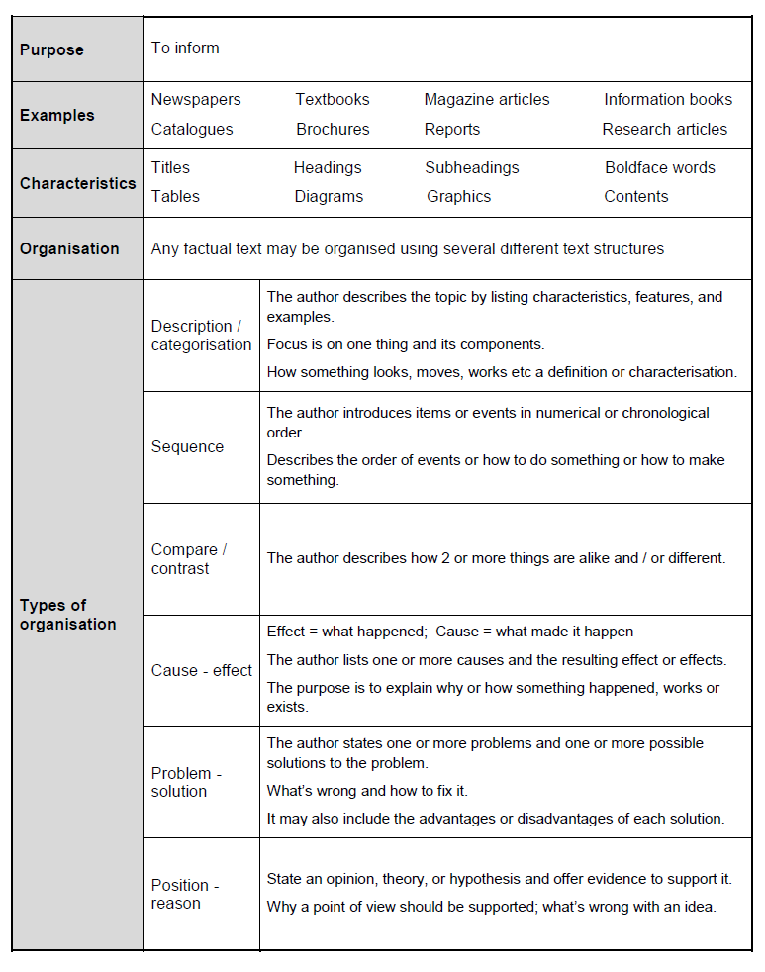
NSW Centre for Effective Reading Comprehension Handbook, p.42.

Appendix 5

Student copy: analysing informative texts
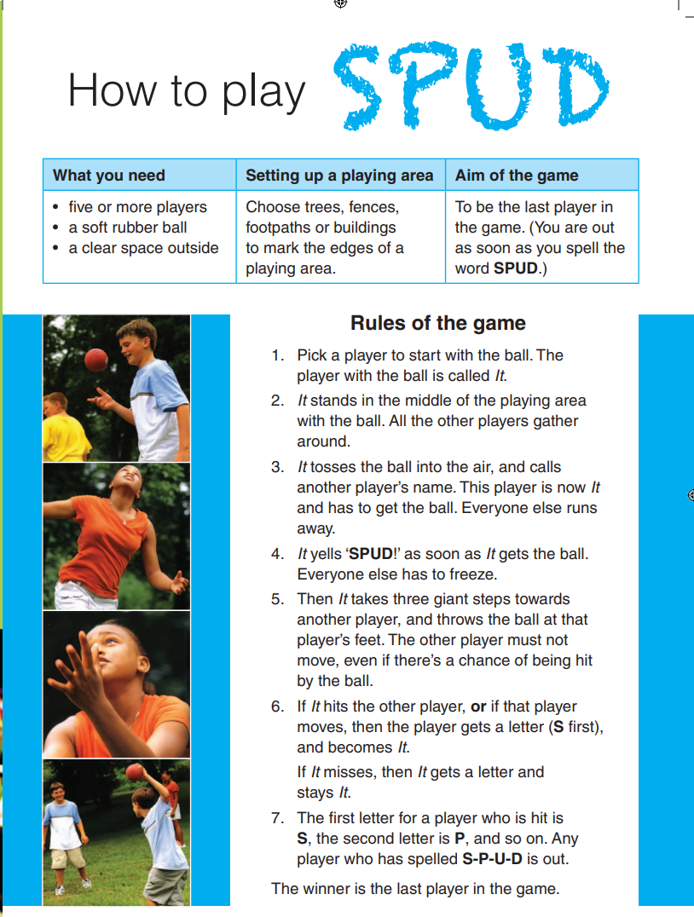
Year 5 Reading Magazine, 2011 ACARA

Teacher guide: analysing informative texts
Key structural features:
- Title
- Headings
- Sub-headings
- Numbered points
- Supporting images
Signal words:
- How
- ‘What you need’
- Rules
Think aloud ideas:
I am going to skim and scan this text to help me predict what kind of text this is. I can see this is set out with a clear title and some boxes directly underneath which give me clear information in bullet points about what I need, how to set up playing area and the aim of the game. I can see some images which shows me this is about how to play a ball game which makes me think I will be reading an informative text explaining how to play a game.

Year 5 Reading Magazine, 2011 ACARA

Analysing informative texts – accessible version
How to Play SPUD
What you need
- five or more players
- a soft rubber ball
- a clear space outside
Setting up a playing area
Choose trees, fences, footpaths or buildings to mark the edges of a playing area.
Aim of the game
To be the last player in the game. (You are out as soon as you spell the word SPUD.)
Rules of the game
- Pick a player to start with the ball. The player with the ball is called It.
- It stands in the middle of the playing area with the ball. All the other players gather around.
- It tosses the ball into the air, and calls another player’s name. This player is now It and has to get the ball. Everyone else runs away.
- It yells ‘SPUD!’ as soon as It gets the ball. Everyone else has to freeze.
- Then It takes three giant steps towards another player, and throws the ball at that player’s feet. The other player must not move, even if there’s a chance of being hit by the ball.
- If It hits the other player, or if that player moves, then the player gets a letter (S first), and becomes It. If It misses, then It gets a letter and stays It.
- The first letter for a player who is hit is S, the second letter is P, and so on. Any player who has spelled S-P-U-D is out. The winner is the last player in the game.
Year 5 Reading Magazine, 2011 ACARA

Appendix 6

Student informative text examples
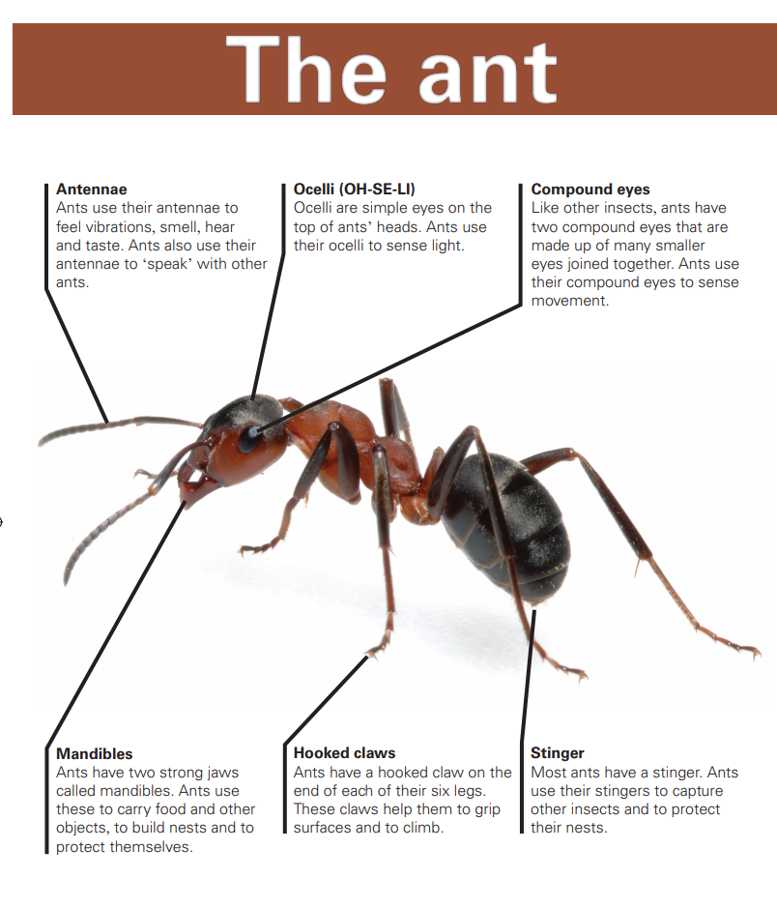
My prediction:

Text structural features:

Signal words:

Type of text:

Year 5 NAPLAN Reading Magazine, 2010 ACARA

Student informative text examples – accessible version
The ant
Antennae Ants use their antennae to feel vibrations, smell, hear and taste. Ants also use their antennae to ‘speak’ with other ants.
Ocelli (OH-SE-LI)
Ocelli are simple eyes on the top of ants’ heads. Ants use their ocelli to sense light.
Compound eyes
Like other insects, ants have two compound eyes that are made up of many smaller eyes joined together. Ants use their compound eyes to sense movement.
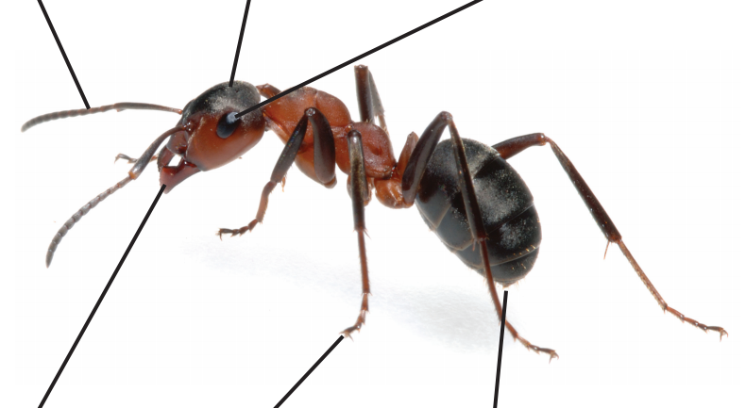
Mandibles
Ants have two strong jaws called mandibles. Ants use these to carry food and other objects, to build nests and to protect themselves.
Hooked claws
Ants have a hooked claw on the end of each of their six legs. These claws help them to grip surfaces and to climb.
Stinger
Most ants have a stinger. Ants use their stingers to capture other insects and to protect their nests.
Year 5 NAPLAN Reading Magazine, 2010 ACARA

Student informative text examples

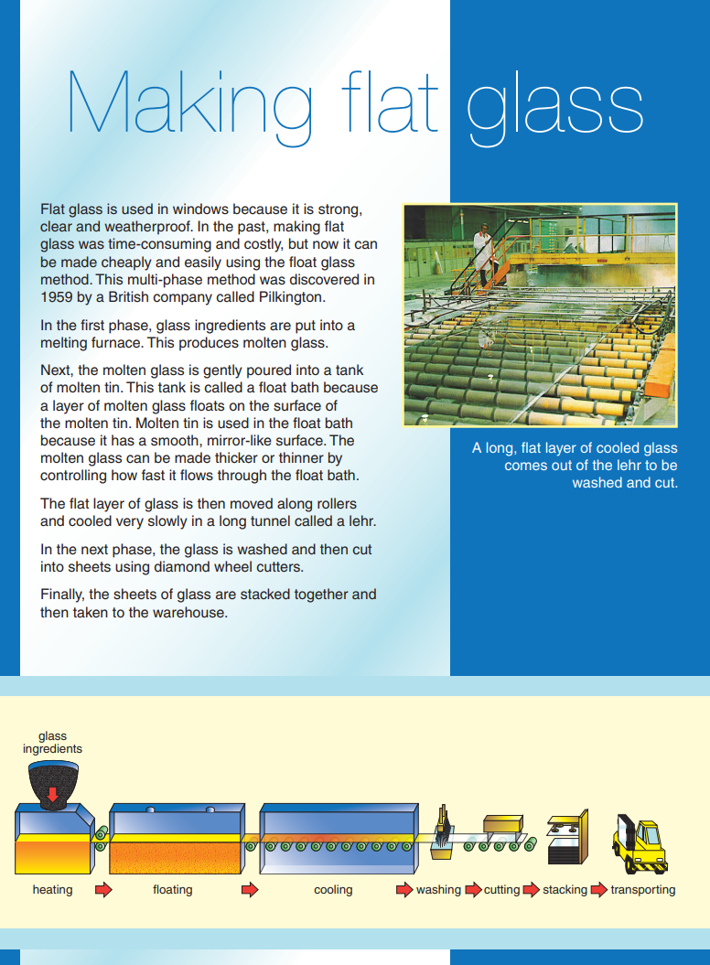
My prediction:

Text structural features:

Signal words:

Type of text:

Year 5 NAPLAN Reading Magazine, 2010 ACARA

Student informative text examples - accessible version
Making Flat glass
Flat glass is used in windows because it is strong, clear and weatherproof. In the past, making flat glass was time-consuming and costly, but now it can be made cheaply and easily using the float glass method. This multi-phase method was discovered in 1959 by a British company called Pilkington.
In the first phase, glass ingredients are put into a melting furnace. This produces molten glass.
Next, the molten glass is gently poured into a tank of molten tin. This tank is called a float bath because a layer of molten glass floats on the surface of the molten tin. Molten tin is used in the float bath because it has a smooth, mirror-like surface. The molten glass can be made thicker or thinner by controlling how fast it flows through the float bath.
The flat layer of glass is then moved along rollers and cooled very slowly in a long tunnel called a lehr.
In the next phase, the glass is washed and then cut into sheets using diamond wheel cutters.
Finally, the sheets of glass are stacked together and then taken to the warehouse.
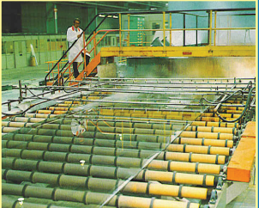
A long, flat layer of cooled glass comes out of the lehr to be washed and cut.
Glass ingredients
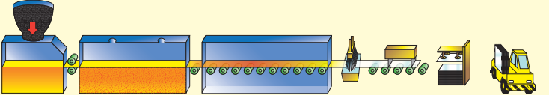
Heating Floating Cooling washing cutting stacking transporting
Year 5 NAPLAN Reading Magazine, 2010 ACARA

Student informative text examples

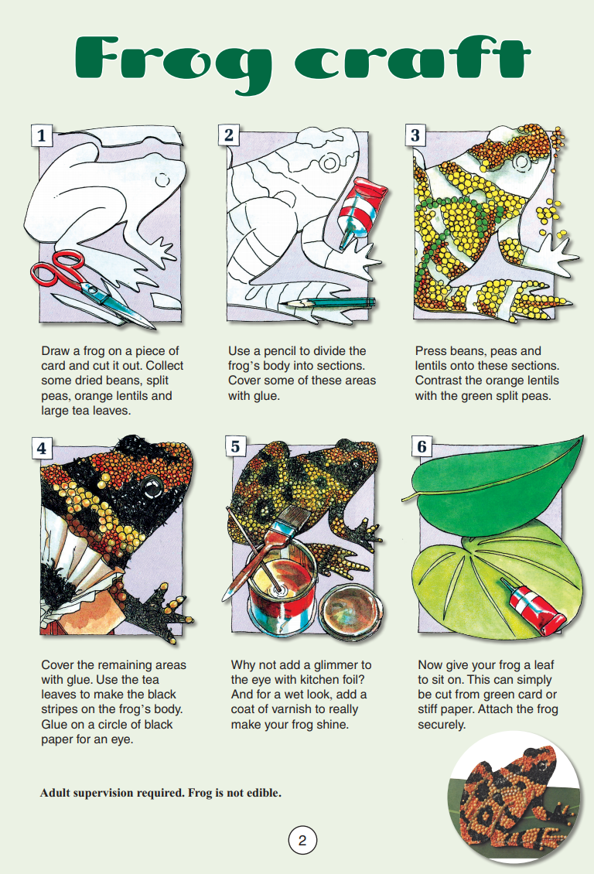
My prediction:

Text structural features:

Signal words:

Type of text:

Year 5 Reading Magazine, 2010 ACARA

Student informative text examples – accessible version
Frog Craft
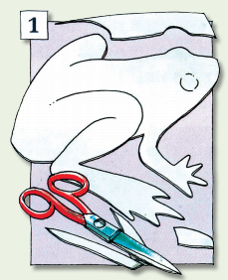
- Draw a frog on a piece of card and cut it out. Collect some dried beans, split peas, orange lentils and large tea leaves.
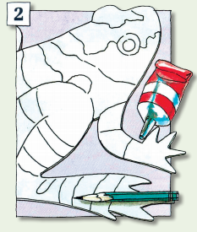
- Use a pencil to divide the frog’s body into sections. Cover some of these areas with glue.
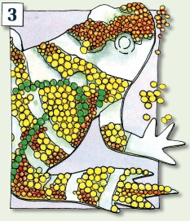
- Press beans, peas and lentils onto these sections. Contrast the orange lentils with the green split peas.
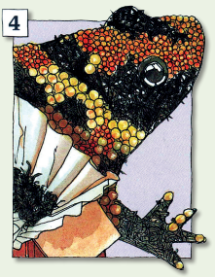
- Cover the remaining areas with glue. Use the tea leaves to make the black stripes on the frog’s body. Glue on a circle of black paper for an eye.
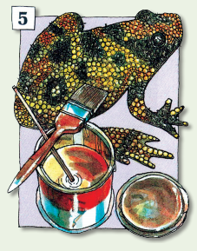
- Why not add a glimmer to the eye with kitchen foil? And for a wet look, add a coat of varnish to really make your frog shine.
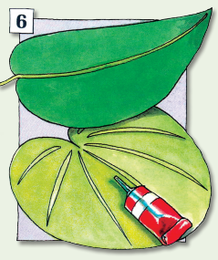
- Now give your frog a leaf to sit on. This can simply be cut from green card or stiff paper. Attach the frog securely.
Adult supervision required. Frog is not edible.
Year 5 NAPLAN Reading Magazine, 2010 ACARA

Appendix 7

Headlines
Social media: taking over the world
Cows lose their jobs
Stay out of the water! Beaches closed! Killer shark at large
Unfit for office
Grapefruit: Good for every meal
Monster meal deals hard to digest
Kids make nutritious snacks
Are lamingtons really our national food?
Kids need to get out and play!

Appendix 8

Student persuasive text example

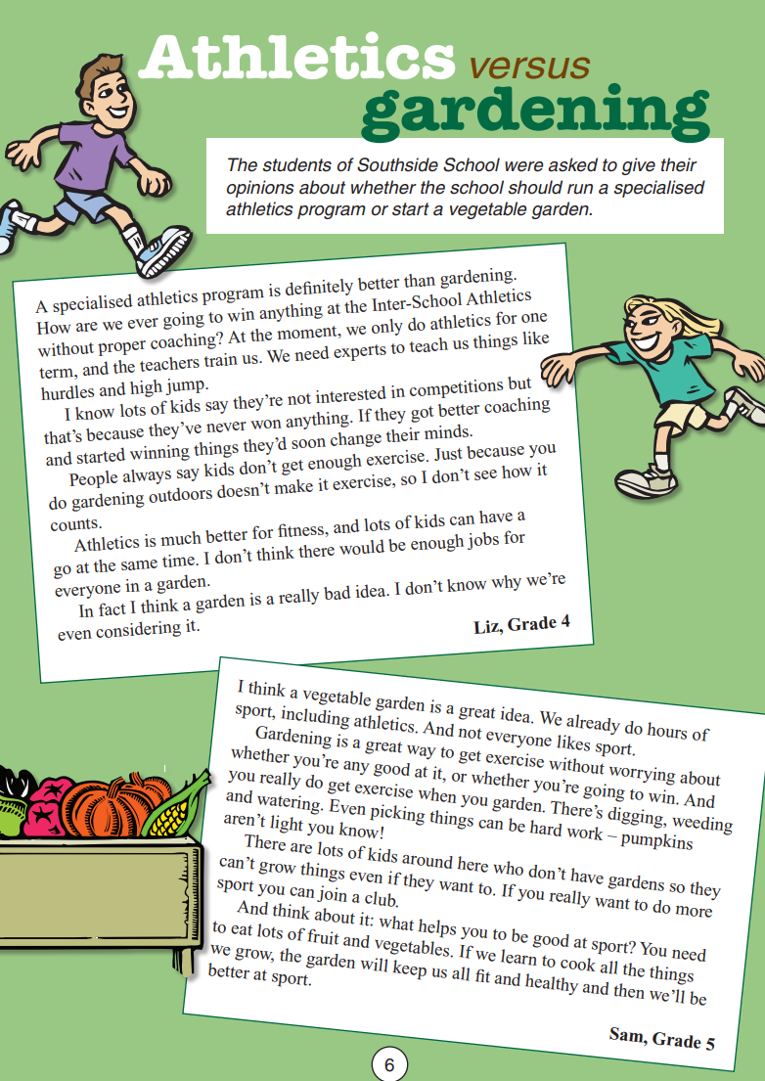
My prediction:

Text structural features:

Signal words:

Type of text:

Year 5 NAPLAN Reading Magazine, 2010 ACARA

Student persuasive text example - accessible version
Athletics versus gardening
The students of Southside School were asked to give their opinions about whether the school should run a specialised athletics program or start a vegetable garden.
Student 1 - A specialised athletics program is definitely better than gardening. How are we ever going to win anything at the InterSchool Athletics without proper coaching? At the moment, we only do athletics for one term, and the teachers train us. We need experts to teach us things like hurdles and high jump.
I know lots of kids say they’re not interested in competitions but that’s because they’ve never won anything. If they got better coaching and started winning things they’d soon change their minds.
People always say kids don’t get enough exercise. Just because you do gardening outdoors doesn’t make it exercise, so I don’t see how it counts.
Athletics is much better for fitness, and lots of kids can have a go at the same time. I don’t think there would be enough jobs for everyone in a garden.
In fact I think a garden is a really bad idea. I don’t know why we’re even considering it.
Liz, Grade 4
Student 2 - I think a vegetable garden is a great idea. We already do hours of sport, including athletics. And not everyone likes sport.
Gardening is a great way to get exercise without worrying about whether you’re any good at it, or whether you’re going to win. And you really do get exercise when you garden. There’s digging, weeding and watering. Even picking things can be hard work – pumpkins aren’t light you know!
There are lots of kids around here who don’t have gardens so they can’t grow things even if they want to. If you really want to do more sport you can join a club.
And think about it: what helps you to be good at sport? You need to eat lots of fruit and vegetables. If we learn to cook all the things we grow, the garden will keep us all fit and healthy and then we’ll be better at sport.
Sam, Grade 5
Year 5 NAPLAN Reading Magazine, 2010 ACARA

Appendix 9

Reviewing Curious Children: persuasive text comparison
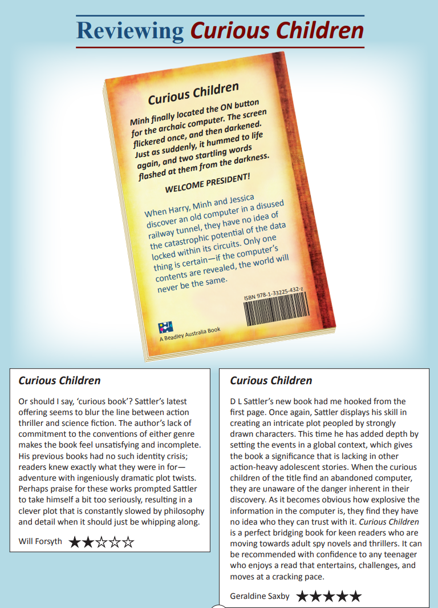
Year 5 NAPLAN Reading Magazine, 2016 ACARA

Reviewing Curious Children: persuasive text comparison
Accessible version
Reviewing Curious Children
Minh finally located the ON button for the archaic computer. The screen flickered once, and then darkened. Just as suddenly, it hummed to life again, and two startling words flashed at them from the darkness.
WELCOME PRESIDENT!
When Harry, Minh and Jessica discover an old computer in a disused railway tunnel, they have no idea of the catastrophic potential of the data locked within its circuits. Only one thing is certain—if the computer’s contents are revealed, the world will never be the same.
Review 1 - Curious Children Or should I say, ‘curious book’? Sattler’s latest offering seems to blur the line between action thriller and science fiction. The author’s lack of commitment to the conventions of either genre makes the book feel unsatisfying and incomplete. His previous books had no such identity crisis; readers knew exactly what they were in for— adventure with ingeniously dramatic plot twists. Perhaps praise for these works prompted Sattler to take himself a bit too seriously, resulting in a clever plot that is constantly slowed by philosophy and detail when it should just be whipping along.
Will Forsyth. 2 stars.
Review 2 - Curious Children D L Sattler’s new book had me hooked from the first page. Once again, Sattler displays his skill in creating an intricate plot peopled by strongly drawn characters. This time he has added depth by setting the events in a global context, which gives the book a significance that is lacking in other action-heavy adolescent stories. When the curious children of the title find an abandoned computer, they are unaware of the danger inherent in their discovery. As it becomes obvious how explosive the information in the computer is, they find they have no idea who they can trust with it. Curious Children is a perfect bridging book for keen readers who are moving towards adult spy novels and thrillers. It can be recommended with confidence to any teenager who enjoys a read that entertains, challenges, and moves at a cracking pace.
Geraldine Saxby. 5 stars.
Year 5 NAPLAN Reading Magazine, 2016 ACARA

Reviewing Curious Children: persuasive text comparison (questions)
Question | Ideas, questions and elaboration
Forsyth thinks a good adventure story
- has a complex plot and plenty of action
- has an intricate plot and some reflection
- challenges the conventions of the genre
- is predictable in terms of the subject matter of its plot
What is the aim of Saxby’s final two sentences?
- to inform people of the book’s content
- to identify the likely audience for the book
- to explain the book is a spy novel
- to recommend the book to librarians
On which aspect of the novel are both reviewers positive?
- characters
- plot
- setting
- writing style
Which statement is most similar to an opinion expressed in Forsyth’s review?
- Sattler again displays his distinctive use of language.
- This book is unlike Sattler’s earlier works.
- Sattler is a writer who understands what his readers want.
- This book is a departure from Sattler’s usual subject matter.
What is the identity crisis that Forsyth refers to in his review?
____________________________________________________
____________________________________________________
____________________________________________________
____________________________________________________
At the end of each review, what do the stars represent?
- the difficulty of the book
- the age classification for the book
- the rating of the book by readers
- the reviewer’s judgement

Informative | Imaginative | Persuasive
Title | Title | Title
Headings | Setting | Rhetorical question  Are cats really better companions than dogs?
Sub-headings | Characters | Modality  Must, ought to, it is important…
Maps | Descriptions | Experts
Diagrams | Plot | Evidence
Facts | Complication | Introduction
Experts | Series of events | Arguments
Introduction | Resolutions | Conclusion
Topic sentence | Coda | Opinion
Research | Pictures | Bias

Appendix 10

Which text? Match and sort

Appendix 11

Identifying features of texts
Which type of text and genre are these excerpts?
WHAT WOULD YOU do if someone told you about a place where there was enough gold to make you a millionaire, and offered to share it with you?  Would you believe them? Or would you laugh it off as a joke and forget about it?  That was the question facing some men in March 1930, and this is the story of what happened afterwards.  Gold Fever article by Noelene Martin in The School Magazine, © State of New South Wales (Department of Education), Issue 4 2017. | MAISIE’S DAD WAS the best finder of crazy holidays in the universe. Every week, he searched the internet for the cheapest deals and the weirdest, wackiest, zaniest places to stay. But this weekend, Maisie’s mum took charge. ‘Enough of yurts and lava caves and renovated, oversized sewerage pipes,’ she announced. ‘I want somewhere ordinary. Nothing unusual. No surprises. No out-of-the-ordinary experiences! I’ve found the perfect guesthouse, and it’s available this weekend!’  The Haunted Holiday story by Marian McGuiness in The School Magazine, © State of New South Wales (Department of Education), Issue 10, 2018.
Shark Bay has a salinity level twice that of the ocean. This hypersalinity creates a favourable environment for the survival of some marine animals—such as cockles—as well as an unfavourable environment for its predators. Because the Shark Bay cockle has no predators, and because it has existed in such huge numbers for thousands of years, its shells have washed ashore to create a snow-white beach that stretches nearly 70 kilometres.  Dossier of Discovery: A Seashell Smorgasbord article by Anne Renaud in The School Magazine, © State of New South Wales (Department of Education), Issue 6 2019. | Birds are the only visitors now, perched high on the sooty squares watching the wind ruffled grass dance at the base of the chimneys and feeling the ghosts of who knows who once lived there.  Who was it that once gathered in the lounge on the rug sharing stories while someone knitted in the old rocking chair warmed by the rollicking orange flames?  A History Through Chimneys poem by Kaye Baillie in The School Magazine, © State of New South Wales (Department of Education), Issue 8 2019.
This Halloween was shaping up to be the best yet. Sanjay had only been trick or treating for forty-five minutes and already his bag was overflowing with sweets. He looked at his watch. He was due to be home in ten minutes, but there was still one door he hadn’t knocked on. It was the door of the old weatherboard house at the end of his street. Someone new had moved in only last week, and Sanjay was eager to meet his newest neighbour.  A Puzzling Tale: Halloween Hoax story by Cheryl Bullow in The School Magazine, © State of New South Wales (Department of Education), Orbit Issue 1 2019. | For some people, great success comes from dealing with great adversity. This article is about one of those people.  It happened many years ago; two hundred years ago, to be exact. It happened far away, in the city of Vienna, Austria. And it happened to a man called Ludwig.  Ludwig loved music more than anything else in his life. It was his greatest passion. He was an excellent pianist, and often the rich folks of Vienna invited him to their homes.  ‘Please, Ludwig, will you play the piano for us?’ they begged. ‘We have guests coming on Saturday night. They would love to hear you. We will pay you well.’  The Worst, Worst Thing in the World article by Jenny Robson in The School Magazine, © State of New South Wales (Department of Education), Orbit Issue 1 2019

Appendix 12

Persuasive/informative text example
Use colour-coding, arrows and labels to identify features in this text (or any other relevant annotations).

Yum Yum!
Article by Susan Lett, The School Magazine Issue 6, 2019.
We all need protein as part of a healthy diet, but would you be keen to get that protein from a six-legged critter? Read on and you just might change your mind.
Feel like a snack? A packet of potato chips? How about a bowl of crunchy crickets instead? Did you say ‘Yuck’?
Believe it or not, crickets and other bugs are tasty.
Now don’t go munching on insects from your garden. They need to be bred and prepared for eating.
Skye Blackburn—Food Scientist and Entomologist (a person who studies insects)—is an insect breeder. Sky started Australia’s first insect breeding farm in 2007. She has developed insect products to eat and cook with. These products are widely distributed throughout Australia.
Right now, farmers are discovering the benefits of breeding insects. This could be the start of a ‘Bug Boom’ in Australia!
Around the world, more than two billion people include insects in their diet. Why? Because bugs are actually good for you! Here are just some of the benefits of eating bugs:
- They're nutritious
- They’re rich in protein
- Most bugs contain healthy fats, iron and calcium
- They’re low in carbohydrates
- Bugs are also good for the environment. They’re eco-friendly!
Meat production is one of the largest contributors to greenhouse gases. Animal methane and effluent waste are a large part of the problem.
With population growth comes an increased demand for grass-fed meats. This will have a significant impact on our environment. Substituting eco-friendly bugs will not only benefit us, but our planet as well.
Today, many chefs in Australia include insects in their dishes. They are mindful of nutrition and the benefits of eco-friendly food. There is even an Insect Only café!
Are you ready to be bugged?
When you are offered a snack of crunchy crickets or roasted mealworms, or if you see bugs on the menu, be brave and give them a try.
You might just say, ‘YUM YUM!’
The School Magazine © State of New South Wales (Department of Education), Issue 6 2019

Appendix 13

Responding to texts graphic organiser
What type of text is this text? How do you know?  Ideas: Imaginative, informative or persuasive? | This text mostly helps me to…  Ideas: Understand? Explain? Choose? Find out about?
The main purpose of this text is to…?  Ideas: Encourage me to…give interesting facts about…outline where…show me… | What genre is this text?  Ideas: Adventure? Science-fiction? Letter? Recipe?
What is the purpose of first paragraph? | What question does this text answer?
Is there a problem in the text? If so what is it? | Do you think the end of the text is effective? Why/why not?

Appendix 14

PAFT Planning template
PAFT | Synonyms | Examples | How do I know?  (Evidence) | Planning Space
Purpose | Goal, Intention, Reason, (Why?) | To convince  To persuade  To argue  To prove  To influence  To entertain  To inform | Words  Phrases  Images  Structural Features
Audience | Reader, Responder, (Who?) | Male/Female  Teenager/ Elderly  Student/Teacher  Politician  Children/Adult  Professional  Race/Religion  Society/Culture  Hobby/Interest | Words  Phrases  Images  Structural Features
Form | Text type, Structure, Arrangement,  (What?) | Persuasive/ Imaginative  Informative/ Narrative  Letter/Article  Website/ Diary Entry  Novel/ Film | Words  Phrases  Images  Structural Features
Tone | Attitude, Voice, Manner, Feeling  (How?) | Persuasive/ Informative  Sad/ Angry/ Happy  Joyful/ Optimistic  Melancholy/ Humorous  Subjective/ Objective | Words  Phrases  Images  Structural Features

Appendix 15

PAFT – Sample questions and answers
Discussion Questions | Sample Answers
How do you know the text is persuasive/ informative/ imaginative? | I know the text is persuasive because the author uses high modality words like ‘must’ to reinforce/strengthen their point of view.
What words/phrases/images helped you decide what the purpose is? | I know the text is informative because the author uses a lot of facts and no opinion. I also see a lot of diagrams and graphs which are included to enhance my understanding of how the human body works.
How do you know who the intended audience is? | I know the audience is young children because the story is about being respectful to adults.
What words/ phrases/ images helped you decide who the intended audience is? | The language is simple and easy to understand. There are also bright and colourful pictures. These kinds of images are usually found in children’s picture books.
How do you know what the form and/or text type is? | I know the form is a letter because there is a forwarding address at the top of the page and the writing starts with the salutation ‘To Mr Smith’.
What words/ phrases/ images/ structural features helped you decide what the form is? | The text is also written in first-person which is the perspective letters are usually written in. This text is also persuasive because the author is trying to convince the recipient to give her a job.
Can you describe the tone of your text? | I know the tone is optimistic because the author uses phrases like ‘I hope’ and ‘amazing opportunity’.
What words/ phrases/ images helped you decide what the tone is? | I know the tone is sad and serious because the author uses words like ‘miserable’ and ‘horrific’. The image next to the text also shows a character crying in the rain.

Appendix 16

Who wrote the letter?
- Read the following letters individually or in pairs/groups.
- Annotate each letter identifying the purpose, audience, form and tone.
- Use the salutation, layout and content details of each letter to help you identify the correct author. Fill in the signature once you are confident with your decision. Make sure you identify and record the evidence as you explore each text.
Author profiles:
Letter 1 | Letter 2 | Letter 3
Miss Sarah Golding  Age: 22  POB: Sydney, Australia | Liam  Age: 19  POB: Broken Hill, Australia | Mr. Wordsworth  Age: 55  POB: Lake District, England
Evidence: | Evidence: | Evidence:

Letter 4 | Letter 5 | Letter 6
Dr Richards  Age: 53  POB: Perth, Australia | Mrs. Cavallaro  Age: 29  POB: Naples, Italy | Anonymous Mother  Age: 35  POB: Auckland, New Zealand
Evidence: | Evidence: | Evidence:
© State of New South Wales (Department of Education), 2021

Who wrote the letter?
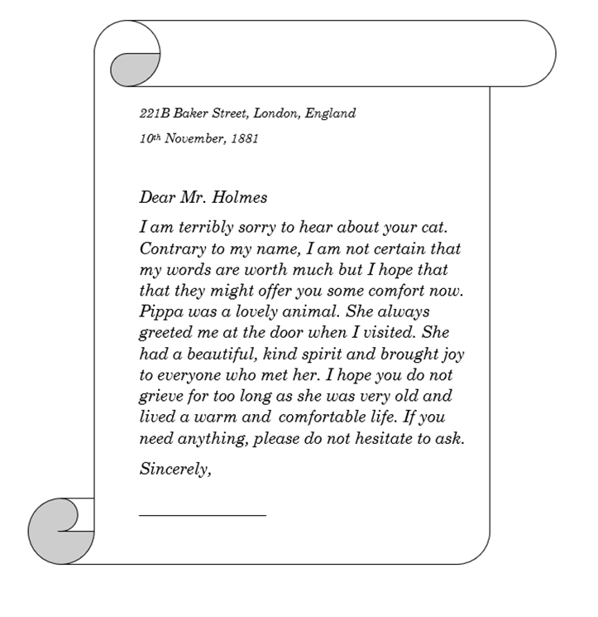© State of New South Wales (Department of Education), 2021

Who wrote the letter?
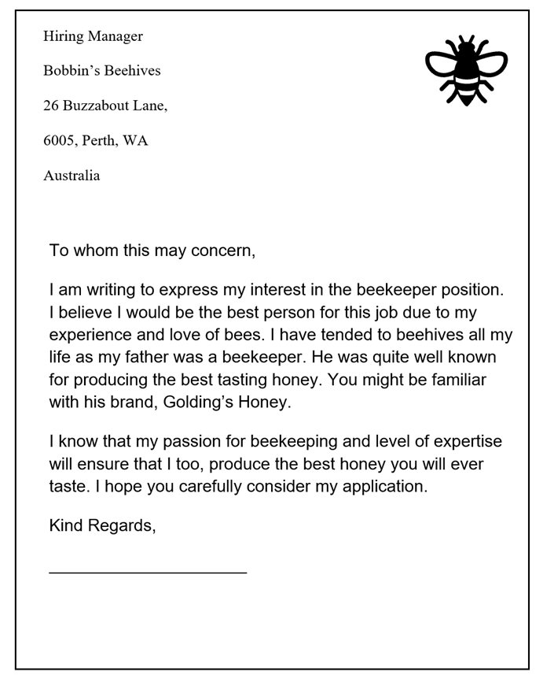© State of New South Wales (Department of Education), 2021

Who wrote the letter?
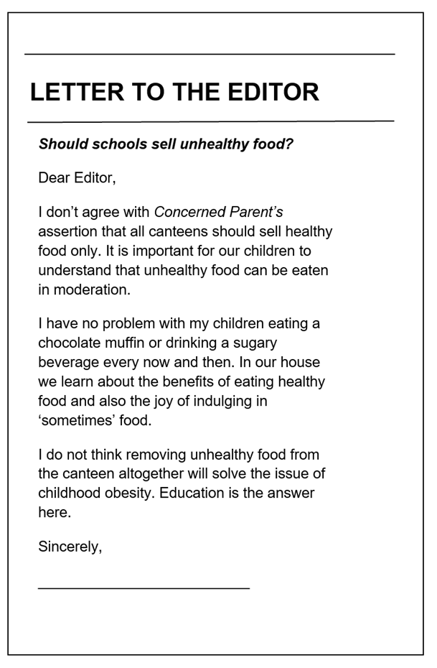
© State of New South Wales (Department of Education), 2021

Who wrote the letter?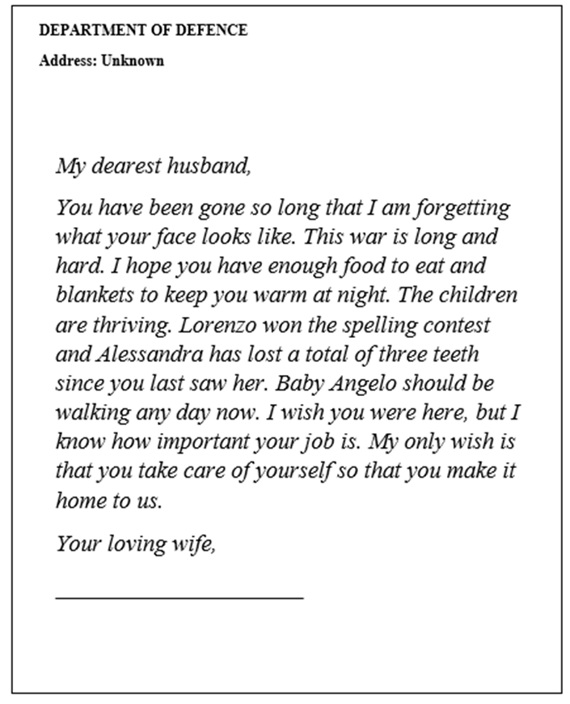 © State of New South Wales (Department of Education), 2021

Who wrote the letter?
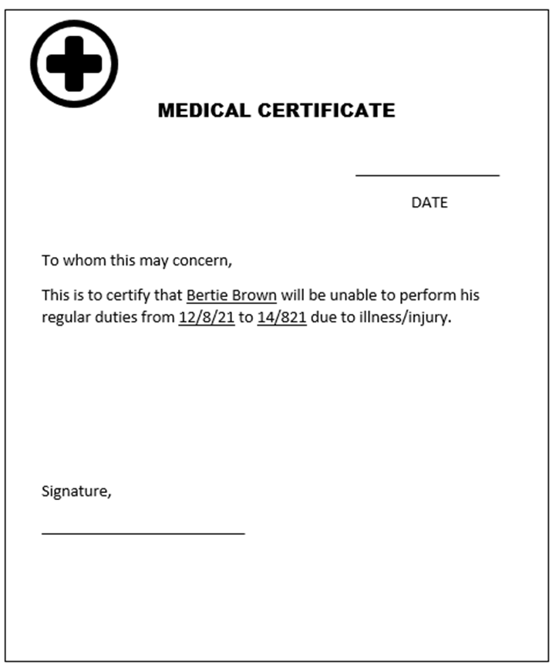© State of New South Wales (Department of Education), 2021

Who wrote the letter?
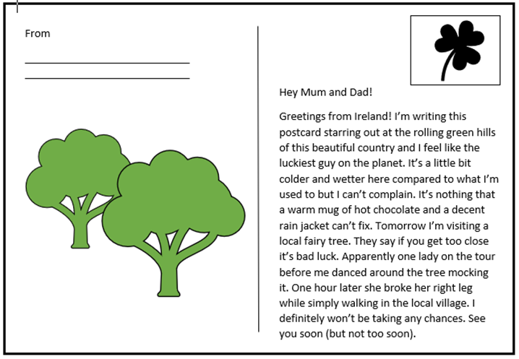© State of New South Wales (Department of Education), 2021

Who wrote the letter? Accessible version.
Letter 1:
221B Baker Street, London, England
10th November, 1881
Dear Mr Holmes
I am terribly sorry to hear about your cat. Contrary to my name, I am not certain that my words are worth much but I hope that that they may offer you some comfort now. Pippa was a lovely animal. She always greeted me at the door when I visited. She had a beautiful, kind spirit and brought joy to everyone who met her. I hope you do not grieve for too long as she was very old and lived a warm and comfortable life. If you need anything, please do not hesitate to ask.
Sincerely,

Letter 2:
Hiring manager
Bobbin’s Beehives
26 Buzzabout Lane,
6005, Perth, WA
Australia
To whom this may concern,
I am writing to express my interest in the beekeeper position. I believe I would be the best person for this job due to my experience and love of bees. I have tended to beehives all my life as my father was a beekeeper. He was quite well known for producing the best tasting honey. You might be familiar with his brand, Golding’s Honey.
I know that my passion for beekeeping and level of expertise will ensure that I too, produce the best honey you will ever taste. I hope you carefully consider my application.
Kind Regards,
____________
© State of New South Wales (Department of Education), 2021

Who wrote the letter? Accessible version.
Letter 3:
Letter to the Editor
Should schools sell unhealthy food?
Dear Editor,
I don’t agree with Concerned Parent’s assertion that all canteens should sell healthy food only. It is important for our children to understand that unhealthy food can be eaten in moderation.
I have no problem with my children eating a chocolate muffin or drinking a sugary beverage every now and then. In our house we learn about the benefits of eating healthy food and also the joy of indulging in ‘sometimes’ food.
I do not think removing unhealthy food from the canteen altogether will solve the issue of childhood obesity. Education is the answer here
Sincerely,
______________

Letter 4:
Department of Defence
Address: Unknown
My dearest husband,
You have been gone so long that I am forgetting what your face looks like. This war is long and hard. I hope you have enough food to eat and blankets to keep you warm at night. The children are thriving. Lorenzo won the spelling contest and Alessandra has lost a total of three teeth since you last saw her. Baby Angelo should be walking any day now. I wish you were here, but I know how important your job is. My only wish is that you take care of yourself so that you make it home to us.
Your loving wife,
_______________
© State of New South Wales (Department of Education), 2021

Who wrote the letter? Accessible version.
Letter 5:
Medical Certificate
______________
DATE
To whom this may concern,
This is to certify that Bertie Brown will be unable to perform his regular duties from 12/8/21 to 14/8/21 due to illness/injury.
Signature,
________________

Letter 6:
From
_______________
Hey Mum and Dad!
Greetings from Ireland! I’m writing this postcard staring out at the rolling green hills of this beautiful country and I feel like the luckiest guy on the planet. It’s a little bit colder and wetter here compared to what I’m used to but I can’t complain. It’s nothing that a warm mug of hot chocolate and a decent rain jacket can’t fix. Tomorrow I’m visiting a local fairy tree. They say if you get too close it’s bad luck. Apparently one lady on the tour before me danced around the tree mocking it. One hour later she broke her right leg while simply walking in the local village. I definitely won’t be taking any chances. See you soon (but not too soon).
____________
© State of New South Wales (Department of Education), 2021

