Sequencing events

Stage 3

Overview

Purpose
This literacy teaching strategy supports teaching and learning for Stage 3 students across all key learning areas. It targets specific literacy skills and suggests a learning sequence to build skill development. Teachers can select individual tasks, or a sequence, and embed into their teaching and learning program according to their students’ needs. While exemplar texts are provided throughout this resource, it is recommended that teachers select texts which are relevant to their students and curriculum.

Learning intention
Students will learn to sequence language and events by connecting contextual and language clues to chronological order.

Syllabus outcome
The following teaching and learning strategy will assist in covering elements of the following outcomes:
- EN3-RECOM-01: fluently reads and comprehends texts for wide purposes, analysing text structures and language, and by monitoring comprehension
- EN3-UARL-01: analyses representations of ideas in literature through narrative, character, imagery, symbol and connotation, and adapts these representations when recreating texts.
NSW English K-10 Syllabus 2022

Success criteria
The following Year 5 NAPLAN item descriptors may guide teachers to co-construct success criteria for student learning.
- sequences events from an information text
- sequences events referred to in an information text
- locates directly stated information in an information text
- interprets directly stated information in an information text
- sequences the order of events in a narrative
- interprets a simple flow chart

National Literacy Learning Progression guide

Understanding Texts (UnT8-UnT9)
Key: C=comprehension P=process V=vocabulary

UnT6
- uses cohesive devices to connect ideas or events (e.g. tracks pronoun referencing) (see Grammar) (P)

UnT7
- reads and views predictable texts (see Text complexity) (C)
- navigates texts using common signposting devices such as headings, subheadings, paragraphs, navigation bars and links (P)

UnT8
- reads and views some moderately complex texts (see Text complexity) (C)
- uses knowledge of cohesive devices to track meaning throughout a text (e.g. connectives such as however, on the other hand) (see Grammar) (P)
- skims and scans texts for key words to track the development of ideas (P)
- understands precise meaning of words with similar connotations (e.g. generous, kind-hearted, charitable) (V)

UnT9
- builds meaning by actively linking ideas from a number of texts or a range of digital sources (C)
- uses processes such as predicting, confirming predictions, monitoring, and connecting relevant elements of the text to build or repair meaning (P)
National Literacy Learning Progression

Evidence base
- Centre for Education Statistics and Evaluation (2017). Effective reading instruction in the early years of school, literature review.
- Konza, D. (2014). Teaching Reading: Why the “Fab Five” should be the “Big Six”. Australian Journal of Teacher Education, 39(12).
- Oakhill, J., Cain, K. & Elbro, C. (2015). Understanding and teaching reading comprehension: A handbook. Routledge.
- Quigley, A. (2020). Closing the reading gap. Routledge.
- Scarborough, H.S. (2001). Connecting early language and literacy to later reading (dis)abilities: Evidence, theory and practice. In S. Neuman & D. Dickson (Eds.), Handbook for research in early literacy (pp. 97-110). New York, NY: Guilford Press.
Alignment to system priorities and/or needs: Five priorities for Literacy and Numeracy, Our Plan for NSW Public Education, School Excellence Policy (nsw.gov.au)
Alignment to School Excellence Framework: Learning domain: Curriculum, Teaching domain: Effective classroom practice and Professional standards
Consulted with: Strategic Delivery, Teaching Quality and Impact
Author: Literacy and Numeracy
Reviewed by: Literacy and Numeracy, Teaching Quality and Impact
Created/last updated: January 2024
Anticipated resource review date: January 2025
Feedback: Complete the online form to provide any feedback

Copyright
Section 113P Notice
Texts, Artistic Works and Broadcast Notice
Some of this material has been copied and communicated to you in accordance with the statutory licence in section 113P of the Copyright Act. Any further reproduction or communication of this material by you may be the subject of copyright protection under the Act. Do not remove this notice.

Teaching strategies
Task | Appendices
Shades of meaning | Appendix 1 - ‘Shades of Meaning’
Sequencing non-fiction texts – History of chocolate | Appendix 2a - ‘Chocolate Trees’  Appendix 2b- ‘Chocolate Trees’ scaffolded copy
Sequencing events in a narrative | Appendix 3 - Narrative Texts  Appendix 4 - Graphic organisers
Sequencing information texts | Appendix 1 - ‘Shades of Meaning’
Sequencing information

Background Information

Sequencing events
Sequencing is an important comprehension skill for students to organise and structure ideas and events in order of occurrence. Opportunities for sequencing can include using pictures, letters and numbers, recipes, pieces of music and dance steps.
Students learn to sequence key parts which show a shift in behaviour, people and settings.
Students will need to be able to summarise an event and find the main idea in a paragraph in order to sequence events.

Where to next?
- Text structure
- Literal comprehension
- Understanding character

Overview of teaching strategies

Purpose
These literacy teaching strategies support teaching and learning from Stage 2 to Stage 5. They are linked to NAPLAN task descriptors, syllabus outcomes and literacy and numeracy learning progressions.
These teaching strategies target specific literacy and numeracy skills and suggest a learning sequence to build skill development. Teachers can select individual tasks or a sequence to suit their students.

Access points
The resources can be accessed from:
- NAPLAN App in Scout using the teaching strategy links from NAPLAN items
- NSW Department of Education literacy and numeracy website.

What works best
Explicit teaching practices involve teachers clearly explaining to students why they are learning something, how it connects to what they already know, what they are expected to do, how to do it and what it looks like when they have succeeded. Students are given opportunities and time to check their understanding, ask questions and receive clear, effective feedback.
This resource reflects the latest evidence base and can be used by teachers as they plan for explicit teaching.
Teachers can use classroom observations and other assessment information to make decisions about when and how they use this resource as they design teaching and learning sequences to meet the learning needs of their students.
Further support with What works best is available.

Differentiation
When using these resources in the classroom, it is important for teachers to consider the needs of all students, including Aboriginal and EAL/D learners.
EAL/D learners will require explicit English language support and scaffolding, informed by the EAL/D enhanced teaching and learning cycle and the student’s phase on the EAL/D Learning Progression. Teachers can access information about supporting EAL/D learners and literacy and numeracy support specific to EAL/D learners.
Learning adjustments enable students with disability and additional learning and support needs to access syllabus outcomes and content on the same basis as their peers. Teachers can use a range of adjustments to ensure a personalised approach to student learning.
Assessing and identifying high potential and gifted learners will help teachers decide which students may benefit from extension and additional challenge. Effective strategies and contributors to achievement for high potential and gifted learners helps teachers to identify and target areas for growth and improvement. A differentiation adjustment tool can be found on the High potential and gifted education website.

Using tasks across learning areas
This resource may be used across learning areas where it supports teaching and learning aligned with syllabus outcomes.
Literacy and numeracy are embedded throughout all syllabus documents as general capabilities. As the English and mathematics learning areas have a particular role in developing literacy and numeracy, NSW English and Mathematics syllabus outcomes aligned to literacy and numeracy skills have been identified.

Text selection
Example texts are used throughout this resource. Teachers can adjust activities to use texts which are linked to their unit of learning.
Further support with text selection can be found within the National Literacy Learning Progression Text Complexity appendix.
The NESA website has additional information on text requirements within the NSW English syllabus.

Teaching strategies

Shades of meaning
- Modelled instruction: Shades of meaning: Demonstrate sequencing a set of words on a word cline using the ‘Shades of Meaning’ resource (Appendix 1 - ‘Shades of Meaning’). Discuss a decision-making process as to why things are in a certain sequence. Why do you think this word is stronger? What would we see? Students notice the action verbs they use to describe facial gestures or actions and behaviours.
- Students are given a set of vocabulary that is based around the same adjective, for example, ‘happiness’. Working in teams, students sequence the words from most to least. For example, being happy might range from being content through to ecstatic. It is the discussion that occurs with this activity that is most important, not necessarily the correct answer.
Differentiation: Students who need support may use a shortened list with familiar words and introducing fewer new words.
- Students create their own ‘Shades of Meaning’ word clines. They might use their own background knowledge and tools such as a thesaurus and dictionary (online or paper) to sequence language.

Sequencing non-fiction texts – History of chocolate
- Students watch a short film from Behind the News: ‘History of Chocolate’. Advise students of their role during viewing: identify important vocabulary and vocabulary they are unsure of. Students add vocabulary to sticky notes/whiteboards/device throughout the viewing. Teacher to build a vocabulary bank for students to use in the next activity.
- Pose the question: Where does chocolate come from? Students discuss and teacher uses information suggested to gauge prior learning of content.
- Ask students: Did you know chocolate grows on trees? Students read Appendix 2a - ‘Chocolate Trees’. (There is a simplified version of the text included in Appendix 2b- ‘Chocolate Trees’ scaffolded copy.) Students verbally recount the sequence of events of how chocolate is made.
Differentiation: Students use additional scientific sources to further develop their understanding such as the CSIRO website and science.org.

Sequencing events in a narrative
- Modelled instruction: Read a quality text aloud without reading the ending. Students then develop a series of freeze frames to sequence a predicted ending.
Additional task: Students compose supporting text for their sequence of actions.
- Students read one of the texts from Appendix 3 - Narrative texts.
Using the table below, scope events into beginning, middle and end.
Beginning | Middle | End
1.  2. | 1.  2. | 1.  2.
- Students analyse key events in the text, ensuring they are using key events that show a shift in behaviour, people and settings. Students use a graphic organiser to sequence events. Differentiation: Select or design own graphic organiser to represent their sequence. (Refer to Appendix 4 - Graphic organisers.)

Sequencing information texts
- Advise class they will be learning to sequence an information text. Using a quality information text that links to the current unit of learning, teacher first brainstorms the topic with the class, prompting background knowledge and vocabulary. Show class images and/or the title from the information text to prompt further discussion. Ask students:
  - What information might we expect in an information text on this topic?
  - What facts might we need to know for this topic?’
- Read the first paragraph of the information text aloud, advising students to look for the ‘expected facts.’ Students locate facts in the opening paragraph and underline. Class discussion:
  - Have we found any of the facts we expected?
  - What do we think needs to come next in the information text?
  - Has anything been left out?
- Teacher reads aloud the information text, noting and highlighting the language that indicates order (connectives) as well as any essential vocabulary for the topic. Teacher creates a word wall of sequencing connectives such as firstly, after that, lastly, in conclusion.

Sequencing information
- Advise class they will be learning to sequence information into a text form. Teacher discusses that since COVID-19 there have been many health warnings about hand hygiene to the whole population but, sometimes people can’t read the words and need images to help them understand.
- Show sample graphic organisers which use minimal text and discusses their effectiveness. Identify key features on these texts, such as headings, graphics, use of symbols such as arrows, to guide the sequence.
- Generate discussion on the different types of hand hygiene. Prompt with questions, for example. How do we clean our hands? Is there a process to sanitising our hands? Can you remember each step? Why is it important to follow each in order?
- Students create success criteria for a poster that could be displayed in the school environment demonstrating good hand hygiene. Explain that there needs to be a sequence of events that can be easily followed.
- Additional task: Students create their own posters using graphic organisers like flow charts, a comic strip, steps, but they must be visual with minimal text.

Appendix 1

Shades of meaning – sequencing language page 1
Synonyms for angry | Synonyms for big
angry | big
furious | large
vexed | great
displeased | huge
mad | massive
irate | enormous
piqued | immense
cross | colossal
annoyed | gigantic
irritated | vast
enraged | mammoth
incensed | gargantuan
Livid | tremendous
fuming | monumental
peeved | megalithic

Shades of meaning – sequencing language page 2
Synonyms for beautiful | Synonyms for happy
beautiful | happy
pretty | joyful
attractive | pleased
lovely | contented
fair | glad
elegant | ecstatic
ravishing | elated
good-looking | cheerful
stunning | merry
gorgeous | jolly
exquisite | delighted
glamorous | gleeful

Appendix 2a

Student copy
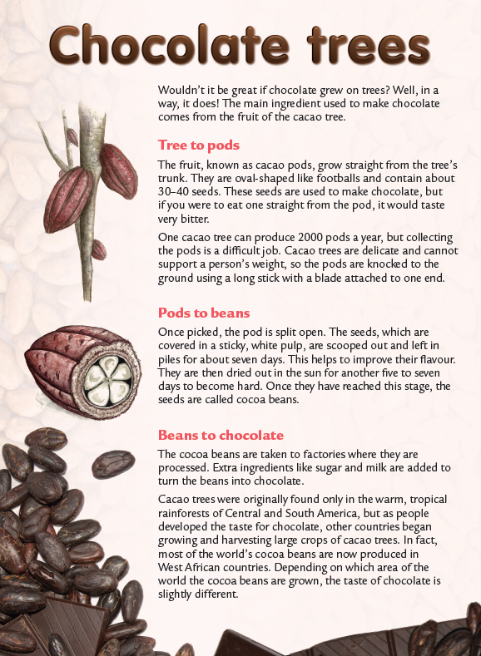
Year 3 NAPLAN Reading Magazine, 2014 ACARA.

Student copy – accessible version
Chocolate Trees
Wouldn’t it be great if chocolate grew on trees? Well, in a way, it does! The main ingredient used to make chocolate comes from the fruit of the cacao tree.
Tree to pods
The fruit, known as cacao pods, grow straight from the tree’s trunk. They are oval-shaped like footballs and contain about 30–40 seeds. These seeds are used to make chocolate, but if you were to eat one straight from the pod, it would taste very bitter.
One cacao tree can produce 2000 pods a year, but collecting the pods is a difficult job. Cacao trees are delicate and cannot support a person’s weight, so the pods are knocked to the ground using a long stick with a blade attached to one end. Wouldn’t it be great if chocolate grew on trees? Well, in a way, it does! The main ingredient used to make chocolate comes from the fruit of the cacao tree.
Pods to beans
Once picked, the pod is split open. The seeds, which are covered in a sticky, white pulp, are scooped out and left in piles for about seven days. This helps to improve their flavour. They are then dried out in the sun for another five to seven days to become hard. Once they have reached this stage, the seeds are called cocoa beans.
Beans to chocolate
The cocoa beans are taken to factories where they are processed. Extra ingredients like sugar and milk are added to turn the beans into chocolate.
Cacao trees were originally found only in the warm, tropical rainforests of Central and South America, but as people developed the taste for chocolate, other countries began growing and harvesting large crops of cacao trees. In fact, most of the world’s cocoa beans are now produced in West African countries. Depending on which area of the world the cocoa beans are grown, the taste of chocolate is slightly different.
Year 3 NAPLAN Reading Magazine, 2014 ACARA.

Appendix 2b

Scaffolded student copy
Wouldn’t it be great if chocolate grew on trees? Well, in a way, it does! The main ingredient used to make chocolate comes from the fruit of the cacao tree.

Image of the stage of chocolate processing | Explanation of the process
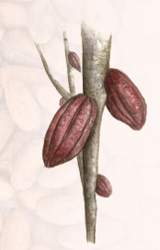 | Trees to pods  The fruit, which is known as a cacao (kah-cow) pod, grows from the tree’s trunk. They are oval and shaped like a football and have about 30-40 seeds in them. These seeds are not sweet and we can describe them as being bitter.
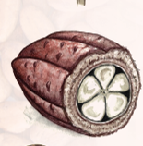 | Pods to beans  After they are picked, the pod is opened. The sticky seeds improve the taste.  Next, they are dried out for another five to seven days to become hard.  Now they are called cocoa (coh-coh) beans.
Beans to chocolate
Finally, the beans are taken to a factory where sugar and milk are added to turn them into chocolate.

Delicious!

Appendix 3

Narrative texts
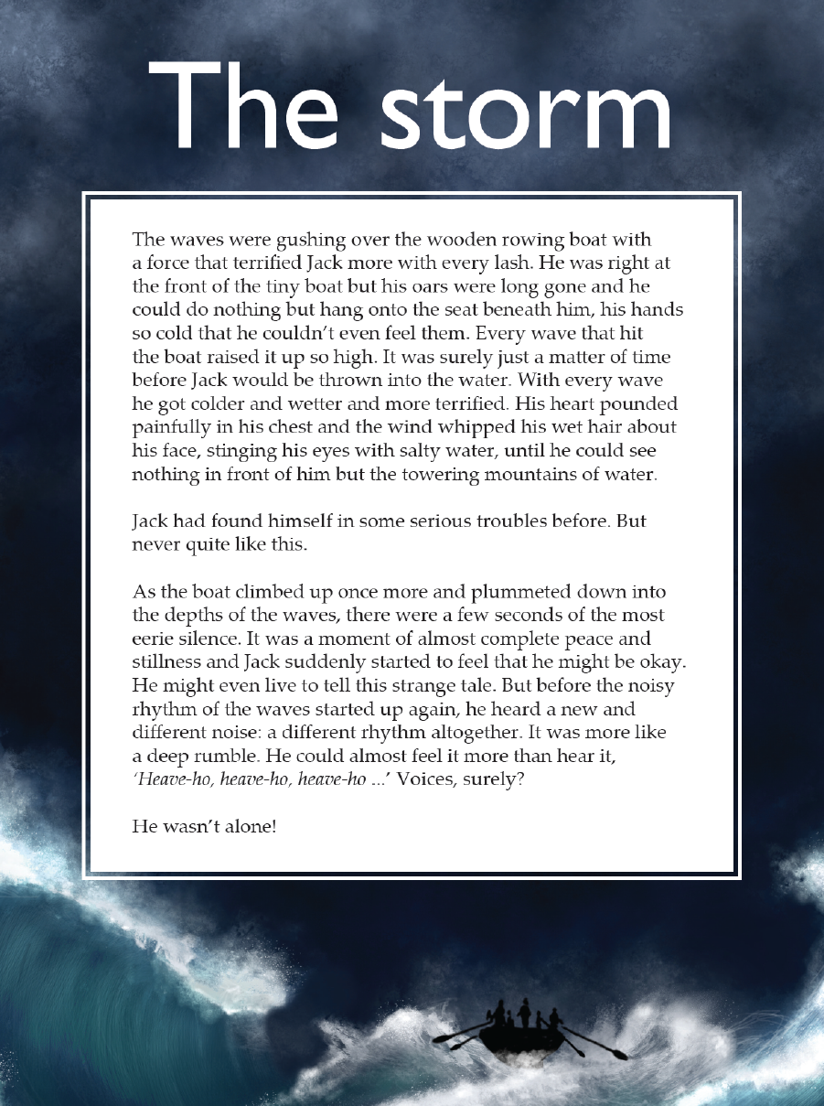
Year 5 NAPLAN Reading Magazine, 2016 ACARA

Narrative texts – accessible version

The storm
The waves were gushing over the wooden rowing boat with a force that terrified Jack more with every lash. He was right at the front of the tiny boat but his oars were long gone and he could do nothing but hang onto the seat beneath him, his hands so cold that he couldn’t even feel them. Every wave that hit the boat raised it up so high. It was surely just a matter of time before Jack would be thrown into the water. With every wave he got colder and wetter and more terrified. His heart pounded painfully in his chest and the wind whipped his wet hair about his face, stinging his eyes with salty water, until he could see nothing in front of him but the towering mountains of water.
Jack had found himself in some serious troubles before. But never quite like this.
As the boat climbed up once more and plummeted down into the depths of the waves, there were a few seconds of the most eerie silence. It was a moment of almost complete peace and stillness and Jack suddenly started to feel that he might be okay. He might even live to tell his strange tale. But before the noisy rhythm of the waves started up again, he heard a new and different noise: a different rhythm altogether. It was more like a deep rumble. He could almost feel it more than hear it, ‘Heave-ho, heave-ho, heave-ho…’ Voices, surely?
He wasn’t alone!
Year 5 NAPLAN Reading Magazine, 2016 ACARA

Narrative texts
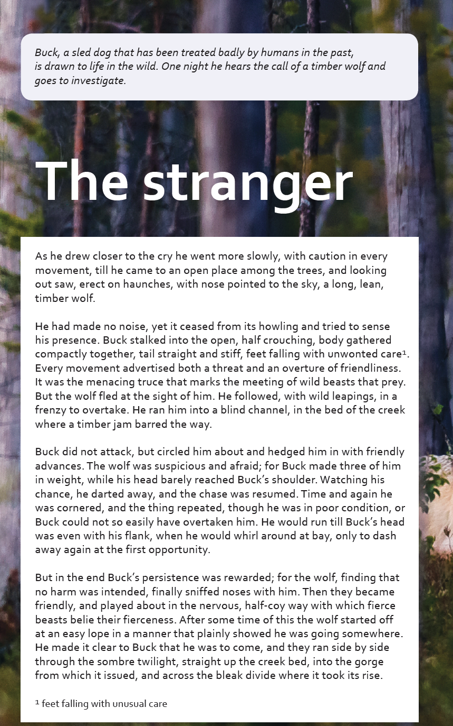
Year 5 NAPLAN Reading Magazine, 2016 ACARA

Narrative texts – accessible version
Buck, a sled dog that has been treated badly by humans in the past, is drawn to life in the wild. One night he hears the call of a timber wolf and goes to investigate.

The stranger
As he drew closer to the cry he went more slowly, with caution in every movement, till he came to an open place among the trees, and looking out saw, erect on haunches, with nose pointed to the sky, a long, lean, timber wolf.
He had made no noise, yet it ceased from its howling and tried to sense his presence. Buck stalked into the open, half crouching, body gathered compactly together, tail straight and still, feet falling with unwonted care¹. Every movement advertised both a threat and an overture of friendliness. It was the menacing truce that marks the meeting of wild beasts that prey. But the wolf fled at the sight of him. He followed, with wild leaping, in a frenzy to overtake. He ran him into a blind channel, in the bed of the creek where a timber jam barred the way.
Buck did not attack, but circled him about and hedged him in with friendly advances. The wolf was suspicious and afraid; for Buck made three of him in weight, while his head barely reached Buck’s shoulder. Watching his chance, he darted away, and the chase resumed. Time and again he was cornered, and the thing repeated, though he was in poor condition, or Buck could not so easily have overtaken him. He would run till Buck’s head was even with his flank, when he would whirl around at bay, only to dash away again at the first opportunity.
But in the end Buck’s persistence was rewarded; for the wolf, finding that no harm was intended, finally sniffed noses with him. Then they became friendly, and played about in the nervous, half-coy way with which fierce beasts belie their fierceness. After some time of this the wolf started off at an easy lope in a manner that plainly showed he was going somewhere. He made it clear to Buck that he was to come, and they ran side by side through the sombre twilight, straight up the creek bed, into the gorge from which it issued, and across the bleak divide where it took its rise.
¹feet falling with unusual care.
Year 5 NAPLAN Reading Magazine, 2016 ACARA

Narrative texts
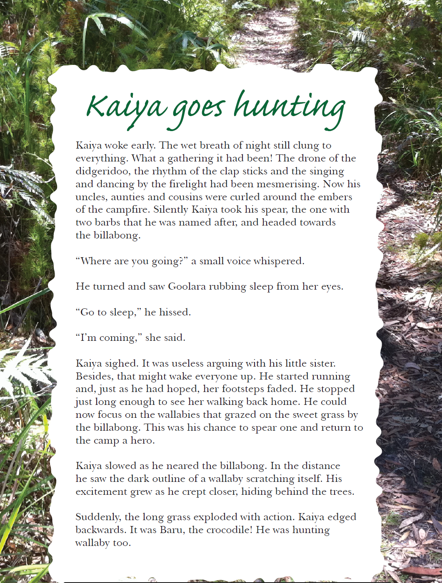
Year 5 NAPLAN Reading Magazine, 2013 ACARA

Narrative texts – accessible version
Kaiya goes hunting
Kaiya woke early. The wet breath of night still clung to everything. What a gathering it had been! The drone of the didgeridoo, the rhythm of the clap sticks and the singing and dancing by the firelight had been mesmerising. Now his uncles, aunties and cousins were curled around the embers of the campfire. Silently Kaiya took his spear, the one with two barbs that he was named after, and headed towards the billabong.
“Where are you going?’ a small voice whispered.
He turned and saw Goolara rubbing sleep from her eyes.
“Got to sleep,’ he hissed.
“I’m, coming,” she said.
Kaiya sighed. It was useless arguing with his little sister. Besides, that might wake everyone up. He started running and, just as he had hoped for, her footsteps faded. He stopped just long enough to see her walking back home. He could now focus on the wallabies that grazed the sweet grass by the billabong. This was his chance to spear one and return to the camp a hero.
Kaiya slowed as he neared the billabong. In the distance he saw the dark outline of a wallaby scratching itself. His excitement grew as he crept closer, hiding behind the trees.
Suddenly, the long grass exploded with action. Kaiya edged backwards. It was Baru, the crocodile! He was hunting wallaby too.
Year 5 NAPLAN Reading Magazine, 2013 ACARA.

Appendix 4

Graphic organiser – Flow chart
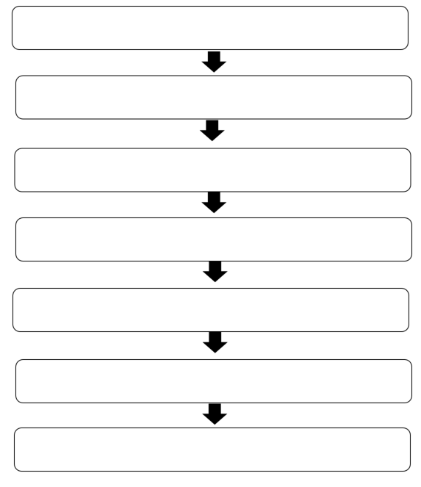

Graphic organiser – Sequencing wheel
