Main idea

Stage 3

Overview

Purpose
This literacy teaching strategy supports teaching and learning for Stage 3 students across all key learning areas. It targets specific literacy skills and suggests a learning sequence to build skill development. Teachers can select individual tasks, or a sequence, and embed into their teaching and learning program according to their students’ needs. While exemplar texts are provided throughout this resource, it is recommended that teachers select texts which are relevant to their students and curriculum.

Learning intention
Students will learn to find the main idea in persuasive, imaginative and informative paragraphs, text sections and whole text. Students will focus on identifying vocabulary and key details to determine an overall main idea.

Syllabus outcome
The following teaching and learning strategy will assist in covering elements of the following outcomes:
- EN3-RECOM-01: fluently reads and comprehends texts for wide purposes, analysing text structures and language, and by monitoring comprehension
NSW English K-10 Syllabus (2022)

Success criteria
The following Year 5 NAPLAN item descriptors may guide teachers to co-construct success criteria for student learning.
- identifies the main idea of a text
- identifies the main idea of each paragraph in an information text
- identifies the main idea of a section of an information text
- identifies the main idea of an information text
- identifies the main idea of a persuasive discussion
- identifies the main idea of a paragraph in a persuasive text
- identifies the main idea of a narrative

National Literacy Learning Progression guide

Understanding Texts (UnT8-UnT10)
Key: C=comprehension P=process V=vocabulary

UnT8
- reads and views some moderately complex texts (see Text complexity) (C)
- accurately retells a text including most relevant details (C)
- identifies main idea and related or supporting ideas in moderately complex texts (see Text complexity) (C)
- skims and scans texts for key words to track the development of ideas (P)

UnT9
- identifies the main themes or concepts in complex texts by synthesising key ideas or information (C)
- summarises the text identifying key details only (C)
- draws inferences, synthesising clues and evidence across a text (C)
- selects reading/viewing strategies appropriate to reading purpose (e.g. scans text for evidence) (P)
- judiciously selects texts for learning area tasks and purposes (P)

UnT10
- reads and views complex or some highly complex texts (see Text complexity) (C)
- integrates automatically a range of processes such as predicting, confirming predictions, monitoring, and connecting relevant elements of the text to build meaning (P)
National Literacy Learning Progression

Evidence base
- Centre for Education Statistics and Evaluation (2017). Effective reading instruction in the early years of school, literature review.
- Konza, D. (2014). Teaching Reading: Why the “Fab Five” should be the “Big Six”. Australian Journal of Teacher Education, 39(12).
- Oakhill, J., Cain, K. & Elbro, C. (2015). Understanding and teaching reading comprehension: A handbook. Routledge.
- Quigley, A. (2020). Closing the reading gap. Routledge.
- Scarborough, H.S. (2001). Connecting early language and literacy to later reading (dis)abilities: Evidence, theory and practice. In S. Neuman & D. Dickson (Eds.), Handbook for research in early literacy (pp. 97-110). New York, NY: Guilford Press.
Alignment to system priorities and/or needs: Five priorities for Literacy and Numeracy, Our Plan for NSW Public Education , School Excellence Policy (nsw.gov.au).
Alignment to School Excellence Framework: Learning domain: Curriculum, Teaching domain: Effective classroom practice and Professional standards
Consulted with: Strategic Delivery, Teaching Quality and Impact
Author: Literacy and Numeracy
Reviewed by: Literacy and Numeracy, Teaching Quality and Impact
Created/last updated: January 2024
Anticipated resource review date: January 2025
Feedback: Complete the online form to provide any feedback

Copyright
Section 113P Notice
Texts, Artistic Works and Broadcast Notice
Some of this material has been copied and communicated to you in accordance with the statutory licence in section 113P of the Copyright Act. Any further reproduction or communication of this material by you may be the subject of copyright protection under the Act. Do not remove this notice.

Teaching strategies
Task | Appendices
A picture paints a thousand words | Appendix 1 - A picture paints a thousand words  Appendix 2 - Student visual stimulus: identifying main idea
Topic, main idea and theme
Determining topic and main idea
Identifying main idea in a paragraph or section of text | Appendix 3 - ‘Headlines’  Appendix 4 - ‘The honey bee mystery’  Appendix 5 - ‘The honey bee mystery’  Appendix 6 - Concept map
Finding main idea in a whole text | Appendix 7 - Newsflash!
Identifying main idea in informative texts | Appendix 8 - ‘Get the GIST’  Appendix 4 - ‘The honey bee mystery’

Background Information

Main idea
Being able to determine the main idea helps readers to recall important information. Locating the main idea and significant details helps the reader understand the points the writer is attempting to express. Identifying the relationship between the main idea and significant details will support comprehension.
Students need to develop a main idea statement based on the following information:
- who or what the paragraph is about (the topic of the paragraph, which will usually be the subject of the main idea statement).
- the most important information about the “who” or “what”.
Reference: NSW Centre for Effective Reading: Comprehension strategies Middle Years

Where to next?
- Compare and contrast
- Literal comprehension
- Inference

Overview of teaching strategies

Purpose
These literacy teaching strategies support teaching and learning from Stage 2 to Stage 5. They are linked to NAPLAN task descriptors, syllabus outcomes and literacy and numeracy learning progressions.
These teaching strategies target specific literacy and numeracy skills and suggest a learning sequence to build skill development. Teachers can select individual tasks or a sequence to suit their students.

Access points
The resources can be accessed from:
- NAPLAN App in Scout using the teaching strategy links from NAPLAN items
- NSW Department of Education literacy and numeracy website.

What works best
Explicit teaching practices involve teachers clearly explaining to students why they are learning something, how it connects to what they already know, what they are expected to do, how to do it and what it looks like when they have succeeded. Students are given opportunities and time to check their understanding, ask questions and receive clear, effective feedback.
This resource reflects the latest evidence base and can be used by teachers as they plan for explicit teaching.
Teachers can use classroom observations and other assessment information to make decisions about when and how they use this resource as they design teaching and learning sequences to meet the learning needs of their students.
Further support with What works best is available.

Differentiation
When using these resources in the classroom, it is important for teachers to consider the needs of all students, including Aboriginal and EAL/D learners.
EAL/D learners will require explicit English language support and scaffolding, informed by the EAL/D enhanced teaching and learning cycle and the student’s phase on the EAL/D Learning Progression. Teachers can access information about supporting EAL/D learners and literacy and numeracy support specific to EAL/D learners.
Learning adjustments enable students with disability and additional learning and support needs to access syllabus outcomes and content on the same basis as their peers. Teachers can use a range of adjustments to ensure a personalised approach to student learning.
Assessing and identifying high potential and gifted learners will help teachers decide which students may benefit from extension and additional challenge. Effective strategies and contributors to achievement for high potential and gifted learners helps teachers to identify and target areas for growth and improvement. A differentiation adjustment tool can be found on the High potential and gifted education website.

Using tasks across learning areas
This resource may be used across learning areas where it supports teaching and learning aligned with syllabus outcomes.
Literacy and numeracy are embedded throughout all syllabus documents as general capabilities. As the English and mathematics learning areas have a particular role in developing literacy and numeracy, NSW English and Mathematics syllabus outcomes aligned to literacy and numeracy skills have been identified.

Text selection
Example texts are used throughout this resource. Teachers can adjust activities to use texts which are linked to their unit of learning.
Further support with text selection can be found within the National Literacy Learning Progression Text Complexity appendix.
The NESA website has additional information on text requirements within the NSW English syllabus.

Teaching strategies

A picture paints a thousand words
- Present an image (refer to Appendix 1 - A picture paints a thousand words) for students to predict what might be happening. Teacher prompts with questions such as:
- Who do you think is involved in this image?
- What might be happening?
- What do you think happened before this?
- What might happen after this image?
- What message do you think this image is sending?
- What was the creator’s intention or message?
- Provide a range of images for students to respond to (refer to Appendix 2 - Student visual stimulus: identifying main idea). This can be done as a Gallery Walk or in an online document (for example Goggle doc)
- To increase higher order thinking, the class chooses their own images and collates the Gallery Walk. These could be based on a current unit of learning. Students vote on the ten best images which could be used to explore the concept that ‘A picture paints a thousand words.’

Topic, main idea and theme
- Explain to students that texts all have a topic and at least one main idea. It is important to be able to identify the topic to then be able to determine the main idea. Explain we will be exploring topics further.
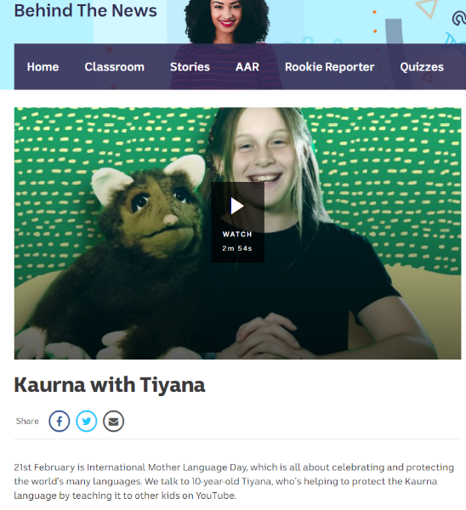
- Select a range of texts such as newspaper articles, BTN videos and other texts linked to a current unit of learning. Model a ‘think aloud’ to determine the topic using elements such as headings, images, subheadings, introductory statements and vocabulary by skimming and scanning the document.
For example, a ‘think aloud’ could be: “In this BTN report, I can see the heading ‘Kaurna with Tiyana’. I am unsure what “Kaurna’ means so I will read the introduction further. I can see the text says that it is International Mother Language Day and Tiyana is helping to protect the Kaurna language. I can see the topic of this text is about protecting the Kaurna language.
- Have students explore BTN website or available texts linked to current unit of learning to use the same text structure and language features to determine the topic.
- Using the same text, review prior knowledge and understanding of the concept of ‘main idea’. The teacher can support student knowledge by explaining that this is a big, over-riding idea. Draw attention to the fact that it is not always explicitly stated in a text, particularly in imaginative texts, but it is the main message or what is most important for a reader to understand.
- Using the same text, use a ‘think aloud’ process to explain how to determine a main idea.
“I know the topic of this text is protecting the Kaurna language. I also know that the text explores International Mother Language Day; this is a day that recognises the importance of language and culture and protecting languages. If the topic is quite specific, the main idea is much broader and can be one sentence bringing all the information together. The main idea of this text is that protecting mother language is important in order to recognise and celebrate culture. This is much broader than just the Kaurna language and helps me to understand what the whole text is about.”
- Have students return to the BTN website or available texts linked to current unit of learning to determine the main idea from the topic and understanding the text.
- Reiterate what has been established so far:
- Topic is protecting the Kaurna language
- Main idea is that protecting mother language is important in order to recognise and celebrate culture
- Introduce the idea of ‘theme’ as an overriding moral or lesson the author wants the reader to take away from the text. Themes can be transferred outside of the text to real life and to other texts and experiences. Some examples of themes include: friendship is important, believing in oneself, being truthful is important and so on. Using the same text, ask students to consider what the theme or moral might be. What might be the learning we can take from this? The theme might be that all we must value all people.
Have students return to the BTN website or available texts linked to current unit of learning to determine the theme using their already-established topic and main idea.

Determining topic and main idea
- Determine prior knowledge and understanding of the concept of ‘main idea’. Support student knowledge by explaining that this is a big, over-riding idea. Draw attention to the fact that it is not always explicitly stated in a text, particularly in imaginative texts, but it is the main message or what is most important for a reader to understand.
- Introduce a topic: ‘wildlife’ and models brainstorming some associated main ideas. Some main ideas could be:
- Protecting wildlife is important
- Wildlife is an important part of Aboriginal culture and heritage
- Wildlife is an important part of Australia’s identity
- Each country has its own native wildlife
- Introduced species must not impact wildlife
- Conduct a class brainstorm of potential topics with the class. These topics can be placed on posters around the classroom, using images to support student understanding.
- Students walk around the posters and add potential main ideas that may link to the topic.

Identifying main idea in a paragraph or section of text
- Gallery walk: Teacher shows a range of headlines as posters around the classroom using Appendix 3’ Students brainstorm responses to these questions:
- What do you think this headline is about?
- What questions do you have about this headline?
- Display and reads the text ‘The honey bee mystery’ (Appendix 4’) using the following guide:
- predict what the text might be about. Use headings, subtitles and captions.
- highlight or circle any repeated terms
- record key words
- predict a possible sentence in the text
- read aloud and mark important points with a highlighter or a sticky note.
- Use questioning to prompt students to identify key details:
- What is this text about?
- What key information is in this paragraph?
- What or who is involved?
- Where is this happening?
- What might have been written before this?
- What might be written after this?
- Display the ‘The honey bee mystery’ paragraph (Appendix 5 - ‘The honey bee mystery’).
Turn and Talk: Students retell in one sentence what this text was about. Teacher underlines and highlights key vocabulary in the text such as pollination, consumers, vital link. Teacher guides students to identify the general ‘gist’ or main idea of the text: “If I need to think of one sentence to explain what the text is about, I would underline the end of the first sentence “…the reality is that bees are a vital link in the production of our food.” This gives the overall idea about the text.
- Model how to pull information into a concept map:

- Students use a range of paragraphs and sections of texts to identify the vocabulary, details and main idea. This can be presented in a concept map (refer to Appendix 6). Students share with their peers for feedback.

Finding main idea in a whole text
- Students watch BTN video on bees: https://www.abc.net.au/btn/classroom/bee-issues/10525994. Students notice the vocabulary, key ideas and interesting facts; these can be recorded on sticky notes/whiteboards.
- Guided instruction: Students categorise their information into headings: main idea, supporting details and vocabulary.
- Model putting information in a Newsflash! template (Appendix 7 - Newsflash! scaffold).
Headline
A succinct and catchy summary sentence of the main idea
Visual representation  An image that represents the main idea or a key element of the text | Supporting details  Dot points
- To further build on background knowledge, students use the second BTN clip on bees ‘Bee Problems’: https://www.abc.net.au/btn/classroom/bee-problems/10527972 to create their own Newsflash! graphic organiser.

Identifying main idea in informative texts
- Explicit instruction: Teacher displays the informative text: ‘The honey bee mystery’ (Appendix 4 - ‘The honey bee mystery’) and models using the GIST process to identify the main idea of a text using the graphic organiser (Appendix 8 - ‘Get the GIST’) to build understanding.
Get the GIST
Gather information about background knowledge and key vocabulary:
Colour 1: Important vocabulary to understand which is pertinent to the text
Colour 2: Unfamiliar vocabulary
Colour 3: Repeated vocabulary
Identify the topic: Use vocabulary to guide ideas and refine to a word: dragonflies or a phrase: ‘photosynthesis occurs when…’.
Summarise the text by placing vocabulary into key points
Top and Tail sentences- check first and last sentences as these may reinforce main idea.
- Students apply GIST process to identify the main idea in a range of informative, persuasive and imaginative texts suited to a current unit of learning.
Gallery walk: Students add their information onto a class record using posters/google docs.
Differentiation: Students determine the product or mode of presentation. If support is needed, use ‘The honey bee mystery’ (Appendix 4 - ‘The honey bee mystery’) as the stimulus after explicit instruction.

Appendix 1

Teacher copy: a picture paints a thousand words
Photo by Markus Spiske on Unsplash.com
What is this text about?
What key information is in this image?
What or who is involved?
Where might this be happening?
What might have been happening before this?

Appendix 2

Student visual stimulus: Identifying main idea
Image by Hammad Shah on Unsplash.com

Student visual stimulus: Identifying main idea
Photo by Eneko Uruñuela on Unsplash.com

Student visual stimulus: Identifying main idea
Photo by ‘Memories on 35mm’ on Unsplash.com

Appendix 3

Headlines
Example headlines
Man on the Moon
Animals Terrorised by Bossy Donkey
We Shall Overcome
Soda Ban Goes Flat
So, there was this squirrel…
Cows lose their jobs

Headlines
Man on the Moon

What do you think this headline is about?
What questions do you have about this headline?

Headlines
Animals Terrorised by Bossy Donkey

What do you think this headline is about?
What questions do you have about this headline?

Headlines
We Shall Overcome
What do you think this headline is about?
What questions do you have about this headline?

Headlines
Soda Ban Goes Flat
What do you think this headline is about?
What questions do you have about this headline?

Headlines
So, there was this squirrel…
What do you think this headline is about?
What questions do you have about this headline?

Headlines
Cows lose their jobs
What do you think this headline is about?
What questions do you have about this headline?

Appendix 4

The Honey Bee Mystery – Whole text
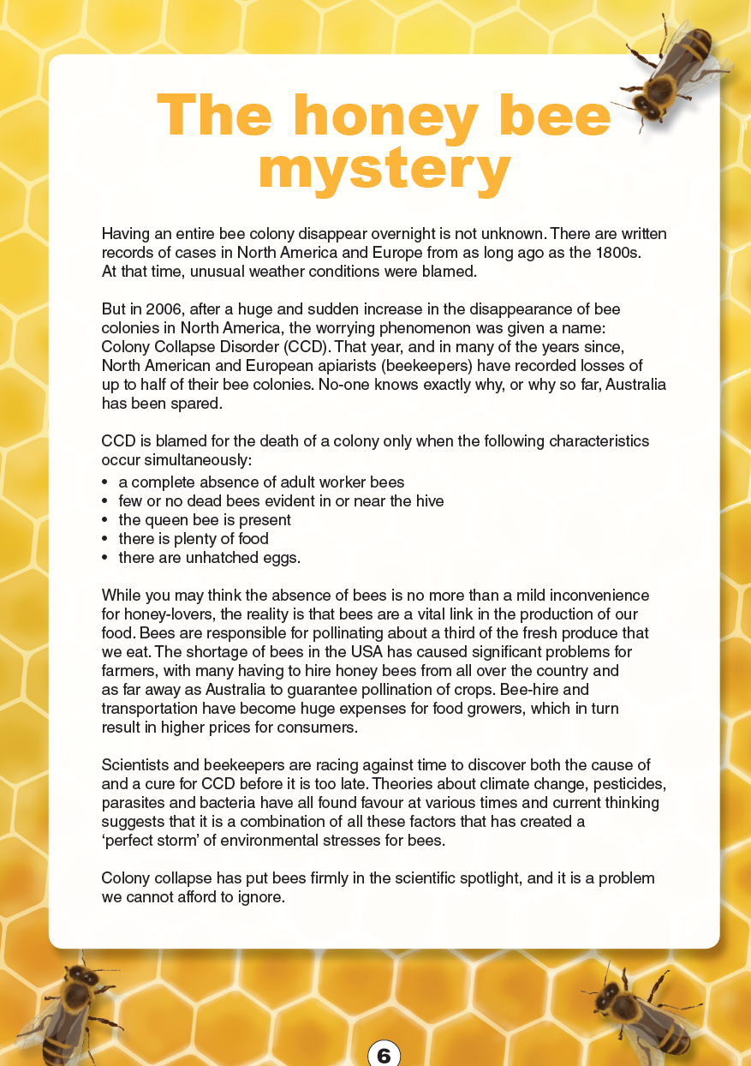
Year 5 NAPLAN Reading Magazine, 2015 ACARA

The honey bee mystery - accessible version
Having an entire bee colony disappear overnight is not unknown. There are written records of cases in North America and Europe from as long ago as the 1800s. At that time, unusual weather conditions were blamed.
But in 2006, after a huge and sudden increase in the disappearance of bee colonies in North America, the worrying phenomenon was given a name: Colony Collapse Disorder (CCD). That year, and in many of the years since, North American and European apiarists (beekeepers) have recorded losses of up to half of their bee colonies. No-one knows exactly why, or why so far, Australia has been spared.
CCD is blamed for the death of a colony only when the following characteristics occur simultaneously:
- a complete absence of adult worker bees
- few or no dead bees evident in or near the hive
- the queen bee is present
- there is plenty of food
- there are unhatched eggs
While you may think the absence of bees is no more than a mild inconvenience for honey-lovers, the reality is that bees are a vital link in the production of our food. Bees are responsible for pollinating about a third of the fresh produce that we eat. The shortage of bees in the USA has caused significant problems for farmers, with many having to hire honey bees from all over the country and as far away as Australia to guarantee pollination of crops. Bee-hire and transportation have become huge expenses for food growers, which in turn result in higher prices for consumers.
Scientists and beekeepers are racing against time to discover both the cause of and a cure for CCD before it is too late. Theories about climate change, pesticides, parasites and bacteria have all found favour at various times and current thinking suggests that it is a combination of all these factors that has created a ‘perfect storm’ of environmental stresses for bees.
Colony collapse has put bees firmly in the scientific spotlight, and it is a problem we cannot afford to ignore.
Year 5 NAPLAN Reading Magazine, 2015 ACARA

Appendix 5

The Honey Bee Mystery – paragraph
The Honey Bee Mystery
While you may think the absence of bees is no more than a mild inconvenience for honey-lovers, the reality is that bees are a vital link in the production of our food. Bees are responsible for pollinating about a third of the fresh produce that we eat. The shortage of bees in the USA has caused significant problems for farmers, with many having to hire honey bees from all over the country and as far away as Australia to guarantee pollination of crops. Bee-hire and transportation have become huge expenses for food growers, which in turn result in higher prices for consumers.
Year 5 NAPLAN Reading Magazine, 2015 ACARA

The Honey Bee Mystery – Paragraph
The Honey Bee Mystery
While you may think the absence of bees is no more than a mild inconvenience for honey-lovers, the reality is that bees are a vital link in the production of our food. Bees are responsible for pollinating about a third of the fresh produce that we eat. The shortage of bees in the USA has caused significant problems for farmers, with many having to hire honey bees from all over the country and as far away as Australia to guarantee pollination of crops. Bee-hire and transportation have become huge expenses for food growers, which in turn result in higher prices for consumers.
Accessibility note:
The following words are underlined in the text above
- absence
- mild inconvenience
- vital link
- pollinating
- shortage of bees
- significant problems
- transportation
- expenses
- consumers
Year 5 NAPLAN Reading Magazine, 2015 ACARA

Appendix 6

Identify main idea – Blank concept map

Appendix 7

Newsflash!
Headline (a succinct and catchy version of the main idea)

Visual representation | Supporting details

Appendix 8

‘Get the GIST’ student scaffold
Get the GIST
Gather information  background knowledge and key vocabulary:  Colour 1: Important vocabulary (black)  Colour 2: Unfamiliar vocabulary (blue)  Colour 3: Repeated vocabulary (red) | Identify the topic  Use vocabulary to guide ideas and refine to a word: dragonflies or a phrase: ‘photosynthesis occurs when...’
Summarise text by placing vocabulary into key points | Top and tail sentences- check first and last sentences as these may reinforce main idea.

